

**Final Assessment for Data Analytics**

HOUSE RENT PRICE   
ANALYSIS REPORT

**Prepared by**

|  |  |
| --- | --- |
| **Pralad Kadel**  Data Analyst Apprentice | Chakupat-10, Lalitpur, Nepal  [coderush.com.np](http://coderush.com.np/) |

**September 28, 2022**

# Introduction

To understand the general house rate prices in India, Code Rush was asked to conduct an evaluation of the rent prices of six major cities in the country. This report contains all information concerning said assessment. Various variables of the house are evaluated (like house size, furnishing status, no. of bathroom, BHK etc.) to see their consequences in the overall rent price of the house. Other factors like floor number, tenant preference, area type etc. are also evaluated to analyze their overall affect in the rent price. The assessment is also a mean to determine the general price range for customer with different needs and requirements.

# Key Aspects of the Assessment

## Data:

Source of the data is unknown as the sample data was provided by the CodeRush team directly as a part of the assessment.

## Methods:

For the analysis of data, various types of descriptive statistics like measure of frequency, correlation, dispersion etc. are used so that we can present the data in a meaningful and understandable way allowing us a simplified interpretation and visualization of the data. We have used various univariate plots (like histogram, pie chart etc.) and multivariate plots (like scatter, linear model plots etc.) for the analysis of the data to understand their relationship with the house rent prices.

## Results and Analysis:

Our task is to analyze the given rent data and identify how the different variables affects the overall rent price of the houses. For that, we have filtered our dataset based on different variables like furnishing status, city, area, area type, no of BHK etc. and observed their relationship with the rent prices. We have also built a predictive model based on the data and some of the results of our analysis are shown and explained below:

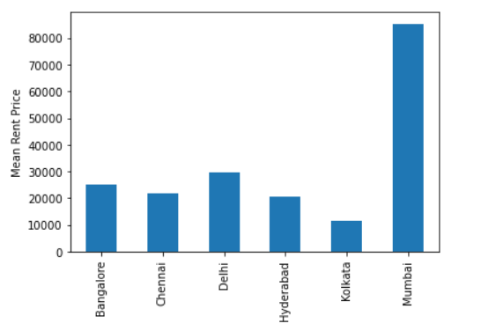

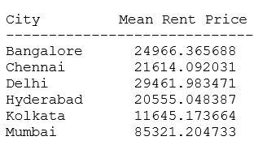

*Figure: Mean house rent price based on different city*

From the bar diagram, we observed that the rent price is highest in the Mumbai city with the average of INR 85,321. The cheapest city to live in is Kolkata with the average rent price of INR 11,645 and the average cost to rent a house in all other cities is between INR 20,000 to INR 30,000.

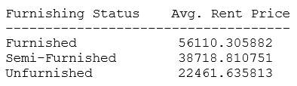

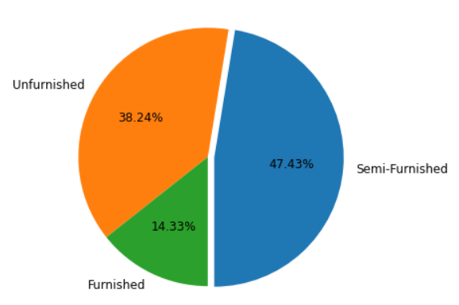

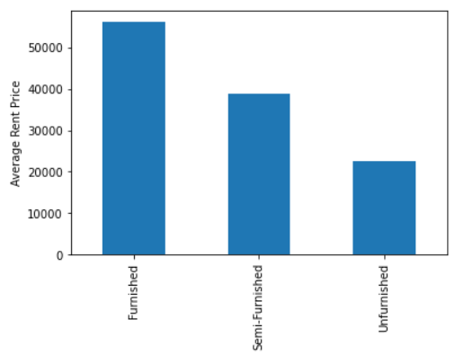

*Figure: Illustration of furnishing status and rent price relationship*

47.43% of the houses in rent are semi-furnished, 38.28% are unfurnished and remaining 14.33% of the houses are fully furnished. We also observed that the average price of rent for a furnished,

semi-furnished and unfurnished houses are INR 56110, INR 38718 and INR 22461 respectively. We inferred that the furnished house cost more than double the unfurnished house.

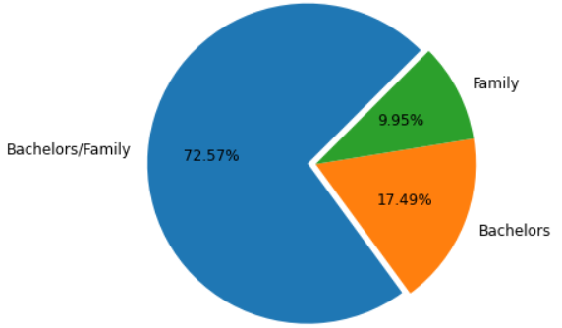

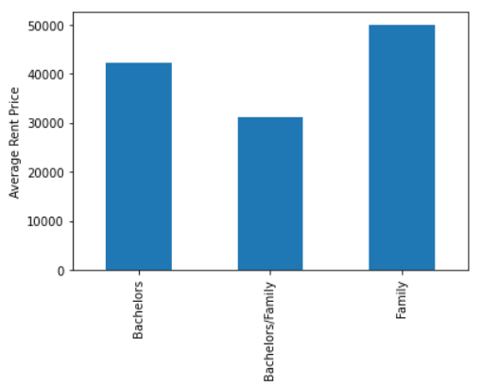

*Figure: Illustration of tenant preferred and rent price relationship*

About 73% of the house owner preferred tenant as either bachelors or family with average rent price as INR 31,210. 17.49% of the owners preferred their tenant as bachelors costing INR 42,143 average rent price and remaining 9.95% of the owners preferred family as their tenant costing INR 50,020 rent price in average.

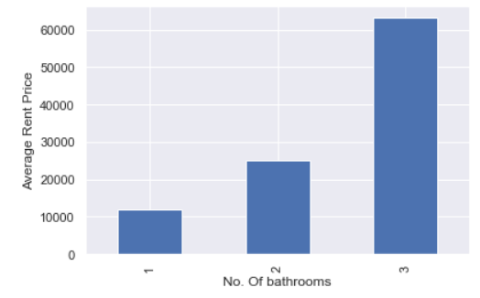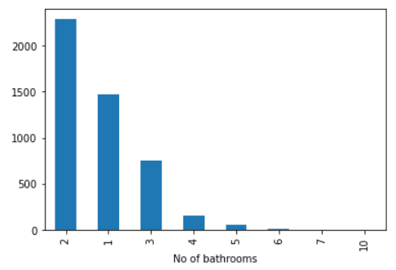

*Figure: Illustration of no. of bathroom and rent price relationship*

About 95% of the total houses had either 1 ,2 or 3 no. of bathrooms in total. Most of the houses for rent had 2 bathrooms in total costing tenants about INR 25,000 in average to rent such houses. Also,

it costs INR 12,000 and INR 63,000 in average to rent a house with 1 and 3 bathrooms respectively.

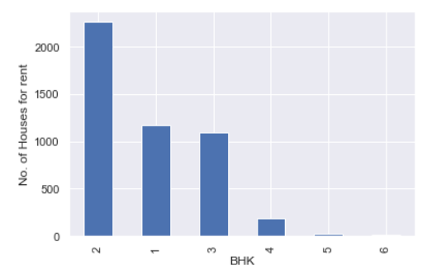

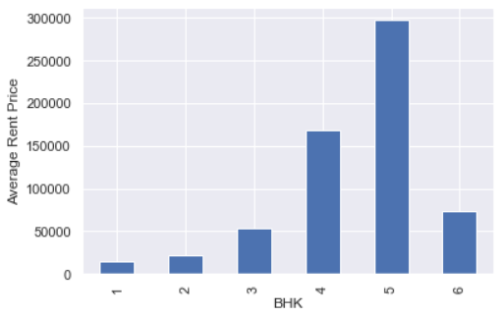

*Figure: Illustration of BHK and rent price relationship*

Most of the houses available for rent had 2-bedroom, hall and kitchen (BHK) and it costed tenants about average of INR 22,000 to rent such houses. The most expensive houses had 5 BHK and it costed about average of INR 297,500 to rent them. Out of all, about 25% of the houses had 1 BHK and it only costed about INR 14,000 in average to rent such houses.

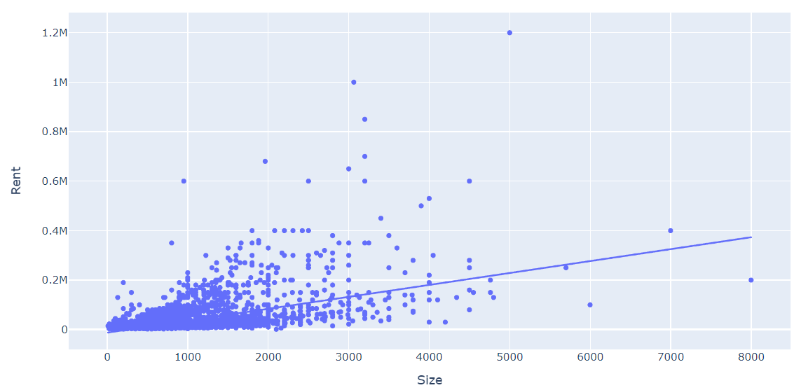

*Figure: Rent price vs Size of the land*

We observed that the rent price and size of the land were directly related with each other in the sense that as the size of the land of the house increased, the price of rent also increased. We observed that the price and size followed following relation:

Rent Price = 48.208 **\*** Land Size **-** 12362

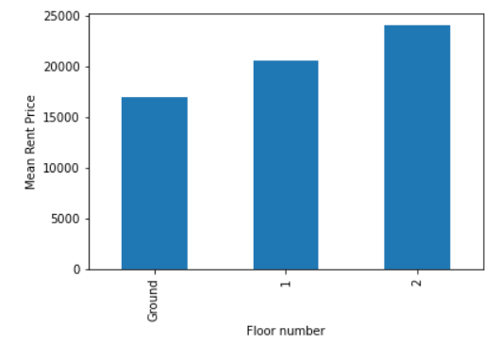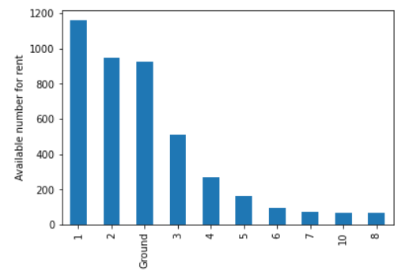

*Figure: Illustration of floor number and rent price relationship*

We observed that first floor was the most available rent option which costed an average of INR 20,600 to rent it. About 64% of the total rents were between ground, first and second floor. The ground floor and second floor house costed about INR 17,000 and INR 24,000 in average respectively.

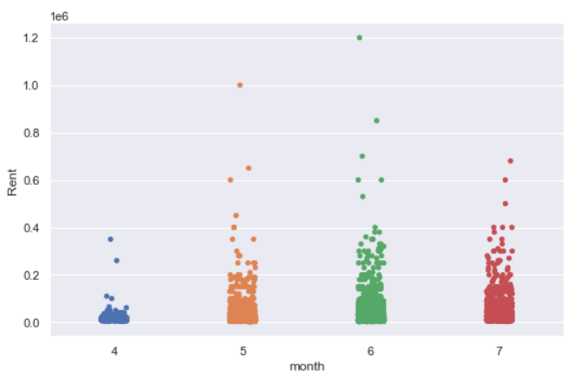

*Figure: Illustration of posted month and rent price*

We observed that all data was collected in 2022 year only. So, on further drilling down, we observed that the data is from 4-month time frame only where most of the data was from June month, following by May, July and April respectively. The rent price was lowest for April month in comparison to others.

Finally, we built two different prediction models which can predict the rent price for clients with different requirements and needs. The performance of these models is shown in the table below:

|  |  |  |  |  |
| --- | --- | --- | --- | --- |
| Model | MAE | RMSE | R2_Score | Random 25 predicted data plot |
| Linear Regression | 21588.27 | 46841.64 | 0.447 |  |
| ­Gradient Boosting Regressor | 12609.57 | 35643.11 | 0.679 |  |

**Client Requirements:**

- Fully furnished, 850 sq. ft size

- 3 BHK, 2 bathrooms (family of 4, extra room and toilet for guest as well)

Based on the client requirement, we predicted the price to rent house based on different city. The price predicted by our model is displayed in the table below:

|  |  |
| --- | --- |
| City Name | Approx. Rent Price Range |
| Mumbai | (58,623) 55k to 60k |
| Kolkata | (17,133) 16 to 20k |
| Delhi | (19,092) 18 to 22k |
| Hyderabad | (17,133) 16 to 20k |
| Bangalore | (19,092) 18 to 22k |
| Chennai | (19,092) 18 to 22k |

**Conclusion and Recommendation:**

Considering that the data provided is accurate, the team can conclude that the rent prices are highest in the Mumbai city. So, we recommend clients to buy houses in Mumbai city only if the circumstances are must. The cheapest option to live in are Kolkata and Hyderabad city in comparison to others. Thus, we recommend these cities as economical renting options. From the data, we observed that the most of the houses available for rent comes semi-furnished. We can also conclude that majority of the house owners do not care if the tenants are bachelors or are intending to live with the family. Above 95% of the available houses have either 1,2 or 3 number of toilets and majority of the available rooms are either ground, first or second floored. We can also conclude that the rent price of house increases with the increase in size of the land.