**Library System**

**Technologies Used** (So Far):

* Spring Boot (Embedded with Tomcat Server).
* Spring Security.
* Spring Validation.
* Maven
* JSP, for simple login pages.
* Bootstrap.
* JQuery.

**How to run**:

1. In your IDE, perform a Maven clean install.
2. Run “com.​Ejadatraining.​Librarysystem.LibrarySystemApplication.java”

# Diagrams

## Class Diagrams

**Package Structure**

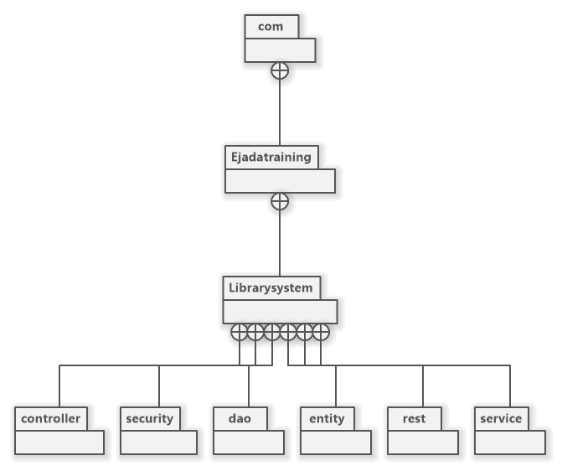

**Package:** **rest**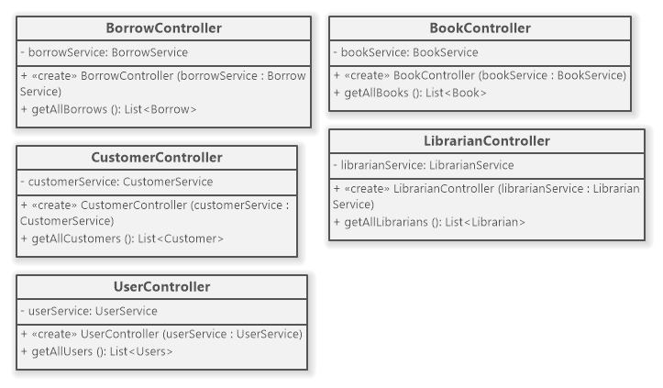

**Package: Entities**

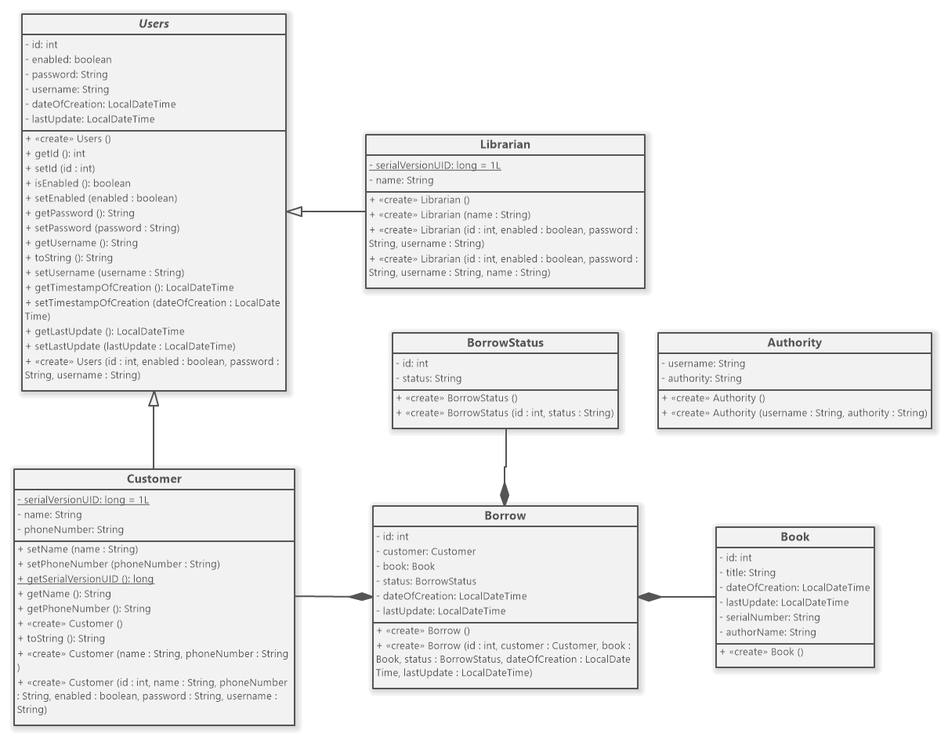

**Package: Service**

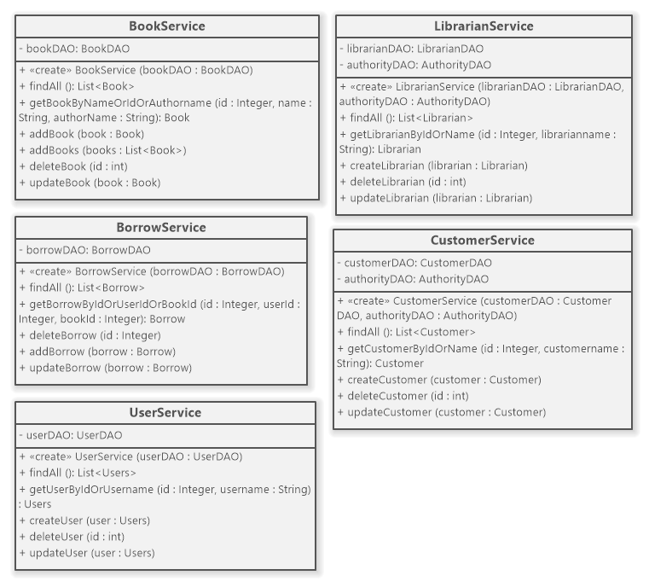

**Package: DAO**

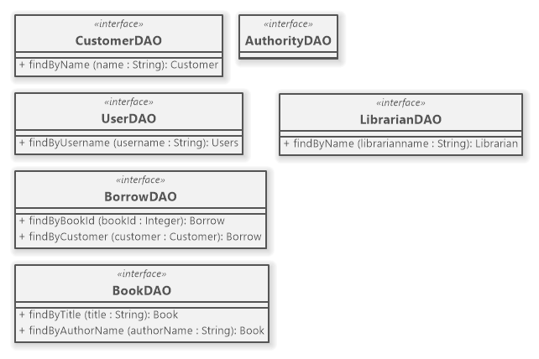

## Entity Relation Diagram (Database)

