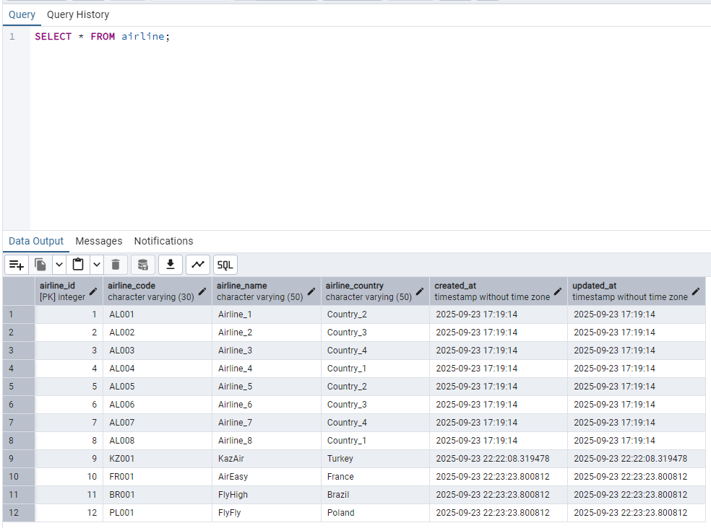

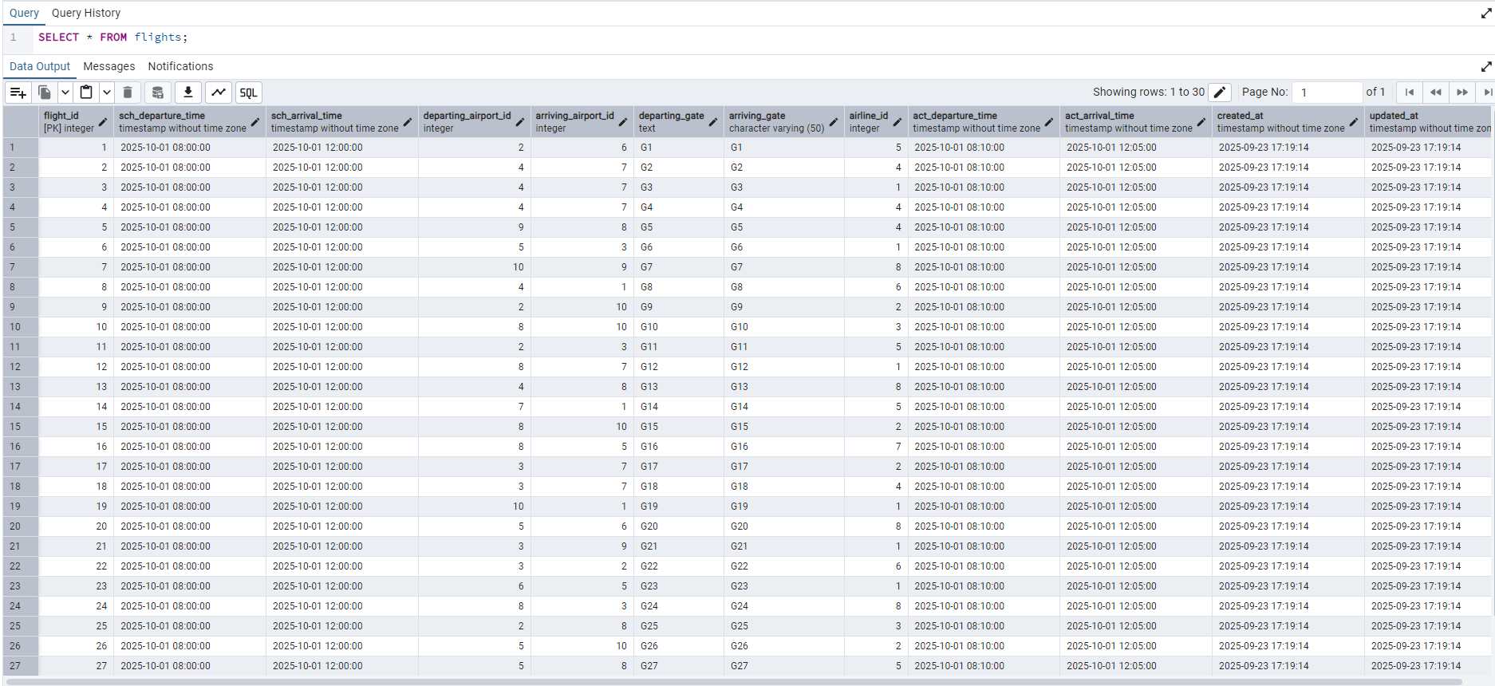

Departing gate as text and no flights from 2024

In the third screenshot a branch of the Airport’s database is included, where there is a Booking table shown, after the changes that multiplied all the prices by 1.15 and removed those less than 10000

