1. Executive Summary
This report analyzes biometric transaction data across multiple centers, focusing on demographic trends, operational bottlenecks, and demand concentration. The analysis highlights the dominant impact of mandatory child biometric updates, significant load imbalance across centers, and strong household-level behavioral patterns. These insights aim to support data-driven policy, capacity planning, and service optimization.

2. Dataset Overview
- Time Period: March 2025 – January 2026
- Demographics:
  - Mandatory biometric updates: Children aged 5–17
  - Voluntary biometric updates: Adults aged 18+
- Dimensions Analyzed:
  - Monthly transaction trends
  - Center-level (pincode) volumes
  - Demographic split
  - Correlation between adult and child updates

3. Key Insights and Findings
3.1 Mandatory vs Voluntary Update Trends
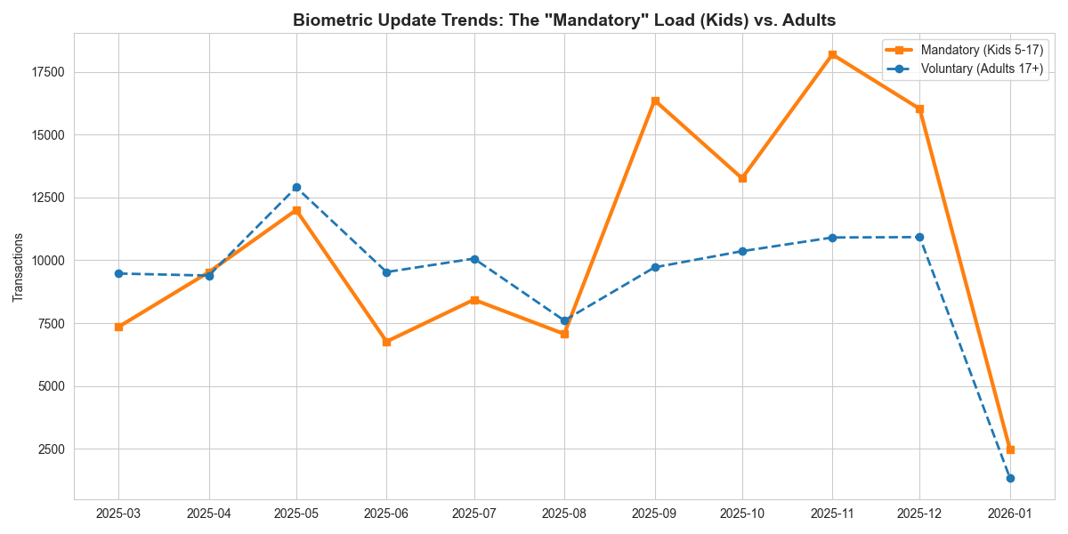
Mandatory biometric updates for children consistently exceed voluntary adult updates throughout the year. Sharp spikes are observed between September and November, indicating seasonal or policy-driven surges.
Implication: System load is heavily influenced by compliance requirements rather than user choice.

3.2 High-Volume Center Bottlenecks
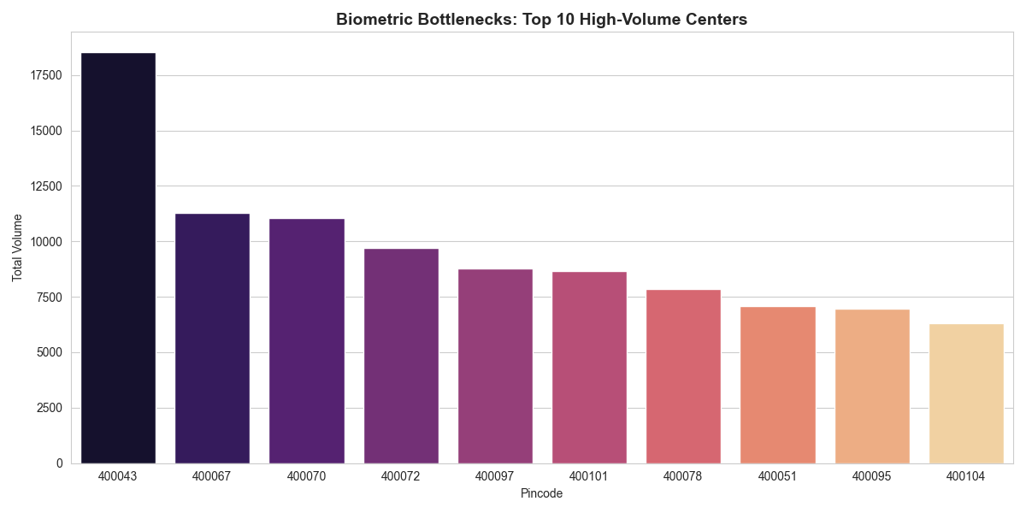
A small number of centers process disproportionately high transaction volumes. Certain pincodes handle two to three times the load of average centers.
Implication: Operational stress and user experience issues are localized but severe.

3.3 Adult–Child Update Correlation
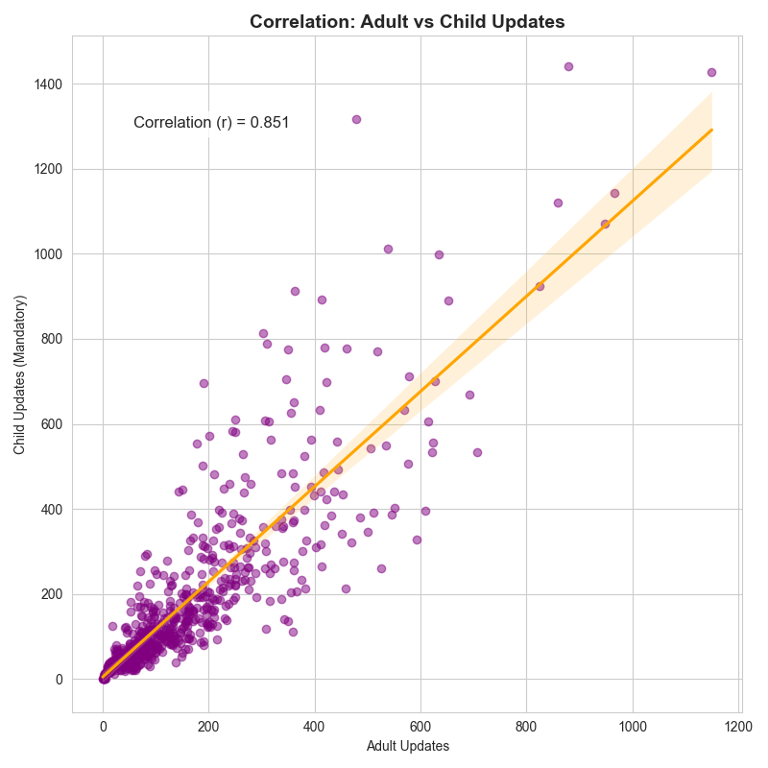
There is a strong positive correlation (r ≈ 0.85) between adult and child biometric updates at the center level.
Implication: Families tend to complete biometric updates together, creating clustered demand patterns.

3.4 Pareto Distribution of Workload
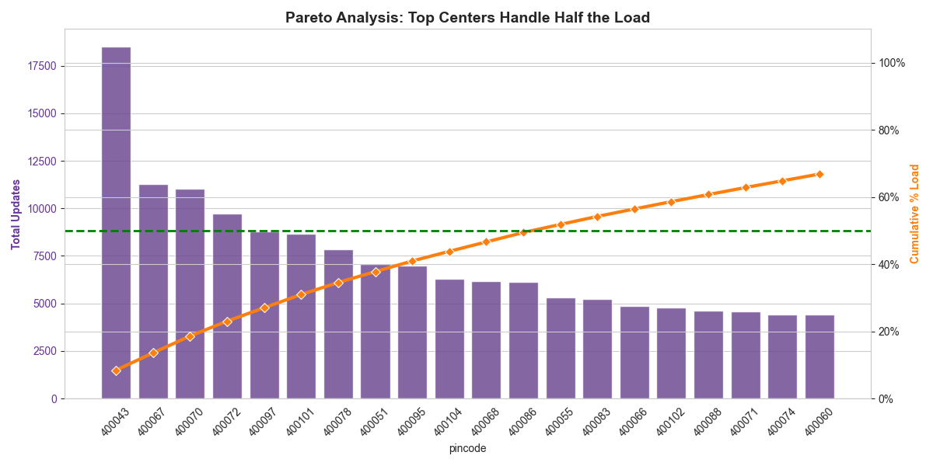
Approximately 20% of centers account for nearly 50% of total biometric transactions.
Implication: System efficiency and reliability depend heavily on a limited number of critical centers.

3.5 Demographic Contribution to Load
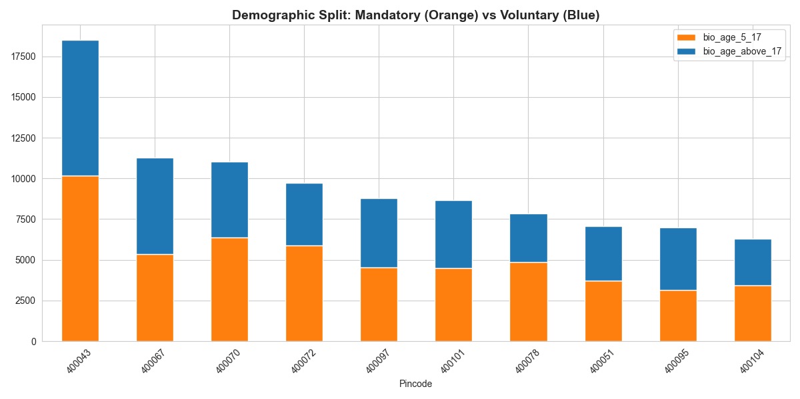
Across all high-volume centers, mandatory child updates form the majority share of total transactions, with adult updates contributing a smaller but stable baseline.
Implication: Uniform resource allocation does not align with demographic-driven demand realities.

4. Key Problems Identified
- Seasonal overload due to mandatory child updates
- Uneven load distribution causing center-level bottlenecks
- Underestimation of household-based demand
- High systemic risk due to dependence on few centers
- Lack of demographic-aware capacity planning

5. Recommendations and Solutions
5.1 Capacity Planning
- Scale staffing and infrastructure during known peak months
- Use historical trends to forecast mandatory update surges
5.2 Center Load Balancing
- Introduce appointment caps and dynamic redirection
- Establish temporary or satellite enrollment centers
5.3 Family-Centric Scheduling
- Enable bundled family appointments
- Allocate counters optimized for child processing
5.4 Pareto Center Prioritization
- Focus upgrades, monitoring, and contingency planning on top-load centers
- Deploy real-time dashboards for high-risk locations
5.5 Demographic-Aware Policy Design
- Align outreach, staffing, and infrastructure with child population density
- Separate planning models for mandatory vs voluntary demand

6. Conclusion
The biometric system’s performance is primarily driven by mandatory child updates and concentrated center-level demand. By shifting toward demographic-aware planning, family-based scheduling, and Pareto-focused optimization, the system can significantly improve efficiency, resilience, and citizen experience.

Prepared for: Policy, Operations, and Program Management Teams
Purpose: Strategic planning and service optimization

