1. Find the Cname and city who place an order of order-amt between 500-13000.

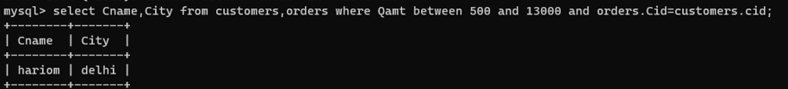

1. Find the salesman who do not live in the same city as their customers lives.



1. Find the customer_name, city, salesman_name and city sorted by ascending order of Cid.

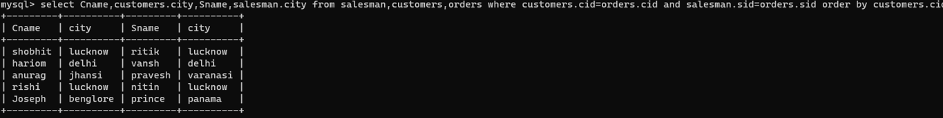

1. Find Cname, city, Oid, Odate and Oamt in Ascending order,according to Odate have placed an order.

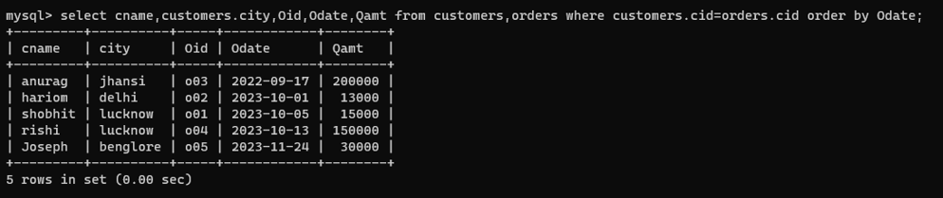

1. Find the 2nd Highest salary of the salesman.

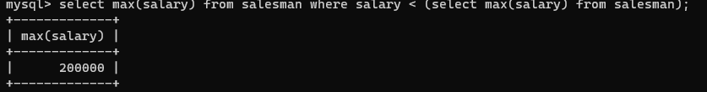

1. Find the name of customer who placed max no of orders.

