1. Creating view in MYSQL

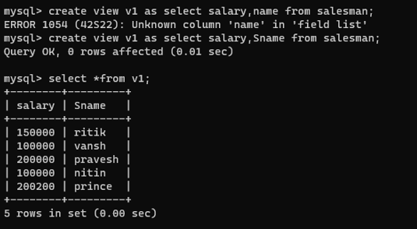

1. Creating and then calling Procedure in MySQL

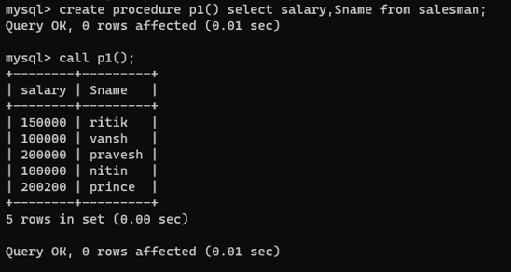

1. Updating View

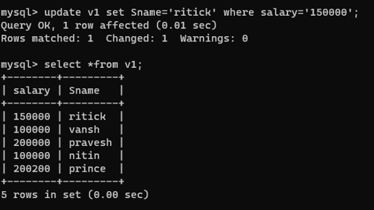

1. Creating Trigger in MYSQL



1. Updating value to check if trigger is working or not.

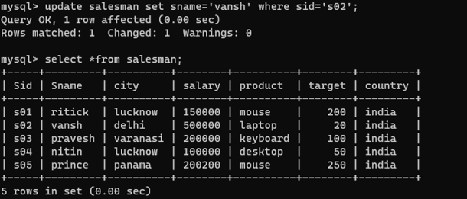

1. Inserting value to check If trigger is working or not

