###### ABSTRACT

###### A responsive portfolio is a web design approach that ensures a portfolio website looks and functions well on various devices, including desktops, tablets, and smartphones. This adaptability is achieved through techniques like fluid grids, flexible images, and media queries, which allow the layout to adjust dynamically based on thescreen size and orientation.

###### Key benefits of a responsive portfolio include:

###### Enhanced User Experience: Visitors can easily navigate and view content regardless of the device they use.

###### Improved SEO: Search engines favor mobile-friendly websites, potentially boosting search rankings.

###### Future-Proofing: As new devices with varying screen sizes emerge, a responsive design ensures compatibility without needing significant redesigns.

###### [By implementing responsive design principles, professionals can showcase their work effectively, providing a seamless and engaging experience for all users](https://www.hongkiat.com/blog/responsive-portfolios-for-inspiration/).

###### TABLE OF CONTENTS

|  |  |  |
| --- | --- | --- |
| **SNO** | **SECTION** | **PAGE NO.** |
| 1 | INTRODUCTION | 1 |
| 2 | PROBLEM STATEMENT | 2 |
| 3 | TECHNICAL DETAILS | 3 |
| 4 | KEY FEATURES | 4 |
| 5 | PROJECT ADVANTAGES | 5 |
| 6 | BONUS FEATURE | 6 |
| 7 | RESULT | 7-11 |
| 8 | CONCLUSION | 12 |

**INTRODUCTION**

**A responsive portfolio is a personal website designed to showcase your work, skills, and experiences in a way that looks great on any device, whether it’s a desktop, tablet, or smartphone. Here are some key points to consider:**

**Why Create a Responsive Portfolio?**

1. **Showcase Your Work: It allows you to display your projects, designs, or any work samples in a professional manner.**
2. **Accessibility: A responsive design ensures that your portfolio is accessible and user-friendly on all devices.**
3. **Professional Image: It helps in building a strong online presence and personal brand.**
4. **Networking: Makes it easier for potential clients or employers to find and contact you.**

* **Key Components of a Responsive Portfolio**

1. **Introduction/Bio: A brief introduction about yourself, your background, and what you do.**
2. **Projects/Work Samples: A section to showcase your best work with descriptions and images.**
3. **Skills: Highlight your skills and expertise.**
4. **Contact Information: Provide ways for visitors to get in touch with you.**
5. **Responsive Design: Use HTML, CSS, and JavaScript to ensure your site looks good on all devices.**

* **Tools and Technologies**
* **HTML: For the structure of your website.**
* **CSS: For styling and layout.**
* **JavaScript: For interactive elements.**
* [**Bootstrap: A popular framework for building responsive websites1**](https://www.freecodecamp.org/news/how-to-create-a-portfolio-website-using-html-css-javascript-and-bootstrap/)[**2**](https://www.codewithfaraz.com/content/139/personal-portfolio-website-a-step-by-step-guide-with-html-css-and-javascript)**.Creating a responsive portfolio can significantly enhance your professional presence online.**

PROBLEM STATEMENT

Objective: Create a responsive portfolio website showcasing projects and skills. Approach: - Design the HTML structure for the portfolio with sections for projects, skills, and about me. - Utilize CSS media queries to adapt the layout for different screen sizes. - Apply Flexbox or Grid for arranging project cards. Use JavaScript to add interactivity and animations for a more engaging experience.

TECHNICAL DETAILS

* HTML5: Used for structuring the content, including sections like navigation, About, Education, Experience, and Contact. Each section has a specific purpose within the portfolio website.
* CSS Styling: Embedded in the

tag, used to design the layout, making the site visually appealing with background gradients, sticky navigation, and a responsive timeline.

* **JavaScript Libraries**: 1. jQuery: Included via CDN for manipulating DOM elements more easily and adding interactive behavior. 2. Typed.js: A JavaScript library used to animate text, which adds a dynamic typing effect to the "Web Developer" text in the About section. Responsive Design: Media queries are used to make the website adapt to different screen sizes, ensuring a smooth experience across desktop and mobile devices. Modal Popups: Included in the Contact section to allow users to interact through a form. The modal is designed to display a popup with input fields for sending messages.

KEY FEATURES

1.**Responsive Design:**Ensures the portfolio looks great on all devices (desktop, tablet, mobile).Utilizes CSS Media Queries for layout adjustments based on screen size.2**. Interactive Navigation:**A sticky navigation bar for easy access to all sections.Smooth scrolling effect for a seamless user experience.3. **Project Showcasing:**Organized project section with a filter option to categorize projects.Lightbox gallery for viewing project images with enhanced visuals.4. **Skill Progress Indicators:**Dynamic progress bars to visually display skills and expertise.Circular progress charts for highlighting key competencies.5**. Contact Form:**A functional and responsive contact form with validation.Modal-based pop-up design for an unobtrusive user interface.6. **Downloadable CV:**Option to download the CV directly from the site.Styled buttons with clear call-to-action.7. **Animations & Interactivity**:JavaScript animations (like typing effect) for engaging the audience.Hover and click effects for an interactive experience.

PROJECT ADVANTAGES

Creating a responsive portfolio offers numerous advantages, especially in today’s digital age. Here are some key benefits:

**1. Enhanced User Experience**

A responsive portfolio ensures that your website looks and functions well on all devices, providing a seamless experience for users whether they are on a desktop, tablet, or smartphone.

**2. Improved Accessibility**

With a responsive design, your portfolio is accessible to a wider audience. This inclusivity can help you reach more potential clients, employers, or collaborators.

**3. Better SEO Performance**

Search engines like Google prioritize mobile-friendly websites. A responsive portfolio can improve your search engine rankings, making it easier for people to find you online.

**4. Professional Appearance**

A well-designed responsive portfolio reflects professionalism and attention to detail. It shows that you care about how your work is presented and are up-to-date with current web design trends.

**5. Cost-Effective**

Maintaining a single responsive website is more cost-effective than creating separate versions for different devices. It reduces the need for duplicate content and simplifies updates.

**6. Increased Engagement**

Users are more likely to stay longer and engage with your content if they have a positive browsing experience. This can lead to higher conversion rates, whether that means more job offers, client inquiries, or project collaborations.

**7. Future-Proofing**

As new devices and screen sizes emerge, a responsive design ensures your portfolio remains functional and visually appealing without needing major overhauls.

BONUS FEATURE

**1.Interactive Elements:**

* **Hover Effects**: Subtle animations when users hover over images, buttons, or links, adding a dynamic feel to your portfolio.
* **Lightbox Gallery**: Allow users to click on images or projects to enlarge them, creating a more engaging experience.
* **Animations & Transitions**: Use CSS or JavaScript to add smooth animations when users scroll or navigate between sections.

**2. Smooth Scrolling & Parallax Effects:**

* **Smooth Scrolling**: Makes moving between sections feel seamless, improving user experience.
* **Parallax Scrolling**: Background elements move at a different speed than the foreground as the user scrolls, adding depth to your site.

**3. Customizable Themes:**

* Let users toggle between different themes (e.g., dark mode, light mode) or color schemes, allowing for a personalized browsing experience.

**4. Contact Forms & Call-to-Action (CTA) Buttons:**

* **Contact Form**: Easy-to-use form to allow potential clients or collaborators to get in touch without needing to leave the site.
* **CTA Buttons**: Strategically placed buttons (e.g., "Hire Me", "Download Resume") that encourage visitors to take action.

**5. Integrated Social Media & External Links:**

* **Social Media Links**: Direct links to your social profiles, including icons that are easily recognizable.
* **Embedded Social Media Feeds**: Display live feeds from your Instagram, Twitter, or LinkedIn directly on the portfolio.

**6. Performance Optimization:**

* **Lazy Loading**: Ensures that images and content load only when they are needed, improving page load times and overall performance.
* **Optimized Images & Media**: Use responsive image techniques, like different image sizes for different screen resolutions, ensuring fast loading on mobile and high-quality visuals on desktop.

**7. Project Filters & Categories:**

* Let visitors filter projects by categories (e.g., web design, photography, graphic design) or tags, allowing for easy navigation through your work.

**8. SEO Optimization:**

* Implement SEO best practices to make your portfolio easily searchable and rank higher on search engines like Google. This includes using meta tags, keywords, and alt text for images.

**9. Downloadable Files:**

* Provide downloadable versions of your resume, project reports, or portfolio PDFs for users who want to take a copy offline.

**10. Testimonials & Reviews Section:**

* Showcase feedback from clients, employers, or collaborators to add credibility to your portfolio and demonstrate your professional value.
* RESULT

HTML

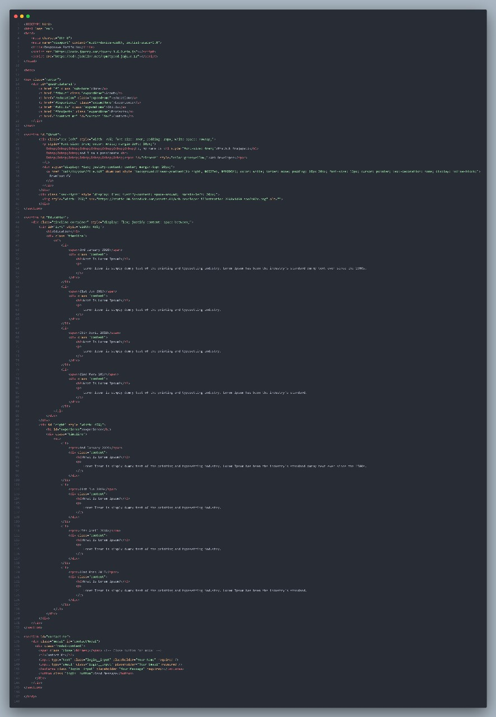

CSS

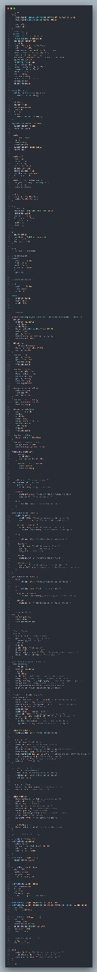

JAVASCRIPT

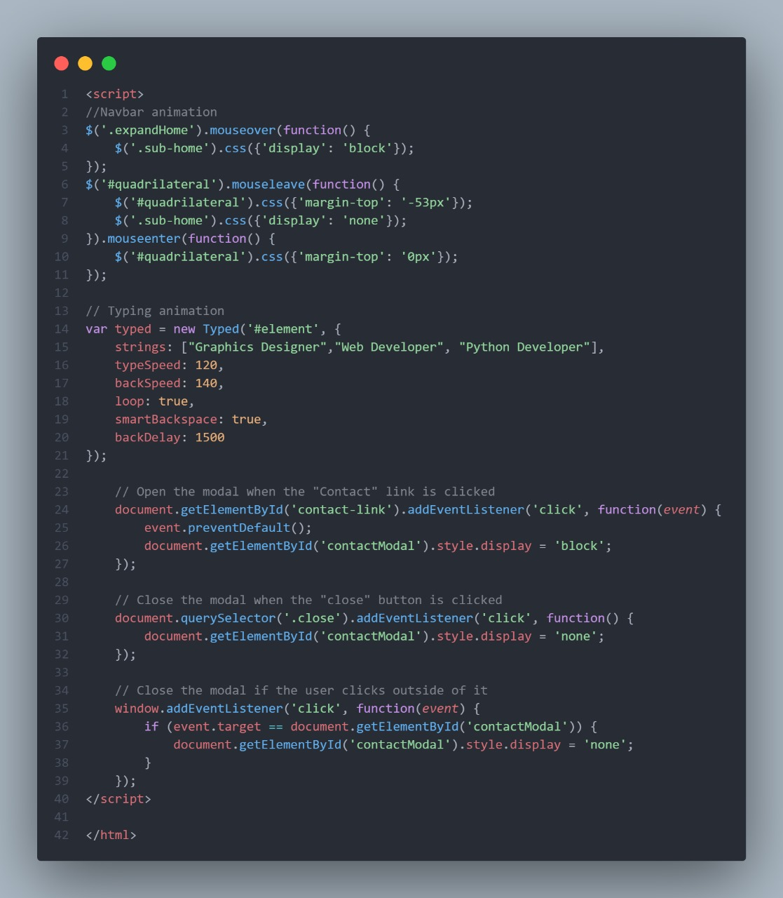

OUTPUT

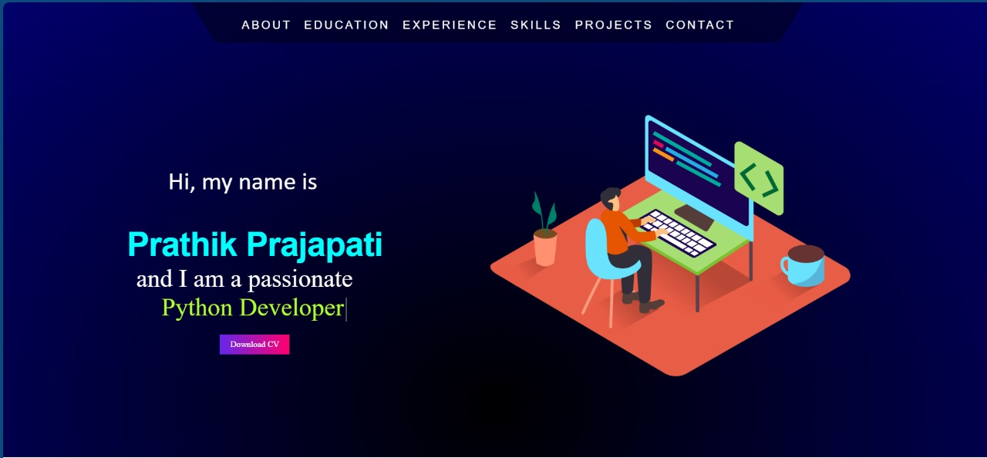

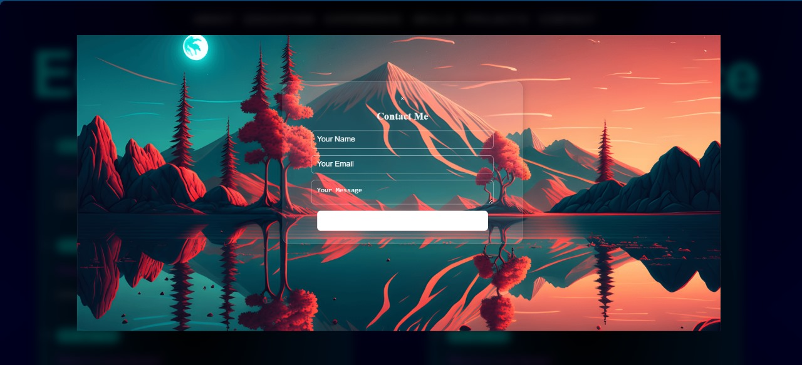

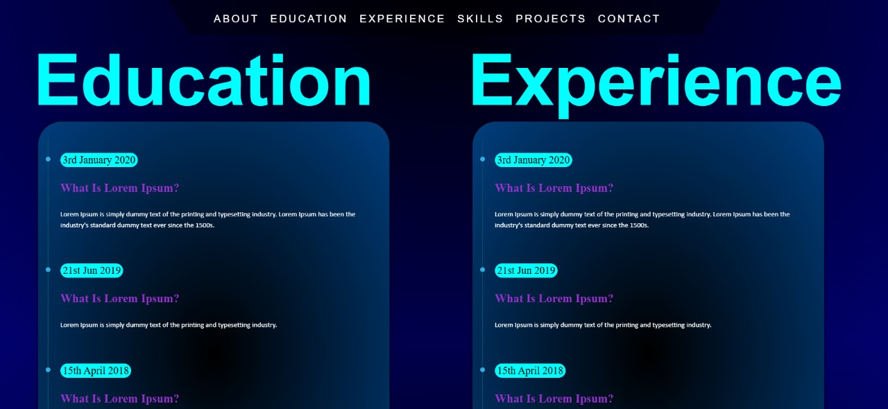 CONCLUSION

In conclusion, a **responsive portfolio** is essential for modern web design, ensuring that your work is accessible and visually appealing across all devices. By adopting responsive design principles, you not only enhance the user experience but also improve your site’s SEO and future-proof your portfolio against emerging technologies. This approach allows you to effectively showcase your skills and projects, making a lasting impression on potential clients and employers.

**Team Work:** The project work was distributed among all the two members of the team. Project involvement was as follows:

**SAIDEEP GHOSH**: Designing of main page for the website, Search bar, Project report , Webpage for About Us

**PRATHIK PRAJAPATI**: Login Portal, Webpage for Home offering multipleplatforms , Contact us , Presentation ppt

REFERENCES

* **W3schools:** [***https://www.w3schools.com/howto/howto_css_image_overlay.asp***](https://www.w3schools.com/howto/howto_css_image_overlay.asp)
* **CodePen**. <https://codepen.io/>