HTML tags are **like keywords which defines that how web browser will format and display the content**.

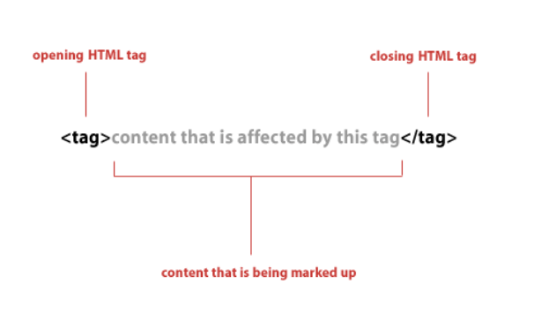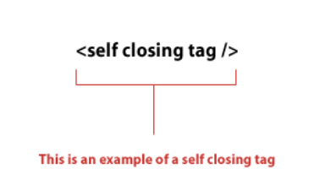

## Attributes are used along with the HTML tags to define the characteristics of the element.

## The alt Attribute

The required alt attribute for the <img> tag specifies an alternate text for an image, if the image for some reason cannot be displayed. This can be due to a slow connection, or an error in the src attribute, or if the user uses a screen reader.

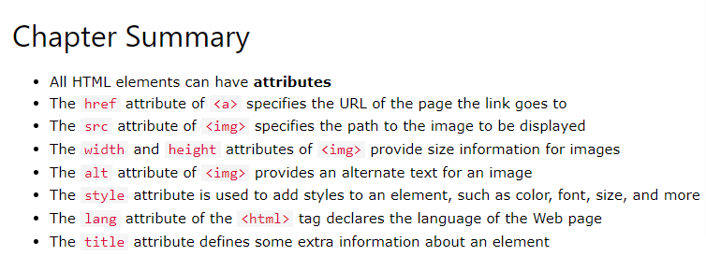

## Definition and Usage

The <strong> tag is used to define text with strong importance. The content inside is typically displayed in **bold**.

**Tip:** Use the [<b>](https://www.w3schools.com/tags/tag_b.asp) tag to specify bold text without any extra importance!

[Grid](https://www.geeksforgeeks.org/css-grid-property/)**:**CSS Grid Layout, is a two-dimensional grid-based layout system with rows and columns, making it easier to design web pagesLike tables, grid layout allow us to align elements into columns and rows.

## The grid-template-columns Property

The grid-template-columns property defines the number of columns in your grid layout, and it can define the width of each column.

### 11. What are Pseudo elements and Pseudo classes?

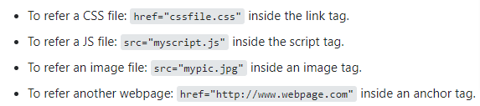

# **HTML src Attribute**

## Definition and Usage

The src (Source) attribute specifies the location (URL) of the external resource.

**href** (Hypertext Reference)

The href attribute specifies the URL of the page the link goes to.

HREF - Hyperlink Reference | Often used in tags to reference another page or web link. SRC - Source | Often used in tags to give the web page the source of an image, video or file

The text-decoration property specifies the decoration added to text, and is a shorthand property for:

* text-decoration-line (required)
* text-decoration-color
* text-decoration-style
* text-decoration-thickness

# **CSS background-repeat Property**

## Definition and Usage

The background-repeat property sets if/how a background image will be repeated.

By default, a [background-image](https://www.w3schools.com/cssref/pr_background-image.asp) is repeated both vertically and horizontally.

## CSS Box Sizing

The CSS box-sizing property allows us to include the padding and border in an element's total width and height.

# **CSS Layout - Overflow**

The CSS overflow property controls what happens to content that is too big to fit into an area.

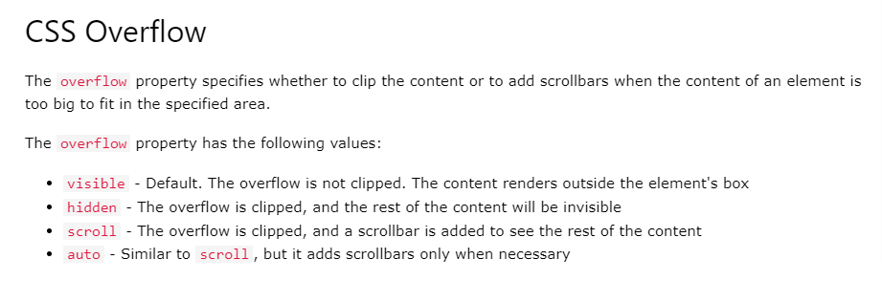

## The @keyframes Rule

When you specify CSS styles inside the @keyframes rule, the animation will gradually change from the current style to the new style at certain times.

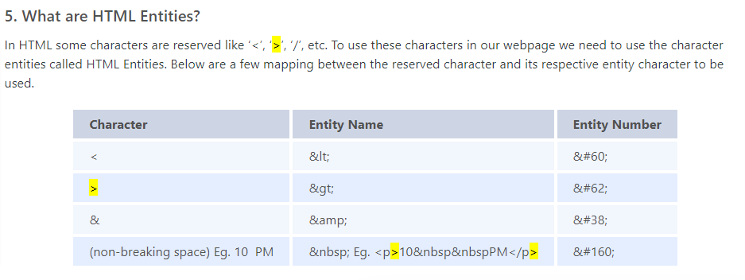

html and html5 difference

A hypertext markup language (HTML) is the primary language for developing web pages. HTML5 is a new version of HTML with new functionalities with markup language with Internet technologies. Language in HTML does not have support for video and audio. HTML5 supports both video and audio.

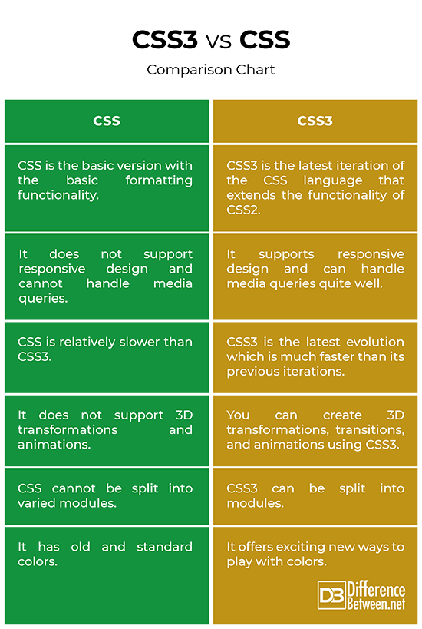

**CSS selectors** are used to "find" (or select) the HTML elements you want to style.

## CSS Box Sizing

The CSS box-sizing property allows us to include the padding and border in an element's total width and height.