**Supermarket Billing**

Choices supermarket is a self-service store offering a wide variety of food, beverages and household products, organised into various categories. The categories can have subcategories. Subcategories have items under them

Items can be sold by

1. Weight e.g. Kilogram, Gram
2. Volume e.g. Litres, Mililitres
3. Numbers e.g. 5, dozen

Every item has a price for which it can be sold. Supermarket employs various discounting strategies. Some of the strategies are.

1. Discounts on categories, subcategories and items price e.g. 15% discount on fruits
   1. Only one discount can be applied on an item from its category tree. The maximum discount from the category branch should be chosen.
2. Giving free items with purchase e.g. buy 2 get 1 free
   1. **Category discount will not be applicable.**

If a customer buys some items you have to print the invoice with item details and total bill.

Along with this print the amount the customer has saved on discounts.

**Reference data:** Please initialize application with following data

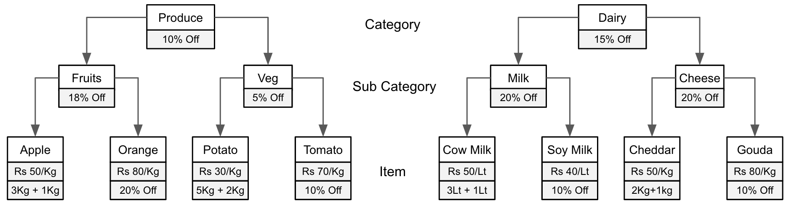

**Input:**

Customer Anish Kumar buys following items

Apple 6Kg, Orange 2Kg, Potato 14Kg, Tomato 3Kg, Cow Milk 8Lt, Gouda 2Kg

**Output:**

Following is the invoice that is generated based on the above items that customer has bought:

**Customer:** Anish Kumar

**Item Qty Amount**

Apple 6 Kg 250.00

Orange 2 Kg 128.00

Potato 14 Kg 300.00

Tomato 3 Kg 189.00

Cow Milk 8 Lt 300.00

Gouda 2 Kg 128.00

———————————————-———————

**Total Amount** 1295.00 Rs

**You saved** 1650.00 - 1295.00 = 355.00 Rs