Closechain AI
MVP Scope


March 9 2026
HyukJoo Kwon

Closechain AI MVP (Minimum Viable Product) Overview
Validating an Automated Close Out Process with STNY
Build AI Assistant to track statuses of Close Out Packages
Pain Point
- The Close Out Tracking Log and Folder Structure are manually generated in Excel, which delays the closeout process.
- Close Out Documents are requested and received via email.
- Close Out Documents are tracked in Excel and stored on the K-drive, limiting the ability to track progress.
- The Close Out Package is provided to the client via ShareFile, USB, or hard copy.
Objectives
Stage 1 Auto generated tracking log and folder structure in Closechain AI
- Develop a web application that automatically generates a Close Out Tracking List, along with its corresponding folder structure for General Contractor.
- The General Contractor will have the ability to upload Close Out Documents and in Portal Structure.
- A Client Dashboard will be generated upon the General Contractor's approval to release the final deliverable.

Stage 2 AI implementation for General Contractor
- AI Assistant will automatically identify the status of Close Out Documents within a given project.
- AI Assistant will identify the status of Close Out Documents across multiple projects.

Detailed Stage 1
ClosechainCCL & Closechain Portal
Purpose & Objective
Auto-populating Folder Structure for General Contractor to track.

Flow
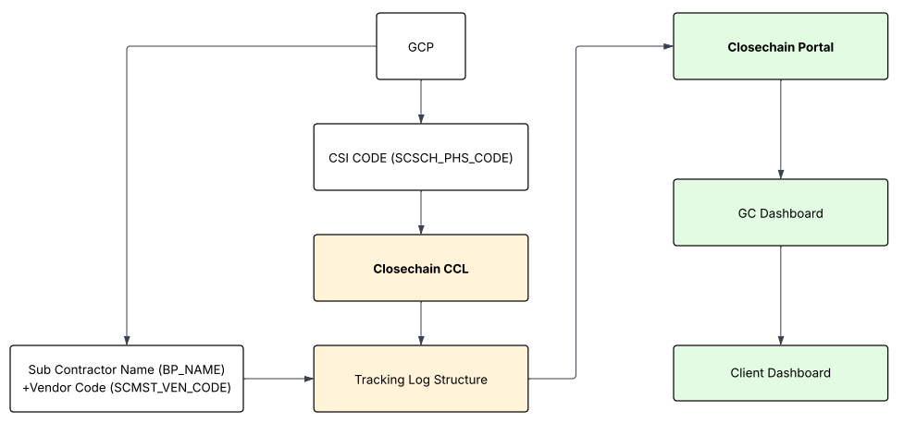
Closechain CCL (CSI Code Conversion Logic)
Subcontractors will be categorized by CSI Codes. During the MVP phase, these codes will be identified and tested in a demo environment.
A Close Out Document Tracking List will be generated by identifying each subcontractor’s CSI Code (SCSCH_PHS_CODE). CCL will match the CSI Code with the Vendor Code (SCMST_VEN_CODE) to ensure each subcontractor is captured correctly. CCL will then match the data with the Vendor Name (BP_NAME) using the following structure:
(SCSCH_PHS_CODE + SCMST_VEN_CODE) + BP_NAME
After CCL will match each Subcontractor with required document automatically. The system will display Vendor Name only, prompting the General Contractor end user to verify the information through an intuitive workflow. Users will also be able to manually input or adjust required subcontractor close-out documents to minimize errors.

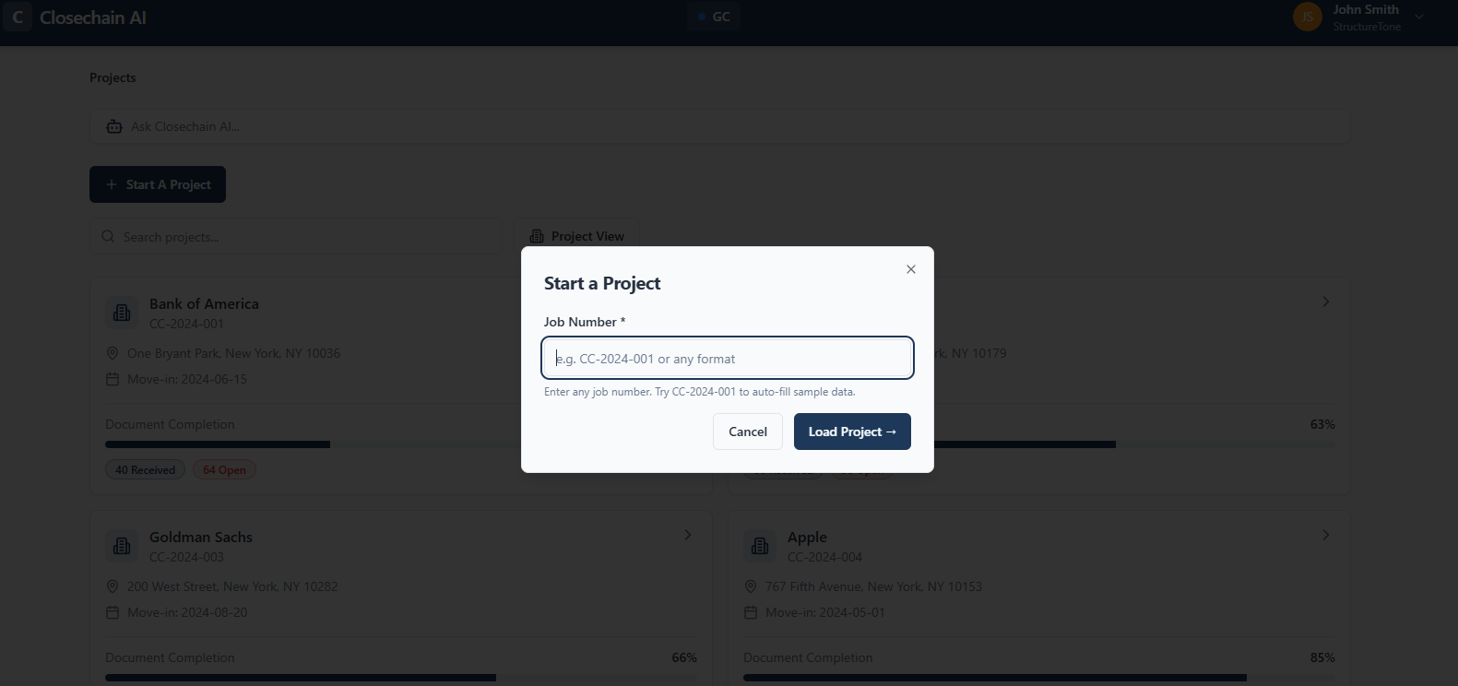
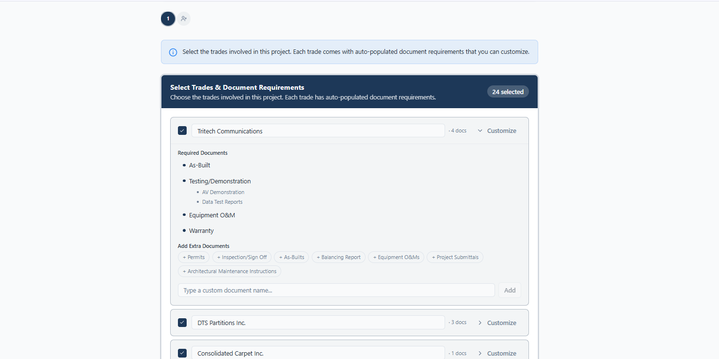

Closechain Portal
Once CCL identifies the required close-out documents, the Closechain Portal will automatically generate a standardized folder structure for the General Contractor end user to upload and manage documents. This structure will also function as the core document tracking framework.
The portal will enable General Contractor users to monitor the status of multiple projects simultaneously through a centralized dashboard. Users will also be able to sort and view close-out document requirements by project or by subcontractor, providing clear visibility into outstanding document exposure across the portfolio. A progress tracking indicator will display the percentage of required documents collected, allowing users to quickly assess close-out readiness for each project.
Client portal will be automatically created once General Contractor End User Approves

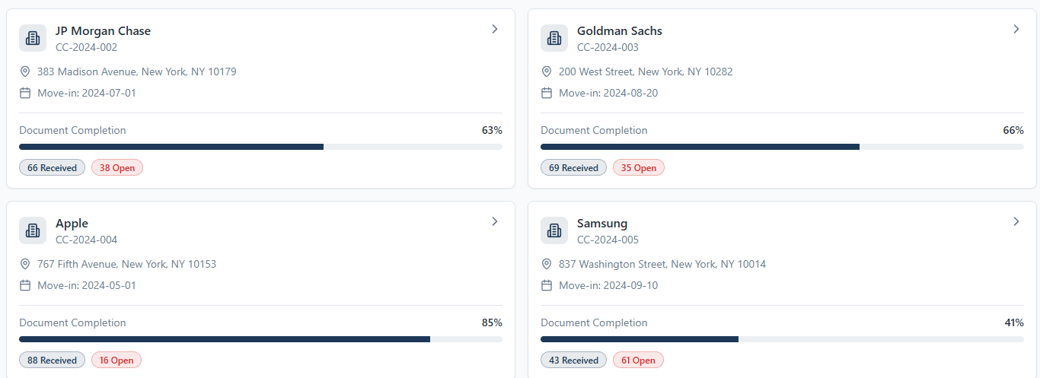

Stage 2 Detailed Scenario
Artificial Intelligence Implementation to identify the Closeout Package Status. ClosechainAI
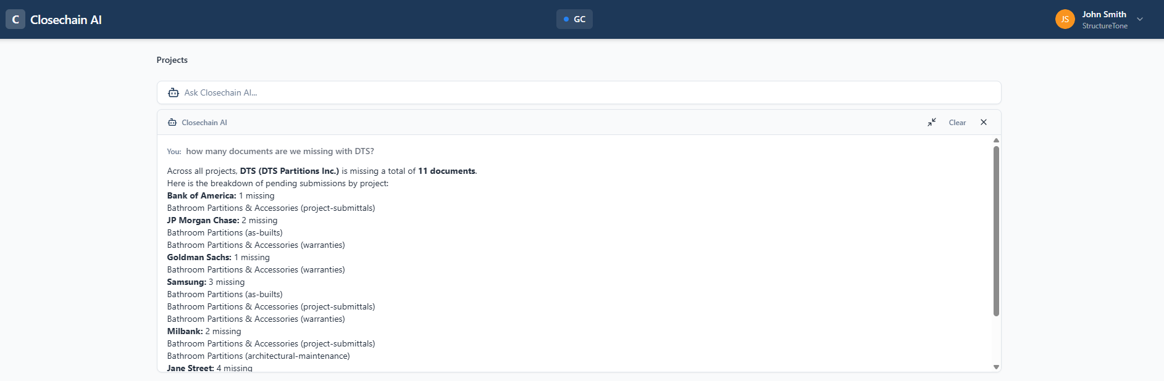
Purpose & Objective
AI Agent to track the status of close out packages by document type or subcontractor.
Closechain AI Technology
During the MVP phase, the Manager AI will be developed and integrated into the Closechain Portal to assist with document management. Manager AI will be trained to track the status of documents uploaded to the Closechain Portal. It will retrieve and report on the status of document submissions from subcontractors.
The system will enable clients to query the AI regarding the documents stored within the portal. Specifically, Manager AI will be able to determine whether required documents exist or are missing. This functionality will streamline document oversight, reduce manual verification, and provide immediate visibility into the progress of subcontractor submissions.

MVP & PoC Timeline
Task | W1 | W2 | W3 | W4 | W5 | W6 | W7 | W8
MVP Setup + UI/UX
Core Platform
AI Setup for GC
AI Setup for Subcontractor
Integrated Test & Demo Prep

*This timeline is illustrative and may be refined
*PoC will run in a sandbox/test environment

