Closechain AI
MVP UIUX


March 9 2026
HyukJoo Kwon

Key Features
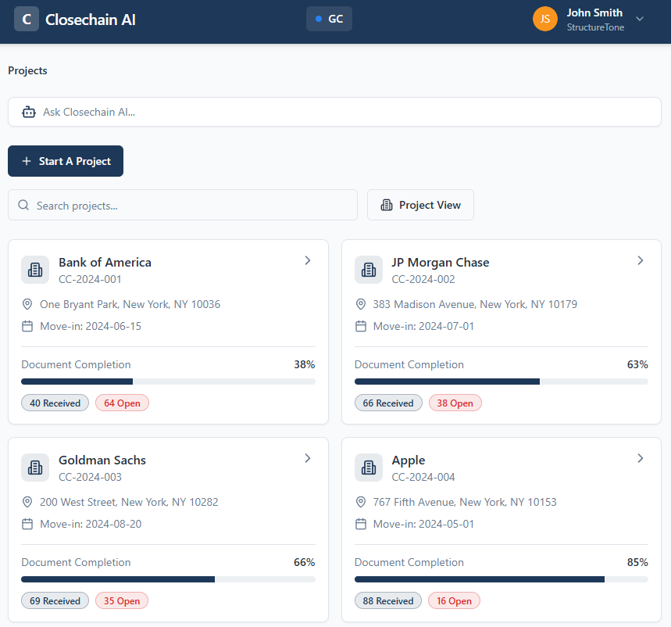

Section | Sub Section
Start A Project (Initiation) | Add a job number
 | Auto-Populated Subcontractor List
 | Auto-Populated Subcontractor List
 | Customizing Required Documents
 | Custom Subcontractor
 | Completion of Creating a close out tracking
Dashboard Views | Project View
 | Subcontractor View
Project Detail View | Document Type View
 | Document Type Detail (Upload by Document Type)
 | Subcontractor View
 | Subcontractor Detail Upload by Subcontractor)
 | Create Client Portal
Client Portal

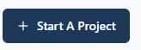
- Start A Project

For MVP Scope: The following fields will be hardcoded for a Job Number since the web application will not yet communicate with GCP:
- Job Name (PMP_PROJ_NAME)
- End Date (PMP_END_DATE)
- CSI Code (SCSCH_PSH_CODE)
- Subcontractor Name (BP_Name)

1a. Add a Job Number
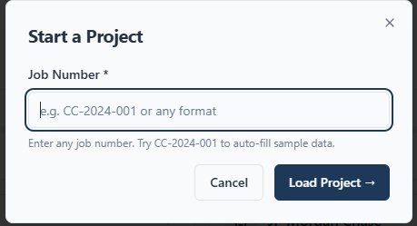
The User enters a Job Number to initiate the Closeout Package Setup

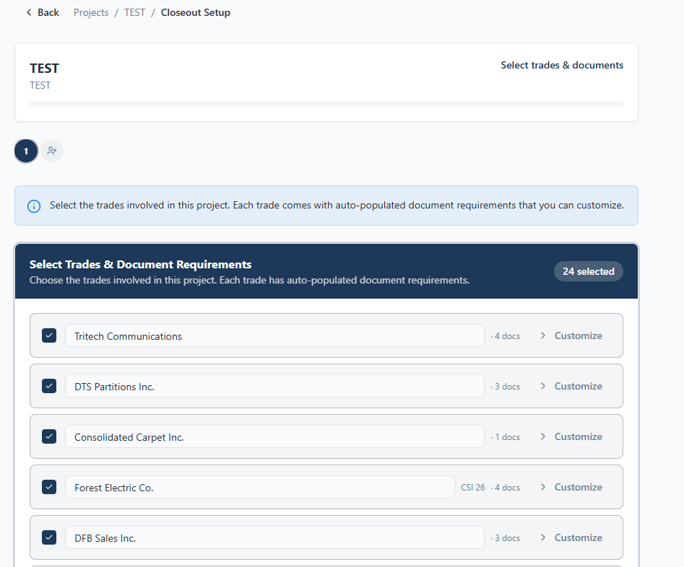
1b. Auto-populated Subcontractor List

- The system will automatically generate a list of subcontractors with Vendor Name
- All Subcontractors will be pre-selected by default
- End user may deselect subcontractors that are not required to submit Closeout Documents

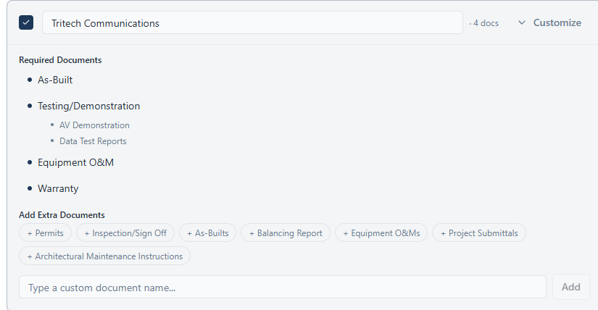
1c. Customizing Required Documents

- “Customize” drop down triggers users to verify required document for each subcontractor.
  - Required document
    - Pre-selected
    - Ability to remove Pre-selected Document
  - Add Extra Document
    - Ability to click and add additional document type
    - Ability to hand type required document
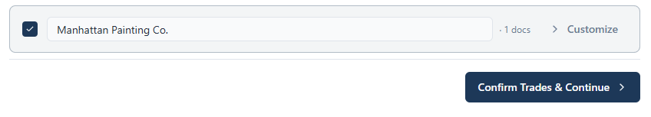
- Once customization of required document for each subcontractor is complete, user can click on “Confirm Trades & Continue”

1d. Custom Subcontractor
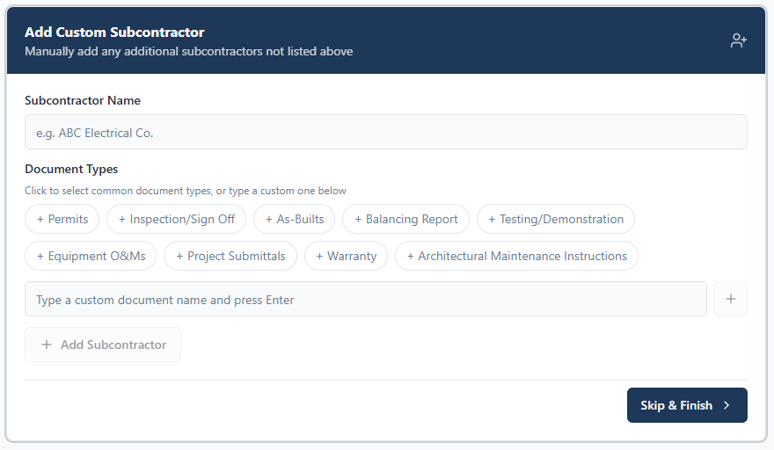
- Users can manually add subcontractors if they were not included in previous step 1c.
- Click on “Skip & Finish” to complete.
- This concludes “Start A Project” process.
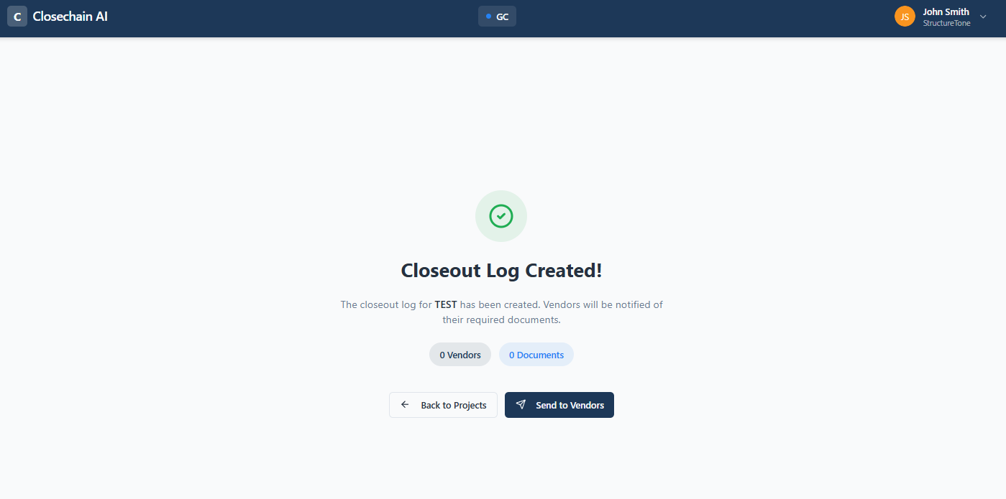

1e. Completed Close Out Package Appear on GC Dashboard
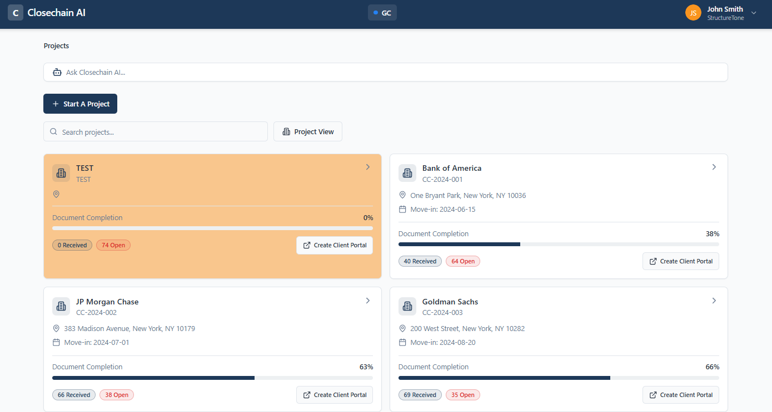
- Once step 1a ~ 1d is completed, the project will then appear in GC Dashboard.

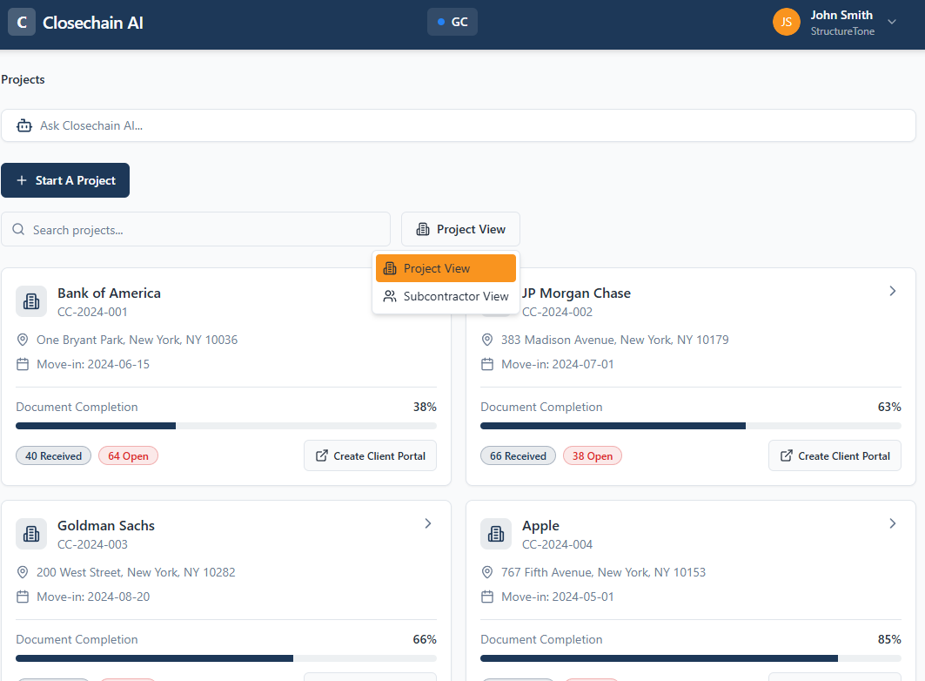
- GC Dashboard

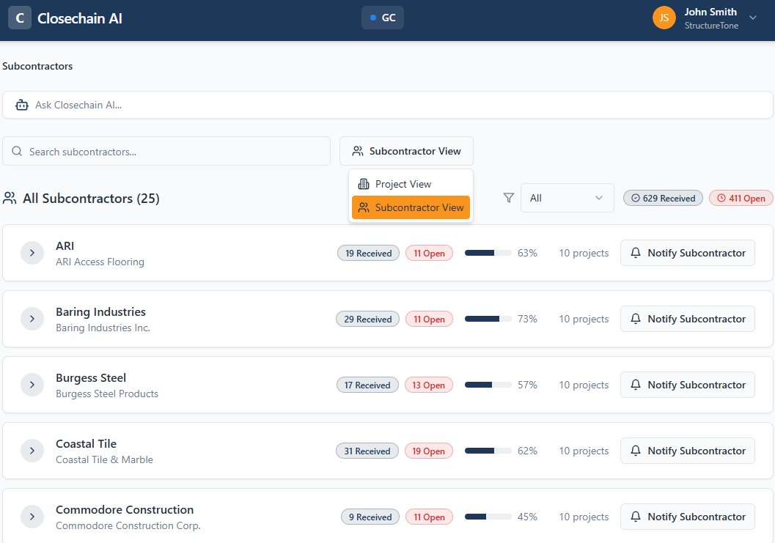

- GC Dashboard displays two different views
  - Project View
  - Subcontractor View
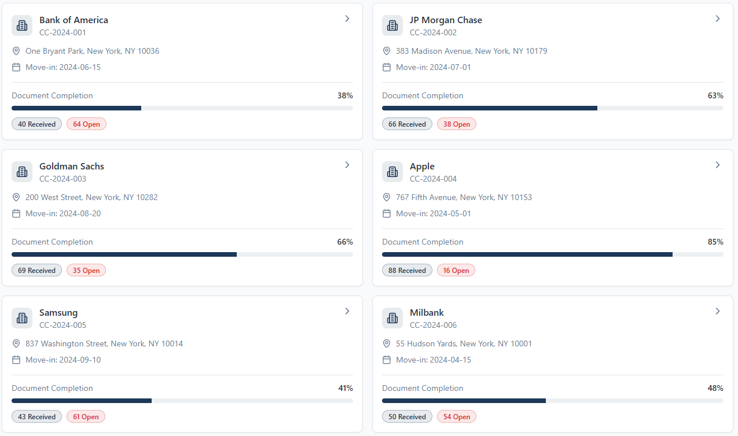
2a. Project View

- List of active projects
- Under each project listed below will be displayed
  - Job Number
  - End Date
  - Progess indicator showing completion Percentage
  - Number of Received Documents
  - Number of Open Documents

2b. Subcontractor View
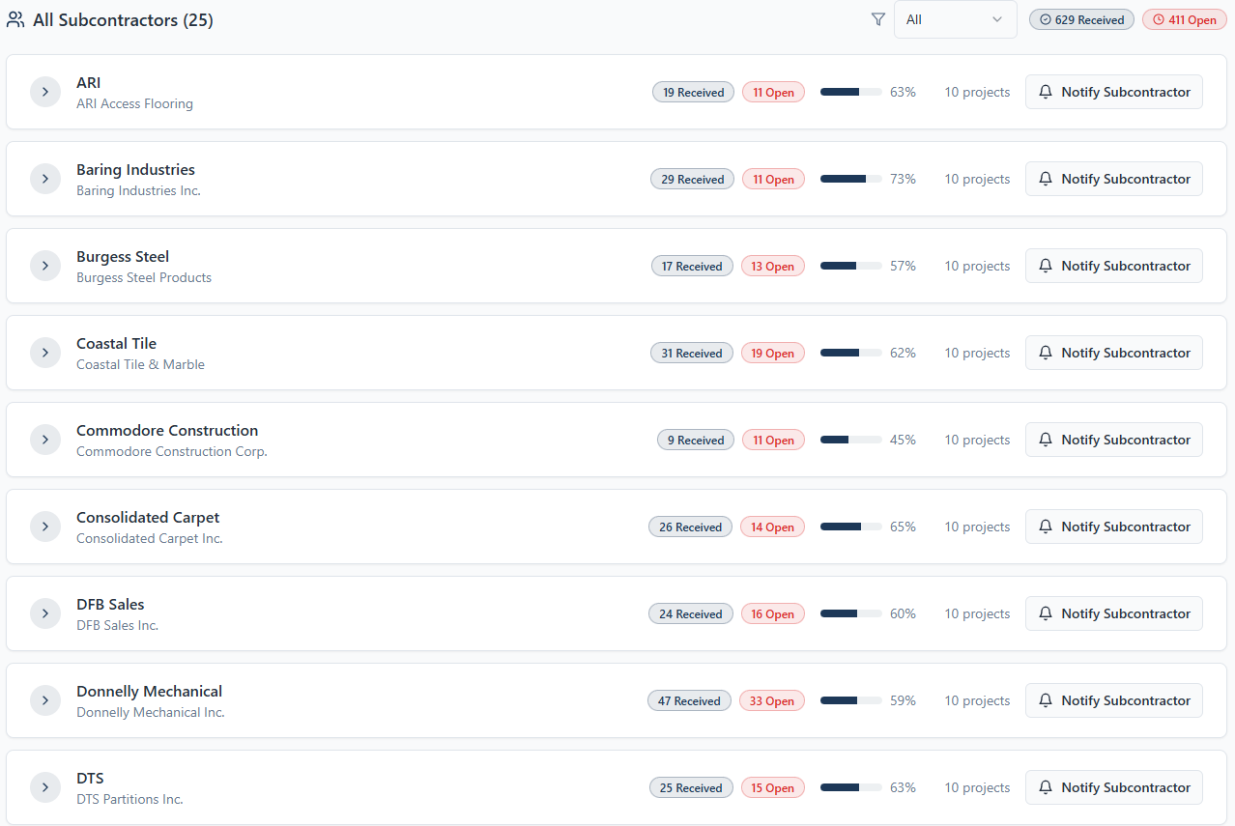
- List of all subcontractors across all projects
- Each subcontractor will display
  - Subcontractor Name (Vendor Name)
  - Count of Receive Documents
  - Count of Open Documents
  - Progress indicator showing completion Percentage
  - Number of projects that they were involved with

- Individual Projects
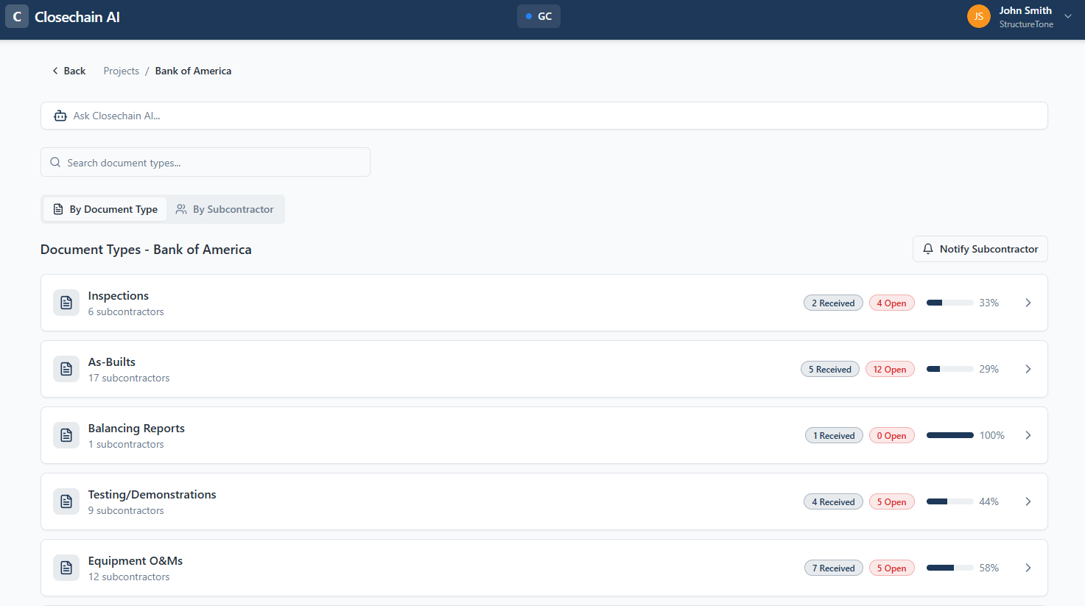

- Within individual project, the system will have an ability to display
  - Document Type View
  - Subcontractor View

3a. Document Type View
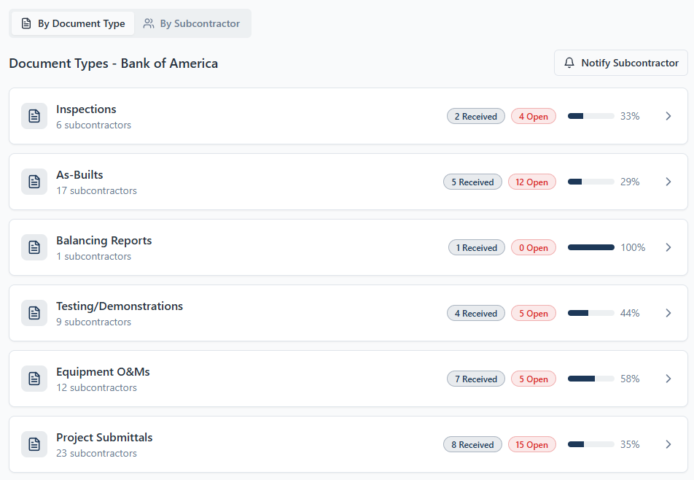

- List of Required Document Types
- Under each Required Document Type
  - Number of subcontractors involved
  - Count of Received Document
  - Count of Open Document
  - Progress indicator showing completion Percentage
- Ability to click into each document type (Document Type Detail)

3a1. Document Type Detail
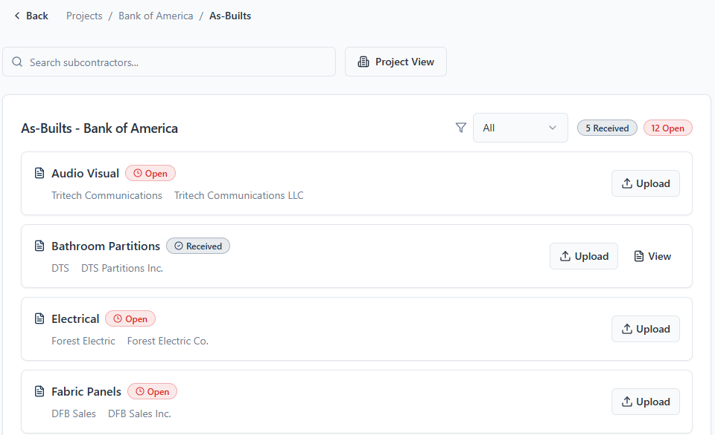

- List of subcontractors required to submit document
- Current submission status for each subcontractor
- Option to upload document directly to the corresponding document category by clicking “upload”
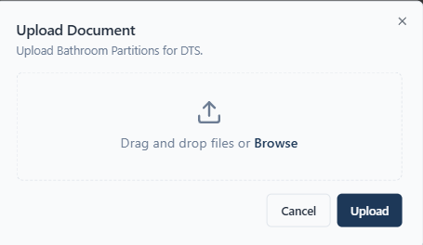

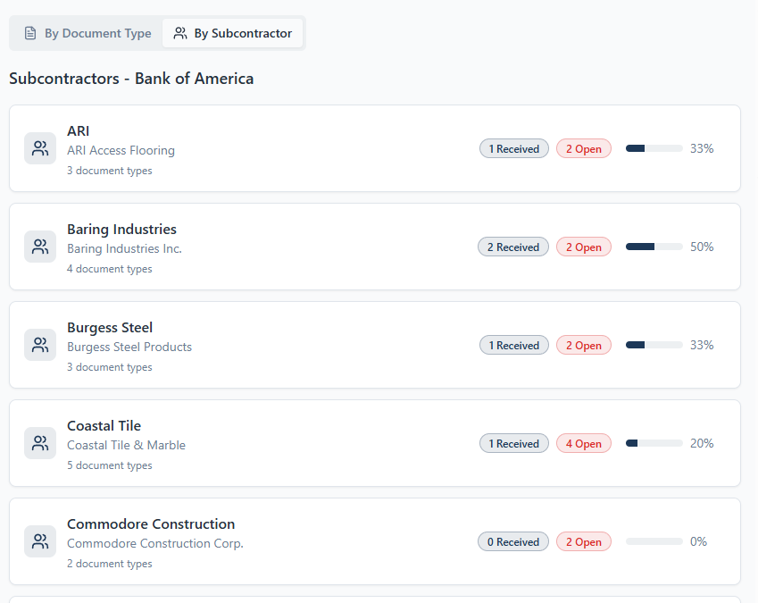
3b. Subcontractor View

- List of Subcontractors
- Under each Subcontractors
  - Subcontractor Name
  - Number of document type
  - Count of Received Document
  - Count of Open Document
  - Progress indicator showing completion Percentage
- Ability to click into each Subcontractor (Subcontractor Detail)

3c. Subcontractor Detail
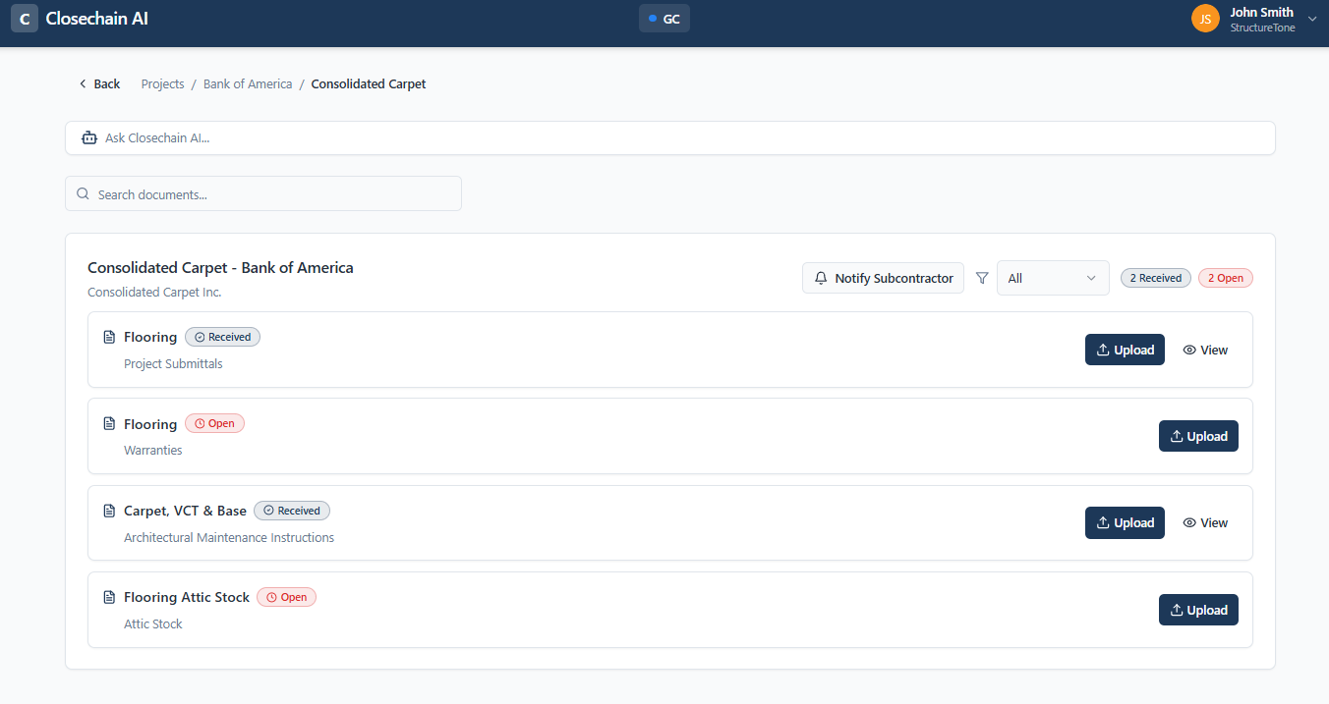
- List of document type that subcontractor needs to submit
- Current submission status for each subcontractor
- Option to upload document directly to the corresponding document category by clicking “upload”
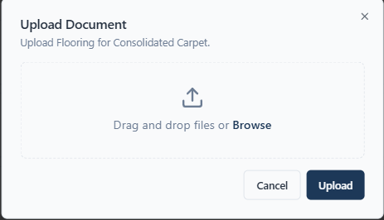

3C) Create Client Portal
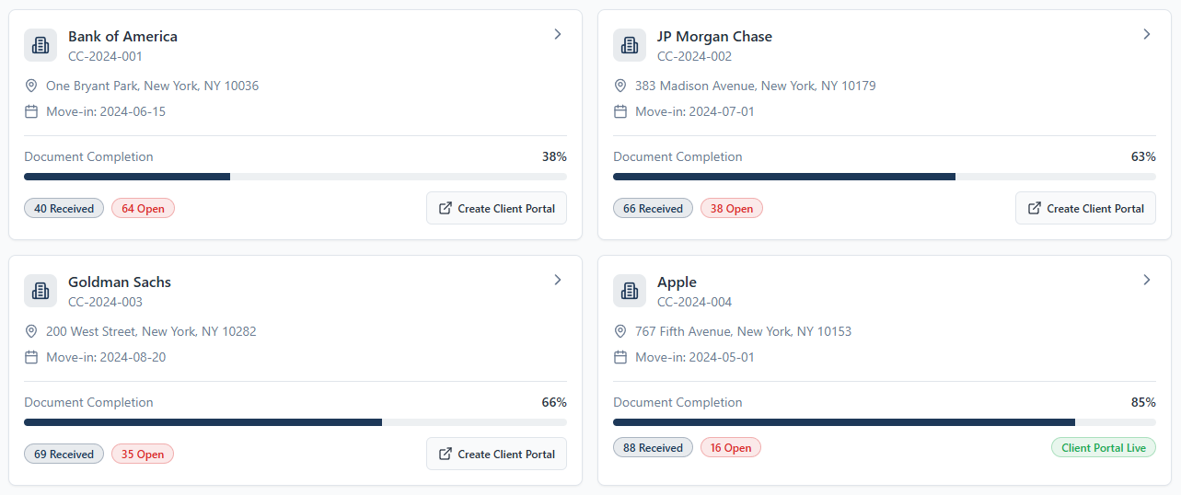

For list of projects there is a “Create Client Portal” which will create a client portal

- Client Portal
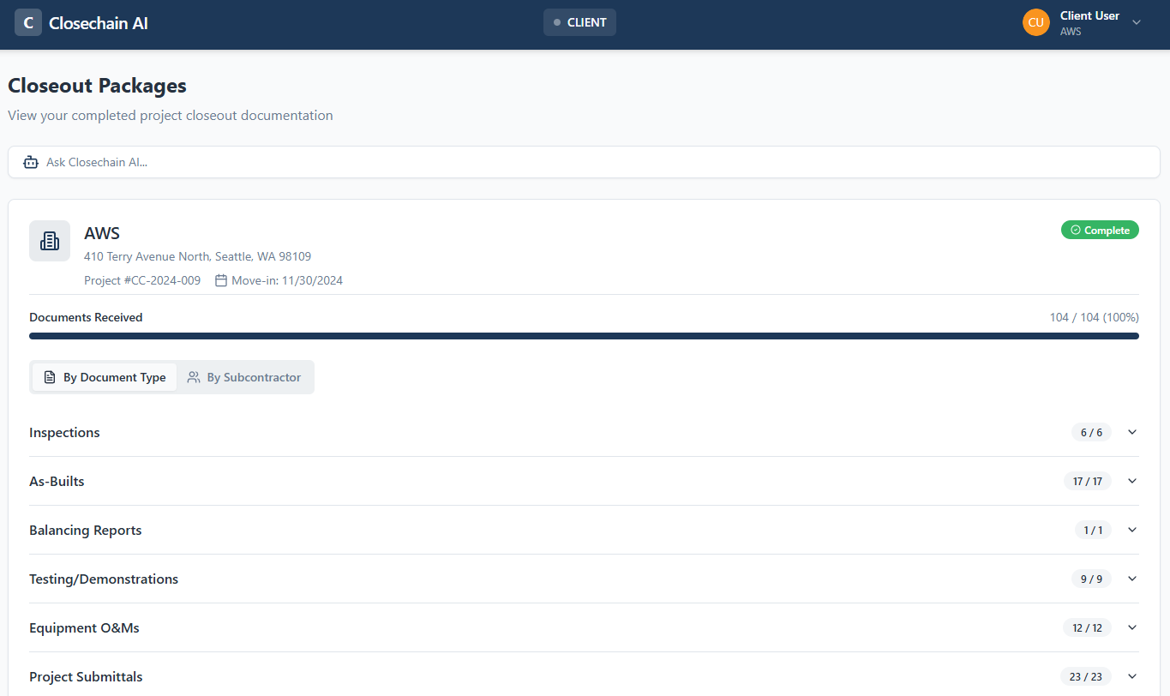
- Client can view / download the completed close out package sorted by
  - Document Type
  - Subcontractor Type

