VIETNAM NATIONAL UNIVERSITY HO CHI MINH CITY
HO CHI MINH CITY UNIVERSITY OF TECHNOLOGY
FACULTY OF COMPUTER SCIENCE
——————– * ———————

Laboratory Report
LAB 1.3 – Website Layout & Frontend
Foundation

Teacher: NGUYỄN ĐỨC THÁI
Class: CC01
—o0o—
Huỳnh Đức Phát (2452940)

Semester project: Medical Clinic

1. Project structure
Wellnest Medical Clinic implements the frontend foundation required by LAB 1.3. In the Medical Clinic domain, catalog items are consultation services. The project is placed under the Apache document root at xamppfiles/htdocs/medical_clinic/.
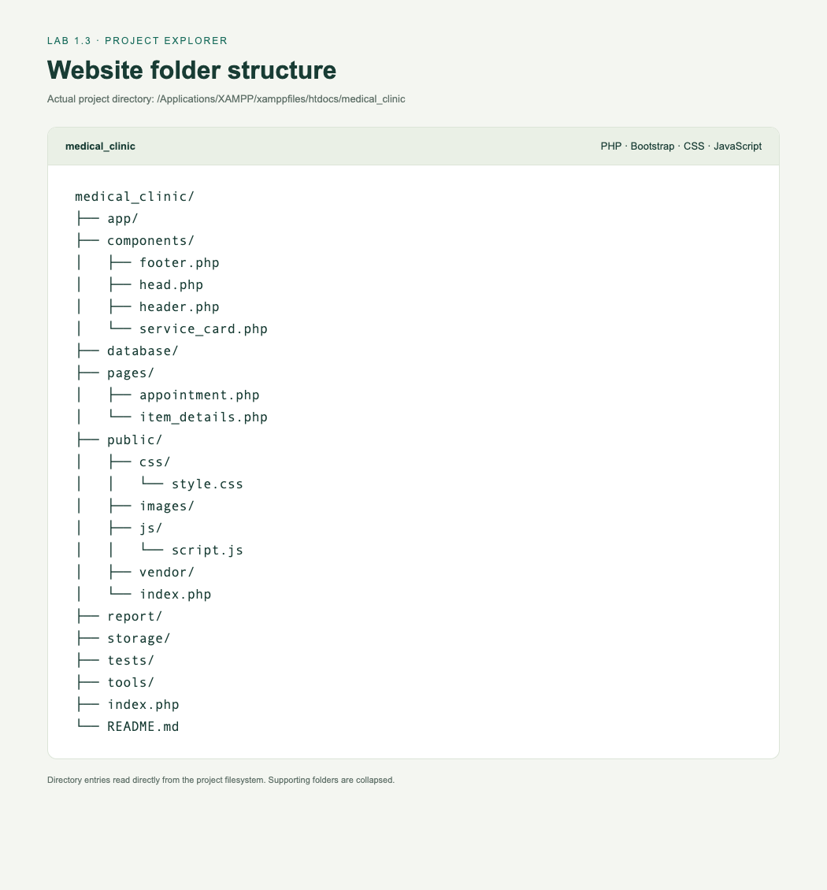
Figure 1. Actual project directory entries; supporting folders are collapsed.
Required files: public/index.php, public/css/style.css, public/js/script.js, public/images/, pages/item_details.php, components/header.php, and components/footer.php.
PHP require_once includes the shared header and footer on the homepage and additional pages. Supporting app/ and database/ files keep service names, descriptions, categories, images, and prices consistent between pages.

2. Homepage and reusable layout
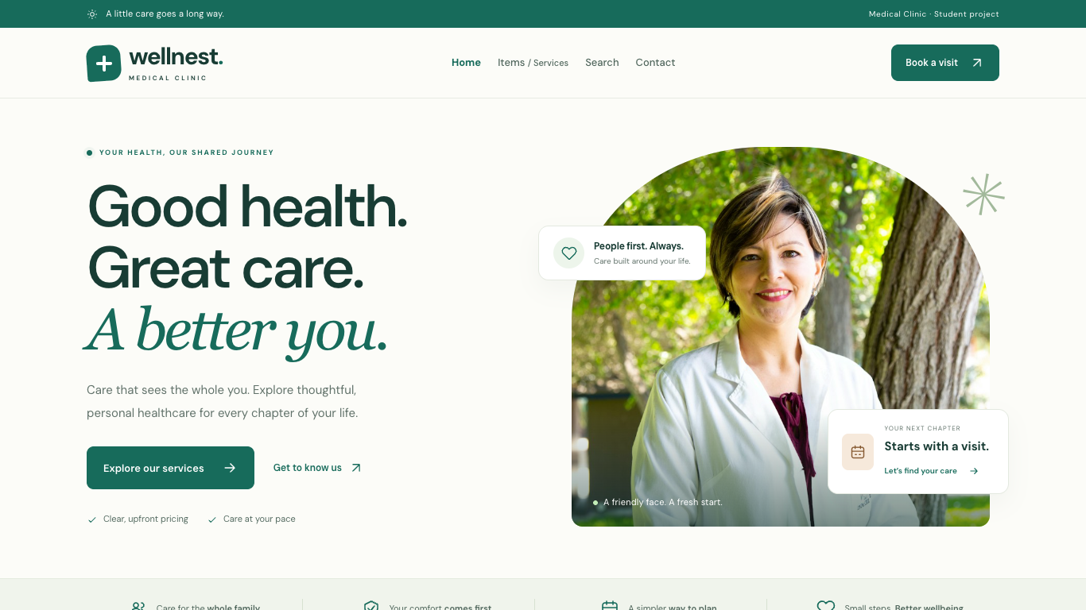
Figure 2. Homepage at the required desktop viewport, 1366 × 768.
The homepage contains a brand header, navigation, hero, item catalog, and footer. The navigation includes Home, Items / Services, Search, and Contact. Book a visit provides a domain-appropriate action. Bootstrap navbar-expand-lg collapses navigation below 992px.
Required feature | Implementation
HTML5 foundation | DOCTYPE, html lang="en", UTF-8, viewport meta, meaningful title; header, nav, main, section, article and footer.
Hero section | Medical Clinic introduction, local doctor photograph, and Explore our services link.
Reusable components | components/header.php and components/footer.php are included using require_once.
Footer | Wellnest name, current-year copyright, illustrative email/location and contact information.
Custom CSS3 | Typography, teal/cream palette, spacing, image shapes, cards, buttons, footer, hover effects and responsive media queries.

3. Medical service catalog
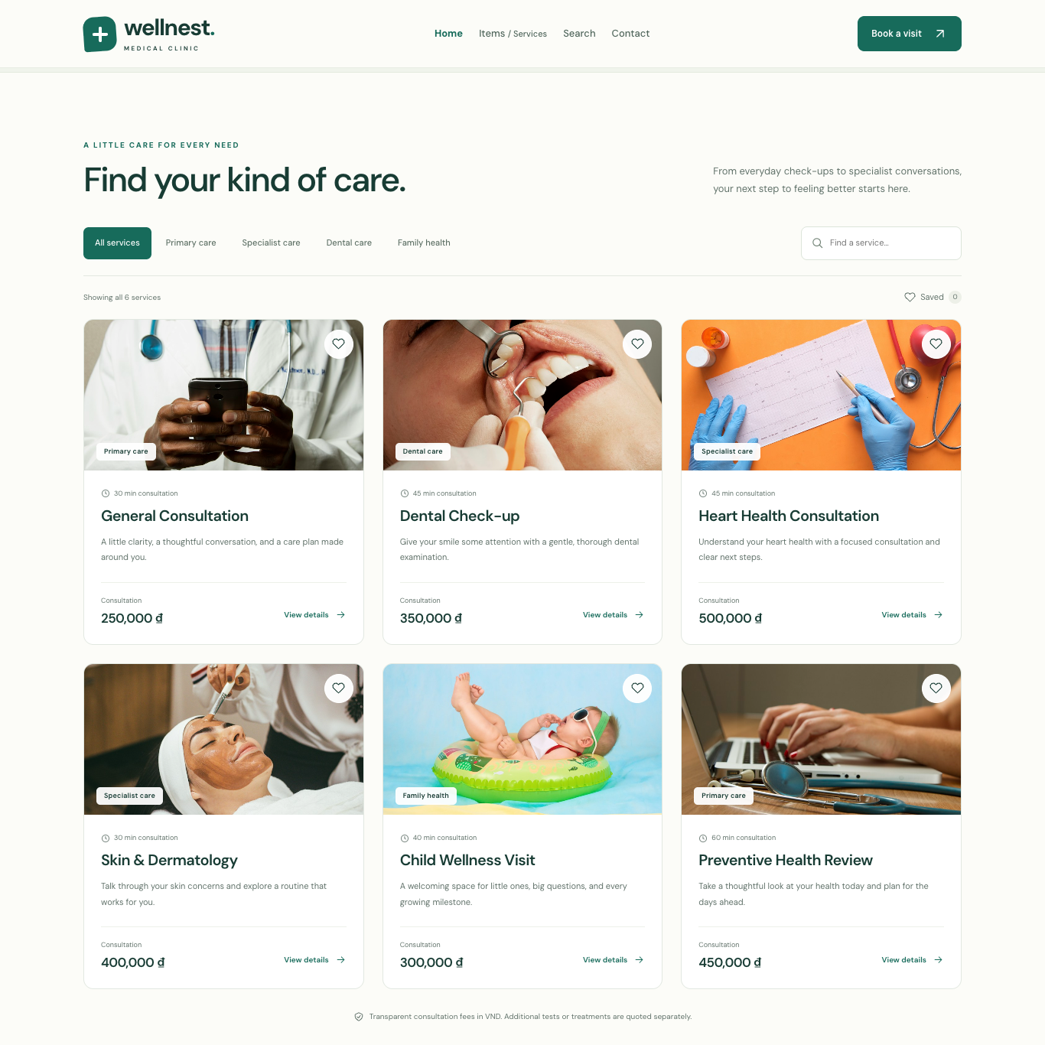
Figure 3. All six service cards in the three-column desktop catalog.
Item name | Category | Price (VND)
General Consultation | Primary care | 250,000
Dental Check-up | Dental care | 350,000
Heart Health Consultation | Specialist care | 500,000
Skin & Dermatology | Specialist care | 400,000
Child Wellness Visit | Family health | 300,000
Preventive Health Review | Primary care | 450,000

Each Bootstrap card contains an image, service name, short description, category, consultation price and View details link. The exact grid classes col-12 col-md-6 col-lg-4 produce one card per row on mobile, two on tablet and three on desktop.
Prices and services are illustrative semester-project content. Stock imagery, brand text, colors, button labels and descriptions are customized for the Medical Clinic domain.

4. Item details page
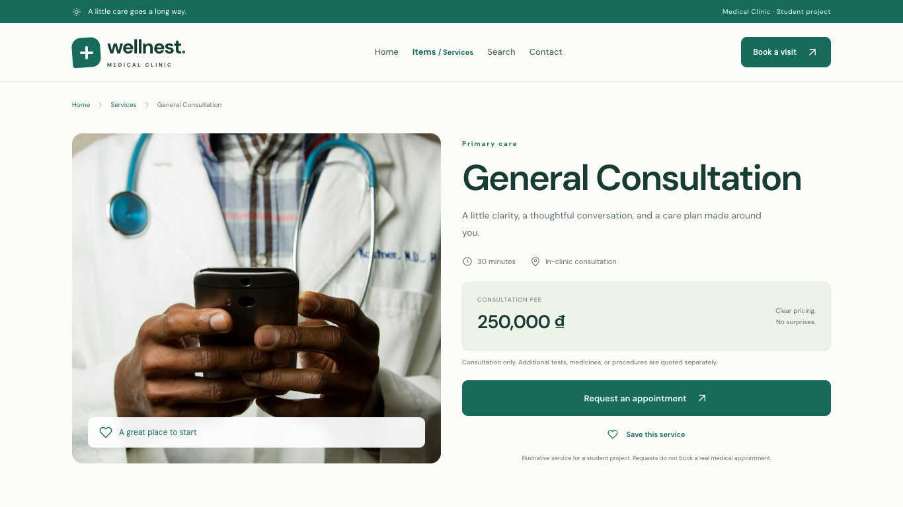
Figure 4. pages/item_details.php?id=1 at 1366 × 768.
Specification requirement | Example on the details page
Item name | General Consultation
Item image | Local healthcare image with descriptive alternative text.
Category | Primary care
Description | Service introduction, full description, inclusions and visit preparation.
Price | 250,000 ₫, consistent with the homepage catalog.
Action button | Request an appointment opens the form with this service preselected.

All six item cards open their own details using a validated service ID. The shared header/footer retain consistent navigation and visual styling. An unknown or malformed ID returns an HTTP 404 page with a link back to services.

5. Responsive design: mobile
 | 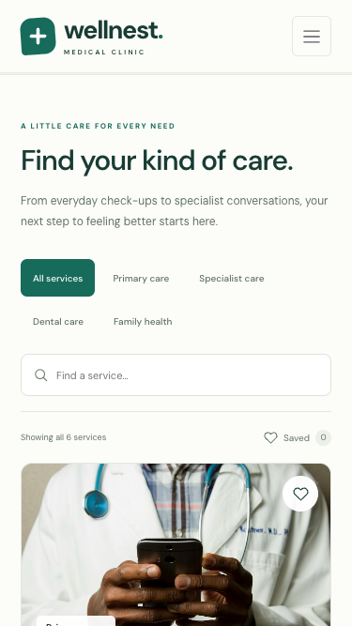
Figure 5. Hero at 375 × 667. | Figure 6. Single-column mobile catalog.
Mobile checks confirm readable text, stacked sections, contained images, accessible controls and no horizontal scrolling. The hamburger opens and closes; selecting Search closes the menu and focuses the service search field.
Required viewport | Catalog layout | Result
Mobile: 375 × 667 | 1 card per row | Passed
Tablet: 768 × 1024 | 2 cards per row | Passed
Desktop: 1366 × 768 | 3 cards per row | Passed

Additional checked widths: 320, 390, 576, 820, 991, 992, 1024 and 1920px. The homepage, service details and appointment form were checked at all 11 sizes. No horizontal overflow or overflowing images was detected.

6. Responsive design: tablet
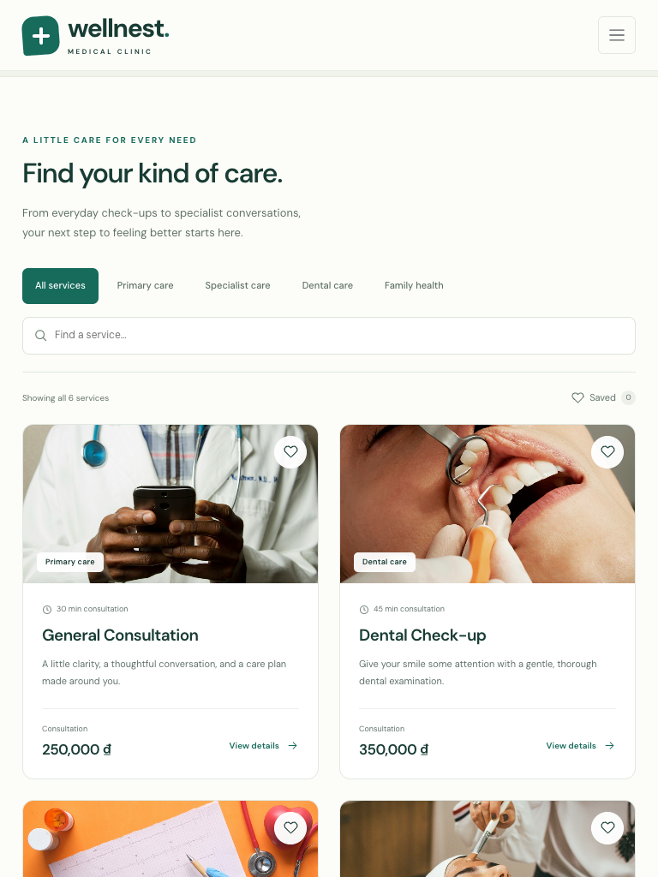
Figure 7. Tablet catalog at the required 768 × 1024 viewport.
At the md breakpoint (768px), the service cards form two columns. The search field and category controls adapt to the available width. Navigation continues to use the collapsible menu until the lg breakpoint (992px).
At desktop widths the catalog forms three columns and the navigation expands. Local images use constrained widths, object-fit and responsive containers. The detail page changes from two side-by-side columns to a stacked layout on smaller screens.

7. JavaScript interaction
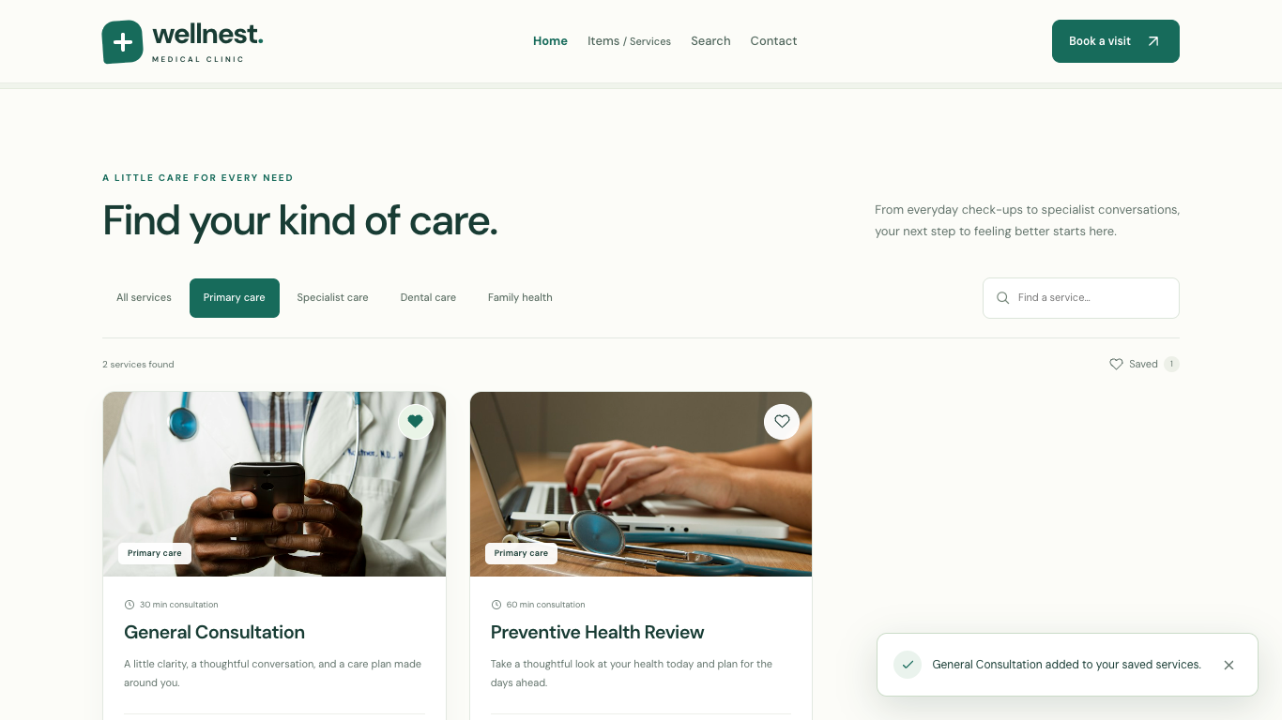
Figure 8. Primary care filter, saved service state and visible confirmation toast.
The required visible JavaScript interaction is demonstrated by saving General Consultation: its heart button changes state, the saved count updates, and a notification announces the action. Saved selections persist in localStorage and remain available after refresh.
Feature | Demonstration
Challenge A: Search | Type preventive to show the matching service; a query without matches shows a resettable empty state.
Challenge B: Categories | Choose Primary care to display only General Consultation and Preventive Health Review. Search and category filters combine.
Challenge E: Interactive cards | Save or unsave a service, filter saved items, refresh to verify persistence, or open its details.
Additional form interaction | Choose a service to update its displayed fee; submit a valid demo request to see a reference and confirmation. The interface explicitly identifies this as a demo.

Demonstration steps: open Items / Services; select Primary care; click the General Consultation heart; observe the changed heart, saved count and toast. These actions are implemented in public/js/script.js.

8. Accessibility and completion
Basic accessibility checks cover meaningful page titles, descriptive image alt attributes, a logical h1–h2–h3 hierarchy, meaningful link labels, text/background contrast, visible keyboard focus, a skip link, form labels and non-image text for important information. Toggle states use aria-pressed/aria-expanded; search results and notifications use live regions.
Automated axe-core WCAG A/AA checks were run on the homepage, details and form at 375px and 1366px: six scans completed with zero reported violations. Keyboard navigation and the mobile menu were also exercised. Reduced-motion preferences disable nonessential transitions.
Lab completion checklist | Status
Project folder under htdocs and required folder structure | Completed
public/index.php and semantic HTML5 structure | Completed
Bootstrap added with a local fallback | Completed
Responsive navigation and hero section | Completed
Six service cards and responsive 1 / 2 / 3-column grid | Completed
Custom CSS with more than three visual customizations | Completed
Reusable header and footer components | Completed
Item details: name, image, category, description, price, action | Completed
Working JavaScript with visible interaction feedback | Completed
Mobile, tablet and desktop layouts tested | Completed
Meaningful alt text, titles, headings, links and contrast checked | Completed
Medical Clinic content replaces generic sample content | Completed
All required screenshots captured | Completed

Submission evidence
The complete project folder accompanies this report. Required screenshots are in report/screenshots/: 01-project-structure.png; 02-homepage-desktop.png; 03-homepage-mobile.png; 05-item-details.png; 06-javascript-interaction.png. Additional full-page, tablet, navigation and form screenshots are included. Browser verification results are stored in report/verification.json.

