Week-3-Day-1-Assignment-AI Extension to support Selenium Python
Before implementation:
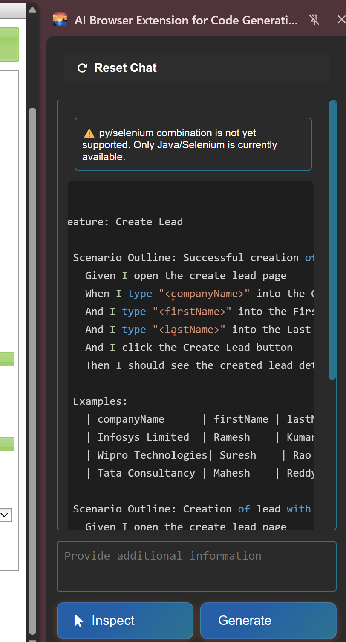

After implementation: (have included the selenium python code generated in the folder)
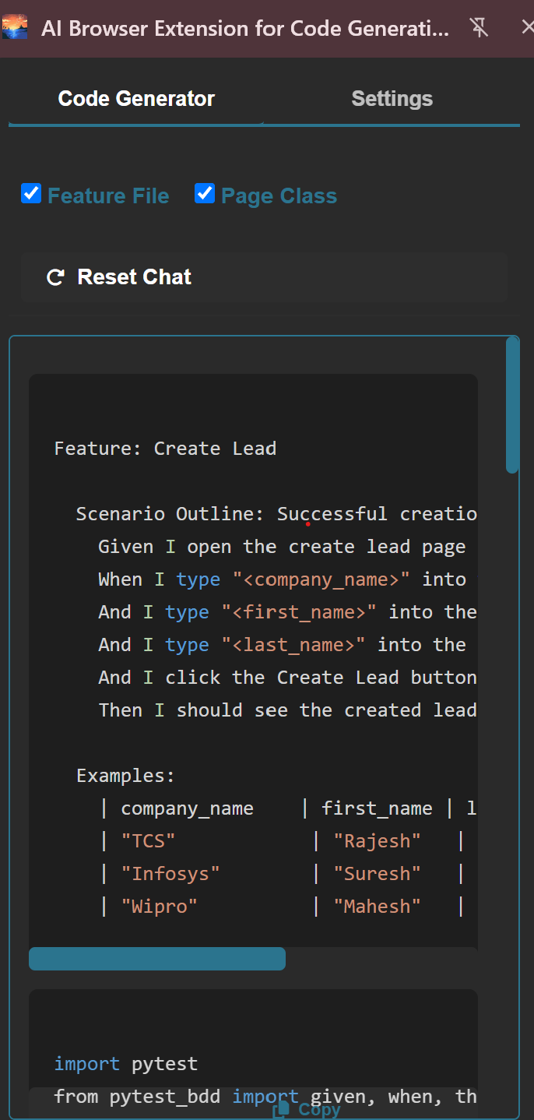

Ask Mode Prompt:
Read the entire workspace named 'AI-EXTENSION'. Tell me what are the files that are impacted if I want to add selenium python implementation same like the selenium java implementation. Tell me the existing changes and new files

Agent Mode Prompt:
Implement the same STEP BY STEP. Ask for my approval before proceeding with the next step. Go one by one after approval

