Team member: Abby Nguyen, Alwin Rajkumar
Project 1: Gradient Descent Variants
Date: 09/13/26
Video:
Code:

INTRODUCTION
The objective of this project is to implement and compare four optimization methods: Gradient Descent, Newton's Method, AdaGrad, and Adam on three two-dimensional objective functions. The experiments evaluate how optimizer choice, initialization, and hyperparameter settings affect convergence speed, robustness, and solution quality.
f1(x, y) = x^2 + y^2. Simple convex quadratic bowl. Global minimum at (0, 0), f = 0.
f2(x, y) = (1-x)^2 + 100(y-x^2)^2. Rosenbrock, narrow curved valley. Global minimum at (1, 1), f = 0.
f3(x, y) = x^2 + y^2 + 10 cos(x) + 10 cos(y). Non-convex, multiple local minima.
Hessian test: f1 has H = 2I (eigenvalues 2, 2), so it is convex. f2 at (0, 1) has eigenvalues -398 and 200, so it is not convex. f3 has H = diag(2-10 cos x, 2-10 cos y). At (0, 0) the eigenvalues are -8, -8. At (-2, 2) they are about 6.16, 6.16.

METHOD
All four methods were implemented in NumPy with analytic gradients. Each run starts from a fresh optimizer state. The same stop rule is used for every method: ||x_new - x|| < 1e-6, 2000 updates max, or the iterate blows up (NaN/inf or ||x|| > 1e8).
The generic first-order step is:
x_{t+1} = x_t - a * g_t
Gradient Descent uses that update as-is.
Newton uses the Hessian: x_{t+1} = x_t - a * H^{-1} g_t. We used a in {0.1, 0.5, 1.0}. If the smaller eigenvalue of H was <= 1e-8 we added a little lambda*I before the solve so the linear system is defined on f3.
AdaGrad accumulates squared gradients and scales each coordinate:
G_t = G_{t-1} + g_t * g_t ; x_t = x_{t-1} - a * g_t / (sqrt(G_t) + eps)
Adam combines a first-moment estimate with a second-moment scale and bias-corrects both:
m_t = b1 m_{t-1} + (1-b1) g_t ; v_t = b2 v_{t-1} + (1-b2) g_t^2
mhat = m_t / (1-b1^t) ; vhat = v_t / (1-b2^t) ; x_t = x_{t-1} - a * mhat / (sqrt(vhat) + eps)
Code is CSE620_Fall26_Project1_Nguyen_Rajkumar.py (Python 3, NumPy, Matplotlib) for all four methods. AdaGrad and Adam were also run in adagrad_adam_revisedrun.ipynb: 3 functions x 3 starts x 2 optimizers x 3 learning rates = 54 configs, with 10 measured repeats (540 rows). Same a, eps, betas, tolerance, and 2000 cap. Iteration counts and final f match the .py because the updates are deterministic; only runtime changes across repeats. Starts: (-2, 2), (0.5, -1.5), (3, 3). GD / AdaGrad / Adam used a in {0.001, 0.01, 0.1}. Newton used a in {0.1, 0.5, 1.0}. Tables below are the mean over the three starts. First-order rows use a = 0.001. Newton rows use a = 1.0.
Lecture check, min x^2 + xy + y^2 from (1, 2): GD a=0.001 went to (0.992, 1.990). Newton a=1 went to (0, 0). Adam a=0.001 went to (0.998, 1.998).

RESULTS
Figure 1. The three objective functions and the three starting points.
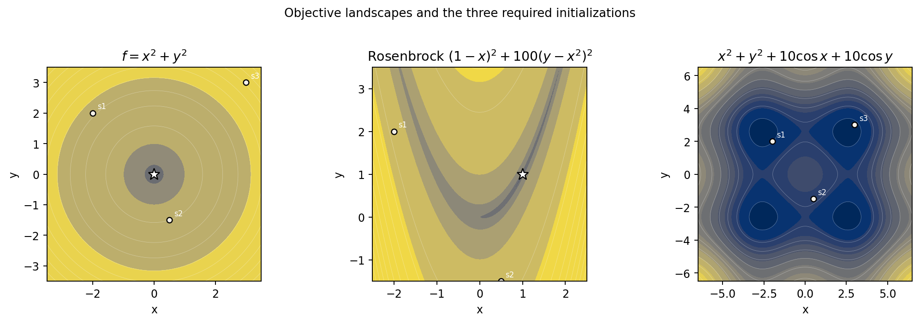
Figure 2. Runs from the matplotlib demo. GD uses a=0.1 from (-2, 2). Newton uses a=1. Cosine Newton is from (0.5, -1.5) so the blow-up shows.
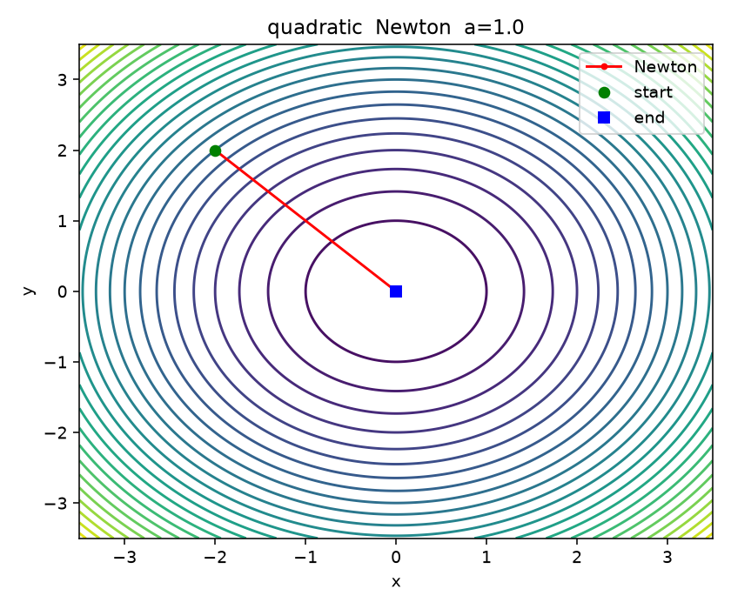
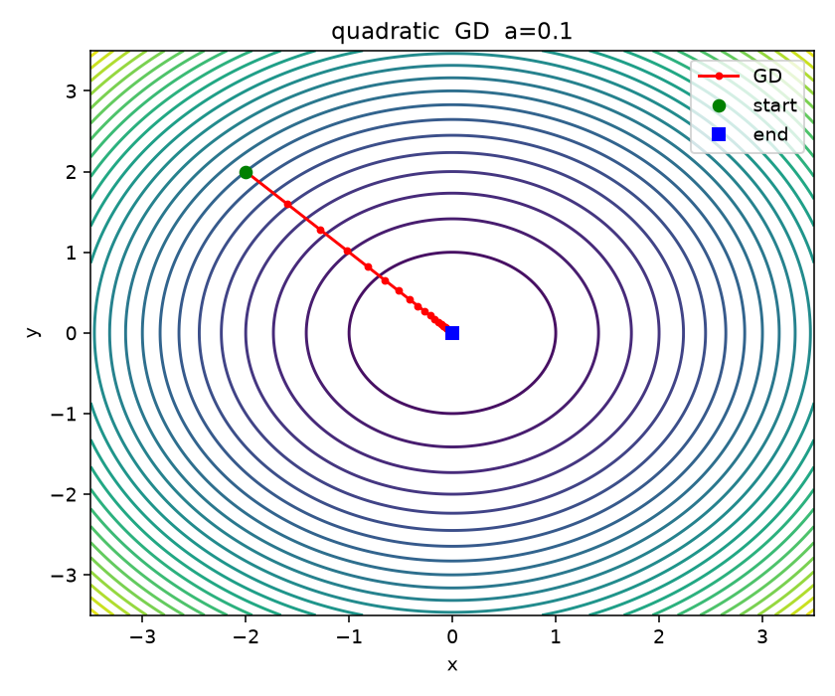
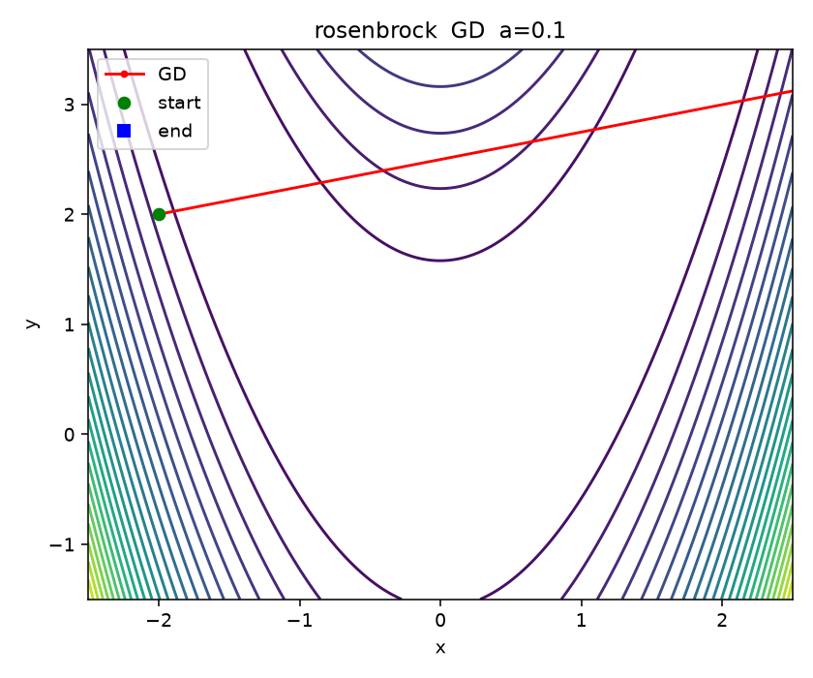
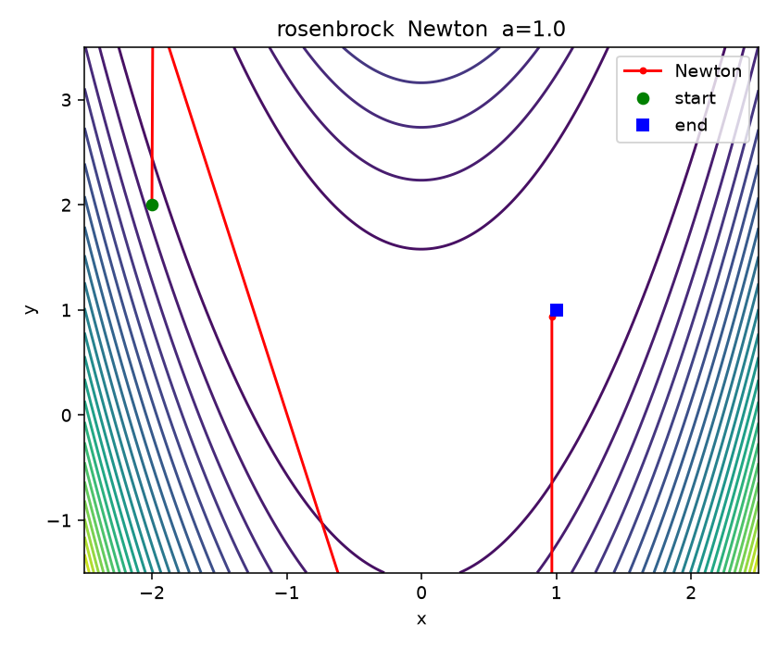
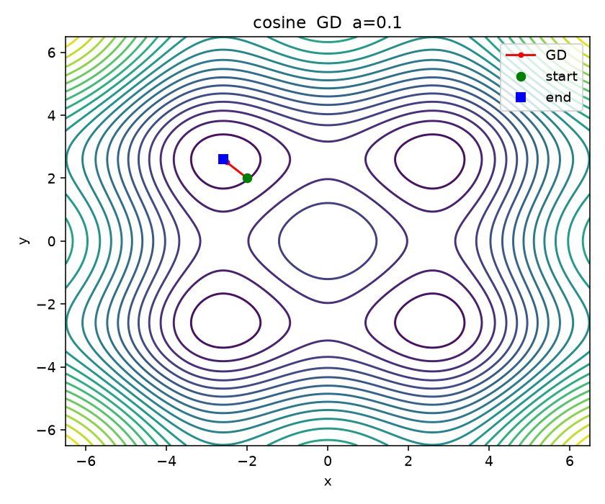
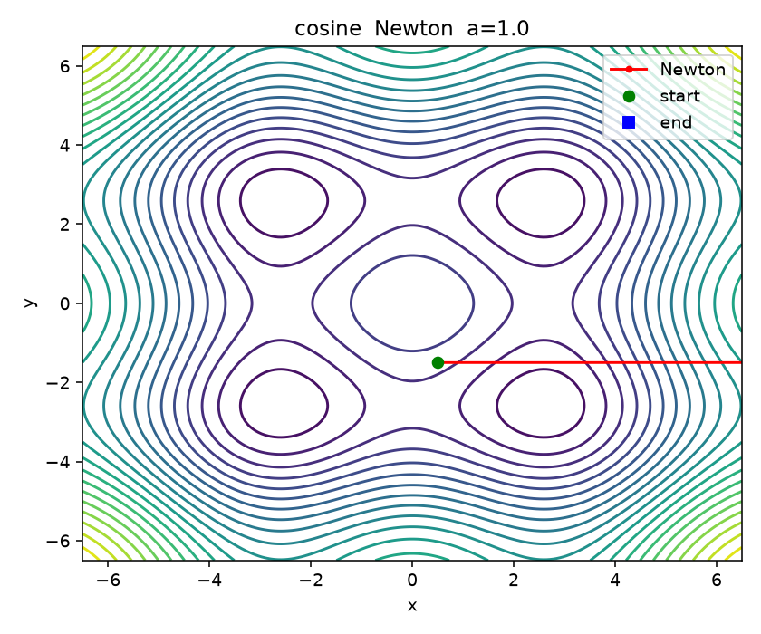
Convex function f1
Method | a | Iteration | Time (ms) | Final f(x,y)
Gradient Descent | 0.001 | 2000 | 22.3 | 3.16e-3
Newton | 1.0 | 2 | 0.07 | 0
AdaGrad | 0.001 | 2000 | 24.6 | 8.82
Adam | 0.001 | 2000 | 33.3 | 1.31

Rosenbrock function f2
Method | a | Iteration | Time (ms) | Final f(x,y)
Gradient Descent | 0.001 | 1334 | 14.3 | stalled / diverged
Newton | 1.0 | 6 | 0.18 | 0
AdaGrad | 0.001 | 2000 | 26.5 | 1146
Adam | 0.001 | 2000 | 34.8 | 6.19

Multimodal function f3
Method | a | Iteration | Time (ms) | Final f(x,y)
Gradient Descent | 0.001 | 929 | 12.1 | -3.618
Newton | 1.0 | 3 | 0.13 | -3.618 or diverged
AdaGrad | 0.001 | 2000 | 30.0 | 2.46
Adam | 0.001 | 1765 | 33.7 | -3.54

Newton on f3: from (0.5, -1.5) it diverged. The other two starts went to -3.618. First-order methods shown at a=0.001. Newton shown at a=1.0.

ANALYSIS
f1 was easy if a was not tiny. Newton a=1 is the same as GD a=0.5 because H^{-1} = (1/2)I, so the first update is already (0, 0). The table shows 2 iterations because we only stop when the next step does not move. GD a=0.1 is stable. a=0.001 hits the 2000 cap. AdaGrad was the weakest on this bowl; the accumulator shrinks the step and a=0.001 and 0.01 never met the tolerance.
f2 is where Newton pulls away. One scalar a cannot be both stable and fast in that valley. GD a=0.01 and 0.1 diverge. AdaGrad stalls (final f still large). Adam gets closer (f about 0.14 at a=0.1) but still never hit the iterate tolerance in 2000 steps. Newton reached (1, 1) for every start and every a we tried. a=1 took about 6 iterations.
f3 is the opposite. When H is indefinite, Newton can point uphill. From (0.5, -1.5) it diverged for all three Newton values of a. GD was the most consistent (all 9 runs, f = -3.618). That is a local min near |x|, |y| ~ 2.60, not the deeper wells near +/- pi. Adam was close (8/9). AdaGrad only finished at a=0.1. The start picks the basin.

CONCLUSION
Performance depends on the shape of the function, the start, and a. The convex quadratic was easy for Newton and for GD with a reasonable step. Rosenbrock and the cosine function split the methods.
Gradient Descent: simplest to implement. Most sensitive to step size. On Rosenbrock a poor learning rate diverges. On f3 it was the most reliable.
Newton's Method: fastest when the Hessian is cheap and positive definite (f1, f2). Without a PSD Hessian it can take huge steps. That is what happened on some f3 starts.
AdaGrad: the denominator keeps growing, so the effective step gets too small and the method stalls on f1 (small a) and on f2.
Adam: better than AdaGrad, not the best on every function. It did not finish Rosenbrock on this grid. It was decent on f3.
No single method worked best in every case.

APPENDIX
Code is CSE620_Fall26_Project1_Nguyen_Rajkumar.py.
From (3, 3): f1 Newton a=1 still (0, 0). f2 Newton a=1 still (1, 1) in 6 steps. f3 GD and Newton a=1 both go to (2.596, 2.596), f = -3.618.

