Team member: Abby Nguyen, Alwin Rajkumar
Project 1 companion: AdaGrad and Adam
Write-up for adagrad_adam_revisedrun.ipynb
Date: 09/13/26

INTRODUCTION
This note is only AdaGrad and Adam. The notebook is adagrad_adam_revisedrun.ipynb. GD and Newton are in the other file, CSE620_Fall26_Project1_Nguyen_Rajkumar.py. Same three functions: quadratic bowl f1, Rosenbrock f2, cosine f3.

METHOD
Generic first-order step: x_{t+1} = x_t - a * g_t
AdaGrad: G_t = G_{t-1} + g_t * g_t ; x_t = x_{t-1} - a * g_t / (sqrt(G_t) + eps)
Adam: m_t = b1 m_{t-1} + (1-b1) g_t ; v_t = b2 v_{t-1} + (1-b2) g_t^2
mhat = m_t/(1-b1^t) ; vhat = v_t/(1-b2^t) ; x_t = x_{t-1} - a * mhat / (sqrt(vhat)+eps)
Python 3, NumPy, pandas, Matplotlib. Starts (-2, 2), (0.5, -1.5), (3, 3). a in {0.001, 0.01, 0.1}. eps = 1e-8. Adam b1 = 0.9, b2 = 0.999. Stop when ||step|| < 1e-6 or 2000 updates. 3 functions x 3 starts x 2 optimizers x 3 learning rates = 54 configs. One warm-up then 10 measured repeats (540 rows). Timer is only the optimizer loop. Gradients were checked against finite differences before the full run.

RESULTS
Figure 1. Landscapes (notebook).
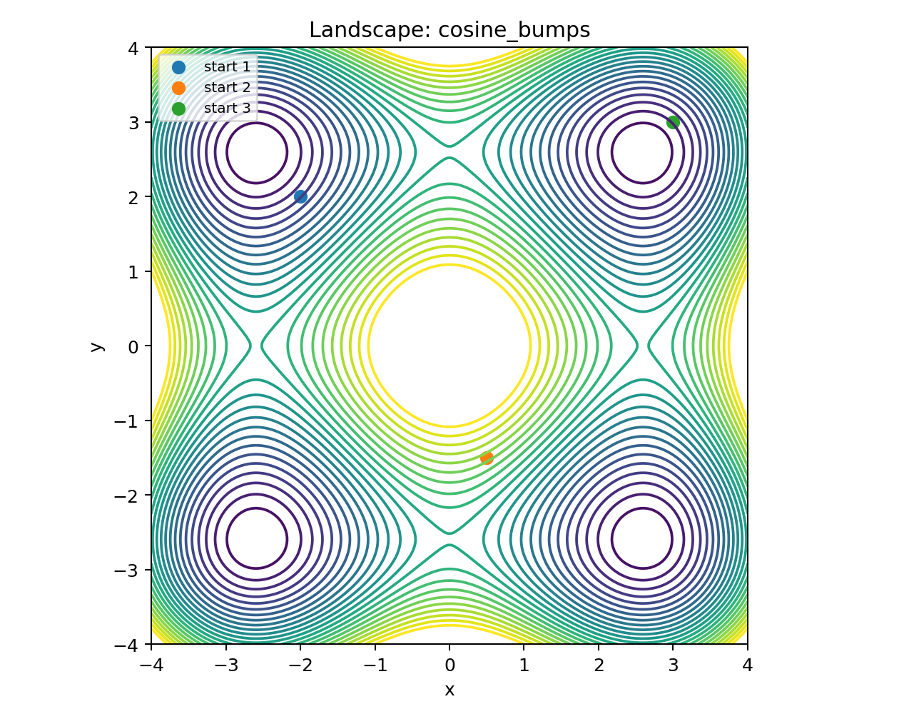
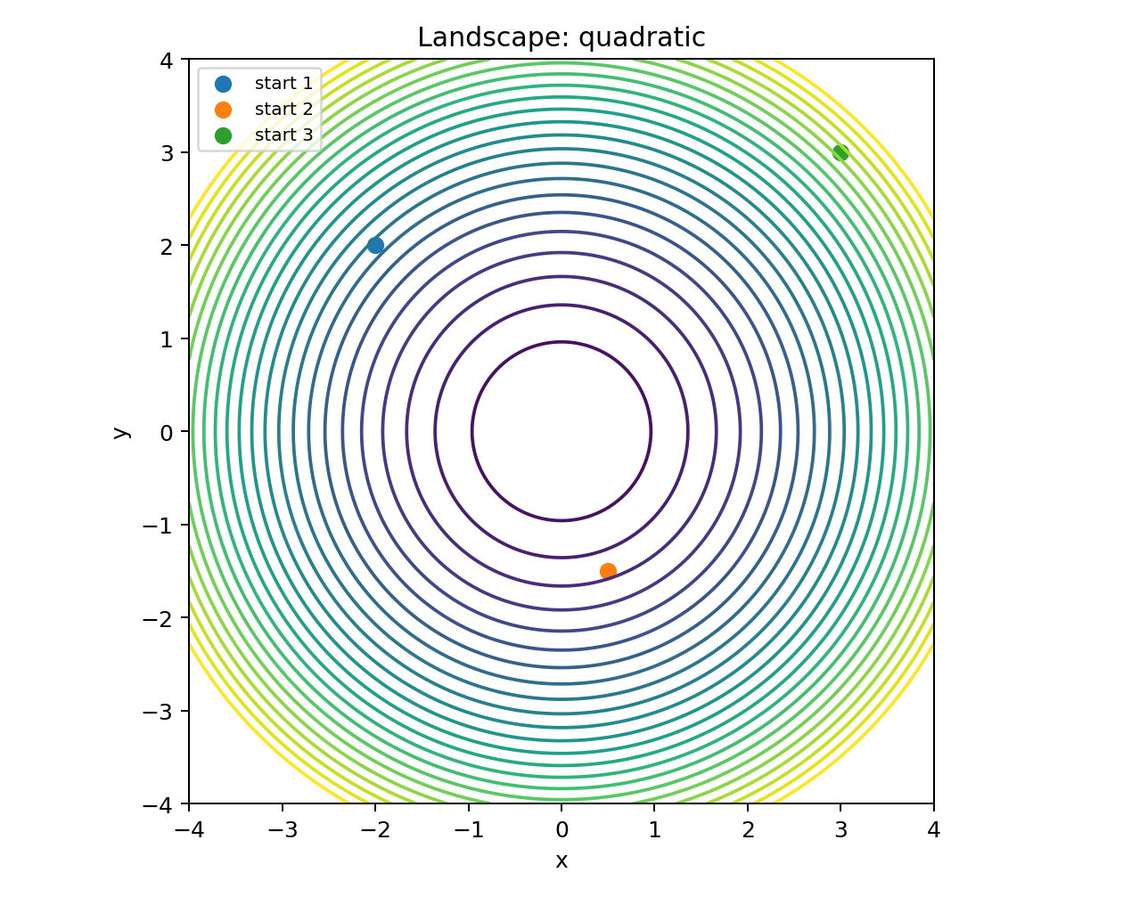
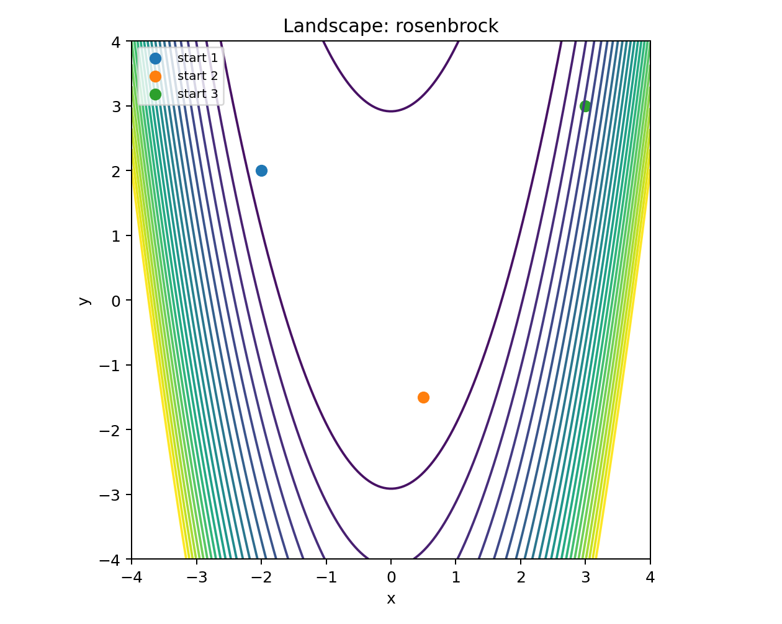
Figure 2. Representative AdaGrad / Adam trajectories.
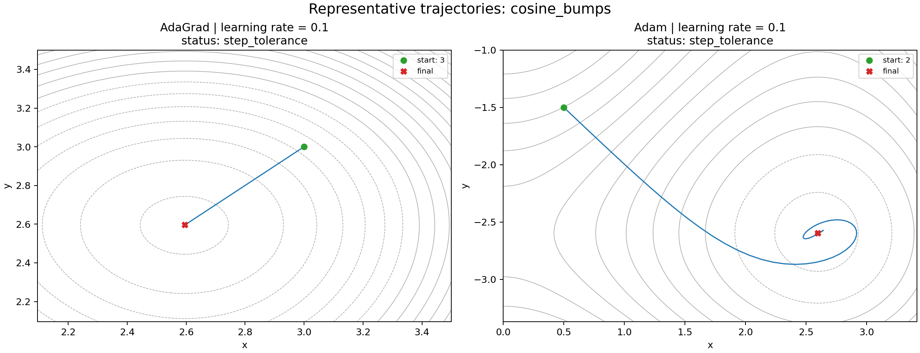
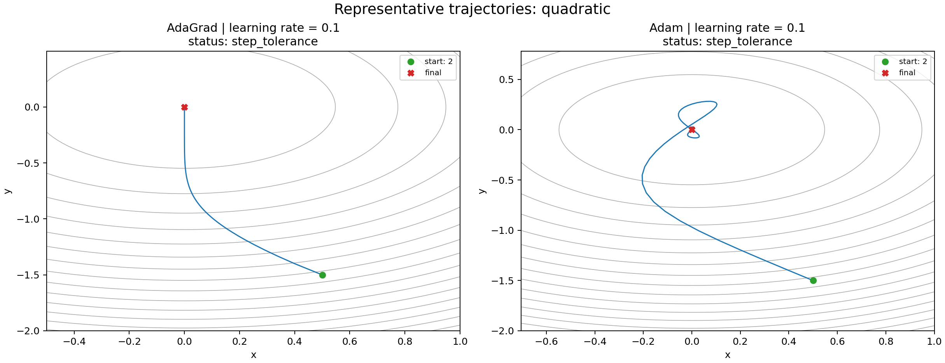
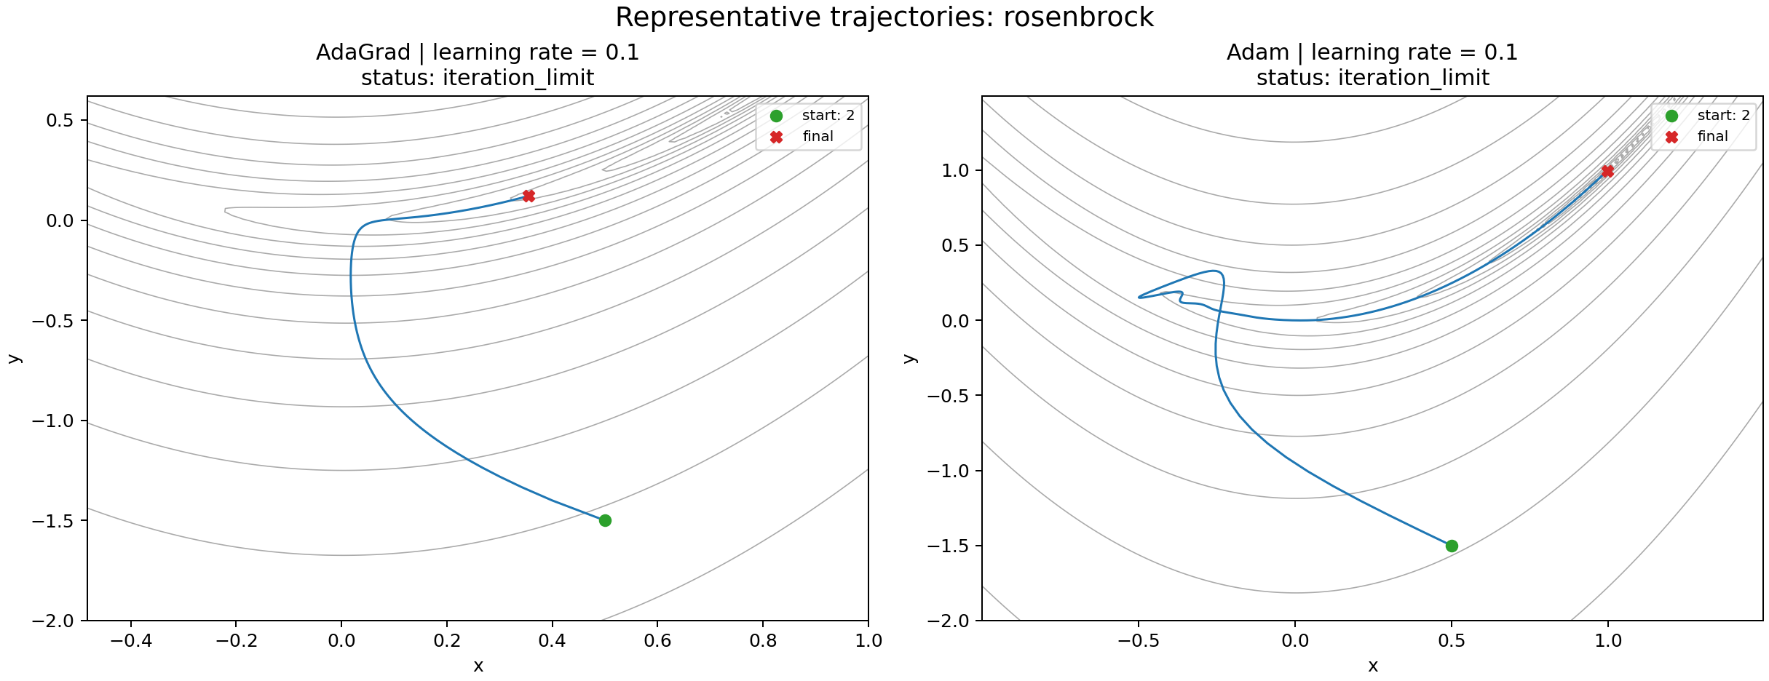
Figure 3. Learning-rate comparison and objective histories.
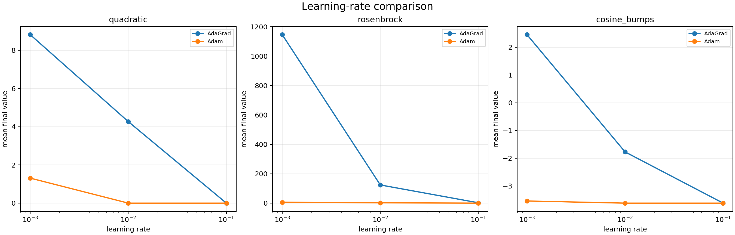
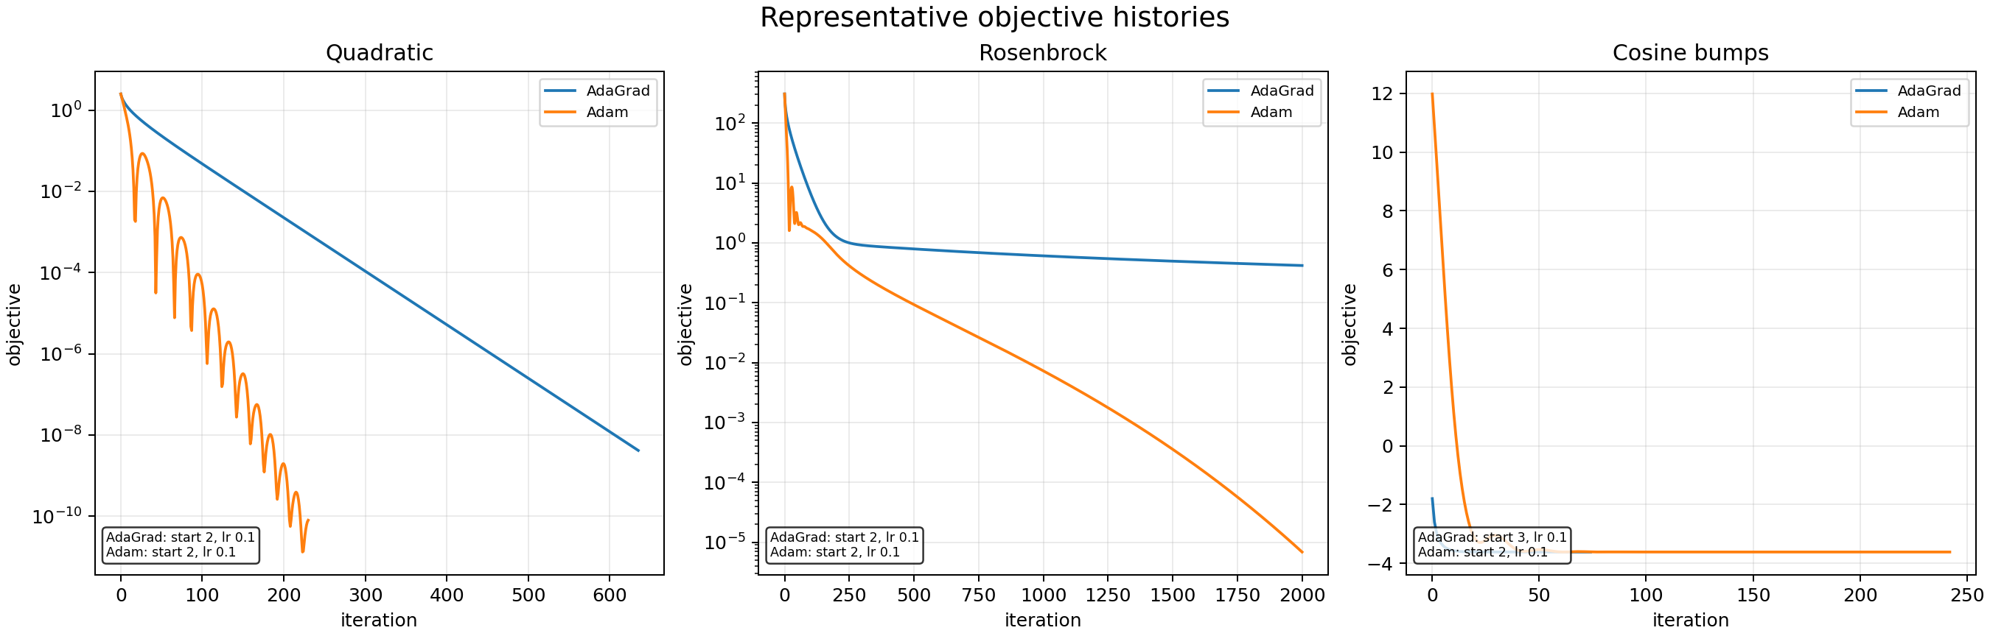
Demo run from the notebook, Rosenbrock, start (-2, 2), a = 0.001:
Method | iterations | final x,y | final f | status
AdaGrad | 2000 | (-1.916, 2.085) | 260.36 | iteration limit
Adam | 2000 | (-1.563, 2.448) | 6.571 | iteration limit

Mean over starts, a = 0.001 (same numbers as the main report tables):
f | Method | a | Iteration | Time (ms) | Final f
f1 | AdaGrad | 0.001 | 2000 | 24.6 | 8.82
f1 | Adam | 0.001 | 2000 | 33.3 | 1.31
f2 | AdaGrad | 0.001 | 2000 | 26.5 | 1146
f2 | Adam | 0.001 | 2000 | 34.8 | 6.19
f3 | AdaGrad | 0.001 | 2000 | 30.0 | 2.46
f3 | Adam | 0.001 | 1765 | 33.7 | -3.54

Best notebook runs (first measured repeat, lowest f): cosine AdaGrad a=0.1 from (3,3) hit f=-3.618 in 74 steps. cosine Adam a=0.1 from (0.5,-1.5) hit f=-3.618 in 242 steps. quadratic AdaGrad a=0.1 from (0.5,-1.5) f=4.16e-9 in 635 steps. quadratic Adam a=0.1 from (0.5,-1.5) f=7.96e-11 in 230 steps. Rosenbrock never met the step tolerance; best Adam f was about 6.9e-6 after 2000 steps.

ANALYSIS
On f1, a=0.001 is too small for both. They hit 2000 steps. AdaGrad is worse (f=8.82) because G keeps growing and the step shrinks. Adam still has some momentum so it gets closer (f=1.31). At a=0.1 both actually finish.
On f2, AdaGrad barely moves in the valley (f=1146 at a=0.001). Adam gets down to about 6.19 but still does not hit ||step|| < 1e-6 in 2000 steps. These two methods are not enough for Rosenbrock on this grid. Newton in the other file is the one that finishes.
On f3, Adam at a=0.001 is close to the local min (f=-3.54). AdaGrad is still sitting at f=2.46. At a=0.1 both find f=-3.618. They stay in the basin of the start.

CONCLUSION
AdaGrad is stable early and then stalls. Adam is stronger than AdaGrad on all three functions in this notebook, but it is not the best method in the whole project: it does not finish Rosenbrock. GD/Newton results are in the main report.

APPENDIX
Notebook: adagrad_adam_revisedrun.ipynb
Main four-method file: CSE620_Fall26_Project1_Nguyen_Rajkumar.py
The .py AdaGrad/Adam updates match the notebook on the checks we compared (Rosenbrock start (-2,2) a=0.001, quadratic AdaGrad a=0.1, quadratic Adam a=0.01). 10 repeats do not change f or iteration count.

