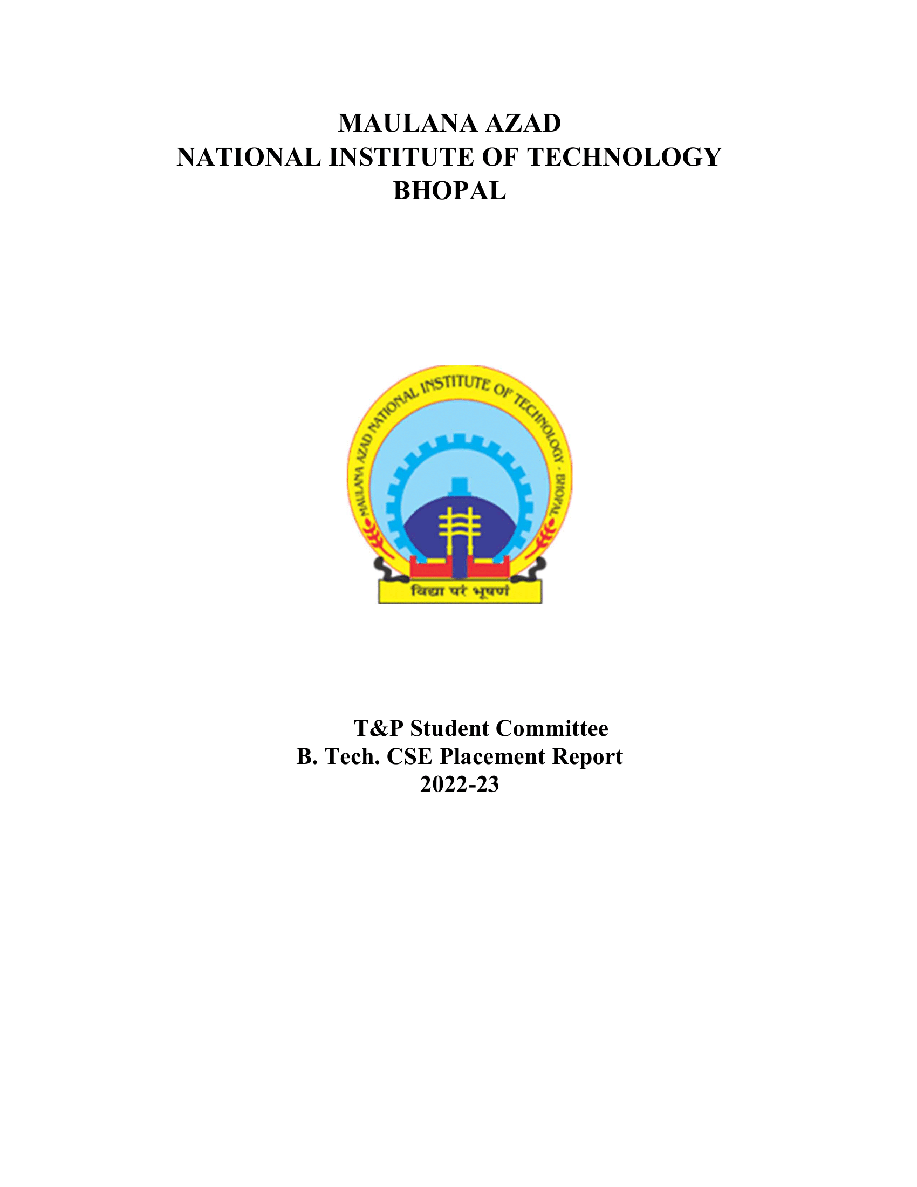

CSE DEPARTMENT (BATCH 2022-2023)

# 1. Placement Stats 2022-23:

|  |  |
| --- | --- |
| No. of companies visited | 151 |
| Total Strength | 231 |
| No. of offers | 265 |
| No. of students placed | 190 |
| No. of students with 6-month Internship | 81 |
| Percentage Placement | 82.25% |
| Average Package | 26.3 |
| Median Package | 19.63 |
| Highest Package | 82 |
| Lowest Package | 8.5 |

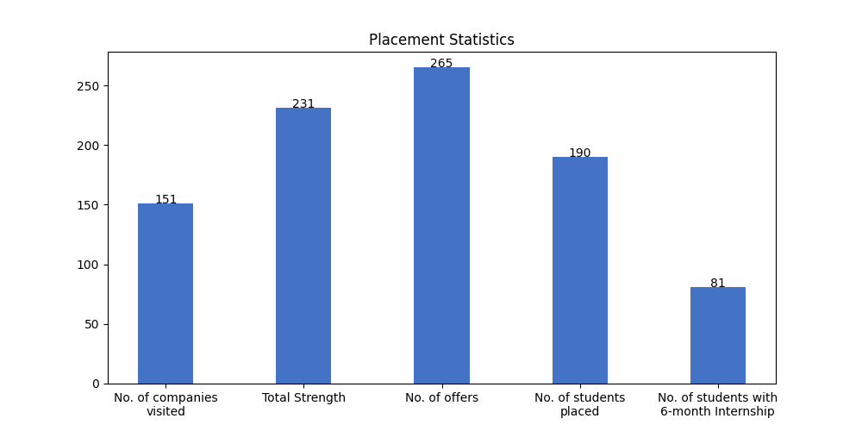

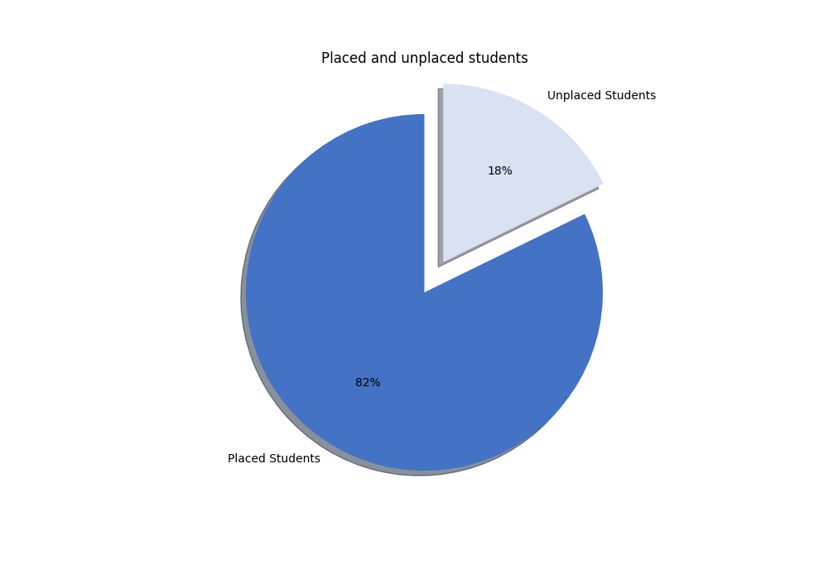

# 1.1 Campus Placement List (FTE):

|  |  |  |  |  |
| --- | --- | --- | --- | --- |
| S. No | Scholar Number | Candidate Name | Company's Name | CTC (LPA) |
| 1 | 191112410 | Rahul Ahirwar | Accenture | 11.89 |
| 2 | 191112249 | ARUN KUMAR | Airtel | 14.75 |
| 3 | 191112272 | Aaditya Singh | Airtel | 14.75 |
| 4 | 191112057 | Addanki V S D Krishna Vivek | Airtel | 14.75 |
| 5 | 191112423 | Amit Kumar | Airtel | 14.75 |
| 6 | 191112207 | Devashree Gajendragadkar | Airtel | 14.75 |
| 7 | 191112015 | Kunal Thite | Airtel | 14.75 |
| 8 | 191112216 | Manav Ahuja | Airtel | 14.75 |
| 9 | 191112250 | Priyanshu Mangal | Airtel | 14.75 |
| 10 | 191112244 | Saksham Shrivastava | Airtel | 14.75 |
| 11 | 191112030 | Shubham Garge | Airtel | 14.75 |
| 12 | 191112201 | Akshay Pandey | Atlassian | 82 |
| 13 | 191112023 | Aman Kulshreshtha | Atlassian | 82 |
| 14 | 191112477 | Ankit Kumar | Atlassian | 82 |
| 15 | 191112215 | Bhavesh Agarwal | Atlassian | 82 |
| 16 | 191112476 | Faisal Jamil | Atlassian | 82 |
| 17 | 191112273 | Mridul Karan | Atlassian | 82 |
| 18 | 191112206 | Pratyush Bansal | Atlassian | 82 |
| 19 | 191112235 | Rahul Singh | Atlassian | 82 |
| 20 | 191112065 | BANOTH HEMANTH | Bharat Electronics Limited(BEL) | 11.5 |
| 21 | 191112270 | Vikas Singh bhadoria | Bharat Electronics Limited(BEL) | 11.5 |
| 22 | 191112228 | Acha Akshaya | C-Dac | 8.5 |
| 23 | 191112050 | Albert Jokelin | CDOT | 19 |
| 24 | 191112240 | Anubhav Das | CDOT | 19 |
| 25 | 191112420 | Anurag Mehar | CDOT | 19 |
| 26 | 191112265 | Ashish Popandiya | CDOT | 19 |
| 27 | 191112069 | Devendra Kumar Singh Yadav | CDOT | 19 |
| 28 | 191112016 | KABOTHU HARSHAVARDHAN | CDOT | 19 |
| 29 | 191112446 | Nayana Krishnan | CDOT | 19 |
| 30 | 191112269 | PRIYANSHU KUMAR YADAV | CDOT | 19 |
| 31 | 191112045 | Prerak Verma | CDOT | 19 |
| 32 | 191112059 | Sachin poonia | CDOT | 19 |
| 33 | 191112236 | Srajan Deo Jain | CDOT | 19 |
| 34 | 191112067 | Sudheer Singh | CDOT | 19 |
| 35 | 191112233 | Zeeshan Quamar | CDOT | 19 |
| 36 | 191112077 | sonde vishnuvardhan rao | CDOT | 19 |
| 37 | 191112020 | Harshit Prajapati | Cashfree | 20.75 |
| 38 | 191112413 | Nikhil Kushwah | Cashfree | 20.75 |
| 39 | 191112470 | Sunkara Lakshmi Manasa | Cashfree | 20.75 |
| 40 | 191112457 | Divyanshu Gupta | Celigo | 21 |
| 41 | 191112031 | VISHWAS SAHU | Celigo | 21 |
| 42 | 191112061 | Vaishali Raghuwanshi | Celigo | 21 |
| 43 | 191112440 | Shaik Ferozuddin | Debar, Accenture | * |
| 44 | 191112421 | Ankit Aakodiya | Delhivery | 14 |
| 45 | 191112231 | Parthesh Gupta | Delhivery | 14 |
| 46 | 191112480 | Ankit Upadhyay | Deutsche Bank | 19.63 |
| 47 | 191112254 | Himakkshi Jain | Deutsche Bank | 19.63 |
| 48 | 191112214 | Jaya Rathore | Deutsche Bank | 19.63 |
| 49 | 191112437 | Komal bisht | Deutsche Bank | 19.63 |
| 50 | 191112432 | Konjeti Sathwika | Deutsche Bank | 19.63 |
| 51 | 191112008 | Mansi Gautam | Deutsche Bank | 19.63 |
| 52 | 191112227 | Naveen Dongre | Deutsche Bank | 19.63 |
| 53 | 191112048 | Nishi Mahalwar | Deutsche Bank | 19.63 |
| 54 | 191112022 | Palak Bende | Deutsche Bank | 19.63 |
| 55 | 191112051 | Preeti Arya | Deutsche Bank | 19.63 |
| 56 | 191112202 | Raghavendra Makarand Kulkarni | Deutsche Bank | 19.63 |
| 57 | 191112402 | SANKALP MAHAJAN | Deutsche Bank | 19.63 |
| 58 | 191112444 | Satyam Singh | Deutsche Bank | 19.63 |
| 59 | 191112221 | Saurav Gupta | Deutsche Bank | 19.63 |
| 60 | 191112467 | Shailly Mishra | Deutsche Bank | 19.63 |
| 61 | 191112256 | Shivanshu Vishnoi | Deutsche Bank | 19.63 |
| 62 | 191112453 | Siddareddygari Amrutha | Deutsche Bank | 19.63 |
| 63 | 191112406 | Vijay Chadokar | Deutsche Bank | 19.63 |
| 64 | 191112419 | Vivek Kumar Ahirwar | Deutsche Bank | 19.63 |
| 65 | 191112433 | ANAY RAJ | Dolat Capital | 18 |
| 66 | 191112060 | ATHARVA MISHRA | Flipkart | 32.577 |
| 67 | 191112435 | Bhumika Gupta | Flipkart | 32.577 |
| 68 | 191112049 | Deepesh Singh Raghuwanshi | Flipkart | 32.577 |
| 69 | 191112211 | Shubham Patidar | Flipkart | 32.577 |
| 70 | 191112044 | Aditya Patel | GEP Solutions | 16 |
| 71 | 191112405 | Aman Rahangdale | GEP Solutions | 16 |
| 72 | 191112253 | Ayush Patel | GEP Solutions | 16 |
| 73 | 191112447 | Harsh Jain | GEP Solutions | 16 |
| 74 | 191112248 | Himanshu kumar | GEP Solutions | 16 |
| 75 | 191112223 | PALAK MEENA | GEP Solutions | 16 |
| 76 | 191112208 | Rishit Sigotia | GEP Solutions | 16 |
| 77 | 191112014 | Aditya Shukla | Galvantrix | 15 |
| 78 | 191112472 | Archit Singh | Goldman Sachs | 24 |
| 79 | 191112034 | Arnav Dixit | Goldman Sachs | 24 |
| 80 | 191112203 | Jeesu jain | Goldman Sachs | 24 |
| 81 | 191112043 | Priyanshu Agrawal | Goldman Sachs | 24 |
| 82 | 191112037 | Tarunendu Arya | Goldman Sachs | 24 |
| 83 | 191112021 | Darshini Sharma | Google | 48 |
| 84 | 191112426 | Rajat Kumar | Google | 48 |
| 85 | 191112429 | Vineet Kumar Chaudhary | Google | 48 |
| 86 | 191112438 | Gyanendra Vikram Singh | HCL Technologies | 8.5 |
| 87 | 191112277 | Mohit Tomar | HCL Technologies | 8.5 |
| 88 | 191112434 | Ritik Parmar | HCL Technologies | 8.5 |
| 89 | 191112010 | Bodhi Yonzon | Hewlett Packard Enterprise(HPE) | 17.5 |
| 90 | 191112003 | Manali Agrawal | IDBI Bank | 12 |
| 91 | 191112278 | Matta Tarun | IDBI Bank | 12 |
| 92 | 191112247 | Rooth Maria Joshi | IDBI Bank | 12 |
| 93 | 191112261 | Abhishek Batti | Incture( Dont Remove) | * |
| 94 | 191112465 | Ayush Gour | JPMC | 17.75 |
| 95 | 191112070 | Divyam Baheti | JPMC | 17.75 |
| 96 | 191112063 | Kshitij Bafna | JPMC | 17.75 |
| 97 | 191112025 | PRABHAT KUMAR | JPMC | 17.75 |
| 98 | 191112427 | Prakhar Gupta | JPMC | 17.75 |
| 99 | 191112013 | Saumel Verma | JPMC | 17.75 |
| 100 | 191112001 | Shrishesh Pratik | JPMC | 17.75 |
| 101 | 191112401 | V V Mansi | JPMC | 17.75 |
| 102 | 191112259 | Cheerla Sai Krusheel | Junglee Games | 23 |
| 103 | 191112242 | Durgesh Kumar Gupta | Junglee Games | 23 |
| 104 | 191112431 | Konjeti Harika | Junglee Games | 23 |
| 105 | 191112478 | Mohammad Areeb Moini | Junglee Games | 23 |
| 106 | 191112473 | Prashant Kaushal | Junglee Games | 23 |
| 107 | 191112012 | Maneet Kaur Bagga | MathWorks | 24.2 |
| 108 | 191112017 | Aayush Dhakad | Microsoft | 51.032 |
| 109 | 191112474 | Akanksha Gupta | Microsoft | 51.032 |
| 110 | 191112029 | Altaf khan | Microsoft | 51.032 |
| 111 | 191112212 | Ayush Anand | Microsoft | 51.032 |
| 112 | 191112416 | Devansh Rathi | Microsoft | 51.032 |
| 113 | 191112038 | GOKUL K. GIJU | Microsoft | 51.032 |
| 114 | 191112479 | Kedar Sharma | Microsoft | 51.032 |
| 115 | 191112054 | Md Anis Ansari | Microsoft | 51.032 |
| 116 | 191112024 | Nikhil Kansliwal | Microsoft | 51.032 |
| 117 | 191112036 | Nimmi Diwakar | Microsoft | 51.032 |
| 118 | 191112274 | Pratyush Govind Gupta | Microsoft | 51.032 |
| 119 | 191112019 | Ravuri Krishna Chaitanya | Microsoft | 51.032 |
| 120 | 191112279 | Sai Yaswanth Ammineni | Microsoft | 51.032 |
| 121 | 191112414 | Sangam Kumar | Microsoft | 51.032 |
| 122 | 191112436 | Seshal Jain | Microsoft | 51.032 |
| 123 | 191112047 | Vineet Widhani | Microsoft | 51.032 |
| 124 | 191112460 | Yogesh Kumar Prajapat | Microsoft | 51.032 |
| 125 | 191112425 | Anchit Kothari | Netradyne | 14 |
| 126 | 191112224 | Aishwarya Eedala | Optum | 14.5 |
| 127 | 191112266 | Anand Bhosle | Optum | 14.5 |
| 128 | 191112255 | Ashwani Meena | Optum | 14.5 |
| 129 | 191112263 | Bodasu Karthik | Optum | 14.5 |
| 130 | 191112062 | Chelsi Garg | Optum | 14.5 |
| 131 | 191112262 | Harish Kumar | Optum | 14.5 |
| 132 | 191112275 | Krishna kant goyal | Optum | 14.5 |
| 133 | 191112238 | Prakhar Sharma | Optum | 14.5 |
| 134 | 191112404 | Pratishtha Pathak | Optum | 14.5 |
| 135 | 191112080 | Satasmi Panda | Optum | 14.5 |
| 136 | 191112449 | Abhishek Jajoo | Oracle | 30.67 |
| 137 | 191112005 | Bhuwan Kumar Singh | Oracle | 30.67 |
| 138 | 191112268 | Divy Badoniya | Oracle | 30.67 |
| 139 | 191112074 | Hemanth Kumar Mandavyapuram | Oracle | 30.67 |
| 140 | 191112007 | MANSI DAS | Oracle | 30.67 |
| 141 | 191112035 | Madhav Anchala | Oracle | 30.67 |
| 142 | 191112055 | Mayank Shukla | Oracle | 30.67 |
| 143 | 191112210 | Nikhar Manchanda | Oracle | 30.67 |
| 144 | 191112424 | Pallav Rohil | Oracle | 30.67 |
| 145 | 191112455 | Shubh Mishra | Oracle | 30.67 |
| 146 | 191112445 | Spoorthi Tatikonda | Oracle | 30.67 |
| 147 | 191112428 | Stuti Srivastava | Oracle | 30.67 |
| 148 | 191112246 | VISHAL DAS | Oracle | 30.67 |
| 149 | 191112042 | prakash Bhardwaj | Oracle | 30.67 |
| 150 | 191112448 | Khushi Chavada | Oracle, Amazon (Offcampus) | * |
| 151 | 191112222 | Mehul Verma | Park+ SDE | * |
| 152 | 191112409 | Nikhil Singh Parihar | Park+ SDE | * |
| 153 | 191112407 | Aanya Chouhan | Paypal | 34.4 |
| 154 | 191112026 | Aditya Jain | Paypal | 34.4 |
| 155 | 191112267 | Akshat Gupta | Paypal | 34.4 |
| 156 | 191112039 | Divya Sharma | Paypal | 34.4 |
| 157 | 191112076 | Sahil Rungta | Paypal | 34.4 |
| 158 | 191112041 | BUDUMURU SOWJANYA | PwC India | 9.08 |
| 159 | 191112463 | Peter Thomas Biju | PwC India | 9.08 |
| 160 | 191112028 | Mallela David Vinay | Samsung R&D Bangalore | 16 |
| 161 | 191112280 | Pawan Patel | Samsung R&D Bangalore | 16 |
| 162 | 191112011 | Satyam Gour | Samsung R&D Bangalore | 16 |
| 163 | 191112243 | Yashwant Patidar | Samsung R&D Bangalore | 16 |
| 164 | 191112450 | Yuvraj Singh Rathore | Samsung R&D Bangalore | 16 |
| 165 | 191112205 | Aarsh Pandey | Samsung R&D Delhi | 15.5 |
| 166 | 191112078 | Ankeet KC | Sandvine | 15.83 |
| 167 | 191112466 | Harshit Sharma | ServiceNow | 33 |
| 168 | 191112430 | Ankit Kumar | Sigmoid Analytics | 15 |
| 169 | 191112204 | Chetan Patel | Spinny | 16 |
| 170 | 191112452 | Aditi Mishra | Tekion | 45 |
| 171 | 191112225 | Mayank Jaiswal | Tekion | 45 |
| 172 | 191112226 | Pratyush Kumar Lokhande | Tekion | 45 |
| 173 | 191112245 | Bimal Shukla | Ultimate Kronos Group | 14.53 |
| 174 | 191112232 | HARSH LAKHOTIA | Ultimate Kronos Group | 14.53 |
| 175 | 191112475 | Prakhar Khandelwal | Ultimate Kronos Group | 14.53 |
| 176 | 191112006 | Vishal Kumar Rajak | Ultimate Kronos Group | 14.53 |
| 177 | 191112276 | Vivek Kumar | Ultimate Kronos Group | 14.53 |
| 178 | 191112441 | Sandeep Raghuvanshi | Veritas | 17 |
| 179 | 191112004 | Kunal Pawar | Warner Bros Discovery | 27 |
| 180 | 191112459 | Aditya Niranjan Mishra | Wells Fargo | 24 |
| 181 | 191112229 | Anshuman Upadhyay | Wells Fargo | 24 |
| 182 | 191112411 | Arif khan | Wells Fargo | 24 |
| 183 | 191112040 | Gyanendra Kumar Shukla | Wells Fargo | 24 |
| 184 | 191112462 | Harsh Jain | Wells Fargo | 24 |
| 185 | 191112220 | Isha Jain | Wells Fargo | 24 |
| 186 | 191112264 | Isha Rani | Wells Fargo | 24 |
| 187 | 191112217 | Mona Gupta | Wells Fargo | 24 |
| 188 | 191112237 | Sauhard Pareek | Wells Fargo | 24 |
| 189 | 191112230 | Tejaswini Tulasi | Wells Fargo | 24 |
| 190 | 191112053 | Uday Chaturvedi | ZS Associates | 13.656 |

# 1.2 Students With PPO:

|  |  |  |  |  |
| --- | --- | --- | --- | --- |
| S. No | Scholar Number | Candidate Name | Company's Name | CTC (LPA) |
| 1 | 191112410 | Rahul Ahirwar | Accenture | 11.89 |
| 2 | 191112440 | Shaik Ferozuddin | Accenture | 11.89 |
| 3 | 191112448 | Khushi Chavada | Amazon (Offcampus) | * |
| 4 | 191112254 | Himakkshi Jain | Deutsche Bank | 19.63 |
| 5 | 191112214 | Jaya Rathore | Deutsche Bank | 19.63 |
| 6 | 191112008 | Mansi Gautam | Deutsche Bank | 19.63 |
| 7 | 191112051 | Preeti Arya | Deutsche Bank | 19.63 |
| 8 | 191112060 | ATHARVA MISHRA | Flipkart | 32.577 |
| 9 | 191112435 | Bhumika Gupta | Flipkart | 32.577 |
| 10 | 191112049 | Deepesh Singh Raghuwanshi | Flipkart | 32.577 |
| 11 | 191112472 | Archit Singh | Goldman Sachs | 24 |
| 12 | 191112034 | Arnav Dixit | Goldman Sachs | 24 |
| 13 | 191112203 | Jeesu jain | Goldman Sachs | 24 |
| 14 | 191112043 | Priyanshu Agrawal | Goldman Sachs | 24 |
| 15 | 191112037 | Tarunendu Arya | Goldman Sachs | 24 |
| 16 | 191112070 | Divyam Baheti | JPMC | 17.75 |
| 17 | 191112013 | Saumel Verma | JPMC | 17.75 |
| 18 | 191112001 | Shrishesh Pratik | JPMC | 17.75 |
| 19 | 191112445 | Spoorthi Tatikonda | JPMC | 17.75 |
| 20 | 191112012 | Maneet Kaur Bagga | MathWorks | 24.2 |
| 21 | 191112474 | Akanksha Gupta | Microsoft | 51.032 |
| 22 | 191112201 | Akshay Pandey | Microsoft | 51.032 |
| 23 | 191112212 | Ayush Anand | Microsoft | 51.032 |
| 24 | 191112416 | Devansh Rathi | Microsoft | 51.032 |
| 25 | 191112038 | GOKUL K. GIJU | Microsoft | 51.032 |
| 26 | 191112054 | Md Anis Ansari | Microsoft | 51.032 |
| 27 | 191112024 | Nikhil Kansliwal | Microsoft | 51.032 |
| 28 | 191112274 | Pratyush Govind Gupta | Microsoft | 51.032 |
| 29 | 191112019 | Ravuri Krishna Chaitanya | Microsoft | 51.032 |
| 30 | 191112436 | Seshal Jain | Microsoft | 51.032 |
| 31 | 191112047 | Vineet Widhani | Microsoft | 51.032 |
| 32 | 191112460 | Yogesh Kumar Prajapat | Microsoft | 51.032 |
| 33 | 191112028 | Mallela David Vinay | Samsung R&D Bangalore | 16 |
| 34 | 191112280 | Pawan Patel | Samsung R&D Bangalore | 16 |
| 35 | 191112011 | Satyam Gour | Samsung R&D Bangalore | 16 |
| 36 | 191112419 | Vivek Kumar Ahirwar | Samsung R&D Bangalore | 16 |
| 37 | 191112243 | Yashwant Patidar | Samsung R&D Bangalore | 16 |
| 38 | 191112450 | Yuvraj Singh Rathore | Samsung R&D Bangalore | 16 |
| 39 | 191112466 | Harshit Sharma | ServiceNow | 33 |
| 40 | 191112229 | Anshuman Upadhyay | Wells Fargo | 24 |
| 41 | 191112411 | Arif khan | Wells Fargo | 24 |
| 42 | 191112040 | Gyanendra Kumar Shukla | Wells Fargo | 24 |
| 43 | 191112220 | Isha Jain | Wells Fargo | 24 |
| 44 | 191112217 | Mona Gupta | Wells Fargo | 24 |
| 45 | 191112206 | Pratyush Bansal | Wells Fargo | 24 |

# 1.3 Internships (6 Month):

|  |  |  |  |  |
| --- | --- | --- | --- | --- |
| S. No | Scholar Number | Candidate Name | Company's Name | Stipend (KPM) |
| 1 | 191112201 | Akshay Pandey | Atlassian | 130 |
| 2 | 191112023 | Aman Kulshreshtha | Atlassian | 130 |
| 3 | 191112477 | Ankit Kumar | Atlassian | 130 |
| 4 | 191112215 | Bhavesh Agarwal | Atlassian | 130 |
| 5 | 191112476 | Faisal Jamil | Atlassian | 130 |
| 6 | 191112273 | Mridul Karan | Atlassian | 130 |
| 7 | 191112206 | Pratyush Bansal | Atlassian | 130 |
| 8 | 191112235 | Rahul Singh | Atlassian | 130 |
| 9 | 191112442 | Saurabh Singh | Bizongo | 60 |
| 10 | 191112020 | Harshit Prajapati | Cashfree | 40 |
| 11 | 191112413 | Nikhil Kushwah | Cashfree | 40 |
| 12 | 191112470 | Sunkara Lakshmi Manasa | Cashfree | 40 |
| 13 | 191112457 | Divyanshu Gupta | Celigo | 33 |
| 14 | 191112031 | VISHWAS SAHU | Celigo | 33 |
| 15 | 191112061 | Vaishali Raghuwanshi | Celigo | 33 |
| 16 | 191112075 | Abhishek Yadav | Coriolis Technologies | 18 |
| 17 | 191112270 | Vikas Singh bhadoria | Coriolis Technologies | 18 |
| 18 | 191112421 | Ankit Aakodiya | Delhivery | 25 |
| 19 | 191112231 | Parthesh Gupta | Delhivery | 25 |
| 20 | 191112044 | Aditya Patel | Directi (Titan) | 125 |
| 21 | 191112433 | ANAY RAJ | Dolat Capital | 20 |
| 22 | 191112060 | ATHARVA MISHRA | Flipkart | 100 |
| 23 | 191112435 | Bhumika Gupta | Flipkart | 100 |
| 24 | 191112049 | Deepesh Singh Raghuwanshi | Flipkart | 100 |
| 25 | 191112238 | Prakhar Sharma | Flipkart | 100 |
| 26 | 191112250 | Priyanshu Mangal | Flipkart | 100 |
| 27 | 191112211 | Shubham Patidar | Flipkart | 100 |
| 28 | 191112052 | Ankush Sharma | GE Digital | 40 |
| 29 | 191112253 | Ayush Patel | GE Digital | 40 |
| 30 | 191112207 | Devashree Gajendragadkar | GE Digital | 40 |
| 31 | 191112447 | Harsh Jain | GE Digital | 40 |
| 32 | 191112015 | Kunal Thite | GE Digital | 40 |
| 33 | 191112014 | Aditya Shukla | Galvantrix | 30 |
| 34 | 191112267 | Akshat Gupta | Groww | 61 |
| 35 | 191112010 | Bodhi Yonzon | Hewlett Packard Enterprise(HPE) | 40 |
| 36 | 191112261 | Abhishek Batti | Incture( Dont Remove) | * |
| 37 | 191112259 | Cheerla Sai Krusheel | Junglee Games | 40 |
| 38 | 191112242 | Durgesh Kumar Gupta | Junglee Games | 40 |
| 39 | 191112431 | Konjeti Harika | Junglee Games | 40 |
| 40 | 191112478 | Mohammad Areeb Moini | Junglee Games | 40 |
| 41 | 191112473 | Prashant Kaushal | Junglee Games | 40 |
| 42 | 191112219 | ANSH KAUSHIK | MSCI | 60 |
| 43 | 191112205 | Aarsh Pandey | MSCI | 60 |
| 44 | 191112026 | Aditya Jain | MSCI | 60 |
| 45 | 191112050 | Albert Jokelin | MSCI | 60 |
| 46 | 191112069 | Devendra Kumar Singh Yadav | MSCI | 60 |
| 47 | 191112441 | Sandeep Raghuvanshi | MSCI | 60 |
| 48 | 191112058 | Tanish Ashish Rangnekar | MSCI | 60 |
| 49 | 191112071 | Vismay Chourasia | MSCI | 60 |
| 50 | 191112064 | Thippani Manideep | Observe AI | 75 |
| 51 | 191112449 | Abhishek Jajoo | Oracle | 50 |
| 52 | 191112005 | Bhuwan Kumar Singh | Oracle | 50 |
| 53 | 191112268 | Divy Badoniya | Oracle | 50 |
| 54 | 191112074 | Hemanth Kumar Mandavyapuram | Oracle | 50 |
| 55 | 191112448 | Khushi Chavada | Oracle | 50 |
| 56 | 191112007 | MANSI DAS | Oracle | 50 |
| 57 | 191112035 | Madhav Anchala | Oracle | 50 |
| 58 | 191112055 | Mayank Shukla | Oracle | 50 |
| 59 | 191112210 | Nikhar Manchanda | Oracle | 50 |
| 60 | 191112424 | Pallav Rohil | Oracle | 50 |
| 61 | 191112455 | Shubh Mishra | Oracle | 50 |
| 62 | 191112445 | Spoorthi Tatikonda | Oracle | 50 |
| 63 | 191112428 | Stuti Srivastava | Oracle | 50 |
| 64 | 191112246 | VISHAL DAS | Oracle | 50 |
| 65 | 191112042 | prakash Bhardwaj | Oracle | 50 |
| 66 | 191112222 | Mehul Verma | Park+ SDE | * |
| 67 | 191112409 | Nikhil Singh Parihar | Park+ SDE | * |
| 68 | 191112415 | Ajay Singh Bais | Paytm | 25 |
| 69 | 191112073 | Ashish Agarwala | Paytm | 25 |
| 70 | 191112033 | Jatin Singh | Paytm | 25 |
| 71 | 191112018 | Nikhil Mishra | Paytm | 25 |
| 72 | 191112461 | RISHABH PANDEY | Paytm | 25 |
| 73 | 191112239 | Reetu Raj | Paytm | 25 |
| 74 | 191112027 | shubham dhakad | Paytm | 25 |
| 75 | 191112078 | Ankeet KC | Sandvine | 60 |
| 76 | 191112430 | Ankit Kumar | Sigmoid Analytics | 25 |
| 77 | 191112204 | Chetan Patel | Spinny | 35 |
| 78 | 191112452 | Aditi Mishra | Tekion | 50 |
| 79 | 191112225 | Mayank Jaiswal | Tekion | 50 |
| 80 | 191112226 | Pratyush Kumar Lokhande | Tekion | 50 |
| 81 | 191112004 | Kunal Pawar | Texas Instruments | 45 |

# 1.4 Companies visited:

|  |  |  |  |
| --- | --- | --- | --- |
| Goldman Sachs | Cyfuture India Pvt Ltd | Debar, Accenture | Bizongo |
| Nation with Namo | EXL | Convegenius | Galvantrix |
| Flipkart | Box8 | Amazon* | Oracle, Amazon (Offcampus) |
| Media.Net SRE(DevOps) | NexTurn India Pvt. Ltd | Directi (Titan) | WSP |
| Cashfree | Pie INFOCOMM | Alstom Transport | People Interacitve |
| Optum | Texas Instruments | Vassar Lab | Zycus |
| Dyeus | Digite Infotech | Piramal | BillDesk |
| Samsung R&D Bangalore | Applied Materials | Samsung R&D Delhi | Quantiphi |
| JPMC | NSL HUB | IDBI Bank | Panel IQ |
| Merilytics | Atlassian | CodeYoung | Intellipaat |
| Oracle | Digiotech Solutions Pvt Ltd | InfoObjects | Hewlett Packard Enterprise(HPE) |
| MSCI | MathWorks | Ninjacart | Ganit Business Solutions Pvt Ltd |
| Dolat Capital | MyCaptain | Walkover Web Solutions | Zscaler |
| Microsoft | Reliance Jio | Daimler | Ciena Networks |
| Netcracker | Vedanta Limited | UI Path | Infineon Technologies |
| ZS Associates | Sigmoid Analytics | Sutherland | TATA IQ |
| Incture( Dont Remove) | Forbes Marhsall | Abhibus | Observe AI |
| Biz 4 Solutions | PharmaAce | Hexware Technologies | Nation With Namo(Associate Consultant) |
| Indraprastha Gas Ltd | Media.net (SDE) | Capace Software | Edustation |
| Sandvine | Physics Wallah | Comviva | Truminds |
| Paytm | Frugal Tesitng | Spinny | PwC India |
| Groww | C-Dac | Applied Material(Software Profile) | Google* |
| Netradyne | Thrillophilia | Live your best life | Airtel |
| Wells Fargo | Axis Bank | Morphle Labs | Delhivery |
| Genpact (Enquero) | Coriolis Technologies | Amazon (Offcampus) | Aakash Byjus |
| Google | CGI | Winjit Technologies | Teradata |
| Accenture | Deutsche Bank | APT Portfolio | ServiceNow |
| PlanetSpark | Incedo | O9 Solutions | Fanatics |
| Edgistify | Warner Bros Discovery | Atyati Technologies Pvt Ltd | Affine |
| Chqbook | Nokia | CDOT | Indus Valley Partners |
| Carwale | Trianz | MAQ software | Decimal Point Analytics |
| Jivox | Learning Routes Pvt Ltd | Junglee Games | Bharat Electronics Limited(BEL) |
| GE Digital | Toshibha | GEP Solutions | BizWiz |
| Paypal | Tekion | HCL Technologies | TCS R&I |
| Chaayos | Latentview | Plan Realty | Trilogy |
| Lucent Innovation | Incture | NucleusTeq | Ultimate Kronos Group |
| Park+ | Veritas | Park+ SDE | JTG (Josh Technology Group) |

# 1.5. Companies visited(with selections):

|  |  |  |  |
| --- | --- | --- | --- |
| S. No | Company Name | Selections | CTC (LPA) |
| 1 | Deutsche Bank | 19 | 19.63 |
| 2 | Microsoft | 18 | 51.032 |
| 3 | Oracle | 15 | 30.67 |
| 4 | CDOT | 14 | 19 |
| 5 | JPMC | 13 | 17.75 |
| 6 | Optum | 12 | 14.5 |
| 7 | Wells Fargo | 11 | 24 |
| 8 | Airtel | 10 | 14.75 |
| 9 | Atlassian | 8 | 82 |
| 10 | GEP Solutions | 8 | 16 |
| 11 | Samsung R&D Bangalore | 6 | 16 |
| 12 | Paypal | 5 | 34.4 |
| 13 | Goldman Sachs | 5 | 24 |
| 14 | Junglee Games | 5 | 23 |
| 15 | Ultimate Kronos Group | 5 | 14.53 |
| 16 | Flipkart | 4 | 32.577 |
| 17 | Google | 3 | 48 |
| 18 | Tekion | 3 | 45 |
| 19 | Celigo | 3 | 21 |
| 20 | Cashfree | 3 | 20.75 |
| 21 | Samsung R&D Delhi | 3 | 15.5 |
| 22 | IDBI Bank | 3 | 12 |
| 23 | HCL Technologies | 3 | 8.5 |
| 24 | Park+ | 2 | 31.5 |
| 25 | Delhivery | 2 | 14 |
| 26 | Accenture | 2 | 11.89 |
| 27 | Bharat Electronics Limited(BEL) | 2 | 11.5 |
| 28 | PwC India | 2 | 9.08 |
| 29 | Amazon* | 1 | 46.3 |
| 30 | ServiceNow | 1 | 33 |
| 31 | Warner Bros Discovery | 1 | 27 |
| 32 | MathWorks | 1 | 24.2 |
| 33 | Google* | 1 | 22 |
| 34 | Dolat Capital | 1 | 18 |
| 35 | Hewlett Packard Enterprise(HPE) | 1 | 17.5 |
| 36 | Veritas | 1 | 17 |
| 37 | Spinny | 1 | 16 |
| 38 | Sandvine | 1 | 15.83 |
| 39 | Sigmoid Analytics | 1 | 15 |
| 40 | Galvantrix | 1 | 15 |
| 41 | Hexware Technologies | 1 | 15 |
| 42 | Netradyne | 1 | 14 |
| 43 | ZS Associates | 1 | 13.656 |
| 44 | Incture | 1 | 8.5 |
| 45 | C-Dac | 1 | 8.5 |
| 46 | CGI | 1 | 7.87 |

# 1.6. Companies visited(with no selections):

|  |  |  |  |
| --- | --- | --- | --- |
| Fanatics | Media.net (SDE) | Trilogy | Merilytics |
| BillDesk | O9 Solutions | Digite Infotech | TCS R&I |
| Chqbook | EXL | Carwale | Affine |
| Pie INFOCOMM | NucleusTeq | MAQ software | Nation with Namo |
| Teradata | Sutherland | Dyeus | Publicis Sapient |
| Ciena Networks | Piramal | Indus Valley Partners | Panel IQ |
| Quantiphi | PharmaAce | Digiotech Solutions Pvt Ltd | Decimal Point Analytics |
| Morphle Labs | Reliance Jio | Netcracker | Convegenius |
| Zycus | BizWiz | Forbes Marhsall | Alstom Transport |
| Ninjacart | Intellipaat | Jivox | Latentview |
| Nation With Namo(Associate Consultant) | Daimler | Plan Realty | Frugal Tesitng |
| WSP | Thrillophilia | Aakash Byjus | Lucent Innovation |
| Vassar Lab | Vedanta Limited | Capace Software | People Interacitve |
| UI Path | CodeYoung | Physics Wallah | Walkover Web Solutions |
| PlanetSpark | Ganit Business Solutions Pvt Ltd | TATA IQ | Edgistify |
| Indraprastha Gas Ltd | Learning Routes Pvt Ltd | MyCaptain | Cyfuture India Pvt Ltd |

# 2.1 Tabular Comparison:

|  |  |  |  |  |  |  |  |  |  |
| --- | --- | --- | --- | --- | --- | --- | --- | --- | --- |
| Session | 2014-15 | 2015-16 | 2016-17 | 2017-18 | 2018-19 | 2019-20 | 2020-21 | 2021-22 | 2022-23 |
| No of Companies visited | 45 | 59 | 54 | 60 | 81 | 91 | 65 | 155 | 151 |
| No. of oﬀers | 142 | 131 | 186 | 193 | 182 | 193 | 149 | 261 | 265 |
| Average Package | 5.92 | 6.5 | 6.05 | 10.65 | 12.51 | 15.56 | 11.69 | 17.45 | 26.3 |

# 2.2 Graphs for Comparison with previous years:

## a) No of companies visited:

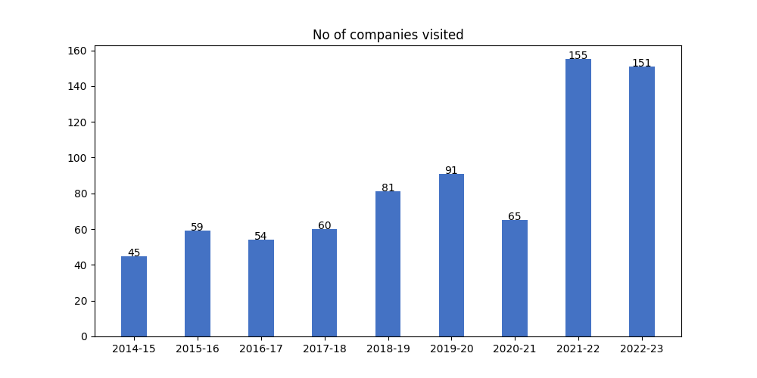

## b) Average package distribution:

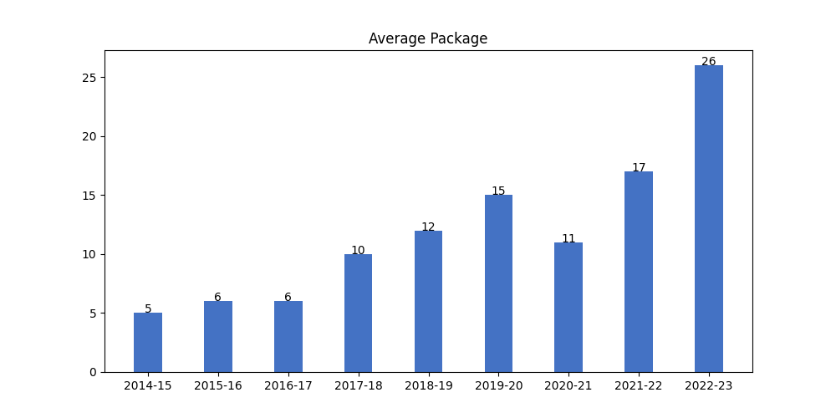

## c) No. of Offers:

