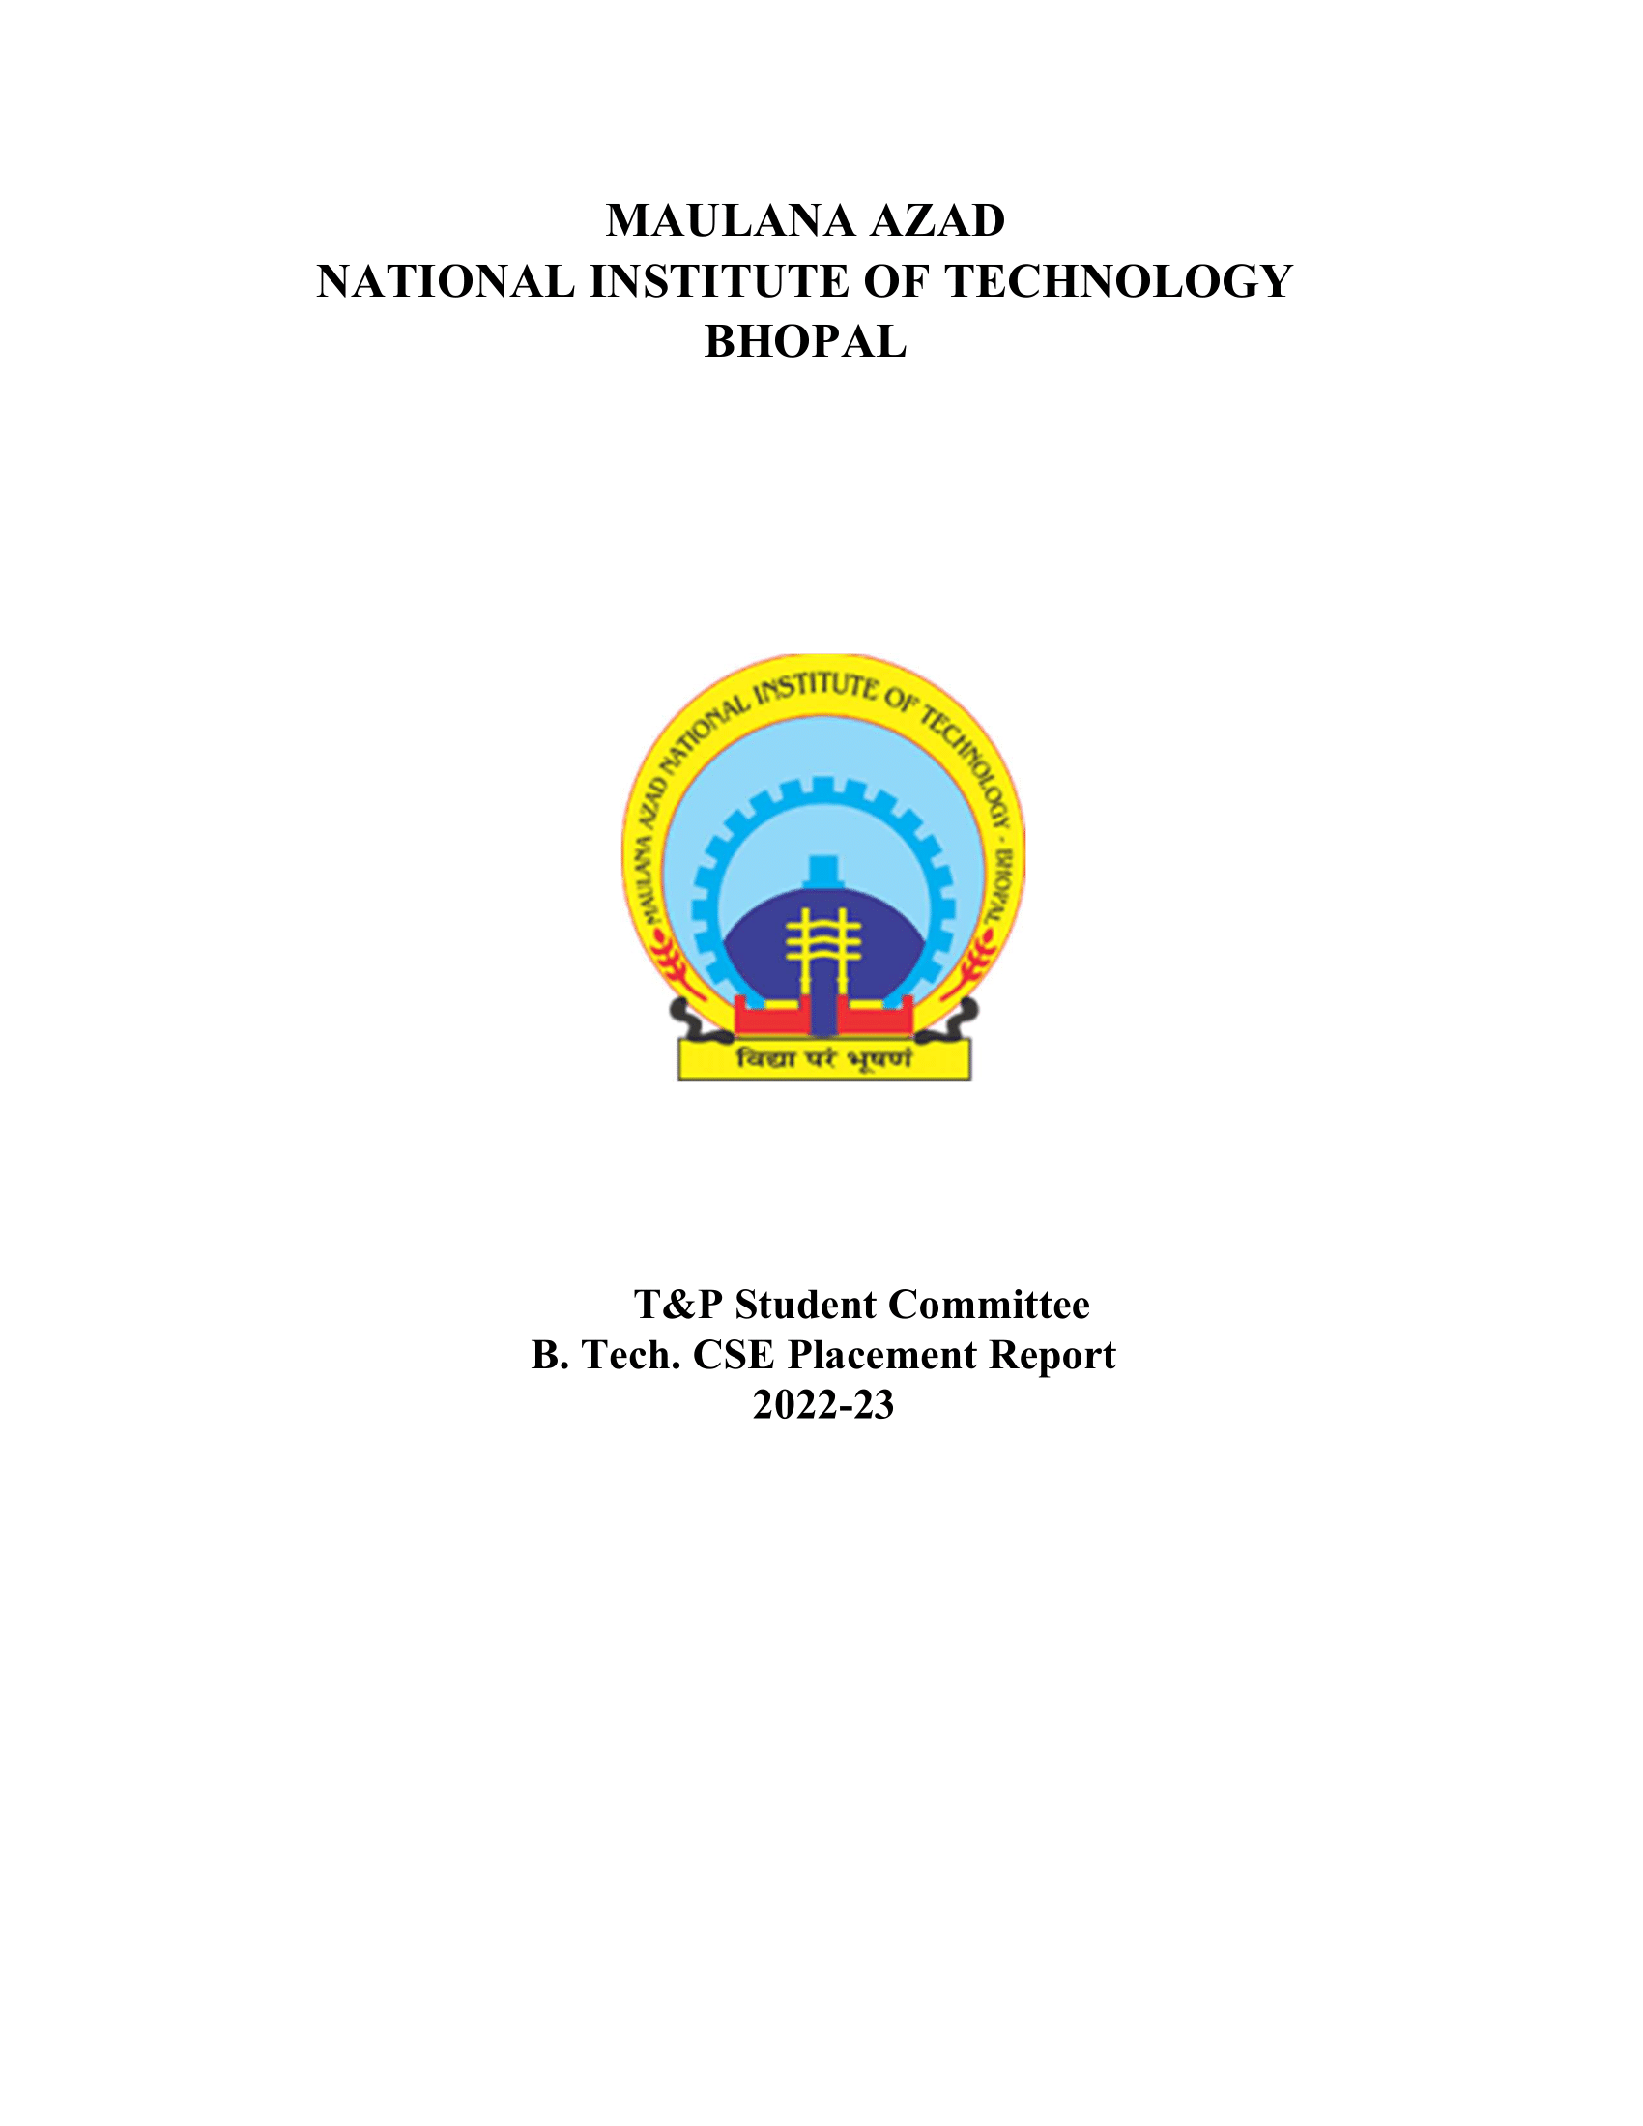

CHEM DEPARTMENT (BATCH 2022-2023)

# 1. Overview:

Materials & Metallurgical Engineering department of MANIT Bhopal have always been a growing and expanding department in terms of strength and achievements. Core companies have just started their recruitment process in our college but there were many non-core companies which visited campus.

# 2. Placement Stats 2022-23:

|  |  |
| --- | --- |
| No. of companies visited | 59 |
| Total Strength | 66 |
| No. of offers | 62 |
| No. of students placed | 53 |
| No. of students with 6-month Internship | 9 |
| Percentage Placement | 80.3% |
| Average Package | 9.14 |
| Median Package | 7.71 |
| Highest Package | 18.95 |
| Lowest Package | 5.5 |

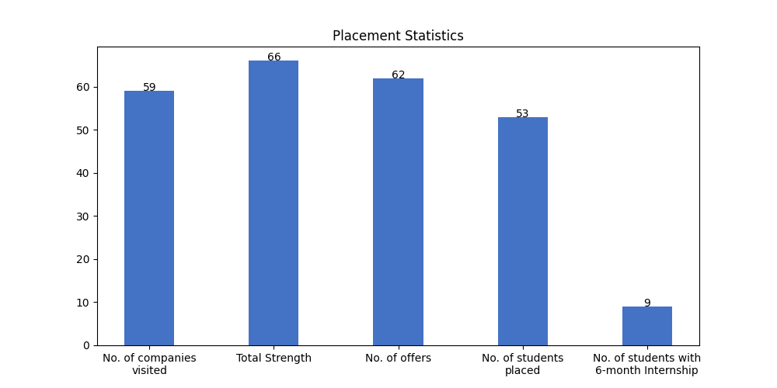

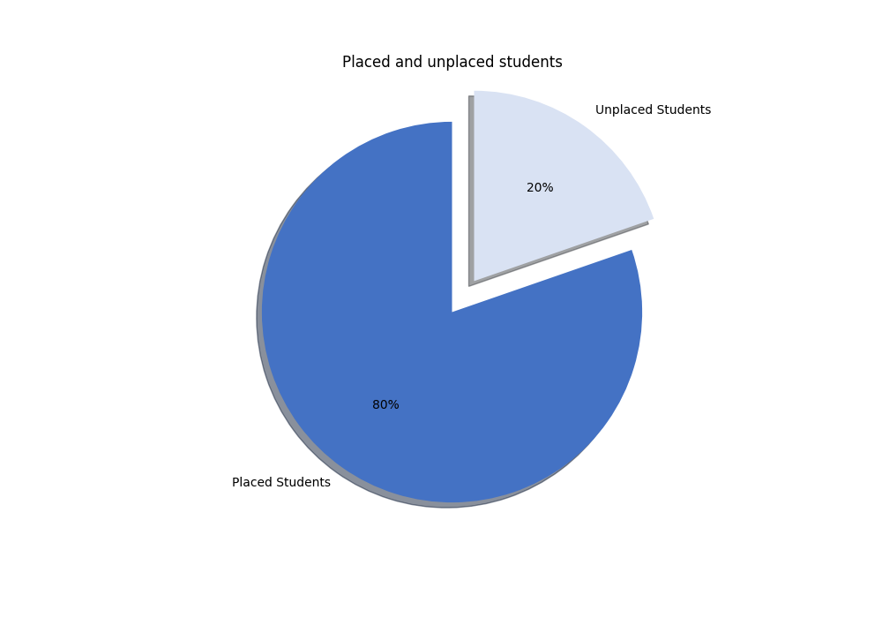

# 2.1 Campus Placement List (FTE):

|  |  |  |  |  |
| --- | --- | --- | --- | --- |
| S. No | Scholar Number | Candidate Name | Company's Name | CTC (LPA) |
| 1 | 191117074 | Ritik Jain | Aakash Byjus | 9 |
| 2 | 191117049 | Bhawani Malooka | Aarti Industries | 5.5 |
| 3 | 191117005 | Ganesh nateriya | Aarti Industries | 5.5 |
| 4 | 191117006 | Kashish Raj | Aarti Industries | 5.5 |
| 5 | 191117027 | Mahesh Dawar | Aarti Industries | 5.5 |
| 6 | 191117046 | Shiv kumar Gupta | Aarti Industries | 5.5 |
| 7 | 191117008 | Gaurav Dhakad | Aditya Birla | 7 |
| 8 | 191117057 | Jyotish Kumar Patar | Aditya Birla | 7 |
| 9 | 191117069 | Kartikeya Bhadoriya | Aditya Birla | 7 |
| 10 | 191117071 | Rajendra kaler | Aditya Birla | 7 |
| 11 | 191117048 | Sandeep Singh Rawat | Aditya Birla | 7 |
| 12 | 191117068 | Vikas rathore | Aditya Birla | 7 |
| 13 | 191117050 | Jitendra Patel | Axis Bank | 7.93 |
| 14 | 191117051 | Anuj Kumar | Axxela | 14.1 |
| 15 | 191117037 | Charvi Arora | BPCL | 18.95 |
| 16 | 191117043 | Jha Ameshkumar Chandrabhagwan | BPCL | 18.95 |
| 17 | 191117085 | Sambhav Bhatt | BillDesk | 8.5 |
| 18 | 191117036 | SHASHANK SINGH | Carwale | 9 |
| 19 | 191117052 | ASHUTOSH SHARMA | EXL | 6.5 |
| 20 | 191117067 | Kalyan Roy | EXL | 6.5 |
| 21 | 191117011 | Rakesh rawat | EXL | 6.5 |
| 22 | 191117010 | Dhruv Pratap Singh | Intellipaat | 9 |
| 23 | 191117054 | Akshit Singh | NSL HUB | 12 |
| 24 | 191117058 | Dhruv Arora | NSL HUB | 12 |
| 25 | 191117083 | Sanskar Yadav | OfBusiness | 8 |
| 26 | 191117082 | Diksha kabra | Park+ SDE | * |
| 27 | 191117009 | Ashutosh Kumar Kapri | PharmaAce | 7.5 |
| 28 | 191117076 | Kapil Upadhyaya | PharmaAce | 7.5 |
| 29 | 191117084 | KVNJ Vamsi Krishna | Piramal | 12.54 |
| 30 | 191117039 | Abhijeet Singh Baghel | PwC India | 9.08 |
| 31 | 191117077 | Harshit pratap singh | PwC India | 9.08 |
| 32 | 191117056 | Kailash Janyani | PwC India | 9.08 |
| 33 | 191117038 | NEERAJ PATEL | PwC India | 9.08 |
| 34 | 191117079 | Shivi Jain | PwC India | 9.08 |
| 35 | 191117053 | Srushti Indrabhan Shinde | PwC India | 9.08 |
| 36 | 191117072 | Aashay Mehta | Quantiphi | 8.5 |
| 37 | 191117061 | ABHISHEK SHARMA | Reliance Industries Limited | 7.5 |
| 38 | 191117017 | AMAN GUPTA | Reliance Industries Limited | 7.5 |
| 39 | 191117055 | Abhishek Vijay Meena | Reliance Industries Limited | 7.5 |
| 40 | 191117001 | Amay Maheshwari | Reliance Industries Limited | 7.5 |
| 41 | 191117012 | Nikhil Thakur | Reliance Industries Limited | 7.5 |
| 42 | 191117066 | Parv Vijayvargiya | Reliance Industries Limited | 7.5 |
| 43 | 191117080 | RAHUL MEENA | Reliance Industries Limited | 7.5 |
| 44 | 191117014 | Shivang Gupta | Reliance Industries Limited | 7.5 |
| 45 | 191117075 | Tejas Gadekar | Reliance Industries Limited | 7.5 |
| 46 | 191117020 | Khushi Gupta | Truminds | 11 |
| 47 | 191117019 | Ashish Bankariya | Vedanta Limited | 14.45 |
| 48 | 191117029 | KAPIL RAI | Vedanta Limited | 14.45 |
| 49 | 191117040 | Rajendra Chandravanshi | Vedanta Limited | 14.45 |
| 50 | 191117041 | Deepansh Gupta | Vedanta, Cairn Oil & Gas | 14.1 |
| 51 | 191117065 | Rushantthan Elankeswaran | Vedanta, Cairn Oil & Gas | 14.1 |

# 2.2 Students With PPO:

|  |  |  |  |  |
| --- | --- | --- | --- | --- |
| S. No | Scholar Number | Candidate Name | Company's Name | CTC (LPA) |
| 1 | 191117016 | Harshita Sharma | ExxonMobil | 11.41 |
| 2 | 191117021 | Surbhi Mukati | ExxonMobil | 11.41 |

# 2.3 Internships (6 Month):

|  |  |  |  |  |
| --- | --- | --- | --- | --- |
| S. No | Scholar Number | Candidate Name | Company's Name | Stipend (KPM) |
| 1 | 191117050 | Jitendra Patel | Axis Bank | 25 |
| 2 | 191117051 | Anuj Kumar | Axxela | 20 |
| 3 | 191117035 | Devank Choudhary | Bizongo | 60 |
| 4 | 191117037 | Charvi Arora | Darwinbox | 25 |
| 5 | 191117010 | Dhruv Pratap Singh | Intellipaat | * |
| 6 | 191117054 | Akshit Singh | NSL HUB | 30 |
| 7 | 191117058 | Dhruv Arora | NSL HUB | 30 |
| 8 | 191117082 | Diksha kabra | Park+ SDE | * |
| 9 | 191117020 | Khushi Gupta | Truminds | 20 |

# 2.4 Companies visited:

|  |  |  |  |
| --- | --- | --- | --- |
| Merilytics | Quantiphi | Nation with Namo | Zycus |
| Latentview | Trianz | Axxela | PwC India |
| ExxonMobil | OfBusiness | Intellipaat | Darwinbox |
| Incedo | Indus Valley Partners | Biz 4 Solutions | Nation With Namo(Associate Consultant) |
| Park+ | Plan Realty | Sutherland | NSL HUB |
| TCS R&I | L&T | Piramal | NexTurn India Pvt. Ltd |
| BillDesk | Aarti Industries | Carwale | DCM SHRIRAM |
| Pie INFOCOMM | PlanetSpark | Reliance Industries Limited | Axis Bank |
| PharmaAce | Bizongo | Park+ SDE | Zscaler |
| BizWiz | Aakash Byjus | Ganit Business Solutions Pvt Ltd | Netradyne |
| Abhibus | Physics Wallah | NucleusTeq | Dyeus |
| Aditya Birla | BPCL | Ninjacart | Vedanta Limited |
| InfoObjects | Incture | APT Portfolio | EXL |
| CodeYoung | Vedanta, Cairn Oil & Gas | Paypal | Truminds |

# 2.5. Companies visited(with selections):

|  |  |  |  |
| --- | --- | --- | --- |
| S. No | Company Name | Selections | CTC (LPA) |
| 1 | Reliance Industries Limited | 9 | 7.5 |
| 2 | PwC India | 7 | 9.08 |
| 3 | Aditya Birla | 6 | 7 |
| 4 | Aarti Industries | 5 | 5.5 |
| 5 | Vedanta Limited | 3 | 14.45 |
| 6 | EXL | 3 | 6.5 |
| 7 | BPCL | 2 | 18.95 |
| 8 | Vedanta, Cairn Oil & Gas | 2 | 14.1 |
| 9 | NSL HUB | 2 | 12 |
| 10 | ExxonMobil | 2 | 11.41 |
| 11 | PharmaAce | 2 | 7.5 |
| 12 | Park+ | 1 | 31.5 |
| 13 | Axxela | 1 | 14.1 |
| 14 | Piramal | 1 | 12.54 |
| 15 | Truminds | 1 | 11 |
| 16 | Carwale | 1 | 9 |
| 17 | Intellipaat | 1 | 9 |
| 18 | Aakash Byjus | 1 | 9 |
| 19 | BillDesk | 1 | 8.5 |
| 20 | Quantiphi | 1 | 8.5 |
| 21 | OfBusiness | 1 | 8 |
| 22 | Axis Bank | 1 | 7.93 |
| 23 | Plan Realty | 1 | 7.2 |

# 2.6. Companies visited(with no selections):

|  |  |  |  |
| --- | --- | --- | --- |
| Trilogy | Merilytics | TCS R&I | Netradyne |
| Pie INFOCOMM | NucleusTeq | Nation with Namo | Sutherland |
| Dyeus | Indus Valley Partners | Decimal Point Analytics | Zycus |
| BizWiz | DCM SHRIRAM | L&T | Ninjacart |
| Latentview | Paypal | Nation With Namo(Associate Consultant) | CodeYoung |

# 3.1 Tabular Comparison:

|  |  |  |  |
| --- | --- | --- | --- |
| Session | 2021-22 | 2020-21 | 2022-23 |
| No of Companies visited | 61 | 27 | 59 |
| No. of oﬀers | 53 | 23 | 62 |
| Average Package | 7.63 | 7.81 | 9.14 |

# 3.2 Graphs for Comparison with previous years:

## a) No of companies visited:

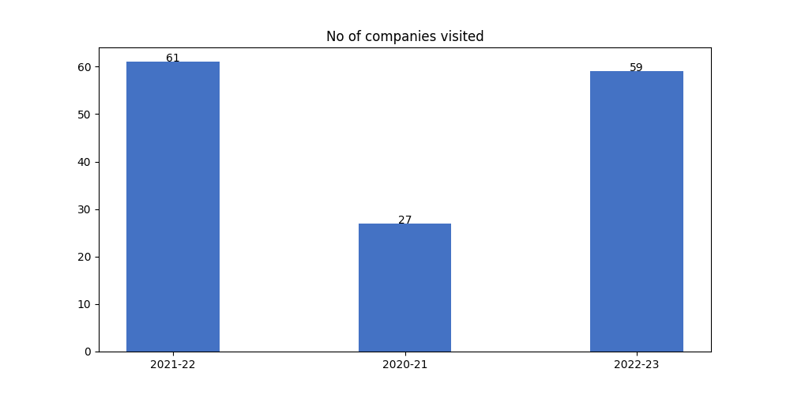

## b) Average package distribution:

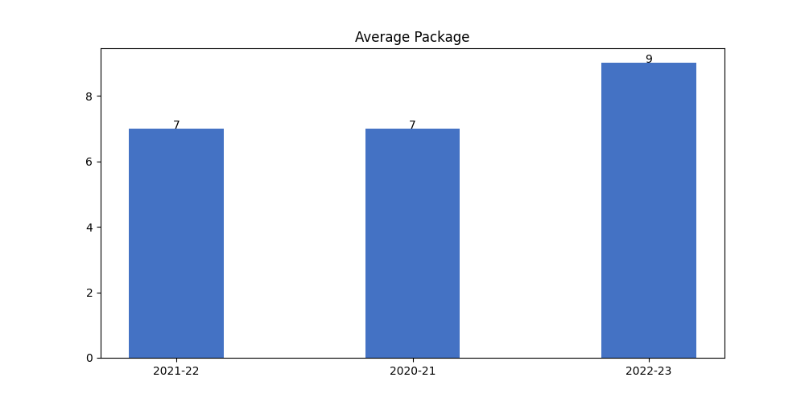

## c) No. of Offers:

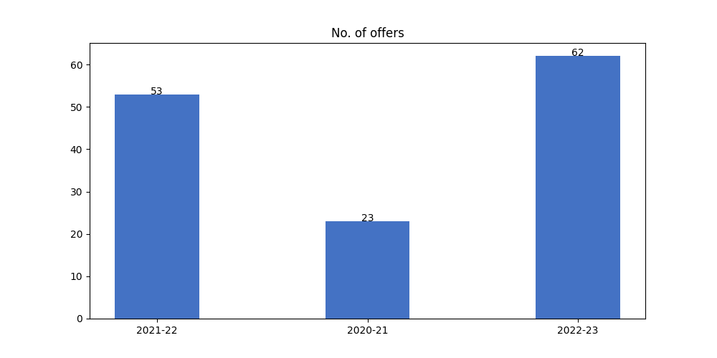

# 3. Analysis:

All companies require good communication skills for any role whether it be non- core profiles such as sales and marketing, etc or core profiles and the students are not very comfortable with them. Department could encourage students in enhancing such skills by setting up mock Group Discussions, debate sessions among respective batches or with other departments. Some companies of the had zero selection from the batch might be because students lacked fundamental practical knowledge and basics of respective fields. For this it is suggested to organize workshops and competitions to increase practical skills of students.