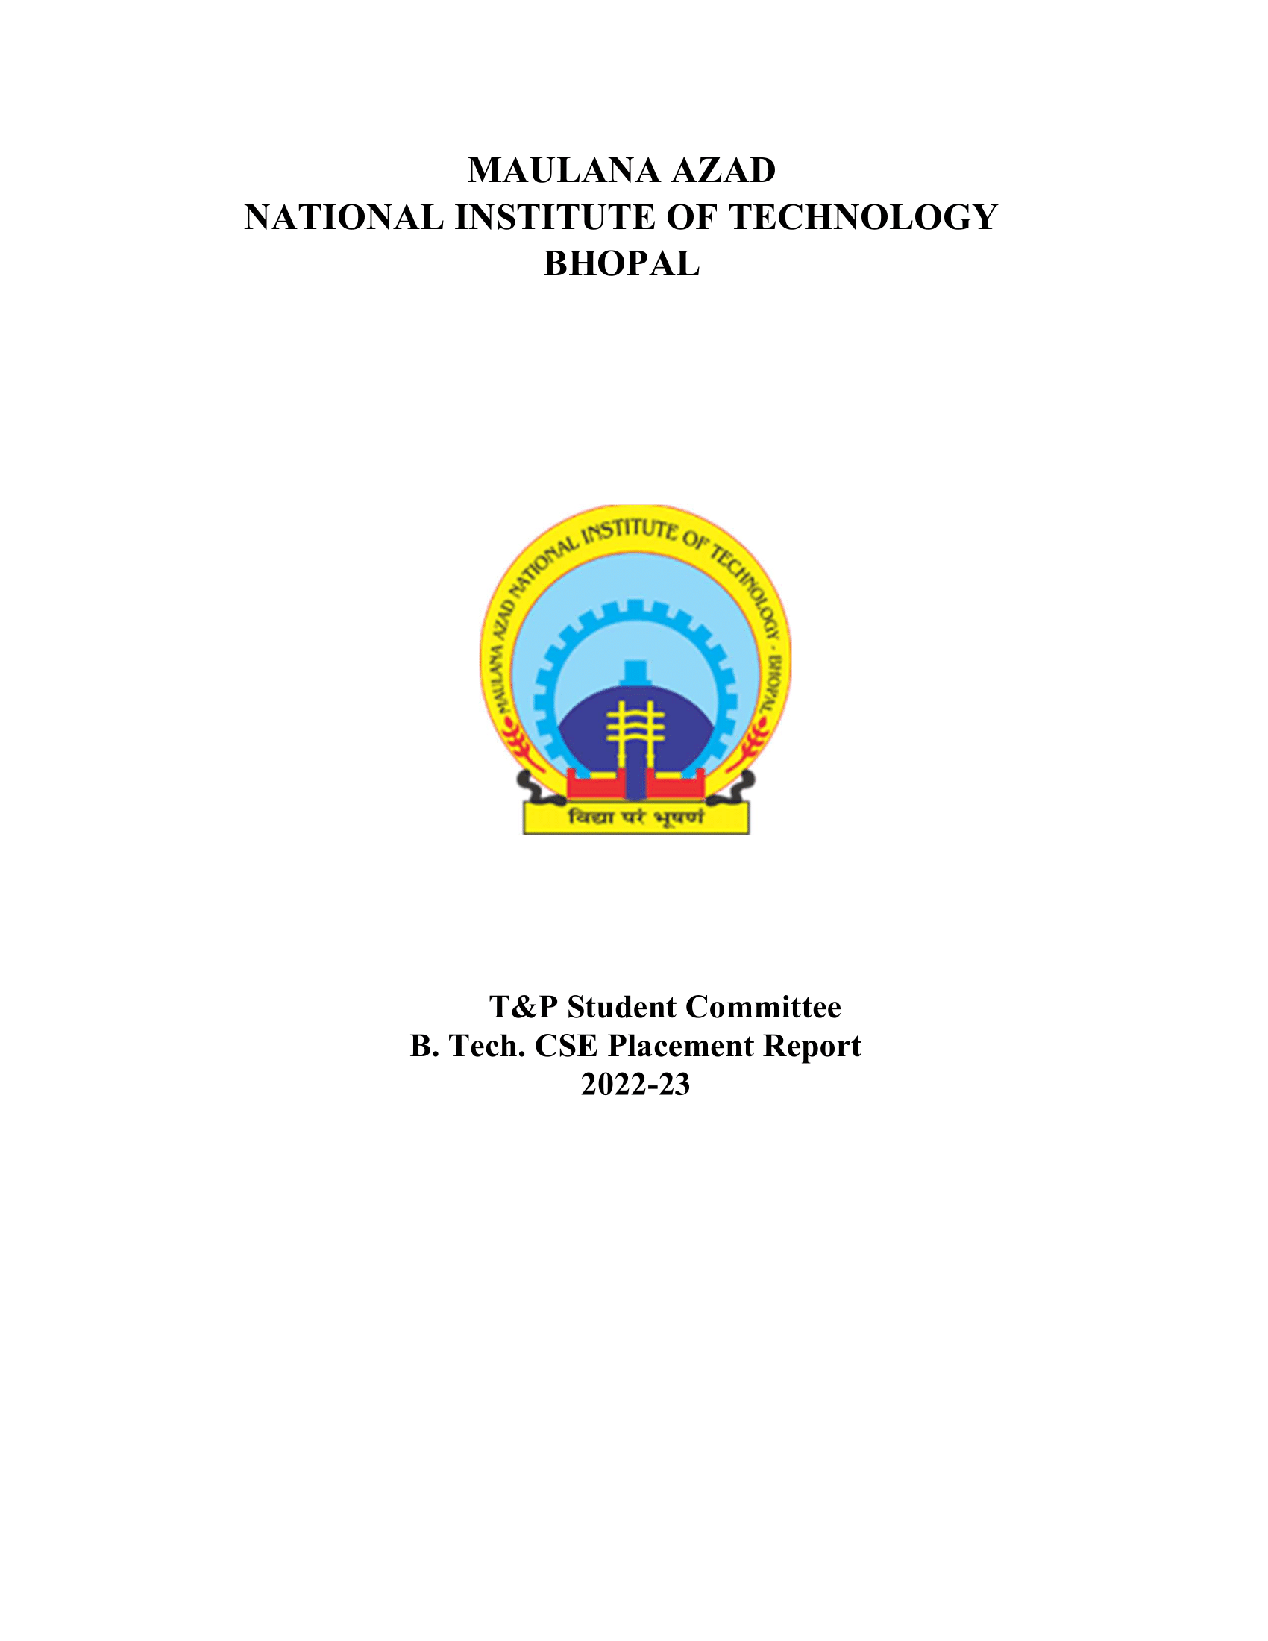

ECE DEPARTMENT (BATCH 2022-2023)

# 1. Placement Stats 2022-23:

|  |  |
| --- | --- |
| No. of companies visited | 133 |
| Total Strength | 161 |
| No. of offers | 146 |
| No. of students placed | 88 |
| No. of students with 6-month Internship | 58 |
| Percentage Placement | 54.66% |
| Average Package | 18.93 |
| Median Package | 15.25 |
| Highest Package | 82 |
| Lowest Package | 6 |

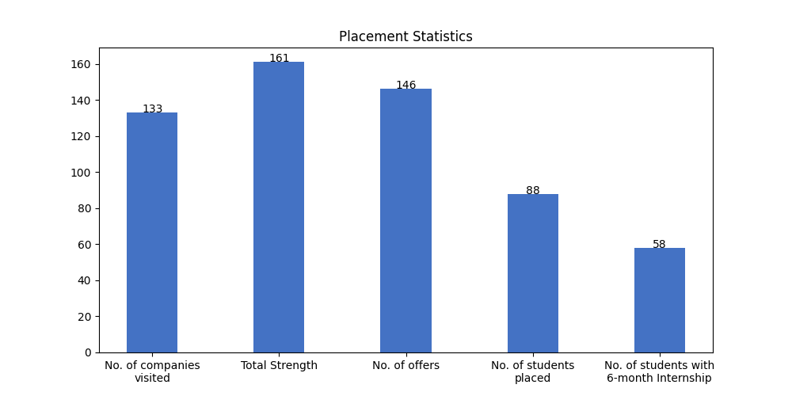

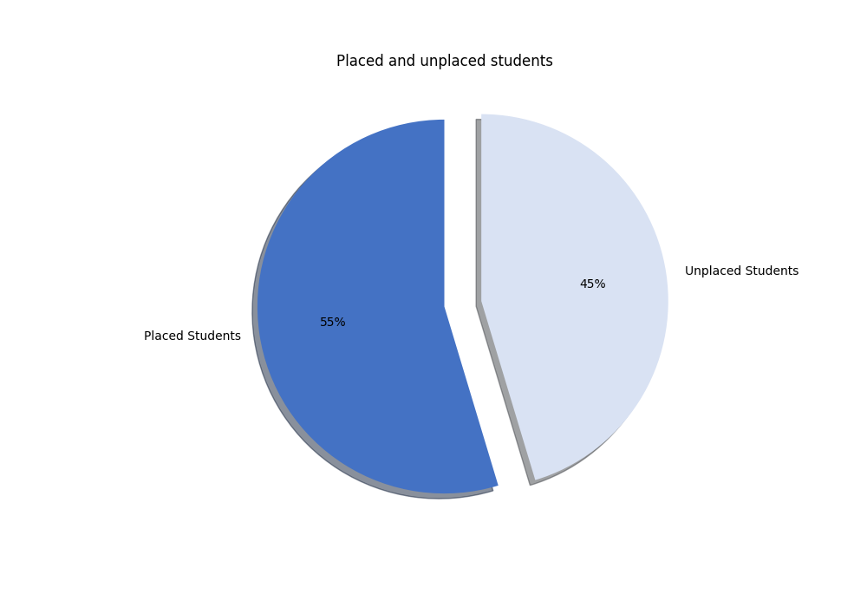

# 1.1 Campus Placement List (FTE):

|  |  |  |  |  |
| --- | --- | --- | --- | --- |
| S. No | Scholar Number | Candidate Name | Company's Name | CTC (LPA) |
| 1 | 191114264 | Abhigyna Meruga | Alstom Transport | 6.8 |
| 2 | 191114238 | Aashika Jain | Atlassian | 82 |
| 3 | 191114030 | Daniyaal Saifee Nayeem | Axis Bank | 7.93 |
| 4 | 191114229 | Akhlesh Dixit | Box8 | 21 |
| 5 | 191114209 | Rohit Singh Ahirwar | CDOT | 19 |
| 6 | 191114012 | chitransh mandeliya | CDOT | 19 |
| 7 | 191114289 | SURAKATTULA ROHITH | CGI | 7.87 |
| 8 | 191114205 | Allen Namdeo | Cashfree | 20.75 |
| 9 | 191114020 | Suryansh Yadav | Cashfree | 20.75 |
| 10 | 191114210 | Aditya rathore | Deutsche Bank | 19.63 |
| 11 | 191114038 | Muskan Soni | Deutsche Bank | 19.63 |
| 12 | 191114241 | Neha Sai | Deutsche Bank | 19.63 |
| 13 | 191114022 | Pranav Gupta | Deutsche Bank | 19.63 |
| 14 | 191114258 | Prateek Jain | Deutsche Bank | 19.63 |
| 15 | 191114206 | Yashika Singh | Deutsche Bank | 19.63 |
| 16 | 191114025 | Narendra Jatav | Dolat Capital | 18 |
| 17 | 191114003 | Sahil Mourya | Dolat Capital | 18 |
| 18 | 191114018 | Yash Gupta | Dolat Capital | 18 |
| 19 | 191114065 | S Chandan | EXL | 6.5 |
| 20 | 191114279 | Sarvesh Pal | Flipkart | 32.577 |
| 21 | 191114273 | BODA NIKHITHA | Genpact (Enquero) | 10 |
| 22 | 191114092 | Bedadala Lahari | Genpact (Enquero) | 10 |
| 23 | 191114270 | Archit Sharma | Google | 48 |
| 24 | 191114235 | Piyush Kumar | IDBI Bank | 12 |
| 25 | 191114232 | Ravi Sahu | IDBI Bank | 12 |
| 26 | 191114255 | petla pradeep naidu | Infineon Technologies | 20.345 |
| 27 | 191114280 | Mansi Rai | JPMC | 17.75 |
| 28 | 191114048 | Rishi Gupta | JPMC | 17.75 |
| 29 | 191114069 | METTA VENKATESH | Jivox | 24 |
| 30 | 191114039 | Matsa Jahnavi | Junglee Games | 23 |
| 31 | 191114026 | Anand patware | Live your best life | 18.7 |
| 32 | 191114253 | Sneha Bhagwat | Merilytics | 8.4 |
| 33 | 191114259 | Ankit Kumar Singh | Microsoft | 51.032 |
| 34 | 191114091 | KUMUD VERMA | Microsoft | 51.032 |
| 35 | 191114029 | Kushal Gupta | Microsoft | 51.032 |
| 36 | 191114040 | Diwesh Gangrade | Netradyne | 14 |
| 37 | 191114228 | Sarthak Mutreja | Netradyne | 14 |
| 38 | 191114045 | Md Saquib salim | NexTurn, PwC India | * |
| 39 | 191114261 | S SATYA SAI SRI HARSHA GULLAPUDI | Ninjacart | 14 |
| 40 | 191114204 | Abhinav Singh Rajput | Optum | 14.5 |
| 41 | 191114073 | Annavarapu Tejaswini | Optum | 14.5 |
| 42 | 191114056 | Asif Ali Khan | Optum | 14.5 |
| 43 | 191114008 | Chandolu Manoj Kumar | Optum | 14.5 |
| 44 | 191114058 | Diya khandelwal | Optum | 14.5 |
| 45 | 191114224 | Laxmi narayan soni | Optum | 14.5 |
| 46 | 191114077 | NAKKA AJAY | Optum | 14.5 |
| 47 | 191114009 | Pradeep Kumar Sahu | Optum | 14.5 |
| 48 | 191114211 | Prateek Gupta | Optum | 14.5 |
| 49 | 191114024 | Priyadarshna Jain | Optum | 14.5 |
| 50 | 191114007 | Purvi Pawar | Optum | 14.5 |
| 51 | 191114084 | Rishabh Vijayvargiya | Optum | 14.5 |
| 52 | 181114015 | Ritik Kumar | Optum | 14.5 |
| 53 | 191114275 | Vangala Snigdha Reddy | Optum | 14.5 |
| 54 | 191114203 | Yash Choubey | Optum | 14.5 |
| 55 | 191114081 | anshul khandelwal | Optum | 14.5 |
| 56 | 191114252 | Anshu Patidar | Oracle | 30.67 |
| 57 | 191114087 | Mayur Verma | Oracle | 30.67 |
| 58 | 191114247 | Vedant Kalia | Oracle | 30.67 |
| 59 | 191114207 | Abhishek Rajput | Park+ SDE | * |
| 60 | 191114086 | ANAND KUMAR | Physics Wallah | 6 |
| 61 | 191114236 | Harshit Gupta | Piramal | 12.54 |
| 62 | 191114287 | Anmol Agarwal | Publicis Sapient | 20.63 |
| 63 | 191114028 | Vijay Singh Dudve | Publicis Sapient | 20.63 |
| 64 | 191114290 | Poorvi Vachhani | PwC India | 9.08 |
| 65 | 191114214 | Priyansh Jain | PwC India | 9.08 |
| 66 | 191114223 | MANISH KUMAR | Reliance Jio | 8.5 |
| 67 | 191114017 | Mahesh Kumar Saran | Reliance Jio | 8.5 |
| 68 | 191114083 | AJAY KUMAR | Samsung R&D Delhi | 15.5 |
| 69 | 191114218 | Abhishek thakur | Samsung R&D Delhi | 15.5 |
| 70 | 191114239 | Kalash Chouhan | Samsung R&D Delhi | 15.5 |
| 71 | 191114067 | Vikhyat Jain | Samsung R&D Delhi | 15.5 |
| 72 | 191114233 | AKASH SINGHAL | Sigmoid Analytics | 15 |
| 73 | 191114213 | Kothapally Gnana Praneeth | Sigmoid Analytics | 15 |
| 74 | 191114085 | Sai Charan Atluri | Sutherland | 8 |
| 75 | 191114082 | Abhishek Sinha | Toshiba | * |
| 76 | 191114080 | Akshat Rajput | Toshiba | * |
| 77 | 191114044 | Ankit Tiwari | Toshiba | * |
| 78 | 191114262 | JAYANT SWAMI | Toshiba | * |
| 79 | 191114269 | Kolli Jahnavi | Ultimate Kronos Group | 14.53 |
| 80 | 191114059 | Satyam Tiwari | Wells Fargo | 24 |
| 81 | 191114095 | Sudhanshu Pandey | Wells Fargo | 24 |
| 82 | 191114061 | Utkarsh Rajpal | Wells Fargo | 24 |
| 83 | 191114278 | Valavala Bhavahar | Winjit Technologies | 12 |
| 84 | 191114271 | ROHIT PORWAL | Zscaler | 25.87 |

# 1.2 Students With PPO:

|  |  |  |  |  |
| --- | --- | --- | --- | --- |
| S. No | Scholar Number | Candidate Name | Company's Name | CTC (LPA) |
| 1 | 191114096 | Sapan Jain | Deutsche Bank | 19.63 |
| 2 | 191114097 | Shreansh Mani Tripathi | Deutsche Bank | 19.63 |
| 3 | 191114242 | Chandrakanth Reddy Gaddam | Microsoft | 51.032 |
| 4 | 191114050 | Anmol Sharma | Samsung R&D Bangalore | 16 |

# 1.3 Internships (6 Month):

|  |  |  |  |  |
| --- | --- | --- | --- | --- |
| S. No | Scholar Number | Candidate Name | Company's Name | Stipend (KPM) |
| 1 | 191114222 | Sandeep Kumar Ahirwar | APT Portfolio | 40 |
| 2 | 191114261 | S SATYA SAI SRI HARSHA GULLAPUDI | Applied Material(Software Profile) | 35 |
| 3 | 191114238 | Aashika Jain | Atlassian | 130 |
| 4 | 191114030 | Daniyaal Saifee Nayeem | Axis Bank | 25 |
| 5 | 191114288 | GUGGILLA KUSHAL | Bizongo | 60 |
| 6 | 191114202 | Lokesh Sistu | Bizongo | 60 |
| 7 | 191114046 | vaibhav jaiswal | Bizongo | 60 |
| 8 | 191114216 | Abhinandan Saole | Blackrock | 50 |
| 9 | 191114229 | Akhlesh Dixit | Box8 | 35 |
| 10 | 191114205 | Allen Namdeo | Cashfree | 40 |
| 11 | 191114020 | Suryansh Yadav | Cashfree | 40 |
| 12 | 191114085 | Sai Charan Atluri | Darwinbox | 25 |
| 13 | 191114025 | Narendra Jatav | Dolat Capital | 20 |
| 14 | 191114003 | Sahil Mourya | Dolat Capital | 20 |
| 15 | 191114018 | Yash Gupta | Dolat Capital | 20 |
| 16 | 191114226 | Manan Shrishrimal | Electronic Arts | 44.6 |
| 17 | 191114279 | Sarvesh Pal | Flipkart | 100 |
| 18 | 191114231 | Abdullah Sajjad Masvood Javid | Futures First | 25 |
| 19 | 191114273 | BODA NIKHITHA | Genpact (Enquero) | 25 |
| 20 | 191114092 | Bedadala Lahari | Genpact (Enquero) | 25 |
| 21 | 191114033 | JAYASH KHOIYA | Groww | 61 |
| 22 | 191114036 | Jitendra Singh | Groww | 61 |
| 23 | 191114255 | petla pradeep naidu | Infineon Technologies | 36 |
| 24 | 191114256 | Vikash Tiwari | JPMC(Data Science Analyst) | * |
| 25 | 191114039 | Matsa Jahnavi | Junglee Games | 40 |
| 26 | 191114026 | Anand patware | Live your best life | 30 |
| 27 | 191114027 | Arepalli Devisree | MSCI | 60 |
| 28 | 191114064 | Gadi Uma Maheswara Satya Sai | MSCI | 60 |
| 29 | 191114090 | Muhammad Misbah Juned Nayab | MSCI | 60 |
| 30 | 191114084 | Rishabh Vijayvargiya | MSCI | 60 |
| 31 | 191114230 | Vinay Dharmpal Bagde | MSCI | 60 |
| 32 | 191114037 | Ayush Porwal | NVIDIA (SW) | 75 |
| 33 | 191114045 | Md Saquib salim | NexTurn | * |
| 34 | 191114063 | Meenal Mohnani | Nvidia (HW) | 75 |
| 35 | 191114252 | Anshu Patidar | Oracle | 50 |
| 36 | 191114087 | Mayur Verma | Oracle | 50 |
| 37 | 191114247 | Vedant Kalia | Oracle | 50 |
| 38 | 191114207 | Abhishek Rajput | Park+ SDE | * |
| 39 | 191114066 | Aman Kumar Malviya | Paytm | 25 |
| 40 | 191114043 | Amrit Dalal | Paytm | 25 |
| 41 | 191114234 | DEEPAK DHAKAD | Paytm | 25 |
| 42 | 191114257 | Divyanshu Jojaware | Paytm | 25 |
| 43 | 191114240 | Sheel Bouddh | Paytm | 25 |
| 44 | 191114083 | AJAY KUMAR | Samsung R&D Delhi | 45 |
| 45 | 191114218 | Abhishek thakur | Samsung R&D Delhi | 45 |
| 46 | 191114067 | Vikhyat Jain | Samsung R&D Delhi | 45 |
| 47 | 191114233 | AKASH SINGHAL | Sigmoid Analytics | 25 |
| 48 | 191114213 | Kothapally Gnana Praneeth | Sigmoid Analytics | 25 |
| 49 | 191114061 | Utkarsh Rajpal | Steradian Semiconductors | 20 |
| 50 | 191114040 | Diwesh Gangrade | Texas Instruments | 45 |
| 51 | 191114239 | Kalash Chouhan | Texas Instruments | 45 |
| 52 | 191114055 | Shivam Kumar | Texas Instruments | 45 |
| 53 | 191114082 | Abhishek Sinha | Toshiba | * |
| 54 | 191114080 | Akshat Rajput | Toshiba | * |
| 55 | 191114044 | Ankit Tiwari | Toshiba | * |
| 56 | 191114262 | JAYANT SWAMI | Toshiba | * |
| 57 | 191114278 | Valavala Bhavahar | Winjit Technologies | 100 |
| 58 | 191114271 | ROHIT PORWAL | Zscaler | 50 |

# 1.4 Companies visited:

|  |  |  |  |
| --- | --- | --- | --- |
| Merilytics | Quantiphi | Zycus | Ciena Networks |
| Dolat Capital | Hexware Technologies | Atyati Technologies Pvt Ltd | Nokia |
| Trianz | Axxela | PwC India | WSP |
| Spinny | Intellipaat | Nextuple | Thrillophilia |
| Indus Valley Partners | Flipkart | Box8 | Sigmoid Analytics |
| Plan Realty | Sutherland | NSL HUB | Coriolis Technologies |
| O9 Solutions | Vassar Lab | Netcracker | Texas Instruments |
| NexTurn, PwC India | Optum | Reliance Jio | Carwale |
| Pie INFOCOMM | Sandvine | Samsung R&D Delhi | Axis Bank |
| Applied Materials | NVIDIA (SW) | Park+ SDE | BizWiz |
| Celigo | Panel IQ | Aakash Byjus | HLS ASIA |
| Media.net (SDE) | Live your best life | Abhibus | CGI |
| Blackrock | Bajaj | Publicis Sapient | Ninjacart |
| Vedanta Limited | InfoObjects | Incture | Winjit Technologies |
| Nvidia (HW) | EXL | Frugal Tesitng | Affine |
| CodeYoung | Toshibha | Steradian Semiconductors | Convegenius |
| JPMC | Paypal | Decimal Point Analytics | Junglee Games |
| Chaayos | Ultimate Kronos Group | Applied Material(Software Profile) | Morphle Labs |
| NexTurn | Nation with Namo | Microsoft | Samsung R&D Bangalore |
| Wells Fargo | CDOT | Digiotech Solutions Pvt Ltd | Hewlett Packard Enterprise(HPE) |
| Latentview | Comviva | UI Path | Groww |
| Darwinbox | Incedo | Walkover Web Solutions | MSCI |
| Biz 4 Solutions | Nation With Namo(Associate Consultant) | JTG (Josh Technology Group) | Oracle |
| Alstom Transport | Park+ | TCS R&I | Piramal |
| Electronic Arts | NexTurn India Pvt. Ltd | BillDesk | Futures First |
| Paytm | Infineon Technologies | Jivox | Daimler |
| DCM SHRIRAM | PlanetSpark | Bizongo | Toshiba |
| Goldman Sachs | Zscaler | C-Dac | Ganit Business Solutions Pvt Ltd |
| Tekion | Media.Net SRE(DevOps) | Netradyne | Google |
| ZS Associates | Genpact (Enquero) | Forbes Marhsall | Physics Wallah |
| NucleusTeq | Dyeus | Cashfree | Deutsche Bank |
| Digite Infotech | Chqbook | APT Portfolio | Adani Group |
| IDBI Bank | JPMC(Data Science Analyst) | Truminds | Atlassian |

# 1.5. Companies visited(with selections):

|  |  |  |  |
| --- | --- | --- | --- |
| S. No | Company Name | Selections | CTC (LPA) |
| 1 | Optum | 16 | 14.5 |
| 2 | Deutsche Bank | 8 | 19.63 |
| 3 | Microsoft | 5 | 51.032 |
| 4 | Wells Fargo | 4 | 24 |
| 5 | Samsung R&D Delhi | 4 | 15.5 |
| 6 | Toshibha | 4 | 10 |
| 7 | Oracle | 3 | 30.67 |
| 8 | Dolat Capital | 3 | 18 |
| 9 | PwC India | 3 | 9.08 |
| 10 | Cashfree | 2 | 20.75 |
| 11 | Publicis Sapient | 2 | 20.63 |
| 12 | CDOT | 2 | 19 |
| 13 | JPMC | 2 | 17.75 |
| 14 | Sigmoid Analytics | 2 | 15 |
| 15 | Netradyne | 2 | 14 |
| 16 | IDBI Bank | 2 | 12 |
| 17 | Genpact (Enquero) | 2 | 10 |
| 18 | Reliance Jio | 2 | 8.5 |
| 19 | Atlassian | 1 | 82 |
| 20 | Google | 1 | 48 |
| 21 | Flipkart | 1 | 32.577 |
| 22 | Park+ | 1 | 31.5 |
| 23 | Zscaler | 1 | 25.87 |
| 24 | Goldman Sachs | 1 | 24 |
| 25 | Jivox | 1 | 24 |
| 26 | Junglee Games | 1 | 23 |
| 27 | Box8 | 1 | 21 |
| 28 | Infineon Technologies | 1 | 20.345 |
| 29 | Live your best life | 1 | 18.7 |
| 30 | Samsung R&D Bangalore | 1 | 16 |
| 31 | Ultimate Kronos Group | 1 | 14.53 |
| 32 | Ninjacart | 1 | 14 |
| 33 | Piramal | 1 | 12.54 |
| 34 | Winjit Technologies | 1 | 12 |
| 35 | Merilytics | 1 | 8.4 |
| 36 | Sutherland | 1 | 8 |
| 37 | Nextuple | 1 | 8 |
| 38 | Axis Bank | 1 | 7.93 |
| 39 | CGI | 1 | 7.87 |
| 40 | Alstom Transport | 1 | 6.8 |
| 41 | EXL | 1 | 6.5 |
| 42 | NexTurn India Pvt. Ltd | 1 | 6 |
| 43 | Physics Wallah | 1 | 6 |

# 1.6. Companies visited(with no selections):

|  |  |  |  |
| --- | --- | --- | --- |
| Bajaj | Media.net (SDE) | Trilogy | BillDesk |
| O9 Solutions | Digite Infotech | TCS R&I | Chqbook |
| Carwale | HLS ASIA | Affine | Pie INFOCOMM |
| NucleusTeq | Nation with Namo | Dyeus | Ciena Networks |
| Indus Valley Partners | Panel IQ | Quantiphi | Digiotech Solutions Pvt Ltd |
| Decimal Point Analytics | Morphle Labs | Netcracker | Convegenius |
| Zycus | BizWiz | DCM SHRIRAM | Forbes Marhsall |
| ZS Associates | Adani Group | Intellipaat | C-Dac |
| Hexware Technologies | Latentview | Paypal | Nation With Namo(Associate Consultant) |
| Daimler | Plan Realty | Frugal Tesitng | WSP |
| Thrillophilia | Aakash Byjus | Vassar Lab | Vedanta Limited |
| UI Path | CodeYoung | Walkover Web Solutions | PlanetSpark |

# 2.1 Tabular Comparison:

|  |  |  |  |  |  |  |  |  |  |
| --- | --- | --- | --- | --- | --- | --- | --- | --- | --- |
| Session | 2014-15 | 2015-16 | 2016-17 | 2017-18 | 2018-19 | 2019-20 | 2020-21 | 2021-22 | 2022-23 |
| No of Companies visited | 45 | 41 | 37 | 38 | 50 | 51 | 54 | 117 | 133 |
| No. of oﬀers | 142 | 131 | 112 | 110 | 119 | 99 | 95 | 142 | 146 |
| Average Package | 5.92 | 6.5 | 6.05 | 5.86 | 6.18 | 6.82 | 7.2 | 13.03 | 18.93 |

# 2.2 Graphs for Comparison with previous years:

## a) No of companies visited:

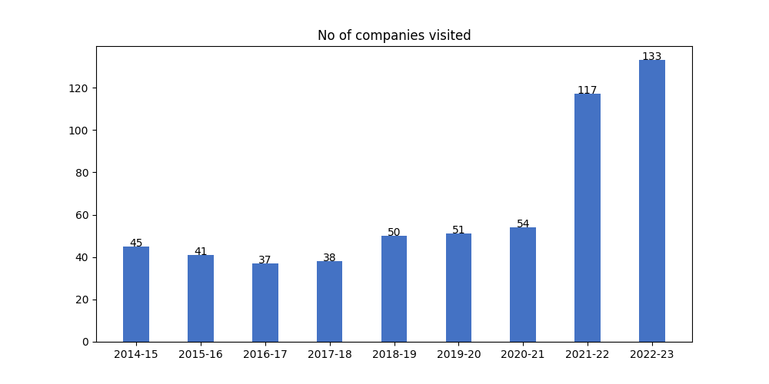

## b) Average package distribution:

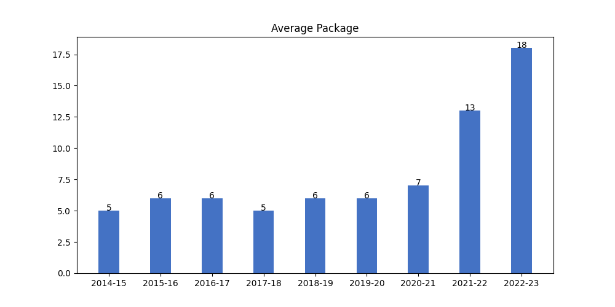

## c) No. of Offers:

