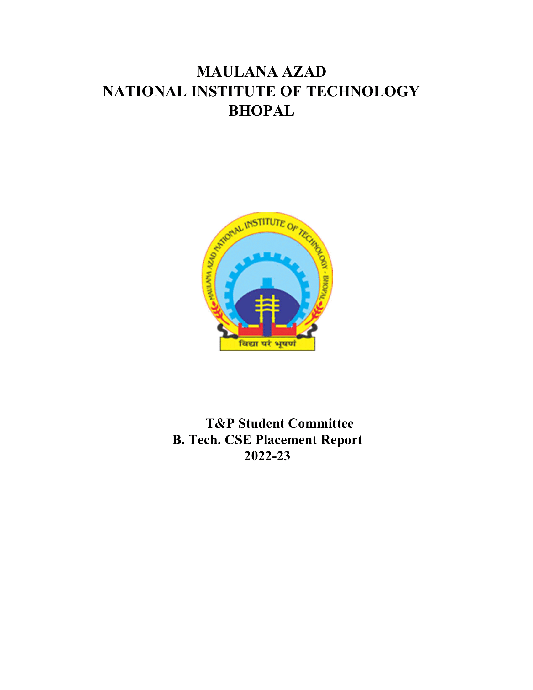

EE DEPARTMENT (BATCH 2022-2023)

# 1. Placement Stats 2022-23:

|  |  |
| --- | --- |
| No. of companies visited | 124 |
| Total Strength | 127 |
| No. of offers | 111 |
| No. of students placed | 76 |
| No. of students with 6-month Internship | 35 |
| Percentage Placement | 59.84% |
| Average Package | 15.49 |
| Median Package | 14.27 |
| Highest Package | 51.032 |
| Lowest Package | 6.5 |

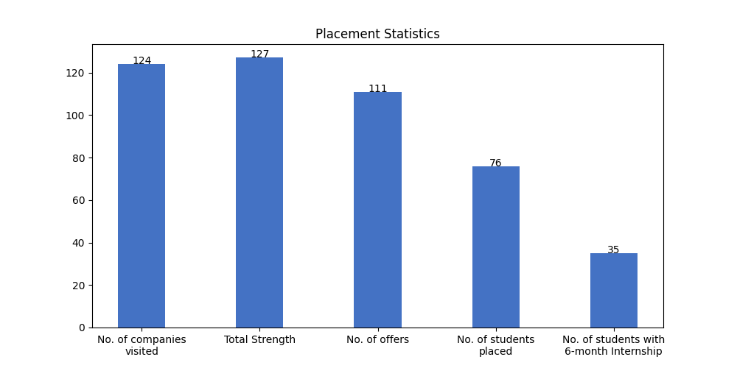

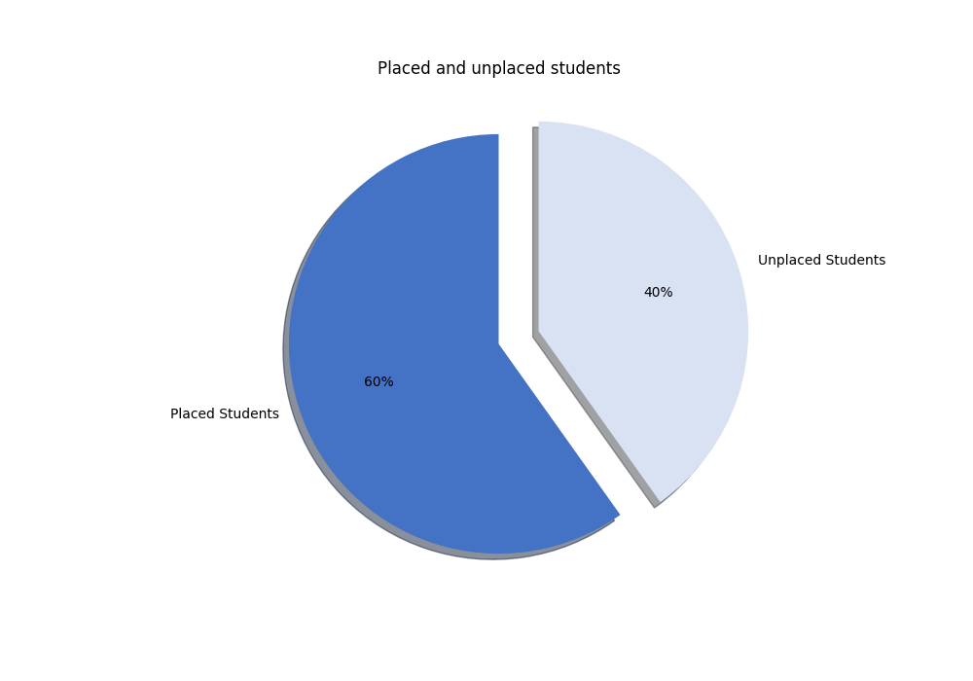

# 1.1 Campus Placement List (FTE):

|  |  |  |  |  |
| --- | --- | --- | --- | --- |
| S. No | Scholar Number | Candidate Name | Company's Name | CTC (LPA) |
| 1 | 191113031 | Somesh Rawat | Abhibus | 10 |
| 2 | 191113239 | Harsh Garg | Aditya Birla | 7 |
| 3 | 191113061 | Krishika Bhaskar | Aditya Birla | 7 |
| 4 | 191113033 | Manoj bairva | Aditya Birla | 7 |
| 5 | 191113005 | VIKASH KUMAR | Aditya Birla | 7 |
| 6 | 191113011 | Nikhil kumar | Affine | 7.86 |
| 7 | 191113045 | ALOK KUMAR KUSHWAHA | Alstom Transport | 6.8 |
| 8 | 191113230 | Gaurav Kumar Singh | Applied Material(Software Profile) | 10.55 |
| 9 | 191113210 | Shubham Gehlot | Bajaj | 12.24 |
| 10 | 191113070 | Vidit Jain | Box8 | 21 |
| 11 | 191113237 | Vidit Singhal | Box8 | 21 |
| 12 | 191113229 | Kunal Mandloi | CGI | 7.87 |
| 13 | 191113218 | NANNEPAGA KALYAN BABU | CGI | 7.87 |
| 14 | 191113010 | Sachin Patel | Caterpillar | 10.1 |
| 15 | 191113034 | Abhishek Rai | Ciena Networks | 11.38 |
| 16 | 191113009 | Aditya Rai | EXL | 6.5 |
| 17 | 191113001 | Pranjal Jain | EXL | 6.5 |
| 18 | 191113039 | Divyansh Lokwani | Flipkart | 32.577 |
| 19 | 191113002 | Gourav Rathore | Genpact (Enquero) | 10 |
| 20 | 191113222 | Rohit Dubey | Genpact (Enquero) | 10 |
| 21 | 191113043 | Abhishek Gupta | Google | 48 |
| 22 | 191113007 | Sunil Sariya | Hero Moto Corp | 7.75 |
| 23 | 191113077 | Mayank Kushwah | Hewlett Packard Enterprise(HPE) | 17.5 |
| 24 | 191113255 | Shreyansh Paliwal | Hewlett Packard Enterprise(HPE) | 17.5 |
| 25 | 191113057 | Narayan lal nayak | Indus Valley Partners | 9 |
| 26 | 191113017 | Abhishek Agarwal | JPMC | 17.75 |
| 27 | 191113019 | Akshat Jain | JPMC | 17.75 |
| 28 | 191113072 | Jitesh Kejriwal | JPMC | 17.75 |
| 29 | 191113051 | Mohd Abu Zaid | JPMC | 17.75 |
| 30 | 191113004 | Sakshi Shrivastava | JPMC | 17.75 |
| 31 | 191113012 | Shoury Sharma | JTG (Josh Technology Group) | 14.75 |
| 32 | 191113207 | Aman Banthia | MathWorks | 24.2 |
| 33 | 191113021 | Sourabh Mishra | Media.Net SRE(DevOps) | 15.77 |
| 34 | 191113025 | Vaishnavi Gupta | Microsoft | 51.032 |
| 35 | 191113078 | Abhishek Rathore | NSL HUB | 12 |
| 36 | 191113014 | Royam Jain | NSL HUB | 12 |
| 37 | 191113243 | Abhishek Gole | NexTurn | * |
| 38 | 191113076 | JANAK SINGH | Nextuple | 8 |
| 39 | 191113216 | Akash Kumar | Nokia | 8.5 |
| 40 | 191113054 | Harshit Shrivastava | O9 Solutions | 12.5 |
| 41 | 191113024 | Ananya Rawat | Optum | 14.5 |
| 42 | 191113250 | Anushka Verma | Optum | 14.5 |
| 43 | 191113205 | Harshit Jain | Optum | 14.5 |
| 44 | 191113212 | Mohit Rathi | Optum | 14.5 |
| 45 | 191113016 | Puneet Agarwal | Optum | 14.5 |
| 46 | 191113228 | Richa Kumari Dubey | Optum | 14.5 |
| 47 | 191113053 | Shaziya Ansari | Optum | 14.5 |
| 48 | 191113247 | Sonu kumar | Optum | 14.5 |
| 49 | 191113238 | Ayush Rusia | Oracle | 30.67 |
| 50 | 191113055 | Hanish Aswani | Oracle | 30.67 |
| 51 | 191113206 | Harsh Gopalani | Oracle | 30.67 |
| 52 | 191113040 | Priyanshu Dawande | Oracle | 30.67 |
| 53 | 191113018 | VISHISTHA GUPTA | Oracle | 30.67 |
| 54 | 191113226 | Prashant mishra | Piramal | 12.54 |
| 55 | 191113079 | Ashish Goyal | PwC India | 9.08 |
| 56 | 191113026 | Harsh Vardhan Saxena | PwC India | 9.08 |
| 57 | 191113246 | Ayush Kasera | Reliance Industries Limited | 7.5 |
| 58 | 191113008 | Himanshu Ghunavat | Reliance Industries Limited | 7.5 |
| 59 | 191113071 | Mohit Pathak | Reliance Industries Limited | 7.5 |
| 60 | 191113209 | Vighnesh Kumar Garkar | Reliance Industries Limited | 7.5 |
| 61 | 191113223 | Ashwin sharma | Saint Gobain | * |
| 62 | 191113227 | Deepak Patidar | Samsung R&D Delhi | 15.5 |
| 63 | 191113268 | Prashant Shrimal | ServiceNow | 33 |
| 64 | 191113028 | Purushottam Dubey | Sigmoid Analytics | 15 |
| 65 | 191113217 | sarthak Garg | Sigmoid Analytics | 15 |
| 66 | 191113068 | PRASHANT PATEL | Sutherland | 8 |
| 67 | 191113066 | Mehul Shah | TCS R&I | 9 |
| 68 | 191113030 | Vedant Patle | Texas Instruments | 17.43 |
| 69 | 191113006 | Kunwar jeevanshu | Vedanta Limited | 14.45 |
| 70 | 191113256 | Prakrati Nag | Vedanta, Cairn Oil & Gas | 14.1 |
| 71 | 191113266 | Rajaman Chaudhary | Vedanta, Cairn Oil & Gas | 14.1 |
| 72 | 191113202 | Vikash Khare | Vedanta, Cairn Oil & Gas | 14.1 |
| 73 | 191113069 | Anubhav Sharma | Wells Fargo | 24 |
| 74 | 191113029 | Tulika Shandilya | Wells Fargo | 24 |

# 1.2 Students With PPO:

|  |  |  |  |  |
| --- | --- | --- | --- | --- |
| S. No | Scholar Number | Candidate Name | Company's Name | CTC (LPA) |
| 1 | 191113270 | Divya Tewari | Amazon (Offcampus) | * |
| 2 | 191113231 | Ishaan Khandait | Cairn Oil and Gas | * |

# 1.3 Internships (6 Month):

|  |  |  |  |  |
| --- | --- | --- | --- | --- |
| S. No | Scholar Number | Candidate Name | Company's Name | Stipend (KPM) |
| 1 | 191113032 | Chetan Patel | Applied Material(Software Profile) | 35 |
| 2 | 191113230 | Gaurav Kumar Singh | Applied Material(Software Profile) | 35 |
| 3 | 191113001 | Pranjal Jain | Axxela | 20 |
| 4 | 191113070 | Vidit Jain | Box8 | 35 |
| 5 | 191113237 | Vidit Singhal | Box8 | 35 |
| 6 | 191113231 | Ishaan Khandait | Darwinbox | 25 |
| 7 | 191113037 | Mayank Bele | Darwinbox | 25 |
| 8 | 191113039 | Divyansh Lokwani | Flipkart | 100 |
| 9 | 191113002 | Gourav Rathore | Genpact (Enquero) | 25 |
| 10 | 191113222 | Rohit Dubey | Genpact (Enquero) | 25 |
| 11 | 191113077 | Mayank Kushwah | Hewlett Packard Enterprise(HPE) | 40 |
| 12 | 191113255 | Shreyansh Paliwal | Hewlett Packard Enterprise(HPE) | 40 |
| 13 | 191113080 | Shashank sharma | JPMC(Data Science Analyst) | * |
| 14 | 191113012 | Shoury Sharma | JTG (Josh Technology Group) | 20 |
| 15 | 191113203 | Vivek Billore | MSCI | 60 |
| 16 | 191113021 | Sourabh Mishra | Media.Net SRE(DevOps) | 100 |
| 17 | 191113078 | Abhishek Rathore | NSL HUB | 30 |
| 18 | 191113014 | Royam Jain | NSL HUB | 30 |
| 19 | 191113243 | Abhishek Gole | NexTurn | * |
| 20 | 191113076 | JANAK SINGH | Nextuple | 20 |
| 21 | 191113216 | Akash Kumar | Nokia | 20 |
| 22 | 191113270 | Divya Tewari | Observe AI | 75 |
| 23 | 191113238 | Ayush Rusia | Oracle | 50 |
| 24 | 191113055 | Hanish Aswani | Oracle | 50 |
| 25 | 191113206 | Harsh Gopalani | Oracle | 50 |
| 26 | 191113040 | Priyanshu Dawande | Oracle | 50 |
| 27 | 191113018 | VISHISTHA GUPTA | Oracle | 50 |
| 28 | 191113259 | Anushka Gupta | Paytm | 25 |
| 29 | 191113263 | Krishna Gupta | Paytm | 25 |
| 30 | 191113003 | Mihir Choudhary | Paytm | 25 |
| 31 | 191113227 | Deepak Patidar | Samsung R&D Delhi | 45 |
| 32 | 191113028 | Purushottam Dubey | Sigmoid Analytics | 25 |
| 33 | 191113217 | sarthak Garg | Sigmoid Analytics | 25 |
| 34 | 191113265 | Medisetti Yashwanth Sai Krishna | Texas Instruments | 45 |
| 35 | 191113031 | Somesh Rawat | Texas Instruments | 45 |

# 1.4 Companies visited:

|  |  |  |  |
| --- | --- | --- | --- |
| Merilytics | Amazon (Offcampus) | Quantiphi | Zycus |
| Ciena Networks | Dolat Capital | Hexware Technologies | Atyati Technologies Pvt Ltd |
| Nokia | Trianz | Axxela | PwC India |
| ServiceNow | Observe AI | OfBusiness | Spinny |
| WSP | Intellipaat | Nextuple | Thrillophilia |
| Indus Valley Partners | Flipkart | Box8 | Sigmoid Analytics |
| Plan Realty | Sutherland | NSL HUB | Coriolis Technologies |
| Ashok Leyland Ltd | O9 Solutions | Netcracker | Biourja |
| Texas Instruments | Aarti Industries | Optum | Carwale |
| Pie INFOCOMM | Sandvine | Samsung R&D Delhi | Axis Bank |
| Applied Materials | BizWiz | Celigo | Panel IQ |
| Aakash Byjus | HLS ASIA | Media.net (SDE) | Abhibus |
| CGI | Bajaj | Amazon* | Ninjacart |
| Vedanta Limited | InfoObjects | Incture | EXL |
| Frugal Tesitng | Affine | CodeYoung | Convegenius |
| Vedanta, Cairn Oil & Gas | JPMC | Paypal | Decimal Point Analytics |
| Chaayos | Saint Gobain | Applied Material(Software Profile) | Morphle Labs |
| NexTurn | Nation with Namo | Microsoft | Wells Fargo |
| Hewlett Packard Enterprise(HPE) | Latentview | Comviva | UI Path |
| Darwinbox | Incedo | Walkover Web Solutions | MSCI |
| Biz 4 Solutions | MathWorks | Nation With Namo(Associate Consultant) | JTG (Josh Technology Group) |
| Oracle | Alstom Transport | Park+ | TCS R&I |
| Cairn Oil and Gas | L&T | Piramal | NexTurn India Pvt. Ltd |
| BillDesk | Paytm | Infineon Technologies | Hero Moto Corp |
| Daimler | DCM SHRIRAM | PlanetSpark | Reliance Industries Limited |
| Caterpillar | Zscaler | C-Dac | Ganit Business Solutions Pvt Ltd |
| Media.Net SRE(DevOps) | Netradyne | Google | ZS Associates |
| Genpact (Enquero) | Ford | Physics Wallah | NucleusTeq |
| Dyeus | Cashfree | Aditya Birla | Digite Infotech |
| Chqbook | APT Portfolio | Adani Group | IDBI Bank |
| JPMC(Data Science Analyst) | Truminds | Atlassian | Trilogy |

# 1.5. Companies visited(with selections):

|  |  |  |  |
| --- | --- | --- | --- |
| S. No | Company Name | Selections | CTC (LPA) |
| 1 | Optum | 8 | 14.5 |
| 2 | Oracle | 5 | 30.67 |
| 3 | JPMC | 5 | 17.75 |
| 4 | Reliance Industries Limited | 4 | 7.5 |
| 5 | Aditya Birla | 4 | 7 |
| 6 | Vedanta, Cairn Oil & Gas | 3 | 14.1 |
| 7 | CGI | 3 | 7.87 |
| 8 | Wells Fargo | 2 | 24 |
| 9 | Box8 | 2 | 21 |
| 10 | Hewlett Packard Enterprise(HPE) | 2 | 17.5 |
| 11 | Sigmoid Analytics | 2 | 15 |
| 12 | NSL HUB | 2 | 12 |
| 13 | Genpact (Enquero) | 2 | 10 |
| 14 | Abhibus | 2 | 10 |
| 15 | PwC India | 2 | 9.08 |
| 16 | EXL | 2 | 6.5 |
| 17 | Microsoft | 1 | 51.032 |
| 18 | Google | 1 | 48 |
| 19 | Amazon* | 1 | 46.3 |
| 20 | ServiceNow | 1 | 33 |
| 21 | Flipkart | 1 | 32.577 |
| 22 | MathWorks | 1 | 24.2 |
| 23 | Texas Instruments | 1 | 17.43 |
| 24 | Media.Net SRE(DevOps) | 1 | 15.77 |
| 25 | Samsung R&D Delhi | 1 | 15.5 |
| 26 | JTG (Josh Technology Group) | 1 | 14.75 |
| 27 | Vedanta Limited | 1 | 14.45 |
| 28 | Piramal | 1 | 12.54 |
| 29 | O9 Solutions | 1 | 12.5 |
| 30 | Bajaj | 1 | 12.24 |
| 31 | Ciena Networks | 1 | 11.38 |
| 32 | Applied Material(Software Profile) | 1 | 10.55 |
| 33 | Caterpillar | 1 | 10.1 |
| 34 | Applied Materials | 1 | 9.67 |
| 35 | Ford | 1 | 9 |
| 36 | TCS R&I | 1 | 9 |
| 37 | Indus Valley Partners | 1 | 9 |
| 38 | Nokia | 1 | 8.5 |
| 39 | Sutherland | 1 | 8 |
| 40 | Affine | 1 | 7.86 |
| 41 | Coriolis Technologies | 1 | 7 |
| 42 | Alstom Transport | 1 | 6.8 |
| 43 | Adani Group | 1 | 6.5 |
| 44 | Saint Gobain | 1 | 6.3 |
| 45 | NexTurn India Pvt. Ltd | 1 | 6 |
| 46 | L&T | 1 | 6 |

# 1.6. Companies visited(with no selections):

|  |  |  |  |
| --- | --- | --- | --- |
| Media.net (SDE) | Trilogy | Merilytics | BillDesk |
| Digite Infotech | Chqbook | Ashok Leyland Ltd | Carwale |
| HLS ASIA | Netradyne | Pie INFOCOMM | NucleusTeq |
| Nation with Namo | Dyeus | Panel IQ | Quantiphi |
| Decimal Point Analytics | Hero Moto Corp | Morphle Labs | Netcracker |
| Convegenius | Zycus | OfBusiness | BizWiz |
| DCM SHRIRAM | Ninjacart | ZS Associates | Intellipaat |
| C-Dac | Hexware Technologies | Latentview | Paypal |
| Aarti Industries | Nation With Namo(Associate Consultant) | Daimler | Plan Realty |
| Frugal Tesitng | WSP | Thrillophilia | Aakash Byjus |
| UI Path | IDBI Bank | CodeYoung | Physics Wallah |

# 2.1 Tabular Comparison:

|  |  |  |  |  |  |
| --- | --- | --- | --- | --- | --- |
| Session | 2021-22 | 2020-21 | 2019-20 | 2018-19 | 2022-23 |
| No of Companies visited | 113 | 27 | 68 | 53 | 124 |
| No. of oﬀers | 94 | 57 | 69 | 73 | 111 |
| Average Package | 11.35 | 6.68 | 6.56 | 6.51 | 15.49 |

# 2.2 Graphs for Comparison with previous years:

## a) No of companies visited:

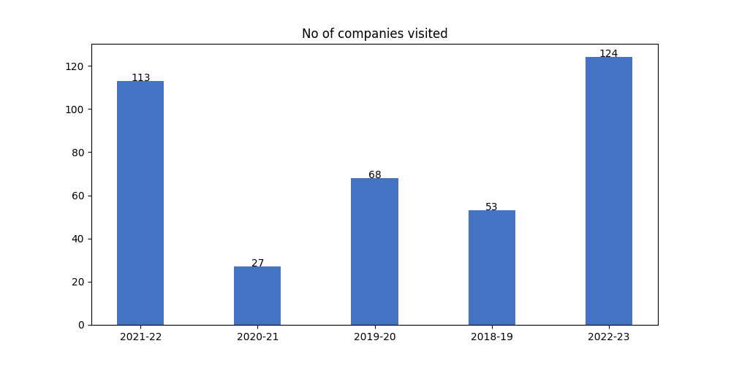

## b) Average package distribution:

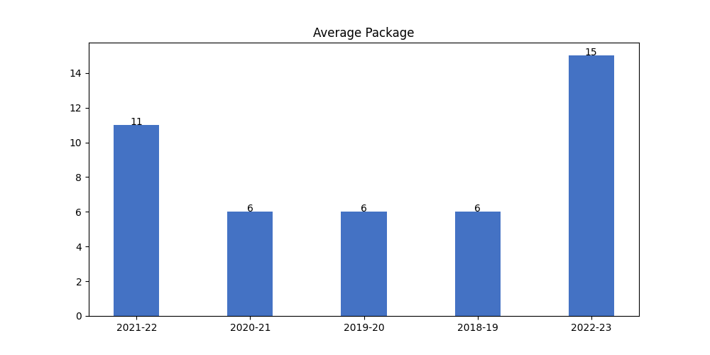

## c) No. of Offers:

