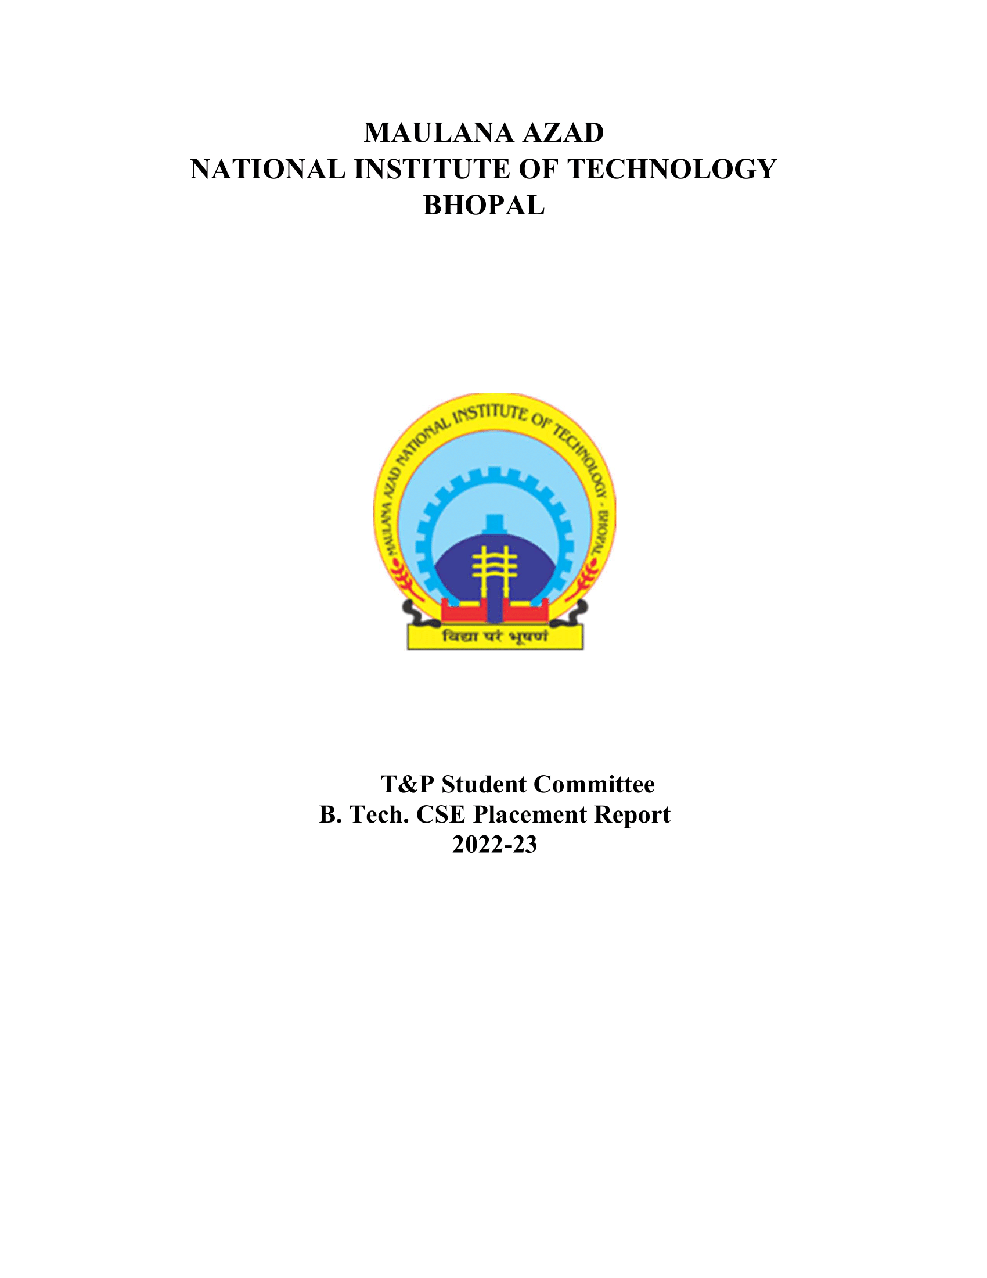

ME DEPARTMENT (BATCH 2022-2023)

# 1. Overview:

The Mechanical department of MANIT Bhopal has always been the biggest department in terms of strength and achievements. The total number of selections are more in non-core sector till now, increase in the core sector is expected in upcoming month.

# 2. Placement Stats 2022-23:

|  |  |
| --- | --- |
| No. of companies visited | 84 |
| Total Strength | 191 |
| No. of offers | 172 |
| No. of students placed | 138 |
| No. of students with 6-month Internship | 34 |
| Percentage Placement | 72.25% |
| Average Package | 9.91 |
| Median Package | 8.88 |
| Highest Package | 19 |
| Lowest Package | 5 |

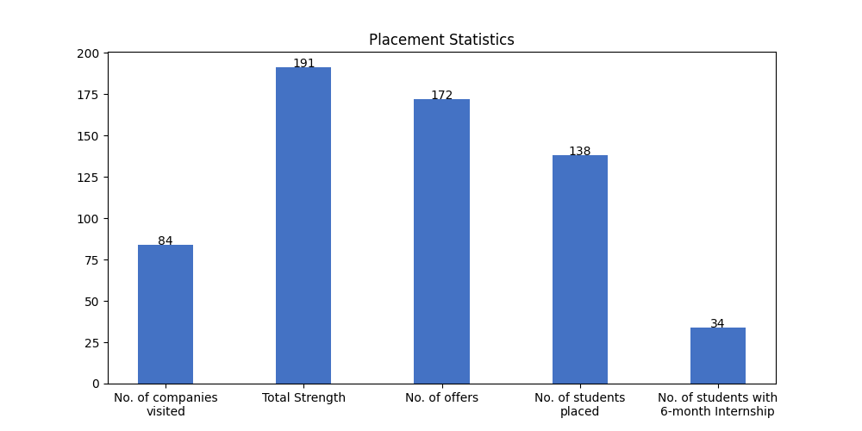

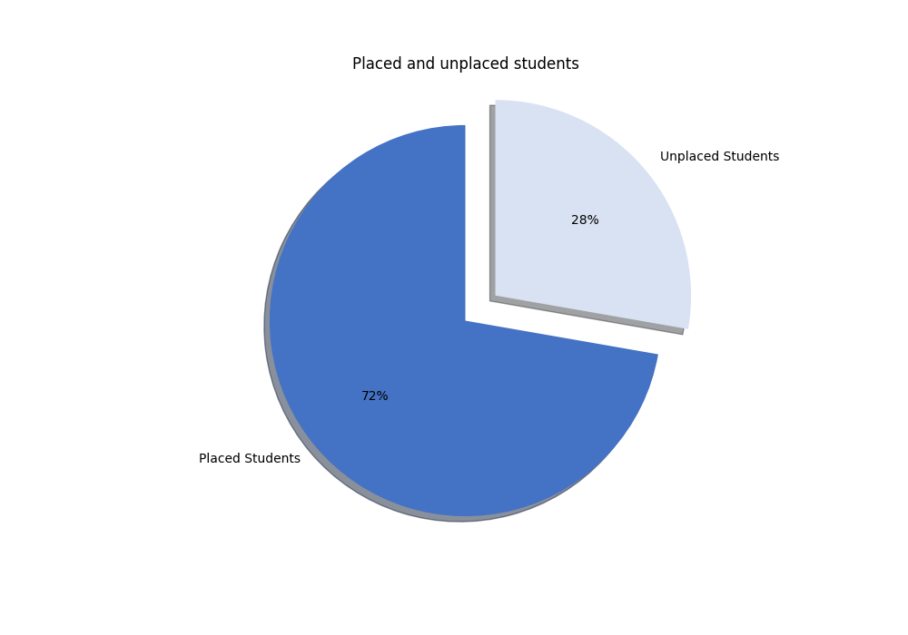

# 2.1 Campus Placement List (FTE):

|  |  |  |  |  |
| --- | --- | --- | --- | --- |
| S. No | Scholar Number | Candidate Name | Company's Name | CTC (LPA) |
| 1 | 191116406 | Anil Kumar | Aarti Industries | 5.5 |
| 2 | 191116224 | Ankush Singh | Aarti Industries | 5.5 |
| 3 | 191116024 | Sandeep Saini | Aarti Industries | 5.5 |
| 4 | 191116275 | Dudekula Afrin | Abhibus | 10 |
| 5 | 191116264 | Vansh Kapoor | Abhibus | 10 |
| 6 | 191116439 | samad sarwar | Abhibus | 10 |
| 7 | 191116001 | Aditya kumar | Aditya Birla | 7 |
| 8 | 191116255 | Mayank Solanki | Aditya Birla | 7 |
| 9 | 191116235 | PRATIK SHUKLA | Aditya Birla | 7 |
| 10 | 191116402 | RISHABH SONKAR | Aditya Birla | 7 |
| 11 | 191116262 | AYUSH DIXIT | Affine | 7.86 |
| 12 | 191116222 | Mayur Pawar | Affine | 7.86 |
| 13 | 191116444 | NEETESH RAGHUWANSHI | Affine | 7.86 |
| 14 | 191116041 | Rishav payasi | Affine | 7.86 |
| 15 | 191116002 | Nidhi Tiwari | Alstom Transport | 6.8 |
| 16 | 191116028 | Satvika Singh | Alstom Transport | 6.8 |
| 17 | 191116204 | Ayushi Chaugaonkar | Applied Materials(Hardware Design) | * |
| 18 | 191116067 | Chirag gupta | Applied Materials(Hardware Design) | * |
| 19 | 191116268 | Dipanshu Rautela | Applied Materials(Hardware Design) | * |
| 20 | 191116063 | Vikas Sakesh | Applied Materials(Hardware Design), Hero Moto Corp | * |
| 21 | 191116247 | Harshit Mourya | Ashok Leyland Ltd | 5 |
| 22 | 191116025 | Pedi Reddy Harika | Ashok Leyland Ltd | 5 |
| 23 | 191116076 | Anurag yadav | Atyati Technologies | * |
| 24 | 191116452 | TALOOK BOPCHE | Atyati Technologies | * |
| 25 | 191116075 | Akant Kumar Agrawal | Axxela | 14.1 |
| 26 | 191116046 | Aditya Vinay Kamat | BPCL | 18.95 |
| 27 | 191116428 | Sharad Singh | BPCL | 18.95 |
| 28 | 191116213 | Shishir Patel | BPCL | 18.95 |
| 29 | 191116265 | Shubhanshi jain | BPCL | 18.95 |
| 30 | 191116234 | Nandini Kesharwani | Bajaj | 12.24 |
| 31 | 191116450 | Madhavi Singh | BillDesk | 8.5 |
| 32 | 191116253 | Nikhil Rathore | BillDesk | 8.5 |
| 33 | 191116424 | Akash Vimal | Biz 4 Solutions | 7 |
| 34 | 191116451 | Dheeraj Kumar Khobre | Biz 4 Solutions | 7 |
| 35 | 191116453 | Sachin singh Kaurav | Biz 4 Solutions | 7 |
| 36 | 191116215 | Vaibhav Dwivedi | Biz 4 Solutions | 7 |
| 37 | 191116221 | Anvita Saxena | Caterpillar | 10.1 |
| 38 | 191116055 | Suryansh Shahi | Chaayos | 12 |
| 39 | 191116279 | Lalit Kumar Singh | Decimal Point Analytics | 11 |
| 40 | 191116237 | Avadhesh Singh | EXL | 6.5 |
| 41 | 191116425 | Dikshant Gahlot | EXL | 6.5 |
| 42 | 191116415 | Faizan khan | EXL | 6.5 |
| 43 | 191116020 | Mohit Pawar | EXL | 6.5 |
| 44 | 191116216 | Shantanu Dhakad | EXL | 6.5 |
| 45 | 191116414 | Shivansh Jaiswal | EXL | 6.5 |
| 46 | 191116466 | Harshit Chaube | ExxonMobil | 11.41 |
| 47 | 191116266 | Sneha Gupta | ExxonMobil | 11.41 |
| 48 | 191116214 | Apeksha Gupta | Forbes Marshall, Maruti Suzuki | * |
| 49 | 191116229 | Kajal Meena | Hero Moto Corp | 7.75 |
| 50 | 191116401 | MRADUL AGRAWAL | Hero Moto Corp | 7.75 |
| 51 | 191116210 | PRIYANSHU JOSHI | Hero Moto Corp | 7.75 |
| 52 | 191116223 | SHUBHAM GUPTA | Hero Moto Corp | 7.75 |
| 53 | 191116015 | Shubham Pandey | Hero Moto Corp | 7.75 |
| 54 | 191116239 | Siddharth Shrivastava | Hero Moto Corp | 7.75 |
| 55 | 191116003 | Mahak Jain | Incedo | 7.55 |
| 56 | 191116440 | Rudraksh Sharma | Incedo | 7.55 |
| 57 | 191116447 | Abdul Rahim | InfoObjects | 6.5 |
| 58 | 191116274 | YARAGUTI VENKATA KOTI REDDY | L&T | 6 |
| 59 | 191116029 | Ayush Saini | Maruti Suzuki | 8.88 |
| 60 | 191116069 | Banka Narendranath Reddy | Maruti Suzuki | 8.88 |
| 61 | 191116441 | Diya Trivedi | Maruti Suzuki | 8.88 |
| 62 | 191116007 | Govind Patidar | Maruti Suzuki | 8.88 |
| 63 | 191116272 | Kalash Tripathi | Maruti Suzuki | 8.88 |
| 64 | 191116011 | Madhusudhan Bilawliya | Maruti Suzuki | 8.88 |
| 65 | 191116448 | Pranjul Gautam | Maruti Suzuki | 8.88 |
| 66 | 191116417 | Prathmesh Amol Lekurwale | Maruti Suzuki | 8.88 |
| 67 | 191116050 | ROHIT SADANAND LENDE | Maruti Suzuki | 8.88 |
| 68 | 191116039 | SANDEEP PATEL | Maruti Suzuki | 8.88 |
| 69 | 191116422 | Vikash chaturvedi | Maruti Suzuki | 8.88 |
| 70 | 191116263 | Divyanshu Shukla | NSL HUB | 12 |
| 71 | 191116233 | Pradyumna Gupta | NSL HUB | 12 |
| 72 | 191116241 | Pranjal Bahore | NSL HUB | 12 |
| 73 | 191116040 | Ashish Kumar Rai | Nation with Namo | 19 |
| 74 | 191116072 | Anushka Agarwal | Netradyne | 14 |
| 75 | 191116018 | Aditya Periwal | O9 Solutions | 12.5 |
| 76 | 191116049 | Anjali Singh | O9 Solutions | 12.5 |
| 77 | 191116470 | Hardik Rastogi | O9 Solutions | 12.5 |
| 78 | 191116017 | Arshit Rathore | OfBusiness | 8 |
| 79 | 191116023 | Navneet Kumar | OfBusiness | 8 |
| 80 | 191116257 | Nimish Agrawal | OfBusiness | 8 |
| 81 | 191116032 | Sachin Yadav | PharmaAce | 7.5 |
| 82 | 191116418 | Somesh Kumar Dewangan | PharmaAce | 7.5 |
| 83 | 191116409 | Hrishank Soni | Piramal | 12.54 |
| 84 | 191116462 | SHYAM DWIVEDI | Piramal | 12.54 |
| 85 | 191116231 | Sanjana Kanodia | Piramal | 12.54 |
| 86 | 191116426 | Yash kumar singh | Piramal | 12.54 |
| 87 | 1 | Vaibhav Bhaskar | Pradan | 8.16 |
| 88 | 191116468 | Abhinav Kumar | PwC India | 9.08 |
| 89 | 191116249 | Akshat Srivastava | PwC India | 9.08 |
| 90 | 191116220 | Anshul Baretiya | PwC India | 9.08 |
| 91 | 191116053 | Anuj kumar chaturvedi | PwC India | 9.08 |
| 92 | 191116005 | Arjit Shrivastava | PwC India | 9.08 |
| 93 | 191116277 | BHUPATHI THARUN DEV | PwC India | 9.08 |
| 94 | 191116457 | Nehal Anandkumar Chauhan | PwC India | 9.08 |
| 95 | 191116030 | Nikhil Punwani | PwC India | 9.08 |
| 96 | 191116051 | Nishita goyal | PwC India | 9.08 |
| 97 | 191116059 | Rishika Varma | PwC India | 9.08 |
| 98 | 191116270 | Fazil Khan | Quantiphi | 8.5 |
| 99 | 191116208 | Ritul Choudhary | Quantiphi | 8.5 |
| 100 | 191116207 | Aditya Trivedi | Reliance Industries Limited | 7.5 |
| 101 | 191116027 | Divya Yadav | Reliance Industries Limited | 7.5 |
| 102 | 191116071 | Gandla Vengalarao | Reliance Industries Limited | 7.5 |
| 103 | 191116080 | Kundkar Prem Narendra | Reliance Industries Limited | 7.5 |
| 104 | 191116258 | Pooja Modi | Reliance Industries Limited | 7.5 |
| 105 | 191116021 | Prinshu Singh | Reliance Industries Limited | 7.5 |
| 106 | 191116269 | Priya Singh | Reliance Industries Limited | 7.5 |
| 107 | 191116435 | RAVI KUMAR GADDAM | Reliance Industries Limited | 7.5 |
| 108 | 191116227 | Syed Azin Ali | Reliance Industries Limited | 7.5 |
| 109 | 191116410 | Yugandhar Pahade | Reliance Industries Limited | 7.5 |
| 110 | 191116469 | Abhishek Gupta | Tata Advanced Systems | 5 |
| 111 | 191116252 | ARVIND SINGH TANWAR | Trianz | 10 |
| 112 | 191116079 | Aryan Pandey | Trianz | 10 |
| 113 | 191116206 | Kavita Akhade | Trianz | 10 |
| 114 | 191116052 | Piyush Upadhyay | Trianz | 10 |
| 115 | 191116419 | Shivam Patel | Trianz | 10 |
| 116 | 191116054 | Shubham Parashar | Trianz | 10 |
| 117 | 191116026 | ABHISHEK KUMAR | Vedanta Limited | 14.45 |
| 118 | 191116273 | Aman Sirshyam | Vedanta Limited | 14.45 |
| 119 | 191116461 | Anirudh Singh | Vedanta Limited | 14.45 |
| 120 | 191116261 | Dhairya Verma | Vedanta Limited | 14.45 |
| 121 | 191116271 | Harsham Paliwal | Vedanta Limited | 14.45 |
| 122 | 191116004 | Harshit Saket | Vedanta Limited | 14.45 |
| 123 | 191116434 | Kalasapati venkata srikanth | Vedanta Limited | 14.45 |
| 124 | 191116251 | Mangali Venkata Subbaiah | Vedanta Limited | 14.45 |
| 125 | 191116077 | Neeraj kumar meena | Vedanta Limited | 14.45 |
| 126 | 191116034 | RISHIKA CHOUBEY | Vedanta Limited | 14.45 |
| 127 | 191116019 | Ritik vishwakarma | Vedanta Limited | 14.45 |
| 128 | 191116006 | Somil Sharma | Vedanta Limited | 14.45 |
| 129 | 191116456 | Sumit Jamre | Vedanta Limited | 14.45 |
| 130 | 191116061 | Vunnam Sree Navya | Vedanta Limited | 14.45 |
| 131 | 191116201 | YASHMIT SINGH | Vedanta Limited | 14.45 |
| 132 | 191116056 | Yarram Sri Harsha Vardhan Reddy | Vedanta Limited | 14.45 |
| 133 | 191116256 | Yerukala Srinivas | Vedanta Limited | 14.45 |
| 134 | 191116259 | AKULA KRISHNA VAMSI | Vedanta, Cairn Oil & Gas | 14.1 |
| 135 | 191116467 | Nishtha Choubey | Vedanta, Cairn Oil & Gas | 14.1 |

# 2.2 Students With PPO:

|  |  |  |  |  |
| --- | --- | --- | --- | --- |
| S. No | Scholar Number | Candidate Name | Company's Name | CTC (LPA) |
| 1 | 191116074 | Nishant Singh | Decimal Point Analytics | 11 |
| 2 | 191116404 | HARSHIT NAMDEO | ExxonMobil | 11.41 |
| 3 | 191116048 | R Shriya | Saint Gobain | * |

# 2.3 Internships (6 Month):

|  |  |  |  |  |
| --- | --- | --- | --- | --- |
| S. No | Scholar Number | Candidate Name | Company's Name | Stipend (KPM) |
| 1 | 191116405 | Ankur Singh | AMNS | 13 |
| 2 | 191116023 | Navneet Kumar | AMNS | 13 |
| 3 | 191116028 | Satvika Singh | AMNS | 13 |
| 4 | 191116418 | Somesh Kumar Dewangan | AMNS | 13 |
| 5 | 191116426 | Yash kumar singh | AMNS | 13 |
| 6 | 191116275 | Dudekula Afrin | Abhibus | 25 |
| 7 | 191116264 | Vansh Kapoor | Abhibus | 25 |
| 8 | 191116439 | samad sarwar | Abhibus | 25 |
| 9 | 191116029 | Ayush Saini | Algouniversty | * |
| 10 | 191116076 | Anurag yadav | Atyati Technologies | * |
| 11 | 191116452 | TALOOK BOPCHE | Atyati Technologies | * |
| 12 | 191116075 | Akant Kumar Agrawal | Axxela | 20 |
| 13 | 191116249 | Akshat Srivastava | Axxela | 20 |
| 14 | 191116424 | Akash Vimal | Biz 4 Solutions | 20 |
| 15 | 191116451 | Dheeraj Kumar Khobre | Biz 4 Solutions | 20 |
| 16 | 191116453 | Sachin singh Kaurav | Biz 4 Solutions | 20 |
| 17 | 191116215 | Vaibhav Dwivedi | Biz 4 Solutions | 20 |
| 18 | 191116446 | Maddukuri Paramesh Kumar | Bizongo | 60 |
| 19 | 191116055 | Suryansh Shahi | Chaayos | 25 |
| 20 | 191116428 | Sharad Singh | Darwinbox | 25 |
| 21 | 191116227 | Syed Azin Ali | Futures First | 25 |
| 22 | 191116003 | Mahak Jain | Incedo | 25 |
| 23 | 191116440 | Rudraksh Sharma | Incedo | 25 |
| 24 | 191116447 | Abdul Rahim | InfoObjects | 15 |
| 25 | 191116263 | Divyanshu Shukla | NSL HUB | 30 |
| 26 | 191116233 | Pradyumna Gupta | NSL HUB | 30 |
| 27 | 191116241 | Pranjal Bahore | NSL HUB | 30 |
| 28 | 191116248 | Rounak Sartaliya | NxtWave Disruptive Technologies Pvt. Ltd. | * |
| 29 | 191116252 | ARVIND SINGH TANWAR | Trianz | 25 |
| 30 | 191116079 | Aryan Pandey | Trianz | 25 |
| 31 | 191116206 | Kavita Akhade | Trianz | 25 |
| 32 | 191116052 | Piyush Upadhyay | Trianz | 25 |
| 33 | 191116419 | Shivam Patel | Trianz | 25 |
| 34 | 191116054 | Shubham Parashar | Trianz | 25 |

# 2.4 Companies visited:

|  |  |  |  |
| --- | --- | --- | --- |
| Merilytics | Saint Gobain | Quantiphi | Nation with Namo |
| Zycus | Latentview | Atyati Technologies Pvt Ltd | Trianz |
| AMNS | Axxela | PwC India | Algouniversty |
| ExxonMobil | OfBusiness | Spinny | Intellipaat |
| Tata Advanced Systems | Darwinbox | Incedo | Forbes Marshall, Maruti Suzuki |
| Indus Valley Partners | Biz 4 Solutions | Nation With Namo(Associate Consultant) | Alstom Transport |
| Park+ | NxtWave Disruptive Technologies Pvt. Ltd. | Plan Realty | Sutherland |
| NSL HUB | TCS R&I | Applied Materials(Hardware Design), Hero Moto Corp | L&T |
| Ashok Leyland Ltd | O9 Solutions | Piramal | NexTurn India Pvt. Ltd |
| BillDesk | Futures First | Aarti Industries | Hero Moto Corp |
| Carwale | DCM SHRIRAM | Pie INFOCOMM | PlanetSpark |
| Reliance Industries Limited | Caterpillar | Axis Bank | PharmaAce |
| Applied Materials | Bizongo | Zscaler | BizWiz |
| Celigo | C-Dac | Maruti Suzuki | Aakash Byjus |
| Ganit Business Solutions Pvt Ltd | HLS ASIA | Netradyne | Applied Materials(Hardware Design) |
| Abhibus | Bajaj | Forbes Marhsall | Physics Wallah |
| NucleusTeq | Dyeus | Aditya Birla | BPCL |
| Ninjacart | Vedanta Limited | InfoObjects | Incture |
| APT Portfolio | EXL | Atyati Technologies | Affine |
| Pradan | CodeYoung | Vedanta, Cairn Oil & Gas | Paypal |
| Truminds | Decimal Point Analytics | Chaayos | Trilogy |

# 2.5. Companies visited(with selections):

|  |  |  |  |
| --- | --- | --- | --- |
| S. No | Company Name | Selections | CTC (LPA) |
| 1 | Vedanta Limited | 17 | 14.45 |
| 2 | Maruti Suzuki | 12 | 8.88 |
| 3 | Reliance Industries Limited | 11 | 7.5 |
| 4 | PwC India | 10 | 9.08 |
| 5 | Trianz | 6 | 10 |
| 6 | EXL | 6 | 6.5 |
| 7 | BPCL | 4 | 18.95 |
| 8 | Piramal | 4 | 12.54 |
| 9 | Applied Materials | 4 | 9.67 |
| 10 | Affine | 4 | 7.86 |
| 11 | Hero Moto Corp | 4 | 7.75 |
| 12 | Biz 4 Solutions | 4 | 7 |
| 13 | Aditya Birla | 4 | 7 |
| 14 | L&T | 4 | 6 |
| 15 | Aarti Industries | 4 | 5.5 |
| 16 | O9 Solutions | 3 | 12.5 |
| 17 | NSL HUB | 3 | 12 |
| 18 | ExxonMobil | 3 | 11.41 |
| 19 | Abhibus | 3 | 10 |
| 20 | OfBusiness | 3 | 8 |
| 21 | Vedanta, Cairn Oil & Gas | 2 | 14.1 |
| 22 | Decimal Point Analytics | 2 | 11 |
| 23 | BillDesk | 2 | 8.5 |
| 24 | Quantiphi | 2 | 8.5 |
| 25 | Incedo | 2 | 7.55 |
| 26 | PharmaAce | 2 | 7.5 |
| 27 | Alstom Transport | 2 | 6.8 |
| 28 | Atyati Technologies Pvt Ltd | 2 | 6.45 |
| 29 | Ashok Leyland Ltd | 2 | 5 |
| 30 | Nation with Namo | 1 | 19 |
| 31 | Axxela | 1 | 14.1 |
| 32 | Netradyne | 1 | 14 |
| 33 | Bajaj | 1 | 12.24 |
| 34 | Chaayos | 1 | 12 |
| 35 | Caterpillar | 1 | 10.1 |
| 36 | Pradan | 1 | 8.16 |
| 37 | Forbes Marhsall | 1 | 7.8 |
| 38 | InfoObjects | 1 | 6.5 |
| 39 | Saint Gobain | 1 | 6.3 |
| 40 | Tata Advanced Systems | 1 | 5 |

# 2.6. Companies visited(with no selections):

|  |  |  |  |
| --- | --- | --- | --- |
| Trilogy | Merilytics | TCS R&I | Carwale |
| HLS ASIA | Pie INFOCOMM | NucleusTeq | Sutherland |
| Dyeus | Indus Valley Partners | Zycus | BizWiz |
| DCM SHRIRAM | Ninjacart | Intellipaat | C-Dac |
| Latentview | Paypal | Nation With Namo(Associate Consultant) | Plan Realty |
| Aakash Byjus | CodeYoung | Physics Wallah | PlanetSpark |

# 3.1 Tabular Comparison:

|  |  |  |  |  |  |  |  |  |
| --- | --- | --- | --- | --- | --- | --- | --- | --- |
| Session | 2015-16 | 2016-17 | 2017-18 | 2018-19 | 2019-20 | 2020-21 | 2021-22 | 2022-23 |
| No of Companies visited | 41 | 37 | 38 | 50 | 51 | 54 | 85 | 84 |
| No. of oﬀers | 131 | 112 | 110 | 119 | 99 | 95 | 150 | 172 |
| Average Package | 6.5 | 6.05 | 5.86 | 6.17 | 6.17 | 7.2 | 8.05 | 9.91 |

# 3.2 Graphs for Comparison with previous years:

## a) No of companies visited:

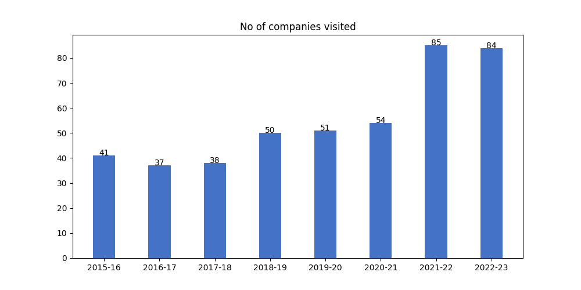

## b) Average package distribution:

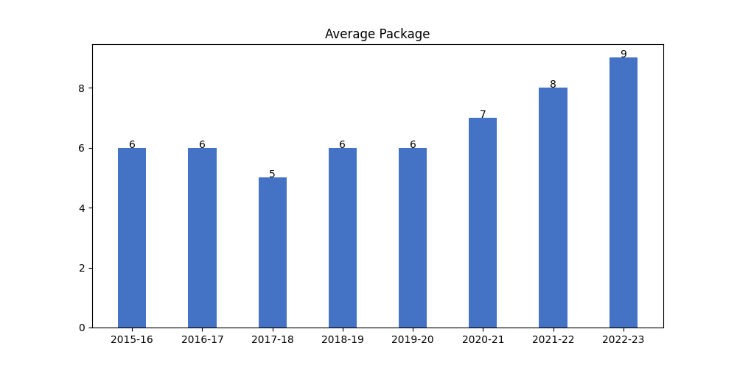

## c) No. of Offers:

