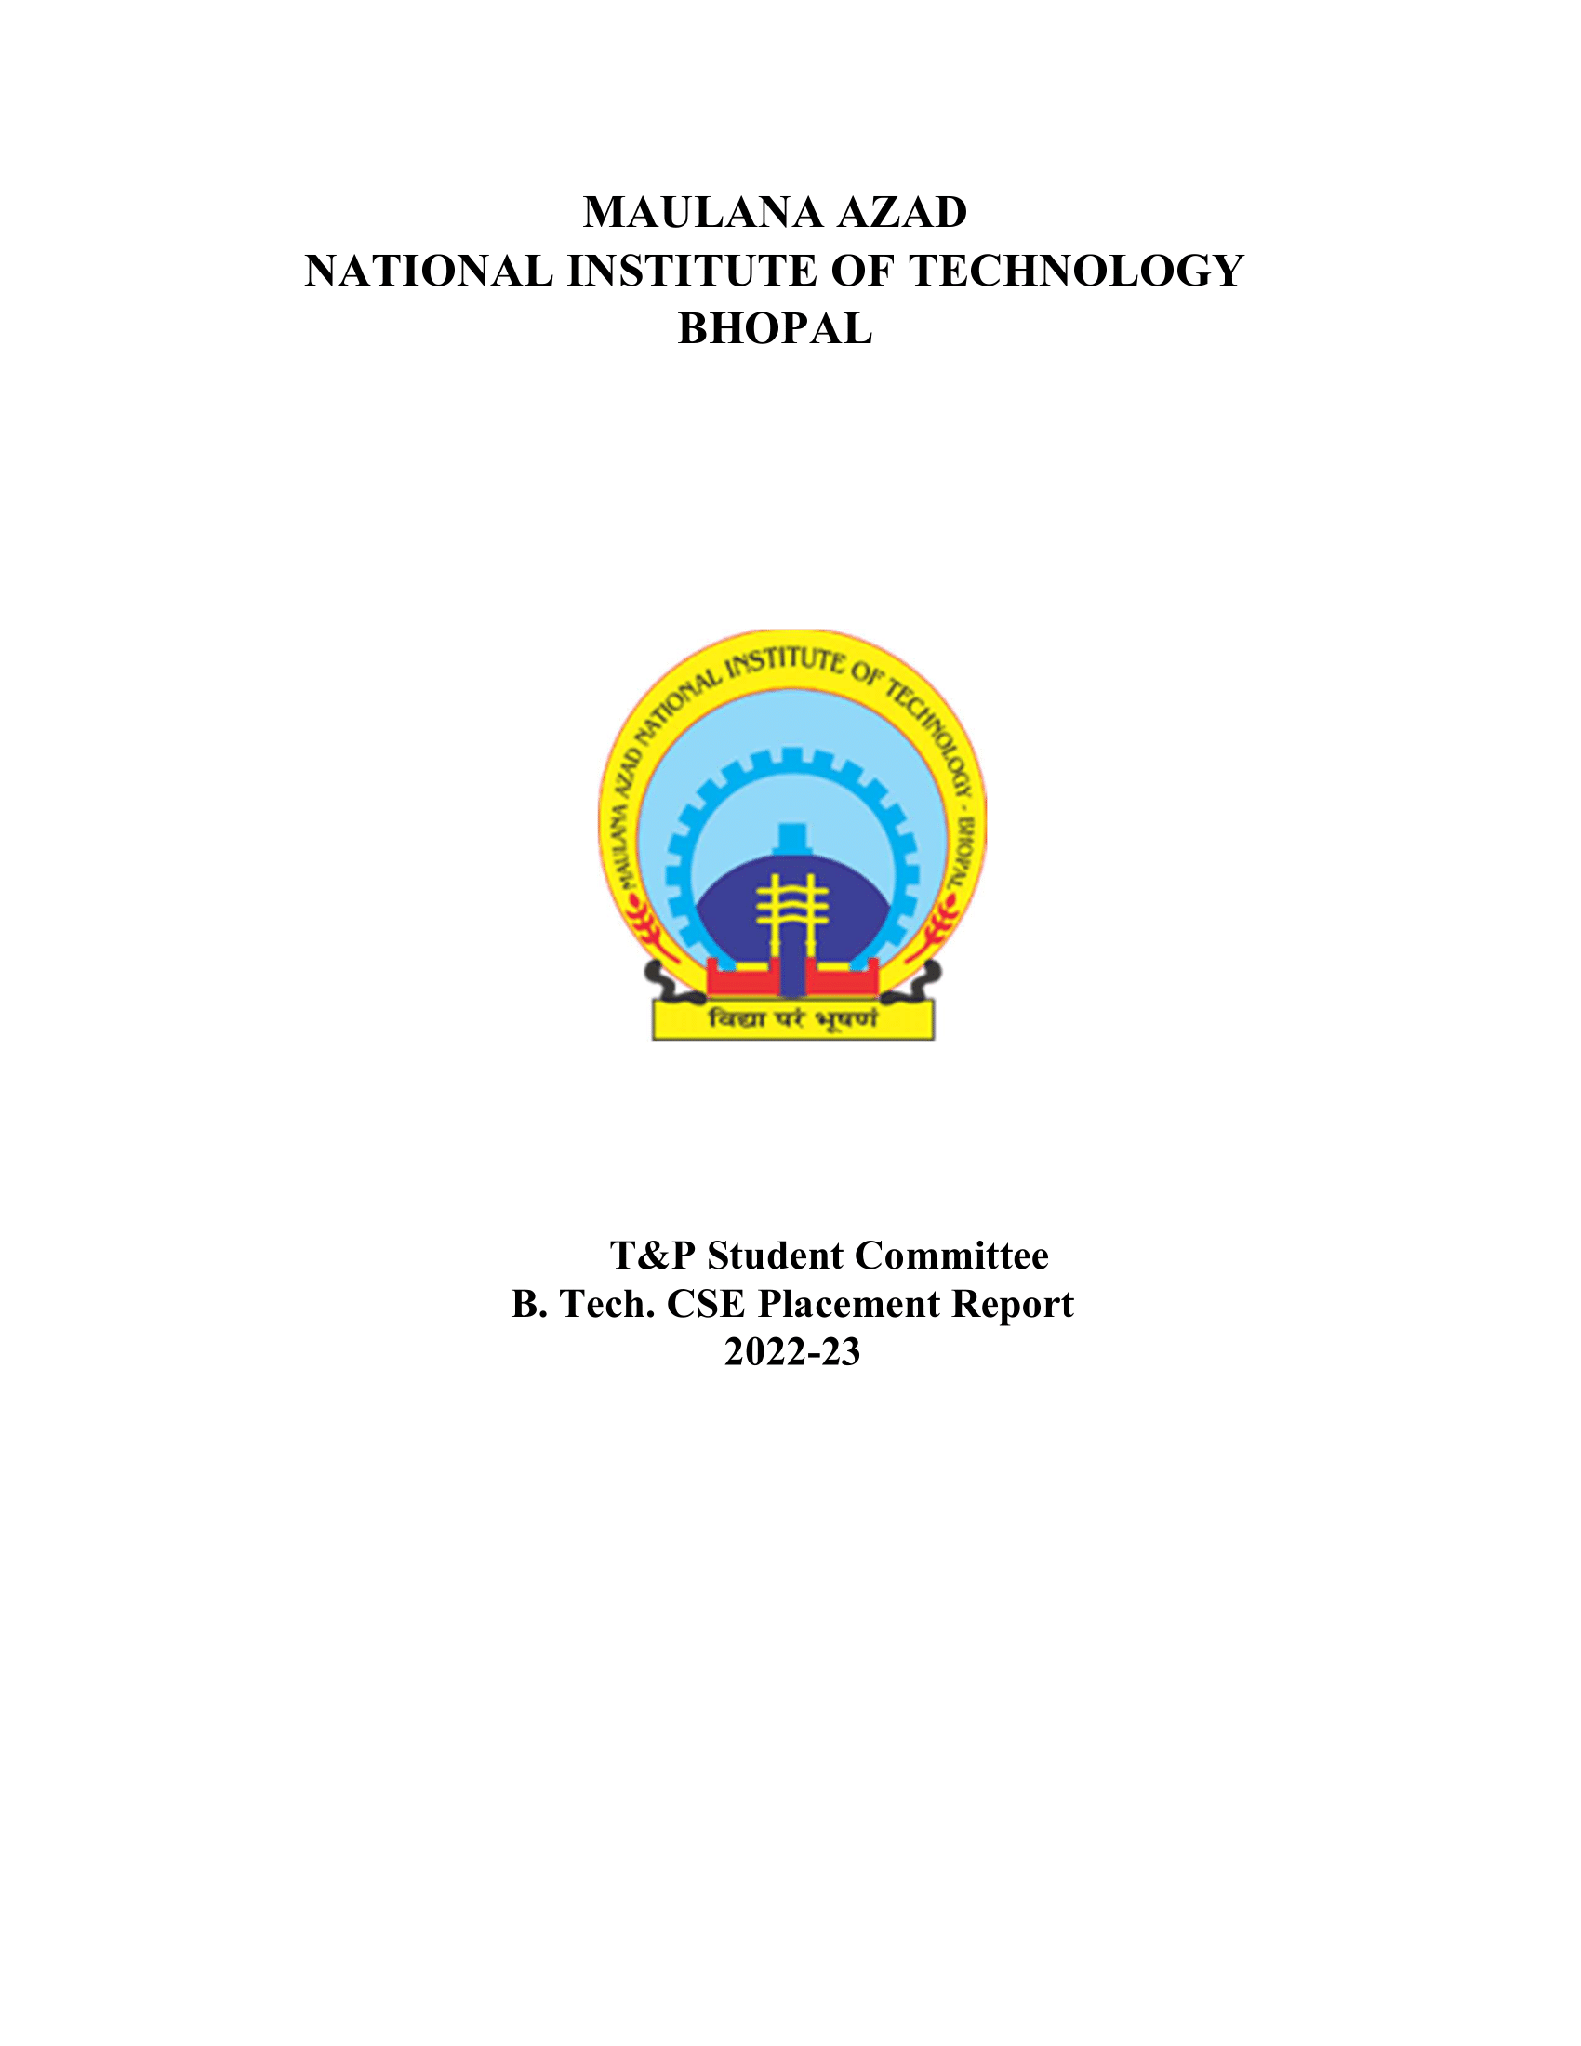

CE DEPARTMENT (BATCH 2022-2023)

# 1. Placement Stats 2022-23:

|  |  |
| --- | --- |
| No. of companies visited | 221 |
| Total Strength | 99 |
| No. of offers | 64 |
| No. of students placed | 54 |
| No. of students with 6-month Internship | 10 |
| Percentage Placement | 54.55% |
| Average Package | 9.1 |
| Median Package | 9.08 |
| Highest Package | 19 |
| Lowest Package | 5.5 |

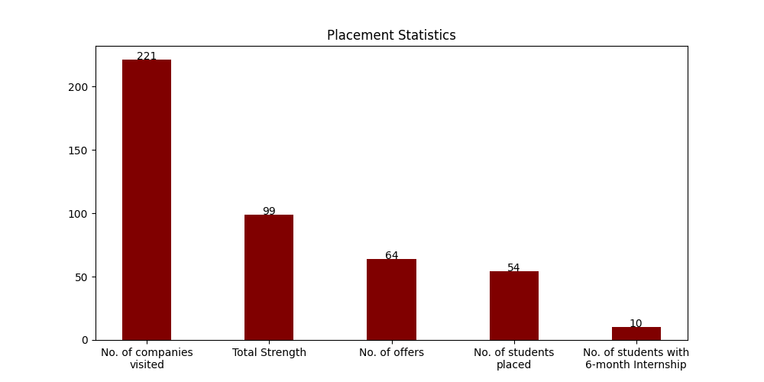

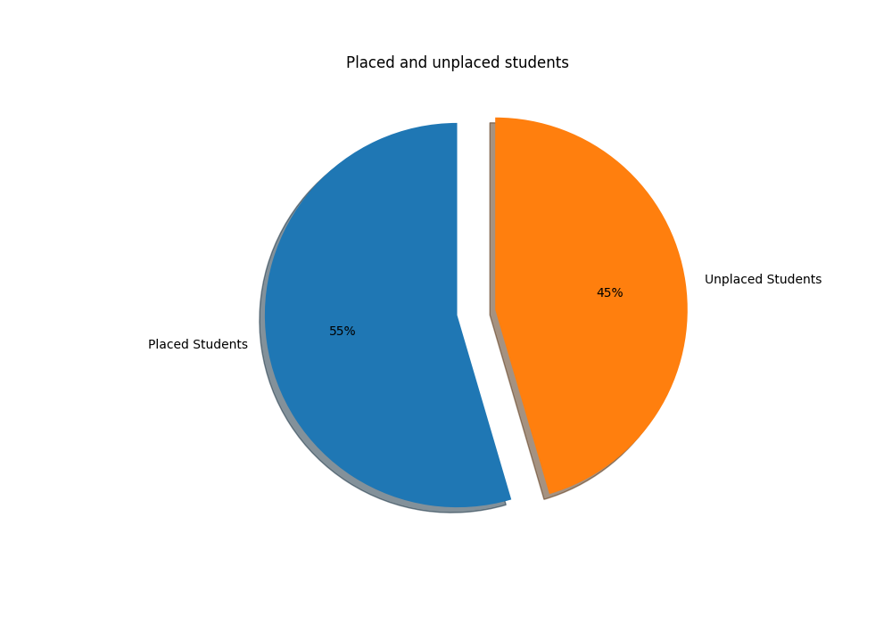

# 1.1 Campus Placement List (FTE):

|  |  |  |  |  |
| --- | --- | --- | --- | --- |
| S. No | Scholar Number | Candidate Name | Company's Name | CTC (LPA) |
| 1 | 191111227 | Abhishek Yadav | Aarti Industries | 5.5 |
| 2 | 191111205 | Nitish Kumar Verma | Aarti Industries | 5.5 |
| 3 | 191111256 | Rahul Kumar | Aarti Industries | 5.5 |
| 4 | 191111008 | Richa Sharma | Aarti Industries | 5.5 |
| 5 | 191111259 | Subhanshu Garg | Axis Bank | 7.93 |
| 6 | 191111030 | Sahil gupta | Axxela | 14.1 |
| 7 | 191111016 | Deepansh Chaturvedi | BillDesk | 8.5 |
| 8 | 191111017 | Sakshi Talreja | BillDesk | 8.5 |
| 9 | 191111218 | Ayush Saxena | Biz 4 Solutions | 7 |
| 10 | 191111061 | Jayant Motwani | Decimal Point Analytics | 11 |
| 11 | 191111241 | Himanshu chourey | EXL | 6.5 |
| 12 | 191111007 | Mohit Jorwal | EXL | 6.5 |
| 13 | 191111002 | Satyam Kumar | EXL | 6.5 |
| 14 | 191111020 | Sumit Rathore | EXL | 6.5 |
| 15 | 191111206 | Siddharth Singh | ExxonMobil | 11.41 |
| 16 | 191111203 | Rohit Gupta | Incedo | 7.55 |
| 17 | 191111013 | Anshul Patel | Incture( Dont Remove) | * |
| 18 | 191111204 | Anshika Kalesh | L&T | 6 |
| 19 | 191111036 | Ashok Kumar Chaturvedi | L&T | 6 |
| 20 | 191111026 | Kuldeep Singh Ranawat | L&T | 6 |
| 21 | 191111011 | Parnish Kumar Ghodki | L&T | 6 |
| 22 | 191111009 | RAVIRAJ SINGH | L&T | 6 |
| 23 | 191111213 | Ashutosh Chaubey | Nation with Namo | 19 |
| 24 | 191111055 | Manushree Singh | Netradyne | 14 |
| 25 | 191111234 | ANIL KUMAR JAT | NexTurn | * |
| 26 | 191111212 | Ansh Pandey | NucleusTeq | 7 |
| 27 | 191111247 | Ishita Tandon | O9 Solutions | 12.5 |
| 28 | 191111050 | Shailendra Choudhary | Piramal | 12.54 |
| 29 | 191111255 | Shagun Mittal | PlanetSpark | 6.5 |
| 30 | 191111252 | Aman Pandey | PwC India | 9.08 |
| 31 | 191111254 | Anchuri Pranathi | PwC India | 9.08 |
| 32 | 191111224 | BHAVESH TEJWANI | PwC India | 9.08 |
| 33 | 191111031 | Krishan kant sharma | PwC India | 9.08 |
| 34 | 191111053 | MANSINGH | PwC India | 9.08 |
| 35 | 191111211 | Nidhi Borkar | PwC India | 9.08 |
| 36 | 191111249 | Prachi Tiwari | PwC India | 9.08 |
| 37 | 191111258 | Sunil kumar dubey | PwC India | 9.08 |
| 38 | 191111260 | Tushar | PwC India | 9.08 |
| 39 | 191111226 | Umashankar yadav | PwC India | 9.08 |
| 40 | 191111215 | Veeresh Singh Kushwah | PwC India | 9.08 |
| 41 | 191111214 | Yashvi | PwC India | 9.08 |
| 42 | 191111219 | Yugansh Verma | PwC India | 9.08 |
| 43 | 191111032 | Harsh Tiwari | Quantiphi | 8.5 |
| 44 | 191111063 | Aman Kumar | Reliance Industries Limited | 7.5 |
| 45 | 191111202 | Aman bagri | Reliance Industries Limited | 7.5 |
| 46 | 191111041 | Prachi Pardhi | Reliance Industries Limited | 7.5 |
| 47 | 191111222 | TATHAGAT VATSAYAN MISHRA | Reliance Industries Limited | 7.5 |
| 48 | 191111052 | Shivani Gautam | Trianz | 10 |
| 49 | 191111246 | Gandharv kurmi | Vedanta Limited | 14.45 |
| 50 | 191111064 | Kavita Agrawal | Vedanta Limited | 14.45 |
| 51 | 191111207 | Neelesh Choudhary | Vedanta Limited | 14.45 |
| 52 | 191111027 | Shivam Choudhary | Vedanta Limited | 14.45 |
| 53 | 191111062 | Sriyesh Pandey | Vedanta Limited | 14.45 |

# 1.2 Students With PPO:

|  |  |  |  |  |
| --- | --- | --- | --- | --- |
| S. No | Scholar Number | Candidate Name | Company's Name | CTC (LPA) |
| 1 | 191111057 | Pratham Khare | Decimal Point Analytics | 11 |

# 1.2 Internships (6 Month):

|  |  |  |  |  |
| --- | --- | --- | --- | --- |
| S. No | Scholar Number | Candidate Name | Company's Name | CTC (LPA) |
| 1 | 191111259 | Subhanshu Garg | Axis Bank | 7.93 |
| 2 | 191111030 | Sahil gupta | Axxela | 14.1 |
| 3 | 191111218 | Ayush Saxena | Biz 4 Solutions | 7 |
| 4 | 191111029 | ANIRUDHA GOUR | Blackrock | 12.5 |
| 5 | 191111224 | BHAVESH TEJWANI | Darwinbox | 9.75 |
| 6 | 191111203 | Rohit Gupta | Incedo | 7.55 |
| 7 | 191111013 | Anshul Patel | Incture( Dont Remove) | * |
| 8 | 191111234 | ANIL KUMAR JAT | NexTurn | * |
| 9 | 191111054 | Yashpal Solanki | NxtWave Disruptive Technologies Pvt. Ltd. | * |
| 10 | 191111052 | Shivani Gautam | Trianz | 10 |

# 1.4 Companies visited:

|  |  |  |  |
| --- | --- | --- | --- |
| Axxela | ExxonMobil | Trilogy | Incedo |
| Merilytics | BillDesk | NSL HUB | Trianz |
| Incture | O9 Solutions | Axis Bank | TCS R&I |
| Truminds | EXL | Carwale | Netradyne |
| Pie INFOCOMM | NucleusTeq | Park+ | Nation with Namo |
| Abhibus | Sutherland | Dyeus | NexTurn India Pvt. Ltd |
| Piramal | Indus Valley Partners | Biz 4 Solutions | Quantiphi |
| InfoObjects | Decimal Point Analytics | PwC India | Chaayos |
| Zscaler | Zycus | OfBusiness | BizWiz |
| DCM SHRIRAM | APT Portfolio | L&T | Ninjacart |
| Reliance Industries Limited | Adani Group | Intellipaat | Latentview |
| Paypal | Aarti Industries | Vedanta, Cairn Oil & Gas | Nation With Namo(Associate Consultant) |
| Plan Realty | Aakash Byjus | Vedanta Limited | Physics Wallah |

# 1.5. Companies visited(with selections):

|  |  |  |  |
| --- | --- | --- | --- |
| S. No | Company Name | Selections | CTC (LPA) |
| 1 | PwC India | 13 | 9.08 |
| 2 | L&T | 7 | 6 |
| 3 | Aarti Industries | 6 | 5.5 |
| 4 | Vedanta Limited | 5 | 14.45 |
| 5 | Reliance Industries Limited | 4 | 7.5 |
| 6 | EXL | 4 | 6.5 |
| 7 | Decimal Point Analytics | 2 | 11 |
| 8 | BillDesk | 2 | 8.5 |
| 9 | Nation with Namo | 1 | 19 |
| 10 | Axxela | 1 | 14.1 |
| 11 | Netradyne | 1 | 14 |
| 12 | Piramal | 1 | 12.54 |
| 13 | O9 Solutions | 1 | 12.5 |
| 14 | ExxonMobil | 1 | 11.41 |
| 15 | Trianz | 1 | 10 |
| 16 | Incture | 1 | 8.5 |
| 17 | Quantiphi | 1 | 8.5 |
| 18 | Axis Bank | 1 | 7.93 |
| 19 | Incedo | 1 | 7.55 |
| 20 | NucleusTeq | 1 | 7 |
| 21 | Biz 4 Solutions | 1 | 7 |
| 22 | Adani Group | 1 | 6.5 |
| 23 | PlanetSpark | 1 | 6.5 |
| 24 | NexTurn India Pvt. Ltd | 1 | 6 |

# 1.6. Companies visited(with no selections):

|  |  |  |  |
| --- | --- | --- | --- |
| Trilogy | Merilytics | NSL HUB | TCS R&I |
| Truminds | Carwale | Pie INFOCOMM | Park+ |
| Abhibus | Sutherland | Dyeus | Indus Valley Partners |
| InfoObjects | Chaayos | Zscaler | Zycus |
| OfBusiness | BizWiz | DCM SHRIRAM | APT Portfolio |
| Ninjacart | Intellipaat | Latentview | Paypal |
| Vedanta, Cairn Oil & Gas | Nation With Namo(Associate Consultant) | Plan Realty | Aakash Byjus |