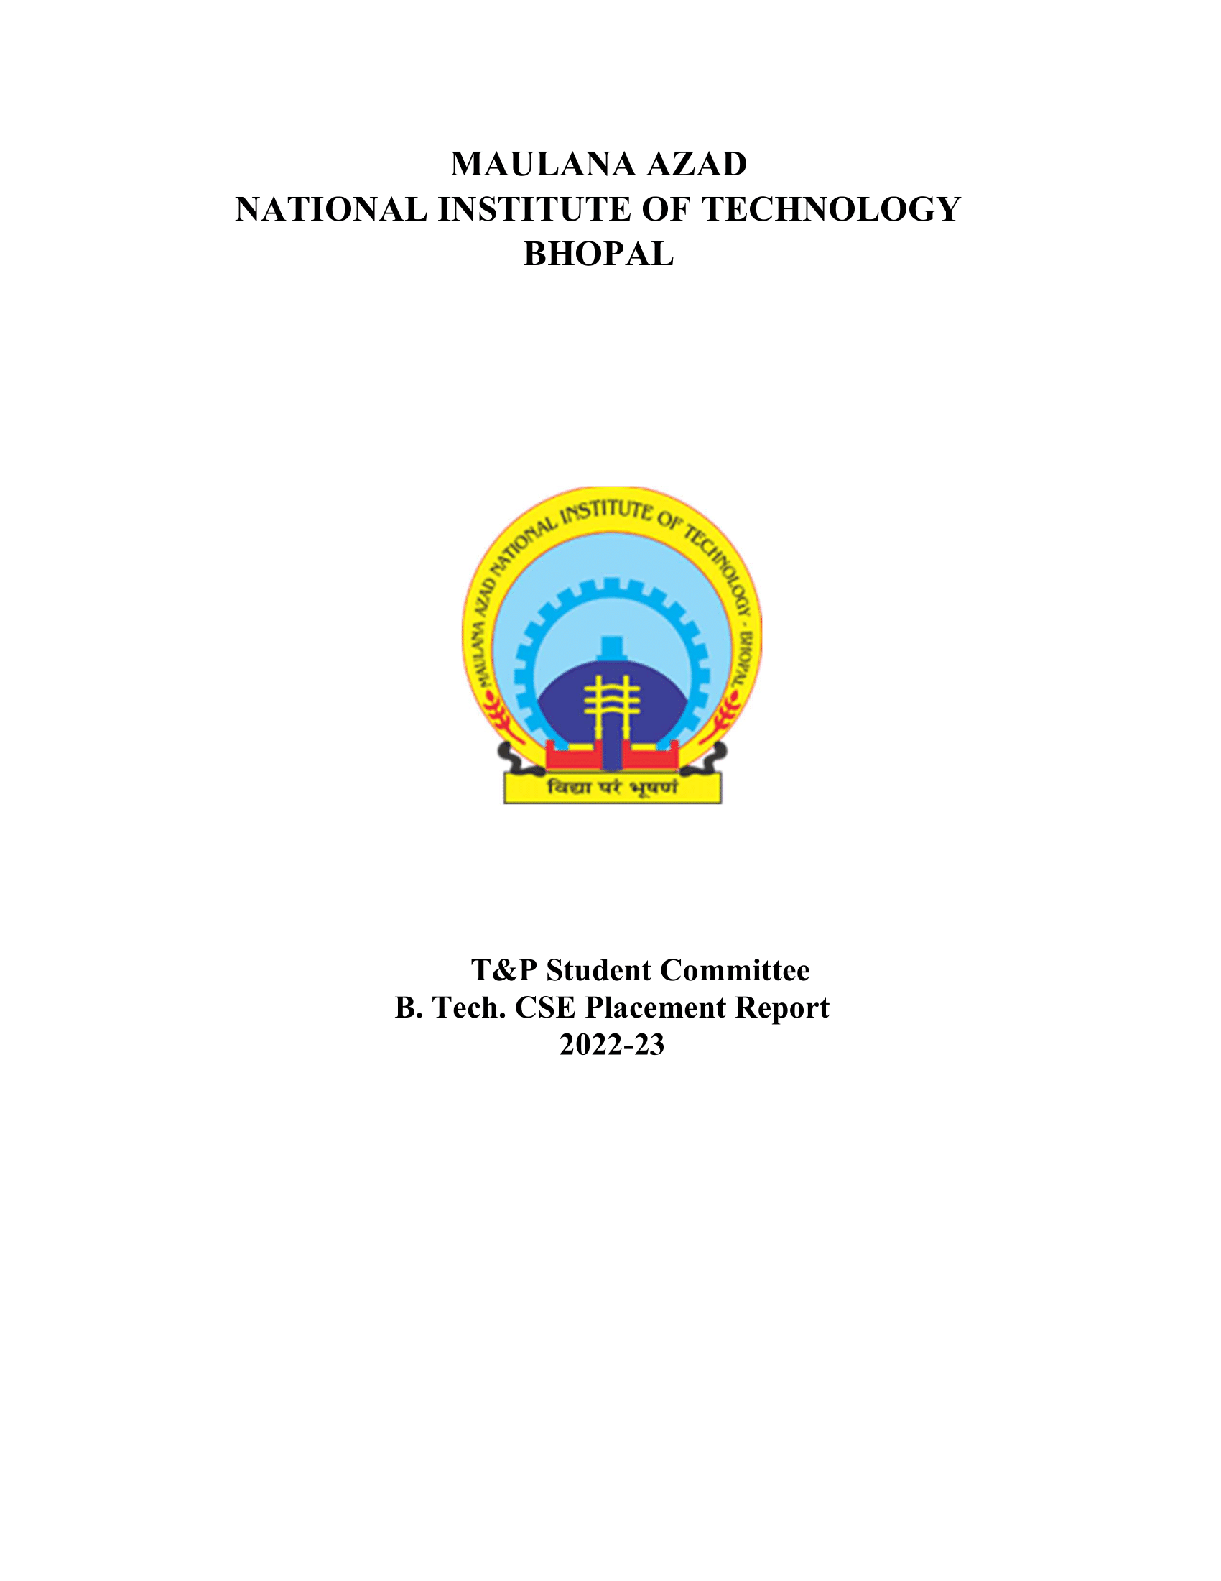

CHEM DEPARTMENT (BATCH 2022-2023)

# 1. Placement Stats 2022-23:

|  |  |
| --- | --- |
| No. of companies visited | 56 |
| Total Strength | 66 |
| No. of offers | 62 |
| No. of students placed | 53 |
| No. of students with 6-month Internship | 9 |
| Percentage Placement | 80.3% |
| Average Package | 9.14 |
| Median Package | 7.71 |
| Highest Package | 18.95 |
| Lowest Package | 5.5 |

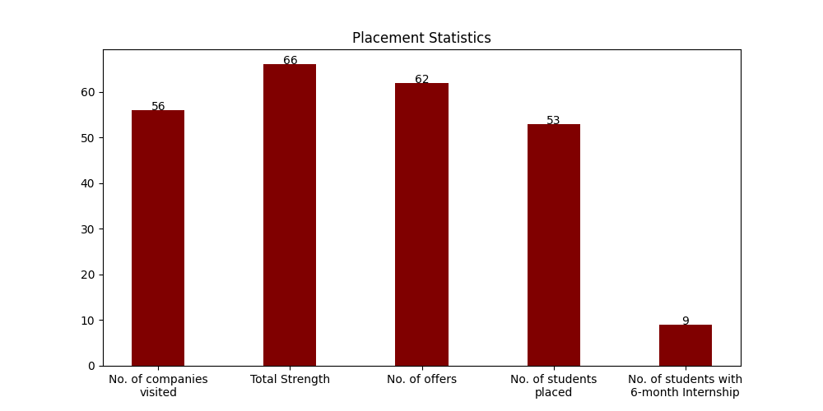

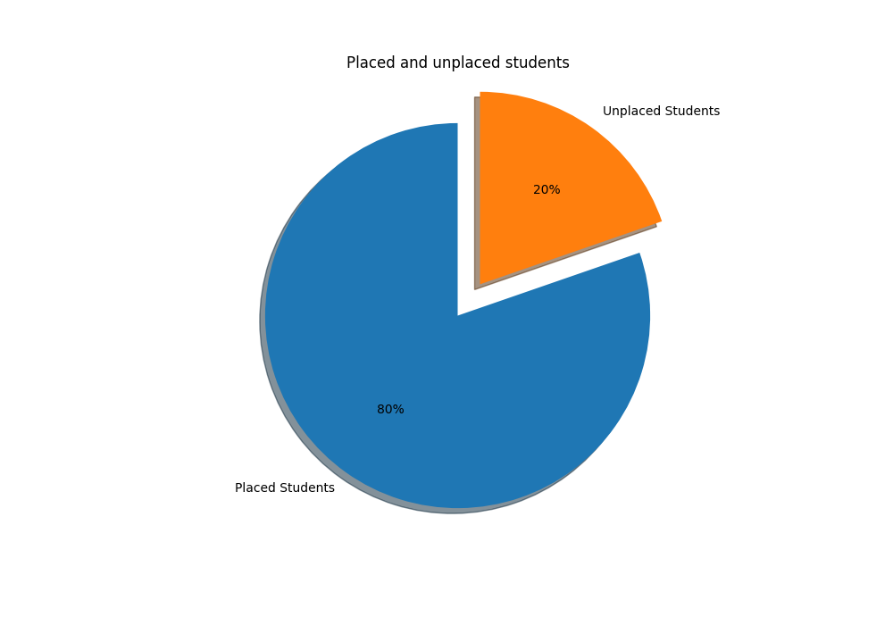

# 1.1 Campus Placement List (FTE):

|  |  |  |  |  |
| --- | --- | --- | --- | --- |
| S. No | Scholar Number | Candidate Name | Company's Name | CTC (LPA) |
| 1 | 191117074 | Ritik Jain | Aakash Byjus | 9 |
| 2 | 191117049 | Bhawani Malooka | Aarti Industries | 5.5 |
| 3 | 191117005 | Ganesh nateriya | Aarti Industries | 5.5 |
| 4 | 191117006 | Kashish Raj | Aarti Industries | 5.5 |
| 5 | 191117027 | Mahesh Dawar | Aarti Industries | 5.5 |
| 6 | 191117046 | Shiv kumar Gupta | Aarti Industries | 5.5 |
| 7 | 191117008 | Gaurav Dhakad | Aditya Birla | 7 |
| 8 | 191117057 | Jyotish Kumar Patar | Aditya Birla | 7 |
| 9 | 191117069 | Kartikeya Bhadoriya | Aditya Birla | 7 |
| 10 | 191117071 | Rajendra kaler | Aditya Birla | 7 |
| 11 | 191117048 | Sandeep Singh Rawat | Aditya Birla | 7 |
| 12 | 191117068 | Vikas rathore | Aditya Birla | 7 |
| 13 | 191117050 | Jitendra Patel | Axis Bank | 7.93 |
| 14 | 191117051 | Anuj Kumar | Axxela | 14.1 |
| 15 | 191117037 | Charvi Arora | BPCL | 18.95 |
| 16 | 191117043 | Jha Ameshkumar Chandrabhagwan | BPCL | 18.95 |
| 17 | 191117085 | Sambhav Bhatt | BillDesk | 8.5 |
| 18 | 191117036 | SHASHANK SINGH | Carwale | 9 |
| 19 | 191117052 | ASHUTOSH SHARMA | EXL | 6.5 |
| 20 | 191117067 | Kalyan Roy | EXL | 6.5 |
| 21 | 191117011 | Rakesh rawat | EXL | 6.5 |
| 22 | 191117010 | Dhruv Pratap Singh | Intellipaat | 9 |
| 23 | 191117054 | Akshit Singh | NSL HUB | 12 |
| 24 | 191117058 | Dhruv Arora | NSL HUB | 12 |
| 25 | 191117083 | Sanskar Yadav | OfBusiness | 8 |
| 26 | 191117082 | Diksha kabra | Park+ SDE | * |
| 27 | 191117009 | Ashutosh Kumar Kapri | PharmaAce | 7.5 |
| 28 | 191117076 | Kapil Upadhyaya | PharmaAce | 7.5 |
| 29 | 191117084 | KVNJ Vamsi Krishna | Piramal | 12.54 |
| 30 | 191117039 | Abhijeet Singh Baghel | PwC India | 9.08 |
| 31 | 191117077 | Harshit pratap singh | PwC India | 9.08 |
| 32 | 191117056 | Kailash Janyani | PwC India | 9.08 |
| 33 | 191117038 | NEERAJ PATEL | PwC India | 9.08 |
| 34 | 191117079 | Shivi Jain | PwC India | 9.08 |
| 35 | 191117053 | Srushti Indrabhan Shinde | PwC India | 9.08 |
| 36 | 191117072 | Aashay Mehta | Quantiphi | 8.5 |
| 37 | 191117061 | ABHISHEK SHARMA | Reliance Industries Limited | 7.5 |
| 38 | 191117017 | AMAN GUPTA | Reliance Industries Limited | 7.5 |
| 39 | 191117055 | Abhishek Vijay Meena | Reliance Industries Limited | 7.5 |
| 40 | 191117001 | Amay Maheshwari | Reliance Industries Limited | 7.5 |
| 41 | 191117012 | Nikhil Thakur | Reliance Industries Limited | 7.5 |
| 42 | 191117066 | Parv Vijayvargiya | Reliance Industries Limited | 7.5 |
| 43 | 191117080 | RAHUL MEENA | Reliance Industries Limited | 7.5 |
| 44 | 191117014 | Shivang Gupta | Reliance Industries Limited | 7.5 |
| 45 | 191117075 | Tejas Gadekar | Reliance Industries Limited | 7.5 |
| 46 | 191117020 | Khushi Gupta | Truminds | 11 |
| 47 | 191117019 | Ashish Bankariya | Vedanta Limited | 14.45 |
| 48 | 191117029 | KAPIL RAI | Vedanta Limited | 14.45 |
| 49 | 191117040 | Rajendra Chandravanshi | Vedanta Limited | 14.45 |
| 50 | 191117041 | Deepansh Gupta | Vedanta, Cairn Oil & Gas | 14.1 |
| 51 | 191117065 | Rushantthan Elankeswaran | Vedanta, Cairn Oil & Gas | 14.1 |

# 1.2 Students With PPO:

|  |  |  |  |  |
| --- | --- | --- | --- | --- |
| S. No | Scholar Number | Candidate Name | Company's Name | CTC (LPA) |
| 1 | 191117016 | Harshita Sharma | ExxonMobil | 11.41 |
| 2 | 191117021 | Surbhi Mukati | ExxonMobil | 11.41 |

# 1.2 Internships (6 Month):

|  |  |  |  |  |
| --- | --- | --- | --- | --- |
| S. No | Scholar Number | Candidate Name | Company's Name | Stipend (KPM) |
| 1 | 191117050 | Jitendra Patel | Axis Bank | 25 |
| 2 | 191117051 | Anuj Kumar | Axxela | 20 |
| 3 | 191117035 | Devank Choudhary | Bizongo | 60 |
| 4 | 191117037 | Charvi Arora | Darwinbox | 25 |
| 5 | 191117010 | Dhruv Pratap Singh | Intellipaat | * |
| 6 | 191117054 | Akshit Singh | NSL HUB | 30 |
| 7 | 191117058 | Dhruv Arora | NSL HUB | 30 |
| 8 | 191117082 | Diksha kabra | Park+ SDE | * |
| 9 | 191117020 | Khushi Gupta | Truminds | 20 |

# 1.4 Companies visited:

|  |  |  |  |
| --- | --- | --- | --- |
| Nation With Namo(Associate Consultant) | Chaayos | Paypal | Piramal |
| Vedanta Limited | PlanetSpark | Aakash Byjus | Physics Wallah |
| Trilogy | Reliance Industries Limited | Trianz | Nation with Namo |
| Abhibus | L&T | Truminds | APT Portfolio |
| Aarti Industries | Darwinbox | Incture | ExxonMobil |
| Plan Realty | BillDesk | Dyeus | Vedanta, Cairn Oil & Gas |
| PwC India | Indus Valley Partners | Aditya Birla | OfBusiness |
| InfoObjects | CodeYoung | Axis Bank | Zycus |
| Park+ SDE | Sutherland | Biz 4 Solutions | NucleusTeq |
| Ganit Business Solutions Pvt Ltd | Pie INFOCOMM | BizWiz | Latentview |
| Incedo | NexTurn India Pvt. Ltd | EXL | Intellipaat |
| Bizongo | Netradyne | Quantiphi | Decimal Point Analytics |
| Ninjacart | PharmaAce | DCM SHRIRAM | BPCL |
| Axxela | Park+ | TCS R&I | Carwale |

# 1.5. Companies visited(with selections):

|  |  |  |  |
| --- | --- | --- | --- |
| S. No | Company Name | Selections | CTC (LPA) |
| 1 | Reliance Industries Limited | 9 | 7.5 |
| 2 | PwC India | 7 | 9.08 |
| 3 | Aditya Birla | 6 | 7 |
| 4 | Aarti Industries | 5 | 5.5 |
| 5 | Vedanta Limited | 3 | 14.45 |
| 6 | EXL | 3 | 6.5 |
| 7 | BPCL | 2 | 18.95 |
| 8 | Vedanta, Cairn Oil & Gas | 2 | 14.1 |
| 9 | NSL HUB | 2 | 12 |
| 10 | ExxonMobil | 2 | 11.41 |
| 11 | PharmaAce | 2 | 7.5 |
| 12 | Park+ | 1 | 31.5 |
| 13 | Axxela | 1 | 14.1 |
| 14 | Piramal | 1 | 12.54 |
| 15 | Truminds | 1 | 11 |
| 16 | Carwale | 1 | 9 |
| 17 | Intellipaat | 1 | 9 |
| 18 | Aakash Byjus | 1 | 9 |
| 19 | BillDesk | 1 | 8.5 |
| 20 | Quantiphi | 1 | 8.5 |
| 21 | OfBusiness | 1 | 8 |
| 22 | Axis Bank | 1 | 7.93 |
| 23 | Plan Realty | 1 | 7.2 |

# 1.6. Companies visited(with no selections):

|  |  |  |  |
| --- | --- | --- | --- |
| Trilogy | Merilytics | TCS R&I | Netradyne |
| Pie INFOCOMM | NucleusTeq | Nation with Namo | Sutherland |
| Dyeus | Indus Valley Partners | Decimal Point Analytics | Zycus |
| BizWiz | DCM SHRIRAM | L&T | Ninjacart |
| Latentview | Paypal | Nation With Namo(Associate Consultant) | CodeYoung |

# 2.1 Tabular Comparison:

|  |  |  |  |
| --- | --- | --- | --- |
| Session | 2021-22 | 2020-21 | 2022-23 |
| No of Companies visited | 61 | 27 | 56 |
| No. of oﬀers | 53 | 23 | 62 |
| Average Package | 7.63 | 7.81 | 9.14 |

# 2.2 Graphs for Comparison with previous years:

## a) No of companies visited:

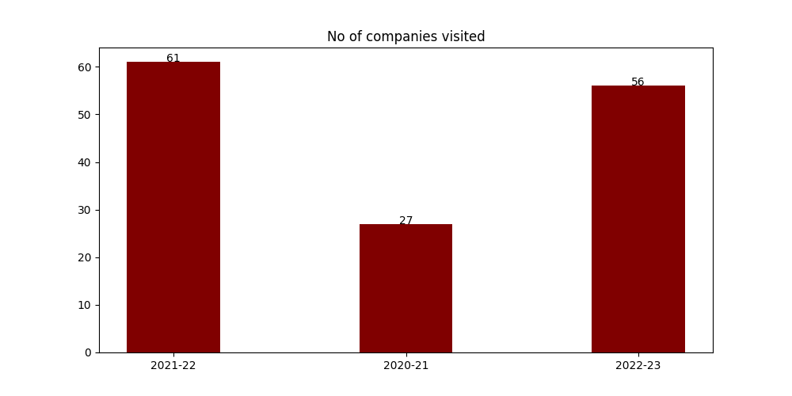

## b) Average package distribution:

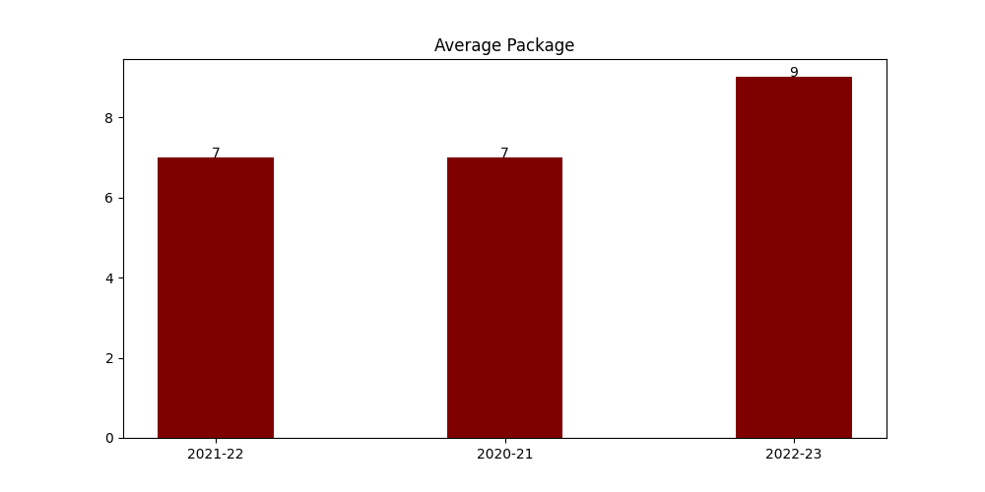

## c) No. of Offers:

