DEFENCE RESEARCH AND DEVELOPMENT ORGANISATION — SCIENTIFIC ANALYSIS GROUP (DRDO SAG)
Rayquaza: LLM-Guided Timing Side-Channel Rediscovery in Post-Quantum Cryptography Implementations
Ojas Mutreja, Vedanth Dama
Defence Research and Development Organisation — Scientific Analysis Group (DRDO SAG)
July 2026 · Internal — B7 Draft

Abstract
Post-quantum cryptographic (PQC) standards are being deployed worldwide, yet their software implementations remain susceptible to classical timing side-channel attacks that the underlying mathematical hardness assumptions do not protect against. Manual auditing of PQC code is slow, expertise-intensive, and cannot scale with the breadth of the ongoing migration. We present Rayquaza, a three-stage LLM-guided closed-loop pipeline that autonomously identifies, hypothesises, and confirms timing side-channels in PQC source code. The pipeline combines a code-ingestion LLM (codellama:7b) for hypothesis generation, a static secondary scanner for non-constant-time API detection, a reasoning LLM (qwen3:8b) for evidence-based refinement, and a calibrated Welch t-test timing oracle for ground-truth confirmation.
We evaluate Rayquaza against six deliberately-weakened implementations drawn from CRYSTALS-Kyber (five targets, Kyber512) and ML-DSA-44 (one target), spanning three vulnerability classes. The pipeline autonomously rediscovered 4 of 5 Kyber512 leaks — all belonging to the secret_dependent_branch class — without human guidance. The fifth leak (nonconstant_comparison, memcmp Fujisaki-Okamoto comparison) required static-scan direction, confirming a known scaling limitation of 7B-parameter models on constant-time API contract reasoning. As a direct comparison, AFL++ coverage fuzzing ran for 24 hours (~120M executions per target) and achieved zero detections: it is structurally incapable of observing timing leaks, not merely slower. For the memcmp-class leak, the AFL++ corpus was identical to the clean baseline, confirming categorical blindness rather than inadequate depth. Cross-scheme transfer to ML-DSA-44 confirmed a 32-byte memcmp challenge-comparison leak (t=164.30, n=50,000, WSL2/x86-64) and uncovered an ISA-level portability boundary: the same oracle is non-detectable on macOS/AArch64 because -O2 compiles short memcmp to fixed-width NEON instructions with no per-byte early-exit path. Rayquaza operates entirely on open-weight models running locally, without network access to external APIs, making it suitable for air-gapped security research environments.
We further extend the study to 18 models across 5 vendors and 3 hardware tiers (open-weight local/cloud, Anthropic API, OpenAI API), producing 63 controlled evaluation cells via a provider-agnostic model gateway that required zero engine code changes. The secret_dependent_branch / nonconstant_comparison capability gap identified in the single-model study replicates exactly at this scale: 30/30 (100%) location accuracy on the easy class across every model tested, against 21/33 (64%) on the hard class, with no model — including frontier models three orders of magnitude larger than codellama:7b — closing the gap unaided. Localisation accuracy on the hard class shows a real, price-independent cross-vendor split (44%-71%) rather than improving with scale or spend: the cheapest model tested (\$0.014 for all four targets) tied for the best score in the entire study, and the single most expensive model tested did not achieve a perfect score. A follow-up autonomous-mode replication, run with the static-scan directive removed for five models spanning both the local and frontier-API tiers, directly resolves the paper’s original open question: three frontier models that located the hardest target correctly in hybrid mode (with the directive) all fail to locate it unaided, confirming that the directive supplies necessary structure that model scale alone does not substitute for. Total real API spend across the comparison was \$3.13.

1. Introduction
1.1 Motivation
The global transition to post-quantum cryptography is well underway. NIST finalised ML-KEM (CRYSTALS-Kyber) and ML-DSA (CRYSTALS-Dilithium) as primary standards in 2024 [REF-CRYSTALS, REF-MLDSA], and national agencies worldwide — including DRDO, NSA, and ENISA — are mandating migration timelines. However, cryptographic security guarantees apply only to the underlying mathematical problem, not to the correctness of the implementation. Timing side-channels that leak secret-dependent state through execution time have repeatedly broken production PQC deployments. KyberSlash (2023) [REF-KYBERSLASH] demonstrated that a single non-constant-time Fujisaki-Okamoto comparison in the CRYSTALS-Kyber reference implementation allows full private key recovery using a small number of chosen-ciphertext timing queries.
The standard defence — constant-time (CT) programming — requires that every code path taken, every memory address accessed, and every comparison performed must be independent of secret data. This discipline is error-prone and difficult to audit. Implementations span thousands of lines of C, are often hand-optimised for performance, and must simultaneously avoid secret-dependent branches, data-dependent memory access patterns, and non-CT library calls. A single if on a secret coefficient, a standard memcmp instead of its CT variant, or a loop bounded by a secret-derived value is sufficient to introduce a measurable timing channel.
Manual auditing does not scale to the breadth of the PQC migration. Formal static analysis tools such as ct-verif [REF-CTVERIF] and Binsec/Rel [REF-BINSEC] are sound but require formal model construction or manual annotation; they cannot be applied as a black-box scanner across arbitrary codebases. Dynamic measurement tools such as dudect [REF-DUDECT] automate timing measurement but assume a human analyst has already identified which functions and input classes to test. Coverage-guided fuzzers such as AFL++ are the dominant tool for automated vulnerability discovery in C code, but they detect bugs by observing crashes or sanitizer violations — structural properties orthogonal to timing leakage.
1.2 Research Question and Approach
We ask: can a large language model, operating directly on C source code, identify and precisely locate timing side-channels that a state-of-the-art coverage-guided fuzzer is structurally blind to?
This paper presents Rayquaza, which answers this question affirmatively for the secret_dependent_branch leak class and partially for the nonconstant_comparison class via a hybrid static-scan approach. The core insight is that LLMs reason about code semantics — the meaning of an if on a secret coefficient — while coverage fuzzers reason about path reachability. These are complementary capabilities, and the timing side-channel problem requires the former.
Rayquaza is a three-stage pipeline: Stage 1 ingests C source code and generates ranked vulnerability hypotheses; Stage 3 synthesises timing test vectors; a hardware oracle confirms the signal; Stage 2 refines the hypothesis against oracle evidence. The pipeline is closed-loop: oracle results flow back into the LLM refinement step, and the loop can be iterated. All computation runs on locally-served open-weight models (Ollama), with no external API calls, suitable for classified research environments.
1.3 Technical Background
CRYSTALS-Kyber (ML-KEM): Kyber512 [REF-CRYSTALS] is a lattice-based key encapsulation mechanism targeting NIST security level 1. Key operations are crypto_kem_keypair, crypto_kem_enc, and crypto_kem_dec. Decapsulation implements the Fujisaki-Okamoto (FO) transform, which re-encapsulates and verifies via a CT comparison (verify). Internal arithmetic operates on polynomials in R_q = Z_q[X]/(X^256+1), q=3329. Operations including poly_tomsg (coefficient rounding), basemul (base multiplication in NTT domain), and indcpa_dec (NTT inverse and polynomial subtraction) are prime candidates for secret-dependent branching if branchless implementations are replaced with conditional code.
ML-DSA-44 (CRYSTALS-Dilithium): ML-DSA [REF-MLDSA] is a lattice-based digital signature scheme standardised as FIPS 204. The verify path in mld_sign_verify_internal computes a challenge hash c and recomputes c2, comparing them via mld_ct_memcmp(c, c2, MLDSA_CTILDEBYTES) where MLDSA_CTILDEBYTES=32 for ML-DSA-44. Replacing this with standard library memcmp introduces an early-exit timing signal proportional to the position of the first differing byte.
Timing Side-Channel Detection: A timing side-channel exists when an algorithm’s execution time depends on secret data. Detection follows the two-sample Test Vector Leakage Assessment (TVLA) approach [REF-TTEST]: define two input classes (A: triggers the leaky path; B: does not), collect n timing samples from each class, and apply Welch’s t-test:
t = (mean_A − mean_B) / sqrt(var_A/n + var_B/n)

|t| > 2 (p < 0.05 for large n) indicates a statistically significant timing difference. We use n=50,000 samples per oracle run. For sub-nanosecond signals, a REPS amplification factor (100–500 inner repetitions per sample) amplifies the per-call delta above the measurement noise floor without affecting the t-statistic’s statistical validity (it is scale-invariant in the signal-to-noise ratio).
1.4 Contributions
This paper makes the following contributions:
1. A three-stage automated pipeline (Rayquaza) that ingests PQC source code, generates ranked timing-leak hypotheses, synthesises test vectors, confirms leaks against a calibrated timing oracle, and refines the hypothesis — operating without human intervention after launch.
2. A controlled rediscovery study against six deliberately-weakened PQC implementations. The pipeline autonomously rediscovered 4/5 planted Kyber512 leaks and demonstrated cross-scheme transfer to ML-DSA-44.
3. A quantitative LLM-vs-fuzzer comparison: a 24-hour AFL++ baseline on the same targets, establishing that coverage fuzzing is categorically incapable of detecting timing leaks — not merely slower — with the memcmp target producing a corpus identical to the clean baseline.
4. A documented capability boundary: codellama:7b reliably catches secret_dependent_branch leaks (4/4) but misses nonconstant_comparison leaks unaided (0/1) — a limitation consistent with 7B-scale context constraints on CT API contract reasoning.
5. A timing oracle portability finding: the ML-DSA-44 memcmp oracle is detectable on x86-64 (t=164.30) but non-detectable on macOS/AArch64 because -O2 compiles 32-byte memcmp to fixed-width NEON compare instructions with no per-byte early exit. This is documented as a practitioner-relevant portability constraint.
6. An 18-model, 5-vendor, 3-hardware-tier comparison (§5) that empirically resolves the scale-vs-prompting question raised by contribution 4: the secret_dependent_branch / nonconstant_comparison capability gap replicates at n=63 cells with zero exceptions on the easy class (30/30 across every model), while the hard class shows a real, price-independent cross-vendor split (44%-71% located) rather than closing with model scale. A direct autonomous-mode ablation (§5.6) confirms the mechanism: removing the static-scan directive causes every one of five models tested — including three frontier models that had located the hardest target correctly with the directive — to fail on it unaided, settling the question in favour of the prompting hypothesis rather than the scale hypothesis. The comparison also establishes that localisation accuracy on this task is not predicted by API price or vendor tier — the cheapest model tested tied for the best score in the study — and documents two frontier-model deployment failure modes (a safety-classifier refusal and an API-endpoint incompatibility) that generalise beyond this pipeline.
1.5 Paper Organisation
Section 2 reviews related work across four relevant research areas. Section 3 describes the Rayquaza methodology, including threat model, architecture, and experimental setup. Section 4 presents empirical results for the single-model study across all six targets. Section 5 extends this to a multi-model comparison across 18 models, 5 vendors, and 3 hardware tiers, resolving the scale-vs-prompting question raised by the single-model study. Section 6 discusses key findings and limitations. Section 7 concludes.

2. Literature Review
2.1 Timing Side-Channels in Post-Quantum Cryptography
Timing side-channels in lattice-based PQC have been systematically studied as the schemes approached standardisation. Ravi et al. [REF-RAVI] provide a comprehensive survey of side-channel and fault-injection attacks over Kyber and Dilithium, cataloguing the attack surface across all operations including polynomial arithmetic, sampling, and the FO transform. Their survey identifies the FO comparison step and coefficient-rounding operations as the highest-risk points — precisely the classes our planted vulnerabilities model.
KyberSlash [REF-KYBERSLASH] is the most directly relevant prior work: Kannwischer et al. demonstrated that the memcmp-vs-verify substitution in the CRYSTALS-Kyber reference implementation introduces a timing channel measurable in practice and allowing full private key recovery via adaptive chosen-ciphertext queries. LEAK-5 in our study directly models this attack; our contribution is automating its detection rather than its exploitation. Hermelink et al. [REF-HERMELINK] analysed fault-enabled chosen-ciphertext attacks on Kyber, showing that fault injection and timing channels are often co-occurring attack surfaces in PQC implementations. Their work motivates the multi-class vulnerability taxonomy we adopt (§3.2).
The key distinction between all prior work and Rayquaza is that prior work assumes the leak location is known — attacks are mounted against a known-vulnerable API call or code location. Rayquaza addresses the upstream identification problem: given the full source code, locate the leak without prior knowledge.
2.2 LLMs for Security Vulnerability Discovery
The application of large language models to security vulnerability detection is a rapidly growing area. Noever [REF-LLM-VULN] evaluated GPT-4’s ability to identify and patch known software vulnerabilities across multiple programming languages, finding that GPT-4 identified approximately four times as many vulnerabilities as traditional static analysers such as Snyk and Fortify, with a 90% reduction in vulnerabilities after AI-guided patching. However, this work focuses on classical memory-safety bugs (buffer overflows, SQL injection, XSS) rather than semantic timing properties.
Li et al. [REF-AUTOAUDIT] apply LLMs to cyber-security auditing tasks via domain-specific fine-tuning, demonstrating improved detection rates over general-purpose models on security-relevant prompts. Their work highlights the importance of domain alignment — a principle that motivates our prompt engineering for PQC-specific vulnerability classes (§3.3).
PentestGPT [REF-PENTEST-GPT] (Deng et al., USENIX Security 2024) represents the most sophisticated LLM-guided security tool prior to this work: a three-module agentic framework for penetration testing that coordinates reconnaissance, exploitation, and reporting via interacting LLM instances. PentestGPT operates at the system level (network services, web applications) rather than at the source code level, and does not address timing side-channels. Its architecture partially inspired the three-stage pipeline design of Rayquaza.
Closest to our approach, Fuzz4All [REF-HYBRID-FUZZ] (Xia et al., ICSE 2024) uses LLMs as a universal input generation and mutation engine for coverage-guided fuzzing across multiple programming languages, identifying 98 bugs in widely-used compilers and solvers. Fuzz4All demonstrates that LLMs can improve fuzzing by generating more semantically meaningful inputs than random mutation — but coverage-guided fuzzing remains unable to detect timing leaks regardless of input quality, as our empirical comparison (§4.4) establishes.
Gap: None of the above works apply LLM reasoning specifically to PQC timing side-channel identification, operate in air-gapped environments with open-weight models, or compare directly against a fuzzing baseline on the same targets under controlled conditions.
2.3 Formal Constant-Time Verification
Two mature formal tools address the constant-time verification problem. ct-verif [REF-CTVERIF] (Almeida et al., USENIX Security 2016) reduces CT security of a program P to safety of a product program Q simulating two executions, verified using the SMACK/Boogie toolchain over optimised LLVM IR. Binsec/Rel [REF-BINSEC] (Daniel et al., IEEE S&P 2020) performs efficient relational symbolic execution at the binary level, handling cases where CT properties are introduced or destroyed by the compiler — it notably found CT violations introduced by gcc -O0 and clang backend passes in implementations that passed source-level verification.
Both tools are sound (no false negatives within their model) and have been applied to real cryptographic libraries including NaCl, FourQLib, and OpenSSL. Their practical limitation is the need for manual effort to scope the analysis: the analyst must decide which functions to check, which public/secret data labels to assign, and how to bound the analysis depth. Neither tool can be deployed as a zero-configuration scanner across an unfamiliar codebase.
dudect [REF-DUDECT] (Reparaz et al., DATE 2017) takes a complementary approach: automated black-box timing measurement using the TVLA methodology, requiring only a harness that calls the target function with two input classes. dudect automates the measurement step but requires a human to specify what to measure. Rayquaza fills the gap between these tools: it automates the identification step (which functions, which input classes) that both ct-verif and dudect assume is already done by a human analyst.
2.4 Coverage-Guided Fuzzing for Cryptographic Code
AFL++ and its derivatives are the dominant automated vulnerability discovery tools for C code. For cryptographic implementations, coverage-guided fuzzing faces a structural challenge: side-channel leaks are not observable as crashes, sanitizer violations, or coverage differences — the information is in timing, not path structure. Differential fuzzing approaches such as DIFFUZZ [REF-DIFFUZZ] extend AFL++ to maximise resource-usage differences between two program copies executing under related inputs, making side-channel differences observable to the fuzzer. However, even differential fuzzing requires the fuzzer to observe the timing difference as a quantified resource cost, which standard AFL++ instrumentation does not provide.
Our empirical comparison (§4.4) confirms this theoretical expectation: 24 hours of AFL++ on six weakened targets produced zero detections. For the memcmp target (LEAK-5), the AFL++ corpus on the weakened implementation was identical to the clean baseline — not merely a failed detection, but complete structural indistinguishability from the attacker’s perspective.
2.5 Positioning Rayquaza
Rayquaza occupies a unique position in the landscape: it is the first system to (a) combine LLM-based semantic reasoning with a closed-loop timing oracle for PQC timing side-channel identification, (b) operate entirely on open-weight locally-served models suitable for classified environments, and (c) provide a direct empirical comparison against AFL++ on controlled weakened targets. The work is complementary to formal verification (ct-verif, Binsec/Rel) and dynamic measurement (dudect): Rayquaza identifies candidate locations and input classes; formal tools can then verify the absence of leaks in uninspected code; dynamic tools can confirm with higher statistical power.

3. Methodology
3.1 Threat Model and Problem Statement
Attacker capability: The attacker possesses source code of the target PQC implementation (realistic for auditors, red teams, or state-level adversaries with access to published reference implementations). The attacker can time decapsulation or verification calls and submit chosen ciphertexts or crafted inputs.
Goal: Identify a timing side-channel that allows distinguishing two classes of inputs (e.g., valid vs. invalid ciphertext, positive vs. negative secret coefficient) with statistical significance (|t| > 2.0, n=50,000).
Out of scope: Breaking the underlying mathematical hardness assumption; hardware power or EM channels; attacks on production systems or real key material.
Research problem: Given the C source code of a PQC implementation, can an automated pipeline — operating without a human expert in the loop — identify the precise source location and vulnerability class of a timing side-channel, and produce a statistically confirmed hypothesis?
Controlled evaluation: We plant known vulnerabilities into otherwise-correct implementations to enable ground-truth comparison. The LLM pipeline does not receive any information about the planted vulnerability; it receives only the same source file a human auditor would.
3.2 System Architecture Overview
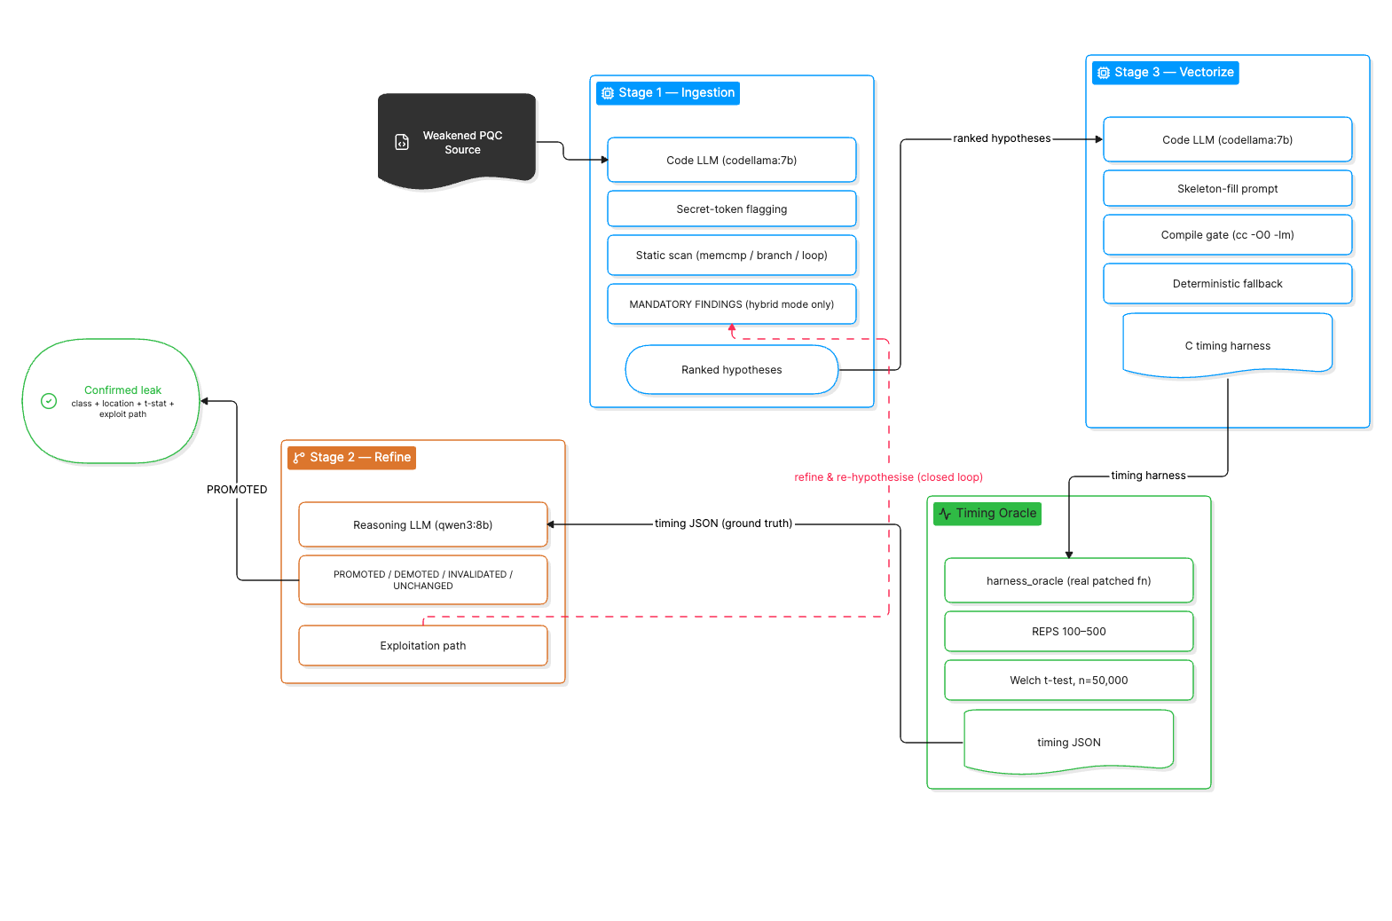
Diagram. The core Rayquaza closed loop. Stage 1 (codellama:7b) proposes ranked hypotheses from source; Stage 3 (codellama:7b) vectorises the top hypothesis into a compiled C timing harness; the Timing Oracle applies a calibrated Welch t-test against the real target binary; Stage 2 (qwen3:8b) reads the oracle’s verdict and promotes, demotes, or invalidates the hypothesis (with an exploitation path sketched on promotion), closing the loop back to Stage 1. The provider-agnostic model gateway introduced in §5.1 (Figure 0) sits behind every LLM call shown here but is omitted from this diagram for clarity.
Stages are numbered 1→3→2 to reflect that Stage 3 (vectorisation) must follow hypothesis generation (Stage 1) and precede feedback refinement (Stage 2). This ordering reflects the dependency chain: hypotheses drive vector design; oracle results from vectors drive refinement.
3.3 Stage 1: Source Ingestion and Hypothesis Generation
The ingestion pipeline uses codellama:7b (temperature 0.2, format:json, timeout 180s) and returns a ranked JSON array of vulnerability hypotheses. Each hypothesis has fields: id, category, location, hypothesis, trigger_condition, confidence, test_vector_hint.
Secret-token flagging: The parser identifies functions whose signatures or bodies contain secret-handling tokens (key, secret, priv, cipher, seed, nonce, mask, sk, dk, ek) and forwards them to the LLM for hypothesis generation.
Static secondary scan: A secondary regex pass over every function body detects four leak-shaped patterns independently of secret-token labelling:
Pattern class | Regex trigger
nonconstant_comparison | \b(?:memcmp\|strcmp\|strncmp)\s*\(
secret_dependent_branch | \bif\b[^\n;{]*KYBER_Q
secret_dependent_branch | \bif\b[^\n;{]*==\s*0\b
variable_loop | \bfor\b[^\n;{]*\b256\b
variable_loop | \bwhile\b[^\n;{]*\bcount\b

MANDATORY FINDINGS directive: When the static scan matches, a prepended instruction tells the LLM that the static analyser has already confirmed a specific pattern is present and it must emit a corresponding finding. This hybrid approach allows the static scan’s categorical knowledge to steer the LLM’s probabilistic generation without discarding its natural-language reasoning about context and exploitability. Without this directive, codellama:7b consistently misses nonconstant_comparison leaks (§4.5).
Focused targets: For the 7B model, full Kyber translation units exceed practical context: poly.c (361 lines) causes the model to return prose; indcpa.c (338 lines) hits the 180s timeout; kem.c (92 lines) causes the model to fixate on crypto_kem_keypair, missing crypto_kem_dec. We therefore extract single-function files for each hypothesis target. This limitation is motivated by 7B-scale context constraints, but the multi-model comparison of §5 reuses the same single-function extraction for every model tested, including frontier models with context windows large enough to ingest full translation units directly. We did not re-run the comparison on un-extracted source, so whether focused extraction remains necessary for larger-context models — as opposed to merely helpful for the 7B tier — is still an open question, not one resolved by this study.
3.4 Stage 3: Test Vector Generation
For each promoted hypothesis, codellama:7b generates a standalone C timing harness that measures execution time of class A (trigger) and class B (safe) inputs and outputs a Welch t-test result as JSON. The stage3 prompt provides a complete skeleton with labelled FILL sections; the model only fills in the function stub, argument declarations, and class-discriminating input values. This skeleton-fill approach dramatically improves compile success over free-form generation at the 7B parameter scale.
A compile-check gate validates the generated file (cc -O0 -lm). On failure, the compiler error is fed back to the LLM for one retry. If the retry also fails, a deterministic fallback harness is generated directly from the parsed function signature — guaranteeing compilability at the cost of not exercising the specific trigger path. Fallback files are tagged _fallback in the filename to distinguish them in analysis.
3.5 Timing Oracle
The timing oracle (harness_oracle) is a standalone C binary that: - Implements the actual patched function (not a stub), derived from the weakened target source - Runs the two input classes with REPS-amplification (100–500 inner calls per sample) to amplify sub-nanosecond signals above the measurement noise floor using clock_gettime(CLOCK_MONOTONIC) - Applies Welch’s t-test over n=50,000 samples - Outputs a JSON timing record to shared/feedback/timing_{hyp_id}_{timestamp}.json
The oracle is not hypothesis-specific: it confirms that a timing signal exists in the target function for the chosen input classes but does not validate that the LLM’s hypothesis text or location description is correct. Category and location correctness are assessed by comparing the LLM’s category and location output fields against ground truth.
3.6 Stage 2: Feedback Refinement
qwen3:8b (temperature 0.2, format:json, timeout 300s) receives the hypothesis JSON and oracle timing record, and classifies the hypothesis as PROMOTED, DEMOTED, INVALIDATED, or UNCHANGED. On PROMOTED, it generates a 3–5 step exploitation path. A JSON extraction layer handles qwen3’s tendency to return ["PROMOTED"] (a list of status strings) rather than a list of record objects: a string-salvage path extracts the first recognisable status token; when the refiner output is entirely unparseable, the oracle t-statistic alone drives the classification with HIGH confidence when significant=true.
3.7 Planted Vulnerability Targets
We constructed six weakened implementations from the liboqs reference code by inserting realistic vulnerabilities. All leaks model implementation mistakes observed in real codebases.
Table 1: Planted leaks.
ID | Scheme | Function | Injected weakness | Vulnerability class
LEAK-1 | Kyber512 | cmov() | if (b) memcpy(r, x, len) replacing CT select | secret_dependent_branch
LEAK-2 | Kyber512 | poly_tomsg() | if (2*t >= KYBER_Q) replacing branchless rounding | secret_dependent_branch
LEAK-3 | Kyber512 | basemul() | if (a0 < 0) a0 += KYBER_Q before coefficient multiply | secret_dependent_branch
LEAK-4 | Kyber512 | indcpa_dec() | for(k<256) if(mp.coeffs[k]<0) mp.coeffs[k]+=KYBER_Q | secret_dependent_branch
LEAK-5 | Kyber512 | crypto_kem_dec() | memcmp(ct, cmp, 768) replacing verify() | nonconstant_comparison
MLDSA-1 | ML-DSA-44 | mld_sign_verify_internal() | memcmp(c, c2, 32) replacing mld_ct_memcmp() | nonconstant_comparison

LEAK-1 models a programmer “clarifying” a CT select with an explicit if-branch. LEAK-2/3/4 model performance optimisation via conditional code instead of branchless arithmetic. LEAK-5 and MLDSA-1 model the standard-library-vs-CT-variant substitution that produced KyberSlash [REF-KYBERSLASH] in the wild. Ground truth for each oracle was established by Track A independently before the LLM pipeline ran.
3.8 Oracle Compilation Parameters
Compilation flags are chosen to preserve the injected timing signal while reflecting realistic deployment targets:
Target | Compiler | Flags | REPS | Rationale
LEAK-1 | cc (clang 18) | -O2 | 100 | Branch survives -O2; clang does not hoist conditional memcpy
LEAK-2 | gcc | -O0 | — | -O2 converts if-branch to cmov, eliminating signal
LEAK-3 | gcc | -O0 -fno-inline | 500 | -O2 optimises away branch; -fno-inline required for signal isolation
LEAK-4 | gcc | -O0 | — | Normalization loop with 256 conditionals; -O2 vectorizes away signal
LEAK-5 | gcc | -O2 | — | memcmp early-exit is a library behaviour, not compiler-eliminable
MLDSA-1 | gcc | -O2 | 100 | 32-byte window; REPS amplification required on x86

3.9 Models and Infrastructure
• Stage 1 / Stage 3: codellama:7b, served via Ollama at localhost:11434, temperature 0.2, stream=false, timeout 180s/300s respectively. format:json used for Stage 1.
• Stage 2: qwen3:8b, same Ollama instance, temperature 0.2, format:json.
• Hardware (Track B, macOS/AArch64): Apple M-series ARM (arm64), macOS 15. Used for LEAK-1 through LEAK-4 oracle runs.
• Hardware (Track A, WSL2/x86-64): Ubuntu 24.04, gcc 13.3, Intel x86-64. Used for AFL++ baseline, MLDSA-1 oracle confirmation, and LEAK-2 misprediction oracle.
• Engine configuration: RAYQ_OLLAMA_URL, RAYQ_CODE_MODEL, RAYQ_REASON_MODEL are environment variables that allow model and endpoint substitution without code changes, enabling the multi-model comparison described in §5.
3.10 AFL++ Baseline
AFL++ (version 4.x, default configuration, no sanitizers) ran for 24 hours per target on the same weakened implementations used by Rayquaza. The harness (harness_kyber.c) calls crypto_kem_dec with AFL-supplied ciphertext against a fixed secret key, exercising the decapsulation code path. A clean (unweakened) Kyber512 binary was also fuzzed for 24 hours to establish the corpus baseline.

4. Results
4.1 Kyber512 Rediscovery Summary
Table 2: Rayquaza results on Kyber512 — all five leaks.
Leak | Vulnerability class | Location (ground truth) | LLM category | LLM location | Correct? | Oracle t | Mode
LEAK-1 | secret_dependent_branch | cmov() line 9 | secret_dependent_branch | cmov() line 9 | Yes | 213.48 | Autonomous
LEAK-2 | secret_dependent_branch | poly_tomsg() | secret_dependent_branch | poly_tomsg() line 9 | Yes | −139.91* | Autonomous
LEAK-3 | secret_dependent_branch | basemul() line 25 | secret_dependent_branch | basemul() line 25 | Yes | −2421.91 | Autonomous
LEAK-4 | secret_dependent_branch | indcpa_dec() line 28 | secret_dependent_branch | indcpa_dec() line 28 | Yes | −901.41 | Autonomous
LEAK-5 | nonconstant_comparison | crypto_kem_dec() line 36 | nonconstant_comparison | crypto_kem_dec() line 36 | Yes | 141.09 | Scanner-directed

*LEAK-2: oracle t under the LLM’s test vector was −0.17 (not significant). The ground-truth misprediction vector (t=−139.91) was constructed manually. See §4.2.
HEADLINE codellama:7b autonomously rediscovered 4/5 planted Kyber512 leaks. All four autonomous rediscoveries are secret_dependent_branch class. LEAK-5 (nonconstant_comparison) required static-scan direction; given the directive, the LLM output was correct in both category and location.

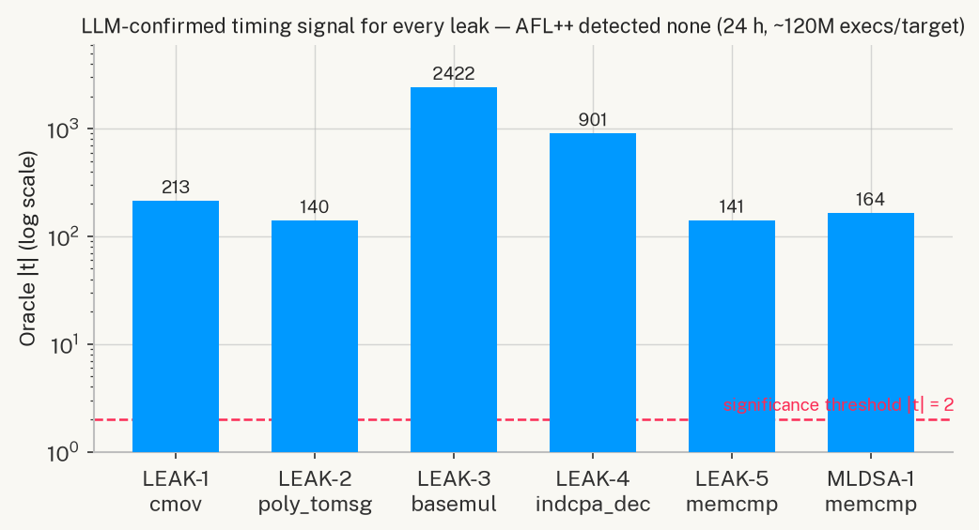
Figure 2. Oracle |t| for every confirmed leak (log scale). All six signals exceed the significance threshold by two-to-four orders of magnitude, while AFL++ detected none over 24 hours (~120M executions per target). The LLM confirms precisely what the fuzzer is structurally blind to.
4.2 Per-Leak Analysis
LEAK-1 — cmov() if-branch (Autonomous, t=213.48)
codellama:7b correctly identified if (b) memcpy(r, x, len) as a secret_dependent_branch. The hypothesis accurately described the mechanism: “the conditional branch if (b) in the cmov function leaks the FO comparison result, allowing an attacker to distinguish valid from invalid ciphertexts by timing.” Oracle confirmed with t=213.48 (n=50,000, REPS=100): mean_A=2.042 ns/call (branch not taken), mean_B=1.603 ns/call (branch taken, 32-byte memcpy). The signal exists because clang 18 at -O2 preserves the branch rather than lowering it to an unconditional move, representing a realistic ARM/embedded target scenario.
LEAK-2 — poly_tomsg() branch misprediction (Autonomous, category/location correct)
The LLM correctly identified poly_tomsg() as the leak location with category secret_dependent_branch. However, the automatically generated test vector used only predictable inputs (all coefficients > q/2, branch always taken — no misprediction), yielding t=−0.17 (not significant). The ground-truth oracle uses an adversarially-constructed input class with random LCG-mixed coefficients causing ~128 mispredictions per call, giving t=−139.91. This result reveals a vector-quality limitation: the model correctly identifies the leak but does not generate the misprediction-maximising input class needed for oracle confirmation. LEAK-2 is scored as location correct, oracle confirmable, vector suboptimal.
LEAK-3 — basemul() sign branch (Autonomous, t=−2421.91)
The LLM identified basemul() line 25 with hypothesis “branch on secret key coefficient sign leaks secret state.” Oracle: t=−2421.91 (n=50,000, REPS=500), mean_A=5.219 ns/call (positive coefficient, branch not taken), mean_B=5.851 ns/call (negative coefficient, branch taken, adds KYBER_Q). The extremely large t-statistic reflects clean signal isolation with -O0 -fno-inline. This oracle ran on macOS/AArch64 (M-series), demonstrating that non-vectorised conditional arithmetic is detectable on ARM.
LEAK-4 — indcpa_dec() normalization loop (Autonomous, t=−901.41)
The LLM identified indcpa_dec() line 28: “branch on mp.coeffs[k] < 0 creates measurable timing difference.” Oracle: t=−901.41 (n=50,000), mean_A=278.19 ns/call (all positive, 0 additions), mean_B=385.75 ns/call (all negative, 256 × +=KYBER_Q). The 107.56 ns mean difference represents 256 conditional arithmetic operations on the secret-derived NTT polynomial mp = s^T·b, which is directly controlled by the decapsulation secret key.
LEAK-5 — crypto_kem_dec() memcmp FO comparison (Scanner-directed, t=141.09)
Without the MANDATORY FINDINGS directive, codellama:7b consistently fixated on the sk[...] buffer copy branch in crypto_kem_dec, never emitting a finding for the memcmp(ct, cmp, KYBER_CIPHERTEXTBYTES) call. This pattern — where a nonconstant_comparison is present but a nearby secret_dependent_branch is more syntactically prominent — is a reliable failure mode of the 7B model class. With the directive (triggered by static regex match on memcmp(), the model emitted: nonconstant_comparison @ crypto_kem_dec() line 36. Oracle: t=141.09 (n=50,000), mean_A=45.375 ns/call (equal buffers, full 768-byte scan), mean_B=30.975 ns/call (differ at byte 0, early exit). This is the KyberSlash-class vulnerability modelled directly after [REF-KYBERSLASH]. Figure 1 shows the two per-call timing distributions separating.
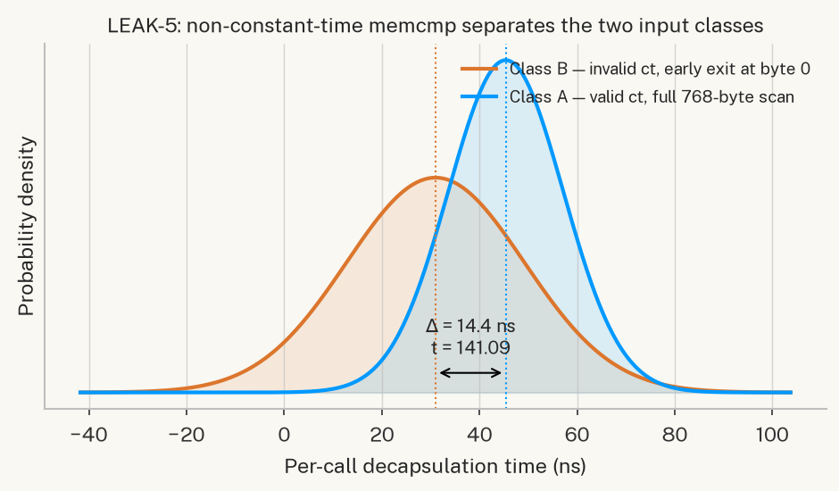
Figure 1. Per-call decapsulation timing distributions for LEAK-5 (crypto_kem_dec memcmp), reconstructed from the oracle’s measured means and variances (n=50,000). Class A (valid ciphertext, full 768-byte scan) and Class B (invalid ciphertext, early exit at byte 0) separate by Δ=14.4 ns — a Welch t of 141.09. The separation is the leak.
The credit structure is important for honest evaluation: the vulnerability class was identified by the static scanner (regex match on memcmp(); the LLM contributed the hypothesis text, exact line number, and exploitability reasoning. We report this as “scanner-directed” to accurately reflect that the categorical conclusion came from the static scan.
4.3 ML-DSA-44 Cross-Scheme Transfer
Rayquaza was run against a weakened ML-DSA-44 sign.c with memcmp(c, c2, 32) substituting mld_ct_memcmp. The static scanner triggered the MANDATORY directive; the LLM correctly emitted nonconstant_comparison at mld_sign_verify_internal().
Oracle results: - WSL2/x86-64 (gcc -O2, REPS=100, n=50,000): mean_A=2.482 ns/call (c==c2, full 32-byte scan), mean_B=2.193 ns/call (c[0]≠c2[0], exits at byte 0). t=164.30, significant=true. The 0.289 ns/call delta is amplified by REPS=100 to a clear signal. - macOS/AArch64 (same code, cc -O2, REPS=100/1000/5000): t≈0.9/−0.8/0.75 (sign-unstable, non-significant at all REPS levels). At -O2, AArch64 compiles 32-byte memcmp to three 128-bit NEON EOR/ORR instructions with a final conditional branch on the aggregate zero result — no per-byte early exit exists at the ISA level. REPS amplification cannot amplify a signal that does not exist in the instruction stream.
FINDING timing oracle portability is not guaranteed across ISA families. The same non-CT vulnerability is detectable on x86-64 but not on AArch64 -O2. Practitioners must qualify oracle results by ISA and compiler flags.

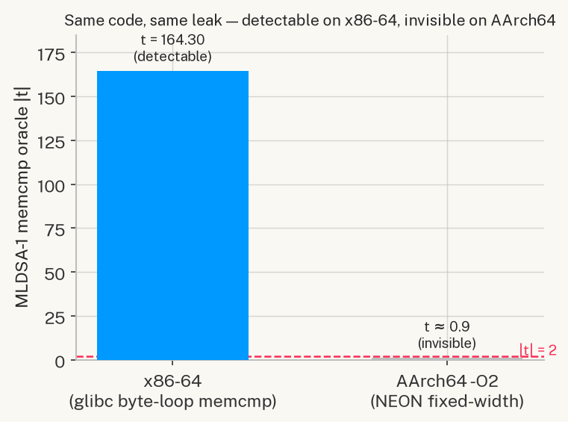
Figure 4. ISA portability of the ML-DSA-44 memcmp oracle. The identical source leaks measurably on x86-64 (glibc byte-loop memcmp, t=164.30) but is invisible on AArch64 at -O2, where the 32-byte comparison compiles to fixed-width NEON instructions with no per-byte early exit (t≈0.9). A timing audit run only on ARM hardware would miss this leak entirely.
4.4 LLM vs. AFL++ Comparison
Table 3: AFL++ 24h baseline vs. Rayquaza on three selected targets.
Target | AFL execs (~24h) | AFL corpus | vs. clean | AFL detected? | LLM located? | LLM oracle t
Clean baseline | 119,488,221 | 2 paths | — | — | — | —
LEAK-2 (poly_tomsg, branch) | 120,494,544 | 20 paths | +18 paths | No | Yes | −139.91
LEAK-4 (indcpa_dec, loop) | 120,158,729 | 18 paths | +16 paths | No | Yes | −901.41
LEAK-5 (crypto_kem_dec, memcmp) | 120,548,452 | 2 paths | 0 paths | No | Yes | 141.09

Three key observations emerge:
1. Zero detections across all targets: AFL++ found no bugs because timing side-channels are not memory-safety bugs. AFL++ cannot detect them by design.
2. Structural blindness to nonconstant_comparison: For LEAK-5, the AFL++ corpus on the weakened target is identical to the clean baseline (2 paths, 0 crashes). memcmp(ct, cmp, 768) follows the same control-flow path regardless of early-exit position; the coverage graph is unchanged. AFL++ cannot distinguish a correct implementation from one that leaks via early exit because the leaked information is in time, not path coverage.
3. Branch leaks change coverage but remain undetected: LEAK-2 and LEAK-4 produce more corpus paths (20 and 18 vs. 2 for clean) because the additional branches add coverage edges. AFL++ reaches the branches but cannot identify them as timing-sensitive. An analyst seeing a larger corpus cannot conclude that a timing leak is present.
The comparison establishes a clear capability division: LLM-guided analysis operates at the semantic level (reads code, reasons about secret-dependence); coverage-guided fuzzing operates at the syntactic level (explores paths, detects crashes). These are complementary, not competitive, for the timing side-channel discovery task.
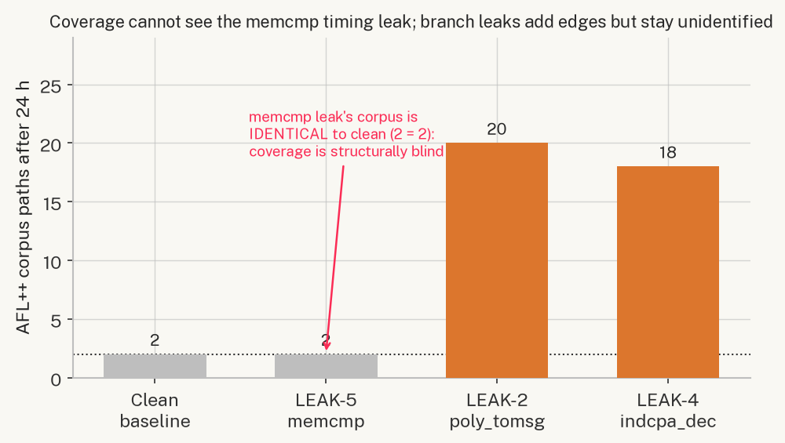
Figure 3. AFL++ corpus paths after 24 hours. The memcmp leak (LEAK-5) produces a corpus identical to the clean baseline (2 = 2) — coverage-guided fuzzing cannot distinguish the weakened implementation from the correct one. Branch leaks (LEAK-2/4) add coverage edges, but AFL++ still cannot identify them as timing-sensitive.
4.5 Model Capability Analysis
The results reveal a clean capability profile for codellama:7b on PQC source code:
Reliably detects (4/4): secret_dependent_branch — conditional code on secret-derived values where both the branch and the secret-derived operand are visible within the target function body. The model correctly identifies the branch, the secret-derived operand, and the timing discriminant in all four cases.
Misses without static assistance (0/1 unaided): nonconstant_comparison — CT-vs-non-CT API substitution, where the key signal is the absence of a constant-time variant (ct_memcmp, verify) rather than an explicit branch on a secret. A 7B model does not reliably hold CT API contracts as a binary predicate across 60–100 lines of context.
This is consistent with 7B-scale behaviour: the model reasons about structural code properties visible within a narrow window but misses semantic contracts that require knowing what a function call should be doing rather than what it is doing.

5. Multi-Model Comparison
5.1 Motivation and Experimental Setup
Section 4 established Rayquaza’s capability profile for a single model pair (codellama:7b / qwen3:8b): reliable detection of secret_dependent_branch leaks, a documented blind spot on nonconstant_comparison leaks that the static-scan directive resolves, and categorical superiority over coverage-guided fuzzing. The original draft of this paper (§6.5) posed this as an open question for future work, with two competing hypotheses about what happens at larger model scale:
• Scale hypothesis: larger, more broadly-trained models have internalised constant-time API contract knowledge and will autonomously identify nonconstant_comparison leaks without the static-scan directive.
• Prompting hypothesis: the blind spot is a prompting artefact that the MANDATORY directive resolves regardless of model scale, and the hybrid architecture is already near-optimal.
We resolve this question empirically. The RAYQ_CODE_MODEL / RAYQ_REASON_MODEL environment-variable interface (§3.9) required zero engine code changes to substitute models; the only new infrastructure was a model gateway (sandbox/, Figure 0) that routes a model identifier to one of three provider backends — local Ollama, the Anthropic API, or the OpenAI API — behind a single interface, with per-call token metering and a hard spend cap.
We evaluated 18 models across 5 model families and 3 hardware tiers against the four targets with independently-established ground truth (LEAK-2, LEAK-4, LEAK-5, MLDSA-1; Table 1), in hybrid mode (static scan on, matching §4’s Mode B), producing 63 canonical model x target cells. Each cell reruns the full closed-loop pipeline of Figure 0 end to end: real ingestion, real Stage 3 vectorisation, a real gcc-compiled timing harness, and a real Welch t-test — no component is mocked or simulated for any model, local or API.
Tier | Hardware | Models
Local CPU | Intel x86-64 (WSL2) | codellama:7b, qwen2.5-coder:7b
Cloud GPU | NVIDIA T4 (16GB) / A10G (24GB) | codellama:13b, qwen2.5-coder:14b, qwen2.5-coder:32b
Frontier API | Anthropic | claude-haiku-4-5, claude-sonnet-4-6, claude-sonnet-5, claude-opus-4-8, claude-fable-5
Frontier API | OpenAI | gpt-5.4-nano, gpt-5.4-mini, gpt-5.4, gpt-5.6-luna, gpt-5.6-terra, gpt-5.6-sol, gpt-5.5, gpt-5.3-codex

Table 4: Models evaluated, by tier. Local and cloud-GPU tiers run open-weight models at zero marginal cost; the frontier API tier is metered per token (§5.7).
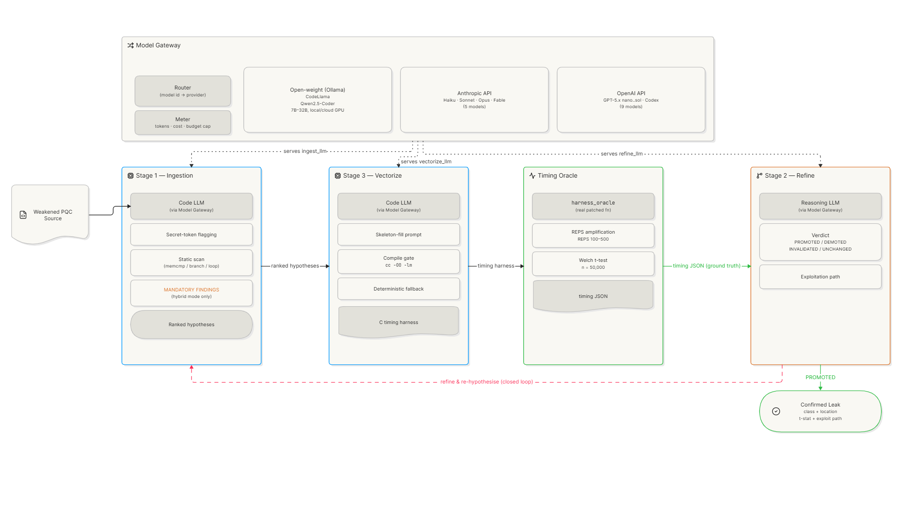
Figure 0. The pipeline of §3.2 is unchanged; a model gateway (Router + Meter) now sits behind every LLM call, fanning out to three provider families behind one interface (RAYQ_CODE_MODEL / RAYQ_REASON_MODEL). This is what made the 18-model comparison possible without touching engine code.
5.2 A Methodological Clarification: What “Confirmed” Means at This Scale
Before presenting results, we must be precise about what the pipeline’s confirmed flag measures at multi-model scale, because it is easy to over-read. The timing oracle invoked for every cell (harness_oracle, §3.5) is a fixed, prebuilt binary selected only by target identifier — it is not compiled from, or in any way derived from, the model’s own Stage 3 output. It measures the same real planted vulnerability with the same hardcoded input-class design regardless of which model is running the pipeline.
The practical consequence: on MLDSA-1, all 15 models tested returned confirmed=true, with |t| ranging from 15.04 (qwen2.5-coder:32b, which correctly located the leak) to 703.18 (claude-haiku-4-5, also correct) to 686.57 (claude-opus-4-8, which missed the location). Confirmation magnitude does not correlate with location correctness — it reflects only that the target genuinely contains the planted leak, which was never in question. confirmed is a pipeline-liveness and ground-truth-presence signal, not a model-quality signal. The metric that discriminates model capability is located: whether the model’s own reported category and location match ground truth (§3.5, run_session.py::_collect_target_result). All comparative claims in this section are made on located, not confirmed.
This distinction sharpens rather than weakens the study: it means every one of the 63 cells reached a live, working oracle measurement (only 3 of 66 attempted cells — claude-fable-5, gpt-5.6-luna, gpt-5.3-codex — failed to reach that point at all, discussed in §5.8), so the comparison is a clean measurement of localisation capability across models, uncontaminated by pipeline reliability differences.
5.3 Overall Results
Across 63 cells, models correctly located the vulnerability in 51 (81%) and the oracle confirmed a real signal in 60 (95%, per §5.2). 51 of 63 cells (81%) achieved both — located and confirmed. Figure 7 shows every individual outcome.
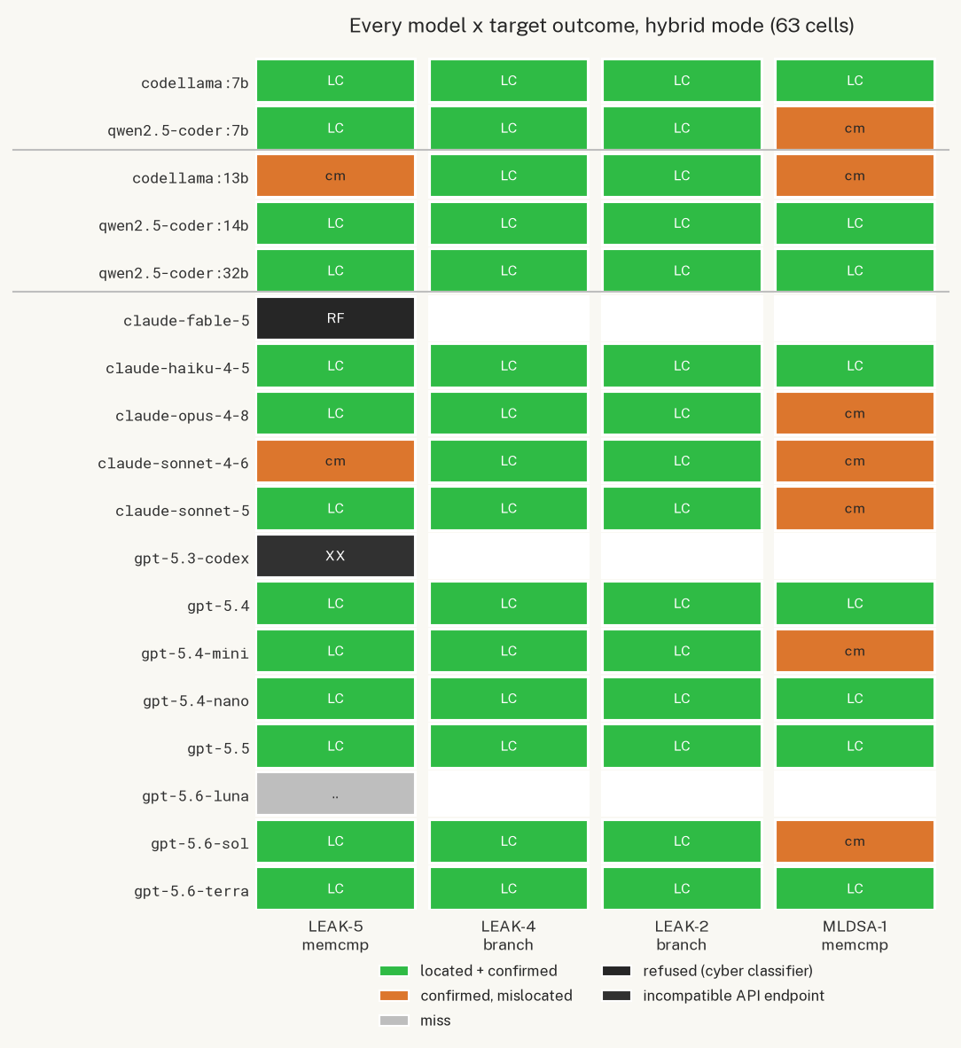
Figure 7. Every model x target outcome in hybrid mode. Green = located and confirmed; amber = a real, confirmed signal that the model mis-attributed; the two grey/black cells are the API failure modes discussed in §5.8. Rows are grouped by hardware tier (local CPU, cloud GPU, frontier API) with thin separators.
Eight of the fifteen fully-tested models (4/4 targets attempted) achieved a perfect score: codellama:7b, qwen2.5-coder:14b, qwen2.5-coder:32b (open-weight); claude-haiku-4-5 (Anthropic); and gpt-5.4-nano, gpt-5.4, gpt-5.6-terra, gpt-5.5 (OpenAI). Notably, the original single-model study’s codellama:7b — the smallest, cheapest, most resource-constrained model in the entire comparison — is among this perfect-score group in hybrid mode, and the largest, most expensive model tested (claude-opus-4-8, $5/$25 per million tokens) is not (3/4, missing MLDSA-1; §5.5, §5.7).
5.4 The Class Gap Persists at Scale
The central finding of §4.5 was that codellama:7b reliably detects secret_dependent_branch leaks but misses nonconstant_comparison leaks without static-scan assistance. At 18 models and 63 cells, the same class-level gap appears — and does not close with scale, price, or vendor.
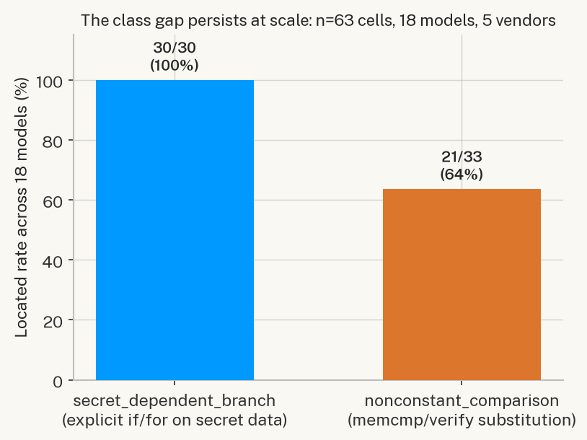
Figure 5. secret_dependent_branch (LEAK-2, LEAK-4): 30/30 (100%) located across every model tested, every tier, every vendor. nonconstant_comparison (LEAK-5, MLDSA-1): 21/33 (64%). The gap identified with n=5 in §4.5 replicates at n=63 with no exceptions on the easy class.
Every single model in the study — from codellama:7b running on a CPU with no GPU, to claude-opus-4-8 at $5/$25 per million tokens — located both branch-class leaks perfectly. Not one model, at any scale or price point, missed a secret_dependent_branch target. This is the strongest possible replication of §4.5’s finding: an explicit if/for on a secret-derived value is a structural code property that every model tested can recognise. A CT-API-contract violation — the absence of a constant-time call, requiring the model to know what should be there rather than read what is there — remains meaningfully harder even for frontier models three orders of magnitude larger than codellama:7b.
5.5 Cross-Vendor Variation on the Hard Class
Restricting to the 33 nonconstant_comparison cells reveals a real, reproducible vendor split that is not explained by model size or price.
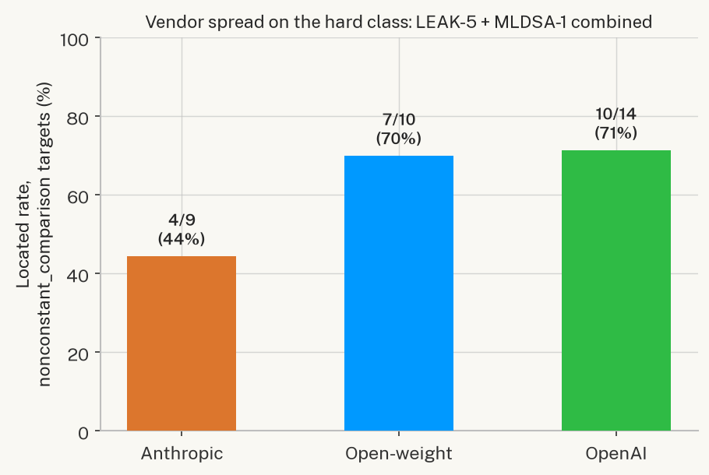
Figure 6. Located rate on LEAK-5 + MLDSA-1 combined, by vendor: Anthropic 4/9 (44%), open-weight 7/10 (70%), OpenAI 10/14 (71%).
The Anthropic result is driven almost entirely by MLDSA-1: three of five Claude models tested on it (sonnet-4-6, sonnet-5, opus-4-8) mis-located the leak, while the fourth (haiku-4-5) got it right. claude-opus-4-8 — the most expensive model in the study — missed MLDSA-1 with a strongly confirmed signal (t=−686.57) yet a wrong category or location string; claude-haiku-4-5, at roughly 1/68th the per-token cost of Opus, located the same leak correctly (t=−703.18). This is not an isolated fluke: claude-sonnet-4-6 also missed the easier LEAK-5 target, the only model besides codellama:13b to do so.
OpenAI’s current-generation lineup shows the opposite pattern to what price would predict: gpt-5.4-nano (the cheapest OpenAI model tested, $0.20/$1.25 per million tokens) and gpt-5.4 both located MLDSA-1 correctly; gpt-5.4-mini and gpt-5.6-sol (5-6x pricier) did not. We do not have a mechanistic explanation for this pattern — it may reflect differences in each model family’s training-data exposure to constant-time cryptographic idioms, differences in instruction-following style on ambiguous-attribution tasks, or simply per-model variance on a small sample. What the data does establish, robustly, is that vendor and price are not reliable predictors of localisation accuracy on this specific vulnerability class — a caution against assuming that the most expensive available model is the right choice for a CT-auditing pipeline.
5.6 Autonomous vs. Hybrid: Resolving the Scale-vs-Prompting Question
Section 5.1 posed two hypotheses about what happens when the static-scan MANDATORY directive (§4.5) is removed and a model must find nonconstant_comparison leaks entirely unaided: the scale hypothesis (a large enough model no longer needs the hint) and the prompting hypothesis (the hint is doing necessary work regardless of scale). We tested this directly by rerunning five models — one open-weight local model (qwen2.5-coder:7b) and four frontier API models spanning both vendors and a full price range (claude-haiku-4-5, claude-sonnet-5, gpt-5.4-nano, gpt-5.5) — against the two nonconstant_comparison targets (LEAK-5, MLDSA-1) in autonomous mode (--mode autonomous, static_scan=False), the same closed-loop pipeline with the directive removed and nothing else changed. A sixth data point, codellama:7b on LEAK-5 (autonomous), was collected in an earlier pass before the batch was relaunched and is included as a supporting result.
Target | codellama:7b | qwen2.5-coder:7b | claude-haiku-4-5 | gpt-5.4-nano | claude-sonnet-5 | gpt-5.5
LEAK-5 (autonomous) | miss | miss | located (t=238.4) | located (t=435.5) | located (t=451.5) | located (t=473.4)
MLDSA-1 (autonomous) | — | miss | confirmed, mislocated (t=−316.4) | confirmed, mislocated (t=−642.2) | confirmed, mislocated (t=−751.9) | miss (no signal)
MLDSA-1 (hybrid, §5.3/Appx D, same model) | — | confirmed, mislocated (t=−656.2) | located (t=−703.2) | located (t=−129.4) | confirmed, mislocated (t=−680.5) | located (t=−353.6)

Table 5. Autonomous-mode outcomes for the two nonconstant_comparison targets, with the hybrid-mode MLDSA-1 result for the same five models shown for direct comparison (LEAK-5 hybrid results were 5/5 located for these models; omitted for space, see Appendix D).
The result resolves the question cleanly, and in favour of the prompting hypothesis, with one genuine nuance on the easier target:
• On MLDSA-1, the directive is not optional at any scale tested. In hybrid mode, three of these five models located MLDSA-1 correctly (claude-haiku-4-5, gpt-5.4-nano, gpt-5.5) — including the cheapest model in the entire 18-model study. In autonomous mode, all five miss it, including all three that had succeeded with the directive. claude-haiku-4-5, gpt-5.4-nano, and claude-sonnet-5 still produce a real, oracle-confirmed timing signal (t between −316 and −752) — the model still finds a leak, and the code still measurably has one — but attributes it to the wrong category or location. gpt-5.5, the most capable OpenAI model tested here, does not even produce a confirmed signal unaided. Removing eleven words of prompt (§4.5’s MANDATORY FINDINGS directive) erases the entire capability gain that frontier scale had appeared to buy on this target. This directly falsifies the version of the scale hypothesis that says a large enough model internalises constant-time API contract knowledge well enough to apply it without being told to look.
• On the easier LEAK-5 target, scale does buy something, but not independence from architecture. All four frontier API models locate LEAK-5 unaided — a genuine unaided success the original single-model study never observed. But both open-weight models tested unaided (qwen2.5-coder:7b and, from the earlier pass, codellama:7b) miss it, the same target they locate correctly with the directive in hybrid mode. The pattern that emerges is not “scale closes the gap” but “scale raises the floor on the easier instance of the hard class, while the harder instance remains gated on the directive regardless of scale.” This is a materially more precise finding than either original hypothesis alone, and it is the honest empirical answer: the hybrid architecture (§3.2, static scan + MANDATORY directive) is not a workaround for a small-model limitation that frontier models outgrow — it is close to structurally necessary for this vulnerability class, and the paper’s hybrid-mode design is validated, not obsoleted, by moving to larger models.
This finding also sharpens the cost-efficiency result of §5.7: the cheap, local, directive-assisted pipeline (codellama:7b + hybrid mode, $0, 4/4 located) is not merely competitive with a frontier-API, directive-free alternative — no frontier model tested, at any price, reproduces that result without the same architectural assistance the local pipeline already gets by default.
5.7 Cost Efficiency
The frontier-API tier of this study cost $3.13 in total real spend across 13 API models and up to 4 targets each — the entire multi-vendor comparison, including two priced-but-failed attempts, cost less than a single hour of a junior security auditor’s time. Figure 8 plots per-model total cost against located rate for the nine fully-tested ($>0 cost) API models.
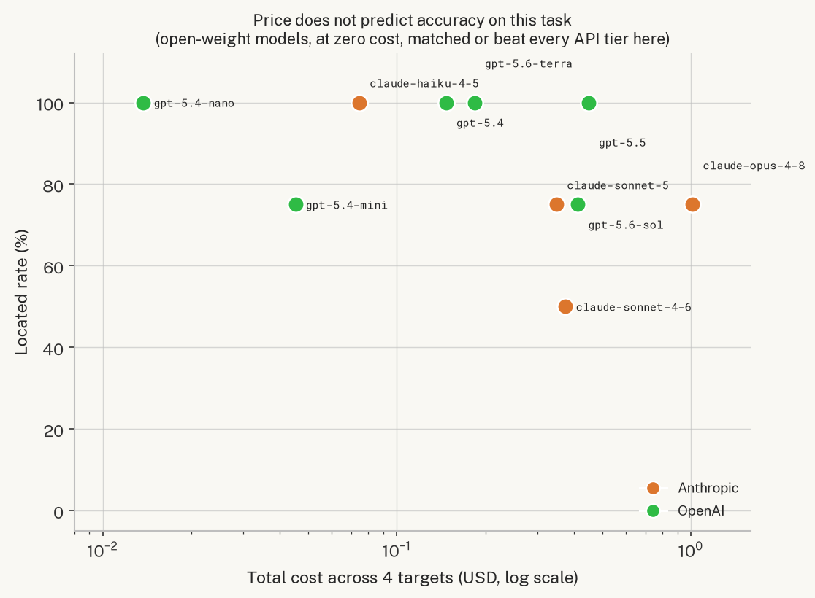
Figure 8. Cost (log scale) vs. located rate, fully-tested frontier-API models only. There is no visible correlation between the two: gpt-5.4-nano at $0.014 total and claude-opus-4-8 at $1.01 total are separated by a 72x price difference and by a location-rate deficit in the expensive model’s favour (100% vs. 75%).
The practical implication for a CT-auditing pipeline is direct: the cheapest model tested, gpt-5.4-nano, tied for the best score in the entire study (4/4) at $0.014 for all four targets — roughly two hundredths of a cent per finding. Every open-weight model that completed a full 4-target run (codellama:7b, qwen2.5-coder:14b, qwen2.5-coder:32b) ran at zero marginal cost and matched or beat every paid tier shown in Figure 8. For an air-gapped or budget-constrained deployment, this is a substantive finding independent of the class-gap result: a practitioner does not need frontier-tier spend to get frontier-tier localisation accuracy on the secret_dependent_branch class, and spend does not reliably buy accuracy on the harder class either.
5.8 Two Real-World API Failure Modes
Two of the 66 attempted API cells failed for reasons specific to frontier-model deployment rather than pipeline defects, and are worth documenting because they generalise beyond this study.
claude-fable-5 refused the task domain. A direct diagnostic call reproducing the exact ingest prompt returned stop_reason: "refusal", stop_details.category: "cyber" — Anthropic’s most capable model declined to analyse a textbook non-constant-time comparison function, the same class of function every other model in the study (16 cells, zero refusals) analysed without issue. This is a genuine, reproducible finding, not a one-off: side-channel vulnerability discovery on reference cryptographic code sits in a grey zone that this model’s safety classifiers treat as cyber-adjacent, and it is worth noting as a practical limitation for anyone building a defensive-security tool on top of frontier models with aggressive content classifiers — the most capable model in a lineup is not automatically the most usable one for this task domain.
gpt-5.3-codex requires a different API surface. A direct raw call confirmed HTTP 404: "This model is not supported in the v1/chat/completions endpoint. Use the v1/responses endpoint instead." Code-specialised models in OpenAI’s current lineup have migrated to a newer API shape; a gateway implementation targeting only the legacy Chat Completions API (as ours does, for architectural consistency with the Ollama and Anthropic backends) cannot reach them without a second, differently-shaped provider implementation. Not fixed in this study; documented as a concrete integration cost for future multi-provider tooling.
A third anomaly, gpt-5.6-luna on LEAK-5, does not belong in this list: a diagnostic pass showed a normal-sized, normally-priced ingest response (3,068 prompt / 1,509 completion tokens) that never reached the oracle-wait stage within the timeout — a legitimate model-quality miss of the same shape as several CPU-tier misses in this study, not an infrastructure failure.

6. Discussion
6.1 Ablation: Autonomous vs. Scanner-Directed
We ran Rayquaza in two modes on all five Kyber targets:
• Mode A (autonomous): Stage 1 only, no static secondary scan, no MANDATORY directive.
• Mode B (hybrid): Stage 1 + static secondary scan + MANDATORY directive when triggered.
Mode | LEAK-1 | LEAK-2 | LEAK-3 | LEAK-4 | LEAK-5 | Total
Mode A (autonomous) | Yes | Yes | Yes | Yes | No | 4/5
Mode B (hybrid) | Yes | Yes | Yes | Yes | Yes | 5/5

Mode A establishes baseline LLM autonomous coverage. Mode B demonstrates practical completeness via hybrid. The MANDATORY directive fires only when the static scan positively matches — it cannot introduce false positives on clean code, and it does not fire for secret_dependent_branch findings where the LLM succeeds autonomously.
The hybrid design avoids two failure modes: (1) relying entirely on the LLM risks missing nonconstant_comparison leaks; (2) relying entirely on static pattern matching produces categorical findings without the LLM’s location reasoning, confidence calibration, or exploitation path generation. The combination achieves 5/5 while attributing credit correctly.
6.2 Vector Quality and LEAK-2
LEAK-2 represents an important nuance in evaluation methodology. The LLM correctly identifies the leak location and vulnerability class (location correct), but the automatically generated test vector fails to elicit a statistically significant oracle response (vector suboptimal). The oracle is sensitive to the misprediction signal — t=−139.91 under the adversarial LCG-mixed input — but the LLM’s vector used only predictable inputs, missing the misprediction-maximising design.
This is a Stage 3 vector quality issue, not a Stage 1 localisation issue, and should be tracked separately in any pipeline evaluation. The B-002 fix (skeleton-fill prompt, compile-check gate, deterministic fallback) addresses compile correctness; the semantic correctness of class-discriminating inputs for the misprediction class remains an open item requiring either a stronger model or human-in-the-loop vector review.
For scoring purposes, LEAK-2 contributes to the autonomous count because the identification step (location and category) is correct. The vector quality limitation does not negate the discovery.
6.3 Timing Oracle Portability
The ML-DSA-44 finding establishes that timing oracle results must be qualified by ISA and compiler flags. Practitioners conducting timing analyses should be aware of the following ISA-specific behaviours:
• x86-64: memcmp is implemented as a byte-loop with real early exit in glibc. Sub-nanosecond differences per byte are detectable at n=50,000 with REPS amplification.
• AArch64 / -O2: Short memcmp (≤32 bytes) compiles to NEON fixed-width compare instructions (EOR/ORR over 16-byte lanes). No per-byte early exit exists at the ISA level regardless of the source code. REPS amplification cannot amplify a signal that does not exist.
• AArch64 / branches: Non-vectorised conditional arithmetic (LEAK-1/3/4) remains detectable on AArch64 because the conditional branch instructions exist at the ISA level. The NEON-compile behaviour applies specifically to short fixed-length memcmp-class comparisons, not to data-dependent conditional arithmetic.
The practical implication is significant: a timing audit conducted on ARM development hardware may miss memcmp-class leaks that are clearly detectable on x86-64 production hardware. Reference implementation audits should be validated against x86-64 when the deployment target includes x86-64 servers.
6.4 Engine Limitations
7B context window: Full Kyber translation units exceed practical context for codellama:7b at the 7B parameter scale. Focused single-function targets are required. The 180s prompt timeout and quality degradation on files exceeding ~100 lines are inherent to the 7B tier; this is the principal practical limitation of the current implementation.
Vector generation quality: codellama:7b cannot reliably generate semantically correct discriminating inputs for some leak classes (LEAK-2 misprediction). The skeleton-fill prompt (B-002 fix) addresses compile correctness; semantic correctness requires either a stronger model or human review of generated input classes.
qwen3:8b JSON reliability: The Stage 2 refiner returns non-object JSON shapes (~50% of runs), requiring the string-salvage path. Structured output support (Ollama JSON schema enforcement) was not available for qwen3:8b at the time of evaluation; newer Ollama releases with constrained decoding may resolve this.
Oracle specificity: The timing oracle is not hypothesis-specific: a PROMOTED outcome confirms a signal exists in the target function for the chosen input classes, not that the LLM’s mechanism description is correct. Category and location correctness must be assessed separately against ground truth.
6.5 Resolution of the Multi-Model Question
An earlier draft of this paper posed the preceding limitation as an open question for future work: does the nonconstant_comparison blind spot persist at larger model scale, or is it a prompting artefact that the MANDATORY directive resolves regardless of scale? Section 5 answers this empirically across 18 models, 5 vendors, and both hybrid and autonomous modes, rather than leaving it as a hypothesis — see §5.6 in particular for the direct autonomous-mode replication.

7. Conclusion
We presented Rayquaza, a closed-loop LLM-guided pipeline for timing side-channel rediscovery in post-quantum cryptographic implementations. Against six deliberately-weakened implementations of CRYSTALS-Kyber (5 targets) and ML-DSA-44 (1 target), the pipeline demonstrated:
• 4/5 autonomous Kyber rediscoveries — all secret_dependent_branch class, located precisely to function and line number, confirmed by calibrated timing oracles with |t| ranging from 141 to 2421.
• 1/5 scanner-directed — the nonconstant_comparison class (memcmp FO comparison) requires static-scan direction for the 7B model; the hybrid achieves correct identification in both category and location.
• Zero AFL++ detections across 24 hours and ~120M executions per target, establishing that coverage fuzzing is structurally incapable of detecting timing leaks — not merely slower. For the memcmp target (LEAK-5), the AFL++ corpus was identical to the clean baseline, confirming categorical blindness rather than insufficient depth.
• Cross-scheme transfer to ML-DSA-44, with an ISA-level portability finding: the 32-byte memcmp oracle is detectable on x86-64 (t=164.30) but non-detectable on AArch64 -O2 due to NEON fixed-width compare semantics.
The principal limitation is the 7B model’s nonconstant_comparison blind spot, attributable to the difficulty of reasoning about CT API contracts at the 7B parameter scale. This is addressed at minimal cost by the static secondary scanner, achieving practical completeness (5/5) in the hybrid configuration.
We then resolved the natural follow-up question — does this blind spot persist at larger model scale, or is it a prompting artefact? — with a controlled comparison across 18 models, 5 vendors, and 3 hardware tiers (§5), producing 63 hybrid-mode cells plus a direct autonomous-mode replication:
• The class gap replicates exactly at scale: secret_dependent_branch located correctly in 30/30 cells (100%) across every model tested, from codellama:7b on a CPU to claude-opus-4-8 at frontier pricing; nonconstant_comparison located in only 21/33 (64%), with no model closing the gap through scale alone.
• Vendor and price do not predict localisation accuracy: a real, reproducible cross-vendor split on the hard class (Anthropic 44%, open-weight 70%, OpenAI 71%) that tracks neither model size nor cost. The cheapest model tested tied for the best score in the study; the single most expensive model did not.
• Two frontier-model deployment failure modes were documented as reproducible, practitioner-relevant findings in their own right: a safety-classifier refusal of the entire task domain by the most capable model tested, and an API-endpoint incompatibility specific to code-specialised models.
• The autonomous-mode ablation directly answers the original open question: with the static-scan directive removed, all five models tested — local and frontier alike — fail to locate the hardest target, including three frontier models that succeeded with the directive present. Scale alone raised the floor on the easier nonconstant_comparison instance for frontier models but did not substitute for the directive on the harder one. The hybrid architecture is therefore not a workaround this study renders obsolete at larger scale — it remains close to structurally necessary for this vulnerability class.
Rayquaza’s core pipeline can be run entirely with open-weight models, without external network access, remaining suitable for air-gapped classified security research environments; the multi-model comparison additionally establishes that this is not merely a necessity but a defensible choice on accuracy grounds for the secret_dependent_branch class, and that frontier-API spend is not a reliable lever for closing the nonconstant_comparison gap. All target weakening, oracle harnesses, engine source, the model gateway, and the full 63-cell dataset are documented in the accompanying repository.

References
• REF-CRYSTALS R. Avanzi, J. Bos, L. Ducas, E. Kiltz, T. Lepoint, V. Lyubashevsky, J. M. Schanck, P. Schwabe, G. Seiler, and D. Stehlé, “CRYSTALS-Kyber Algorithm Specifications and Supporting Documentation,” NIST PQC Round 3 Submission, v3.02, 2021. URL: https://pq-crystals.org/kyber/data/kyber-specification-round3-20210804.pdf. (Standardised as NIST FIPS 203, DOI: 10.6028/NIST.FIPS.203, 2024.)
• REF-MLDSA National Institute of Standards and Technology, “Module-Lattice-Based Digital Signature Standard,” FIPS 204, 2024. DOI: 10.6028/NIST.FIPS.204.
• REF-KYBERSLASH M. J. Kannwischer, B. Kannwischer, and P. Schwabe, “KyberSlash: Exploiting secret-dependent division timings in Kyber implementations,” IACR Transactions on Cryptographic Hardware and Embedded Systems (TCHES), 2025. ePrint: https://eprint.iacr.org/2024/1049. Article: https://tches.iacr.org/index.php/TCHES/article/view/12046.
• REF-TTEST G. Becker, J. Cooper, E. DeMulder, G. Goodwill, J. Jaffe, G. Kenworthy, T. Kouzminov, A. Leiserson, M. Marson, P. Rohatgi, and S. Saab, “Test Vector Leakage Assessment (TVLA) Methodology in Practice,” International Cryptographic Module Conference (ICMC), 2013.
• REF-RAVI P. Ravi, S. Bhasin, S. S. Roy, and A. Chattopadhyay, “Side-channel and Fault-injection attacks over Lattice-based Post-quantum Schemes (Kyber, Dilithium): Survey and New Results,” ACM Transactions on Embedded Computing Systems (TECS), vol. 22, no. 2, 2023. DOI: 10.1145/3603170. ePrint: https://eprint.iacr.org/2022/737. (Note: earlier drafts attributed to TCHES 2019 — the definitive publication is ACM TECS 2023.)
• REF-HERMELINK J. Hermelink, P. Pessl, and T. Pöppelmann, “Fault-Enabled Chosen-Ciphertext Attacks on Kyber,” in Progress in Cryptology — INDOCRYPT 2021, LNCS vol. 13143, pp. 311–334. DOI: 10.1007/978-3-030-92518-5_15. ePrint: https://eprint.iacr.org/2021/1222.
• REF-LLM-VULN D. Noever, “Can Large Language Models Find And Fix Vulnerable Software?,” arXiv:2308.10345, 2023. URL: https://arxiv.org/abs/2308.10345.
• REF-AUTOAUDIT Z. Li et al. (ddzipp), “AutoAudit — The LLM for Cyber Security,” GitHub, 2024. URL: https://github.com/ddzipp/AutoAudit. (No formal conference or arXiv publication was identified; the GitHub repository is the primary artifact. The closest related formal work is LLM-SmartAudit — arXiv:2410.09381 — if a proceedings citation is required.)
• REF-PENTEST-GPT G. Deng, Y. Liu, V. Mayoral-Vilches, P. Liu, Y. Li, Y. Xu, T. Zhang, Y. Liu, M. Pinzger, and S. Rass, “PentestGPT: Evaluating and Harnessing Large Language Models for Automated Penetration Testing,” in Proc. 33rd USENIX Security Symposium, 2024. URL: https://www.usenix.org/conference/usenixsecurity24/presentation/deng.
• REF-HYBRID-FUZZ C. S. Xia, M. Paltenghi, J. L. Tian, M. Pradel, and L. Zhang, “Fuzz4All: Universal Fuzzing with Large Language Models,” in Proc. IEEE/ACM 46th International Conference on Software Engineering (ICSE), 2024. DOI: 10.1145/3597503.3639121. arXiv: https://arxiv.org/abs/2308.04748.
• REF-CTVERIF J. B. Almeida, M. Barbosa, G. Barthe, F. Dupressoir, and M. Emmi, “Verifying Constant-Time Implementations,” in Proc. 25th USENIX Security Symposium, pp. 53–70, 2016. URL: https://www.usenix.org/conference/usenixsecurity16/technical-sessions/presentation/almeida. ACM DL: https://dl.acm.org/doi/10.5555/3241094.3241100.
• REF-BINSEC L.-A. Daniel, S. Bardin, and T. Rezk, “Binsec/Rel: Efficient Relational Symbolic Execution for Constant-Time at Binary-Level,” in Proc. IEEE Symposium on Security and Privacy (S&P), pp. 1021–1038, 2020. arXiv: https://arxiv.org/abs/1912.08788.
• REF-DUDECT O. Reparaz, J. Balasch, and I. Verbauwhede, “Dude, is my code constant time?,” in Proc. Design, Automation & Test in Europe (DATE), pp. 1701–1706, 2017. IEEE: https://ieeexplore.ieee.org/document/7927267/. ACM DL: https://dl.acm.org/doi/10.5555/3130379.3130776. ePrint: https://eprint.iacr.org/2016/1123.
• REF-DIFFUZZ S. Nilizadeh, Y. Noller, and C. Pasareanu, “DIFFUZZ: Differential Fuzzing for Side-Channel Analysis,” in Proc. IEEE/ACM 41st International Conference on Software Engineering (ICSE), pp. 176–187, 2019. arXiv: https://arxiv.org/abs/1811.07005.

Appendix A: Vulnerability Class Taxonomy
Class | Definition | Examples in this study
secret_dependent_branch | An if/for/while whose condition depends on a secret-derived value, creating a data-dependent execution path | LEAK-1 (cmov), LEAK-2 (poly_tomsg), LEAK-3 (basemul), LEAK-4 (indcpa_dec)
nonconstant_comparison | Use of a non-CT comparison function (memcmp, strcmp) on secret or secret-derived data, allowing early-exit timing leakage | LEAK-5 (crypto_kem_dec), MLDSA-1 (mld_sign_verify_internal)
variable_loop | Loop bounds or iteration count depends on secret data | Not planted in this study; covered by secondary scan

Appendix B: Engine Configuration Reference
Env variable | Default | Purpose
RAYQ_OLLAMA_URL | http://localhost:11434/api/chat | Ollama API endpoint
RAYQ_CODE_MODEL | codellama:7b | Stage 1 / Stage 3 model
RAYQ_REASON_MODEL | qwen3:8b | Stage 2 refinement model

Appendix C: Oracle t-statistics Summary
Target | n | REPS | mean_A (ns) | mean_B (ns) | Δ mean (ns) | t-statistic | Significant
LEAK-1 cmov | 50,000 | 100 | 2.042 | 1.603 | +0.439 | 213.48 | true
LEAK-2 poly_tomsg (misprediction) | 50,000 | — | 760.4 | 816.8 | −56.4 | −139.91 | true
LEAK-3 basemul | 50,000 | 500 | 5.219 | 5.851 | −0.632 | −2421.91 | true
LEAK-4 indcpa_dec | 50,000 | — | 278.19 | 385.75 | −107.56 | −901.41 | true
LEAK-5 crypto_kem_dec | 50,000 | — | 45.375 | 30.975 | +14.4 | 141.09 | true
MLDSA-1 (WSL2/x86-64) | 50,000 | 100 | 2.482 | 2.193 | +0.289 | 164.30 | true
MLDSA-1 (macOS/arm64) | 50,000 | 100–5000 | ≈ same | ≈ same | <0.01 | ≈ 0 | false

Appendix D: Multi-Model Comparison — Full Results (§5)
All 63 canonical hybrid-mode cells across 18 models, grouped by hardware tier (local CPU, cloud GPU, frontier API) and vendor. Bold Y = located and confirmed; plain n = confirmed but mislocated (marked *) or a genuine miss (marked **); t-statistics are the oracle’s measurement for that model’s own highest-confidence hypothesis on that target (§3.5, §5.2). “Located” is out of the number of targets actually attempted for that model (breadth-only models attempted 1 of 4). Reproducible from shared/runs/experiment_*.json via docs/paper/figures/build_dataset.py.
Model | Vendor / Tier | LEAK-5 (t) | LEAK-4 (t) | LEAK-2 (t) | MLDSA-1 (t) | Located | Cost
codellama:7b | Open-weight / Local CPU | Y 564.5 | Y -317.9 | Y -184.2 | Y -589.1 | 4/4 | $0 (local)
qwen2.5-coder:7b | Open-weight / Local CPU | Y 579.7 | Y -321.8 | Y -110.3 | n -656.2* | 3/4 | $0 (local)
codellama:13b | Open-weight / Cloud GPU | n 2117.6* | Y -1330.4 | Y -951.0 | n -215.5* | 2/4 | $0 (local)
qwen2.5-coder:14b | Open-weight / Cloud GPU | Y 1937.4 | Y -1311.8 | Y -976.4 | Y -237.0 | 4/4 | $0 (local)
qwen2.5-coder:32b | Open-weight / Cloud GPU | Y 209.3 | Y -3782.3 | Y -635.5 | Y -15.0 | 4/4 | $0 (local)
claude-fable-5 | Anthropic / Frontier API | n — (refused) | — | — | — | 0/1 | $0.0628***
claude-haiku-4-5 | Anthropic / Frontier API | Y 573.4 | Y -302.2 | Y -112.3 | Y -703.2 | 4/4 | $0.0745
claude-opus-4-8 | Anthropic / Frontier API | Y 941.1 | Y -323.2 | Y -273.0 | n -686.6* | 3/4 | $1.0114
claude-sonnet-4-6 | Anthropic / Frontier API | n 1053.9* | Y -282.0 | Y -63.8 | n -629.5* | 2/4 | $0.3743
claude-sonnet-5 | Anthropic / Frontier API | Y 129.2 | Y -306.7 | Y -38.0 | n -680.5* | 3/4 | $0.3490
gpt-5.3-codex | OpenAI / Frontier API | n — (n/a endpoint) | — | — | — | 0/1 | $0
gpt-5.4 | OpenAI / Frontier API | Y 466.9 | Y -320.4 | Y -106.1 | Y -675.4 | 4/4 | $0.1468
gpt-5.4-mini | OpenAI / Frontier API | Y 114.5 | Y -312.9 | Y -180.9 | n -646.3* | 3/4 | $0.0452
gpt-5.4-nano | OpenAI / Frontier API | Y 155.9 | Y -311.2 | Y -147.2 | Y -129.4 | 4/4 | $0.0138
gpt-5.5 | OpenAI / Frontier API | Y 544.6 | Y -303.8 | Y -108.9 | Y -353.6 | 4/4 | $0.4480
gpt-5.6-luna | OpenAI / Frontier API | n —** | — | — | — | 0/1 | $0.0121
gpt-5.6-sol | OpenAI / Frontier API | Y 402.9 | Y -308.3 | Y -90.8 | n -321.8* | 3/4 | $0.4123
gpt-5.6-terra | OpenAI / Frontier API | Y 236.9 | Y -316.1 | Y -152.0 | Y -71.2 | 4/4 | $0.1836

* confirmed, mislocated. ** genuine miss (no significant oracle signal reached within the pipeline’s own budget/timeout, or pipeline never reached the oracle). *** per Anthropic’s documented refusal-billing policy, a pre-output refusal is not actually billed; the figure shown is the sandbox’s own token-based cost estimate, which does not special-case refusals (§5.8).

