Simulation of fluids in XNA using SPH

# Summary

# Introduction

Simulation of different physical phenomena is increasingly used within several fields including such diverse areas as various scientific researches and the entertainment industry, for instance in gaming development or special effects in movies. Consequently, we find that the simulation of fluids would be an exciting and important region to explore. The aim of this project is to program an interactive application which simulates fluids in 3D.

# Method

Below we present the method of the project.

* 1. C#/.Net and XNA

The executable files for this project was written the programming language C# and Microsoft .NET was utilized as a framework. To make graphics easier to display the environment Microsoft XNA was used.

* 1. SPH

SPH, or *Smoothed Particles Hydrodynamics*, is a method to simulate for example fluids or fire using particles. In an article by Müller, Charypar and Gross (2003), the authors present a further development of the method, initially constituted by Lucy (1977) and Gingold and Monaghan (1977). Müller et al concludes that in order to determine the movement of every particle you will need to include the following forces: mass, pressure, viscosity, surface tension and gravity. You will also need to incorporate a smoothing kernels method, which regulates the SPH’s stability, accuracy and speed.

* 1. Marching cubes

Marching cubes is an algorithm for making particles “melt” together and construct a surface or so called “mesh”. Developed by Cline and Lorensen in 1987, at the time working for General Electric Company, marching cubes uses 256 cube configurations to represent every way the mesh could cross the cube. Utilizing symmetries can reduce the configurations to 15 unique patterns.

*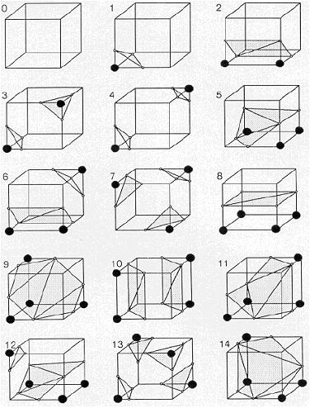fig.1 – 15 different patterns of marching cubes*

This method was added to the project with the sole purpose of making the simulation more realistic.

# Results

# Conclusion

Does the algorithm give a “good” simulation?

- Producing realistic simulation of fluids is very difficult. It is also hard to define what a “good” simulation is. There are several other simulations, often published as short demonstration films that are pre-rendered and not interactive. An example of that is the result of Beaudoin, Clavet and Poulin (2005). Beaudoin et al produces stunning visuals and the clip has gotten 23 956 views on youtube.com (2011-03-09) which certainly could be rubricated as “good”. With that in mind we think that our own result is reasonably good.

What could have been done differently?

- Other environment? Other programming language? Other methods, like *point splatting*?

If we wanted to continue developing the software, what would we have done?

- More collision handling.

# References

Literary

* Müller M., Charypar D., Gross M. Particle based fluid simulation for interactive applications, 2003.
* Lucy L. B. A numerical approach to the testing of the fission hypothesis. *The Astronomical Journal*, 82:1013-1024, 1977.

<http://adsabs.harvard.edu/full/1977AJ.....82.1013L> (2011-03-09)

* Gingold R. A., Monaghan J. J. Smoothed Particle hydrodynamics: theory and application t non-spherical stars. *Monthly Notices of the Royal Astronomical Society*, 181:375-389, 1977.

<http://adsabs.harvard.edu/full/1977MNRAS.181..375G> (2011-03-09)

* Monaghan J. J. Smoothed Particle hydrodynamics. Annual Review of Astronomy and Astrophysics, 30:543-574, 1992.
* Cline H. E., Lorensen W. E. Marching Cubes: A high resolution 3D surface construction algorithm. *SIGGRAPH*, 1987.

<http://kucg.korea.ac.kr/seminar/2001/src/PA-01-16.pdf> (2011-03-09)

* Beaudoin P., Clavet S., Poulin P. Particle-based Viscoelastic Fluid Simulation. *SIGGRAPH*, 2005.

<http://www.iro.umontreal.ca/labs/infographie/papers/Clavet-2005-PVFS/pvfs.pdf> (2011-01)

Visual

* <http://www.youtube.com/watch?v=1Q_zb65SXt0> (2011-03-09), result of Beaudoin et al (2005).

# Appendix