Application Note

Firmware Update Procedure for WINC1500 Wi-Fi Module  
using SAM D21 Xplained Pro

AN-004

42271A−05/14

Prerequisites

* **Hardware Prerequisites**
  + Atmel SAMD21 Xplained Pro Evaluation Kit
  + Atmel WINC1500 extension
  + USB Micro Cable (TypeA / MicroB)
* **Software Prerequisites**
  + Atmel Studio 6.2
  + Firmware update project

Introduction

This application note provides useful information to perform firmware update for the WINC1500 Wi-Fi module.

The following topics will be covered:

* Firmware update procedure.

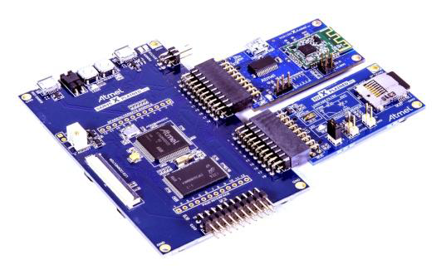

Table of Contents

Prerequisites 1

Introduction 1

Icon Key Identifiers 3

1. Firmware Update Project 4

1.1 Atmel Studio Extension (.vsix) 4

1.2 Project Structure 5

2. Firmware Update Procedure 6

2.1 Enter Update Mode 6

2.2 Run Batch Script 9

3. Frequently Asked Questions 11

3.1 When do I need to update the WINC1500 firmware? 11

3.2 Why is the update batch script failing? 11

4. Revision History 13

Icon Key Identifiers

Icons are used to identify different assignment sections and reduce complexity. These icons are:

* Delivers contextual information about a specific topic

Highlights useful tips and techniques

Highlights objectives to be completed

Highlights the expected result of an assignment step

Indicates important information

Highlights actions to be executed out of the target when necessary

# Firmware Update Project

The WINC1500 Wi-Fi module firmware update project can be retrieved through the following Atmel delivery:

* As an Atmel Studio Extension (**.vsix** file), which can be found on the Atmel Gallery web site (<http://gallery.atmel.com/>) or using the Atmel Studio Extension manager

A firmware update project is included in any Atmel Studio Extension related to the WINC1500 Wi-Fi module. The corresponding version number is printed in the project name as well as in the project description.

## Atmel Studio Extension (.vsix)

Once a WINC1500 Wi-Fi module extension has been installed, you can open and create the Firmware Update project from the *“New Example Project from ASF..."* menu in Atmel Studio.

* The WINC1500 Wi-Fi module related projects installed through an extension are usually under “*Atmel > Atmel Wi-Fi Corp. Extension Name”*.

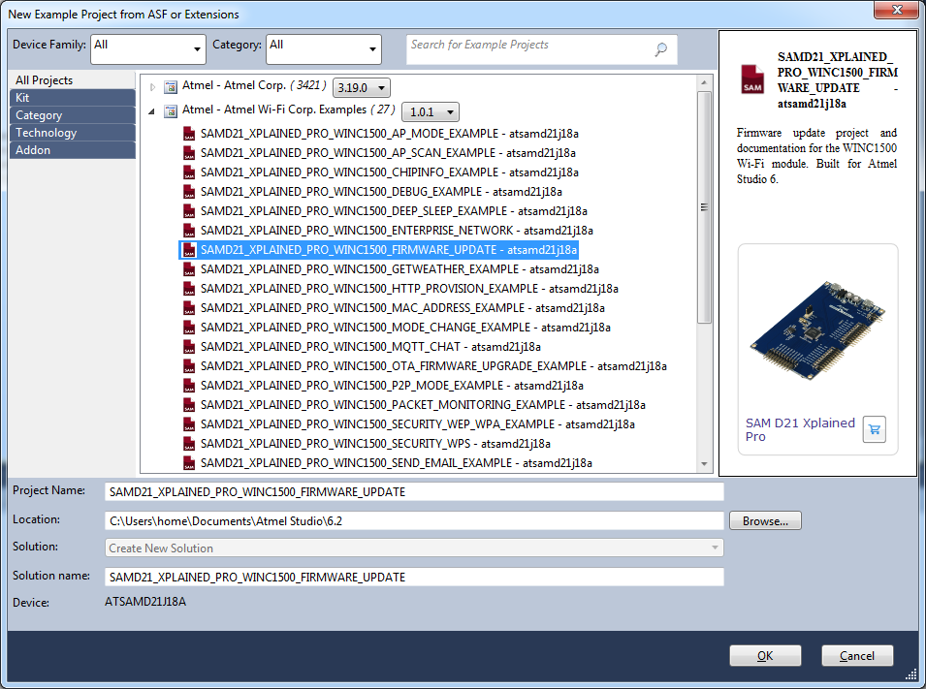

* Select project “*SAMD21_XPLAINED_PRO_WINC1500_FIRMWARE_UPDATE”* project and then press OK button to import firmware update project and related documentation.

## Project Structure

The firmware update project appears as a regular Atmel Studio 6 project for the SAMD21 host processor:

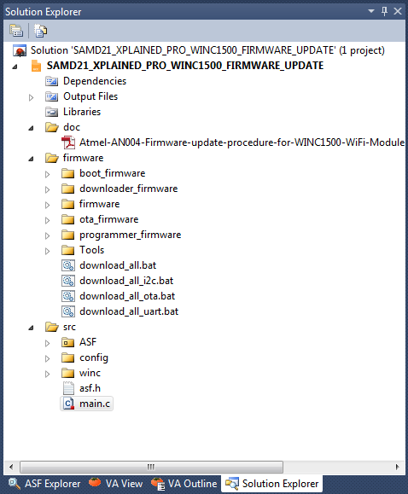

* **/doc folder** – List the available documentation regarding firmware update.
* **/firmware folder** – Contains actual WINC1500 firmware:
  + One update script per serial update mode (only UART mode will be covered here).
  + Provisioning webpage can be found and customized in the following path: /firmware/firmware/wifi_v111/src/nmi_m2m/source/http/Server/config
  + TLS/SSL certificates can be found and changed in the following path:

/firmware/Tools/root_certificate_downloader

* + A version.txt file contains the firmware update version number.
* **/src folder** – Contains the source of the intermediate firmware update project.
* The following update procedure takes care of updating the WINC1500 internal firmware, provisioning webpage and TLS/SSL certificates.

# Firmware Update Procedure

The firmware update process can be described as a 2-stage update procedure:

* A first step is to program an application on the host MCU to let the WINC1500 Wi-Fi module enter the update mode.
* A second step is to run a batch script to trigger the firmware update.

## Enter Update Mode

To let the WINC1500 Wi-Fi module enter the update mode, open the “*SAMD21_XPLAINED_PRO_WINC1500_FIRMWARE_UPDATE”* project and proceed as following:

Build the solution (F7) and ensure you get no errors: 

* Program the SAM D21 Xplained Pro
* Connect the WINC1500 Wi-Fi module on EXT1 of the SAM D21 Xplained Pro, and plug a micro USB cable into the debug USB port as displayed below:

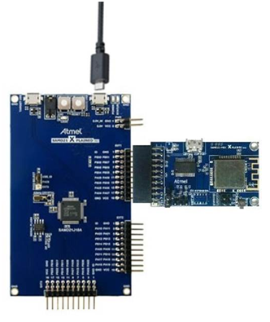

**DEBUG USB**

* Connect the SAM D21 Xplained Pro board to your PC (using DEBUG USB connector).
* Program the application by clicking on the Start Debugging and Break icon: 

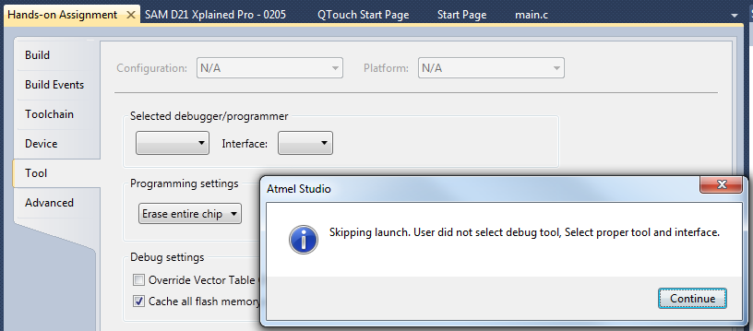

* You will be asked to select your debug tool:
* Select EDBG and SWD (Serial Wire Debug) as Interface:



* Set SWD clock to 8 MHz to speed up programming:

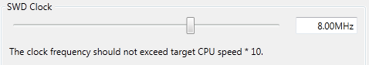

* Click again on the Start Debugging and Break icon: 
* The application will be programmed in the SAM D21 embedded flash and breaks at main function. Click on Continue to execute the application: 
* 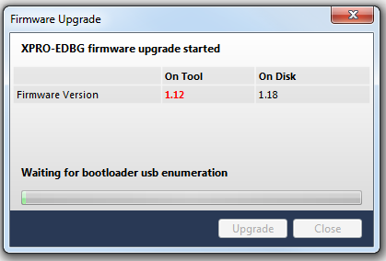You may be asked to upgrade your EDBG firmware. If so, click on Upgrade:
* Upgrade operation may take a few minutes, please **wait** for the operation to complete.
* The firmware update project is now programmed and running.

Open the EDBG DEBUG USB serial COM port, with the following settings: 115200 bauds, 8 bit data, no parity, one stop bit and no flow control. The following output should appears:

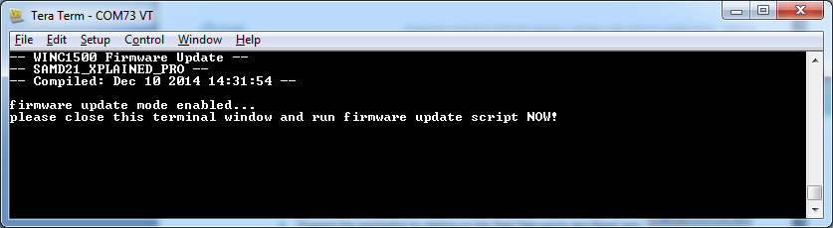

* The WINC1500 Wi-Fi module is now in update mode and ready to perform the actual firmware update. Before moving to the next step, you must close the terminal window to release the access to the USB virtual COM port. Once closed, leave the SAMD21 Xplained Pro in this state and go on to the next step.

## Run Batch Script

In the firmware folder of the “*SAMD21_XPLAINED_PRO_WINC1500_FIRMWARE_UPDATE”* you will find a list of batch (.bat) script files used to trigger a firmware update. This document will only cover the UART serial update.

* Ensure that the SAMD21 Xplained Pro is programmed with the firmware update project and that the board is connected to your laptop via the debug USB port. The underlying virtual COM port should remain available for the batch script to work.

Do not attempt to open the virtual COM port of the SAMD21 Xplained Pro debug USB with a terminal application as it would prevent the batch script to perform the firmware update.  
If the WINC1500 module features a USB port, it is recommended to leave it unconnected while performing this update procedure.

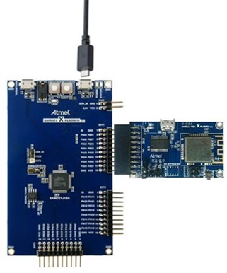

* Run the *download_all_uart.bat* script and ensure that the COM port is detected successfully.

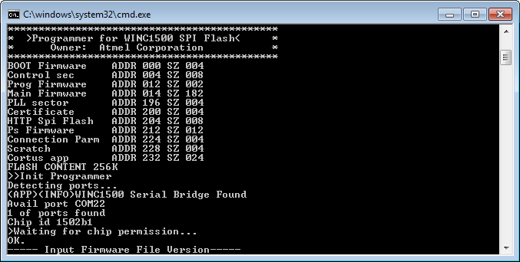

After several seconds the following message should appear, meaning that the WINC1500 Wi-Fi module update procedure is complete:

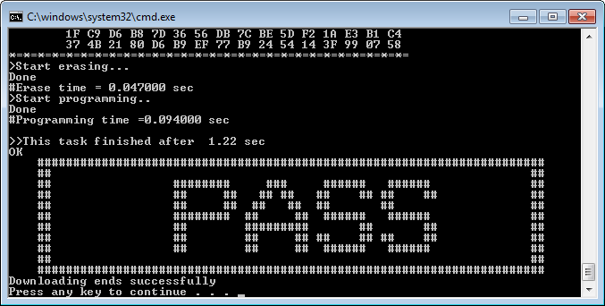

* The WINC1500 Wi-Fi module firmware has been updated successfully.

# Frequently Asked Questions

## When do I need to update the WINC1500 firmware?

Atmel provides frequent updates of the Wi-Fi software API (host MCU) for the WINC1500 Wi-Fi module. The integrity of the solution is guaranteed using a major/minor version number. When a major version mismatch occurs between the host MCU and the WINC1500 Wi-Fi module, the Wi-Fi software API initialization will fail and a m2m_wifi_init() function call will return an error value:

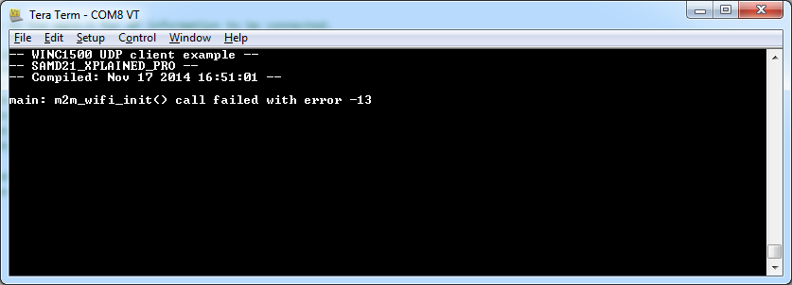

Setting the CONF_WIFI_M2M_DEBUG to 1 in the conf_winc.h configuration file will provide more information about the version mismatch error:

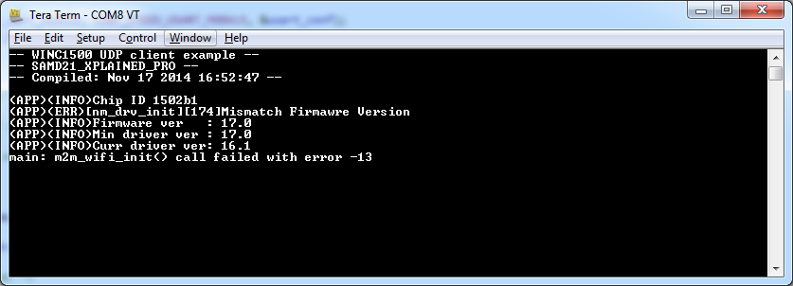

In this scenario a firmware update with the appropriate firmware version number is expected.

## Why is the update batch script failing?

While performing the second stage of the update procedure, the following error can happen:

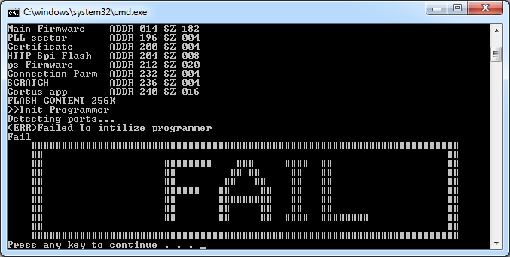

Possible reasons for such a failure include:

* The SAMD21 Xplained Pro debug USB port is not connected to your PC USB port.
* The SAMD21 Xplained Pro debug USB virtual COM port is already opened by another application and preventing the batch script to work (terminal application for instance).
* The host MCU is not programmed or running with the appropriate project: “*SAMD21_XPLAINED_PRO_WINC1500_FIRMWARE_UPDATE”*

# Revision History

|  |  |  |
| --- | --- | --- |
| **Doc. Rev.** | **Date** | **Comments** |
| XXXXXB | 12/2014 | Updated firmware update procedure (serial bridge) |
| XXXXXA | 11/2014 | Initial document release |

** *Do not worry!**

**If you have deleted the line – *Section Break (Next Page)***

* Open another training manual template and select the following:
  + Starting at the instruction field before the last page all the way to the very end of the document.
  + Copy
* Go back to the end of the document where the last page should start
  + Select all lines for last page to the very end
  + Paste Special > Formatted text
  + Click delete once   
    (only because it adds one additional line at bottom and another page after pasting the disclaimer page)

|  |  |  |  |
| --- | --- | --- | --- |
|  | | | |
|  |  |  |  |
| **Atmel Corporation**  1600 Technology Drive  San Jose, CA 95110  USA  **Tel:** (+1)(408) 441-0311  **Fax:** (+1)(408) 487-2600  [www.atmel.com](http://www.atmel.com) | **Atmel Asia Limited**  Unit 01-5 & 16, 19F  BEA Tower, Millennium City 5  418 Kwun Tong Road  Kwun Tong, Kowloon  HONG KONG  **Tel:** (+852) 2245-6100  **Fax:** (+852) 2722-1369 | **Atmel Munich GmbH**  Business Campus  Parkring 4  D-85748 Garching b. Munich  GERMANY  **Tel:** (+49) 89-31970-0  **Fax:** (+49) 89-3194621 | **Atmel Japan G.K.**  16F Shin-Osaki Kangyo Bldg.  1-6-4 Osaki, Shinagawa-ku  Tokyo 141-0032  JAPAN  **Tel:** (+81)(3) 6417-0300  **Fax:** (+81)(3) 6417-0370 |
|  |  |  |  |
| © 2012 Atmel Corporation. All rights reserved. / Rev.: | | | |
| Atmel®, Atmel logo and combinations thereof, Enabling Unlimited Possibilities®, and others are registered trademarks or trademarks of Atmel Corporation or its subsidiaries. Other terms and product names may be trademarks of others. | | | |
| Disclaimer: The information in this document is provided in connection with Atmel products. No license, express or implied, by estoppel or otherwise, to any intellectual property right is granted by this document or in connection with the sale of Atmel products. EXCEPT AS SET FORTH IN THE ATMEL TERMS AND CONDITIONS OF SALES LOCATED ON THE ATMEL WEBSITE, ATMEL ASSUMES NO LIABILITY WHATSOEVER AND DISCLAIMS ANY EXPRESS, IMPLIED OR STATUTORY WARRANTY RELATING TO ITS PRODUCTS INCLUDING, BUT NOT LIMITED TO, THE IMPLIED WARRANTY OF MERCHANTABILITY, FITNESS FOR A PARTICULAR PURPOSE, OR NON-INFRINGEMENT. IN NO EVENT SHALL ATMEL BE LIABLE FOR ANY DIRECT, INDIRECT, CONSEQUENTIAL, PUNITIVE, SPECIAL OR INCIDENTAL DAMAGES (INCLUDING, WITHOUT LIMITATION, DAMAGES FOR LOSS AND PROFITS, BUSINESS INTERRUPTION, OR LOSS OF INFORMATION) ARISING OUT OF THE USE OR INABILITY TO USE THIS DOCUMENT, EVEN IF ATMEL HAS BEEN ADVISED OF THE POSSIBILITY OF SUCH DAMAGES. Atmel makes no representations or warranties with respect to the accuracy or completeness of the contents of this document and reserves the right to make changes to specifications and products descriptions at any time without notice. Atmel does not make any commitment to update the information contained herein. Unless specifically provided otherwise, Atmel products are not suitable for, and shall not be used in, automotive applications. Atmel products are not intended, authorized, or warranted for use as components in applications intended to support or sustain life. | | | |