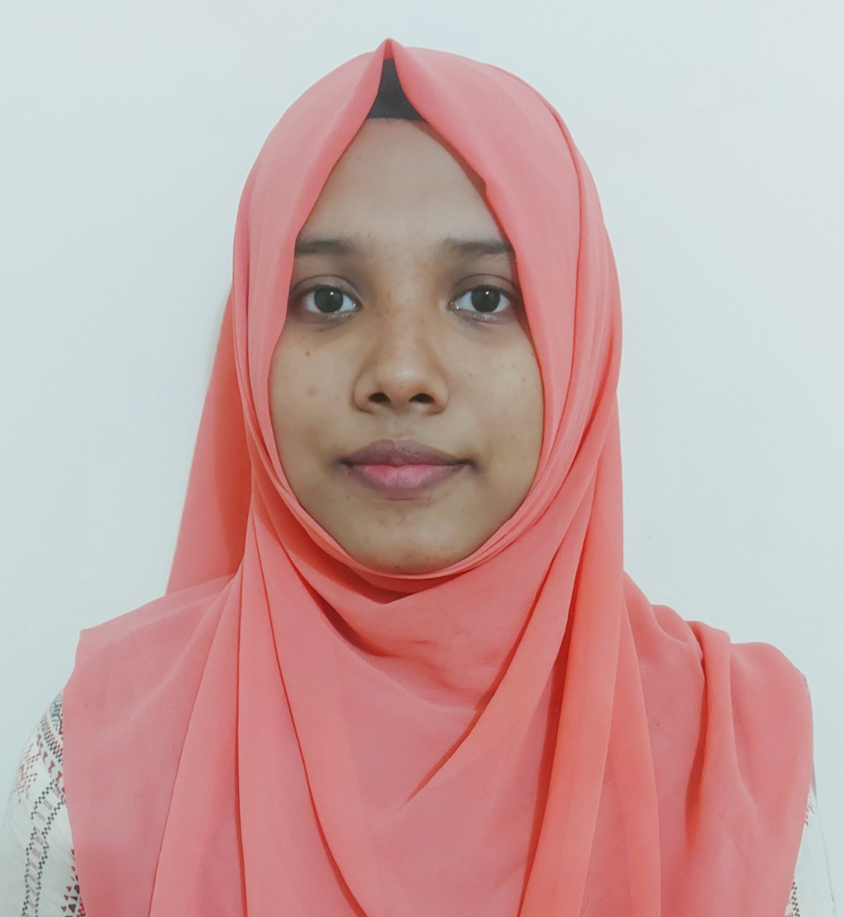
Shahria Sultana Sunnah

Address: Sector 4, Uttara , Dhaka
Phone: +8801997155328
Email: imshahriasunnah@gmail.com
GitHub: https://github.com/HelloSunnah

❖ CAREER OBJECTIVE
As an energetic person, I am confident that my dedication, expertise, team management strength, problem-solving ability, and never give up attitude can help the organization gain a competitive advantage in the industry
❖ SKILL HIGHLIGHTS
▪ Experience in both Frontend Interfaces and Backend Systems
▪ Programming Languages: Php, Basic Js
▪ Database Management: MySQL
▪ Framework & Libraries: Laravel,Livewire, Bootstrap
▪ Well Understanding of Software Development Life-Cycle
▪ Well Understanding of Object-Oriented Programming
▪ Well Understanding of Data Structures and Algorithms
▪ Good Understanding of Version Management (Git)
▪ Good Understanding of Linux Operating System(Ubuntu)

❖ EXPERIENCE
Junior Software Engineer (Laravel)
CodeCell Limited- May 2023 – Present

Internship on Php- Laravel-
▪ CodeCell Limited- February 2023 – April

Work on BootCamp-
Kodeeo Limited October 2022 to January

▪ Experienced by develop Ecommerce, Hotel Management System, School Management System .
▪ Skills used PHP, Laravel, HTML, CSS, JavaScript, JQuery, Bootstrap.

❖ EDUCATION
▪ Bachelor of Science: Computer Science & Engineering - present
Northern University
▪ Diploma in Engineering:
Computer Science & Technology – 2021
Feni Govt Computer Institute

❖ INTEREST
▪ Machine Learning
▪ Big Data
❖ HOBBY
Reading Book, Travelling, Cooking, Watching Movie

