under the supervision of

DR.SUNIL
Assistant Professor,
University Polytechnic
FARHAN KHALID (20DCS8015)
ASHAR AHMAD (20DCS8008)
ADNAN SAMI (20DCS8004)
JAMIA MILLIA ISLAMIA



FAMEDD
Project in PHP, HTML, CSS, JAVA SCRIPT

INDUSTRIAL ORIENTED PROJECT - DCO310

FAMEDD
GET YOURSELF LIVE



Contents
Introduction to the Project (What is the project about?) 3
CHARACTERISTICS OF THE PROJECT 3
How are we doing? 4
TECHNOLOGY USED 4
Apache Server 4
MySQL 4
Why we choose this Project? 6
WORKING OF PRESENT SYSTEM 6
DISADVANTAGES OF PRESENT WORKING SYSTEM 6

FAMEDD

Introduction to the Project (What is the project about?)

This project is aimed at developing a website that, if you want a website for yourself or for your business will help you get in touch with us, choose what kind of website you want and various features that you might like to have in your website. In today's world it has become necessary for small businesses to take themselves online have their and have their websites. After the COVID-19 everyone now prefers to shop online, from groceries to clothes to food everything is now available for you to order online since every large brand or even a smaller one have their own websites from where you can shop but a small businessman or shop owner don't have the kind of money that these big businesses have to spend on a website. So, for those people we have created this project called FAMEDD that will help you get a website which will look as good as the websites of big name brands and would be affordable by you, we will create your UI for you taking in your inputs will provide you with QR solutions and if necessary will give you a database also to store information of the users which are coming to you and help you to compete in this new age of business.

CHARACTERISTICS OF THE PROJECT

- User Friendly: Project FAMEDD is not complex to understand

- Order reports of the system can be easily generated. User can easily submit their information.

- Very less paper work

- Computer operator control: Data feeding and retrieving in this system is very easy. So the work can be done on time.

How are we doing?

TECHNOLOGY USED
- Server : Apache 2.4.4
- Front-end: PHP 5.4.19 (Framework : Codeigniter 2.1.2)
- Back-end: MySQL 5.5.32(using phpmyadmin 4.0.6)
- Integrated Development Environment(IDE): Netbeans 7.3.1
- Platform:Windows 7

We have used XAMPP 1.8.2 which is a free and Open Source Cross-Platform Web Server Solution Stack. It comes with Apache Web Server, MySQL Database, PHP and Perl Programming Languages.

A couple of advantages of using XAMPP for development are:

- You can start and stop the whole web server + database stack with one command.
- XAMPP is portable so you can carry it around on a thumb drive.
- The security settings are strict by default, nobody but you will be able to access the web server.
- PHP error reporting is enabled by default, which helps when debugging scripts.
- Easy to install.

Apache Server
Web server apache is an open source server application. There are a lot of benefits and advantages that are provided from the server. Numerous features like the openness, extensibility, portability and flexibility of apache server provide advantages to administrator leading to higher efficiency and utility.

MySQL

MySQL is easy to use, yet extremely powerful, secure, and scalable. And because of its small size and speed, it is the ideal database solution for Web sites.

Some of its advantages include the following:

- It's easy to use: While a basic knowledge of SQL is required—and most relational databases require the same knowledge—MySQL is very easy to use. With only a few simple SQL statements, you can build and interact with MySQL.
- It's secure: MySQL includes solid data security layers that protect sensitive data from intruders. Rights can be set to allow some or all privileges to individuals. Passwords are encrypted.
- It's inexpensive: MySQL is available by free download from MySQL Web site.
- It's fast: In the interest of speed, MySQL designers made the decision to offer fewer features than other major database competitors, such as Sybase* and Oracle*. However, despite having fewer features than the other commercial database products, MySQL still offers all of the features required by most database developers.
- It's scalable: MySQL can handle almost any amount of data, up to as much as 50 million rows or more. The default file size limit is about 4 GB. However, you can increase this number to a theoretical limit of 8 TB of data.
- It manages memory very well: MySQL server has been thoroughly tested to prevent memory leaks.
- It runs on many operating systems: MySQL runs on many operating systems, including Novell NetWare, Windows* Linux*, many varieties of UNIX* (such as Sun* Solaris*, AIX, and DEC* UNIX), OS/2, FreeBSD*, and others.
- It supports several development interfaces: Development interfaces include JDBC, ODBC, and scripting (PHP and Perl), letting you create database solutions that run not only in your NetWare 6.5 environment, but across all major platforms, including Linux, UNIX, and Windows.

Why we choose this Project?

WORKING OF PRESENT SYSTEM

The idea of this project came to us when we were working on another project. An acquaintance of ours asked us to make a website for his business which was basically a car shop or you can say a dealership of cars for which he was willing to give us a certain amount of money, since he knew that we were in 3rd year of our diploma and have a knowledge of web development. we agreed to make that project for him since we were getting good profit margin and making a project like that would be good with regards to our studies. while we were creating the project and had created the UI we showed the UI to some people and we saw more people being interested in having their own website and were willing to give us money to make their website for them so, we thought while we are making websites for other why don't we make a website for ourselves which will help us in reaching out to more people and have our own business and with that thought FAMEDD was born.

DISADVANTAGES OF PRESENT WORKING SYSTEM

- Not User Friendly: The existing system is not user friendly because the retrieval of data is very slow and data is not maintained efficiently.

- Difficulty in report generating: We require more calculations to generate the report so it is generated at the end of the session.

- Manual control: All calculations to generate report is done manually so there is greater chance of errors.

- Lots of paperwork: Existing system requires lot of paper work.

- Loss of even a single register/record led to difficult situation because all the papers are needed to generate the reports.

- Time consuming: Every work is done manually so we cannot generate report in the middle of the session or as per the requirement because it is very time consuming.

WORK FLOW OF THE FAMEDD

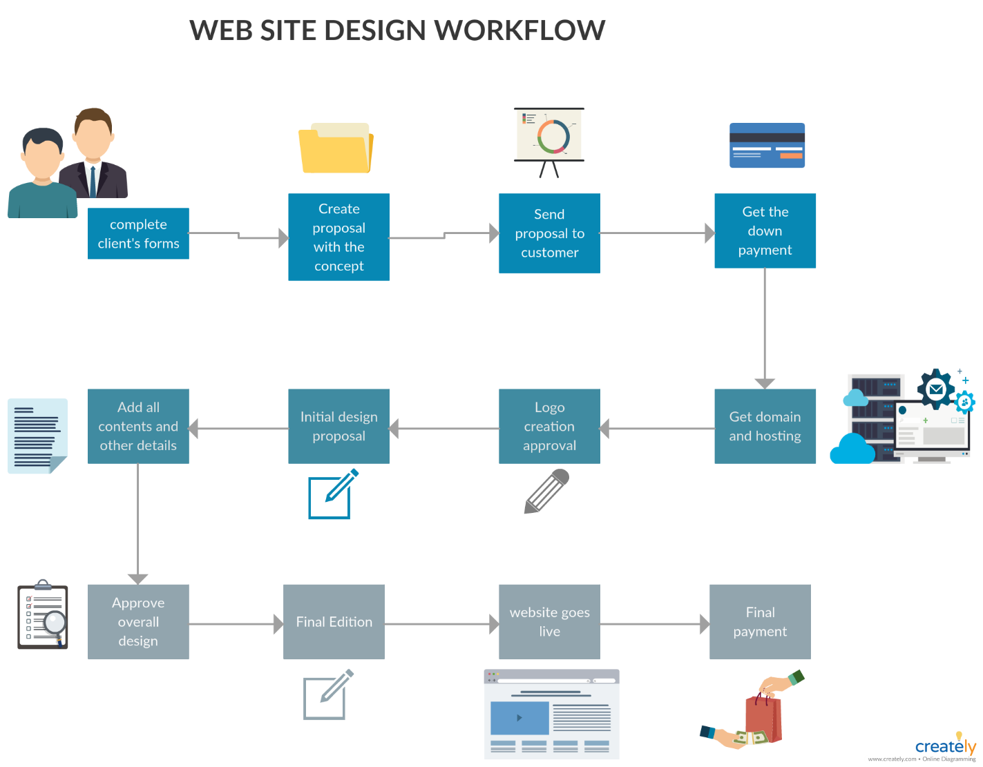

TECHNOLOGY PLATFORM

The idea of this project came to us when we were working on another project. An acquaintance of ours asked us to make a website for his business which was basically a car shop or you can say a dealership of cars for which he was willing to give us a certain amount of money, since he knew that we were in 3rd year of our diploma and have a knowledge of web development. we agreed to make that project for him since we were getting good profit margin and making a project like that would be good with regards to our studies. while we were creating the project and had created the UI we showed the UI to some people and we saw more people being interested in having their own website and were willing to give us money to make their website for them so, we thought while we are making websites for other why don't we make a website for ourselves which will help us in reaching out to more people and have our own business and with that thought FAMEDD was born.

HISTORY

Where the Web was born. Tim Berners-Lee, a British scientist, invented the World Wide Web (WWW) in 1989, while working at CERN. The Web was originally conceived and developed to meet the demand for automated information-sharing between scientists in universities and institutes around the world.

Websites can be used in various fashions: a personal website, a corporate website for a company, a government website, an organization website, etc. Websites can be the work of an individual, a business or other organization, and are typically dedicated to a particular topic or purpose. Any website can contain a hyperlink to any other website, so the distinction between individual sites, as perceived by the user, can be blurred.

idea behind the project title is to provide people a website which can help them to compete stay relevant by paying a price that they can afford.

GET FAMEDD…



