浙江大学2014–2015学年 秋冬 学期
《物理化学》课程期末考试试卷
课程号： 061B9030，开课学院：__理学院_
考试试卷：√A卷、B卷（请在选定项上打√）
考试形式：√闭、开卷（请在选定项上打√），允许带__计算器__入场
考试日期：2015年 1 月 29 日, 考试时间： 120 分钟
诚信考试，沉着应考，杜绝违纪。
考生姓名： 学号： 所属院系： _
题 序 | 一 | 二 | 三 | 四 | 五 | 六 | 七 | 总分
得 分
评卷人
- 1 mol of water vaporizes at 298 K and 100 kPa. Calculate Q, W, ΔU, ΔH, ΔS, ΔG and ΔA. The volume of water can be neglected. The vaporizing enthalpy change of water at 373 K Δ_{vap}H_{m} = 40.668 kJ·mol⁻¹. The isobaric heat capacities of water and vapor (perfect gas) are: C_{p,m} (H₂O,l) = 75.75 J·mol⁻¹·K⁻¹, and C_{p,m} (H₂O,g) = 33.76 J·mol⁻¹·K⁻¹ (15 scores).

ΔH是重点！基尔霍夫定律！
Q与ΔH关系要注意！
计算W用了一长串近似公式要记忆

2. When 2.00 mol of a perfect gas at 330 K and 3.50 atm is subjected to isothermal compression, its entropy decreases by 25.0 J·K⁻¹. Calculate (a) the final pressure of the gas and (b) ΔG for the compression (15 scores).
(5.8a)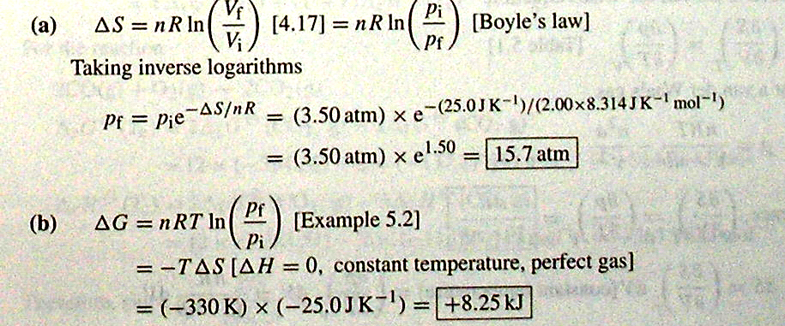
注意：出现deabsorb，decrease之类的字眼要注意物理量的符号
3. The vapor pressure of benzene is 400 Torr at 60.6 ℃, but it fell to 386 Torr when 19.0 g of an involatile organic compound was dissolved in 500 g of benzene. Calculate the molar mass of the compound (10 scores).
(7.9a)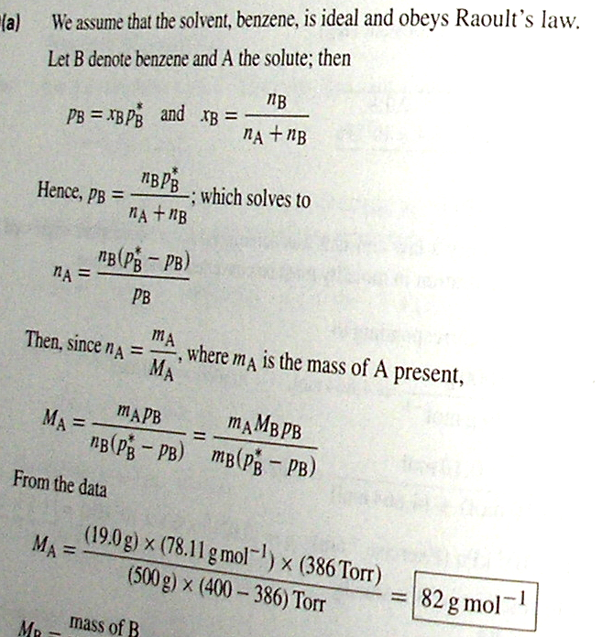

4. The following picture is the phase diagram for silver and tin.
(a) State what substances exist in each region and label each substance as solid, liquid or gas .
(b) Sketch the cooling curves for the given systems a, b and c.
(c) Is there any compound in the diagram? Is it stable or unstable? If it exists, what is the chemical formula?
(d) What is the composition for the last drop of liquid if solution c is cooled below the triple line? (15 scores).
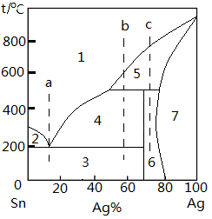

5. The standard potential for the cell reaction:
H₂(g) + 2AgCl(s) = 2Ag + 2HCl(aq)
at 101.325 kPa from 0 ~ 90℃ has a relation to temperature:
E⊖= a + b ( T – T₀) + c ( T – T₀) ² + d ( T – T₀) ³
where a = 0.2369V, b = – 4.8564×10^{– 4} V/K, c = – 3.4205×10^{– 6} V/K²,
d =5.869×10^{– 9} V/K³, T₀ =273.15 K. Calculate Δ_{r}G_{m}⊖, Δ_{r}S_{m}⊖, and Δ_{r}H_{m}⊖ of the cell reaction at 10℃ and 101.325 kPa. Given that F = 96485. (15 scores) （来自中文书）
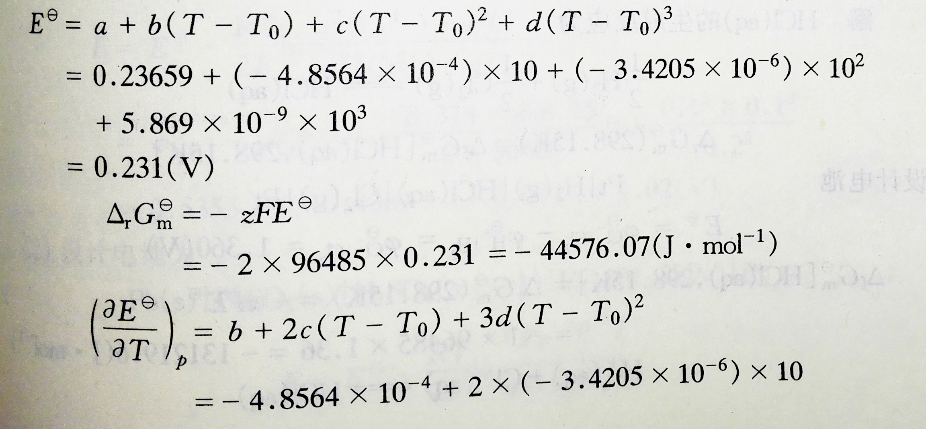
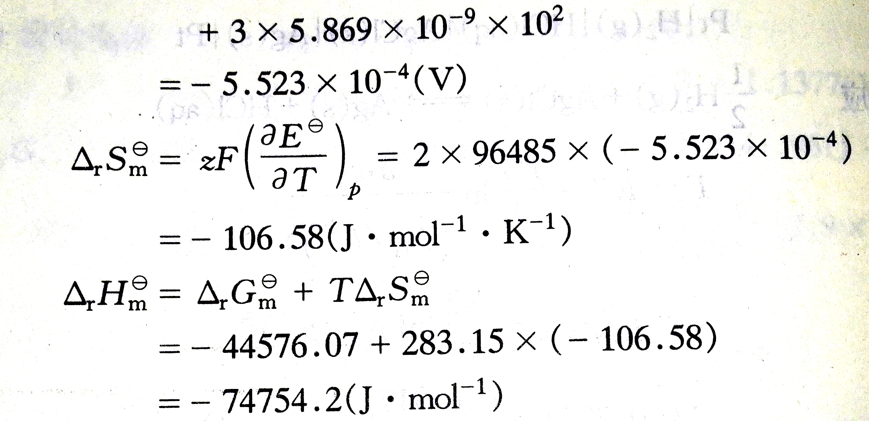

6. Consider the following mechanism for the thermal decomposition of R₂:
(1) R₂→R + R
(2) R + R₂→P_{B} + R′
(3) R′ → P_{A} + R
(4) R + R→P_{A} + P_{B}
where R₂, P_{A}, P_{B} are stable hydrocarbons and R and R′ are radicals. Find the dependence of the rate of decomposition of R₂ on the concentration of R₂. (15 scores)
(26.6 b)跟例题类似
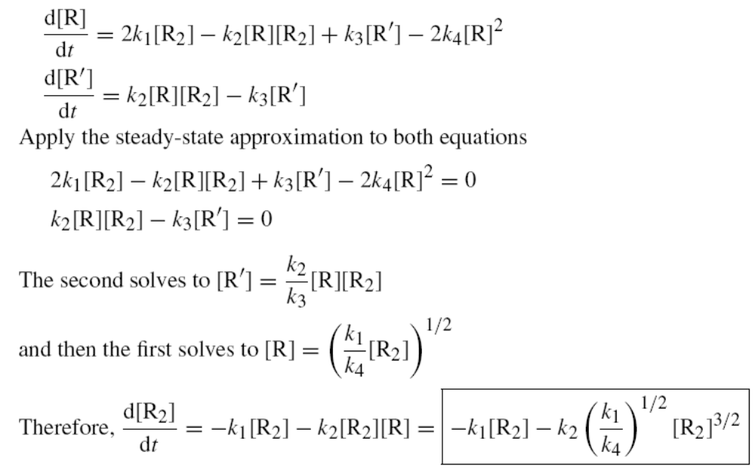

7. N₂ adsorbed on SiO₂ surface to the extent of 1.242 cm³ g⁻¹ at 350 kPa and 180 K, but at 240 K the same amount of adsorption was achieved only when the pressure was increased to 1.02 Mpa. What is the enthalpy of adsorption of N₂ on SiO₂ surface? (15 scores)
（28.17 b）习题为28.17a
