**Python Assignment**

**Problem Statement 1: Student Grading System**

Create a Python program to manage student grades. Allow users to enter the names of students and their respective grades for different subjects. Store this information in a dictionary where the keys are student names and the values are lists of grades. Calculate and display the average grade for each student.

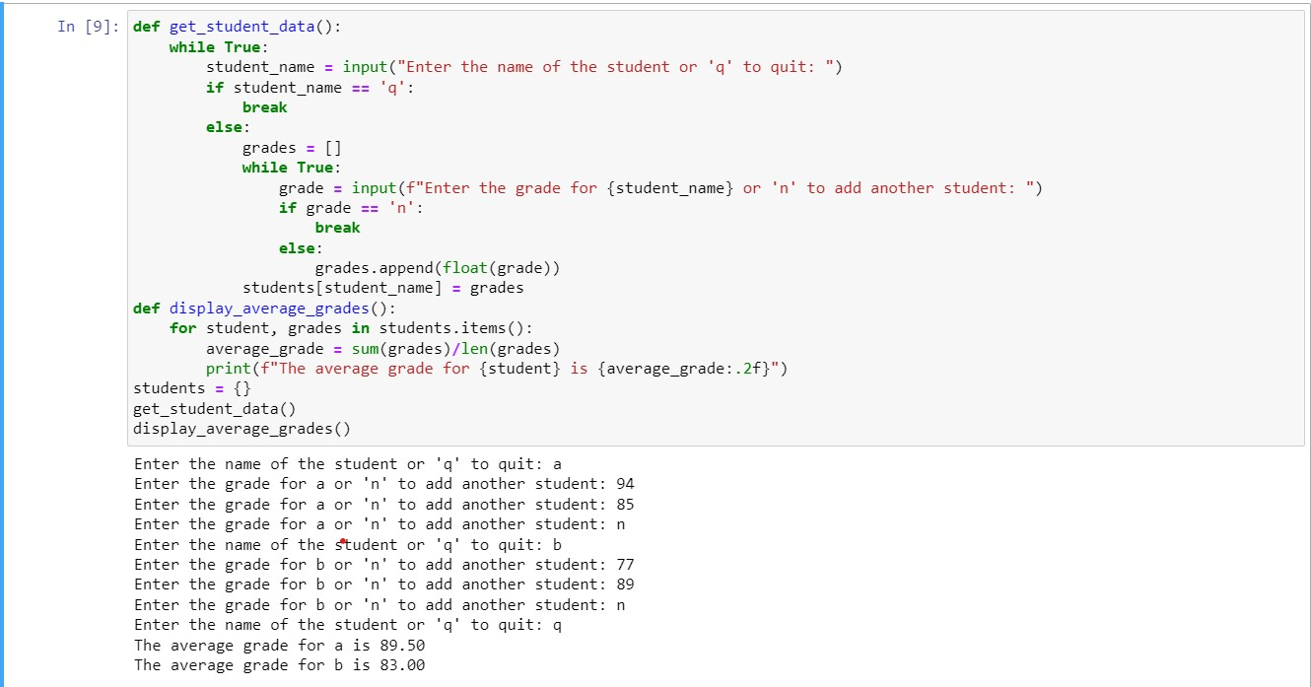

**Problem Statement 2: Unique Characters in a String**

Write a Python function that takes a string as input and returns a set of unique characters present in the string. Ignore spaces and case sensitivity while considering uniqueness. For example, for the input "Hello, World!", the function should return a set containing {'h', 'e', 'l', 'o', 'r', 'd', ','}.

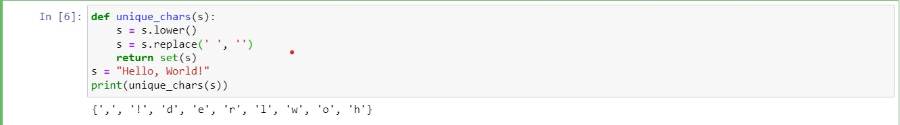

**Problem Statement 3: Tuple Manipulation**

Create a tuple containing the names of your favorite fruits. Allow users to enter a new fruit name. Add this new fruit to the tuple and display the updated tuple. Additionally, allow users to input the index of a fruit and remove it from the tuple. Display the modified tuple after removal.

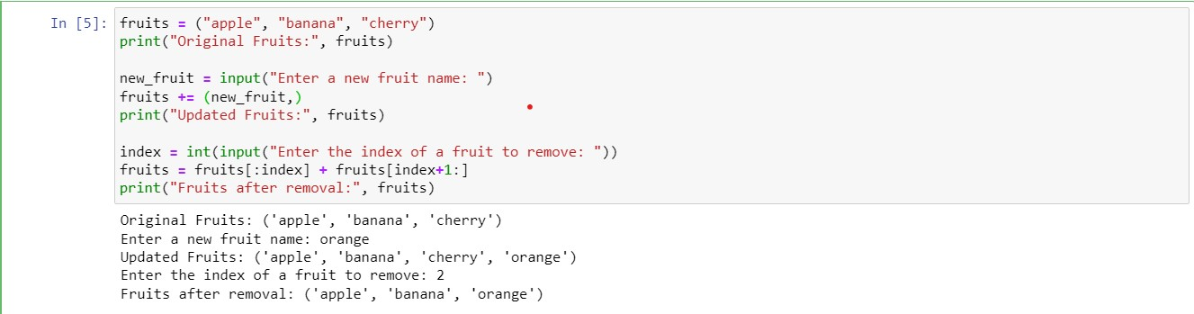

**Problem Statement 4: Dictionary-based Word Counter**

Write a Python function that takes a sentence as input and counts the frequency of each word in the sentence. Store the word frequencies in a dictionary where the keys are words and the values are their corresponding counts. For example, for the input "Hello world, hello Python!", the function should return {'Hello': 1, 'world': 1, 'hello': 1, 'Python': 1}.

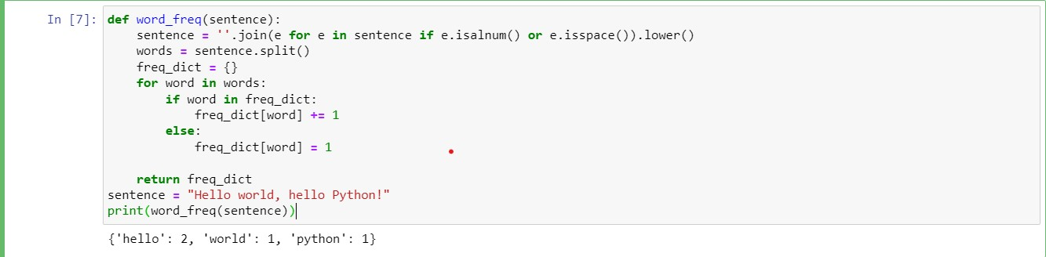

**Problem Statement 5: Set Operations**

Create two sets of integers. Implement a Python program that performs set operations such as union, intersection, and difference on these sets. Display the results of these operations to the user.

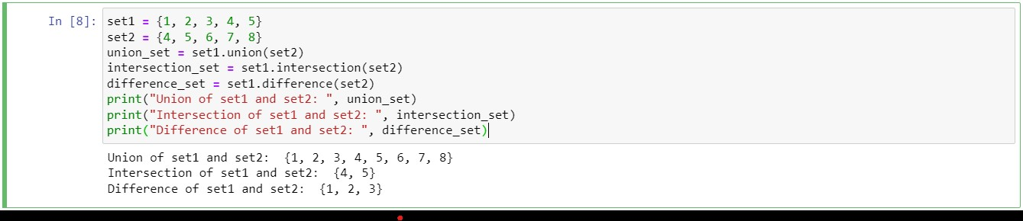Top of Form