**E-learning APP design report3**

**17301159 李智慧**

This report describes the display content, functional requirements, and design-related code of each page of the E-learning APP.

# 1.Lool in the list of courses

This page displays a list of courses offered by the platform. In each display box, the picture is shown on the left, and the right is the university where the course is offered, the teachers and the number of viewers. Click on the course to jump to the corresponding course details interface.

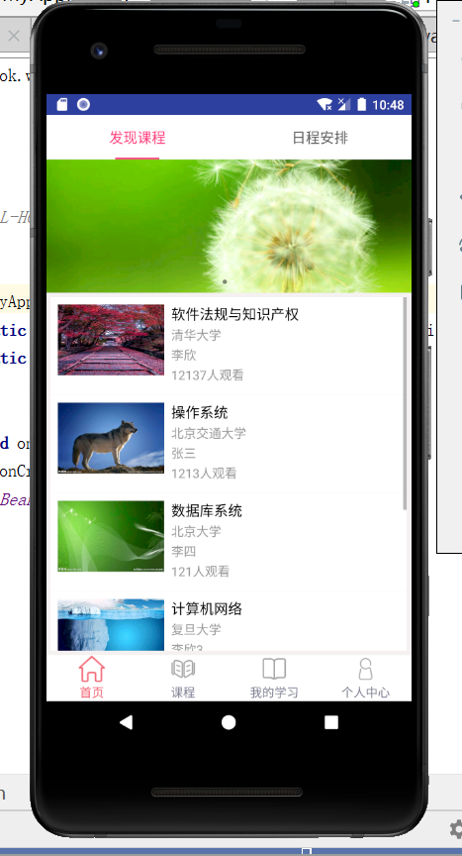

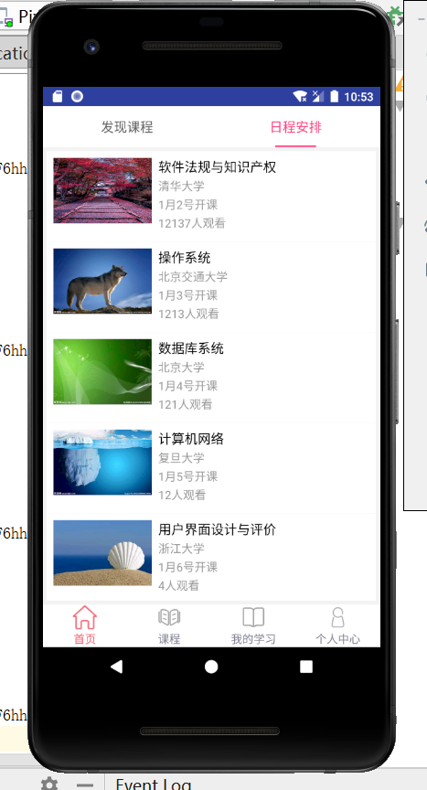



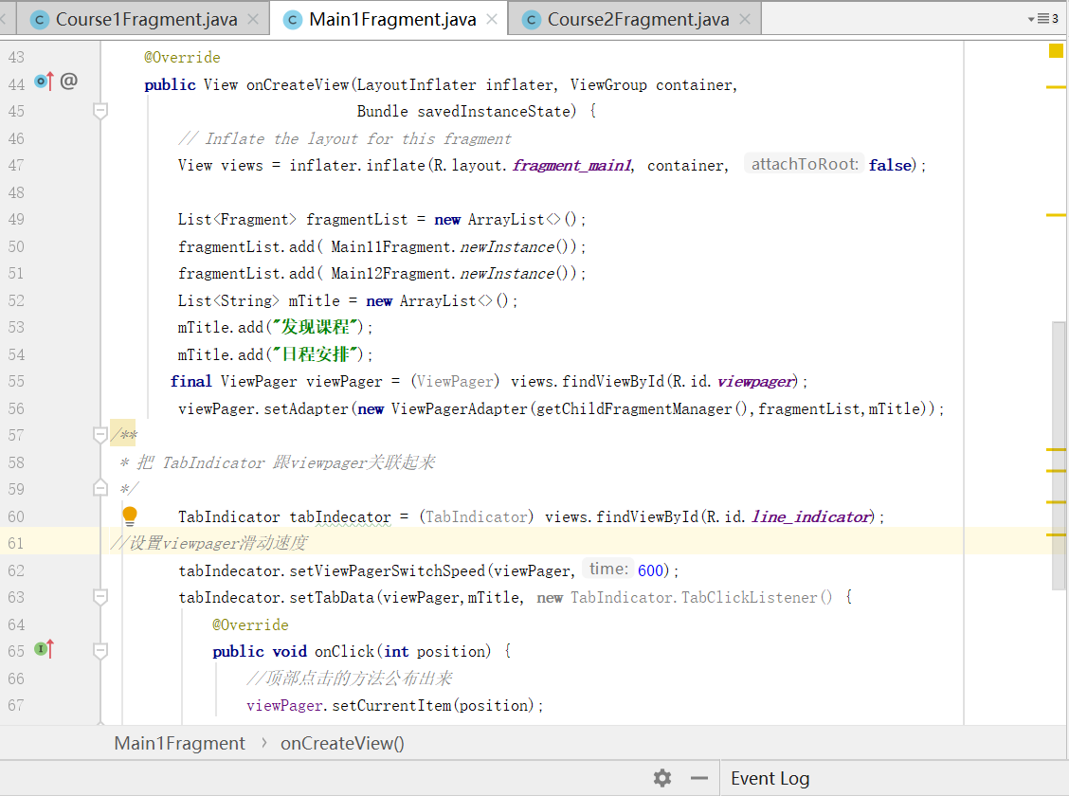

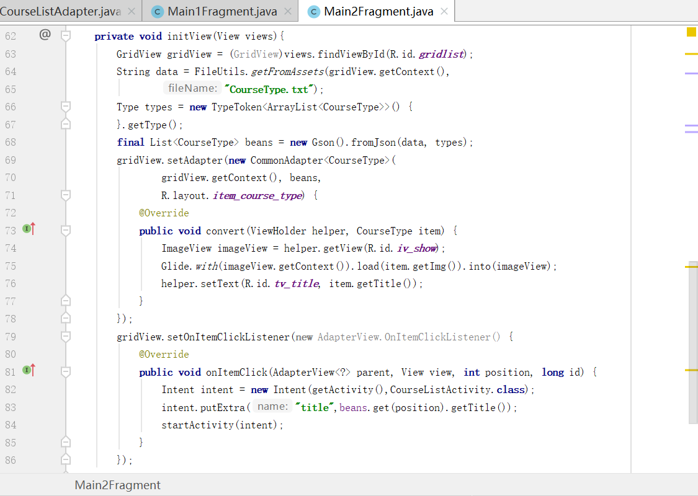

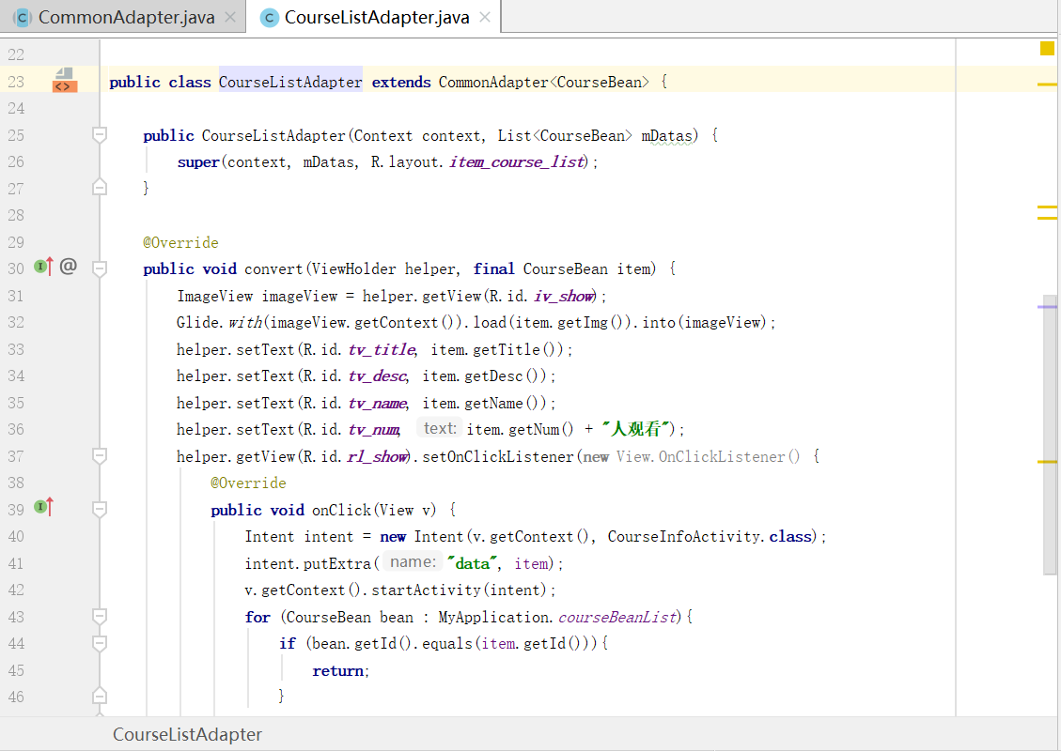

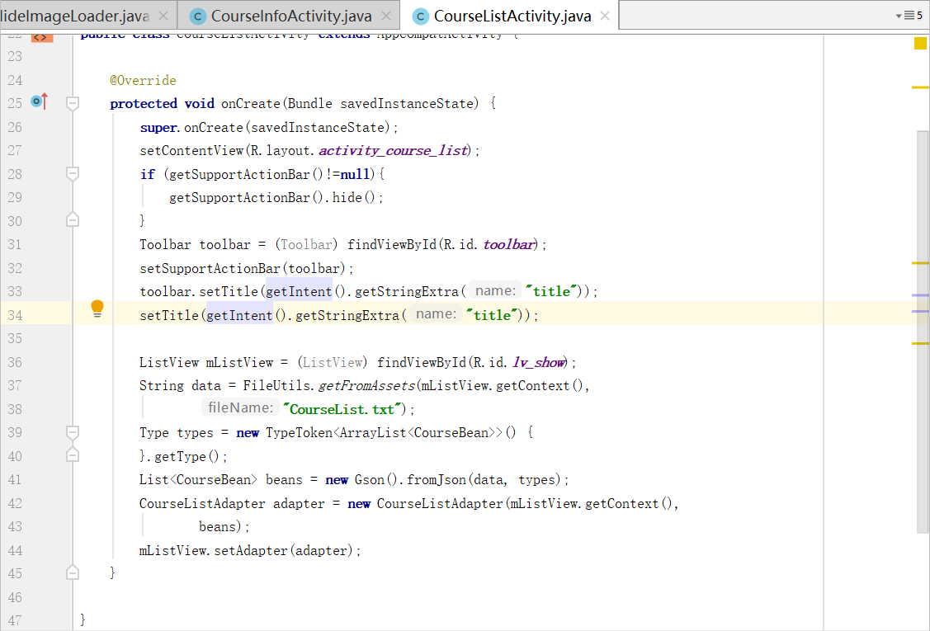

# 2. Navigating with transition animation.

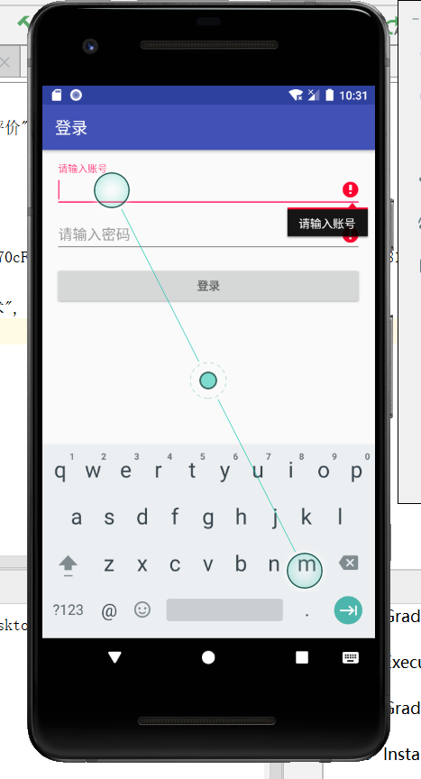 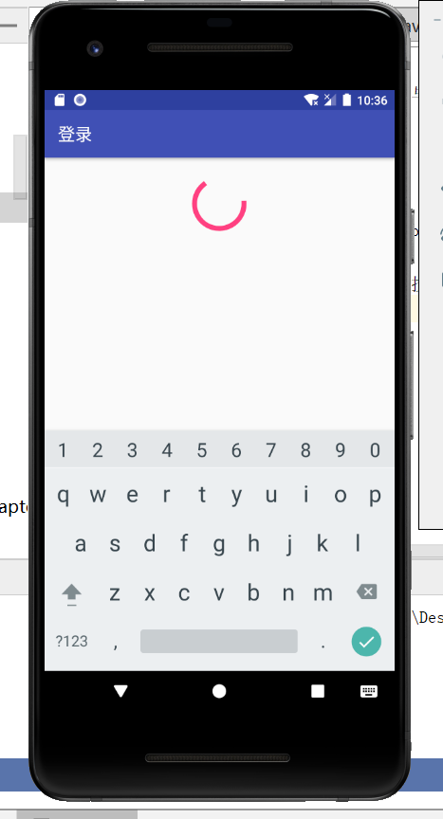

# 3. Login to the E-learning platform

After clicking a course in the course list, you can jump to the relevant course details interface. After entering this interface, the user can click to play the video.

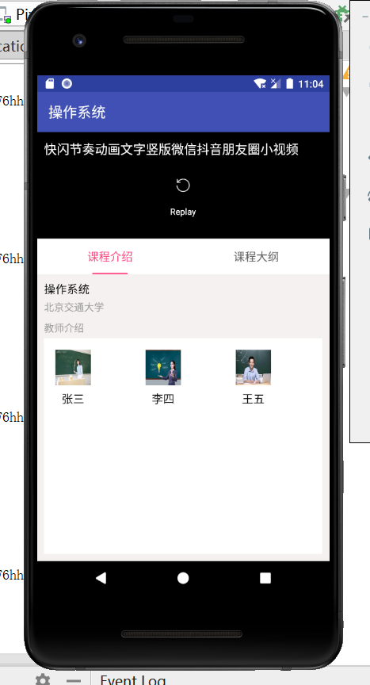 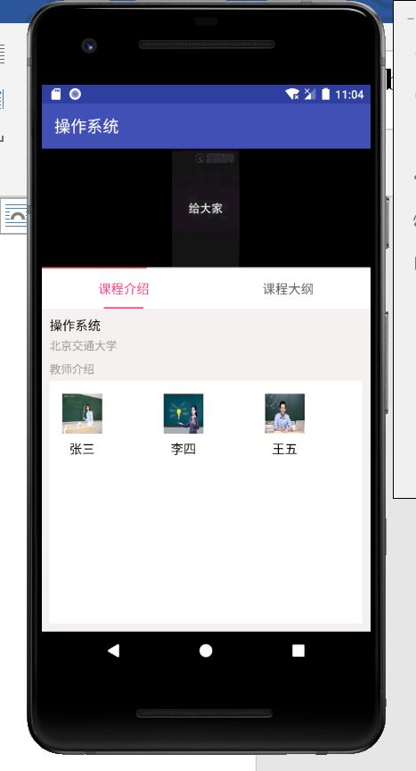

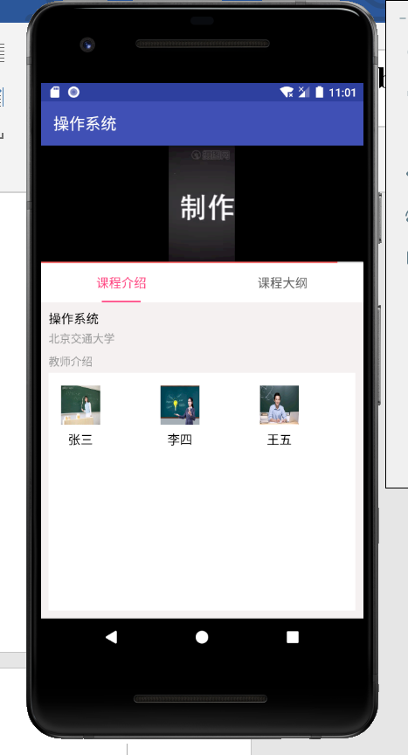

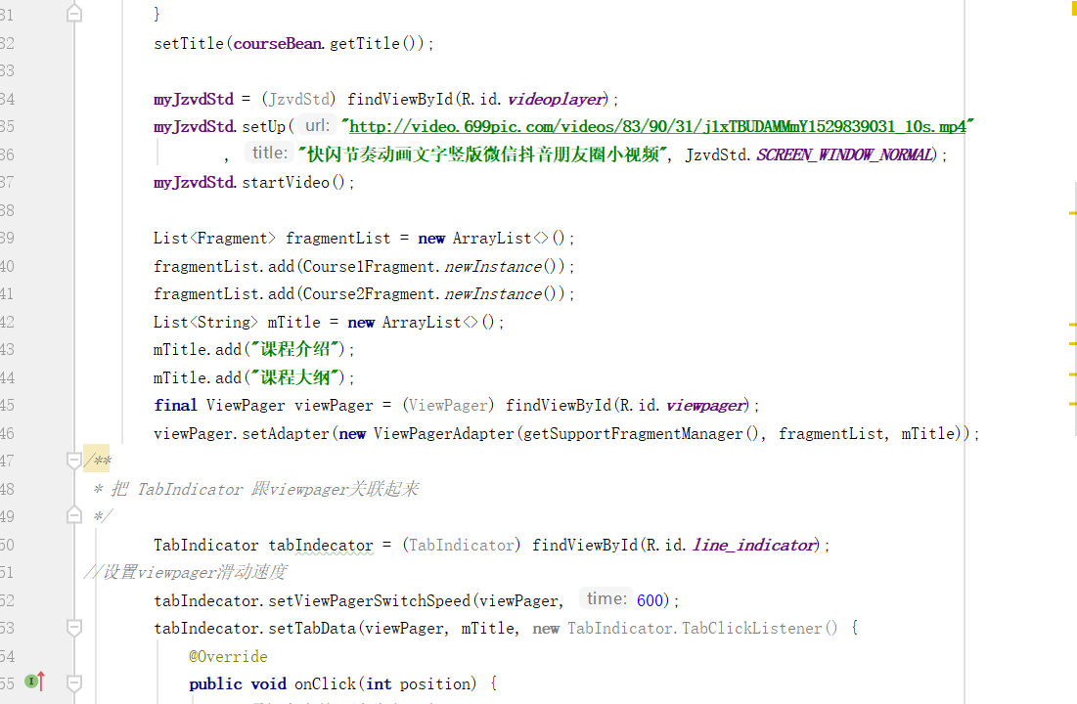

# 4. For long running jobs such as loading/uploading image or video, store in cache file and etc, implmenting with async task or multi thread is necessary.

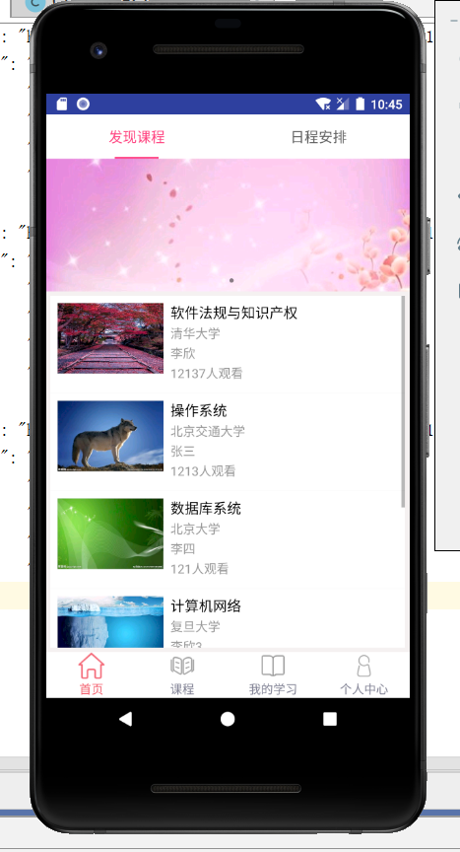 

It can load images asynchronously, the main code is as follows:

