. Detecting Fake Jobposting

Yuqing Liu (yl110057@student.sgh.waw.pl)
Aleksander Wojnarowicz(aw77438@student.sgh.waw.pl)

PART1：Introduction
  - Motivation
In the past few years, people have used intuition to distinguish fake job postings. For example, unusually high salaries may suggest false job postings. Nowadays, big data technology allows us to process these usage models to release job data more reliably and identify fake data. The goal of our project is to train a classifier to identify fake or real job postings using functions such as salary range, benefits, Required_experience, Required_education, etc.

  - Data Resource
https://www.kaggle.com/shivamb/real-or-fake-fake-jobposting-prediction

  - Data Description

Variables | Explain
Job_id | Unique Job ID
title | The title of the job ad entry.Most likely unique for each entry.
location | Geographical location of the job ad：Country, State, City
Department | Corporate department (e.g. sales).Most likely unique for each posting.
Salary_range | Indicative salary range
Company_profile | A brief company description
description | A brief company description
requirements | Enlisted requirements for the job opening.
Benefits | Enlisted requirements for the job opening.
telecommuting | Enlisted requirements for the job opening.
Has_company_logo | True if company logo is present.
Has_quesitons | True if company logo is present.
Employment_type | True if company logo is present.
Required_experience | True if company logo is present.
Required_education | True if company logo is present.
Industry | True if company logo is present.
Function | Consulting, Engineering, Research, Sales et
fraudulent | Target - Classification attribute.

  - Data Report
file:///D:\SGH-Master%20Study\Second%20Semester\Data%20Mining\2020MLF-PROJECT-master\README.md

PART2: Exploratory Data Analysis
2.1 The distribution of category labels

Real Posts
- ✅Telecommuting
- ✅Company Logo
- ✅Employment Type
- ✅Required Experience and Education

Fraudulent Posts
- ❌Telecommuting
- ❌Company Logo
- ✅Employment Type
- ✅Required Experience and Education
2.2 The distribution of text features' length
We want to see whether the length of 'company_profile', 'description', 'requirements', 'benefits' can be used to detect fake jobposting. Fake jobposting posts similar-length description, requirements and benefit to make them more reliable. While there's differences in company profile. Fake jobpostings are not tend to post short & long company profile.

PART3: Data Preprocessing

3.1 Feature trimming

- Delete Variables below:
- 'job_id' is unique for each sample and useless for detecting fake job.
- 'title' is nearly unique and difficult to deal with.
- 'location' is also difficult to handle and we want to find the generality of fake jobposting wherever it is.
- 'department' is just like job title with many different values.
- 'industry' and 'function' is also difficult to deal with and uselless for finding generality.

- Replace text features with length.
To avoid text analysis and simplify the model, use the length of 'company_profile'，'description'，'requirements'，'benefits' to replace the text.

- Divide 'salary_range'
- 'salary_range_min'
- 'salary_range_max'
- Map ordinal feature: 'required_education'，'required_experience'
Map required education level including 'Bachelor's Degree', 'High School or equivalent'.etc with integer from 0 to 10. Map required experience including 'MidSenior level','Associate'.etc with integer from 0 to 5.
- Map ordinal feature: 'required_education'，'required_experience'
Employment type is encoded to 4 columns to represent 5 different types.

3.2 Feature Selection

After trimming the features, there are 17 features. At the same time, one-hot encoding may cause Multicollinearity. Therefore, we need to select important functions. We choose KNN for sequential background selection.

Features selected below:

- 'required_education'
- 'salary_range_min'
- 'employment_type_Other',
- 'employment_type_Part-time'
- 'employment_type_Temporary'
- 'employment_type_Unknown'
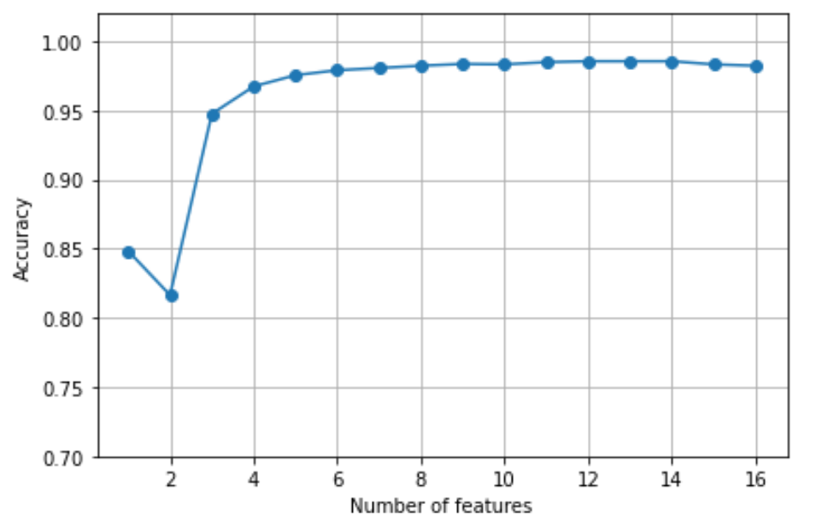

3.3 Feature correlation

After feature selection based on KNN, we also test the correlation of these features. And the results are shown below.
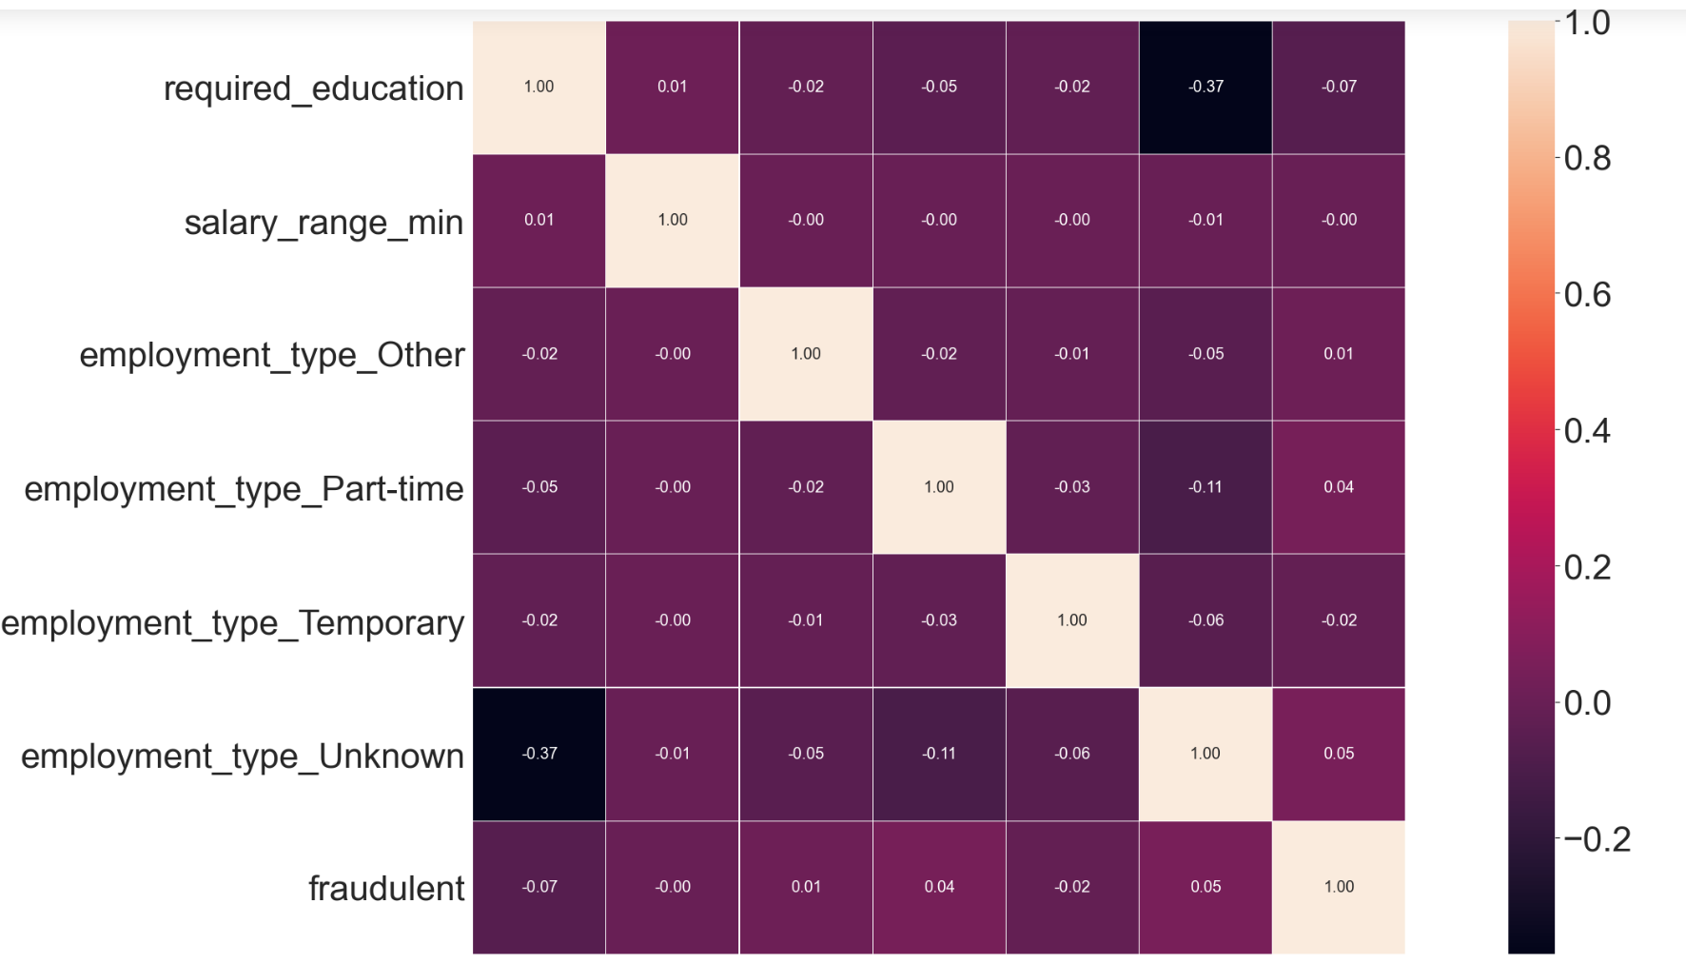

PART4: Model training, evaluation, and hyperparameter tuning in CV
Model: LR/SVM/TREE

Classification: Cross-Validation.

Method: In our sample, we use y = 0 (true Jobposting) as a positive number tag parameters in the code, so we use PRE as model Cross-Validation screening and Evaluation Criteria. The larger the PRE value, the smaller the FP/P Ratio, the easier it is for job seekers to avoid wrong Jobposting. Listed below are the best parameters we obtained and the corresponding Confusion_Matrix for different models.

4.1 Logistic Regression
C = 0.001
Precision: 0.951
Recall: 1.000
F1: 0.975

4.2 SVM
C = 0.001
Precision: 0.951
Recall: 1.000
F1: 0.975

4.3 Decision Tree
Max_depth = 14
Precision: 0.957
Recall: 0.997
F1: 0.977

Sum:
Among these three methods, the PRE = 95.7% of the best result provided by the decision tree. Please note that both LR and SVM have the same PRE as randomly trusting each Jobposting, so we guess that KNN feature selection may have some problems. This is why we try the PCA method in the next part.

PART5: Redo The Process in PCA Dimensionality-Reduced Data
In this part, we use the PCA method instead of the KNN method in 3.2. We set the component n = 2 to a better program velocity. After that, we execute the LR/SVM/Tree algorithm again.
Note that in the code, we use the pipeline method to package them together. The following table illustrates the result of our model.
Model Type | PRE* | REC | F1-score
PCA_LR | 0.884 | 0.936 | 0.909
PCA_SVM(rbf) | 0.972 | 0.919 | 0.945
PCA_Tree(max_depth=14) | 0.974 | 0.875 | 0.922

Sum:
We can see that for Logistic Regression the PCA method is worse than the KNN, but SVM and Decision Tree show the different, which means PCA covers some additional info than KNN. Notice that PCA-Tree, with 0.974 PRE, is the best method among them. We draw an ROC curve to deeply analyze this model.

PART6: Advanced Model (Random forest, Bagging and Adaboost)
In this part, we use both PCA dimensionality-reduced data and KNN feature selection data. These data are both put into training Random forest, Bagging and Adaboost these three models. To show our results more succinctly, the following table is used to show the results.

Model Type | PRE* | REC | F1-score
KNN_RF | 0.991 | 0.988 | 0.989
KNN_Bagging | 0.993 | 0.987 | 0.990
KNN_Adaboost | 0.994 | 0.976 | 0.985
PCA_RF | 0.943 | 0.941 | 0.942
PCA_Bagging | 0.946 | 0.943 | 0.945
PCA_Adaboost | 0.848 | 0.960 | 0.901

Sum:
We can see the models based on KNN data shows a higher Precision, which are better models. The reason behind this is that we just use 2 PCA components. But part3.3 show that the feature correlation is very weak, which means 2 PCA components are not enough to represent the whole feature and explain the results. As we mentioned above, we care more about the precision index. In the models based on KNN data, the Adaboost shows the best results.

PART7: Generally Comparison
Model Type | PRE* | REC | F1-score
PCA_LR | 0.884 | 0.936 | 0.909
PCA_SVM(rbf) | 0.972 | 0.919 | 0.945
PCA_Tree(max_depth=14) | 0.974 | 0.875 | 0.922
KNN_RF | 0.991 | 0.988 | 0.989
KNN_Bagging | 0.993 | 0.987 | 0.990
KNN_Adaboost | 0.994 | 0.976 | 0.985
PCA_RF | 0.943 | 0.941 | 0.942
PCA_Bagging | 0.946 | 0.943 | 0.945
PCA_Adaboost | 0.848 | 0.960 | 0.901

PART8: Upsampling

In our raw data, there are many true jobposting, which means you select the job casually and without any consideration, the possibility that you choose the fake job will be very low. Our raw data is very imbalanced.

We do the upsampling to see if our model works.

- Upsampling
- KNN feature selection

Model Type | PRE* | REC | F1-score
KNN_LR | 0.627 | 0.347 | 0.447
KNN_SVM(line) | 0.631 | 0.355 | 0.455
KNN_TREE(max_depth=15) | 0.892 | 0.860 | 0.876
PCA_LR | 0.558 | 0.534 | 0.546
PCA_SVM | 0.553 | 0.547 | 0.550
PCA_TREE(max_depth=15) | 0.914 | 0.827 | 0.868
KNN_RF | 0.991 | 0.988 | 0.868
KNN_Bagging | 0.993 | 0.987 | 0.990
KNN_Adaboost | 0.994 | 0.976 | 0.985
PCA_RF | 1.000 | 0.927 | 0.962
PCA_Bagging | 1.000 | 0.927 | 0.962
PCA_Adaboost | 0.677 | 0.614 | 0.644

Sum:
Random Forest and Adaboost based on Upsampling PCA data show the best results. After Upsampling, we can see the precision index of all the training models all tend to decline. It is reasonable. Because we enlarge the possibility of choosing the fake job. The models above verify the efficiency of our prediction.

PART9: Explain the behind logistics of our prediction.
Based on the picture of the tree classifier, we can see the salary range and required education play important roles in prediction. That is because for the fake job, they usually do not care your education and salary range. These two items are the most two important factors that the company cares about. Therefore, these two factors play important roles in prediction.

Reference: https://www.kaggle.com/nikitaalbert/is-this-job-for-real

