HIGH LEVEL DESIGN (HLD) DOCUMENT
SCCM to NSO CFS/RFS Service Provisioning Integration
MPLS L3VPN & GPON Service Orchestration via RESTCONF

Document Type: High Level Design (HLD)
Version: 1.0
Date: July 2026

Document Control

Revision History
Version | Date | Author | Description
1.0 | July 2026 | Network Automation Team | Initial version — SCCM to NSO CFS/RFS integration HLD

Table of Contents

1. Introduction

1.1 Purpose
This document describes the High Level Design (HLD) for the end-to-end service provisioning workflow between SCCM (Service Creation and Change Management) and Cisco NSO, covering both the Customer Facing Service (CFS) and Resource Facing Service (RFS) layers in a Layered Service Architecture (LSA). It captures the SCCM service order creation sequence, the RESTCONF-based integration between SCCM and NSO CFS, and the corresponding validation steps performed in NSO CFS and NSO RFS for MPLS L3VPN and GPON service types.

1.2 Scope
The scope of this document covers:
- The three sequential SCCM API calls used for service order creation (Service Order Initialization, Service Order Data Submission, and Service Provisioning).
- Generation and transmission of RESTCONF payloads from SCCM to NSO CFS for MPLS L3VPN and GPON (Nokia/Tejas) service orchestration.
- Service order status verification within SCCM following successful orchestration.
- Validation of the MPLS L3VPN service instance, interface, device, QoS, and VRF configuration within NSO CFS.
- Validation of the GPON service instance within NSO CFS (Nokia Service Manager).
- Device-level verification of the provisioned service within NSO RFS.

1.3 Audience
This document is intended for network automation engineers, OSS/BSS integration teams, NSO developers, and NOC/validation teams involved in the design, deployment, and operational support of the SCCM–NSO service provisioning integration.

1.4 Abbreviations
Term | Description
SCCM | Service Creation and Change Management system
NSO | Cisco Network Services Orchestrator
CFS | Customer Facing Service (NSO service layer)
RFS | Resource Facing Service (NSO service layer)
LSA | Layered Service Architecture
OLT | Optical Line Terminal
ONT | Optical Network Terminal
GPON | Gigabit Passive Optical Network
VRF | Virtual Routing and Forwarding
PE | Provider Edge (router)
QoS | Quality of Service
VLAN | Virtual Local Area Network

2. SCCM Service Order Creation Workflow
The Service Order Creation process in SCCM is performed through a sequence of three API calls (Step 1, Step 2, Step 3). These APIs are executed sequentially to initialize, populate, and provision the service order.

2.1 Step 1 – Service Order Initialization
Purpose
The Service Order Initialization API is the first step in the SCCM service provisioning workflow. It creates a new service deployment request and generates a unique Transaction ID. This Transaction ID serves as a reference identifier and is used by subsequent APIs (Step 2 and Step 3) to process the same service order request.
Description
Upon receiving the service order details, SCCM validates the request and creates a transaction entry in the system. A unique Transaction ID is then generated and returned in the API response. This Transaction ID links all subsequent service order creation and provisioning activities.
Input
Basic service order information such as Service Order ID, Customer ID, Service Type, Location, VLAN, and other service attributes.
Output
A unique Transaction ID generated by SCCM.
Outcome
- Service order request is successfully initialized.
- Transaction record is created in SCCM.
- Transaction ID is returned to the calling application.
- The generated Transaction ID is used in Step 2 for service order data submission and Step 3 for service provisioning.
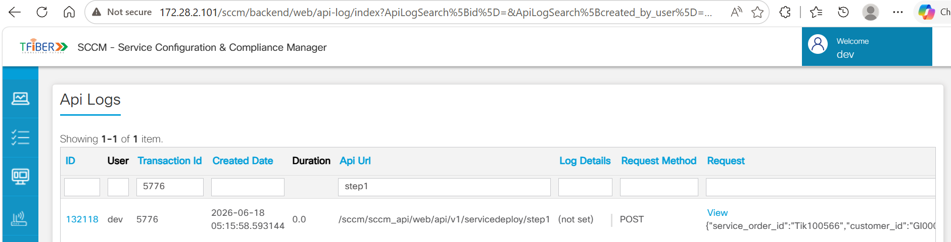
Step 1 – API Request
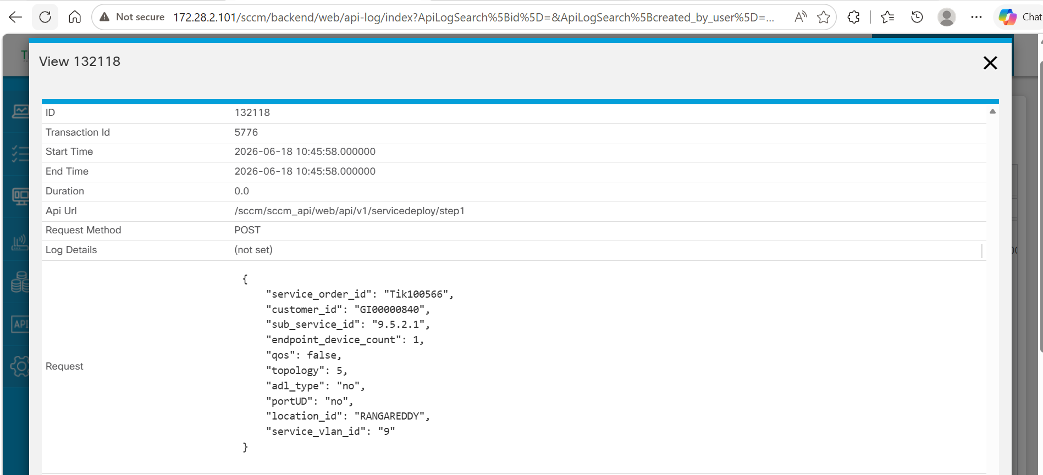
Step 1 – Payload and Response
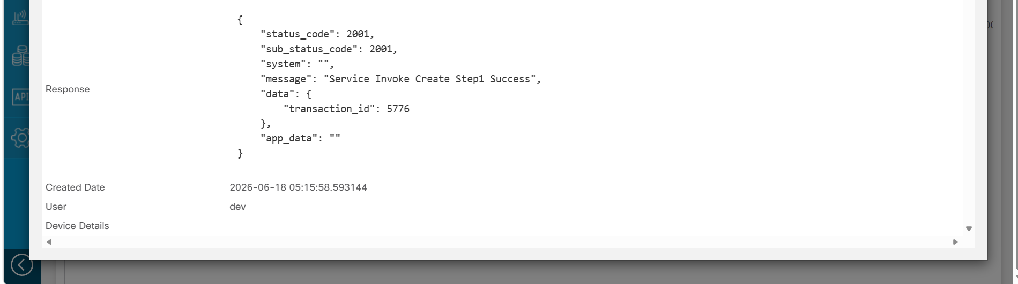
Step 1 – Confirmation

2.2 Step 2 – Service Order Data Submission
Purpose
The Service Order Data Submission API is the second step in the SCCM service provisioning workflow. It uses the Transaction ID generated in Step 1 and submits all service-specific configuration details required for service creation and provisioning.
Description
Upon receiving the Transaction ID and service configuration details, SCCM validates the submitted information and associates it with the corresponding service order transaction. The request includes endpoint device details, bandwidth profiles, ONT information, OLT details, and PE device connectivity information required for provisioning the service.
Input
- Transaction ID generated in Step 1
- Endpoint device count
- Service-specific ID
- Upstream and downstream bandwidth profiles
- ONT details (Model, Serial Number, PON Port, Tagging Information)
- OLT hostname
- PE hostname and PE port
- Other service-specific parameters
Output
Service configuration details are validated and linked to the Transaction ID for further processing in the provisioning workflow.
Outcome
- Service order details are submitted against the Transaction ID generated in Step 1.
- Endpoint device and service configuration information are processed by SCCM.
- ONT, OLT, bandwidth profile, and PE connectivity details are validated.
- The service order transaction is updated with provisioning-related information.
- The Transaction ID remains active and is used in Step 3 to initiate service provisioning or scheduling.
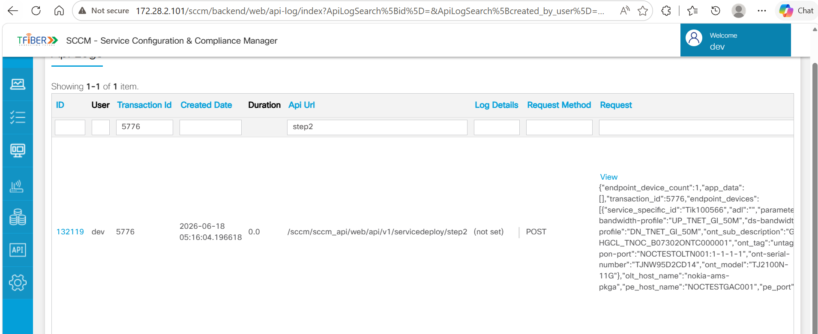
Step 2 – API Request
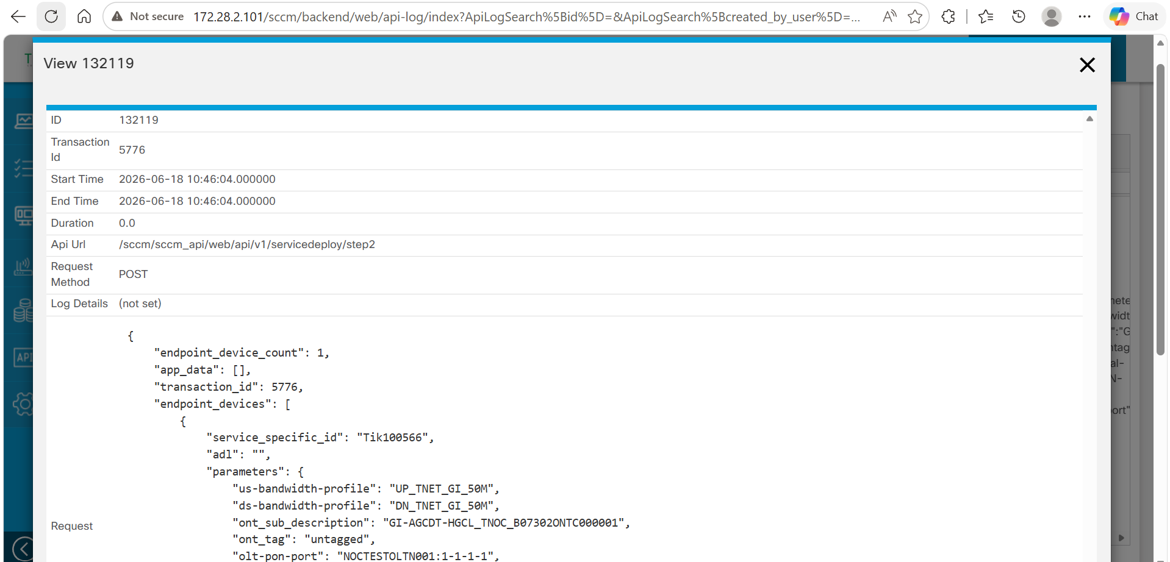
Step 2 – Payload and Response
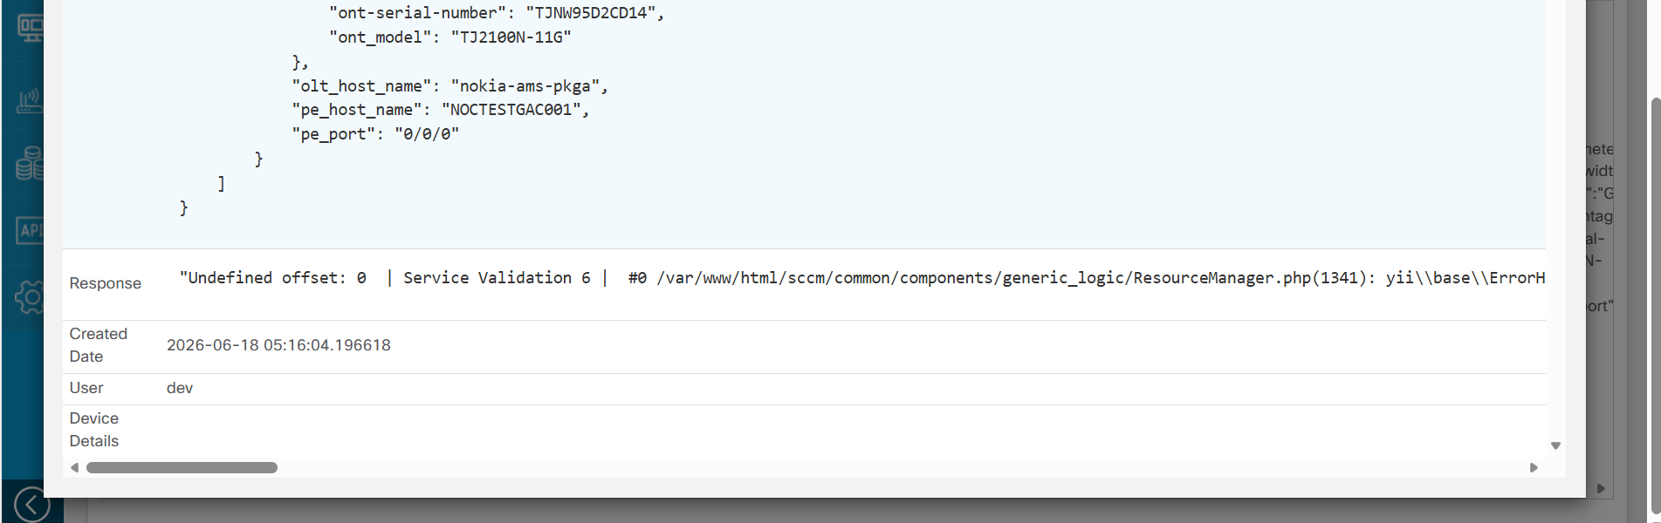
Step 2 – Confirmation

2.3 Step 3 – Service Provisioning
Purpose
The Service Provisioning API is the final step in the SCCM service provisioning workflow. It uses the Transaction ID from the previous steps to initiate the service provisioning process and trigger the required downstream configuration activities.
Description
Upon receiving the Transaction ID, SCCM retrieves the service order information submitted in Steps 1 and 2 and initiates the provisioning workflow. The system validates the service data and executes the required provisioning actions. Once the provisioning request is successfully initiated, SCCM returns a unique service identifier associated with the provisioned service.
Input
- Transaction ID generated in Step 1
- Action value indicating the provisioning operation
- Service order information previously submitted in Step 2
Output
- Service provisioning status
- Unique service identifier generated for the provisioned service
Outcome
- SCCM retrieves the service order details associated with the provided Transaction ID.
- Service provisioning workflow is initiated.
- Required service configuration processing is triggered.
- A unique service identifier is generated for the provisioned service.
- SCCM returns a successful response indicating that the provisioning request has been accepted and processed.
- Generated Service Identifier: A unique service identifier (CKT-L3VPN-GI-BB-SCCM-Tik100566) is generated and returned upon successful initiation of the service provisioning process. This unique identifier can be used to track the provisioned service in subsequent validation and operational workflows.
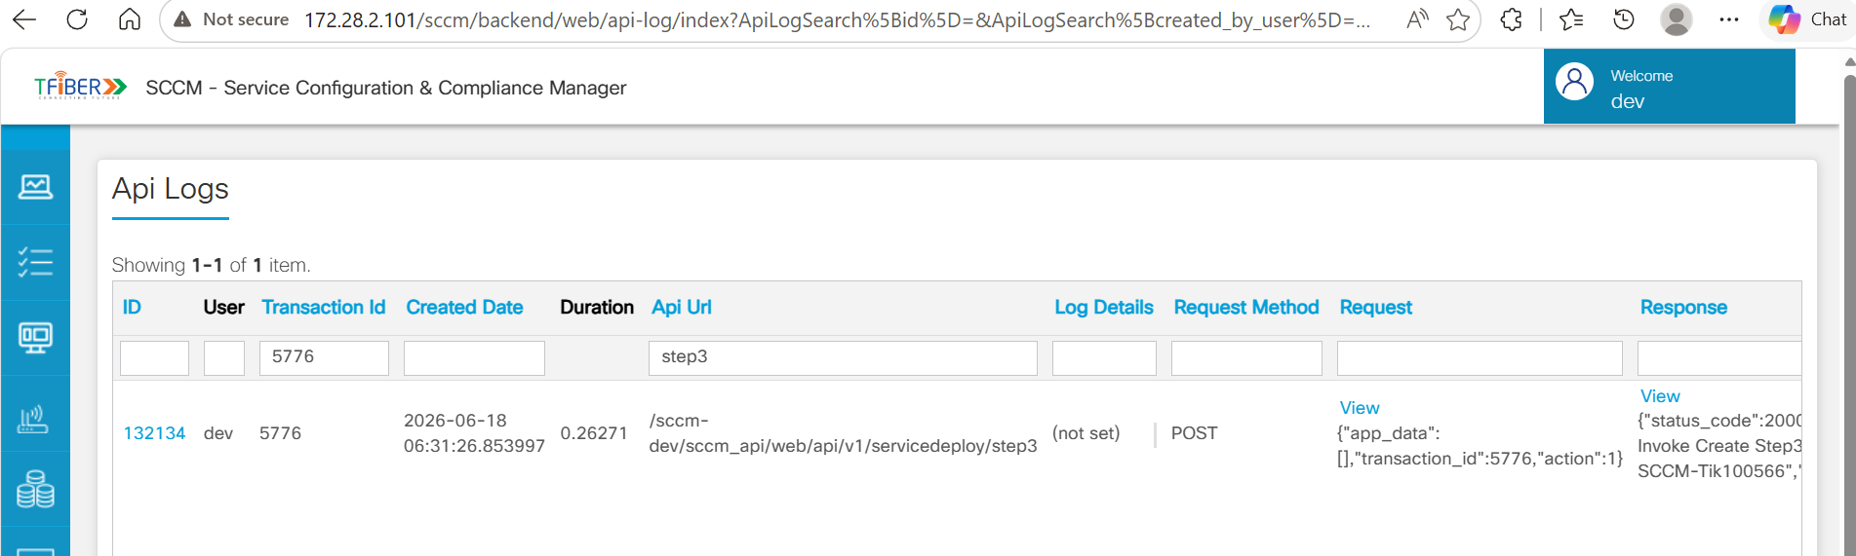
Step 3 – API Request
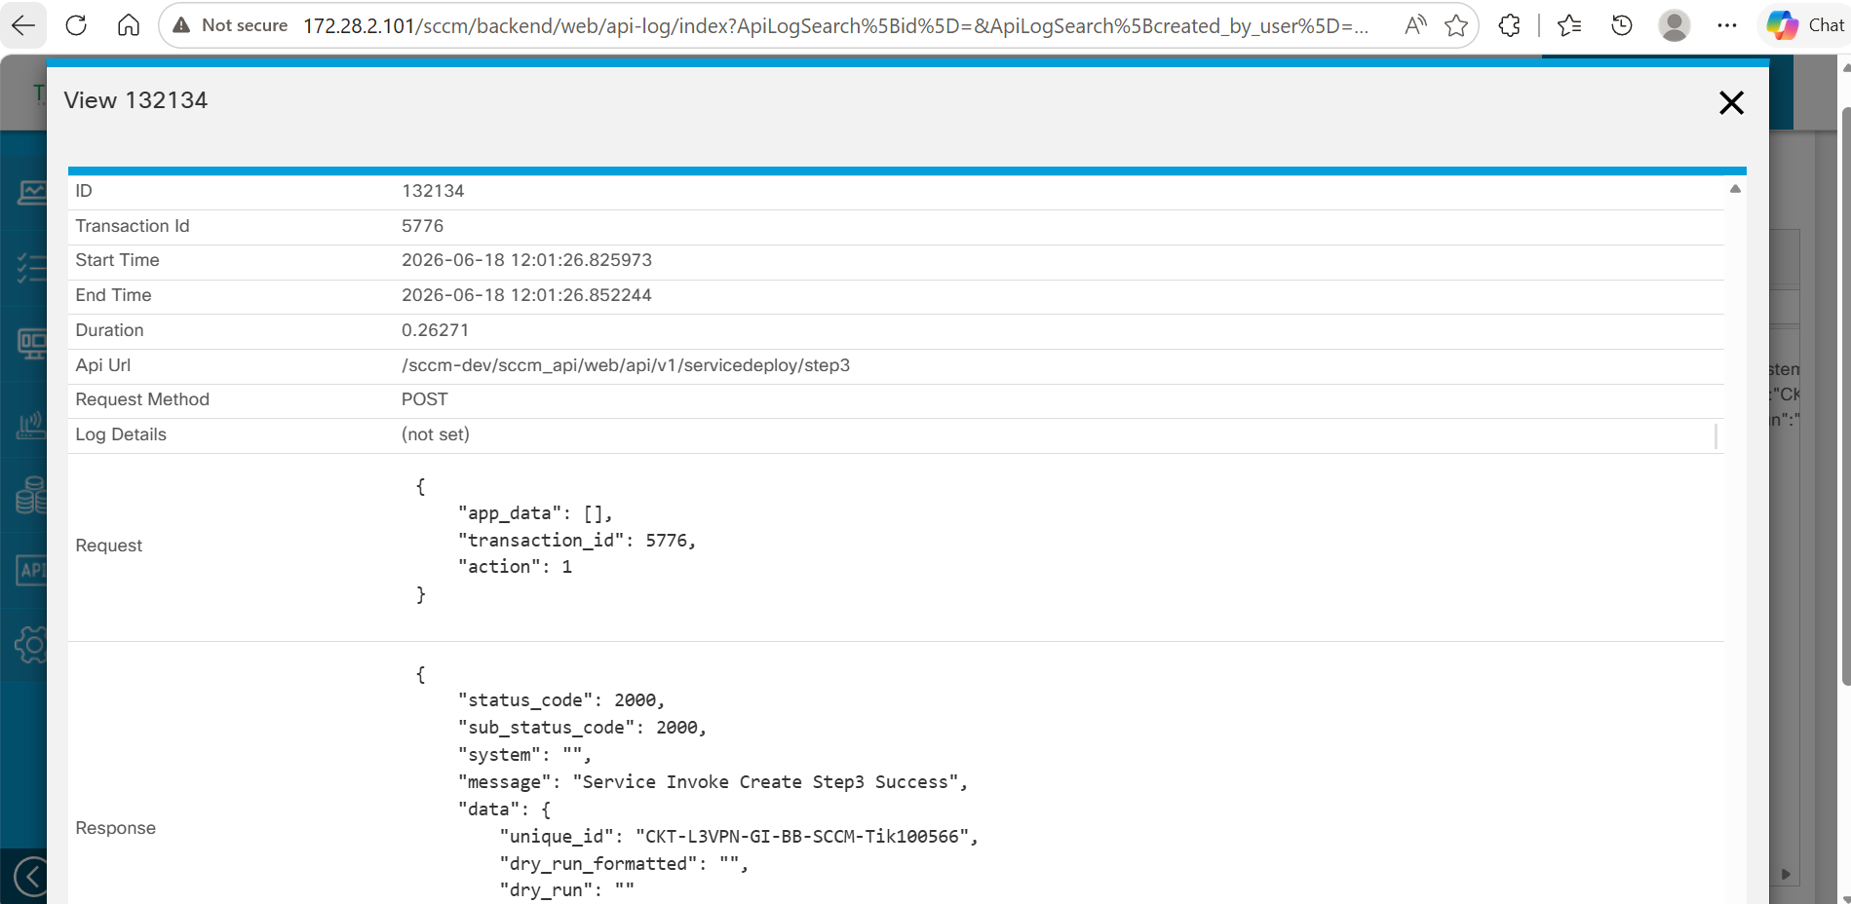
Step 3 – Payload and Response
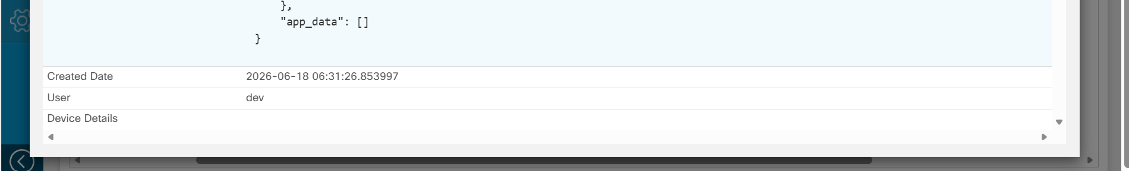
Step 3 – Confirmation

3. RESTCONF API Integration with NSO CFS
Purpose
The RESTCONF APIs act as the integration interface between SCCM and NSO CFS. After successful completion of the service provisioning workflow, SCCM generates RESTCONF payloads and forwards them to NSO CFS for automated service orchestration and network configuration deployment.
Description
After successful execution of Step 1 (Service Order Initialization), Step 2 (Service Order Data Submission), and Step 3 (Service Provisioning), SCCM consolidates the information collected throughout the workflow, including service order details, customer information, VLAN configuration, bandwidth profiles, OLT/ONT details, PE device details, VRF configuration, routing information, and QoS policies.
Using this information, SCCM generates two separate RESTCONF payloads and sends them to NSO CFS through the RESTCONF interface:

MPLS L3VPN RESTCONF Payload (Router Configuration)
This payload contains MPLS L3VPN service configuration details, including Circuit ID, VPN ID, VRF definitions, interface configuration, VLAN information, QoS policies, routing parameters, and PE device details. The payload is consumed by NSO CFS to orchestrate MPLS L3VPN service deployment on the network infrastructure.

GPON RESTCONF Payload (Nokia/Tejas) (OLT, ONT Configuration)
This payload contains GPON access service configuration details, including OLT information, ONT details, ONT serial number, VLAN mapping, bandwidth profiles, subscriber information, and other service-specific parameters. The payload is consumed by NSO CFS to orchestrate GPON service provisioning on Nokia or Tejas OLT infrastructure.
Outcome
- SCCM generates RESTCONF payloads using the data collected during the service provisioning workflow.
- Separate RESTCONF payloads are created for MPLS L3VPN services and GPON access services.
- RESTCONF APIs are triggered towards NSO CFS.
- NSO CFS receives and processes the MPLS L3VPN and GPON service payloads.
- NSO CFS initiates the corresponding service orchestration workflows.
- Service configurations are prepared for deployment on the target MPLS and GPON network infrastructure.

3.1 MPLS L3VPN Service Orchestration Request via RESTCONF to NSO CFS
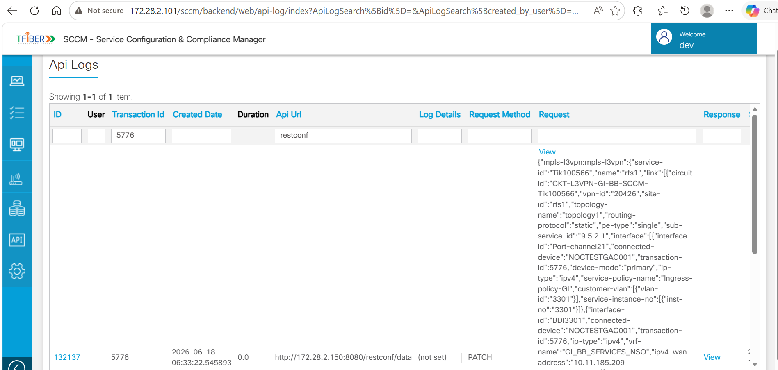
MPLS L3VPN Orchestration Request
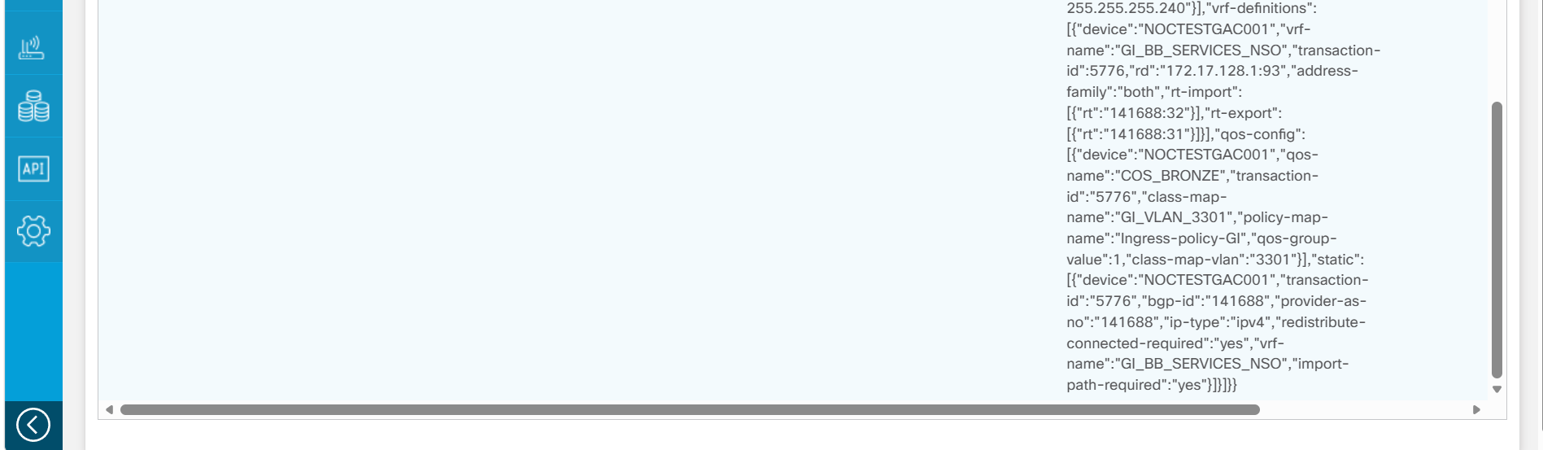
MPLS L3VPN Orchestration Request (contd.)

3.2 MPLS L3VPN RESTCONF Payload
Purpose
The MPLS L3VPN RESTCONF API is used to transfer MPLS L3VPN service configuration details from SCCM to NSO CFS for service orchestration and configuration deployment on the target MPLS network infrastructure.
Description
After successful completion of Step 1 (Service Order Initialization), Step 2 (Service Order Data Submission), and Step 3 (Service Provisioning), SCCM generates an MPLS L3VPN RESTCONF payload using the information collected throughout the service provisioning workflow.
The payload contains all MPLS service-specific configuration details required for service deployment, including service identifiers, VPN information, PE device details, interface configuration, VLAN information, VRF definitions, QoS policies, and routing parameters. SCCM sends this payload to the NSO CFS RESTCONF endpoint, where NSO CFS processes the request and initiates MPLS L3VPN service orchestration.
Input
- Transaction ID
- Service ID
- Circuit ID
- VPN ID
- Sub Service ID
- Customer VLAN Information
- PE Device Information
- Interface Configuration
- VRF Configuration
- QoS Configuration
- Routing Parameters
- WAN IP Address Information
Output
An MPLS L3VPN RESTCONF payload is generated and forwarded to NSO CFS through the RESTCONF interface for MPLS service orchestration.
Outcome
- SCCM generates the MPLS L3VPN RESTCONF payload using the service order information collected during the provisioning workflow.
- The payload contains service, interface, VLAN, VRF, QoS, and routing configuration details required for MPLS L3VPN deployment.
- The RESTCONF API is triggered towards NSO CFS.
- NSO CFS receives and processes the MPLS L3VPN payload.
- NSO CFS initiates the MPLS L3VPN service orchestration workflow.
- MPLS L3VPN configuration is prepared for deployment on the target PE network devices.
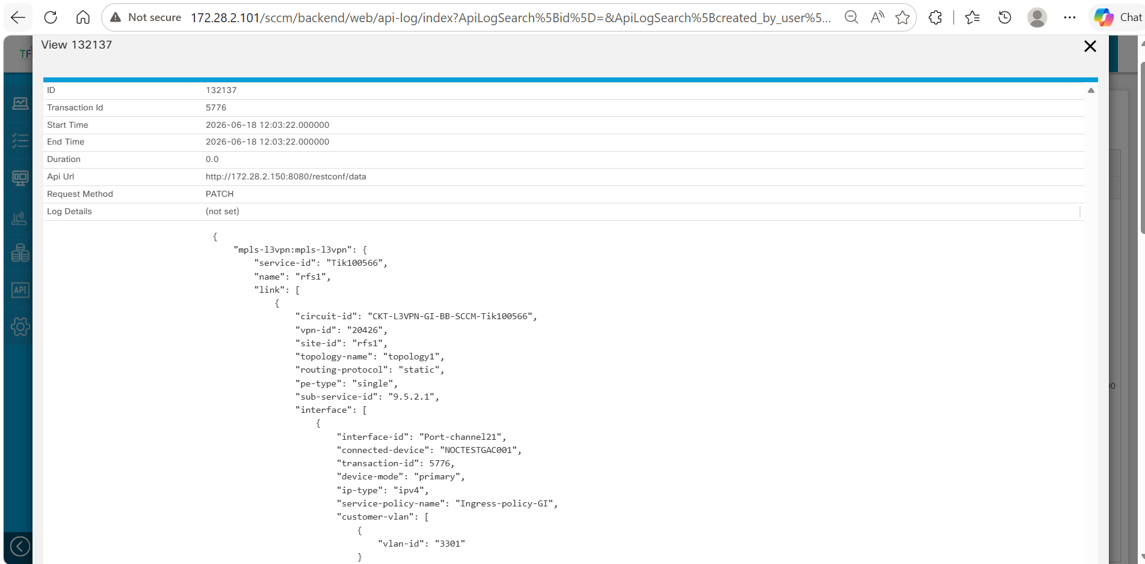
MPLS L3VPN RESTCONF Payload
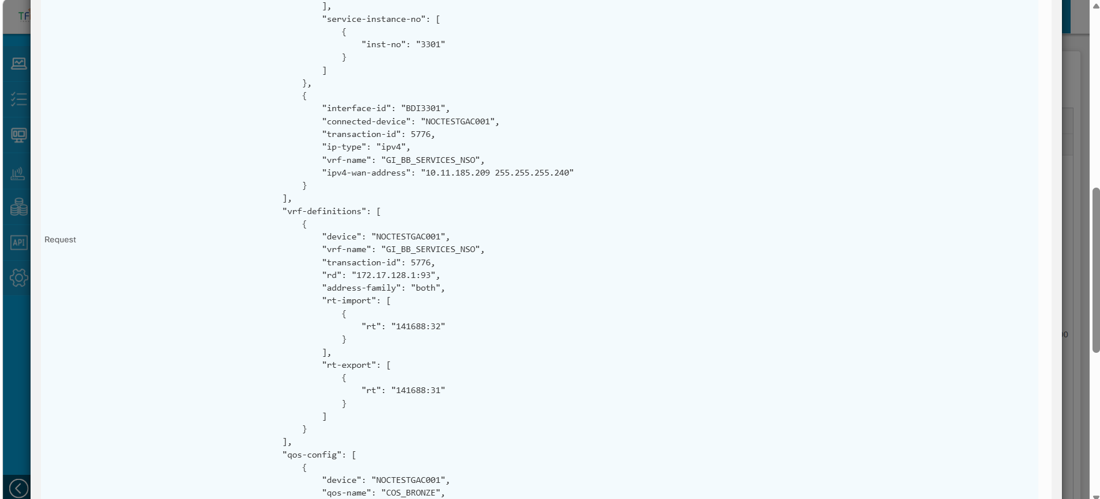
MPLS L3VPN RESTCONF Payload (contd.)
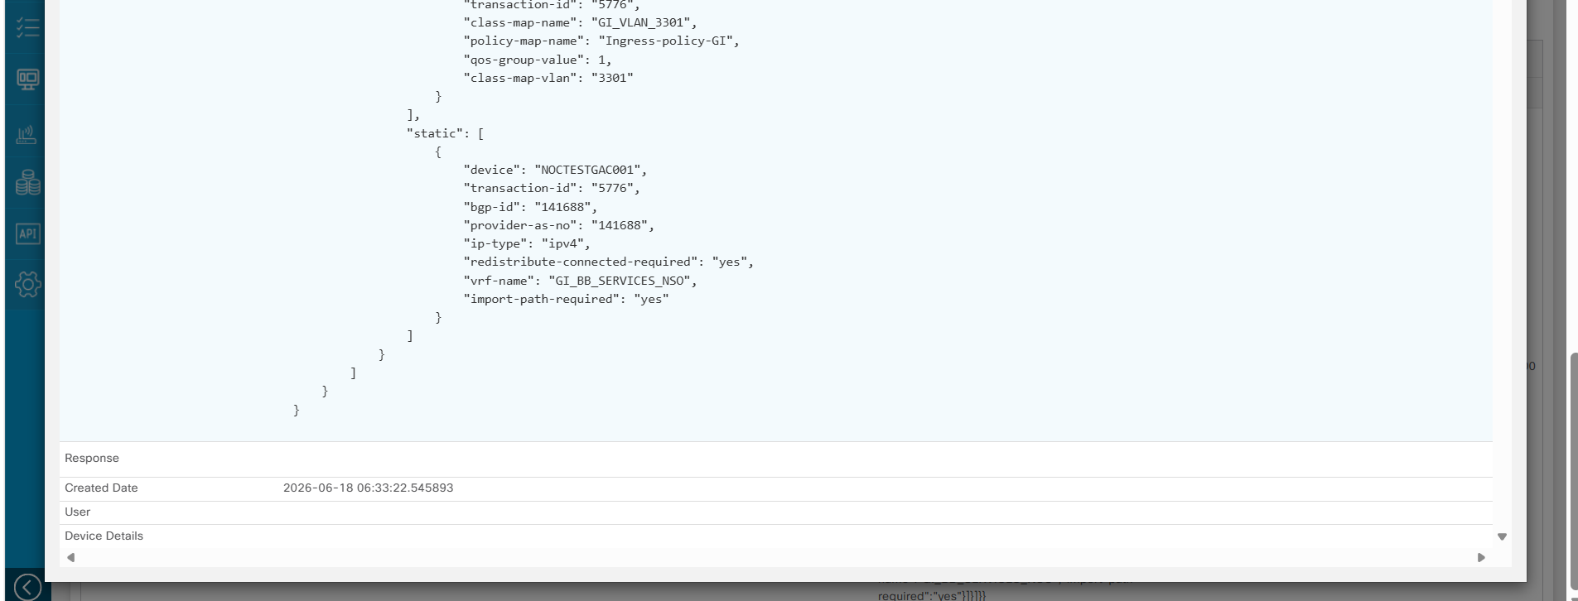
MPLS L3VPN RESTCONF Payload (contd.)

3.3 GPON Service Orchestration Request via RESTCONF to NSO CFS
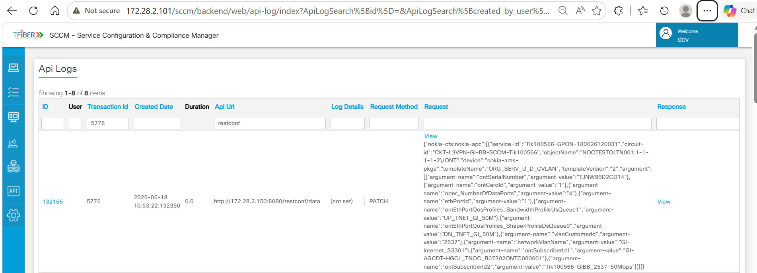
GPON Orchestration Request

3.4 GPON RESTCONF Payload (Nokia/Tejas)
Purpose
The GPON RESTCONF API is used to transfer GPON access service configuration details from SCCM to NSO CFS for service orchestration and configuration deployment on the target Nokia or Tejas GPON network infrastructure.
Description
After successful completion of Step 1 (Service Order Initialization), Step 2 (Service Order Data Submission), and Step 3 (Service Provisioning), SCCM generates a GPON RESTCONF payload using the information collected throughout the service provisioning workflow.
The payload contains all GPON service-specific configuration details required for service deployment, including OLT information, ONT details, ONT serial number, VLAN configuration, bandwidth profiles, subscriber information, and service provisioning parameters. SCCM sends this payload to the NSO CFS RESTCONF endpoint, where NSO CFS processes the request and initiates GPON service orchestration on the target Nokia or Tejas OLT infrastructure.
Input
- Transaction ID
- Service ID
- Circuit ID
- OLT Information
- ONT Information
- ONT Serial Number
- ONT Card and Port Details
- Customer VLAN Information
- Network VLAN Information
- Upstream Bandwidth Profile
- Downstream Bandwidth Profile
- Subscriber Information
- Service-Specific Parameters
Output
A GPON RESTCONF payload is generated and forwarded to NSO CFS through the RESTCONF interface for GPON service orchestration.
Outcome
- SCCM generates the GPON RESTCONF payload using the service order information collected during the provisioning workflow.
- The payload contains OLT, ONT, VLAN, bandwidth profile, and subscriber-specific configuration details required for GPON service deployment.
- The RESTCONF API is triggered towards NSO CFS.
- NSO CFS receives and processes the GPON RESTCONF payload.
- NSO CFS initiates the GPON service orchestration workflow.
- GPON service configuration is prepared for deployment on the target Nokia or Tejas OLT infrastructure.
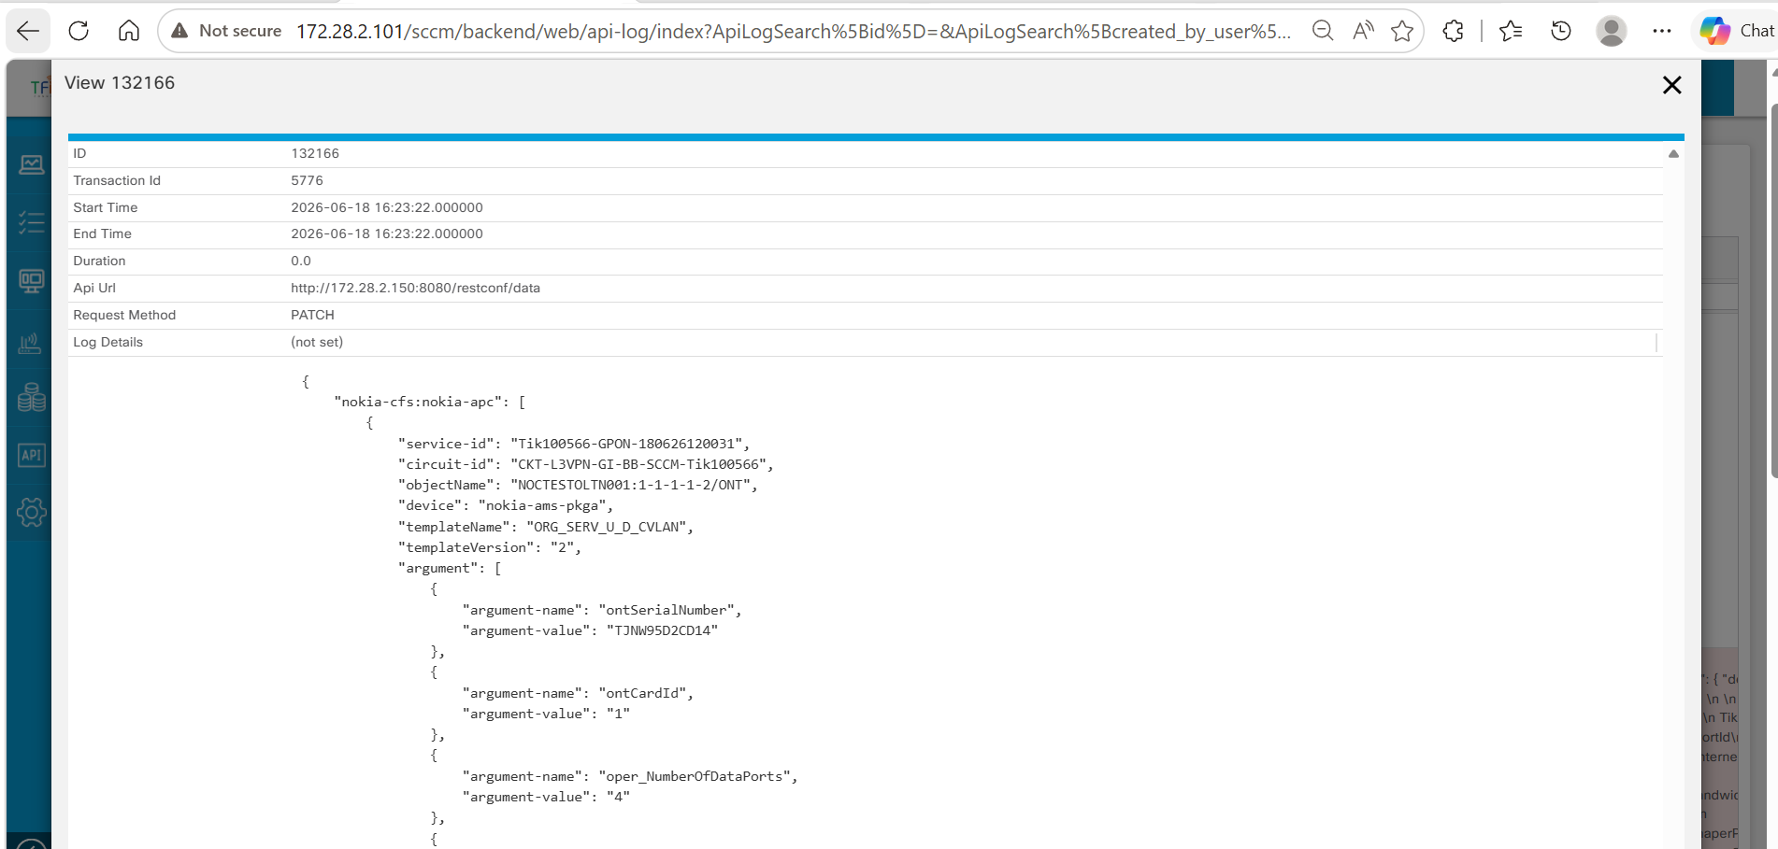
GPON RESTCONF Payload
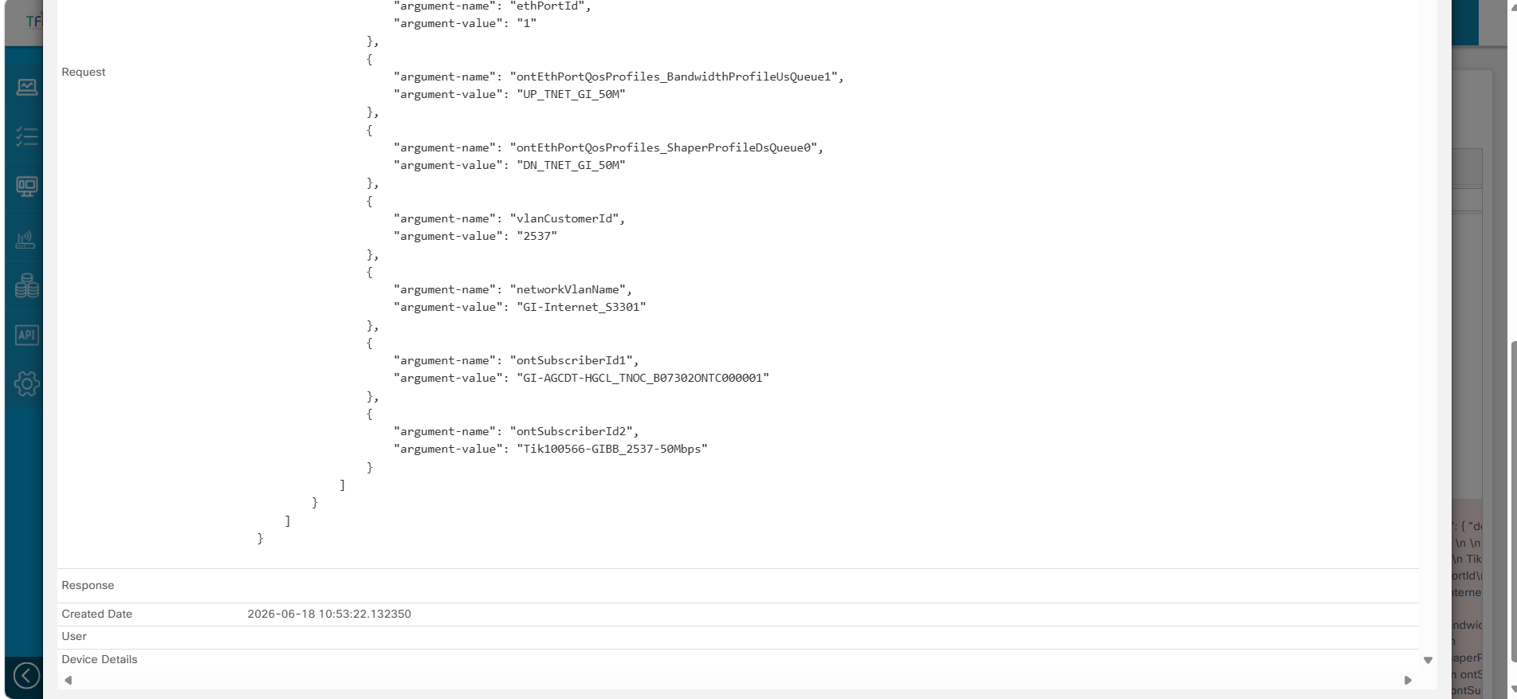
GPON RESTCONF Payload (contd.)

4. Service Order Status Verification in SCCM
After successful completion of Step 1 (Service Order Initialization), Step 2 (Service Order Data Submission), Step 3 (Service Provisioning), and subsequent RESTCONF-based service orchestration in NSO CFS, the service configurations are processed by NSO and applied on the target network infrastructure.
Upon successful completion of the orchestration workflow, NSO updates the provisioning status back to SCCM. SCCM then updates the service order status to Committed, indicating that the service provisioning workflow has been successfully completed.
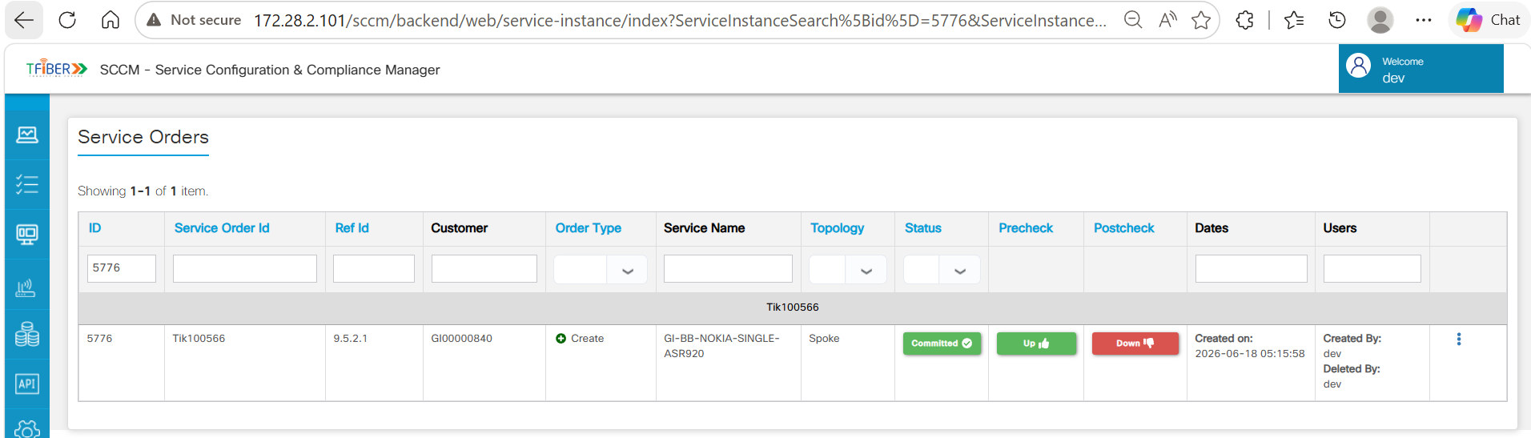
Service Order Status – Committed in SCCM

5. Validation in NSO CFS

5.1 MPLS L3VPN Service Validation
Purpose
This step is used to verify that the MPLS L3VPN service configuration received from SCCM through the RESTCONF API has been successfully processed and created as a service instance in NSO CFS.
Description
After SCCM generates the MPLS L3VPN RESTCONF payload and sends it to NSO CFS, NSO CFS processes the payload and creates the corresponding MPLS L3VPN service instance.
By logging into the NSO CFS portal and navigating to the MPLS L3VPN Service Manager, the created service can be searched and viewed using the Service ID. Selecting the service and opening the associated Circuit ID allows verification of the service attributes populated from the SCCM RESTCONF payload.
The displayed service information in NSO CFS represents the configuration data received from SCCM and confirms that the service request has been successfully onboarded into the NSO orchestration layer.
Validation Points
- Verify that the MPLS L3VPN service instance is available in the NSO CFS Service Manager.
- Verify that the Service ID is displayed as: Tik100566
- Verify that the Circuit ID is displayed as: CKT-L3VPN-GI-BB-SCCM-Tik100566
- Verify that the service details displayed in NSO CFS match the values received through the SCCM RESTCONF payload, including: Circuit ID, Sub Service ID, VPN ID, Site ID, Topology Name, Routing Protocol, PE Type.
Output
The MPLS L3VPN service instance and associated service attributes are displayed in the NSO CFS portal for validation and further orchestration activities.
Outcome
- NSO CFS receives the MPLS L3VPN RESTCONF payload generated by SCCM.
- A corresponding MPLS L3VPN service instance is created in NSO CFS.
- The service can be searched and accessed using the Service ID.
- Service attributes displayed in NSO CFS match the values received through the SCCM RESTCONF payload.
- The successful creation of the service instance confirms that the data sent from SCCM through the RESTCONF interface has been processed by NSO CFS.
- The service instance is available for subsequent synchronization, deployment, and lifecycle management activities within NSO CFS.
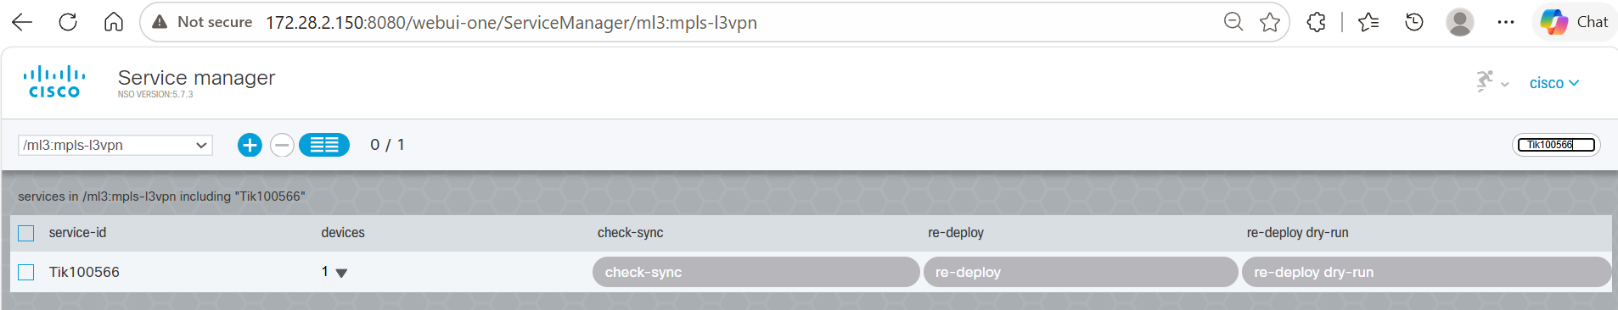
MPLS L3VPN Service Instance Validation in NSO CFS
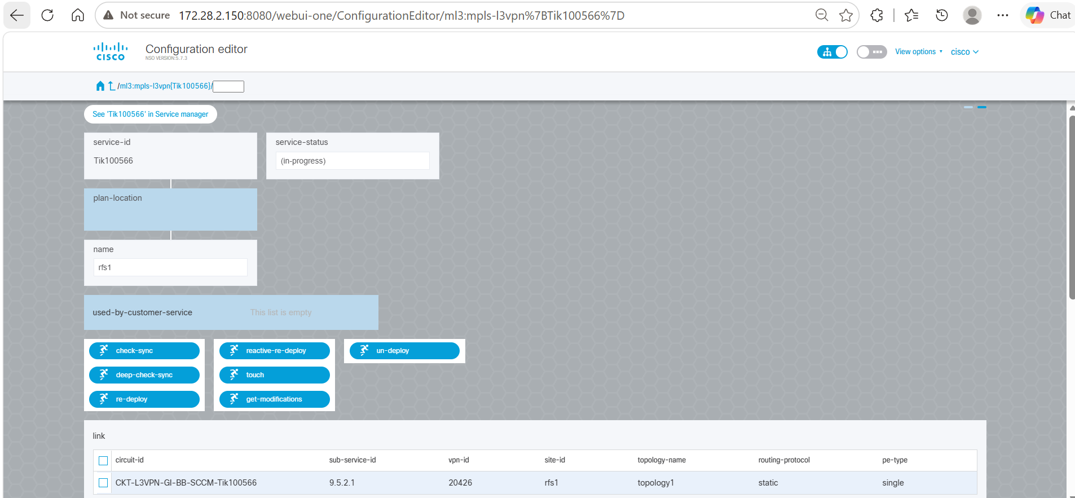
MPLS L3VPN Service Instance Validation (contd.)
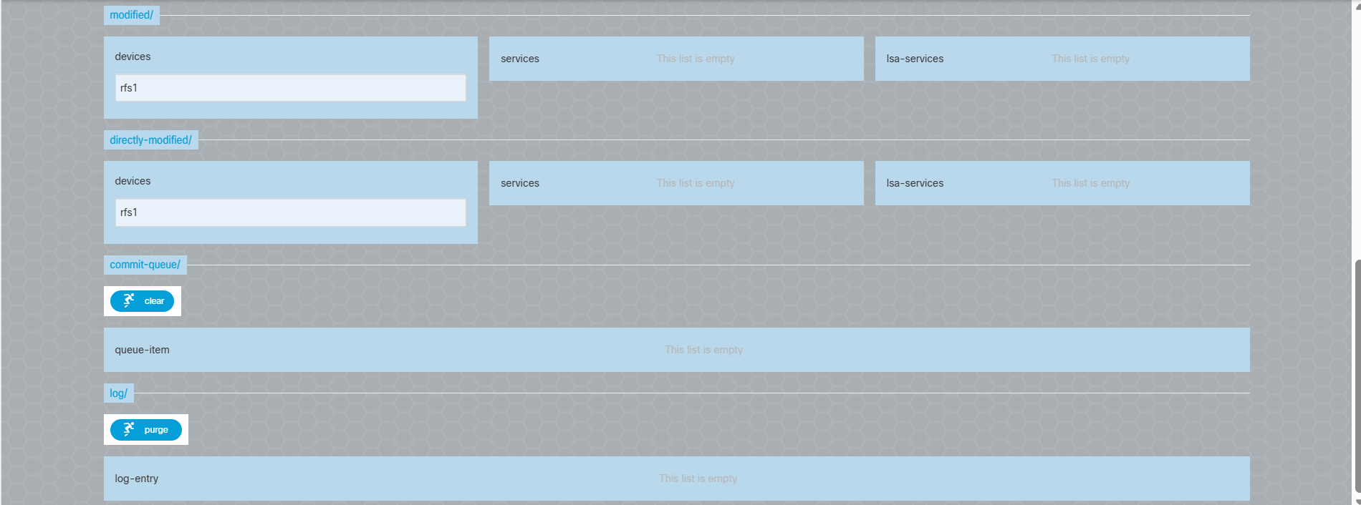
MPLS L3VPN Service Instance Validation (contd.)

5.2 Circuit ID Payload Verification
After the MPLS L3VPN service instance is created in NSO CFS, open the service and click on the Circuit ID. The Configuration Editor displays the detailed service configuration that was received from SCCM through the RESTCONF payload.
Outcome
- The MPLS L3VPN configuration received through the SCCM RESTCONF payload is visible in NSO CFS.
- Device configuration details are successfully associated with the service instance.
- VRF configuration is created and available for verification.
- Static routing configuration is populated in the service instance.
- QoS configuration is applied and available for validation.
- The displayed configuration confirms that the data sent from SCCM through the RESTCONF interface has been successfully processed and stored in NSO CFS.
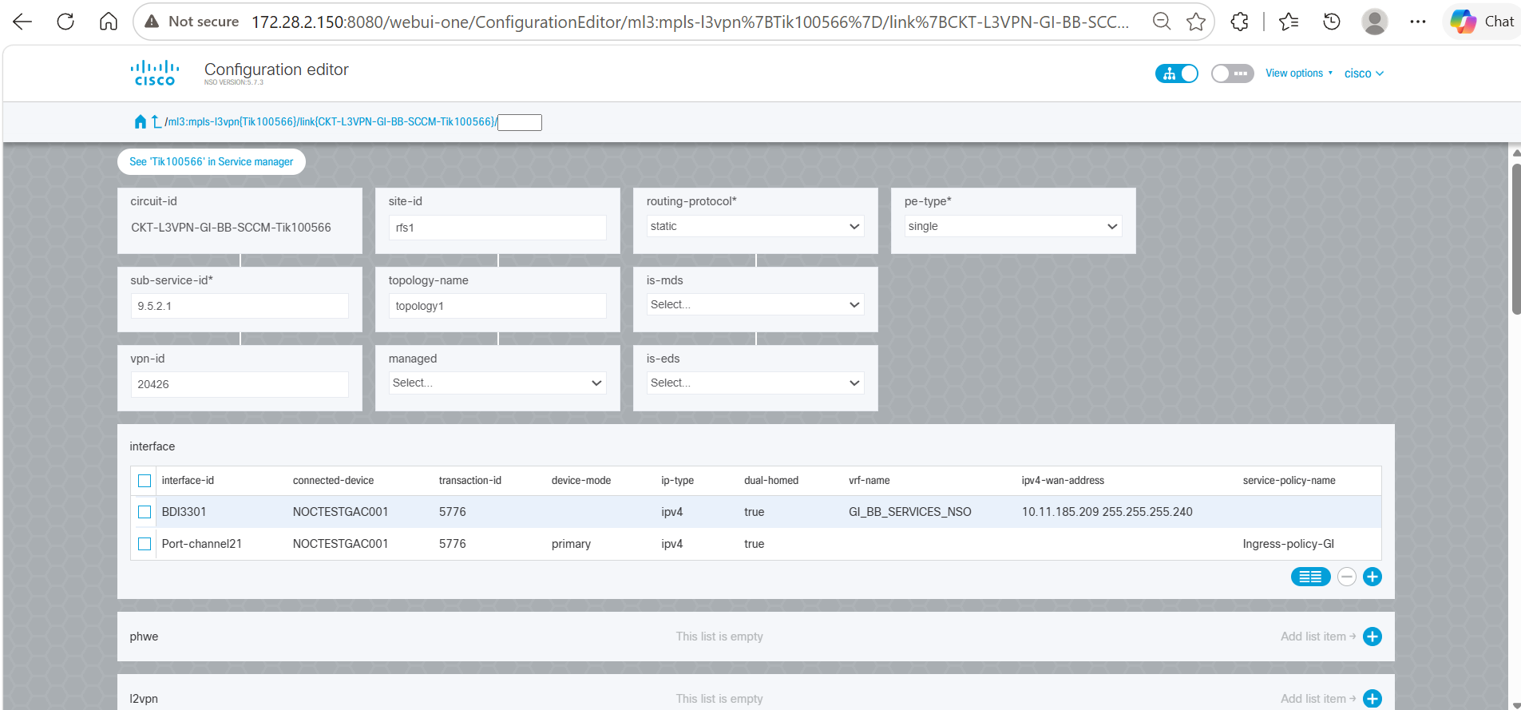
Circuit ID – Service Configuration
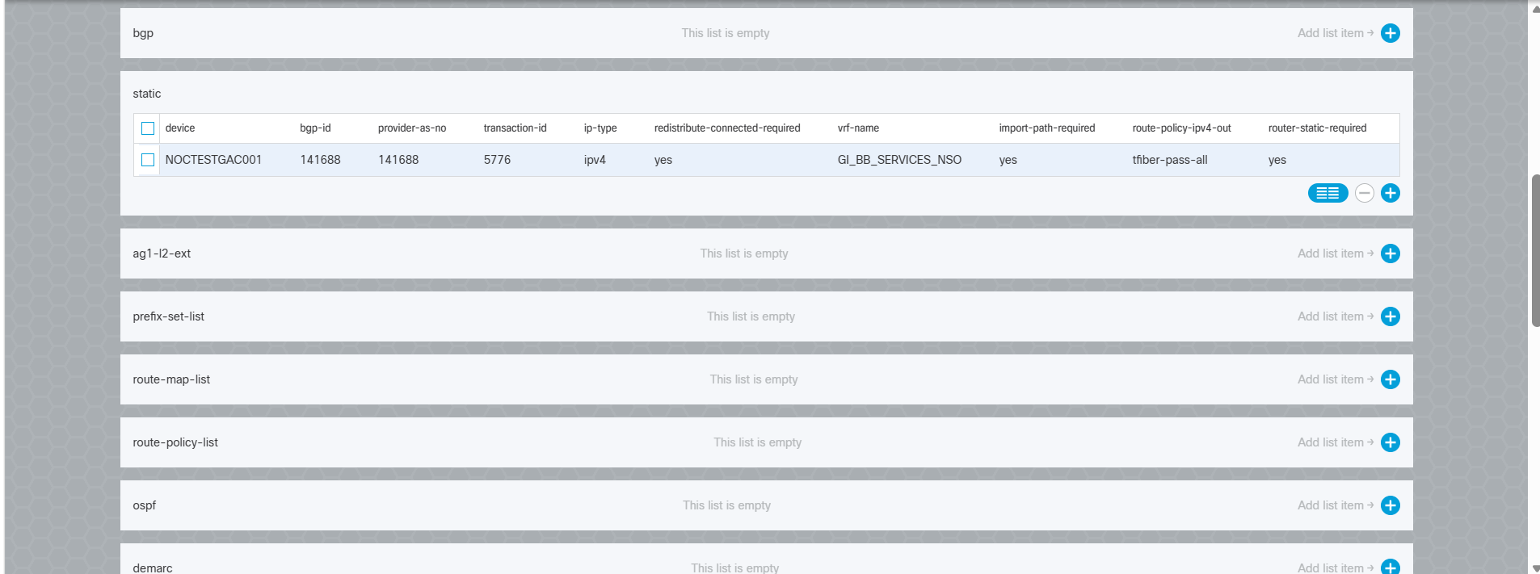
Circuit ID – Service Configuration (contd.)
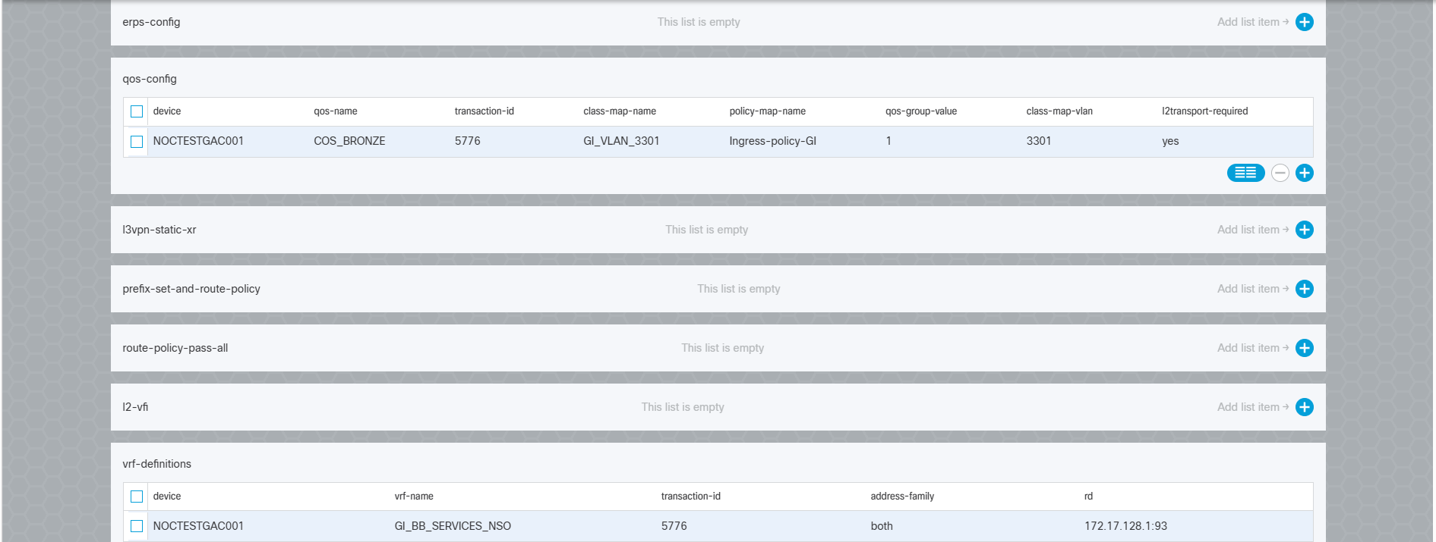
Circuit ID – Service Configuration (contd.)
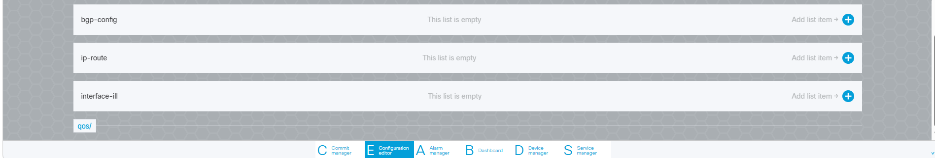
Circuit ID – Service Configuration (contd.)

5.3 Interface Configuration Verification
Description
After opening the MPLS L3VPN service instance and selecting the required interface row, the Configuration Editor displays the detailed interface configuration received from SCCM through the RESTCONF payload. This view can be used to verify that the interface-related attributes have been successfully populated in NSO CFS.
Outcome
- Interface configuration received through the SCCM RESTCONF payload is visible in NSO CFS.
- Connected device details are successfully associated with the service instance.
- Interface parameters such as Interface ID, Transaction ID, IP Type, WAN IP Address, and VRF Name are available for verification.
- Service policy and VLAN-related configuration details are populated within the interface configuration.
- The displayed interface configuration confirms that the data sent from SCCM through the RESTCONF interface has been successfully processed and stored in NSO CFS.
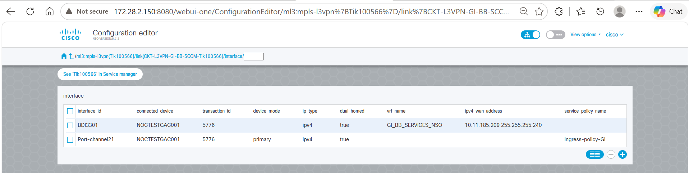
Interface Configuration Verification
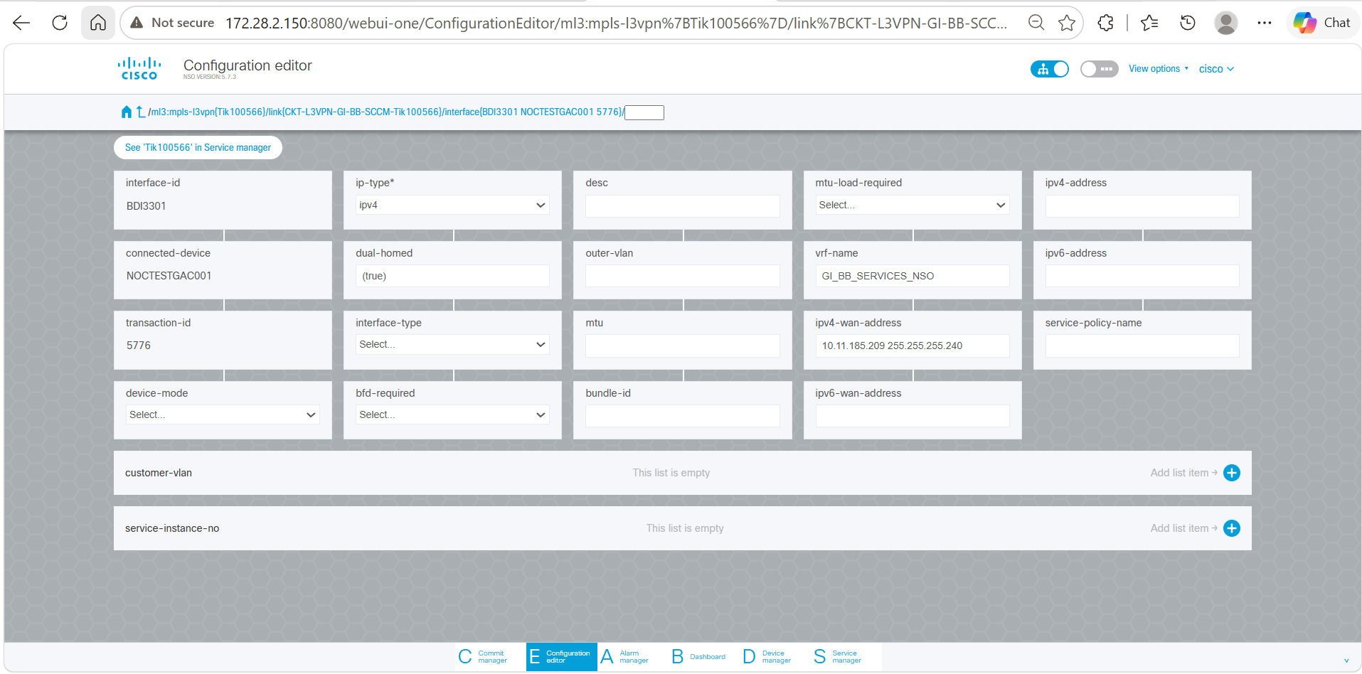
Interface Configuration Verification (contd.)
After opening the MPLS L3VPN service instance and selecting the required interface row (e.g., BDI3301 or Port-channel21):
Outcome
- Interface configuration received from the SCCM RESTCONF payload is available in NSO CFS.
- Verify that the selected interface is associated with the correct connected device (NOCTESTGAC001).
- Verify that the Transaction ID (5776) matches the service provisioning request.
- Verify interface attributes such as Interface ID, Device Mode, IP Type, VRF Name, WAN IP Address, and Service Policy.
- Verify Customer VLAN information associated with the interface.
- Verify that VLAN ID 3301 is populated as received from the SCCM RESTCONF payload.
- Verify that the Service Instance Number is associated with the interface configuration.
- The displayed interface configuration confirms that the data sent from SCCM through the RESTCONF interface has been successfully processed and stored in NSO CFS.
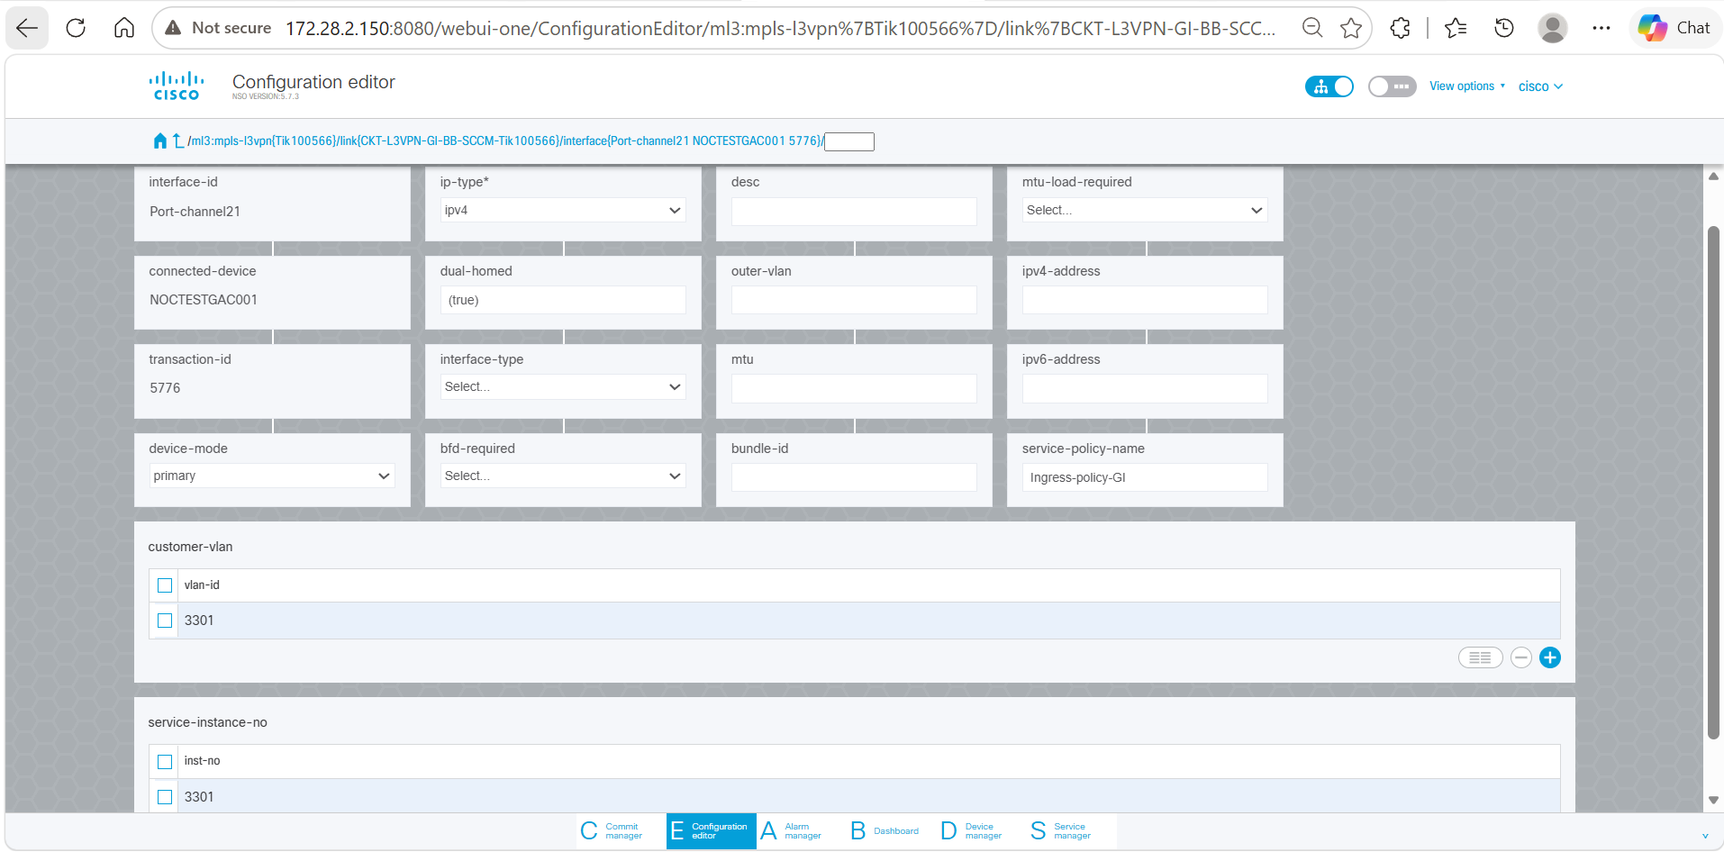
Interface Configuration Validation (contd.)

5.4 Device Configuration Verification
After opening the MPLS L3VPN service instance and selecting the required device row, the Configuration Editor displays the detailed device configuration. This view can be used to validate that the routing, VRF, and device-specific parameters are correctly populated.
Outcome
- Device configuration received from the SCCM RESTCONF payload is available in NSO CFS.
- Verify that the device NOCTESTGAC001 is associated with the service instance.
- Verify that the Transaction ID (5776) matches the service provisioning request.
- Verify routing parameters such as BGP ID, Provider AS Number, and IP Type.
- Verify that the VRF Name (GI_BB_SERVICES_NSO) is correctly populated.
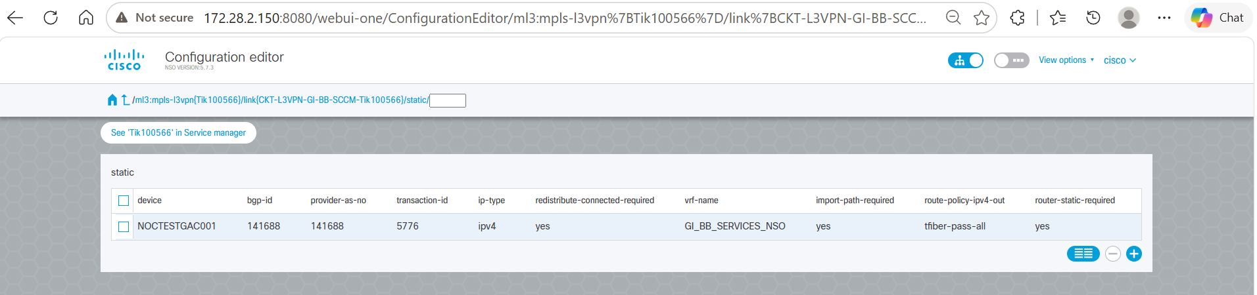
Device Configuration Validation
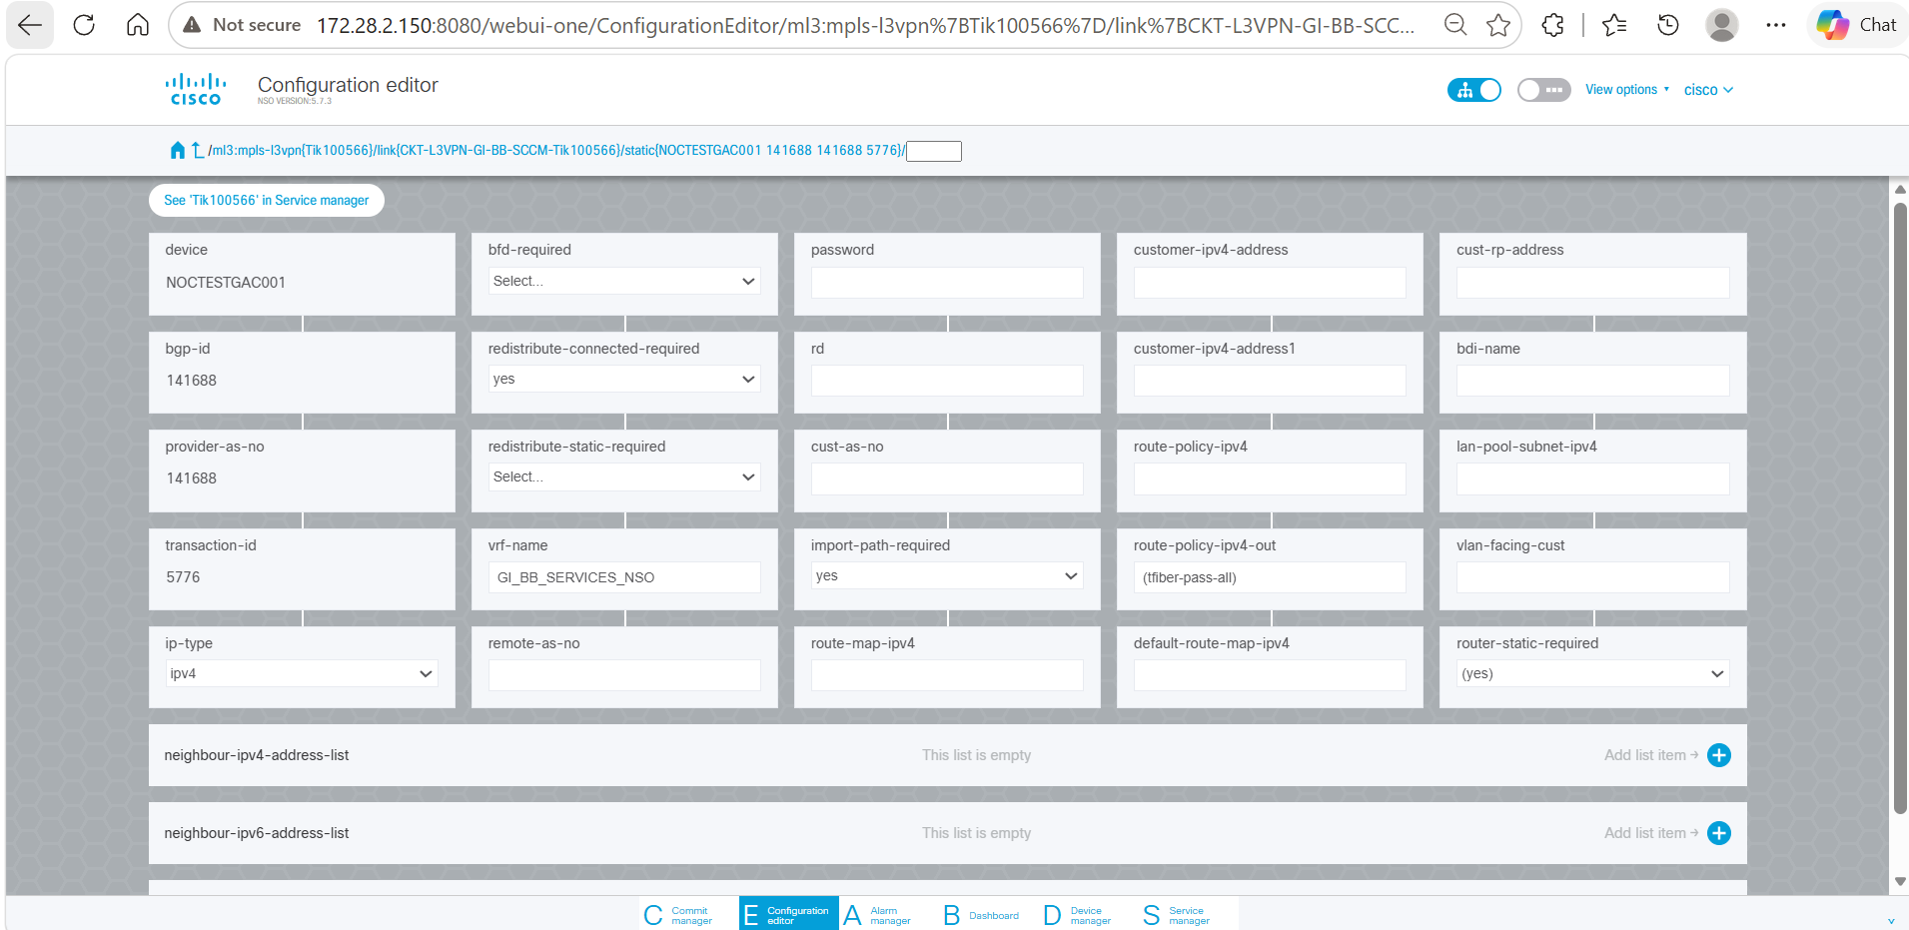
Device Configuration Validation (contd.)

5.5 QoS Configuration Verification
After opening the MPLS L3VPN service instance and navigating to the qos-config section, select the required device row. The Configuration Editor displays the detailed QoS configuration. This view is used to validate that the QoS policies, class maps, and VLAN-related parameters have been successfully populated in NSO CFS.
Outcome
- QoS configuration received from the SCCM RESTCONF payload is available in NSO CFS.
- Verify that the device NOCTESTGAC001 is associated with the QoS configuration.
- Verify that the QoS Name (COS_BRONZE) is correctly populated.
- Verify that the Transaction ID (5776) matches the service provisioning request.
- Verify that the Class Map Name (GI_VLAN_3301) is configured.
- Verify that the Policy Map Name (Ingress-policy-GI) is applied.
- Verify that the QoS Group Value (1) is populated.
- Verify that the Class Map VLAN (3301) is associated with the service.
- The displayed QoS configuration confirms that the QoS parameters sent from SCCM through the RESTCONF interface have been successfully processed and stored in NSO CFS.
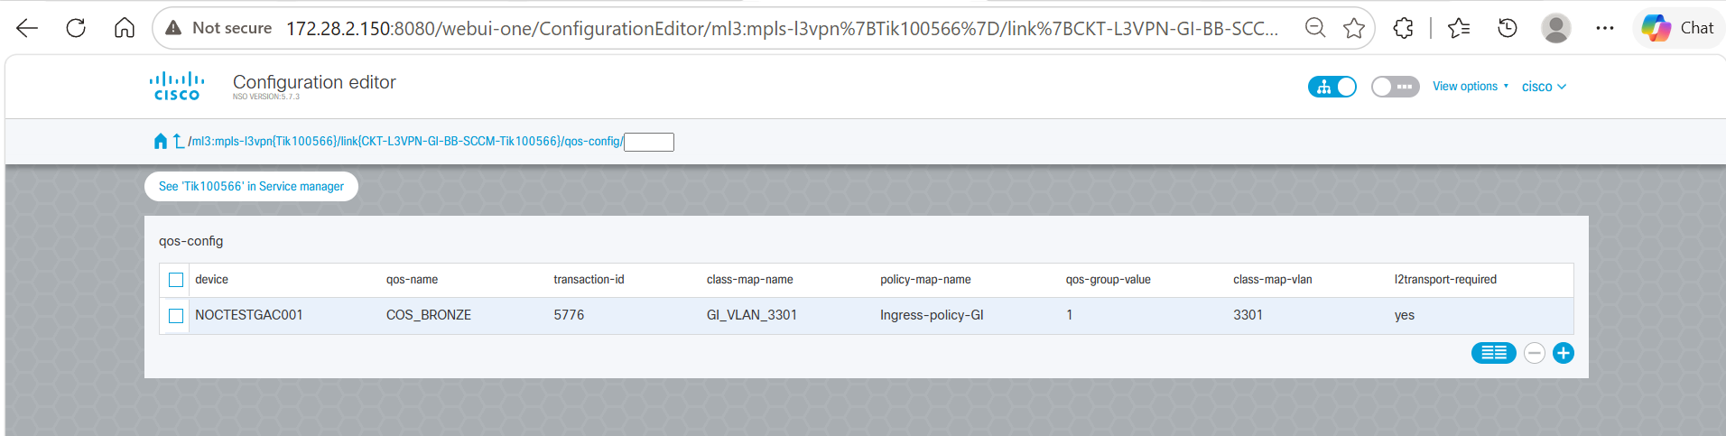
QoS Configuration Validation
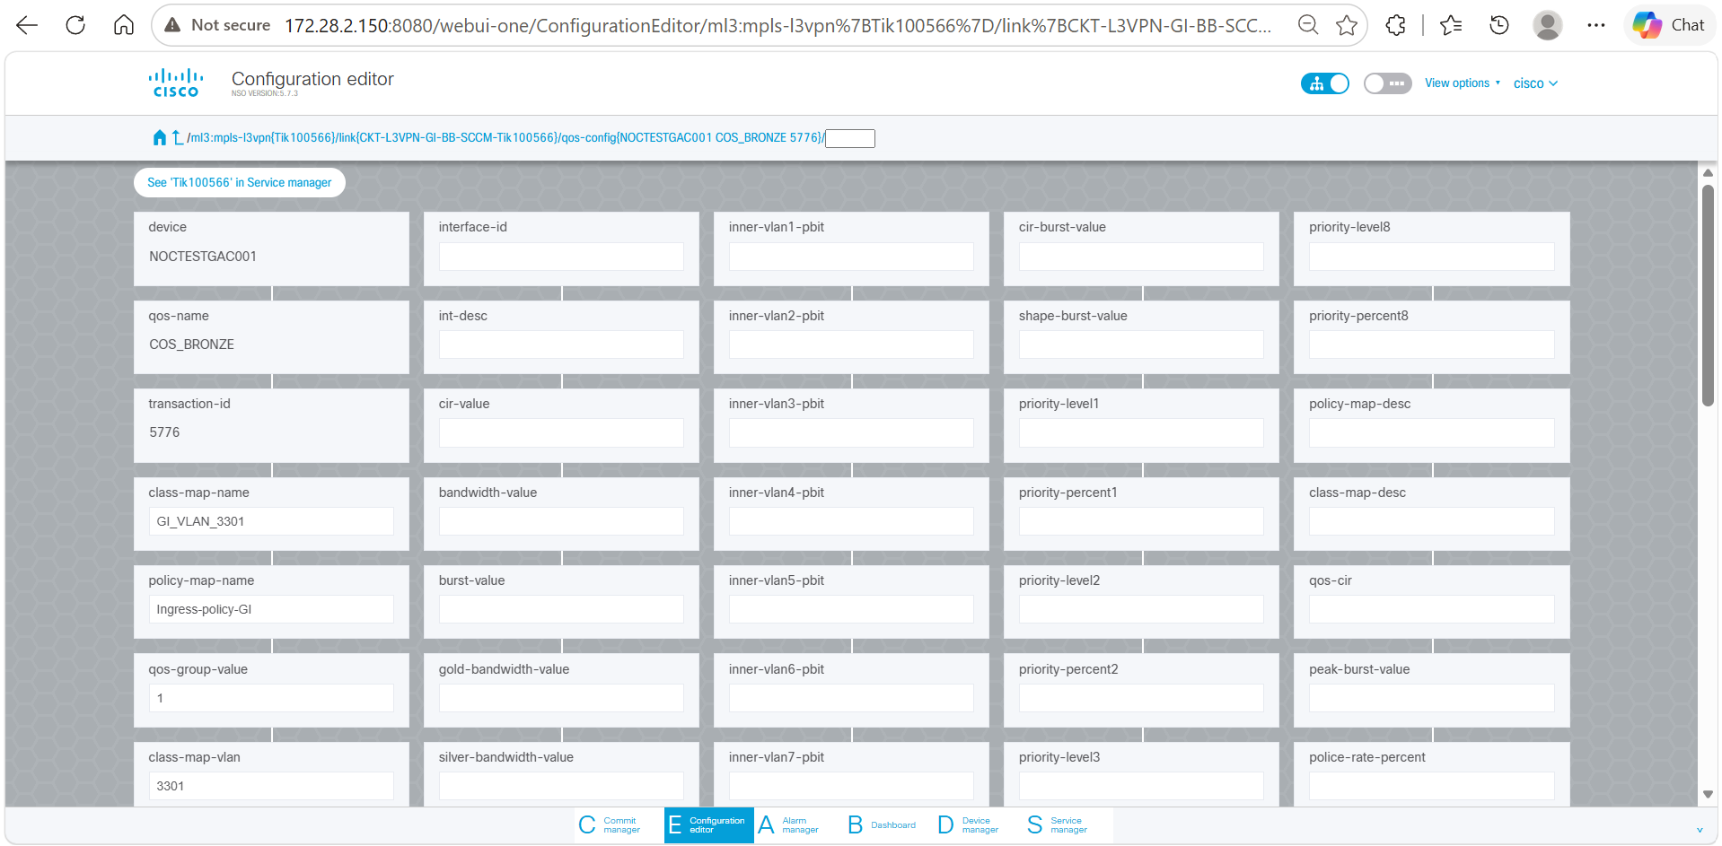
QoS Configuration Validation (contd.)

5.6 VRF Configuration Verification
After opening the MPLS L3VPN service instance and navigating to the vrf-definitions section, select the required device row. This view is used to validate that the VRF-related parameters have been successfully populated in NSO CFS.
Outcome
- VRF configuration received from the SCCM RESTCONF payload is available in NSO CFS.
- Verify that the device NOCTESTGAC001 is associated with the VRF configuration.
- Verify that the VRF Name (GI_BB_SERVICES_NSO) is correctly populated.
- Verify that the Transaction ID (5776) matches the service provisioning request.
- Verify that the Address Family (both) is configured for the VRF.
- Verify that the Route Distinguisher (172.17.128.1:93) is populated.
- Verify that the Import Route Target (141688:32) is configured.
- Verify that the Export Route Target (141688:31) is configured.
- The displayed VRF configuration confirms that the VRF parameters sent from SCCM through the RESTCONF interface have been successfully processed and stored in NSO CFS.
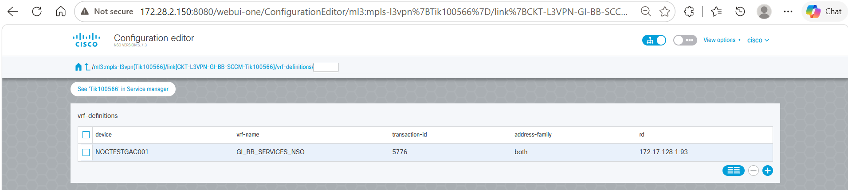
VRF Configuration Validation
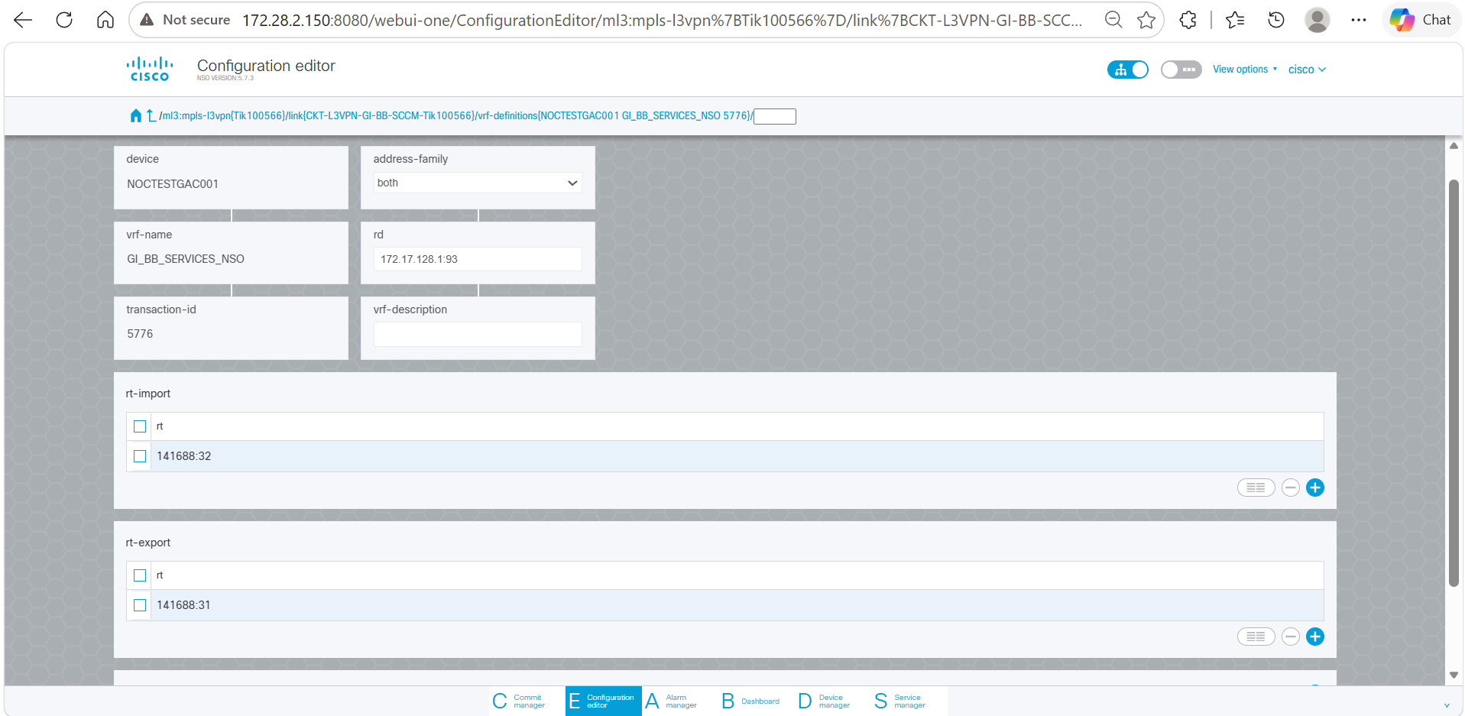
VRF Configuration Validation (contd.)

5.7 GPON Service Instance Validation
After the GPON RESTCONF payload is processed by NSO CFS, navigate to the Nokia Service Manager and verify that the GPON service instance has been created. Search for the Service ID and open the service configuration to validate the parameters received from the SCCM RESTCONF payload.
Verify that the following Service ID: Tik100566-GPON-180626120031
Outcome
- Verify that the GPON Service ID Tik100566-GPON-180626120031 is created in NSO CFS.
- Verify that the Circuit ID CKT-L3VPN-GI-BB-SCCM-Tik100566 is associated with the service.
- Verify that the Nokia OLT device nokia-ams-pkga is populated.
- Verify that the Template Name ORG_SERV_U_D_CVLAN is associated with the service instance.
- Verify that the service status is displayed as ACTIVE.
- Verify that the ONT Serial Number TJNW95D2CD14 is populated.
- Verify that the Upstream Bandwidth Profile UP_TNET_GI_50M is populated.
- Verify that the Downstream Bandwidth Profile DN_TNET_GI_50M is populated.
- Verify that the Subscriber IDs are populated as received from the SCCM RESTCONF payload.
- Verify that the Customer VLAN 2537 is configured.
- Verify that the Network VLAN GI-Internet_S3301 is configured.
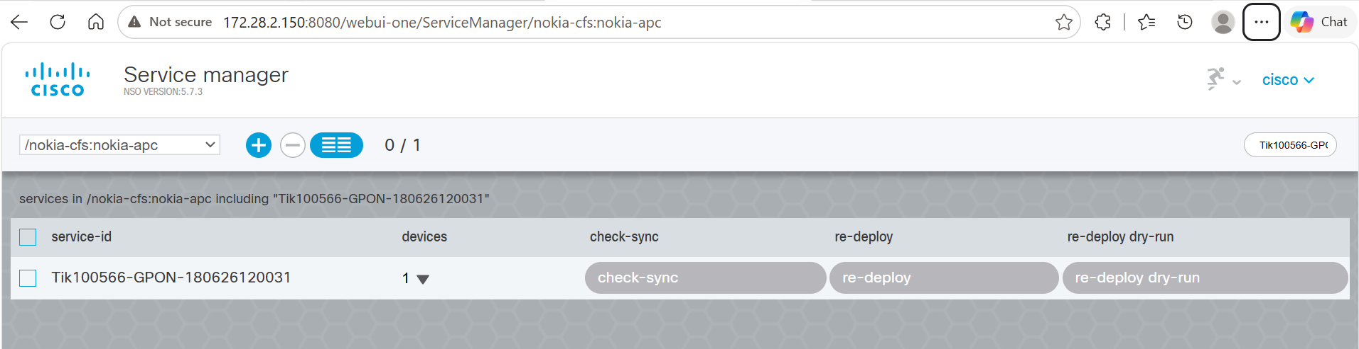
GPON Service Instance Validation in NSO CFS
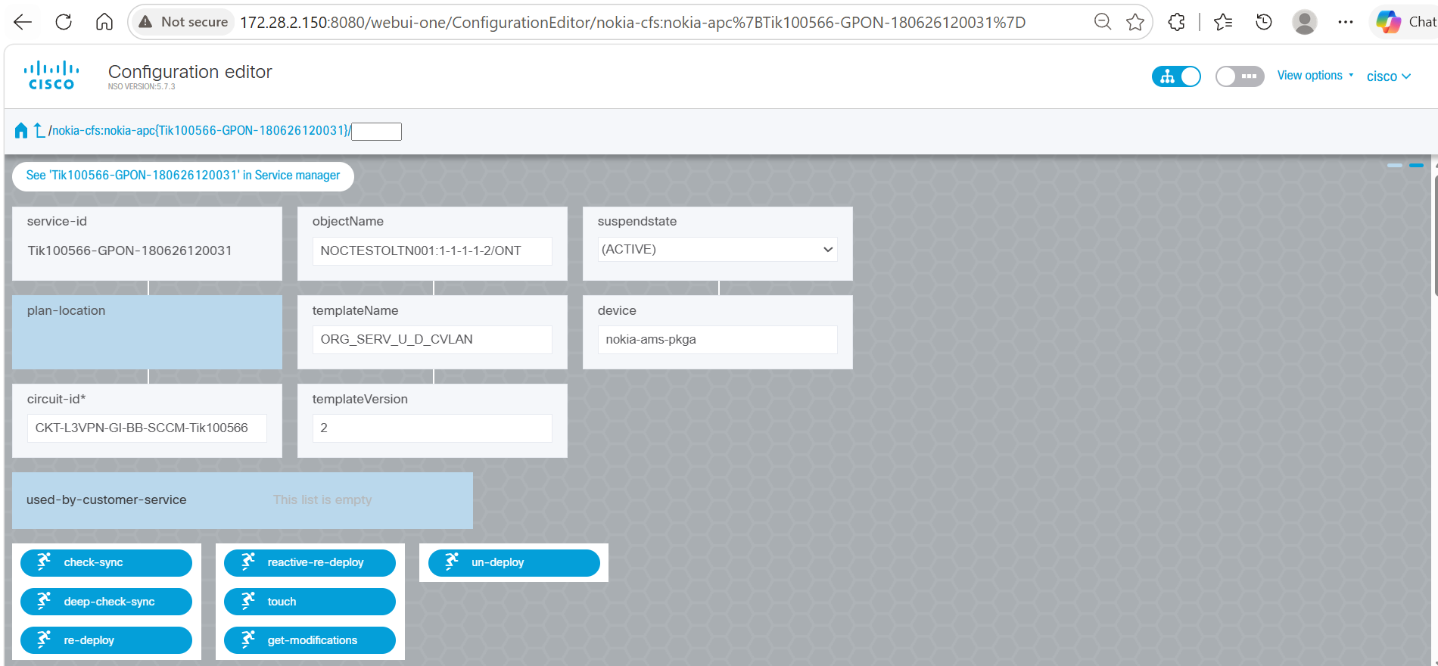
GPON Service Instance Validation (contd.)
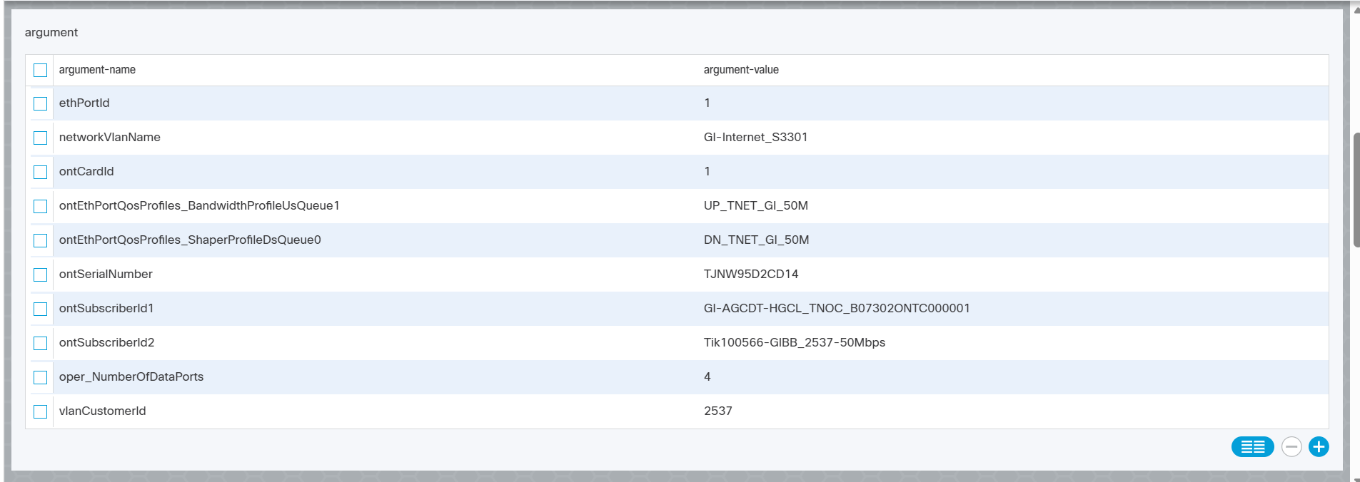
GPON Service Instance Validation (contd.)
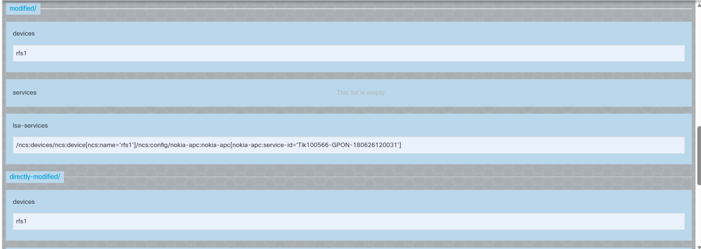
GPON Service Instance Validation (contd.)
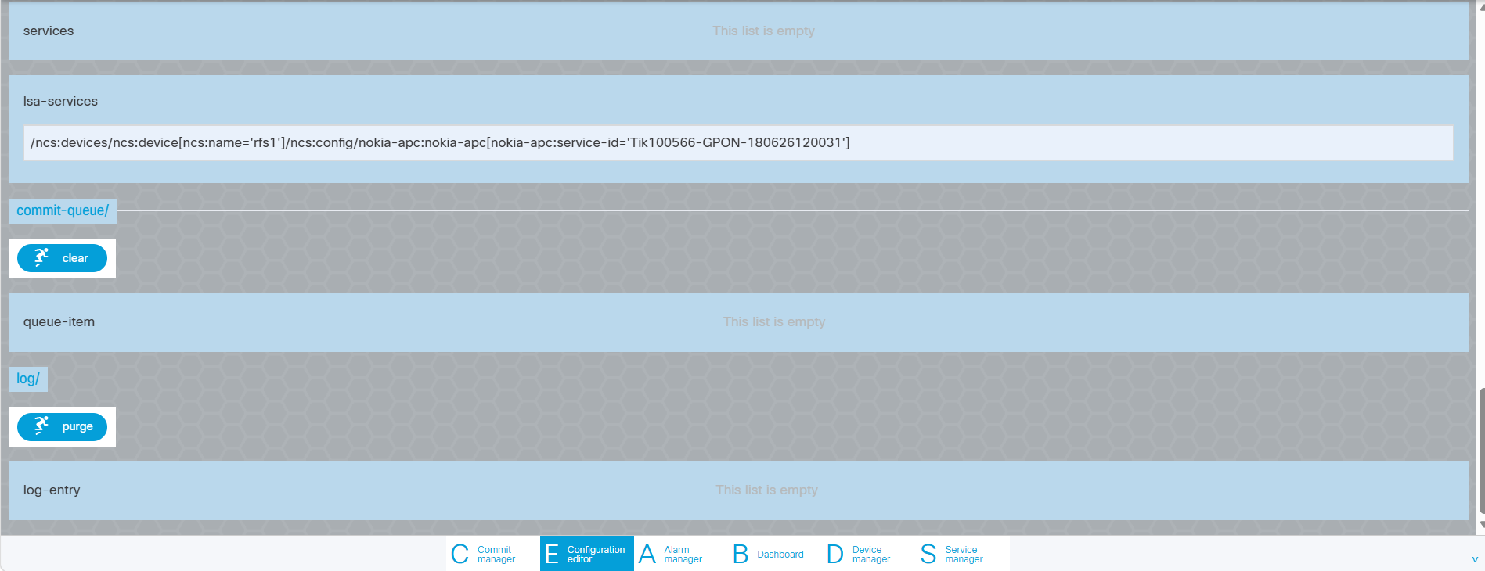
GPON Service Instance Validation (contd.)

6. Device Verification in NSO RFS
Description
After successful service orchestration from NSO CFS, verify the target device in the NSO RFS Device Manager. Search for the device NOCTESTGAC001 and open the device configuration to validate that the service-related configuration has been associated with the device and is available for deployment and synchronization operations.
Outcome
- Verify that the device NOCTESTGAC001 is available in the NSO RFS Device Manager.
- Verify that the device IP Address 172.17.128.1 and Port 22 are configured.
- Verify that the device type is displayed as Cisco IOS CLI.
- Verify that service-related entries are visible under the Service List section.
- Verify that MPLS L3VPN service configurations associated with the device are listed.

6.1 Target Device Validation in NSO RFS for MPLS L3VPN Service Deployment
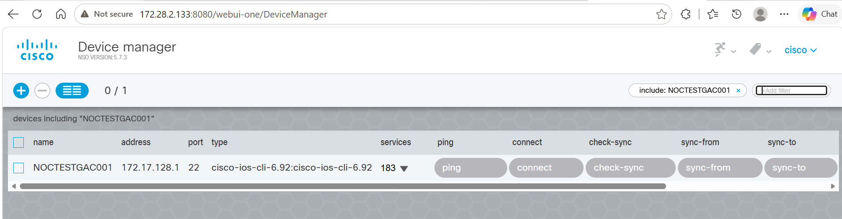
Target Device Validation in NSO RFS
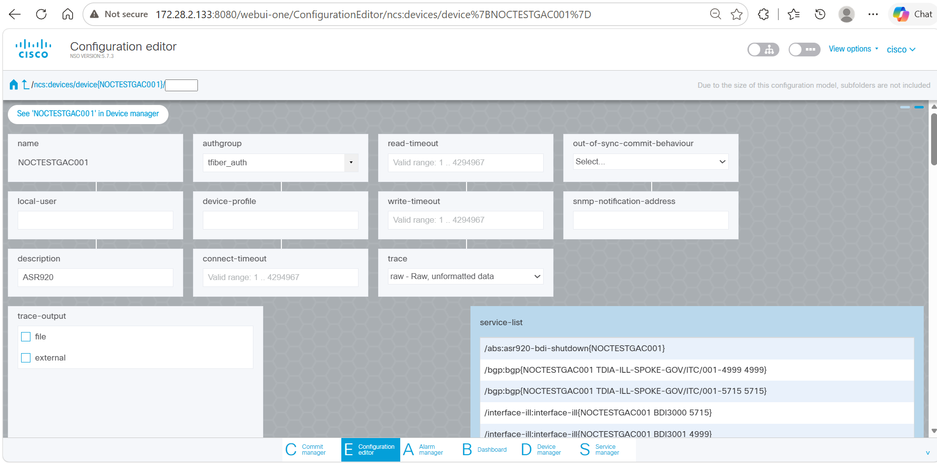
Target Device Validation in NSO RFS (contd.)
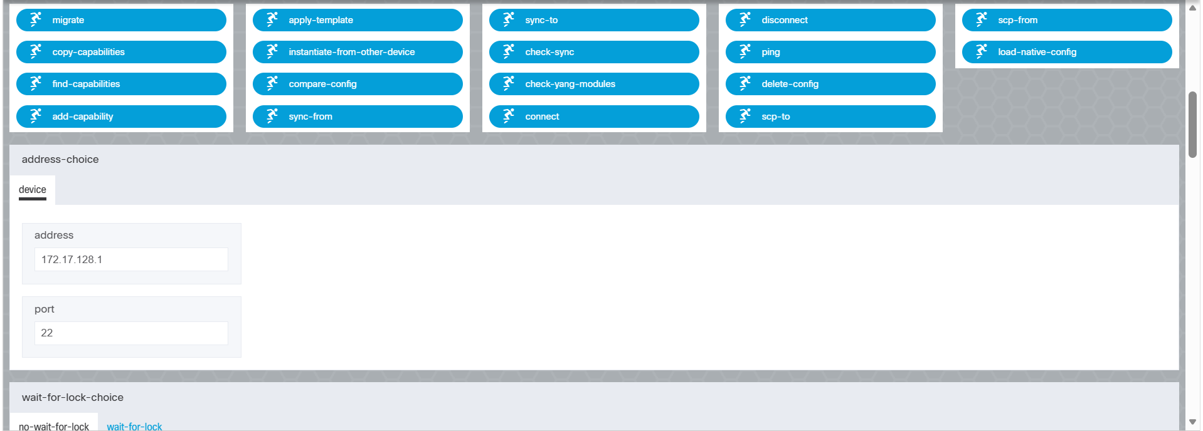
Target Device Validation in NSO RFS (contd.)

