LOW-LEVEL DESIGN (LLD) DOCUMENT
Cisco NSO End-to-End Acceptance Test
CLI-Based Validation – Tejas OLT/ONT Provisioning (tejas-nms-nso-cfs)

Document Title | Cisco NSO End-to-End Acceptance Test – Low-Level Design
Module / Feature | tejas-nms-nso-cfs (CFS) → RFS → Tejas EMS → OLT/ONT Provisioning
Prepared For | Higher Management Review
Environment | NSO Server: 172.28.2.17 | OLT: 172.17.128.38
Document Type | Low-Level Design (LLD) – CLI Acceptance Test Reference
Status | Draft for Review
Version | 1.0

Table of Contents

1. Introduction

1.1 Purpose
This document provides a Low-Level Design (LLD) and step-by-step acceptance test procedure to verify that Cisco NSO (Network Services Orchestrator) is installed and functioning correctly, with a specific focus on CLI-driven validation.
The test procedure verifies the NSO server status, validates NSO CLI login and device connectivity, confirms service package installation, commits a service order carrying OLT/ONT provisioning payload data, and cross-verifies the outcome across CLI, WebUI (CFS and RFS), and the Tejas Element Management System (EMS). The procedure concludes with log verification and deletion of the committed order to validate the complete service lifecycle.

1.2 Background
The tejas-nms-nso-cfs service package provisions GPON subscriber services (OLT/ONT configuration) through Cisco NSO, orchestrating from a Customer Facing Service (CFS) down to a Resource Facing Service (RFS), and ultimately to the Tejas EMS which manages the physical OLT and ONT devices.
This acceptance test validates the full chain — NSO CLI → CFS → RFS → Tejas EMS → OLT/ONT — using a real GPON provisioning payload, and confirms both successful commit and successful deletion (rollback) of a service order.

2. Scope
This document covers the following acceptance test activities, performed primarily via the NSO CLI:
- Verifying NCS server status and version.
- Logging into the NSO CLI and confirming device connectivity.
- Validating that the tejas-nms-nso-cfs service package is correctly loaded (operational status).
- Committing a GPON OLT/ONT service order using a defined JSON-style payload via the CLI config terminal.
- Cross-verifying the committed order in both the CFS and RFS NSO WebUI.
- Reviewing CLI logs for the committed order.
- Confirming OLT provisioning on the Tejas EMS.
- Deleting the committed order to validate clean rollback / lifecycle completion.
Out of scope: performance/load testing of NSO, and detailed Tejas EMS internal configuration beyond OLT/ONT provisioning confirmation.

3. Architecture Overview
The acceptance test validates a CLI-driven provisioning chain: a service order is committed through the NSO CLI, orchestrated from the CFS layer to the RFS layer, and finally pushed to the Tejas EMS, which provisions the physical OLT/ONT.
Figure: CLI-driven provisioning flow – NSO CLI → CFS → RFS → Tejas EMS → OLT/ONT

3.1 Layer Responsibilities
Layer | Responsibility
NSO CLI | Administrative entry point (ncs_cli) used to check status, verify devices, and commit the service payload via config terminal.
CFS (tejas-nms-nso-cfs) | Accepts the customer-facing GPON provisioning payload (OLT IP, PON port, ONT serial, VLANs, bandwidth profiles, etc.).
RFS | Resource-facing layer that translates the CFS payload into device-level provisioning instructions.
Tejas EMS | Element Management System that receives the provisioning instructions and configures the physical OLT/ONT.
OLT / ONT | Physical GPON access equipment (OLT at 172.17.128.38) where the subscriber service is ultimately activated.

4. Environment & Access Details
Component | Details
NSO Server | 172.28.2.17 – hosts the NCS engine and CFS/RFS packages.
CLI Access | ncs_cli -u admin -C (Cisco-style NSO Command Line Interface).
Service Package | tejas-nms-nso-cfs:tejas-nms-nso-cfs
Target Device | tejas-ems-pkga (Tejas EMS instance, Package A)
OLT IP | 172.17.128.38
PON Port | 1|1|11
Sample Service ID | Tik10012-GPON-300626022237

5. Detailed Test Procedure
The following 11 steps were executed sequentially to validate the complete NSO acceptance chain, primarily through the NSO CLI, with cross-verification on the CFS/RFS WebUI and Tejas EMS.

5.1 Step 1 – NCS Status
Verify that the NSO (NCS) service is running and confirm the installed version.
ncs --status – checks NSO status and version
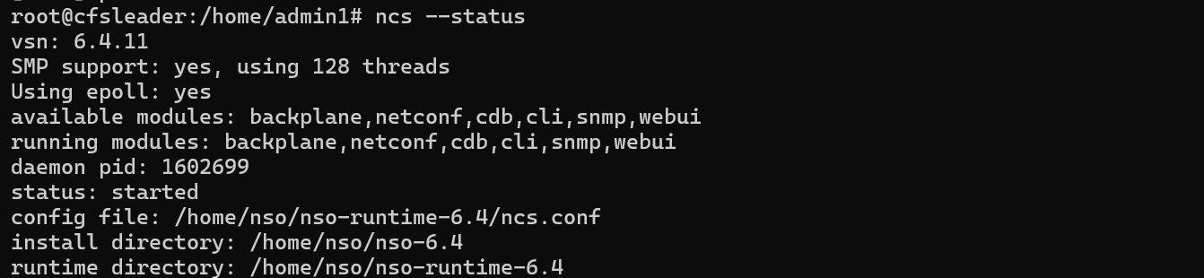
Figure 1: NCS status output confirming the NSO service is running with version details.

5.2 Step 2 – Login to NSO CLI
Start the Cisco NSO Command Line Interface (CLI) as the admin user.
ncs_cli -u admin -C – starts the Cisco NSO CLI in C-style (Cisco-like) mode
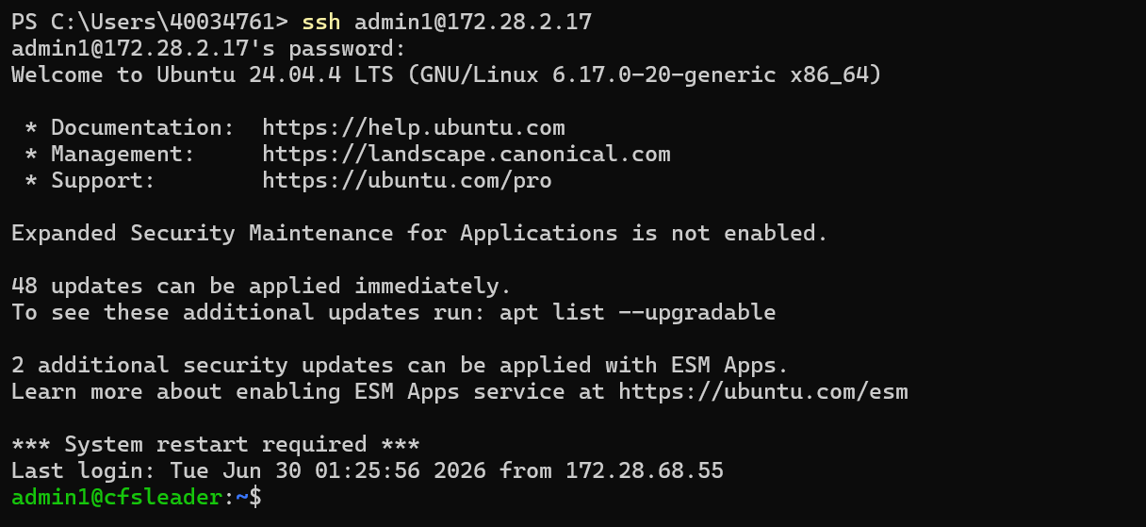
Figures 2–3: NSO CLI login and session start as the admin user.

5.3 Step 3 – Check Devices Connectivity
Unit test: verify that managed devices are reachable from NSO.
show devices list – lists all devices registered in NSO
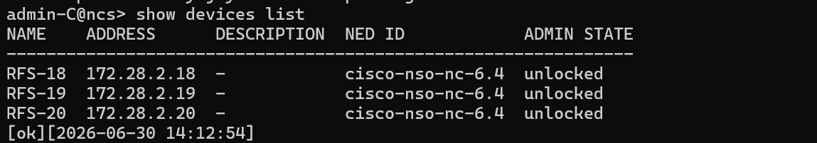
Figure 4: Output of “show devices list” listing registered devices.
show devices device <DEVICE_NAME> state – shows connectivity/sync state for a specific device
Figures 5–7: Device state output confirming reachability and sync status for the target device.

5.4 Step 4 – Validate Service Package Installation
Unit test: confirm that the tejas-nms-nso-cfs service package is loaded and operational.
show packages package oper-status – shows the operational status of installed NSO packages
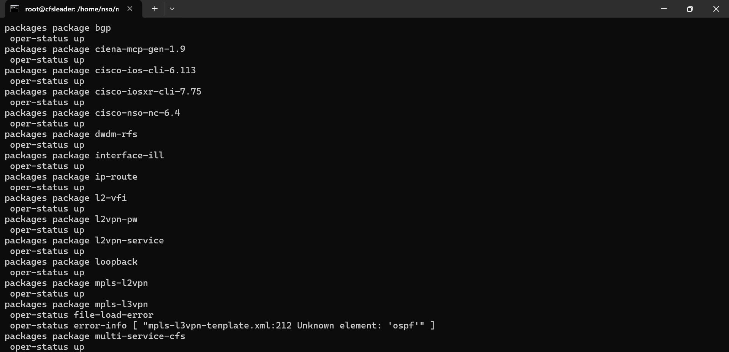
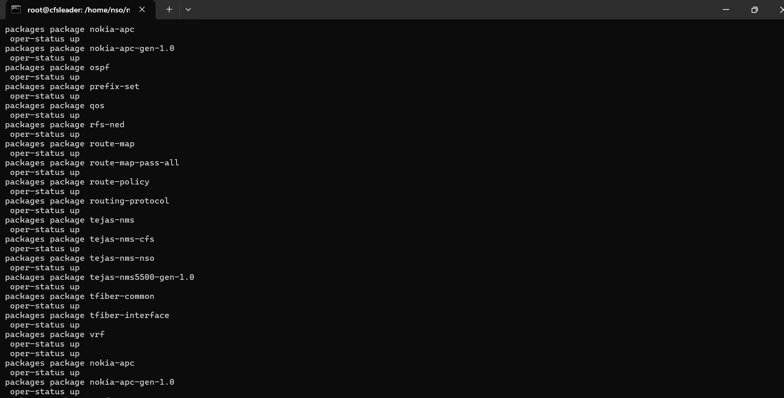
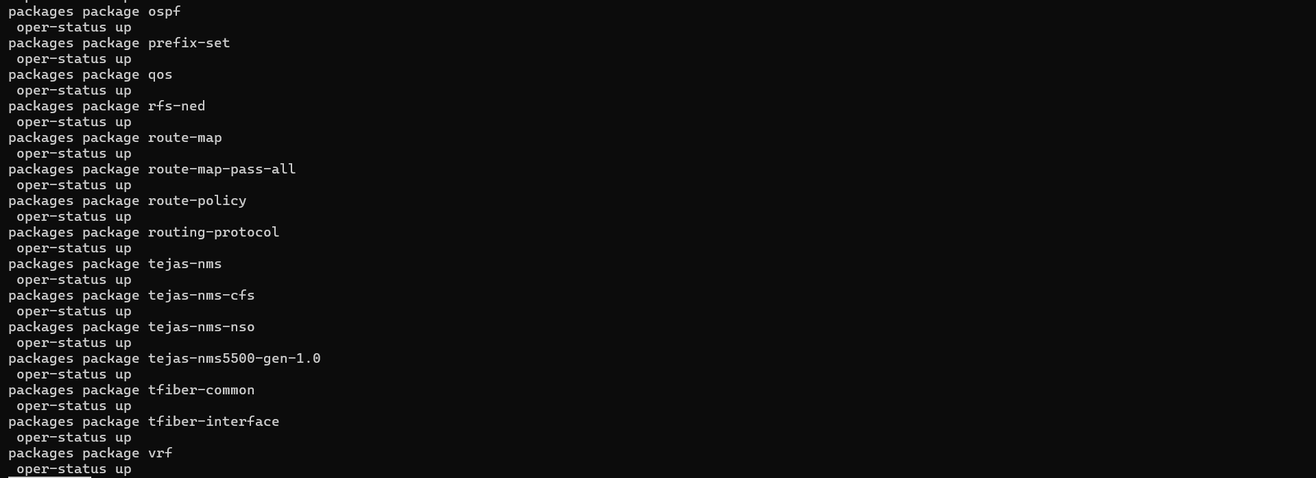
Figures 8–10: Package operational status output confirming tejas-nms-nso-cfs is loaded (up / operational).

5.5 Step 5 – Committing Service Order for tejas-nms-nso-cfs:tejas-nms-nso-cfs
Enter configuration mode and submit the GPON OLT/ONT provisioning payload.
config terminal – enters NSO configuration mode
Payload submitted:
{
"tejas-nms-nso-cfs:tejas-nms-nso-cfs": [
{
"device": "tejas-ems-pkga",
"service-id": "Tik10012-GPON-300626022237",
"package": "A",
"olt-ip": "172.17.128.38",
"pon-port": "1|1|11",
"ont-serial": "TJNW95D01B1D",
"ont-model": "TJ2100N-11G",
"ont-port-instance": "4",
"c-vlan": "3000",
"s-vlan": "3000",
"customer-id": "GOV/ITC/001",
"upstream-bandwidth-profile": "UP_GI_30M",
"downstream-bandwidth-profile": "TejNMS-DN_GI_30M",
"provisioning-mode": "bridge",
"vlan-tagging": "tagged"
}
]
}

5.6 Step 6 – Commit Successful
The configuration is committed via the CLI, confirming successful application of the payload.
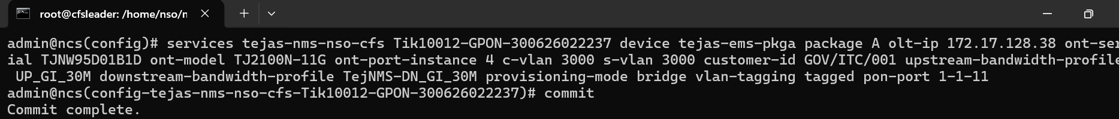
Figure 11: CLI output confirming the commit completed successfully.

5.7 Step 7 – Committed Order Verified in NSO WebUI (CFS)
The committed service order is cross-checked on the CFS NSO WebUI to confirm it is visible at the customer-facing layer.
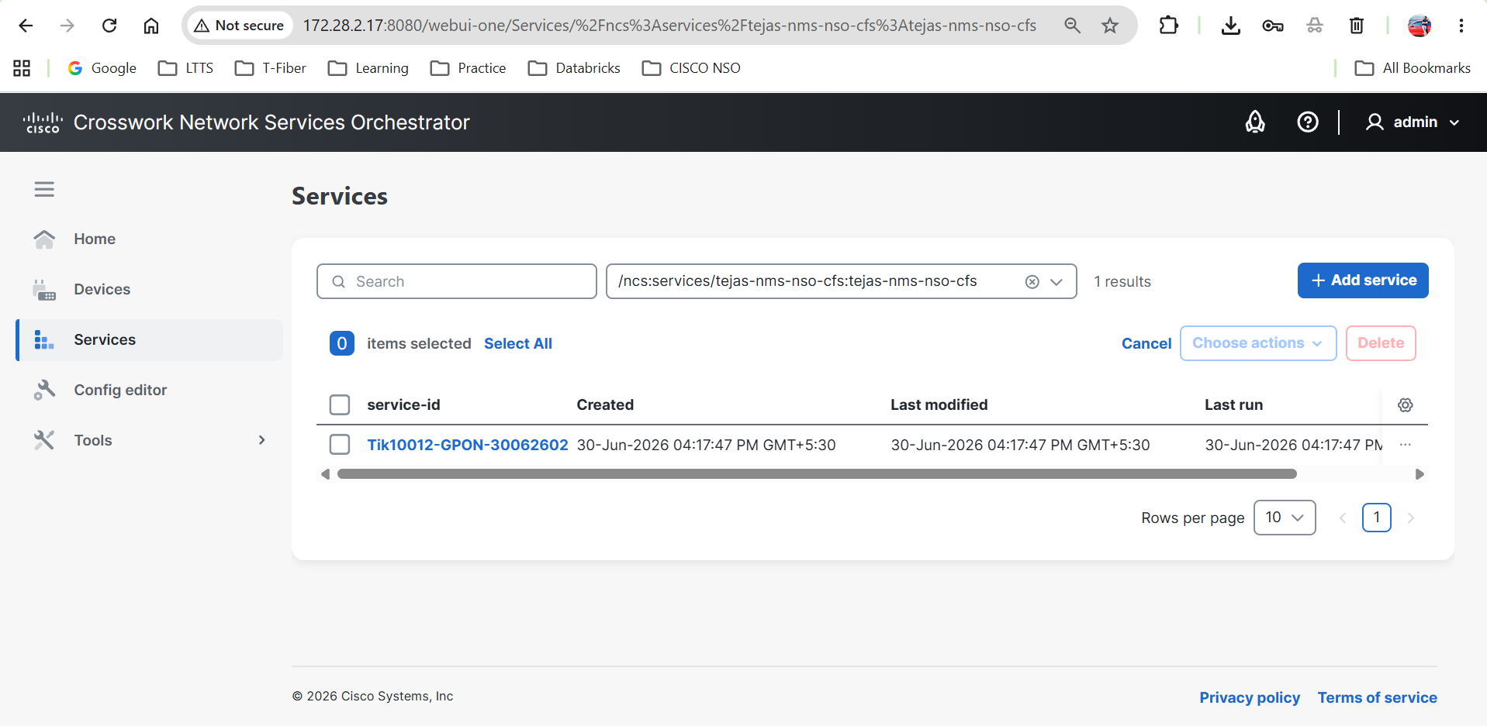
Figure 12: CFS WebUI showing the committed service order (Tik10012-GPON-300626022237).

5.8 Step 8 – Committed Order Verified in NSO WebUI (RFS)
The same order is cross-checked on the RFS NSO WebUI to confirm correct orchestration down to the resource-facing layer.
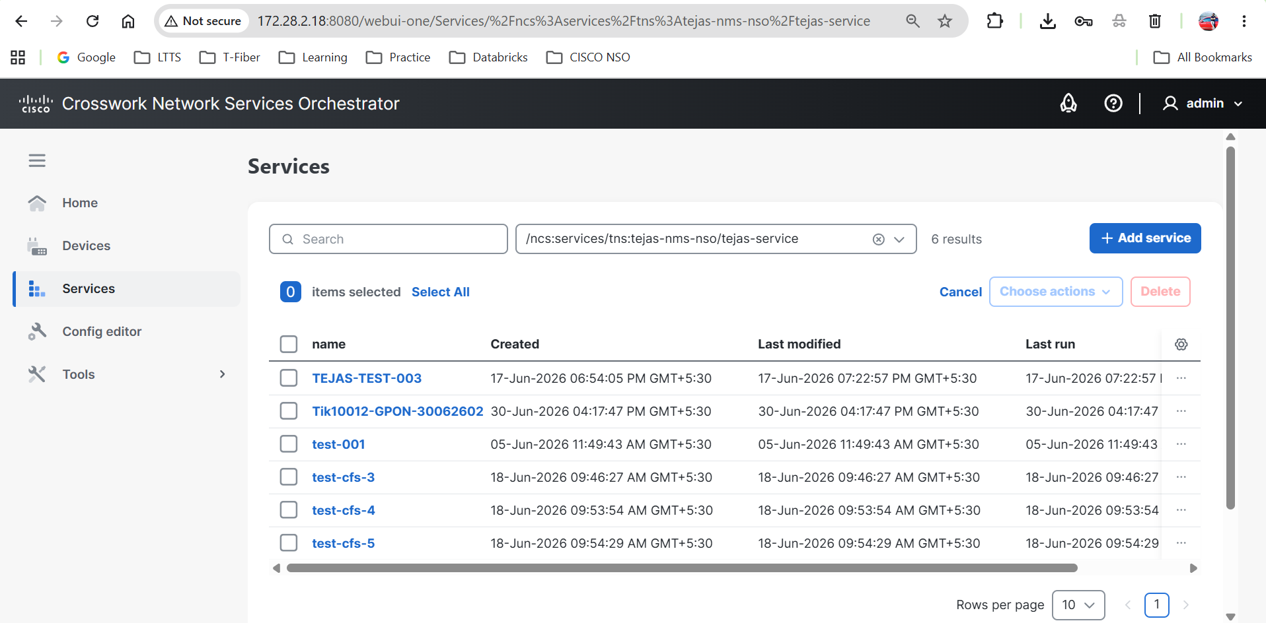
Figure 13: RFS WebUI showing the corresponding resource-facing configuration for the committed order.

5.9 Step 9 – Logs of Committed Order in CLI
CLI logs are reviewed to confirm the transaction history and successful processing of the commit.
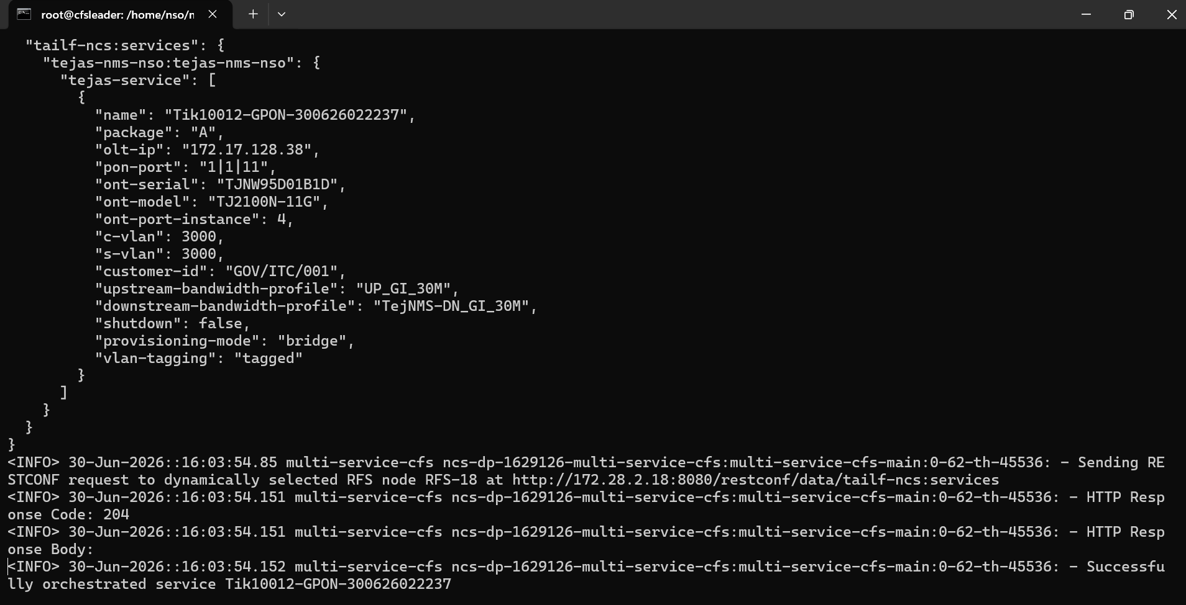
Figure 14: CLI log output for the committed order transaction.

5.10 Step 10 – OLT Provisioning in Tejas EMS
The Tejas EMS is checked to confirm that the OLT/ONT provisioning (PON port, ONT serial, VLAN, bandwidth profile) was applied as instructed by the payload.
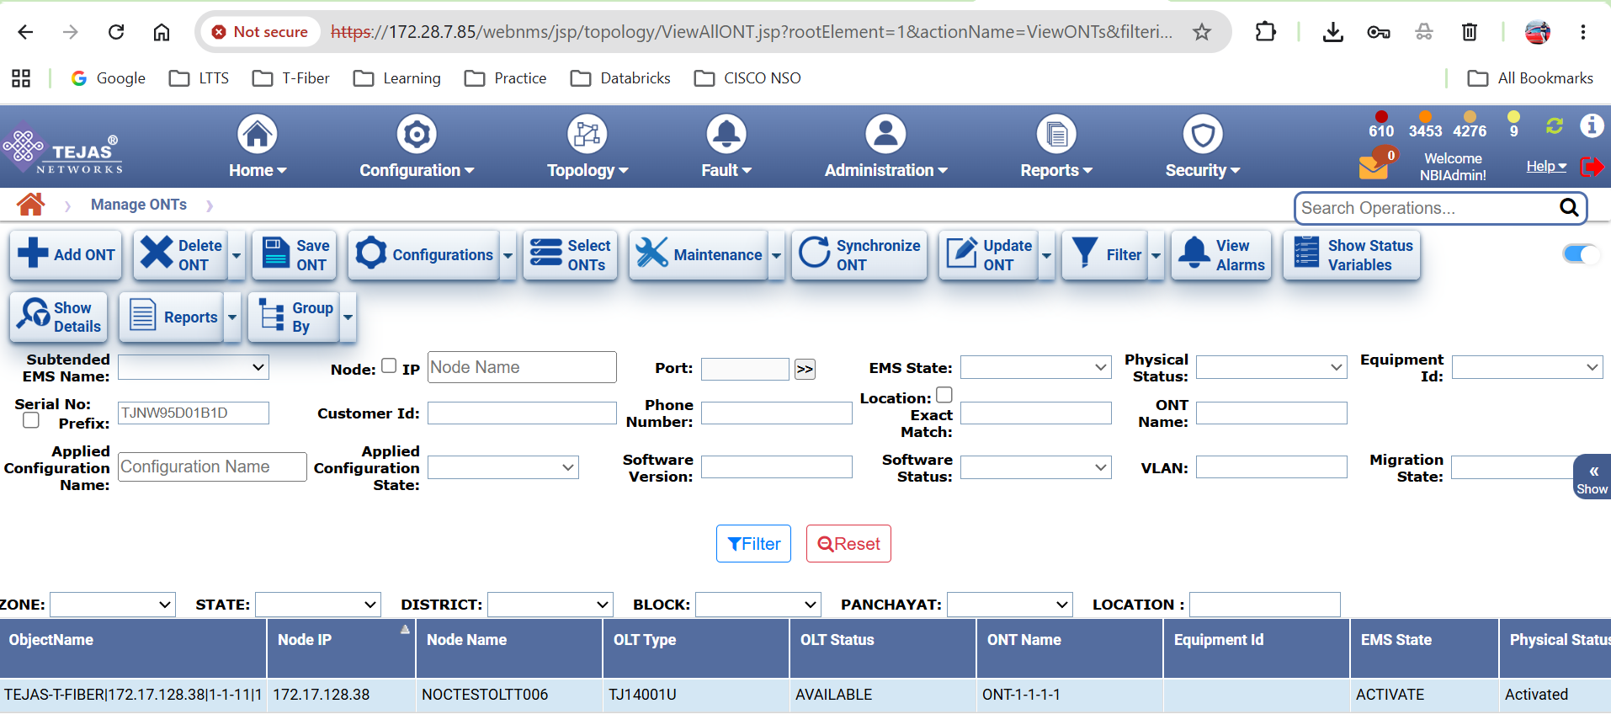
Figure 15: Tejas EMS screen confirming OLT/ONT provisioning for the committed service.

5.11 Step 11 – Deletion of Committed Order
To validate the complete service lifecycle, the committed order is deleted and the rollback is confirmed via CLI and WebUI.
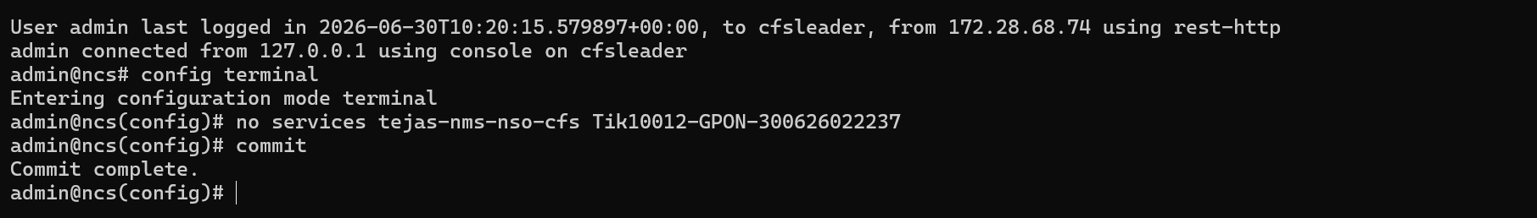
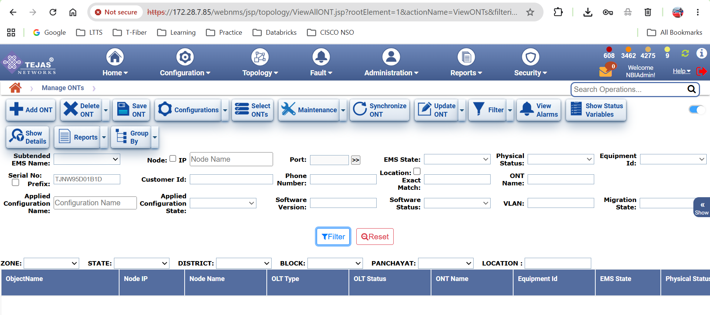
Figures 16–17: CLI deletion command and confirmation for the committed service order.
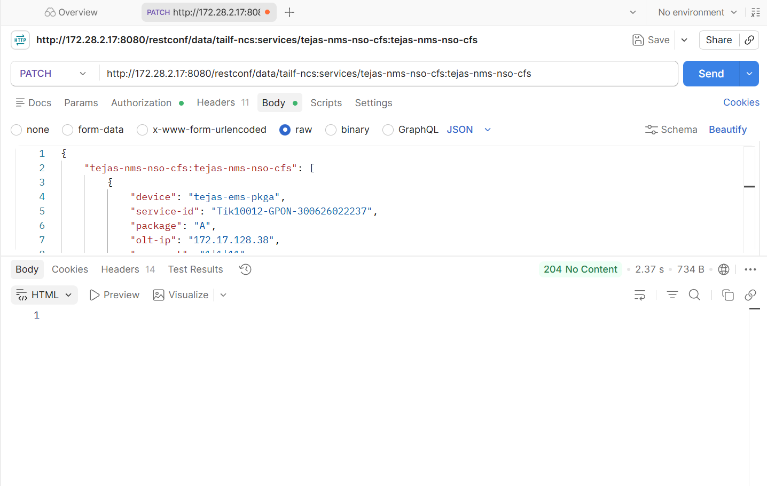
Figure 18: Post-deletion verification confirming the service order no longer appears in NSO.

6. Test Summary / Results
All 11 acceptance test steps were executed successfully, confirming that Cisco NSO is correctly installed, the tejas-nms-nso-cfs package is operational, and the full commit-to-provisioning-to-deletion lifecycle functions as expected.
# | Test Step | Expected Outcome | Result
1 | NCS Status | NSO service running with correct version | Pass
2 | Login to NSO CLI | Admin able to log in and start CLI session | Pass
3 | Device Connectivity | Target device reachable and in sync | Pass
4 | Service Package Validation | tejas-nms-nso-cfs package operational | Pass
5 | Commit Service Order | Payload accepted in config terminal | Pass
6 | Commit Successful | Commit completes without errors | Pass
7 | CFS WebUI Verification | Order visible on CFS WebUI | Pass
8 | RFS WebUI Verification | Order visible on RFS WebUI | Pass
9 | CLI Log Verification | Transaction logged correctly | Pass
10 | OLT Provisioning (Tejas EMS) | OLT/ONT provisioned as per payload | Pass
11 | Deletion of Committed Order | Order removed cleanly from NSO | Pass

7. Conclusion
The Cisco NSO end-to-end acceptance test was completed successfully via the CLI. NSO status, device connectivity, and service package installation were all verified as healthy prior to provisioning.
A GPON OLT/ONT service order (Service ID: Tik10012-GPON-300626022237) was committed using the tejas-nms-nso-cfs payload, and the result was consistently visible across three independent checkpoints:
- NSO CLI – commit success and transaction logs.
- NSO WebUI – both CFS and RFS layers reflected the committed order.
- Tejas EMS – OLT/ONT provisioning was confirmed at the physical network layer.
The subsequent deletion of the committed order was also validated, confirming clean rollback and complete lifecycle coverage (create → verify → delete).

8. Recommendations / Next Steps
- Incorporate this CLI acceptance test sequence into a repeatable regression checklist for future NSO upgrades or package changes.
- Automate the 11-step sequence (status, connectivity, package check, commit, verification, deletion) as a scripted test suite to reduce manual execution time.
- Extend log verification (Step 9) to include automated alerting on commit failures for faster issue detection.
- Document standard rollback procedures based on the deletion step, for use during incident response.
- Once validated on this environment, replicate the acceptance test on additional NSO instances prior to wider production rollout.

