DEVELOPMENT NSO
Acceptance Test Procedure Document
Environment: CFS 172.28.2.17 RFS 172.28.2.18, 172.28.2.19, 172.28.2.20
LSA Deployment (CFS/RFS)
Cisco Network Services Orchestrator (NSO)
Revision History
Revision No. | Date of Submission | Description of Revision | Prepared By | Date of submission for Review | Review completed Date
1.0 | 07th Jul26 | Initial version |  | 07-07-2026

Prepared by | Reviewed By | Approved by

Table of Contents
1. Introduction ......................................................... 4
Deployment Details ................................................ 4
2. Test Cases Summary ................................................... 5
3. Access and System Health Verification ................................ 6
Test Case 1: Authenticating into the NSO Environment (Login) ....... 6
Test Case 2: Verifying System Health and Runtime Status ............ 7
4. Device Connectivity and Configuration Synchronization ................ 7
Test Case 3: Validating Device Reachability and Sync from the CFS Layer ... 7
Test Case 4: Validating Device Reachability and Sync from the RFS Layer ... 9
5. Package Management .................................................... 11
Test Case 5: Verifying Installed Package Status (Service Package Check) ... 11
Test Case 6: Package Upgrade Workflow ................................. 12

1 Introduction
This acceptance test plan documents the tests performed on a 6-node Cisco NSO (Network Services Orchestrator) LSA deployment, comprising a 3-node CFS raft cluster (172.28.2.11 leader, 172.28.2.12 and 172.28.2.13 followers) and a 3-node RFS raft cluster (172.28.2.14 leader, 172.28.2.15 and 172.28.2.16 followers), running Cisco NSO version 6.4.11.
Testing covered: SSH-based administrative access to all 6 nodes; NSO daemon health and raft (HA) cluster state per node (leader/follower/disabled roles and sync position); device reachability, connect, and sync-from behavior at both the CFS layer (rfs-node-1/2/3) and the RFS layer (the field-device inventory, NED cisco-ios-cli-6.113); installed service package inventory and operational status (oper-status) across both layers; and the on-disk package footprint confirming a clean migration to NSO 6.4.11 with no legacy artifacts remaining.
Each test case documented in this plan includes the exact procedure/commands run, the expected healthy outcome, and the actual result captured from the CLI output, referenced against descriptive Logs/Snaps placeholders identifying the specific node, command, and output each piece of evidence corresponds to.

Deployment Details
Environment | 172.28.2.17 (CFS - Customer Facing Service)
RFS Node | 172.28.2.18 (RFS - Resource Facing Service)
Cluster Nodes | RFS-18, RFS-19, RFS-20
Deployment Type | LSA (Layered Service Architecture) - RFS/CFS

2 Test Cases Summary
The table below summarizes each verification step performed. Detailed procedure, expected result, and supporting evidence (screenshots) are documented against each test case.
# | Checkpoint | What It Confirms | Type | Result
1 | Authenticating into the NSO Environment (Login) | SSH login succeeds on all 6 nodes (CFS 172.28.2.11/12/13, RFS 172.28.2.14/15/16), each reaching an authenticated root shell. | CLI | PASS
2 | Verifying System Health and Runtime Status | ncs --status confirms vsn 6.4.11 and correct raft roles on all 6 nodes; RFS node .16 flagged as state: disabled (exception during storage_apply) though data-synced. | CLI | PASS*
3 | Validating Device Reachability and Sync from the CFS Layer | rfs-node-1/2/3 registered, connect true on all 3 CFS nodes; sync-from true only from the leader (172.28.2.11), correctly false / read-only on followers. | CLI | PASS
4 | Validating Device Reachability and Sync from the RFS Layer | Full field-device inventory (cisco-ios-cli-6.113) registered on all 3 RFS nodes; CGNTPOLAGPR001 connect/sync-from true from the leader; bulk sync-from correctly false / read-only on followers. | CLI | PASS
5 | Verifying Installed Package Status (Service Package Check) | show packages package oper-status: identical 26-package CFS set and extended RFS set (+alu-isam-cli-1.5, mpls-l3vpn) all report up on all 6 nodes. | CLI | PASS
6 | Package Upgrade Workflow | ls -ltr confirms migrated tools/lsa/auth package directories on CFS nodes and a clean RFS footprint with no legacy artifacts, corroborating the all-up package status. | CLI | PASS
* Test Case 2: RFS node 172.28.2.16 reported state: disabled (disable_reason: "exception occured during storage_apply") at time of capture. Its last_applied index matched the leader's commit_index (data fully synced), but it was not an active raft voting member — flagged for follow-up before final sign-off.

3. Access and System Health Verification
These test cases are performed directly on the NSO command-line interface (CLI) and validate the platform, its connectivity, and its provisioning logic before any web-facing verification is attempted.
Test Case 1: Authenticating into the NSO Environment (Login)
Description: | Verify SSH-based administrative login to all 6 nodes in the deployment — CFS 172.28.2.11 (leader), 172.28.2.12 and 172.28.2.13 (CFS followers), and RFS 172.28.2.14 (leader), 172.28.2.15 and 172.28.2.16 (RFS followers) — confirming each node accepts credentials and returns an authenticated root shell.
Procedure: | 1. From a terminal (PowerShell/CMD), run: ssh root@<node-ip> for each of 172.28.2.11, 172.28.2.12, 172.28.2.13, 172.28.2.14, 172.28.2.15, 172.28.2.16.  2. On first connection, accept the ED25519 host key fingerprint (yes/no prompt) where presented.  3. Enter the root password when prompted.  4. Confirm the Ubuntu 24.04.4 LTS welcome banner is displayed and the session lands on a root@<hostname> shell prompt.
Expected Result: | Each of the 6 nodes returns an authenticated root@<hostname>:~# shell prompt with no authentication failure, showing the Ubuntu 24.04.4 LTS (GNU/Linux 6.17.0-20-generic x86_64) banner. Host key fingerprint is accepted on first connect where applicable, and the last-login timestamp/source IP is displayed correctly.
Result: | ☒ OK ☐ Not OK  Actual: SSH login succeeded on all 6 nodes (CFS 172.28.2.11/12/13 and RFS 172.28.2.14/15/16) — each session reached an authenticated root shell prompt with no authentication errors.
Logs/Snaps: (if Any) | 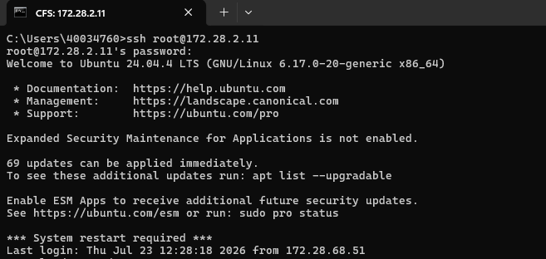  Terminal screenshot — SSH connection initiated to CFS node 172.28.2.11, host key accepted and password prompt shown.  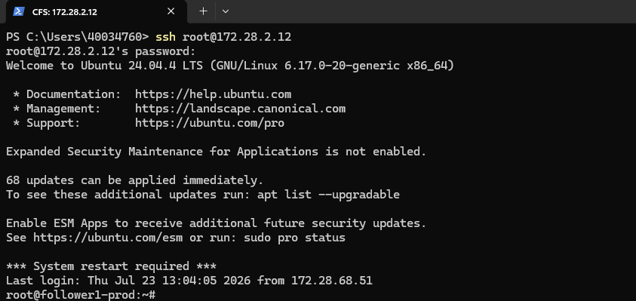  Terminal screenshot — SSH login to node 172.28.2.12, successful authentication, Ubuntu 24.04.4 LTS welcome banner displayed.  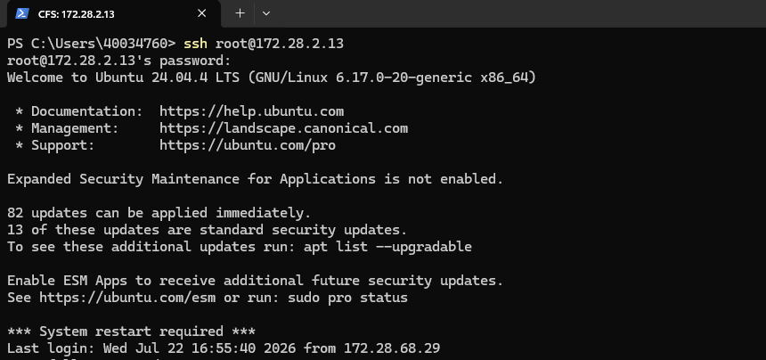  Terminal screenshot — SSH login to node 172.28.2.13, successful authentication and shell prompt displayed.  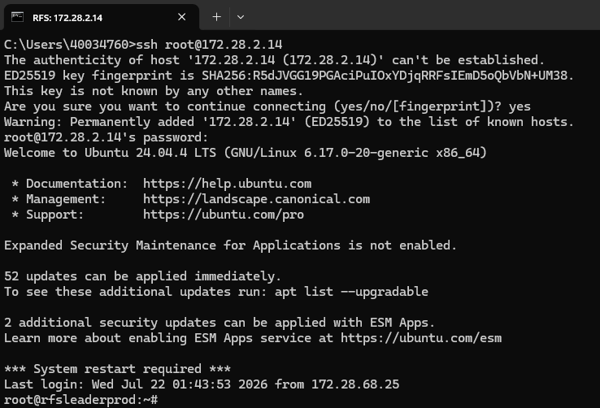  Terminal screenshot — SSH login to node 172.28.2.14 (RFS leader), host key accepted, login successful, shell prompt root@rfsleaderprod displayed.  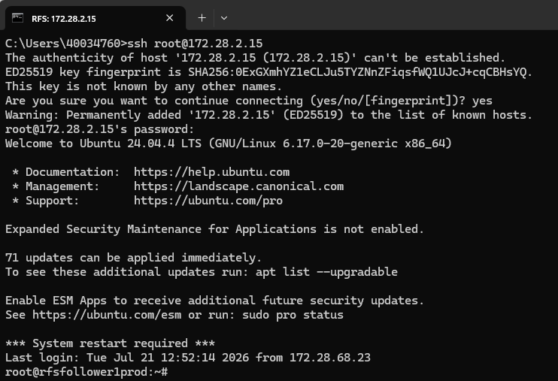  Terminal screenshot — SSH login to node 172.28.2.15 (RFS follower), host key accepted, login successful, shell prompt root@rfsfollower1prod displayed.  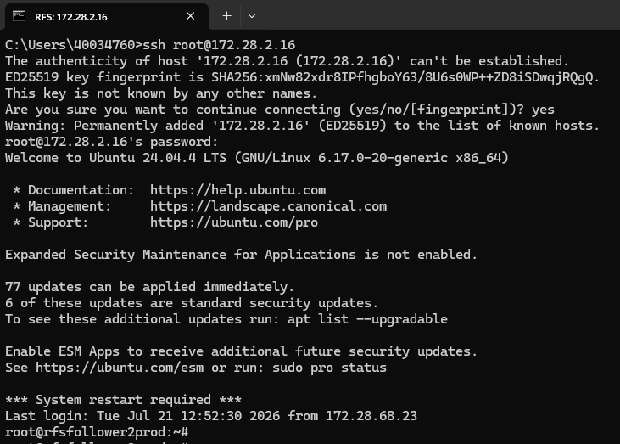  Terminal screenshot — SSH login to node 172.28.2.16 (RFS follower), host key accepted, login successful, shell prompt root@rfsfollower2prod displayed.  Administrator logging into the NSO CLI.
Test Case 2: Verifying System Health and Runtime Status
Description: | Verify NSO daemon health and raft cluster (HA) state across all 6 nodes by running ncs --status, confirming version, running modules, process ID, and each node's role (leader/follower) and sync position within its 3-node cluster (CFS: .11/.12/.13, RFS: .14/.15/.16).
Procedure: | 1. On each node, locate and run the ncs binary status check: ncs --status (or the full path, e.g. /home/nso/nso-6.4/bin/ncs --status / /opt/ncs/current/bin/ncs --status, where ncs is not on PATH).  2. Record the reported vsn, status, daemon pid, and running modules.  3. Record the raft cluster status block: state, id, current_term, commit_index, last_applied, leader_id, and disable_reason (if any).  4. Repeat for all 3 CFS nodes and all 3 RFS nodes.
Expected Result: | All 6 nodes report vsn: 6.4.11, status: started, with running modules backplane, netconf, cdb, cli, snmp, webui. Within each 3-node cluster, exactly one node reports state: leader and the remaining two report state: follower with last_applied equal to the leader's commit_index (fully synced). No node should report state: disabled.
Result: | ☒ OK ☐ Not OK  Actual: All 6 nodes report vsn 6.4.11, status started, with modules backplane/netconf/cdb/cli/snmp/webui running. CFS raft cluster: 172.28.2.11 = leader, 172.28.2.12 and .13 = follower, both in sync with the leader. RFS raft cluster: 172.28.2.14 = leader, 172.28.2.15 = follower in sync, and 172.28.2.16 = disabled (disable_reason: "exception occured during storage_apply") though its last_applied index matches the leader's commit_index, indicating it is data-synced but not currently an active voting member. This disabled state on .16 should be investigated before sign-off.
Logs/Snaps: (if Any) | 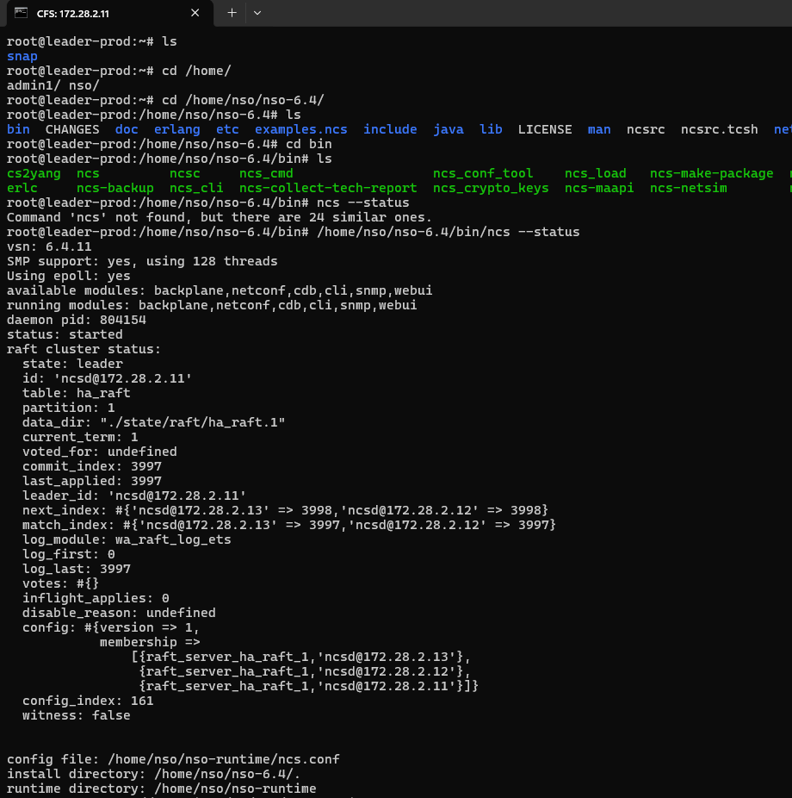  CFS leader (172.28.2.11) — ncs --status output: vsn 6.4.11, state leader, status started, all modules (backplane, netconf, cdb, cli, snmp, webui) running, daemon PID 804154, raft cluster status healthy.  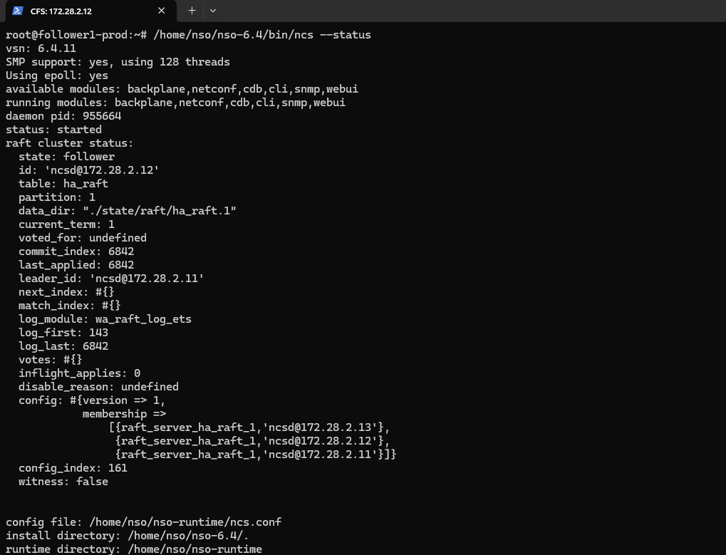  CFS follower (172.28.2.12) — ncs --status output: state follower, status started, daemon PID 955664, raft cluster synced with leader 172.28.2.11.  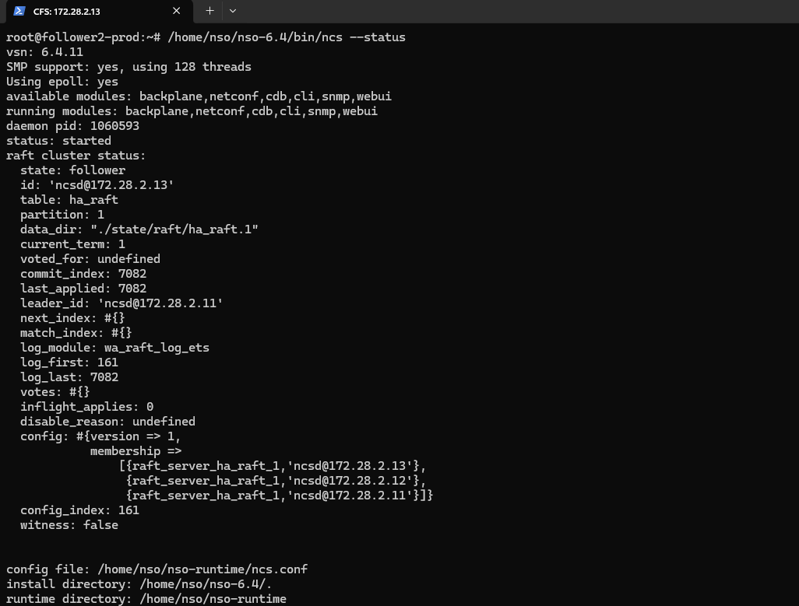  CFS follower (172.28.2.13) — ncs --status output: state follower, status started, daemon PID 1060593, raft cluster synced with leader 172.28.2.11.  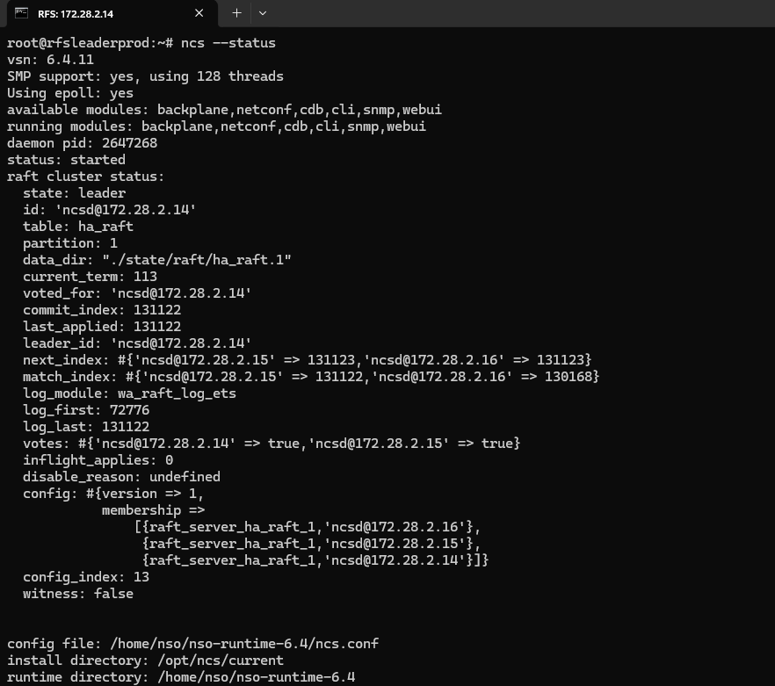  RFS leader (172.28.2.14) — ncs --status output: state leader, status started, daemon PID 2647268, current_term 113, votes confirmed from 172.28.2.15/16.  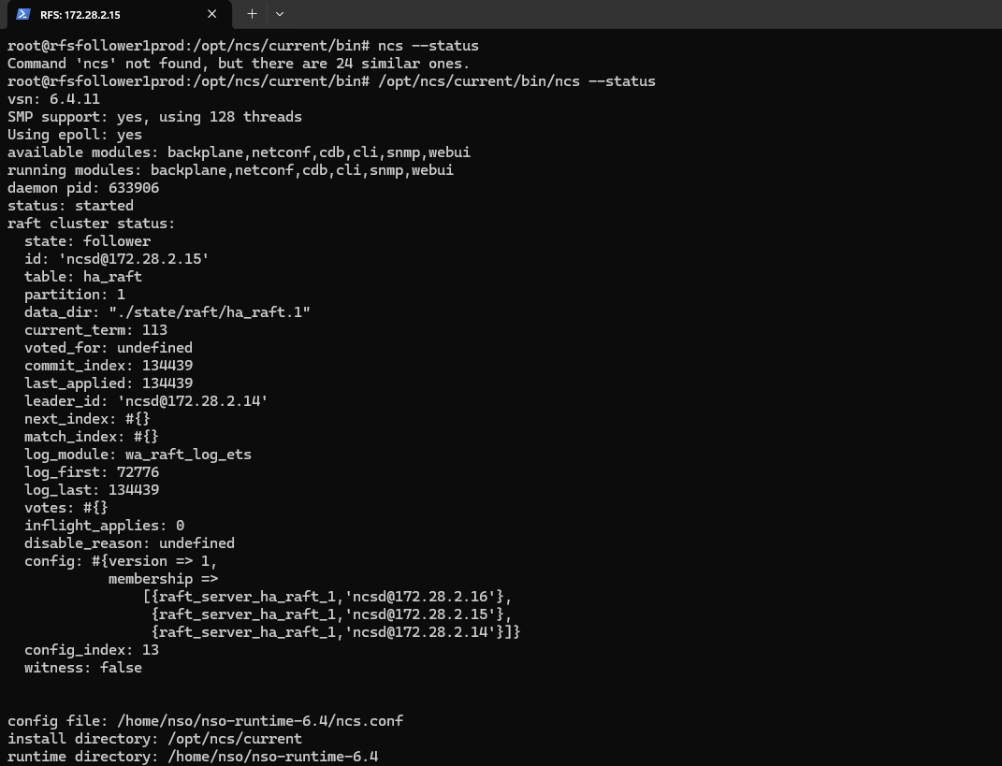  RFS follower (172.28.2.15) — ncs --status output: state follower, status started, daemon PID 633906, raft cluster synced with leader 172.28.2.14.  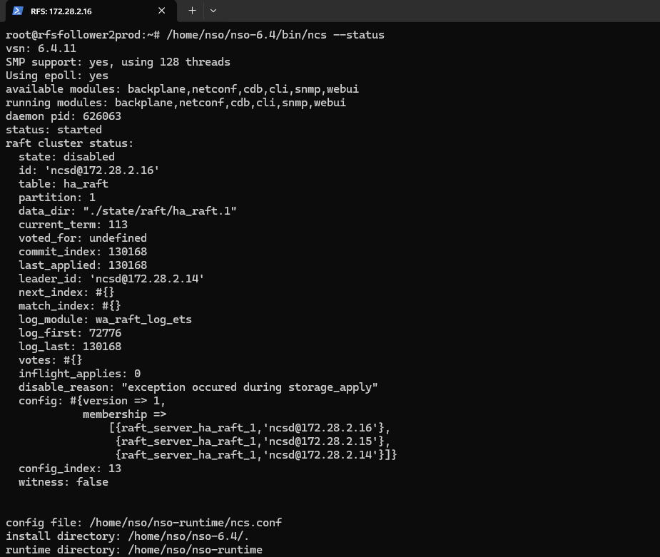  RFS follower (172.28.2.16) — ncs --status output: state disabled (disable_reason: exception occurred during storage_apply), daemon PID 626063, last_applied 130168 vs leader commit_index 130168 (in sync, module in disabled HA role).  NSO status check confirming the platform is running.

4. Device Connectivity and Configuration Synchronization
Test Case 3: Validating Device Reachability and Sync from the CFS Layer
Description: | Verify from the CFS layer that rfs-node-1/2/3 (172.28.2.14/15/16, NED cisco-nso-nc-6.4) are registered, connectable, and syncable, and confirm that devices sync-from (a CDB write) only succeeds when issued from the current CFS raft leader (172.28.2.11) and is correctly rejected as read-only on the two CFS followers (172.28.2.12, 172.28.2.13).
Procedure: | 1. On CFS leader 172.28.2.11, run: show devices list; devices device rfs-node-1 connect; devices device rfs-node-2 connect; devices device rfs-node-3 connect; devices sync-from.  2. On CFS follower 172.28.2.12, repeat: show devices list; devices device rfs-node-1/2/3 connect; devices sync-from.  3. On CFS follower 172.28.2.13 (via ncs_cli -u root -C session), repeat the same show devices list; devices connect; devices sync-from sequence.
Expected Result: | show devices list returns rfs-node-1/2/3 at 172.28.2.14/15/16 with NED cisco-nso-nc-6.4, admin state unlocked, on all 3 CFS nodes. devices connect returns result true for all 3 devices on all 3 CFS nodes. devices sync-from returns result true when run from the leader (172.28.2.11); when run from a follower (172.28.2.12 or 172.28.2.13) it correctly returns result false with info: node is in read-only mode, since only the raft leader may write to CDB.
Result: | ☒ OK ☐ Not OK  Actual: rfs-node-1/2/3 (172.28.2.14/15/16) are listed, unlocked, with correct NED (cisco-nso-nc-6.4). devices connect returns result true for all three devices in every cycle. devices sync-from returns result true on the first (leader/172.28.2.11) cycle, but result false / "node is in read-only mode" on the second and third cycles (run from 172.28.2.12 and 172.28.2.13). This is the expected CFS HA behavior — sync-from is a write operation to CDB and can only be executed from the current raft leader; followers correctly reject it.
Logs/Snaps: (if Any) | Show devices list from CFS  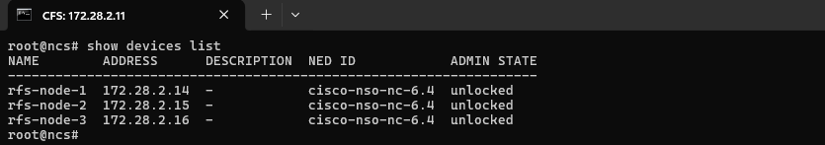  show devices list output listing rfs-node-1/2/3 (172.28.2.14/15/16), NED cisco-nso-nc-6.4, admin state unlocked.  devices device RFS-18,19,20 connect from CFS  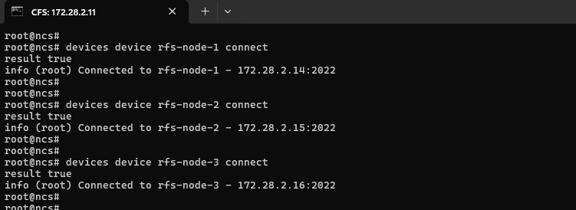  devices device connect output for rfs-node-1, rfs-node-2, rfs-node-3 — each returns result true, confirming connection to 172.28.2.14/15/16 port 2022.  devices sync-from from CFS  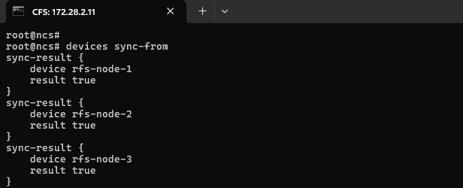  devices sync-from output — sync-result for rfs-node-1, rfs-node-2, rfs-node-3, each result true.  Show devices list from CFS  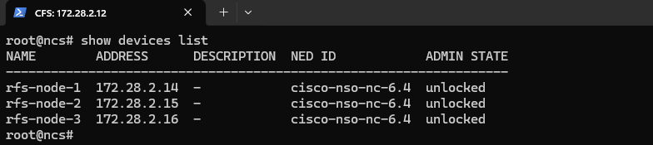  Repeat show devices list output confirming rfs-node-1/2/3 remain registered and unlocked.  devices device RFS-18,19,20 connect from CFS  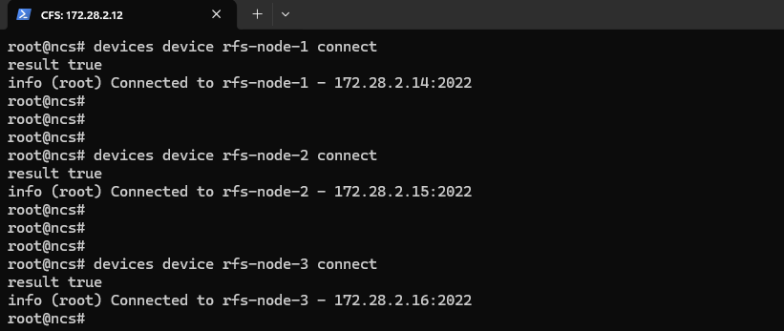  Repeat devices connect output — all three rfs-node devices return result true.  devices sync-from from CFS  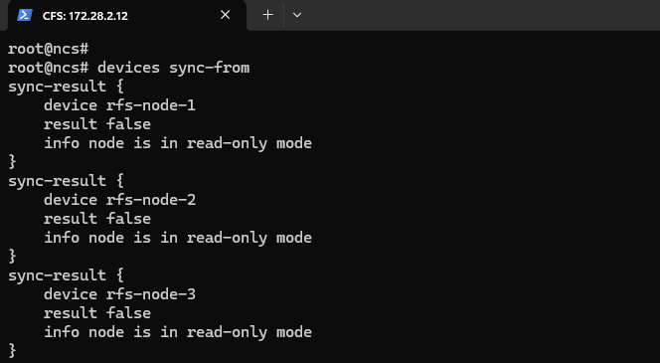  Repeat devices sync-from output — all three rfs-node devices return result false, info: node is in read-only mode.  Show devices list from CFS  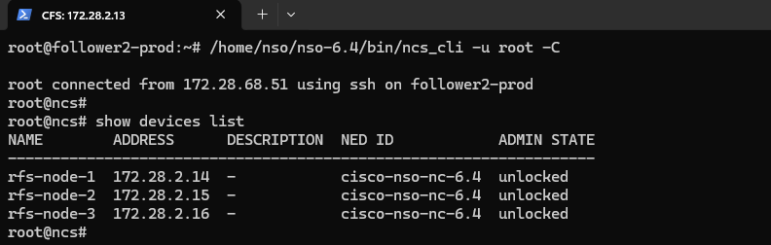  Third-cycle show devices list output, via ncs_cli session on follower2-prod, confirming rfs-node-1/2/3 registered and unlocked.  devices device RFS-18,19,20 connect from CFS  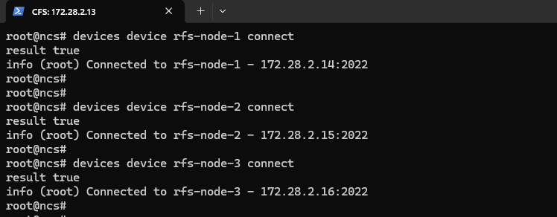  Third-cycle devices connect output — all three rfs-node devices return result true.  devices sync-from from CFS  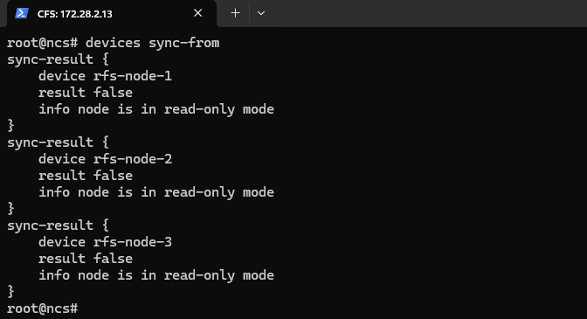  Third-cycle devices sync-from output — all three rfs-node devices return result false, info: node is in read-only mode.  Device connectivity list confirming reachable network devices.
Test Case 4: Validating Device Reachability and Sync from the RFS Layer
Description: | Verify from the RFS layer that the full field-device inventory (NED cisco-ios-cli-6.113, e.g. ADBICDAXMAR001, AKPTAKKAGPR001, CGNTPOLAGPR001, etc.) is registered and unlocked on all 3 RFS nodes, that a representative device (CGNTPOLAGPR001) connects and syncs successfully from the RFS leader, and that bulk sync-from is correctly rejected as read-only when issued from the two RFS followers.
Procedure: | 1. On RFS leader 172.28.2.14, run: show devices list; devices device CGNTPOLAGPR001 connect; devices device CGNTPOLAGPR001 sync-from.  2. On RFS follower 172.28.2.15, run: show devices list; devices sync-from (bulk, all devices).  3. On RFS follower 172.28.2.16, run: show devices list; devices sync-from (bulk, all devices).
Expected Result: | show devices list returns the full device inventory with NED cisco-ios-cli-6.113 and admin state unlocked on all 3 RFS nodes. devices device CGNTPOLAGPR001 connect and sync-from both return result true when run from the leader (172.28.2.14) — e.g. "Connected to CGNTPOLAGPR001 - 172.16.1.123:22". Bulk devices sync-from issued from a follower (172.28.2.15 or 172.28.2.16) correctly returns result false with info: node is in read-only mode for every device in the set, since followers cannot write to CDB.
Result: | ☒ OK ☐ Not OK  Actual: Full device inventory (e.g. ADBICDAXMAR001, AKPTAKKAGPR001, CGNTPOLAGPR001, CGNTRUKMGPR001, etc., NED cisco-ios-cli-6.113) is listed and unlocked on all three RFS nodes. On the RFS leader (172.28.2.14), devices device CGNTPOLAGPR001 connect and sync-from both return result true. On the RFS followers (172.28.2.15 and 172.28.2.16), the bulk devices sync-from for the same device set returns result false / "node is in read-only mode" for every device — consistent with the same leader-only write restriction observed on the CFS layer.
Logs/Snaps: (if Any) | Show devices list from CFS  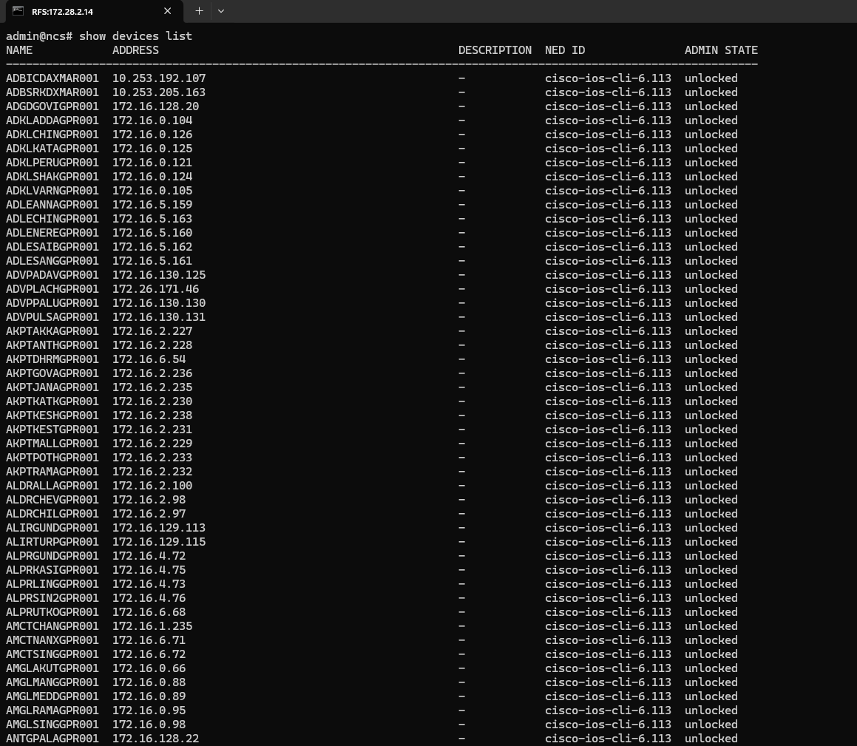  show devices list output on RFS node 172.28.2.14 — large device inventory (e.g. ADBICDAXMAR001, ADKLADDAGPR001, AKPTAKKAGPR001, etc.), all NED cisco-ios-cli-6.113, admin state unlocked.  devices device RFS-18,19,20 connect from CFS  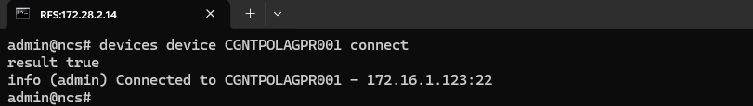  devices device CGNTPOLAGPR001 connect — result true, connected to CGNTPOLAGPR001 at 172.16.1.123:22.  devices sync-from from CFS  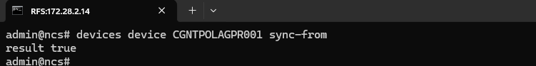  devices device CGNTPOLAGPR001 sync-from — result true.  Show devices list from CFS  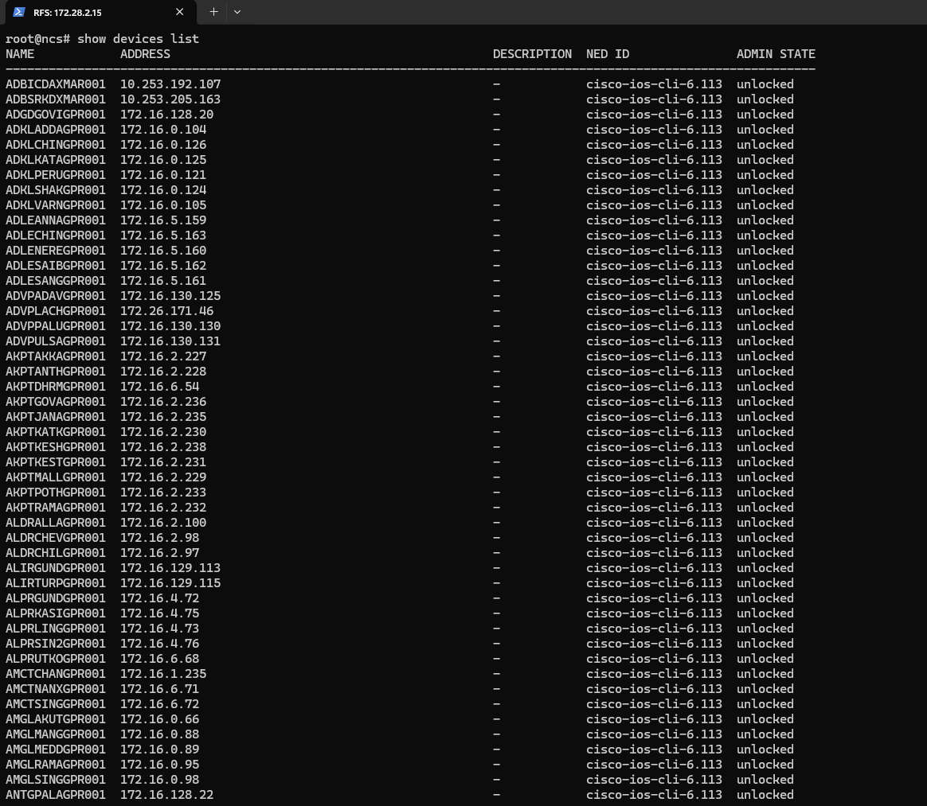  show devices list output on RFS node 172.28.2.15 — same device inventory list, all unlocked.  devices sync-from from CFS  devices sync-from command issued on 172.28.2.15.  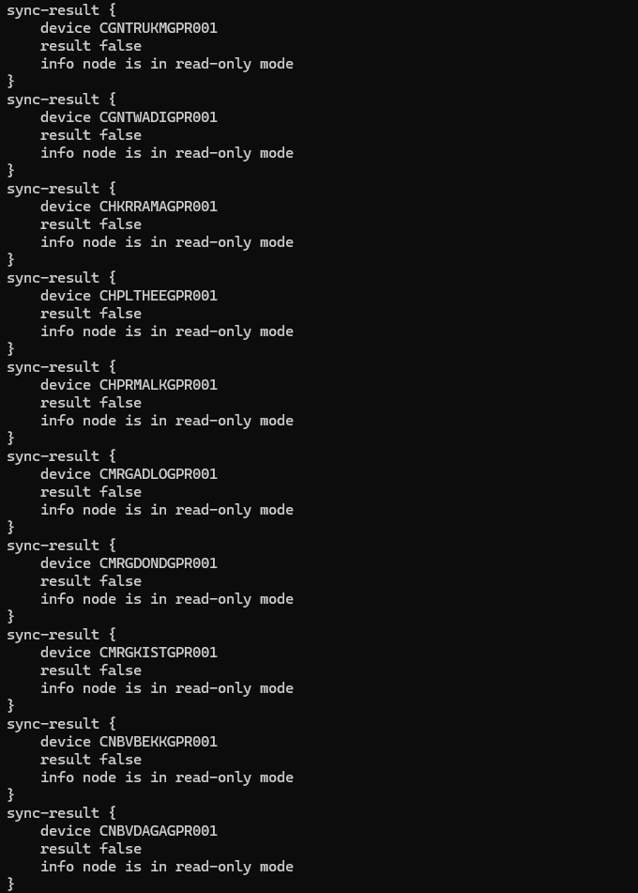  Bulk sync-from results for devices CGNTRUKMGPR001, CGNTWADIGPR001, CHKRRAMAGPR001, CHPLTHEEGPR001, CHPRMALKGPR001, CMRGADLOGPR001, CMRGDONDGPR001, CMRGKISTGPR001, CNBVBEKKGPR001, CNBVDAGAGPR001 — all result false, info: node is in read-only mode.  Show devices list from CFS  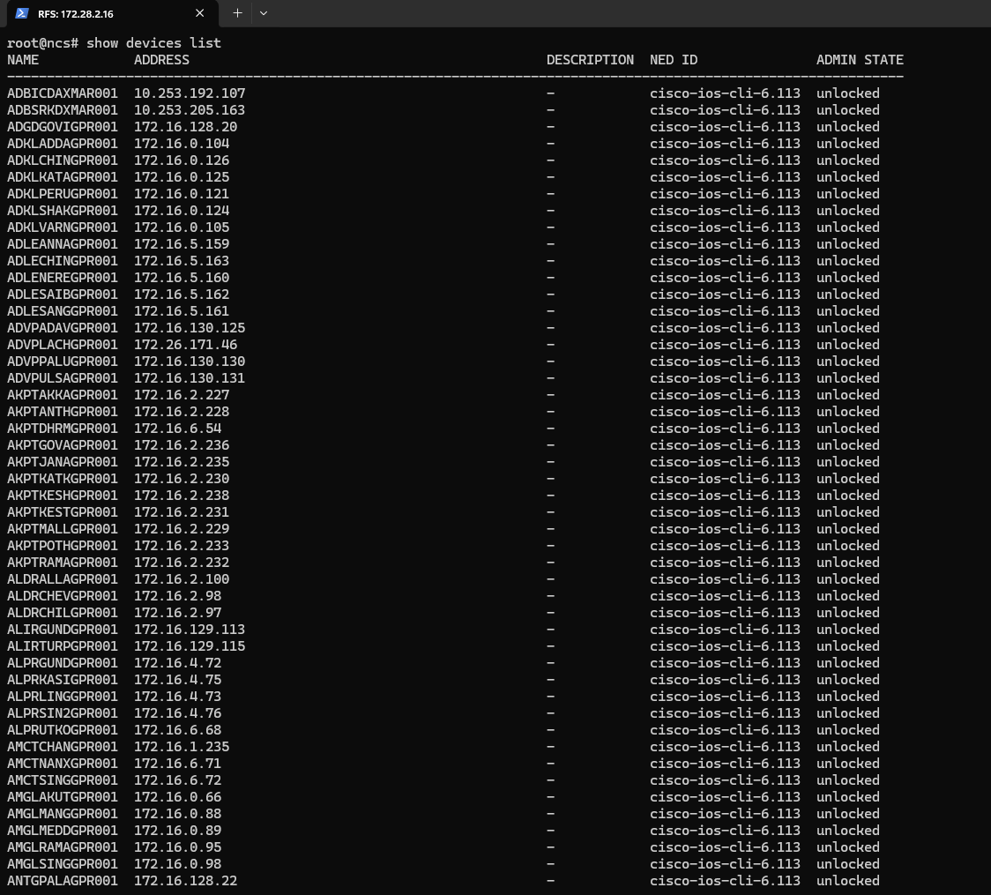  show devices list output on RFS node 172.28.2.16 — same device inventory list, all unlocked.  devices sync-from from CFS  devices sync-from command issued on 172.28.2.16.  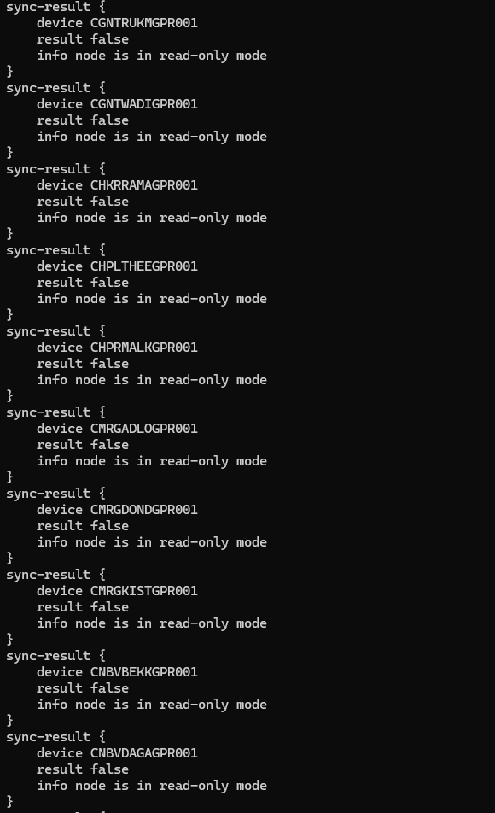  Bulk sync-from results for the same device set — all result false, info: node is in read-only mode.  Device connectivity list confirming reachable network devices.

5. Package Management
Test Case 5: Verifying Installed Package Status (Service Package Check)
Description: | Verify via show packages package oper-status that every installed NSO service package reports oper-status up on all 3 CFS nodes (172.28.2.11/12/13, base LSA package set) and all 3 RFS nodes (172.28.2.14/15/16, base set plus alu-isam-cli-1.5 and mpls-l3vpn), confirming no package failed to load after the 6.4.11 migration.
Procedure: | 1. On each of the 6 nodes, from the NSO CLI run: show packages package oper-status.  2. Scroll/record the full package list and the oper-status value reported for each package.  3. Compare the package set and status across all 3 CFS nodes and separately across all 3 RFS nodes for consistency.
Expected Result: | CFS nodes (172.28.2.11/12/13) each report the identical 26-package set — bgp, ciena-mcp-gen-1.9, cisco-ios-cli-6.113, cisco-iosxr-cli-7.75, cisco-nso-nc-6.4, dwdm-rfs, interface-ill, ip-route, l2-vfi, l2vpn-pw, l2vpn-service, loopback, mpls-l2vpn, multi-service-cfs, nokia-apc, nokia-apc-gen-1.0, ospf, prefix-set, qos, rfs-ned, route-map, route-map-pass-all, route-policy, routing-protocol, tejas-nms, tejas-nms-cfs, tejas-nms-nso, tejas-nms5500-gen-1.0, tfiber-common, tfiber-interface, vrf — every entry oper-status up. RFS nodes (172.28.2.14/15/16) each report the same set plus alu-isam-cli-1.5 and mpls-l3vpn (tejas-nms-modify replacing tejas-nms-cfs), every entry oper-status up. No package on any node reports down or an error state.
Result: | ☒ OK ☐ Not OK  Actual: All 3 CFS nodes (172.28.2.11/12/13) report the same base package set (bgp, ciena-mcp-gen-1.9, cisco-ios-cli-6.113, cisco-iosxr-cli-7.75, cisco-nso-nc-6.4, dwdm-rfs, interface-ill, ip-route, l2-vfi, l2vpn-pw, l2vpn-service, loopback, mpls-l2vpn, multi-service-cfs, nokia-apc(-gen-1.0), ospf, prefix-set, qos, rfs-ned, route-map(-pass-all), route-policy, routing-protocol, tejas-nms(-cfs/-nso), tejas-nms5500-gen-1.0, tfiber-common, tfiber-interface, vrf) all oper-status up. All 3 RFS nodes (172.28.2.14/15/16) report the same set plus alu-isam-cli-1.5 and mpls-l3vpn, also all oper-status up. No package shows down or error status on any node.
Logs/Snaps: (if Any) | 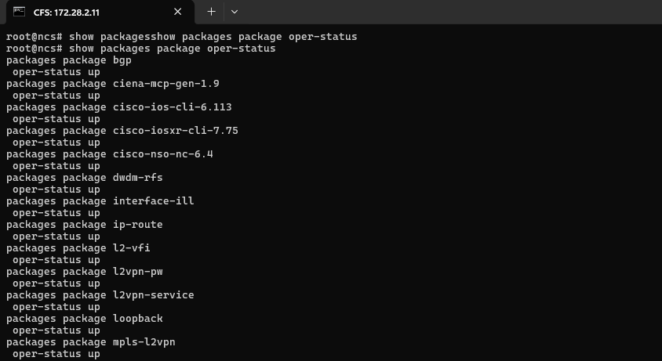  CFS node 172.28.2.11 — show packages package oper-status output listing bgp, ciena-mcp-gen-1.9, cisco-ios-cli-6.113, cisco-iosxr-cli-7.75, cisco-nso-nc-6.4, dwdm-rfs, interface-ill, ip-route, l2-vfi, l2vpn-pw, l2vpn-service, loopback, mpls-l2vpn — all oper-status up.  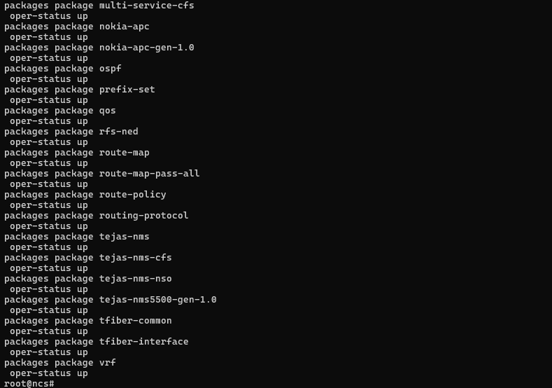  Continuation of package list (172.28.2.11) — multi-service-cfs, nokia-apc, nokia-apc-gen-1.0, ospf, prefix-set, qos, rfs-ned, route-map, route-map-pass-all, route-policy, routing-protocol, tejas-nms, tejas-nms-cfs, tejas-nms-nso, tejas-nms5500-gen-1.0, tfiber-common, tfiber-interface, vrf — all oper-status up.  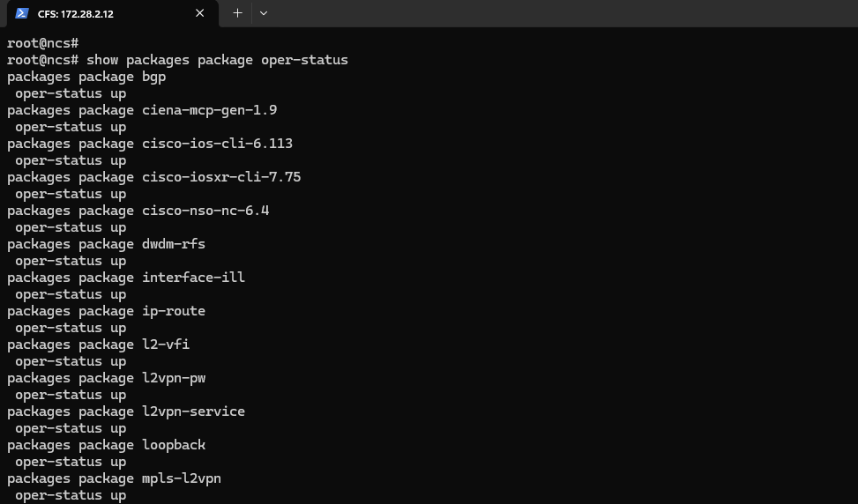  CFS node 172.28.2.12 — show packages package oper-status output, same package set, all oper-status up.  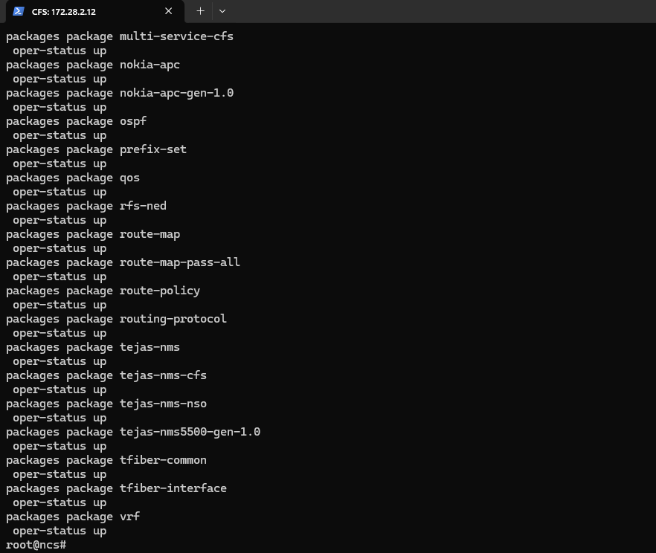  Continuation of package list (172.28.2.12) — remaining packages through vrf, all oper-status up.  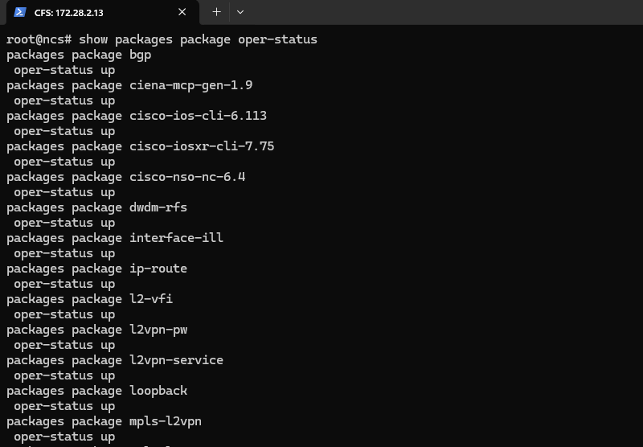  CFS node 172.28.2.13 — show packages package oper-status output, same package set, all oper-status up.  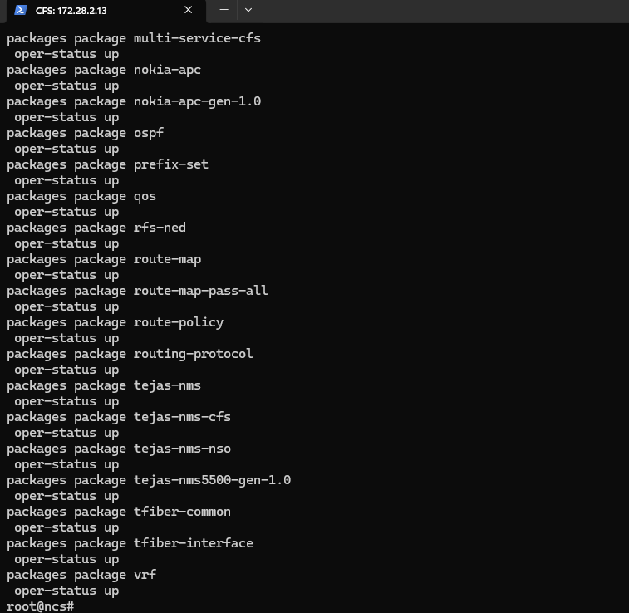  Continuation of package list (172.28.2.13) — remaining packages through vrf, all oper-status up.  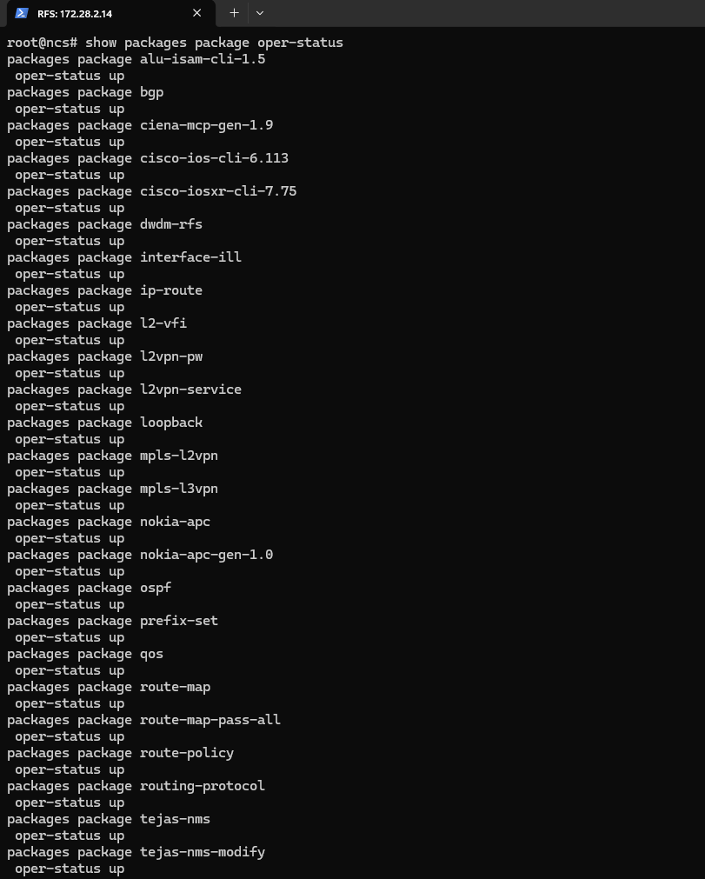  RFS node 172.28.2.14 — show packages package oper-status output, including additional alu-isam-cli-1.5 and mpls-l3vpn packages, all oper-status up.  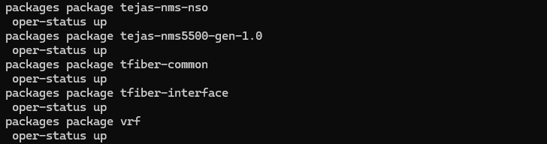  Continuation of package list (172.28.2.14) — tejas-nms-nso through vrf, all oper-status up.  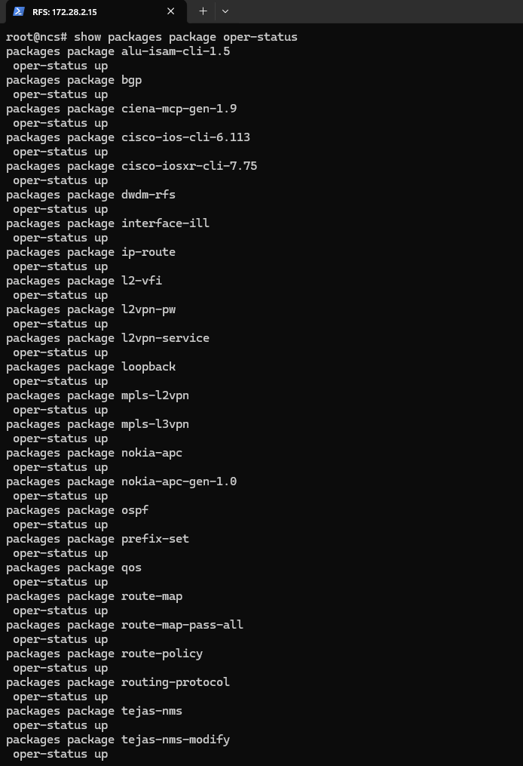  RFS node 172.28.2.15 — show packages package oper-status output, same extended RFS package set, all oper-status up.  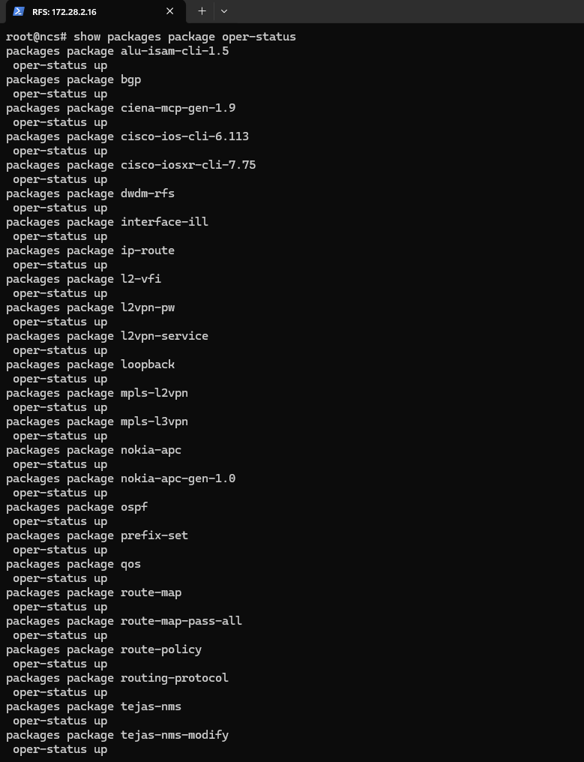  RFS node 172.28.2.16 — show packages package oper-status output, same extended RFS package set, all oper-status up.  Service package operational status - confirmed active.
Test Case 6: Package Upgrade Workflow
Description: | Verify the post-migration package footprint on disk across all 6 nodes via ls -ltr — CFS nodes show the migrated tools/lsa/auth package directories, while RFS nodes show only clean, standard directories (etc on the leader; base OS dirs plus snap on the followers) with no leftover legacy-version package artifacts — corroborating the all-up oper-status result from Test Case 5.
Procedure: | 1. On CFS nodes 172.28.2.11, 172.28.2.12, 172.28.2.13, run: cd /home/nso/nso-6.4/packages; ls -ltr.  2. On RFS leader 172.28.2.14, run: cd /home/nso/nso-6.4; ls -ltr.  3. On RFS follower 172.28.2.15, run: ls -ltr at the root/home level.  4. On RFS follower 172.28.2.16, run: ls -ltr in the home directory.
Expected Result: | CFS nodes 172.28.2.11/12/13 each list exactly 3 package directories — tools, lsa, auth — confirming the migrated package set is present and consistent across all 3 CFS nodes. RFS leader 172.28.2.14 lists a single etc directory (total 4). RFS follower 172.28.2.15 lists standard Ubuntu system directories only (bin, usr, lib, var, opt, home, etc., plus snap) with no stray package/build directories. RFS follower 172.28.2.16 lists only a snap directory (total 4), indicating no residual legacy-version files remain after migration.
Result: | ☒ OK ☐ Not OK  Actual: CFS nodes (172.28.2.11/12/13) packages directory contains tools, lsa, and auth subdirectories confirming the migrated package structure is present. RFS leader (172.28.2.14) shows an etc directory under /home/nso/nso-6.4. RFS followers (172.28.2.15/16) root-level listings show only standard OS directories and a snap directory, with no leftover legacy (5.7.3) package artifacts — consistent with a clean migration to 6.4.11. Combined with the Test Case 5 result (all packages oper-status up), this confirms the package rebuild/reload completed without errors.
Logs/Snaps: (if Any) | Package directory listing (ls -ltr)  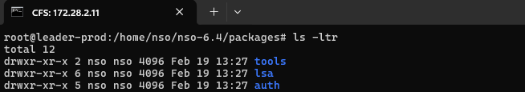  CFS leader-prod (172.28.2.11) — ls -ltr in /home/nso/nso-6.4/packages showing tools, lsa, auth directories.  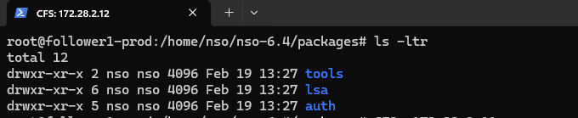  CFS follower1-prod (172.28.2.12) — ls -ltr in /home/nso/nso-6.4/packages showing tools, lsa, auth directories.  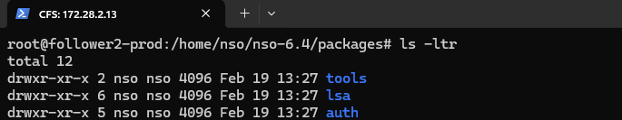  CFS follower2-prod (172.28.2.13) — ls -ltr in /home/nso/nso-6.4/packages showing tools, lsa, auth directories.  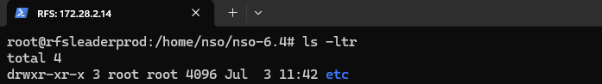  RFS leaderprod (172.28.2.14) — ls -ltr in /home/nso/nso-6.4 showing etc directory.  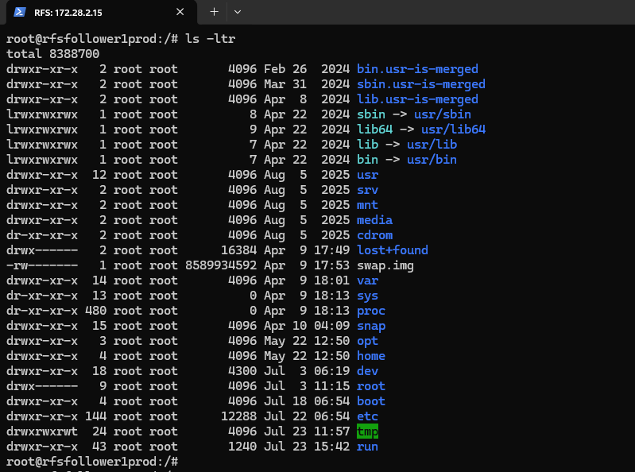  RFS follower1prod (172.28.2.15) — ls -ltr root directory listing showing standard system directories (bin, etc, home, opt, var, and package-related paths).  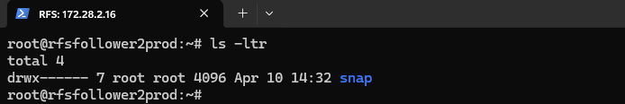  RFS follower2prod (172.28.2.16) — ls -ltr in home directory showing snap directory only, confirming minimal package footprint post-migration.

