Low-Level Design Document
SCCM Service Order Provisioning & RESTCONF Integration with NSO CFS/RFS
Version 1.0 | 15-Jul-2026
Document Title | Low-Level Design (LLD) – SCCM Service Order Provisioning & NSO CFS/RFS Integration
Document Version | 1.0
Prepared Date | 15-Jul-2026
Status | Draft
Source Reference | sccm_steps.docx (process/API walkthrough)

Table of Contents
1. Introduction 3
1.1 Purpose 3
1.2 Scope 3
1.3 Abbreviations & Definitions 3
2. System / Architecture Overview 3
2.1 High-Level Flow 4
3. Detailed Design – SCCM Service Order APIs 5
3.1 Step 1 – Service Order Initialization 5
3.2 Step 2 – Service Order Data Submission 6
3.3 Step 3 – Service Provisioning 8
4. Detailed Design – RESTCONF Integration with NSO CFS 10
4.1 MPLS L3VPN RESTCONF Payload (Router Configuration) 10
4.2 GPON RESTCONF Payload – Nokia/Tejas (OLT/ONT Configuration) 12
5. Service Order Status Update 15
6. Validation Design – NSO CFS / NSO RFS 16
6.1 MPLS L3VPN Service Validation in NSO CFS 16
6.2 Circuit ID Configuration Detail 17
6.3 Interface Configuration Verification 18
6.4 Device Configuration Verification 20
6.5 QoS Configuration Verification 20
6.6 VRF Configuration Verification 21
6.7 GPON Service Instance Validation in NSO CFS 22
6.8 Device Verification in NSO RFS 24
7. Assumptions & Dependencies 26
8. Open Points 26

1. Introduction

1.1 Purpose
This Low-Level Design (LLD) document describes the detailed, step-by-step technical design of the Service Order creation and provisioning workflow executed through SCCM (Service Configuration & Change Management), and the downstream RESTCONF-based integration with Cisco NSO CFS (Customer Facing Service layer) and NSO RFS (Resource Facing Service layer). It captures the sequence of API calls, request/response payload structures, orchestration behaviour, and the verification steps used to confirm that a service order has been correctly provisioned end to end.

1.2 Scope
The scope of this document covers:
- The three sequential SCCM APIs that create and provision a service order (Service Order Initialization, Service Order Data Submission, Service Provisioning).
- Generation and transmission of RESTCONF payloads from SCCM to NSO CFS for MPLS L3VPN and GPON (Nokia/Tejas) services.
- Update of the service order status in SCCM back to “Committed” once orchestration completes.
- Validation of the resulting service instance and device/interface/QoS/VRF configuration inside NSO CFS and NSO RFS.
Out of scope: internal SCCM database schema, NSO YANG model source, and physical network device CLI configuration, which are covered by their respective platform-level design documents.

1.3 Abbreviations & Definitions
Term | Definition
SCCM | Service Configuration & Change Management – the OSS system that originates and tracks service orders
NSO | Network Services Orchestrator (Cisco NSO)
CFS | Customer Facing Service (NSO service model layer)
RFS | Resource Facing Service (NSO device/resource layer)
RESTCONF | HTTP-based protocol used to access YANG-modelled configuration/state data on NSO
MPLS L3VPN | Multiprotocol Label Switching Layer-3 Virtual Private Network service
GPON | Gigabit-capable Passive Optical Network
OLT / ONT | Optical Line Terminal / Optical Network Terminal
PE | Provider Edge (router)
VRF | Virtual Routing and Forwarding instance
QoS | Quality of Service
VLAN | Virtual Local Area Network
Transaction ID | Unique correlation ID generated in Step 1 and reused across Steps 2 and 3

2. System / Architecture Overview
The end-to-end flow spans three logical tiers: (1) SCCM, which owns the service order lifecycle and exposes the three provisioning APIs; (2) NSO CFS, which receives RESTCONF payloads from SCCM and creates service instances for MPLS L3VPN and GPON services; and (3) NSO RFS together with the physical/virtual network devices (PE routers, OLT/ONT), which receive the resulting device-level configuration pushed down by NSO.

2.1 High-Level Flow
- Step 1 – SCCM: Service Order Initialization → generates Transaction ID
- Step 2 – SCCM: Service Order Data Submission → attaches service configuration to the Transaction ID
- Step 3 – SCCM: Service Provisioning → triggers provisioning, returns Service Identifier
- SCCM → RESTCONF → NSO CFS: MPLS L3VPN payload and/or GPON (Nokia/Tejas) payload
- NSO CFS → NSO RFS → Network devices (PE / OLT-ONT): configuration deployment
- NSO → SCCM: provisioning status callback → SCCM sets order status to “Committed”
- Validation: service instance, interface, device, QoS, and VRF data checked in NSO CFS Service Manager and NSO RFS Device Manager

3. Detailed Design – SCCM Service Order APIs
The Service Order Creation process in SCCM is performed through a sequence of three API calls, executed strictly in order, all correlated by a single Transaction ID generated in Step 1.

3.1 Step 1 – Service Order Initialization
Purpose | First step in the SCCM service provisioning workflow. Creates a new service deployment request and generates a unique Transaction ID used by Steps 2 and 3 to process the same service order.
Description | On receiving the service order details, SCCM validates the request and creates a transaction entry. A unique Transaction ID is generated and returned in the API response, linking all subsequent service order activities.
Input | Service Order ID, Customer ID, Service Type, Location, VLAN, and other service attributes.
Output | A unique Transaction ID generated by SCCM.
Outcome | - Service order request is successfully initialized.  - Transaction record is created in SCCM.  - Transaction ID is returned to the calling application.  - The generated Transaction ID is used in Step 2 for data submission and Step 3 for provisioning.
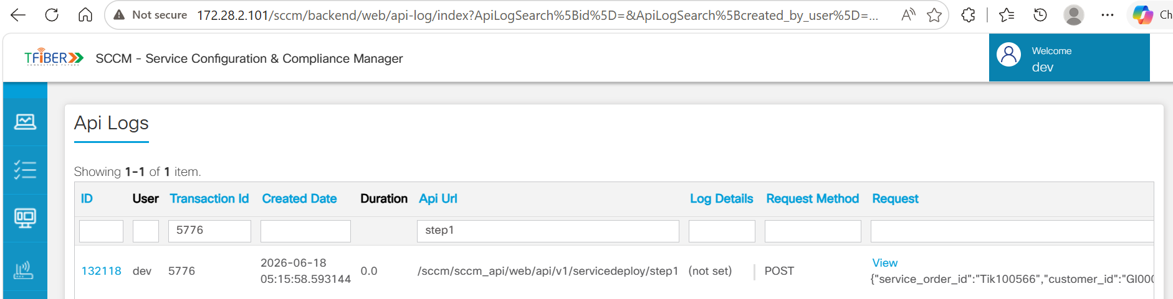
Figure 3.1a – Step 1 request endpoint
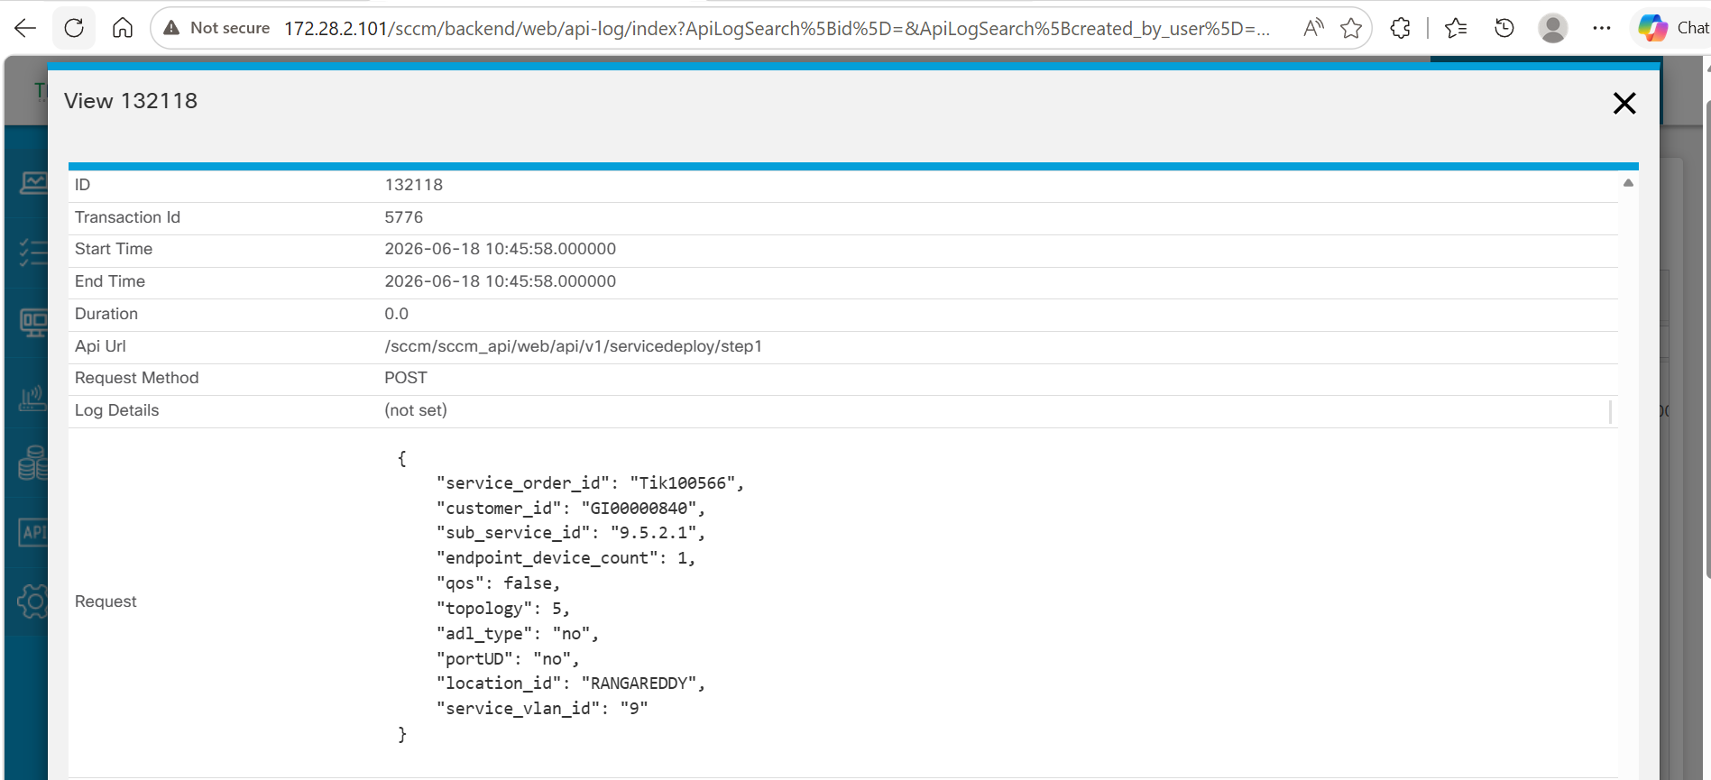
Figure 3.1b – Step 1 request payload
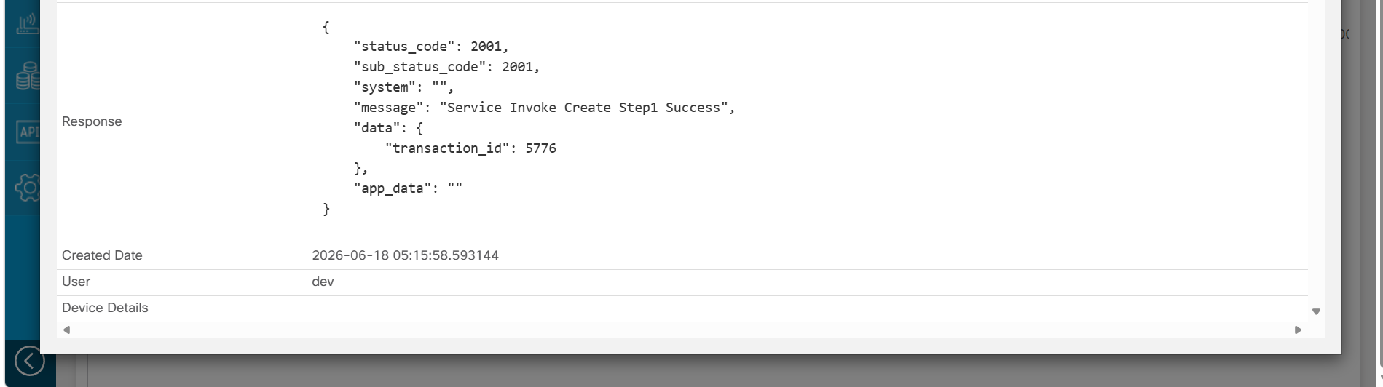
Figure 3.1c – Step 1 response payload

3.2 Step 2 – Service Order Data Submission
Purpose | Second step in the workflow. Uses the Transaction ID from Step 1 and submits all service-specific configuration details required for service creation and provisioning.
Description | SCCM validates the submitted information and associates it with the corresponding transaction. The request includes endpoint device details, bandwidth profiles, ONT information, OLT details, and PE device connectivity information.
Input | - Transaction ID generated in Step 1  - Endpoint device count  - Service-specific ID  - Upstream and downstream bandwidth profiles  - ONT details (Model, Serial Number, PON Port, Tagging Information)  - OLT hostname  - PE hostname and PE port  - Other service-specific parameters
Output | Service configuration details are validated and linked to the Transaction ID for further processing in the provisioning workflow.
Outcome | - Service order details are submitted against the Step 1 Transaction ID.  - Endpoint device and service configuration information are processed by SCCM.  - ONT, OLT, bandwidth profile, and PE connectivity details are validated.  - The transaction is updated with provisioning-related information.  - The Transaction ID remains active for use in Step 3.
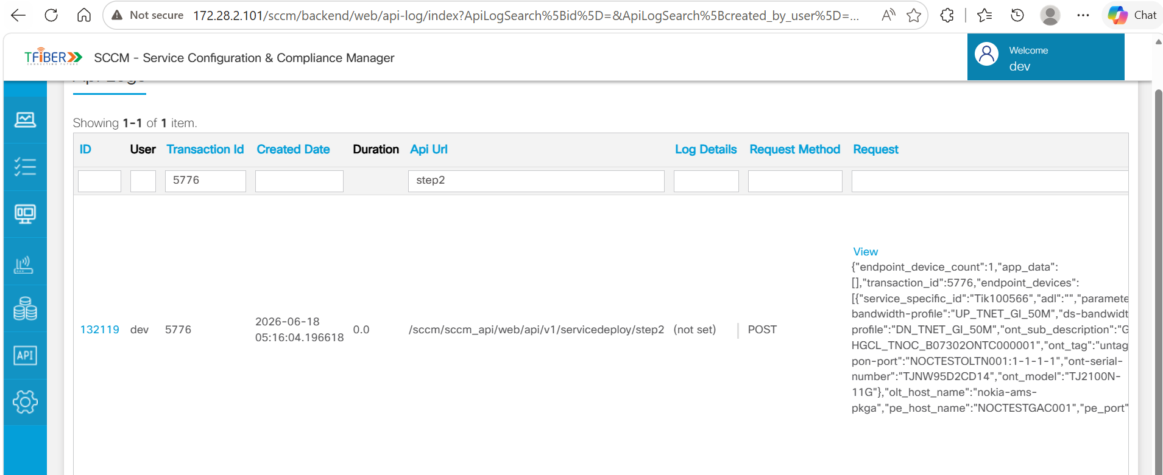
Figure 3.2a – Step 2 request payload (part 1)
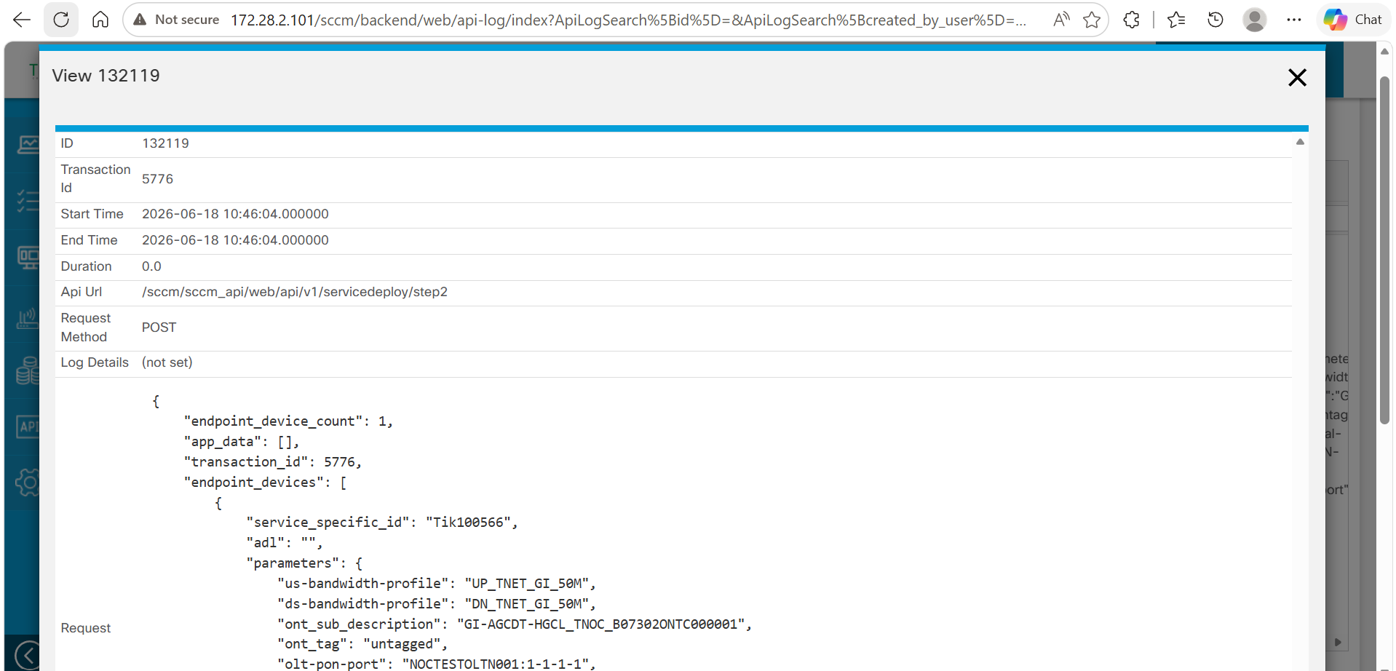
Figure 3.2b – Step 2 request payload (part 2)
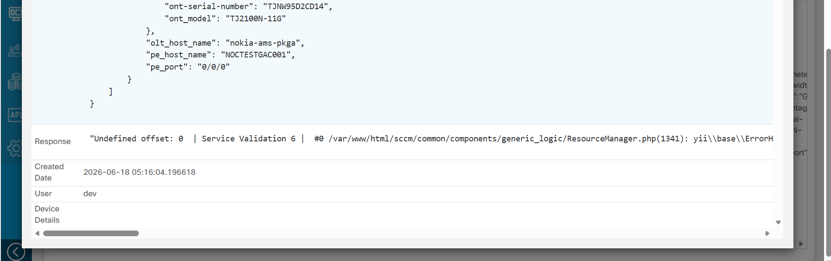
Figure 3.2c – Step 2 response payload

3.3 Step 3 – Service Provisioning
Purpose | Final step. Uses the Transaction ID from the previous steps to initiate service provisioning and trigger downstream configuration activities.
Description | SCCM retrieves the service order information submitted in Steps 1 and 2, validates it, and executes the provisioning actions. On success it returns a unique service identifier for the provisioned service.
Input | - Transaction ID generated in Step 1  - Action value indicating the provisioning operation  - Service order information previously submitted in Step 2
Output | - Service provisioning status  - Unique service identifier generated for the provisioned service
Outcome | - SCCM retrieves the service order details for the given Transaction ID.  - Service provisioning workflow is initiated and required configuration processing is triggered.  - A unique service identifier is generated (e.g. CKT-L3VPN-GI-BB-SCCM-Tik100566), usable for subsequent tracking.  - SCCM returns a successful response indicating the request has been accepted and processed.
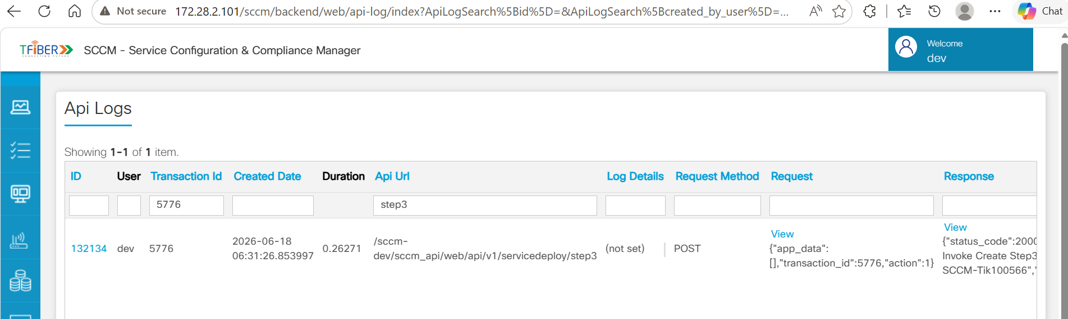
Figure 3.3a – Step 3 request endpoint
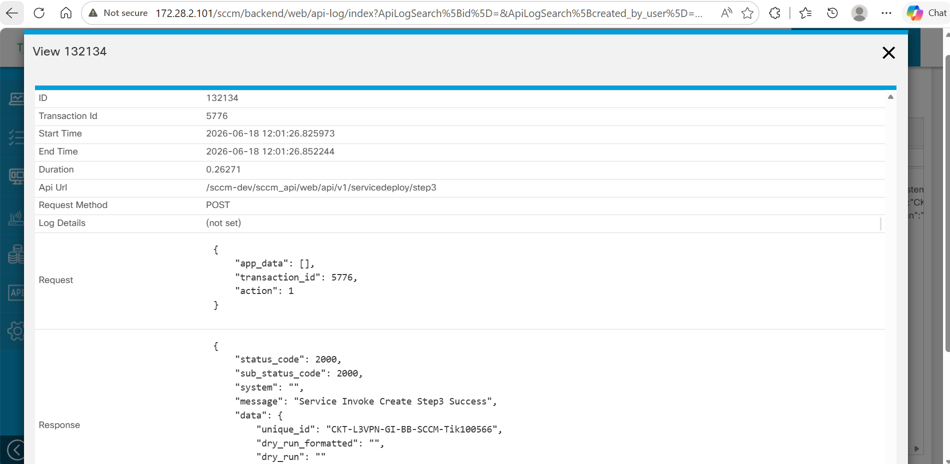
Figure 3.3b – Step 3 request payload
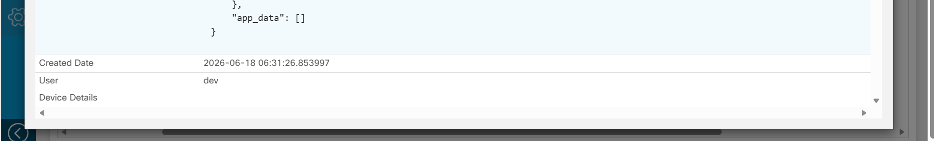
Figure 3.3c – Step 3 response payload

4. Detailed Design – RESTCONF Integration with NSO CFS
Purpose | RESTCONF APIs act as the integration interface between SCCM and NSO CFS. After successful completion of the three-step provisioning workflow, SCCM generates RESTCONF payloads and forwards them to NSO CFS for automated service orchestration and network configuration deployment.
Description | After Steps 1-3 complete, SCCM consolidates all collected data – service order details, customer information, VLAN configuration, bandwidth profiles, OLT/ONT details, PE device details, VRF configuration, routing information, and QoS policies – and generates two separate RESTCONF payloads sent to NSO CFS.
Outcome | - SCCM generates RESTCONF payloads using data collected during the provisioning workflow.  - Separate payloads are created for MPLS L3VPN services and GPON access services.  - RESTCONF APIs are triggered towards NSO CFS.  - NSO CFS receives and processes both payloads and initiates the corresponding orchestration workflows.  - Service configurations are prepared for deployment on the target MPLS and GPON network infrastructure.

4.1 MPLS L3VPN RESTCONF Payload (Router Configuration)
Purpose | Used to transfer MPLS L3VPN service configuration details from SCCM to NSO CFS for service orchestration and configuration deployment on the target MPLS network infrastructure.
Input | - Transaction ID  - Service ID  - Circuit ID  - VPN ID  - Sub Service ID  - Customer VLAN Information  - PE Device Information  - Interface Configuration  - VRF Configuration  - QoS Configuration  - Routing Parameters  - WAN IP Address Information
Output | An MPLS L3VPN RESTCONF payload generated and forwarded to NSO CFS for MPLS service orchestration.
Outcome | - Payload contains service, interface, VLAN, VRF, QoS, and routing configuration required for deployment.  - NSO CFS receives, processes, and initiates the MPLS L3VPN orchestration workflow.  - Configuration is prepared for deployment on the target PE network devices.
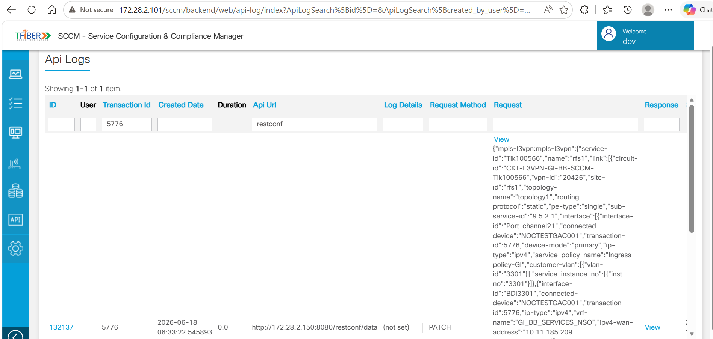
Figure 4.1a – MPLS L3VPN RESTCONF request to NSO CFS
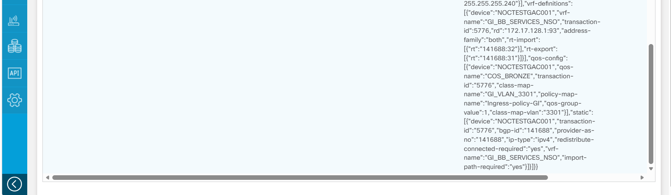
Figure 4.1b – MPLS L3VPN RESTCONF endpoint (continued)
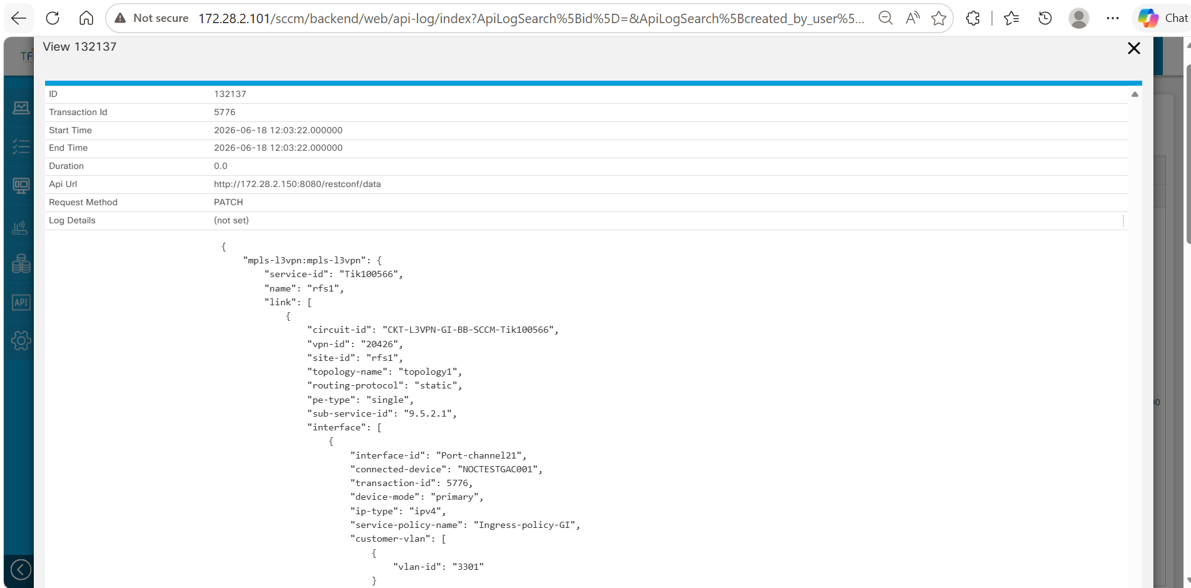
Figure 4.1c – MPLS L3VPN RESTCONF payload body (part 1)
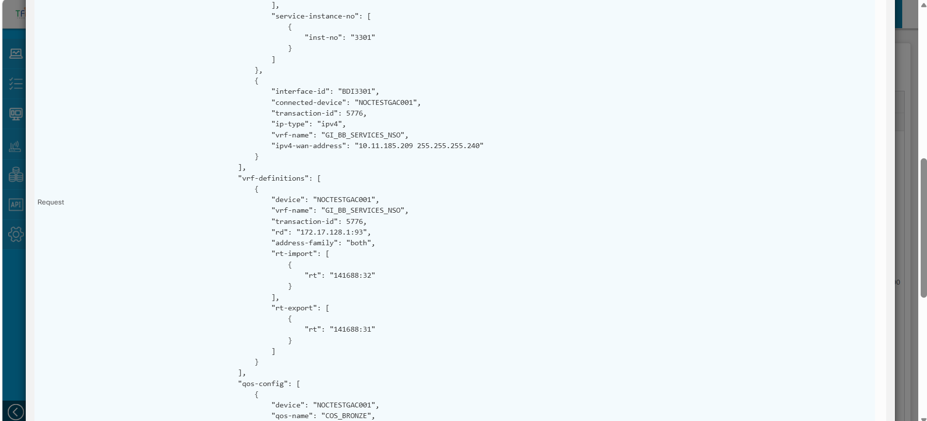
Figure 4.1d – MPLS L3VPN RESTCONF payload body (part 2)
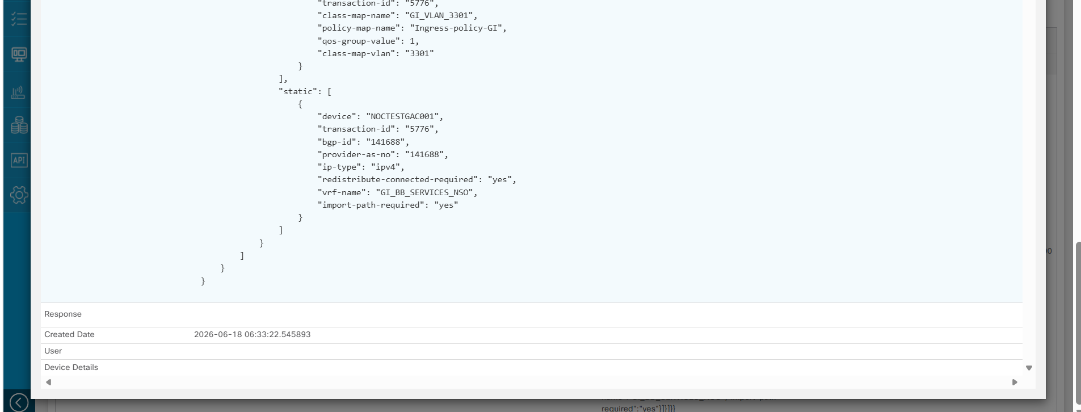
Figure 4.1e – MPLS L3VPN RESTCONF payload body (part 3)

4.2 GPON RESTCONF Payload – Nokia/Tejas (OLT/ONT Configuration)
Purpose | Used to transfer GPON access service configuration details from SCCM to NSO CFS for orchestration and deployment on the target Nokia or Tejas GPON network infrastructure.
Input | - Transaction ID  - Service ID  - Circuit ID  - OLT Information  - ONT Information  - ONT Serial Number  - ONT Card and Port Details  - Customer VLAN Information  - Network VLAN Information  - Upstream Bandwidth Profile  - Downstream Bandwidth Profile  - Subscriber Information  - Service-Specific Parameters
Output | A GPON RESTCONF payload generated and forwarded to NSO CFS for GPON service orchestration.
Outcome | - Payload contains OLT, ONT, VLAN, bandwidth profile, and subscriber-specific configuration.  - NSO CFS receives, processes, and initiates the GPON orchestration workflow.  - Configuration is prepared for deployment on the target Nokia/Tejas OLT infrastructure.
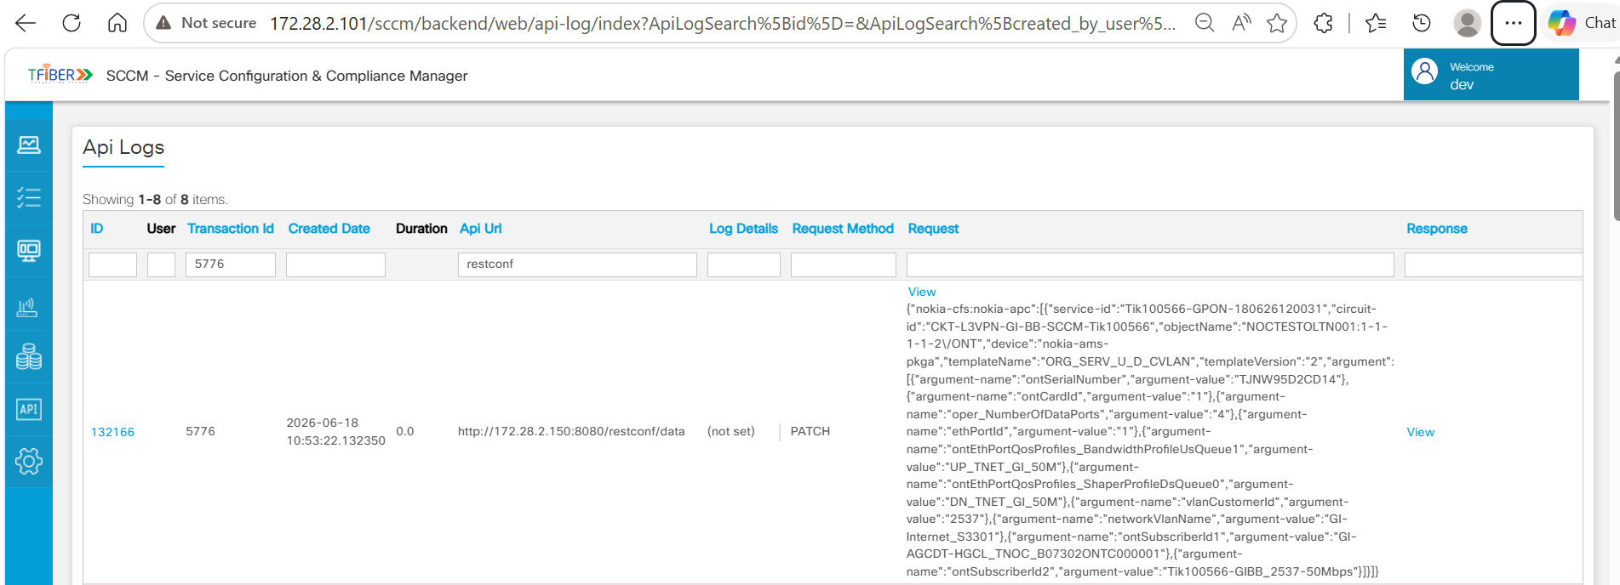
Figure 4.2a – GPON RESTCONF request to NSO CFS
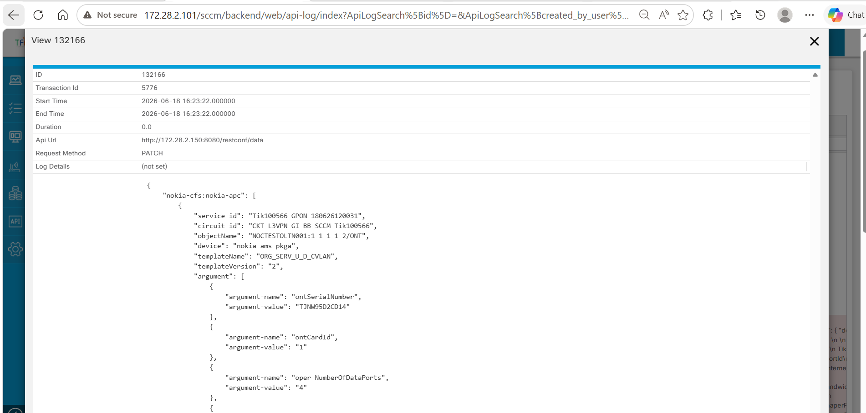
Figure 4.2b – GPON RESTCONF payload body (part 1)
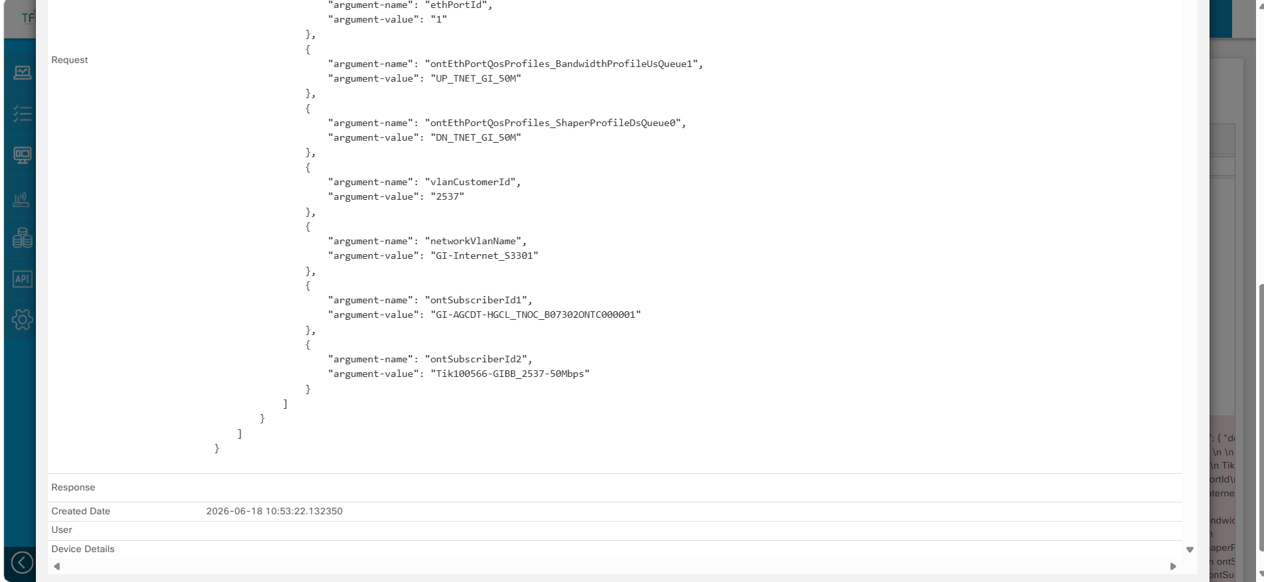
Figure 4.2c – GPON RESTCONF payload body (part 2)

5. Service Order Status Update
After Steps 1-3 and the subsequent RESTCONF-based orchestration in NSO CFS complete, the service configurations are processed by NSO and applied on the target network infrastructure. Upon successful completion of the orchestration workflow, NSO updates the provisioning status back to SCCM, and SCCM updates the service order status to “Committed”, indicating that the service provisioning workflow has been successfully completed.
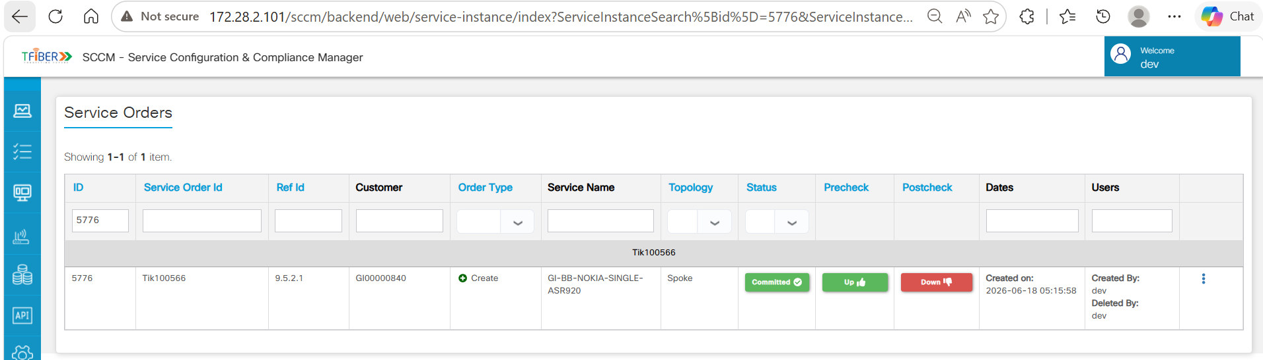
Figure 5.1 – Service order status updated to Committed in SCCM

6. Validation Design – NSO CFS / NSO RFS

6.1 MPLS L3VPN Service Validation in NSO CFS
Purpose | Verify that the MPLS L3VPN service configuration received from SCCM through RESTCONF has been successfully processed and created as a service instance in NSO CFS.
Description | By logging into the NSO CFS portal and navigating to the MPLS L3VPN Service Manager, the created service is searched and viewed using the Service ID. Opening the associated Circuit ID allows verification of the service attributes populated from the SCCM RESTCONF payload.
Validation Points | - MPLS L3VPN service instance is available in the NSO CFS Service Manager.  - Service ID is displayed as Tik100566.  - Circuit ID is displayed as CKT-L3VPN-GI-BB-SCCM-Tik100566.  - Service details match the SCCM RESTCONF payload: Circuit ID, Sub Service ID, VPN ID, Site ID, Topology Name, Routing Protocol, PE Type.
Outcome | - A corresponding MPLS L3VPN service instance is created in NSO CFS and searchable by Service ID.  - Displayed attributes match the values received via the SCCM RESTCONF payload, confirming successful processing.  - The service instance is available for subsequent synchronization, deployment, and lifecycle management.
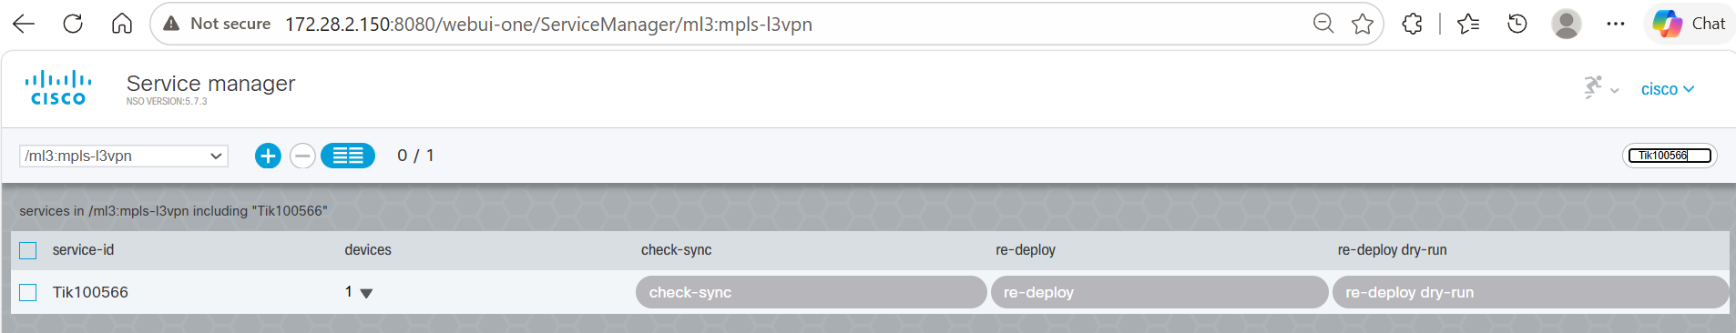
Figure 6.1a – MPLS L3VPN service search by Service ID
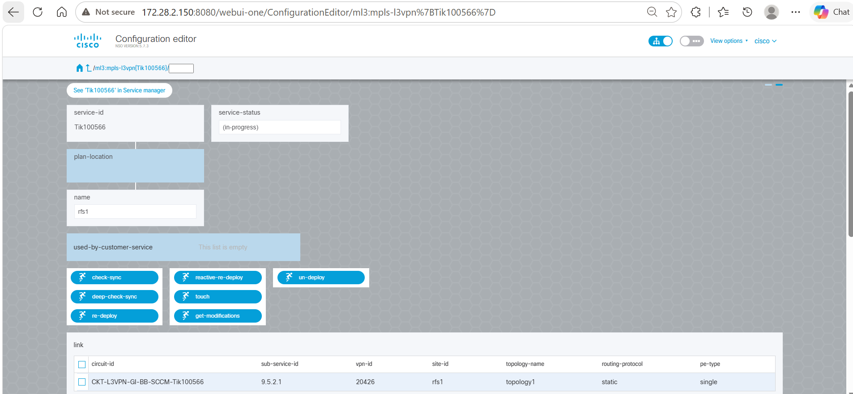
Figure 6.1b – MPLS L3VPN service instance detail
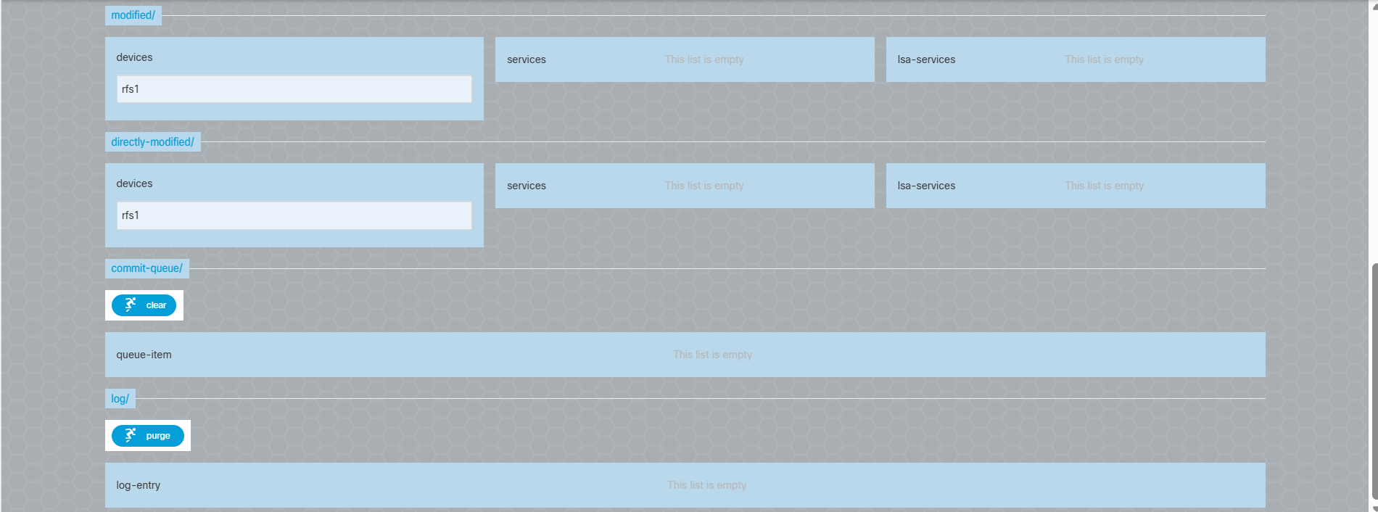
Figure 6.1c – MPLS L3VPN service attributes

6.2 Circuit ID Configuration Detail
After the MPLS L3VPN service instance is created, opening the Circuit ID in the Configuration Editor displays the detailed configuration received from SCCM through the RESTCONF payload.
- MPLS L3VPN configuration received via SCCM RESTCONF is visible in NSO CFS.
- Device configuration details are successfully associated with the service instance.
- VRF configuration is created and available for verification.
- Static routing configuration is populated in the service instance.
- QoS configuration is applied and available for validation.
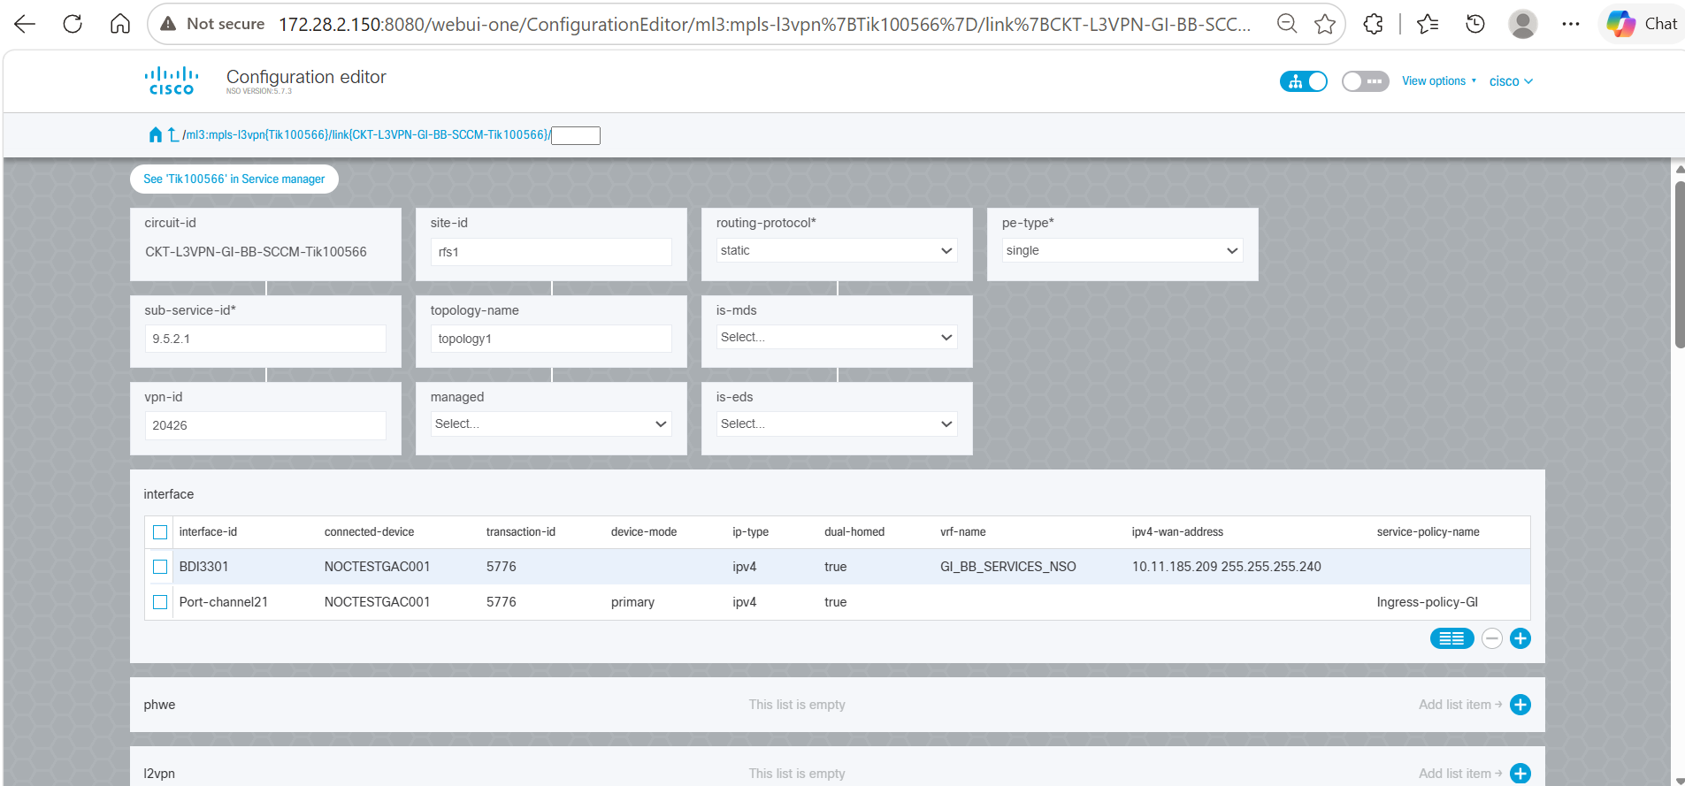
Figure 6.2a – Circuit ID configuration editor
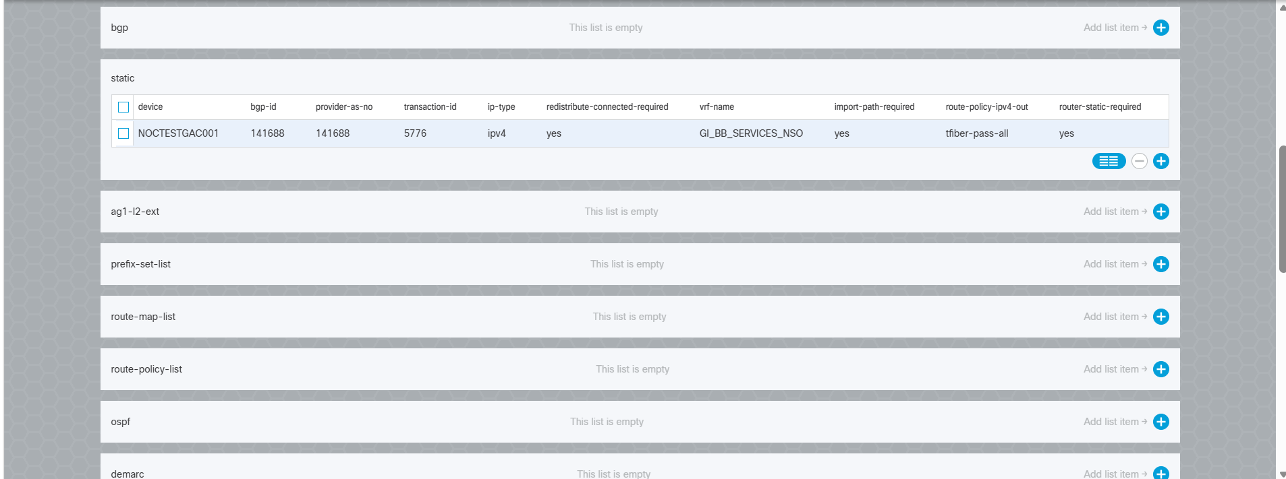
Figure 6.2b – Configuration detail (continued)
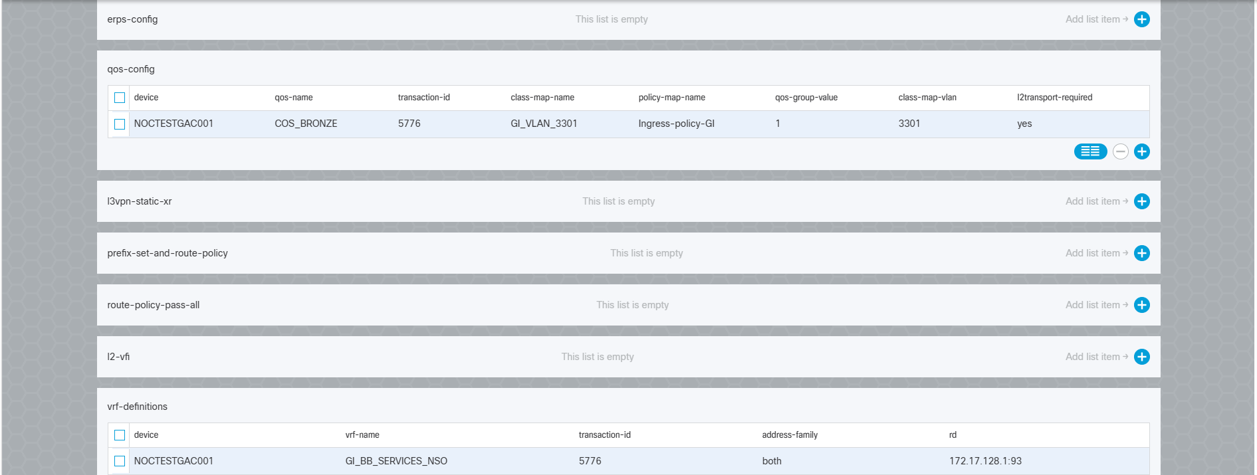
Figure 6.2c – Configuration detail (continued)
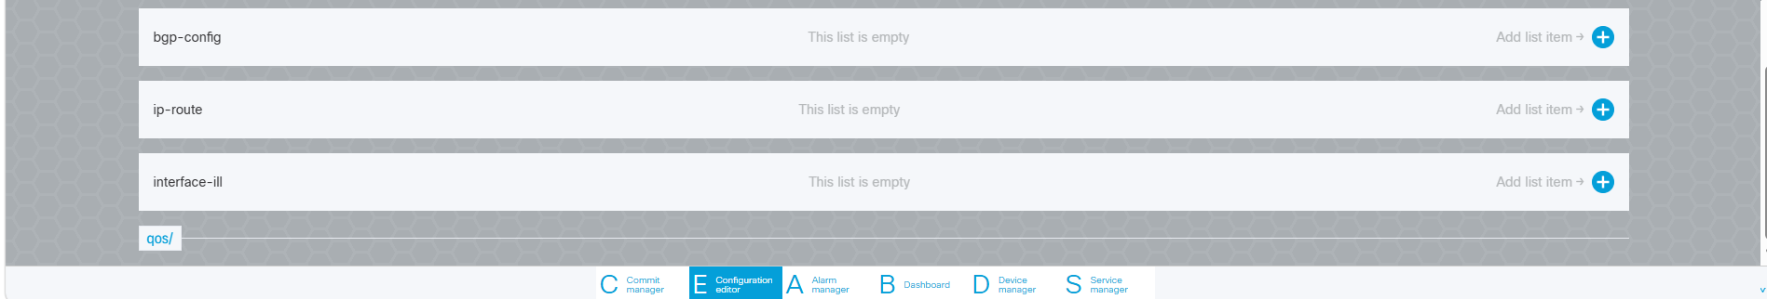
Figure 6.2d – Configuration detail (continued)

6.3 Interface Configuration Verification
Description | After opening the MPLS L3VPN service instance and selecting the required interface row (e.g. BDI3301 or Port-channel21), the Configuration Editor displays the detailed interface configuration received from SCCM through the RESTCONF payload.
Outcome | - Interface configuration received via SCCM RESTCONF is visible in NSO CFS.  - The interface is associated with the correct connected device (NOCTESTGAC001).  - Transaction ID (5776) matches the service provisioning request.  - Interface attributes verified: Interface ID, Device Mode, IP Type, VRF Name, WAN IP Address, Service Policy.  - Customer VLAN information is associated with the interface; VLAN ID 3301 is populated as received from SCCM.  - Service Instance Number is associated with the interface configuration.
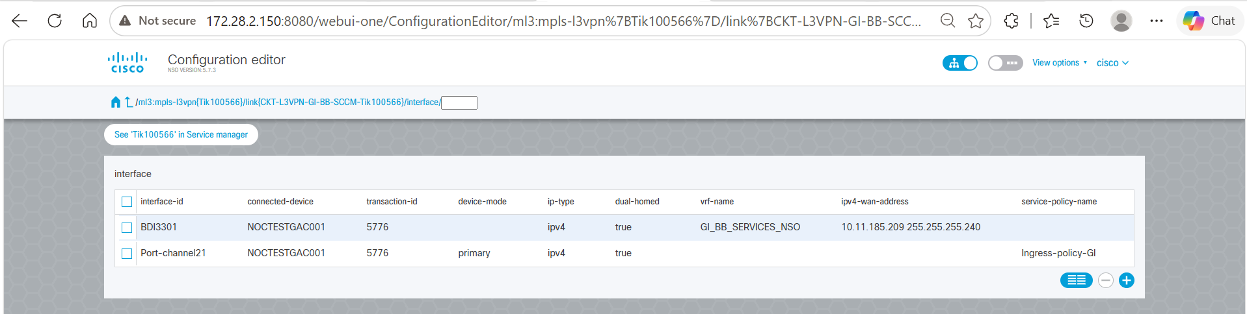
Figure 6.3a – Interface row selection
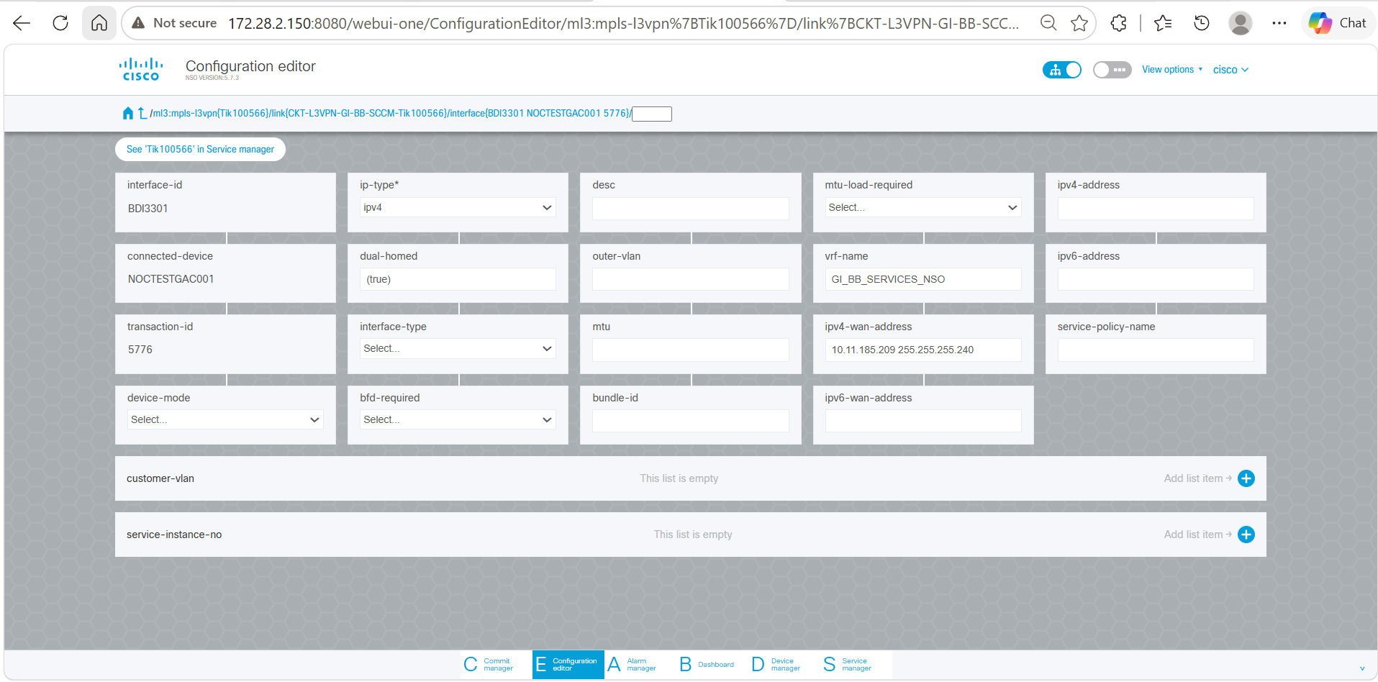
Figure 6.3b – Interface configuration detail
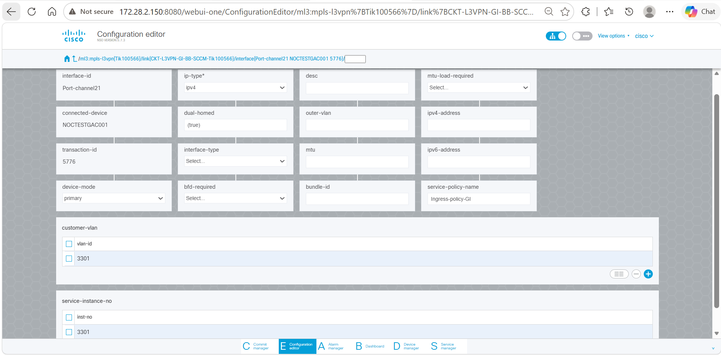
Figure 6.3c – Interface configuration detail (continued)

6.4 Device Configuration Verification
Description | After opening the MPLS L3VPN service instance and selecting the required device row, the Configuration Editor displays the detailed device configuration, used to validate routing, VRF, and device-specific parameters.
Outcome | - Device NOCTESTGAC001 is associated with the service instance.  - Transaction ID (5776) matches the service provisioning request.  - Routing parameters verified: BGP ID, Provider AS Number, IP Type.  - VRF Name (GI_BB_SERVICES_NSO) is correctly populated.
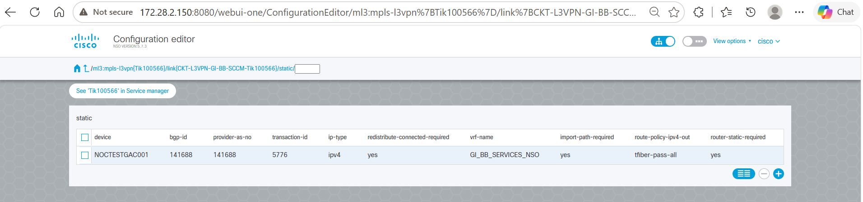
Figure 6.4a – Device row selection
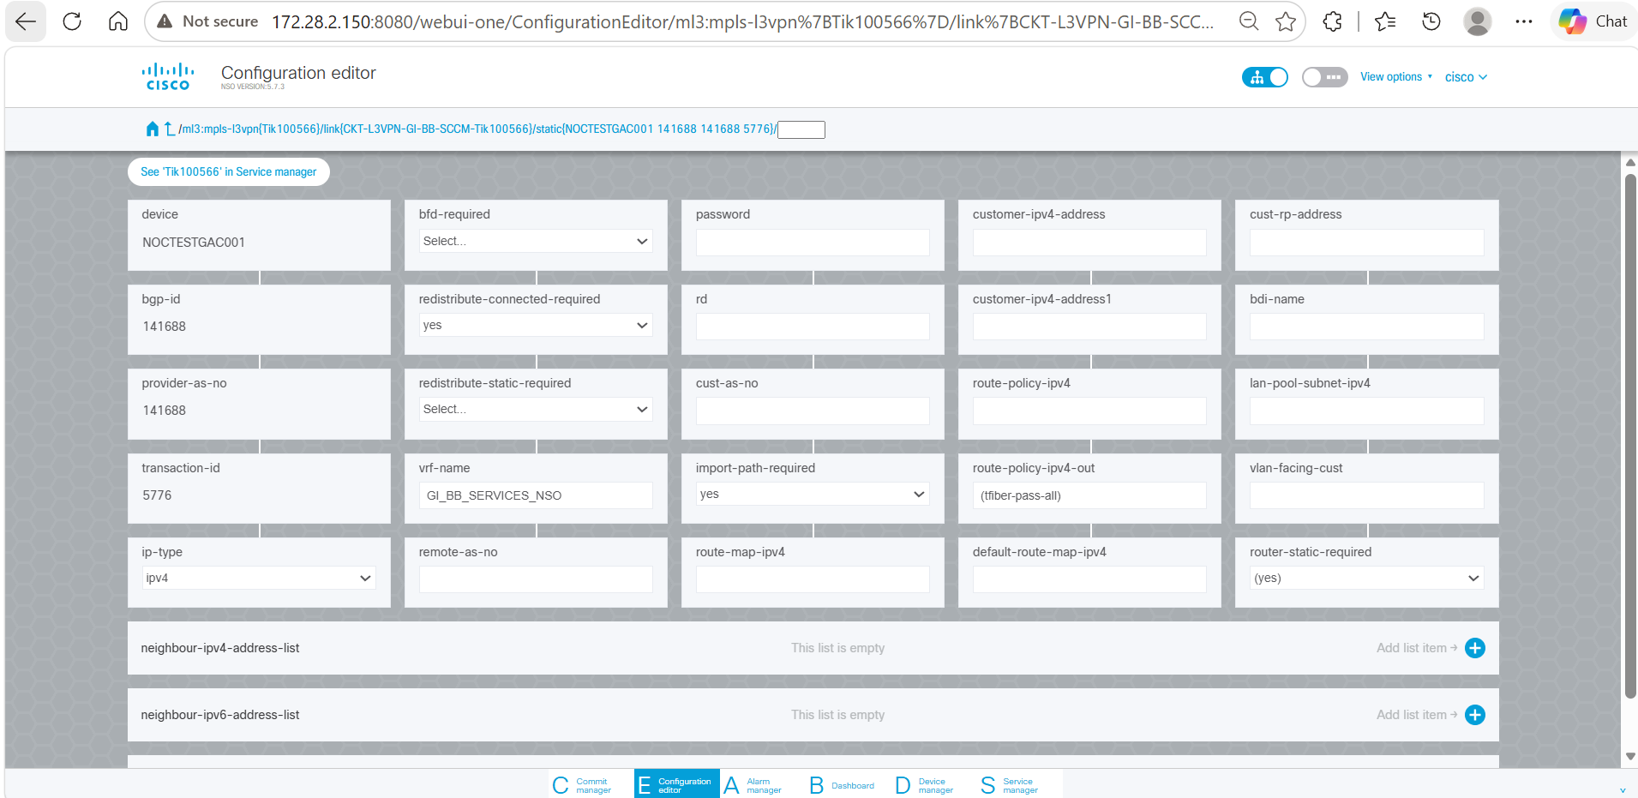
Figure 6.4b – Device configuration detail

6.5 QoS Configuration Verification
Description | After opening the MPLS L3VPN service instance and navigating to the qos-config section, the Configuration Editor displays the detailed QoS configuration, used to validate QoS policies, class maps, and VLAN-related parameters.
Outcome | - Device NOCTESTGAC001 is associated with the QoS configuration.  - QoS Name (COS_BRONZE) is correctly populated.  - Transaction ID (5776) matches the service provisioning request.  - Class Map Name (GI_VLAN_3301) is configured; Policy Map Name (Ingress-policy-GI) is applied.  - QoS Group Value (1) is populated; Class Map VLAN (3301) is associated with the service.
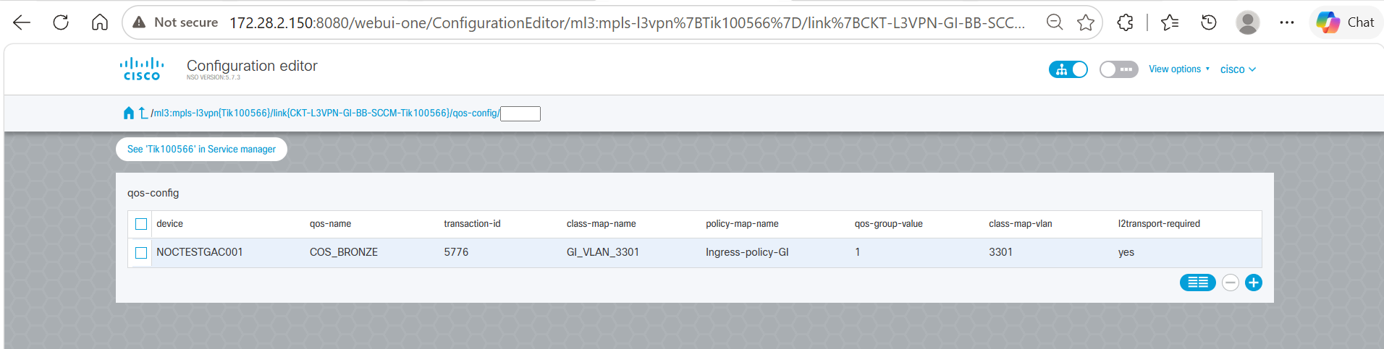
Figure 6.5a – QoS config section
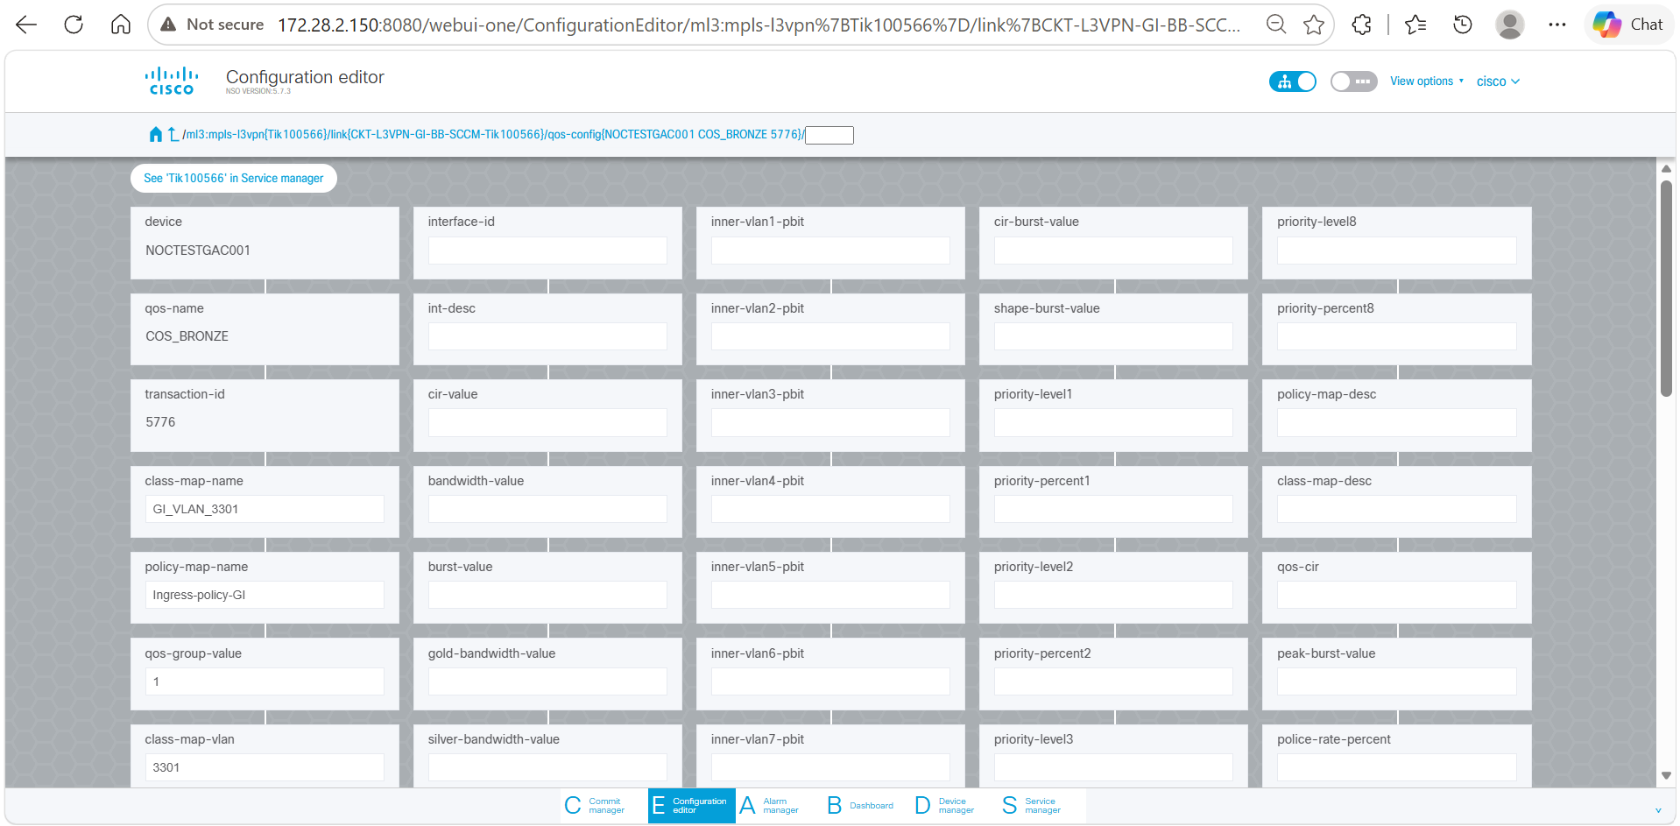
Figure 6.5b – QoS configuration detail

6.6 VRF Configuration Verification
Description | After opening the MPLS L3VPN service instance and navigating to the vrf-definitions section, this view is used to validate that the VRF-related parameters have been successfully populated in NSO CFS.
Outcome | - Device NOCTESTGAC001 is associated with the VRF configuration.  - VRF Name (GI_BB_SERVICES_NSO) is correctly populated.  - Transaction ID (5776) matches the service provisioning request.  - Address Family (both) is configured for the VRF.  - Route Distinguisher (172.17.128.1:93) is populated.  - Import Route Target (141688:32) and Export Route Target (141688:31) are configured.
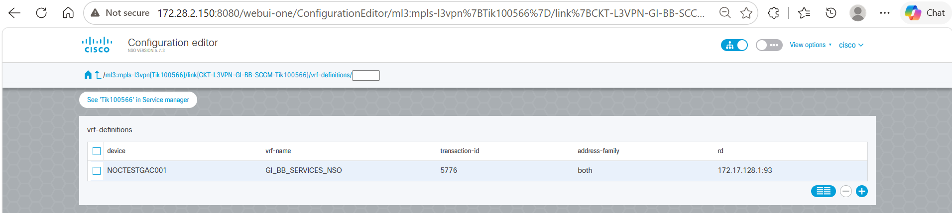
Figure 6.6a – VRF definitions section
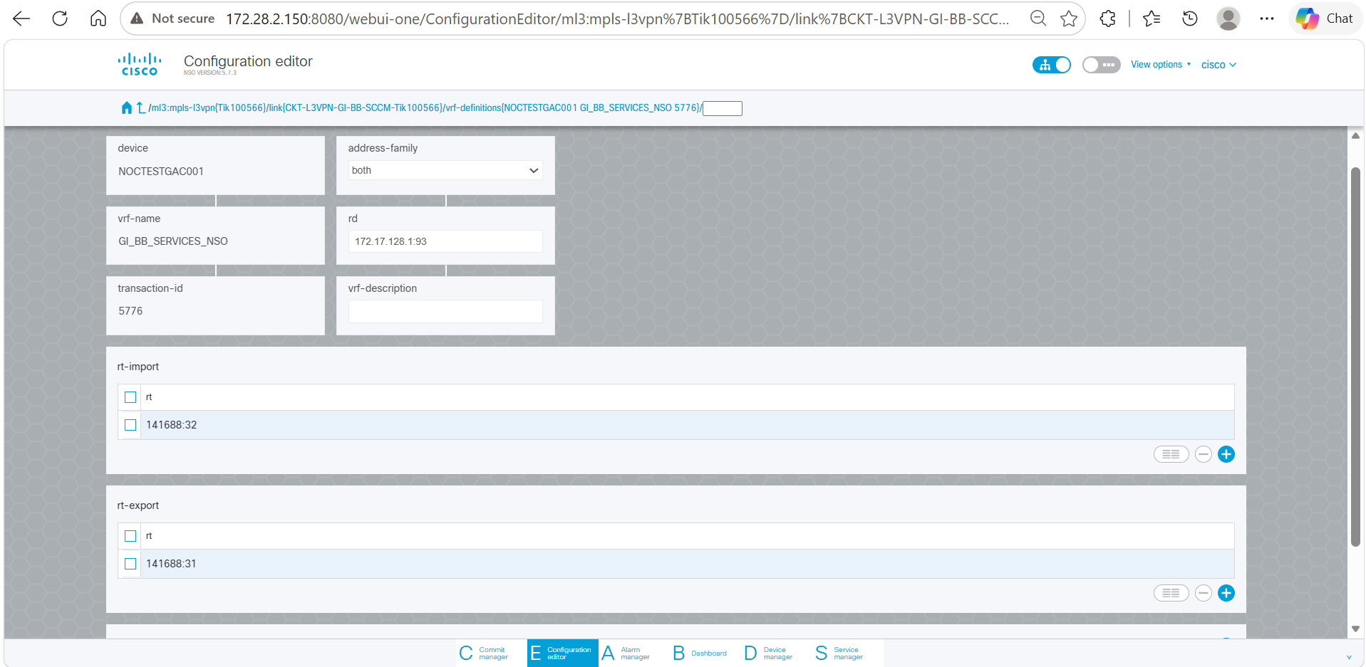
Figure 6.6b – VRF configuration detail

6.7 GPON Service Instance Validation in NSO CFS
Description | After the GPON RESTCONF payload is processed by NSO CFS, navigate to the Nokia Service Manager and verify that the GPON service instance has been created. Search for the Service ID and open the service configuration to validate the parameters received from the SCCM RESTCONF payload.
Outcome | - GPON Service ID Tik100566-GPON-180626120031 is created in NSO CFS.  - Circuit ID CKT-L3VPN-GI-BB-SCCM-Tik100566 is associated with the service.  - Nokia OLT device nokia-ams-pkga is populated.  - Template Name ORG_SERV_U_D_CVLAN is associated with the service instance; status is ACTIVE.  - ONT Serial Number TJNW95D2CD14 is populated.  - Upstream Bandwidth Profile UP_TNET_GI_50M and Downstream Bandwidth Profile DN_TNET_GI_50M are populated.  - Subscriber IDs, Customer VLAN 2537, and Network VLAN GI-Internet_S3301 are configured as received from the SCCM RESTCONF payload.
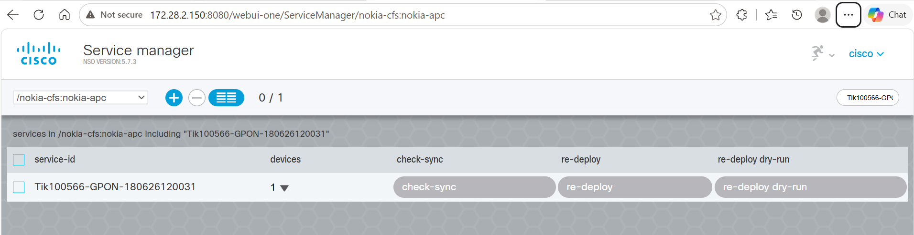
Figure 6.7a – GPON service search
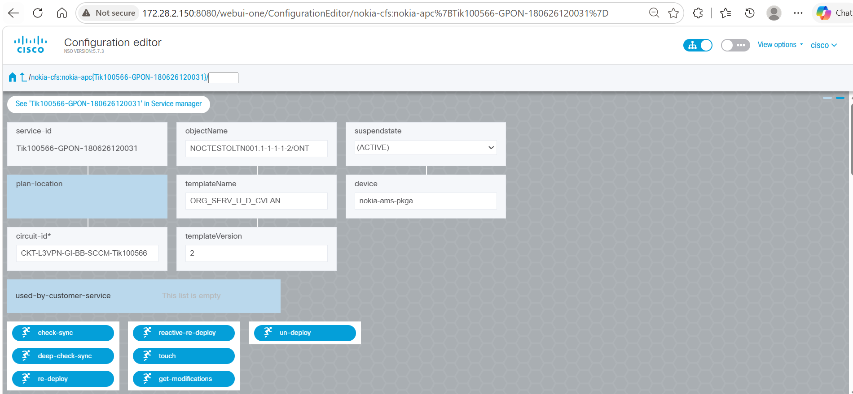
Figure 6.7b – GPON service instance detail
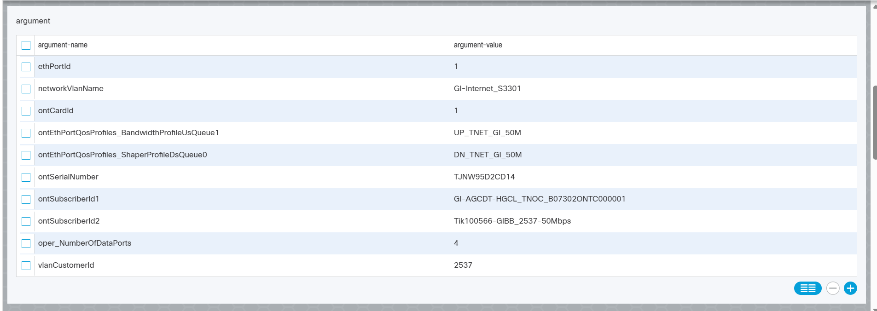
Figure 6.7c – GPON configuration detail
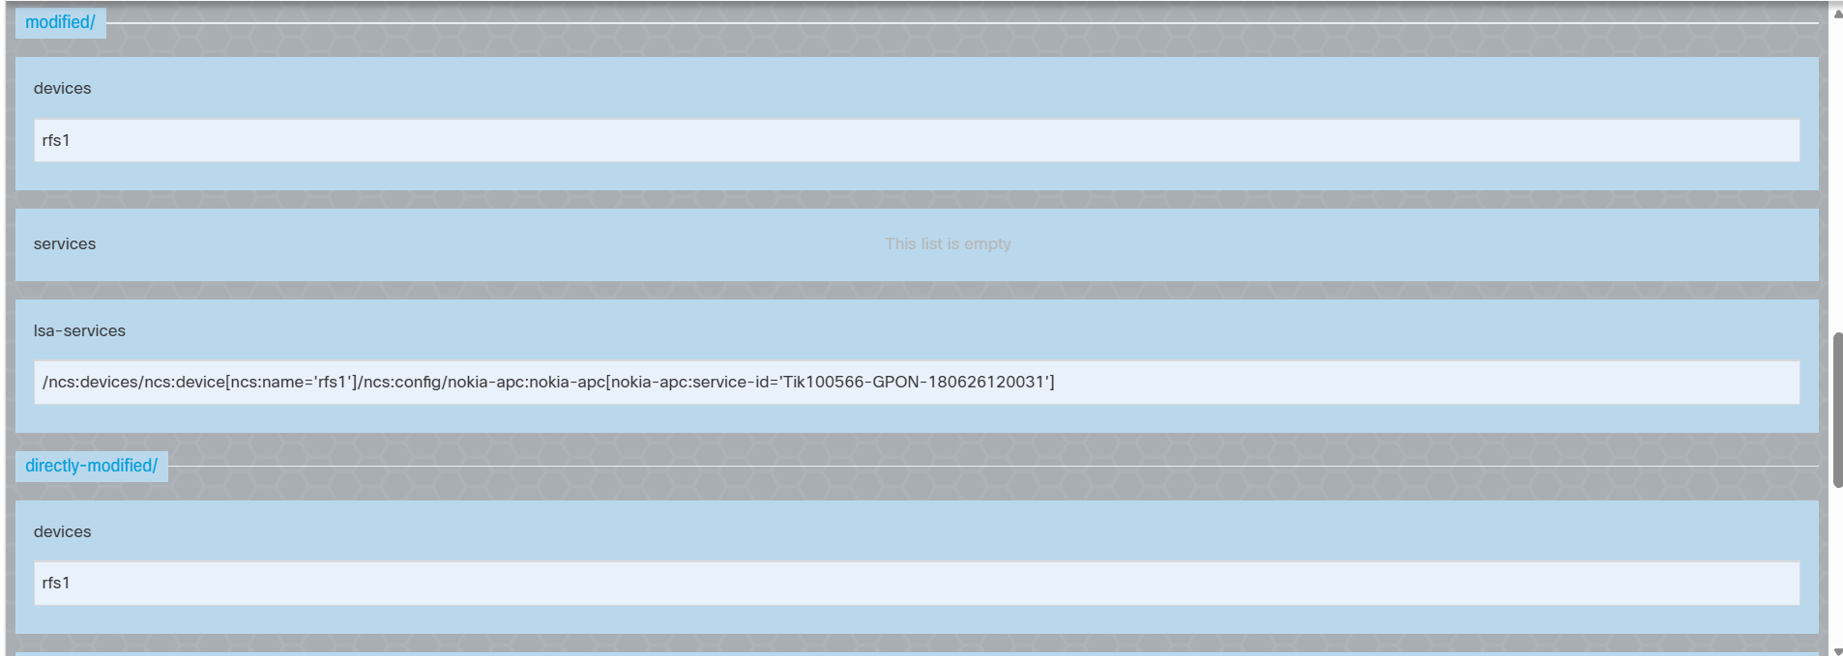
Figure 6.7d – GPON configuration detail (continued)
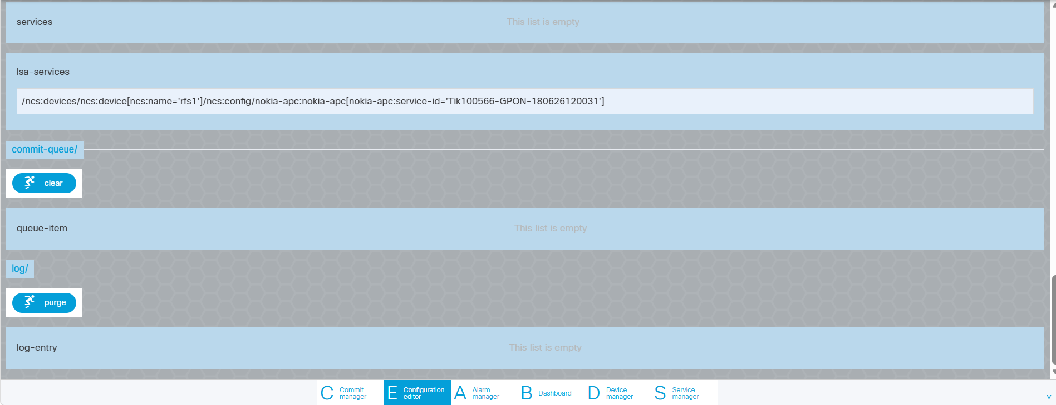
Figure 6.7e – GPON configuration detail (continued)

6.8 Device Verification in NSO RFS
Description | After successful service orchestration from NSO CFS, verify the target device in the NSO RFS Device Manager. Search for the device NOCTESTGAC001 and open the device configuration to validate that the service-related configuration has been associated with the device and is available for deployment and synchronization operations.
Outcome | - Device NOCTESTGAC001 is available in the NSO RFS Device Manager.  - Device IP Address 172.17.128.1 and Port 22 are configured; device type is Cisco IOS CLI.  - Service-related entries are visible under the Service List section.  - MPLS L3VPN service configurations associated with the device are listed.
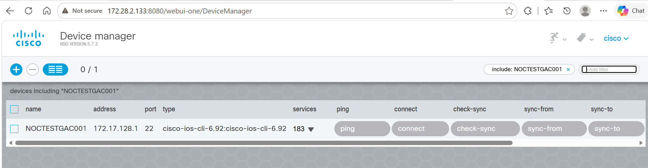
Figure 6.8a – NSO RFS device search
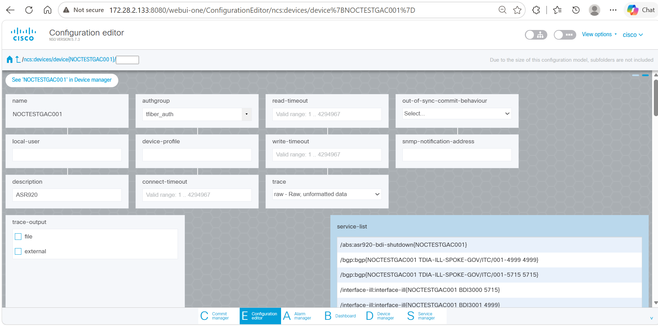
Figure 6.8b – NSO RFS device detail
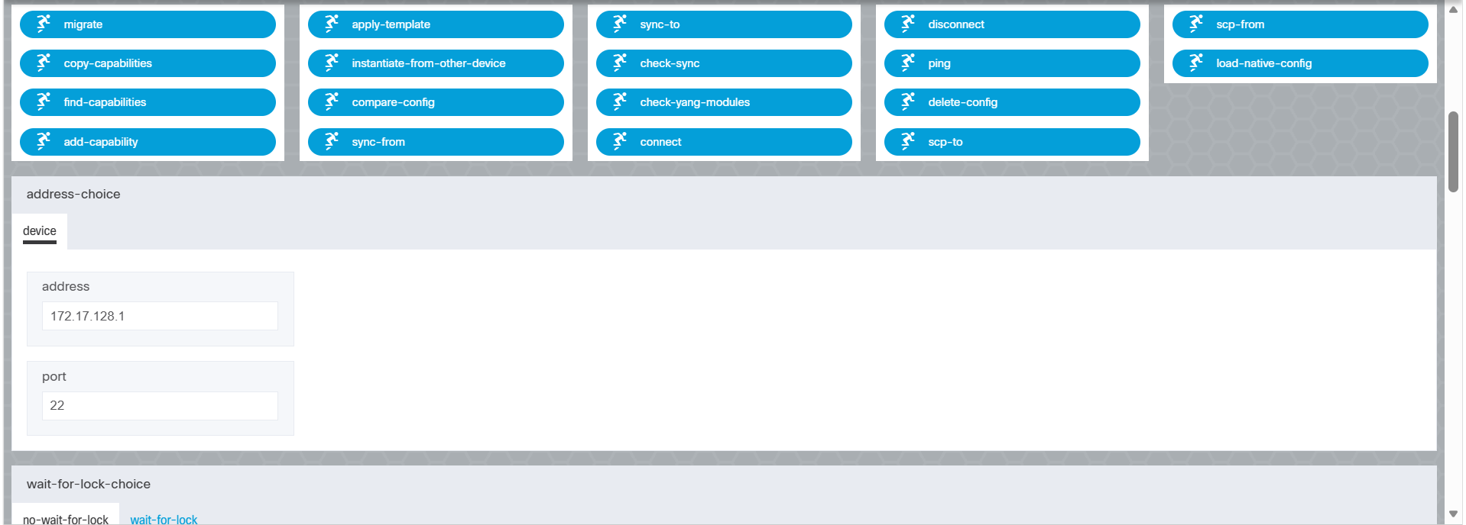
Figure 6.8c – NSO RFS service list

7. Assumptions & Dependencies
- SCCM, NSO CFS, and NSO RFS are already integrated over a reachable RESTCONF interface with valid credentials/certificates in place.
- Transaction IDs generated in Step 1 are unique for the lifetime of a given service order and are not reused across concurrent orders.
- YANG models for MPLS L3VPN and GPON (Nokia/Tejas) services are already onboarded in NSO CFS prior to payload submission.
- Underlying PE routers and OLT/ONT devices are reachable from NSO RFS for configuration deployment and synchronization.
- This document reflects the workflow and sample data captured at the time of writing; field names/values (e.g. Transaction ID 5776, Service ID Tik100566) are illustrative examples from a validated test run.

8. Open Points
- Error-handling and retry behaviour for each of the three SCCM APIs (timeouts, partial failures, rollback of a Transaction ID) is not detailed in the source material and should be confirmed with the SCCM API owners.
- Authentication/authorization mechanism for the SCCM → RESTCONF → NSO CFS calls should be documented in a follow-up security design addendum.

