

**Tribhuvan University**

Faculty of Humanities and Social Sciences

**Online Blogging System**

**A PROJECT REPORT**

**Submitted To:**

**Department of Computer Application**

**Ratna Rajyalaxmi Campus**

***In partial fulfillment of the requirement for the Bachelor in Computer Application***

**Submitted By:**

BISHAM RAJ PANDEY (6-2-40-15-2021)

BISHAL REGMI (6-2-40-14-2021)

**Under the Supervision of**

**Bipin Timilsina**



**Tribhuvan University**

Faculty of Humanities and Social Science

Ratan Rajya Laxmi Campus

# SUPERVISOR’S RECOMMENDATION

I hereby recommend that this project prepared under my supervision by BISHAM RAJ PANDEY and BISHAL REGMI entitled “Online Blogging System” in partial fulfillment of the requirements for the degree of Bachelor of Computer Application is recommended for the final evaluation.

________________________

Bipin Timilsina

SUPERVISOR

Department of Computer Application

Pradarshani Marg, Kathmandu



Tribhuvan University

Faculty of Humanities and Social Sciences

Ratan Rajya Laxmi Campus

# LETTER OF APPROVAL

This is to certify that the project prepared by BISHAM RAJ PANDEY and BISHAL REGMI entitled “Online Blogging System”, In partial fulfillment of the requirements for the degree of Bachelor in Computer Application has been evaluated in our opinion it id satisfactory in the scope and quality as a project for the required degree.

|  |  |
| --- | --- |
| **SIGNATURE of Supervisor**  -------------------------------------  Bipin Timilsina  Lecturer, Project Supervisor  Ranta Rajyalaxmi Campus | **SIGNATURE of HOD/Coordinator**  --------------------------------------------  Mr. Bhupendra Ram Luhar  Coordinator  Department of BCA  Ratna Rajyalaxmi Campus |
| **SIGNATURE of Internal Examiner**  ---------------------------------------- | **SIGNATURE of External Examiner**  **---------------------------------** |

# **ACKNOWLEDGEMENT**

The project detailed in the report was carried out and presented at Ratna Rajya Laxmi Campus, under the Faculty of Humanities and Social Sciences at Tribhuvan University of Technology, as a part of the Bachelor of Arts in Computer Application program. This project stands as evidence not only of technical skill but also of teamwork and performance in the face of various challenges. The successful completion of this endeavor is owed in large part to the invaluable assistance provided by experts.

Furthermore, we express our appreciation to the instructors of the Department of Computer Application for generously sharing their knowledge, which greatly contributed to the development of this project. We are also grateful to our friends for their steadfast support, and to the participants whose feedback helped improve our project.

We are deeply thankful to our supervisor, Mr. Bipin Timilsina, a lecturer whose guidance was instrumental in the success of this project. We also appreciate the support of our department coordinator, Mr. Bhupendra Ram Luhar.

Lastly, our heartfelt gratitude goes to our families, friends, and mentors. Without their unconditional love, care, and support, this achievement would not have been possible

# **ABSTRACT**

The purpose of the "Online Blogging System" is to make it easy for users to create and manage their blogs. This system aims facilitate the creation of blogs, posting of comments and communication. The required software and hardware are readily available and simple to use.

Key Words :

User-

Moderator-

Blogs-

**TABLE OF CONTENTS**

SUPERVISOR’S RECOMMENDATION ii

LETTER OF APPROVAL iii

**ACKNOWLEDGEMENT** iv

**ABSTRACT** v

LIST OF FIGURES viii

LIST OF TABLES ix

LIST OF CONTENT x

**CHAPTER 1: INTRODUCTION** xi

**1.1. Background** xi

**1.2. Problem Statement** xi

**1.3. Objectives** xii

**1.4. Scope and Limitation** xiii

**1.5 Report Organization** xiii

**CHAPTER 2: BACKGROUND STUDY AND LITERATURE REVIEW** xv

**2.1. Background Study** xv

**2.2. Literature Review** xv

**CHAPTER 3: SYSTEM ANALYSIS AND DESIGN** xvii

**3.1. System Analysis** xvii

**I.** **Functional Requirement (Illustrated using use case Diagram/list)** xviii

**II.** **Non-Functional Requirements** xix

**3.1.3. Data Modeling (ER-Diagram)** xx

**3.1.4. Process Modeling (DFD)** xx

**3.2. System Design** xx

**3.2.1. Architectural Design** xx

**3.2.2. Database Schema Design** xx

**3.2.3. Interface Design (UI Interface / Interface Structure Diagrams)** xx

**3.2.4. Physical DFD** xx

**3.2.4. Database Design** **Error! Bookmark not defined.**

**CHAPTER 4: Implementation and Testing** xxi

**4.1. Implementation** xxi

**4.1.1. Tools Used (Case Tools, Programming Languages, Database Platforms)** xxi

**4.1.2. Implementation Details of Modules (Description of Procedures/Function)** xxi

**4.2. Testing** xxiii

**4.2.1. Test Cases for Unit Testing** xxiii

**4.2.1. Test Cases for system Testing** xxv

**5. Conclusion and Future Recommendations** xxvi

**5.1. Lesson Learnt / Outcome** xxvi

**5.2. Conclusion** xxvi

**5.3. Future Recommendations** xxvi

# LIST OF FIGURES

Figure 1: Use Case Diagram of online portal System. xviii

Figure 2: Architectural Design **Error! Bookmark not defined.**

Figure 3: Database Schema Design **Error! Bookmark not defined.**

Figure 4: Add New Reporter **Error! Bookmark not defined.**

Figure 5: Post Table **Error! Bookmark not defined.**

Figure 6: Comment Table **Error! Bookmark not defined.**

# LIST OF TABLES

Table 1: Test case 1 Register xxiii

Table 2: Test case 2 Register Unsuccessful xxiv

Table 3: Test case 3 login **Error! Bookmark not defined.**

Table 4: Test case 4 system Test xxv

# LIST OF CONTENT

# **CHAPTER 1: INTRODUCTION**

## **Background**

Online Blogging System is a system that offers a platform for users to share posts and information. This system allows readers to access blogs from wide range of topics including Entertainment, National and International events etc. The content on this site can be posted by anyone and will be moderated by the Moderators. The Online Blogging System is designed to address the limitations of other methods by providing a user-friendly web-based platform. Users do not need any specialized knowledge to use the system, making it accessible to a global audience. It serves as a valuable source of information for those seeking to gain information on specific topics as well as wanting to record their thoughts and ideas and share them with the world.

## 

## **Problem Statement**

The problems in the current system are:-

* The difficulty in creating and reading blog posts
* The prevalence of Fake News and Misinformation
* The difficulty in communication between users

## **1.3. Objectives**

The objectives of Online Blogging system are:-

* To provide a platform for blog creation
* To prevent inappropriate contents using user reports
* To provide an easy method for communication with the users

## **1.4. Scope and Limitation**

### 1.4.1. Scope

The scopes of Online Blogging system are:-

* Facilitate content creation
* Facilitate information sharing
* Help in communication with users

## 1.4.2 **Limitation**

The limitations of Online Blogging system are:-

* Lack of accessibility and reach
* Limited monetization options for users

**1.5 Report Organization**

The report can be organized into 5 chapters which are given below:

**Chapter 1:** Includes introduction includes the brief introduction of the system, statement of problem, objectives, scope and limitation.

**Chapter 2:** Includes background study and literature review includes the previous work related to the systems and similar works were studied and are summarized.

**Chapter 3:** Includes system analysis and design includes different feasibility analysis and designed system architecture, system flow diagram, dataflow diagram.

**Chapter 4:** Includes implementation and testing includes various implementation method and tools and also contains description of testing.

**Chapter 5:** Includes conclusion and future recommendations includes outcomes of the system, conclusion to the system and description about what features can be added in the future.

# **CHAPTER 2: BACKGROUND STUDY AND LITERATURE REVIEW**

## **2.1. Background Study**

Blogs, short for weblogs, are online platforms where individuals or groups can share their thoughts, opinions, and experiences in a chronological format. Dating back to the late 1990s, early blogging sites such as LiveJournal, Blogger, and WordPress paved the way for the popularity of blogging as a form of personal expression and information dissemination. These platforms offered users the ability to publish content easily and interact with readers through comments and sharing features. Over time, blogging has evolved into a diverse and dynamic medium, with blogs covering a wide range of topics including lifestyle, fashion, technology, travel, and more. Today, blogging remains a popular means of communication and storytelling, with modern platforms offering advanced features and customization options to cater to the needs and preferences of bloggers and readers alike.

## **2.2. Literature Review**

Blogging systems have undergone significant evolution since their inception in the late 1990s, transforming the landscape of online communication and content creation. Early platforms like LiveJournal, Blogger, and WordPress paved the way for the popularity of blogging as a mainstream medium for sharing thoughts, opinions, and experiences [1]. These platforms democratized content creation by offering simple yet effective tools for publishing and managing blogs.

User engagement and community building emerged as critical aspects of blogging platforms' success, with features like comments sections and social sharing buttons facilitating interaction and collaboration among users [2]. Additionally, the integration of social media functionalities into blogging platforms has further enhanced user engagement and content dissemination [3]

Monetization strategies have become increasingly important for bloggers seeking to generate revenue from their content. While advertising and affiliate marketing remain popular options, issues such as ad blockers and declining ad rates pose challenges to monetization efforts [4] .Moreover, accessibility barriers such as language and device compatibility may limit the reach and impact of bloggers, particularly in underserved regions.

Overall, blogging systems continue to evolve in response to changing user needs, technological advancements, and cultural shifts. By understanding the key themes and trends in the development and usage of blogging systems, researchers and practitioners can better address the challenges and opportunities facing this dynamic medium.

# **CHAPTER 3: SYSTEM ANALYSIS AND DESIGN**

# 3.1. System Analysis

System analysis involves collecting and understanding information about the Online Blogging System to identify problems and suggest improvements. It's a problem-solving process that requires communication between users and developers. The analyst closely examines the current system, identifying issues and proposing solutions. These proposals are compared with the existing system, and the best one is chosen after user approval. Preliminary study gathers facts and conducts feasibility studies to guide further analysis and decision-making.

## 3.1.1. Requirement Analysis

Requirement analysis was performed by examining existing systems. Systems like blogger, medium and Quora were examined and studied to gather requirements for the system.

3.1.1.1. Functional Requirement

Function requirements define the fundamental actions that system must perform. The functional requirements for the system are divided into two categories, moderators and users as well as further details, referred to as use cases. The Use case Diagram of the system is given below:

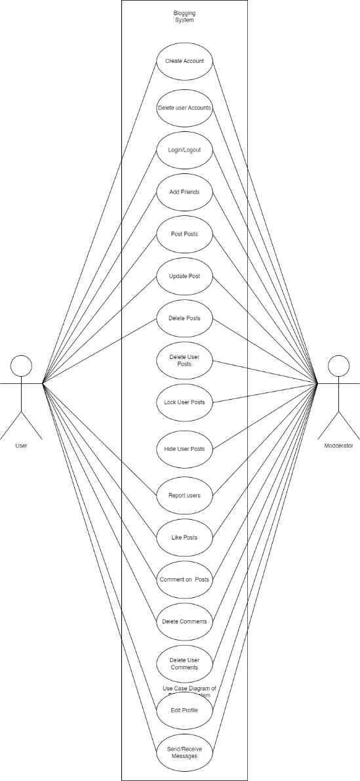

Figure 1: Use Case Diagram of online portal System.

### **3.1.1.2. Non-**Functional Requirement

1. Portability: Our system platform independent system so it can run in any browser.
2. Security: There is a high security in keeping the information of user and transaction of money.
3. Backup: Incase of system failure there is database which will store all the information about all the client.
4. User friendly: Our system is user friendly, it can be easily use and understand by user.

**3.1.2. Feasibility Analysis**

A feasibility study aims to objectively and rationally uncover the strengths and weaknesses of an existing business or proposed venture, opportunities and threats present in the natural environment, the resources required to carry through, and ultimately the prospects for success.

### 3.1.2.1. Technical Feasibility

Since the project is design with PHP as code behind and MySQL as backend it is easy to install in the systems whenever needed. It is more efficient, easy and user friendly to understand by almost everyone. Huge amount of data can be handled efficiently using MySQL as backend. Hence this project has good technical feasibility*.*

### 3.1.2.2. Operational Feasibility

Operational feasibility pertains to the effectiveness with which the system addresses issues and capitalizes on opportunities as outlined during the system's scope definition. The project is deemed to be feasible to operate.

* The current mode of operation provides good throughput and response time.
* The organization will gain significant benefits from the proposed system.
* The resources available are used to the maximum capacity to deliver quality system on time.

### 3.1.2.3. Economic Feasibility

This seeks to assess the positive economic advantages that the proposed system will offer to the organization.

* The system is cost effective
* The efficient management of rehouses will diminish the cost of this system
* The benefits of this system will outweigh the costs.

### 3.1.2.4. Scheduling Feasibility

This seeks to assess the time that the proposed system will take to develop and implement.

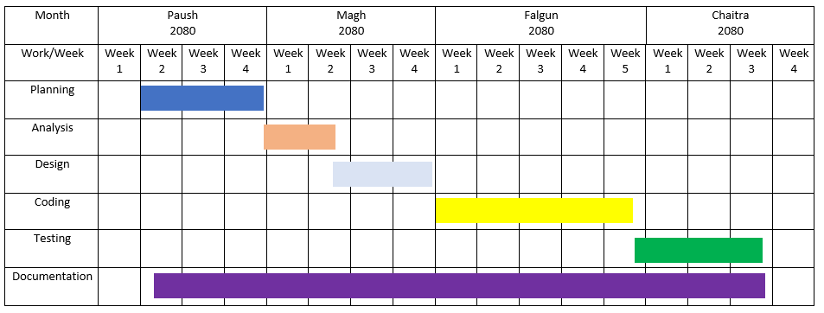

Gantt Chart

### 3.1.3**. Data Modeling (ER-Diagram)**

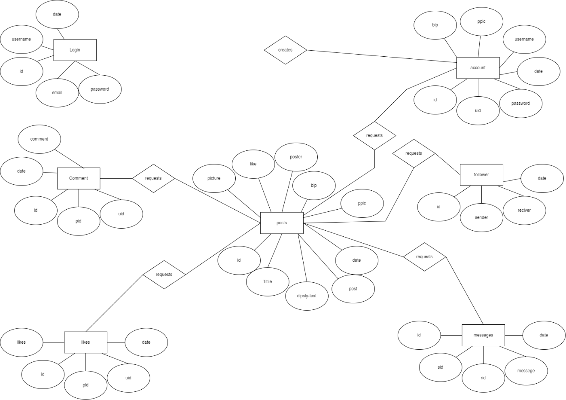

### 3.1.4. Process Modeling (DFD)

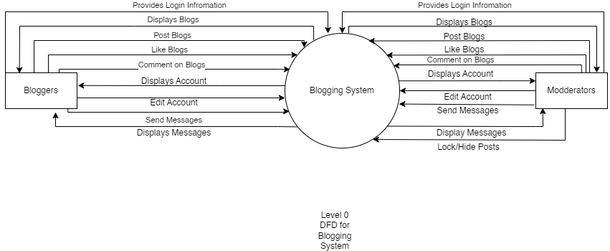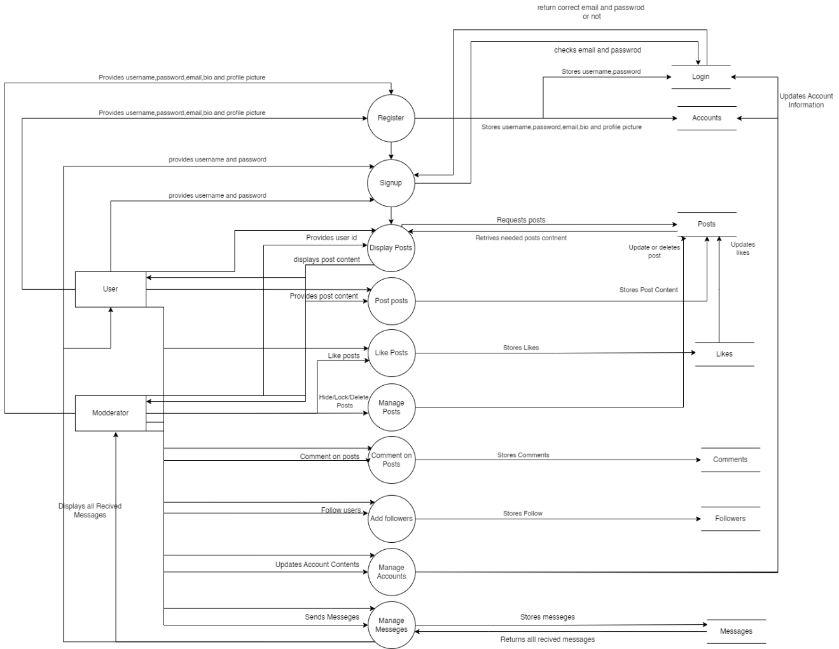

### 

### 3.2. System Design

System design is the most creative and challenging. The System Design Document describe the system requirements, Operating, system and subsystem architecture, files and database design, input formats, output layouts, human-machine interface, detailed design, processing logic, and external interface.

### 3.2.1. Architectural Design

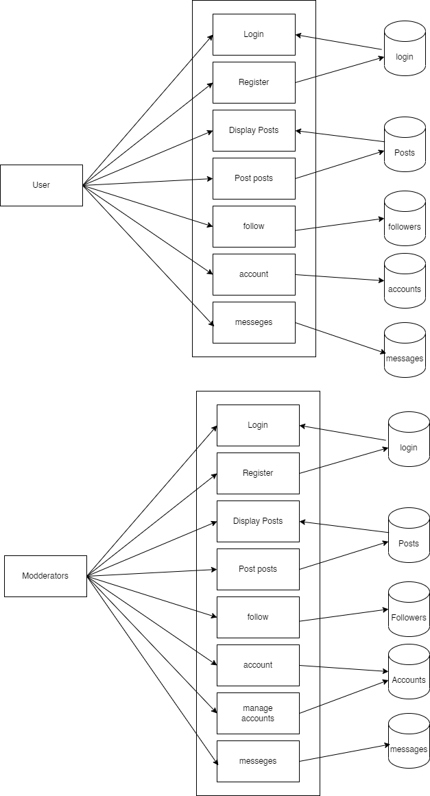

### 3.2.2. Database Schema Design

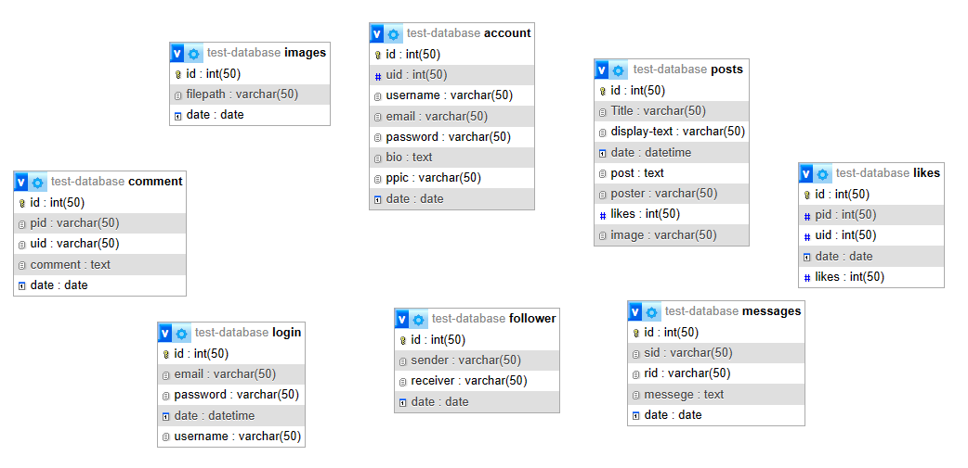

### 3.2.3. Interface Design

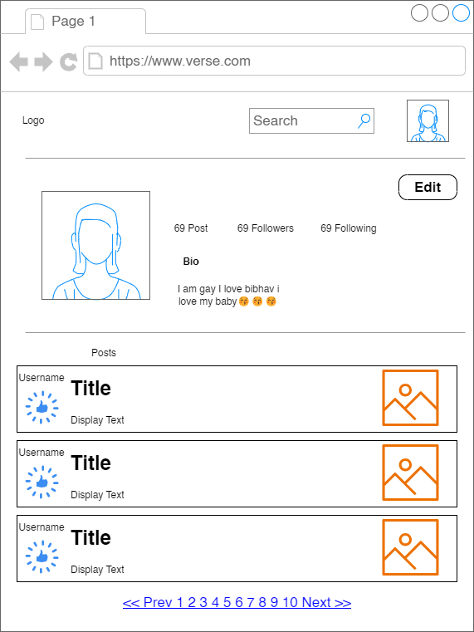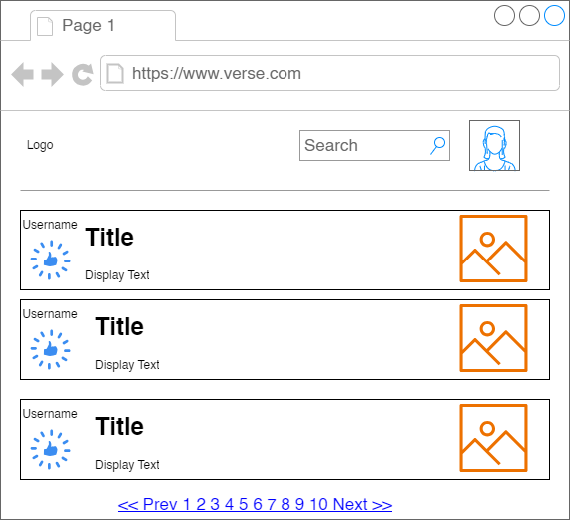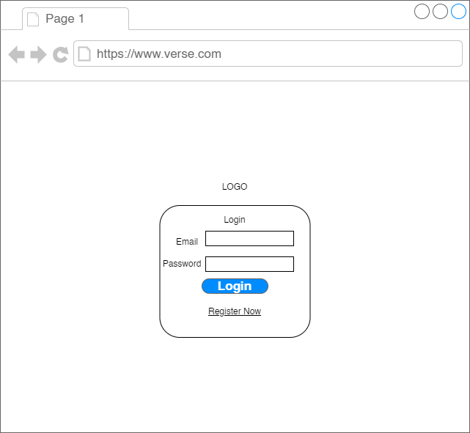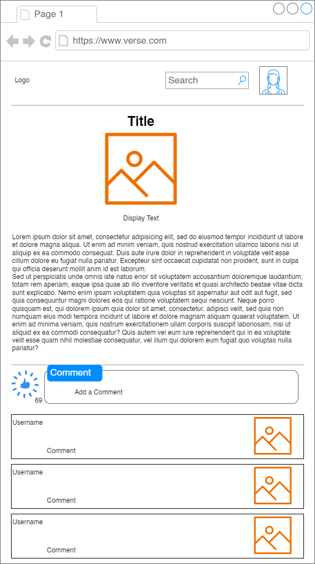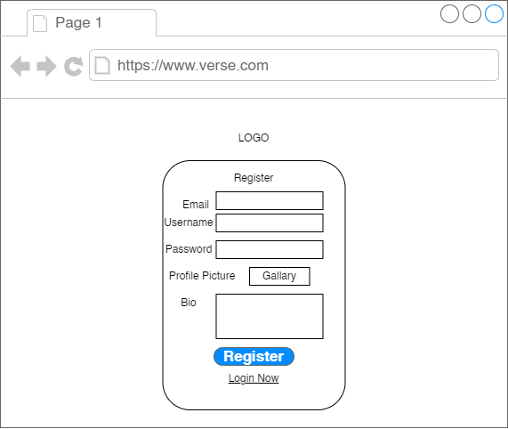

### 3.2.4. Physical DFD

# **CHAPTER 4: Implementation and Testing**

### 4.1. Implementation

The implementation phase involves the application of design specifications done before. The implementation involves coding of the system designs if this project, systems testing are live running. During implementation we start coding according to our requirement.

### 4.1.1. Tools Used

This project is developed using the tools, which are most suited for development of the PSTU web-based system. These tools are as follows:

* HTML (For develeoping the basic structure of the site)
* CSS (for designing and styling the html page)
* Javascript(for making the site more responsive and adding additional functions)
* PHP (For interacting with database)
* MYSQL (For database Storage)

### 

### 4.1.2. Implementation Details of Modules

There are various modules present in this system. They are

Login Module

The Login module facilitates the login process for registered users. The user provides their username and password which will lead them to the system.

Register Module

The Register module facilitates the registration process for new users. The user provides information such as username, email, profile picture etc.

Post Module

This module allows the user to post posts. The user provides information such as title, text image which is then stored and displayed to other users.

Display Module

This module allows the user to see the post other users have posted. This allows users to read other people's blogs

Account Module

This module allows the user to see their own account. This allows the user to change their username, password, profile picture etc.

### 4.2. Testing

The testing section is accomplished to validate the News portal System. The News Portal System is examined to test if the final system can work in keeping with what we have been waiting for and is free from any programming and logical errors. It additionally makes sure whether or not all of the system and requirements are met or not.

### 4.2.1. Test Cases for Unit Testing

Unit testing is a software program development method in which the smallest testable components of an application, know as units, are individually and independently scrutinized for correct operation. Below are the numerous tables for distinctive test case.

Table 1: Test case 1 Register

|  |  |  |  |  |
| --- | --- | --- | --- | --- |
| **S.N** | **Test Case** | **Input** | **Expected Outcome** | **outcome** |
| 1 | Navigate to Register page | Path: http://localhost/codes/4th%20sem/unit-2-php/test/test-register.php | Register page should open | As expected i.e. Member is navigated to register in page of system |
| 2 | Provide own details | Email, username, password, profile picture, bio | Credential should be entered | As expected |
| 3 | Click register Button | Button clicked | User should be registerd | As Expected |

Table 2: Test case for login

|  |  |  |  |  |
| --- | --- | --- | --- | --- |
| **S.N** | **Test Case** | **Input** | **Expected Outcome** | **outcome** |
| 1 | Navigate to Login page | Path: http://localhost/codes/4th%20sem/unit-2-php/test/test-login.php | Login page should open | As expected i.e. Member is navigated to login page of system |
| 2 | Provide details | Email and password | Credential should be entered | As expected |
| 3 | Click login Button | Button Clicked | User should log in | User is logged in |
| 4 | Provide wrong email | Wrong email and password | Credential should be entered | As expected |
| 5 | Navigate to register page | Link to go to register page is clicked | Register page should open | As expected i.e. Member is navigated to register page of system |
| |  |  |  |  |  | | --- | --- | --- | --- | --- | | **S.N.** | **Test Case** | **Input** | **Expected output** | **Output** | | **1** | **Navigated from login page** | **Button click ed** | **Redirected to display page** | **As expected** | | **2** | **Search for blogger** | **Blogger username** | **Failure** | **Not redirected to user** | | **3** | **Like post** | **Button clicked** | **Blogged like** | **As expected** | | **4** | **Redirected to test display page** | **Title clicked** | **Redirected to display page** | **As expected** | | | | | |

|  |  |  |  |  |
| --- | --- | --- | --- | --- |
| **S.N.** | **Test case** | **Input** | **Expected Outcome** | **Output** |
| **1** | **Redirected from test case** | **Button clicked** | **Success** | **As expected** |
| **2** | **Like post** | **Button clicked** | **If previously like unlike and vise versa** | **As expected** |
| **3** | **Display comments** |  | **Comment should be displayed** | **As expected** |
| **4** | **Post comments** | **Comment text** | **Comment should be posted** | **As expected** |
|  |  |  |  |  |

### 4.2.1. Test Cases for system Testing

System Testing is a from of software testing that is executed on a complete integrated system to assess the compliance of the system with the corresponding requirements.

|  |  |  |  |  |
| --- | --- | --- | --- | --- |
| Sn | Test Case | **Test Data** | **Expected Outcome** | **outcome** |
| 1 | Check Register | Username, password, email  Profile picture, bio | User register | As expected |
| 2 | Check Login | Email, password | User login | As expected |
| 3 | Check display |  | Displays posts of all followed people | As expected |
| 4 | Check Posts | Title, display text, actual text, image | Post created and saved | As expected |
| 5 | Like posts | Button clicked | Post liked if unliked before, unliked if liked before | As expected |
| 6 | Find other users | username | Redirected to searched user account | failure |
| 7 | Comment on post | Comment text | Comment added | As expected |

# **5. Conclusion and Future Recommendations**

## **5.1. Lesson Learnt**

In creating the online blogging system, we've learned some important lessons. First, listening to users and making changes based on their feedback is crucial for improving the platform. Second, ensuring accessibility for all users, including those with disabilities, is essential. Third, having effective tools for content moderation helps maintain a positive community atmosphere. Lastly, staying adaptable and keeping up with trends is key for the platform's success in a fast-changing digital world.

## **5.2. Conclusion**

## In conclusion, the development of an online blogging system represents a significant opportunity to harness the power of digital technology for creative expression, information sharing, and community building. By providing users with user-friendly platforms to publish content, interact with audiences, and explore diverse topics, online blogging systems empower individuals and organizations to amplify their voices and connect with others on a global scale. While challenges such as content moderation, monetization, and accessibility remain, the evolving landscape of blogging continues to offer exciting possibilities for innovation and collaboration. As we move forward, it is essential to prioritize user experience, inclusivity, and ethical practices to ensure that online blogging systems continue to thrive as vibrant and valuable tools for communication and engagement in the digital age.

## **5.3. Future Recommendations**

As the Project comes up with some limitation which can be improved in future and further more advancement can also be made. The different features that can be added are as follows:

* Videos should also be able to be uploaded
* Live support should be enabled.

# References

|  |  |
| --- | --- |
| [1] | R. Blood, 7 september 2000. [Online]. Available: http://www.rebeccablood.net/essays/weblog_history.html. [Accessed 15 2 2024]. |
| [2] | S. Herring, L. Scheidt, S. Bonus and E. Wright, "Bridging the Gap: A Genre Analysis of Weblogs," January 2004. [Online]. Available: https://www.researchgate.net/publication/261299701_Bridging_the_Gap_A_Genre_Analysis_of_Weblogs. [Accessed 12 2 2024]. |
| [3] | A. Java, X. Song, T. Finin and B. Tseng, "Why We Twitter: Understanding Microblogging," 12 August 2007. [Online]. Available: https://ebiquity.umbc.edu/_file_directory_/papers/369.pdf. [Accessed 1 March 2024]. |
| [4] | B. A. Nardi, D. J. Schiano, M. Gumbrecht, L. Swart and L. Swart, "Why we Blog," 1 December 2004. [Online]. Available: https://dl.acm.org/doi/pdf/10.1145/1035134.1035163. [Accessed 18 2 2024]. |
| [5] | B. Tancer, "Click," 2 September 2008. [Online]. Available: https://archive.org/details/clickwhatmillion0000tanc. [Accessed 1 March 2024]. |