

**Tribhuvan University**

**Faculties of Humanities and Social Sciences**

**PERSONAL FINANCE MANAGEMENT SYSTEM**

**A PROJECT PROPOSAL**

**Submitted to**

**Department of Computer Application**

**Ratna Rajyalaxmi College**

**Exhibition Road, Kathmandu**

***In partial fulfillment of the requirements for the Bachelors in Computer Application***

**Submitted by**

Aashutosh Khadka

Preshuk Luitel

February, 2025

**TABLE OF CONTENTS**

1. INTRODUCTION 1

2. PROBLEM STATEMENT 2

3.OBJECTIVES 3

4.METHODOLOGY 4

4.1. Requirement Identification 4

4.1.1. Study of Existing System 4

4.1.2. Requirement Collection 5

4.2. Feasibility Study 6

4.2.1. Technical 6

4.2.2. Operational 7

4.2.3. Economic 7

4.3. High Level System Design 8

4.3.1. System Flowchart 8

5.GANTT CHART 9

6.EXPECTED OUTCOME 10

7.REFERENCES 11

**TABLE OF FIGURES**

Figure 1: System Flowchart of Music Streaming Platform 7

Figure 2: Gantt Chart of Music Streaming Platform 8

# INTRODUCTION

Our finance management system is thoughtfully designed to help individuals efficiently track and manage their expenses, while also providing insightful data to make informed financial decisions. The system allows users to easily log their transactions, categorizing them into relevant groups such as food, shopping, bills, entertainment transportation, education and health. This makes it simpler to understand exactly where your money is going and helps highlight areas for improvement.

One of the key features of the system is its use of budget forecasting. By analyzing past spending patterns, the system can predict future expenses, giving users a clearer picture of what to expect financially. This forecasted data empowers users to make smarter decisions, enabling them to plan their finances more effectively and ensure they stay within their desired budget.

Furthermore, the system includes a fraud detection mechanism, which plays a vital role in ensuring the security of users' financial data. By identifying unusual or irregular spending behavior, the system can quickly flag potentially fraudulent activity, providing an extra layer of protection and peace of mind.

With user-friendly interface, the system integrates intelligent automation to make financial management as simple and efficient as possible. It encourages users to adopt better spending habits and promotes a proactive approach to managing personal finances. Whether you're looking to save more, reduce unnecessary spending, or simply stay on top of your expenses, this system is here to help you make smarter financial choices and work toward your financial goals with ease.

# 2. PROBLEM STATEMENT

Many finance apps out there are either too complicated or rely too much on automation, like pulling in transactions from banks or parsing SMS, which can be frustrating or not always accurate. For users who prefer to have full control over their finances and enter their expenses manually, these apps often feel overwhelming or confusing. There’s also the issue of inaccurate expense categorization, where users have to spend time fixing mistakes.

* Complicated Interfaces – Too many features that make tracking expenses harder than it should be.
* Incorrect Categorization – Transactions often end up in the wrong categories, requiring more effort to fix.
* No Predictive Budgeting – It’s tough to plan for future spending based on past habits.
* Limited Fraud Protection – There’s no easy way to catch suspicious spending patterns.

Our Finance Management System is designed to address these problems by giving users an easy and simple way to manually enter their expenses, automatically categorize them accurately, forecast budgets based on their spending patterns, and even spot unusual spending—all without unnecessary complexity. It’s all about making finance management simple and accessible.

# 3.OBJECTIVES

To solve the problems users, face with existing finance apps, our Finance Management System will:

* Give Users Full Control Over Their Expenses – We’ll focus on manual entry, so users can input their expenses exactly as they happen, without relying on automated systems that may not always be accurate. This way, users have the confidence that their data is correct and under their control.
* Make Expense Tracking Simple and Smart – The system will automatically categorize expenses, so users won’t have to worry about sorting every transaction themselves. It will also help users forecast their budgets based on what they’ve spent in the past, making it easier to plan for future expenses without the guesswork.
* Ensure It's Easy and Safe to Use – We want the app to be as simple as possible, with a clean interface that anyone can navigate. Plus, we’ll make sure that user data is protected, so people can feel secure knowing their financial information is safe while using the system.

With these solutions, our goal is to make finance management straightforward, secure, and accessible to everyone—without adding any unnecessary complexity or hidden costs.

# 4.METHODOLOGY

## 4.1. Requirement Identification

Secondary Sources of data collection was the primary method to gather requirements for the project. This has led to us finding useful requirements for the system.

### 4.1.1. Study of Existing System

Most finance management apps today come with a lot of unnecessary features and rely too much on automation, like bank syncing or SMS parsing. While this might be convenient for some, it’s not always accurate, and users who prefer manual control over their expenses often find these apps frustrating. Many also have complicated interfaces, making it harder than it should be to track spending.

Another big issue is inaccurate expense categorization, where transactions often end up in the wrong category, forcing users to correct them manually. Budgeting tools in these apps mostly focus on past spending rather than helping users plan ahead. On top of that, many apps charge high subscription fees, making finance tracking expensive when it should be simple and accessible.

Security is also a concern, as some platforms store sensitive financial data on external servers, raising privacy risks. With all these challenges, there’s a need for a simple, manual-entry-based finance management system that gives users full control, is easy to use, and doesn’t come with unnecessary costs or complex automation.

**Problems of Existing System**

* Over-Reliance on Automation – Many apps depend on bank syncing or SMS parsing, which may not be accurate or suitable for users who prefer manual control.
* Complex Interfaces – Too many unnecessary features make finance tracking overwhelming instead of simple.
* Inaccurate Expense Categorization – Automated systems often misclassify transactions, requiring users to correct them manually.
* Limited Budget Planning – Most apps focus on tracking past expenses rather than helping users forecast future spending.
* Security and Privacy Risks – Some apps store sensitive financial data on external servers, raising concerns about data protection.
* Lack of Personalization – Users have limited flexibility to customize their expense categories or budgeting methods according to their needs.

**Advantages of Proposed System**

To overcome the limitations of existing finance management apps, our Finance

Management System offers the following advantages:

* Full Manual Control – Unlike automated systems, users have complete control over their expense tracking, ensuring accuracy and transparency in their financial records.
* Simplified Expense Categorization – The system automatically categorizes expenses based on user-defined preferences, reducing the hassle of sorting transactions manually.
* Accurate Budget Forecasting – By analyzing past spending patterns, the system provides smart budget predictions to help users plan their finances effectively.
* User-Friendly Interface – The application is designed with a clean and simple UI, making it easy for users of all technical levels to navigate.
* Privacy & Security – Since the system does not rely on external bank syncing, users' financial data remains secure and private, reducing risks associated with third-party access.

### 4.1.2. Requirement Collection

To develop our Finance Management System, we started by carefully analyzing the challenges users face with existing finance tracking apps. Our goal was to create a simple, user-friendly, and efficient system that gives users full control over their finances without unnecessary automation. To ensure we built something truly useful, we gathered insights using different methods:

* Literary Analysis – We researched existing finance management solutions to understand their strengths and weaknesses. This helped us refine our objectives and address the shortcomings of current systems.
* Observation – We explored various budgeting and expense-tracking apps to identify common trends and user pain points. By studying how people manage their finances, we shaped a system that meets real-world needs.
* Brainstorming – Through team discussions, we generated creative ideas and refined the system’s features. This process helped us prioritize simplicity, accuracy, and security in our approach.

## 4.2. Feasibility Study

The analysis of feasibility has concluded that the project is feasible with respect to time and cost. The technology used to develop are almost Open Source, therefore less cost for implementation and maintenance will be involved.

### 4.2.1. Technical

The implementation of the system is adaptable to a range of current technologies and is designed to integrate with any future technologies that may be introduced.

* Hardware Requirement

Processor: 800MHz Intel Pentium III or equivalent or new

Disk space: 50MB or more

RAM: 128MB or more

* Software Requirement

Operating System: Windows (7 or more)

Web Browser: IE 10 or above, Mozilla FF and above or Google Chrome

* Language used:

### 4.2.2. Operational

Operational feasibility assesses how well our Finance Management System solves the problems identified and enhances financial tracking for users. From an operational perspective, the system is well-structured and practical.

* User-Friendly and Efficient – The system ensures a smooth experience by allowing manual entry while incorporating smart automation for categorization and budgeting.
* Practical Benefits – Users gain better financial awareness and control over their spending habits without relying on automated bank syncing or external data sources.
* Optimized Resource Use – The system is developed with efficient coding practices, ensuring fast performance and reliability within the given development timeline.

### 4.2.3. Economic

This section evaluates the economic benefits the proposed system will bring to the organization.

* The system offers cost-effectiveness.
* The streamlined resource management will lower the overall system cost.
* The advantages provided by the system will significantly outweigh its costs.

## 4.3. High Level System Design

### 4.3.1. System Flowchart

The system flowchart of music streaming platform is shown as follows:

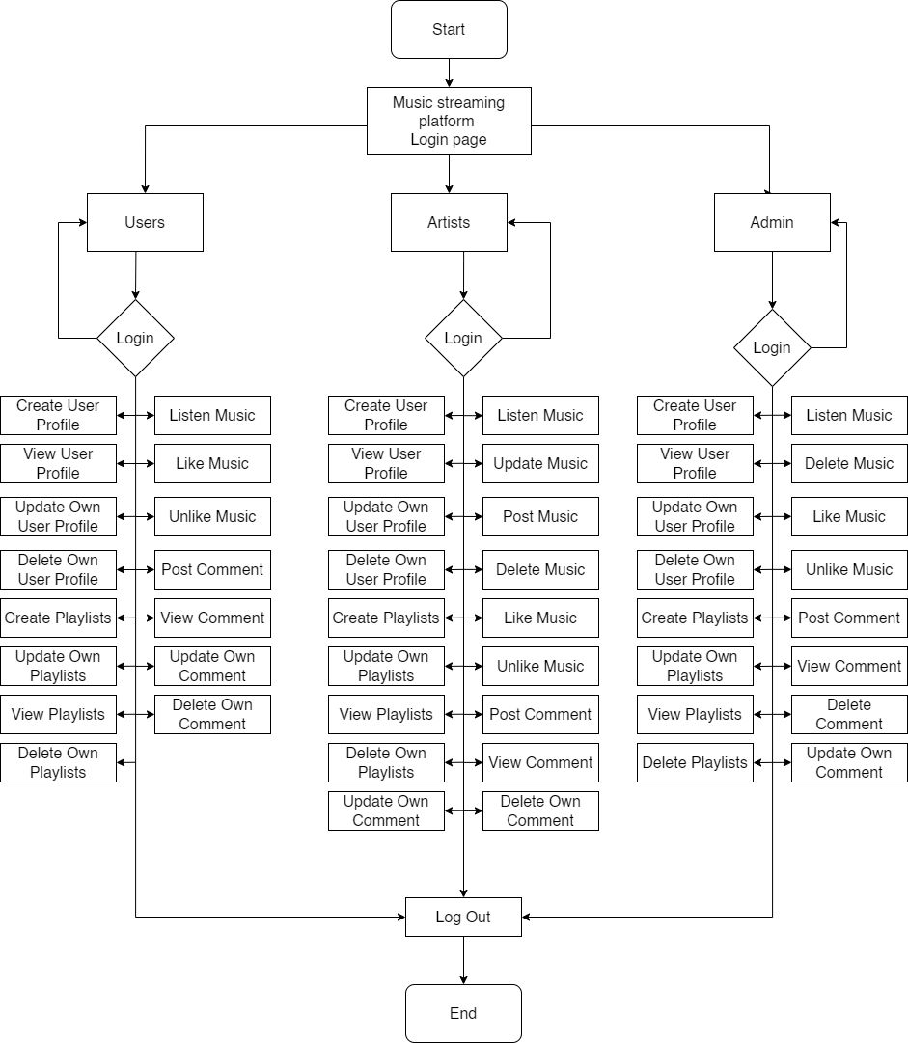

# Figure 1: System Flowchart of Music Streaming Platform

# 5.GANTT CHART

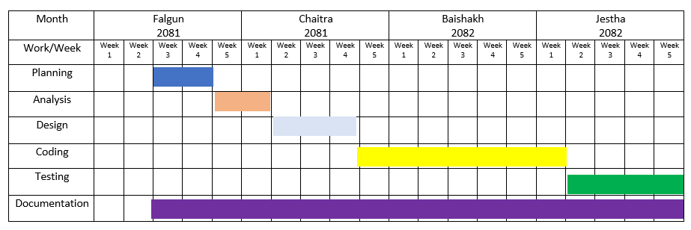

# Figure 2: Gantt Chart of Music Streaming Platform

The project is scheduled to commence in the third week of Falgun 2081, beginning with the Planning phase. This phase will last for one week, establishing a structured foundation for subsequent stages. Following this, the Analysis phase will take place from the fourth week of Falgun to the first week of Chaitra 2081, during which the system’s requirements will be thoroughly examined and defined.

Upon completion of the analysis, the project will proceed to the Design phase, spanning from the second to the fourth week of Chaitra 2081. During this stage, the system’s architecture, interface, and database structure will be developed to ensure a coherent and functional design.

The Coding phase will begin in the first week of Baishakh 2082 and continue through the entire month. This stage will focus on implementing the system based on the established design. Once the coding phase is completed, the Testing phase will commence in the second week of Jestha 2082, ensuring system reliability and functionality.

In parallel, the Documentation process will be conducted continuously, beginning in the third week of Falgun 2081 and extending through the end of Jestha 2082. This will ensure comprehensive records of each phase of development, facilitating future maintenance and improvements.

By the conclusion of Jestha 2082, the project is expected to be fully developed, tested, and documented, ready for deployment or further refinement.

# 6.EXPECTED OUTCOME

Once the Finance Management System is up and running, we expect it to bring some key benefits that will make managing finances easier and more intuitive for users:

* Simple and Easy-to-Use: Users will be able to track their expenses effortlessly by manually entering their data, categorizing their spending, and setting up budgets without feeling overwhelmed.
* Smooth and Responsive: Whether on a phone, tablet, or computer, the system will work seamlessly across all devices, making it easy to access and use anytime, anywhere.
* Better Financial Insights: With features like budget forecasting and fraud alerts, users will have a clearer understanding of their spending habits, helping them make smarter financial decisions.

# 7.REFERENCES