

**Prepared by Webdunia**

***Version – V1.0***

Webdunia (India) Pvt. Ltd.

Labh Ganga 582, M G Road

Indore 452 003

Madhya Pradesh, INDIA

Tel: +91-731-4273409  
Web: [www.webdunia.net](http://www.webdunia.net)

www.webdunia.com

**Statement of Work**

**For**

**Patient-Frontend**

**(LiveProject)**

# OBJECTIVE

The document is prepared and presented to share my contribution to the patient front end project

## Background

The tasks performed related to this project were given to me by Sir Hardik.

## Contact

Name : Sooraj Dube

Email: [soorajdube.is@gmail.com](mailto:soorajdube.is@gmail.com)

Phone no. :- 9425057088

# CORE OBJECTIVE OF ENGAGEMENT

# SCOPE OF WORK

* The Scope of work incorporates adding email templates to the web application so that replying to the customers becomes easier and fast



# TASKS

* **Setting up the project on windows machine.**
  + Setting up front-end that is the “Admin user front end”.
    - Steps provided in the read-me file are as follows:
      * 1. Under app/scripts/core/config/parameters, copy the file `local.sample.js` to `local.js`, and modify the settings to match your setup.
      * 2. Install dependencies

npm install

* + - * 3. Install bower globally

sudo npm install -g bower

* + - * 4. Run bower installation

bower install

* + - * 5. Install grunt globally.

sudo npm install -g grunt grunt-cli

* + - * 6. Serve application on port 9000.
    - **If the above steps do not create the component folder for angular in the app directory and the app doesn’t work as desired then follow these troubleshooting steps.**
      * 1. Create a resolution property in bower.json and add all the versioning that are provided in the dependency property before the devdependencies

Like this:

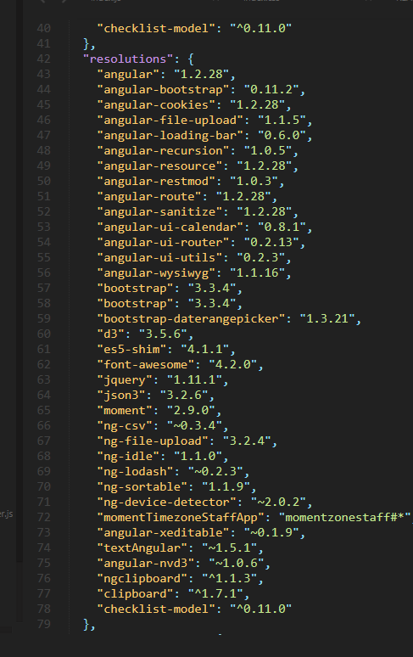

* + - * 2. Now run “ bower update ” to update all the packages
      * 3.This will probably create the components folder in the app directory and the app will run as desired.
      * 4.If this still somehow does not work then download the bower.json file from the link below.
        + **https://drive.google.com/file/d/1hT-O1NRWm4V58lKWGSNMUGAkrFW3bjef/view?usp=sharing**
      * Now run “ bower update
  + Setting up patient-front-end.
    - Steps provided in the read-me file are similar as above.
    - Follow same procedure as above for troubleshooting .
    - Note some exception:
      * Bower-components folder will be created in the root directory.
      * Link for bower.json file is:
        + <https://drive.google.com/file/d/15oWPb7ScPgdM6XIgIsPo_blUJHMcz5Uf/view?usp=sharing>
* **Add Email templates to the application**
  + **Objectives of the task**
    - Add a dropdown on the attempted contact page when general contact is selected as Email.
    - Options in the drop down should only contain templates which are attached to that particular issue.
    - Clicking on the templates should add the message attached to the template on the textbox given for reply.
    - Label should also be provided to every template.
    - Create an easy method to add new templates that can be compatible with JSON.
  + **Source code and explanation for the above objectives:**
    - Changes in “attempted-contact.html”
      * Added a select tag which cycles through every issue and displays the templates for the currently opened issue.
      * Also when the issue is found the array of templates for the particular issue is cycled and each template is displayed as a option.
      * When the options are changed the reply body of the text area also changes according to the value in the ng-model.
      * The ng-model value is assigned by the message corresponding to the reply template selected.
      * Refer the code below.

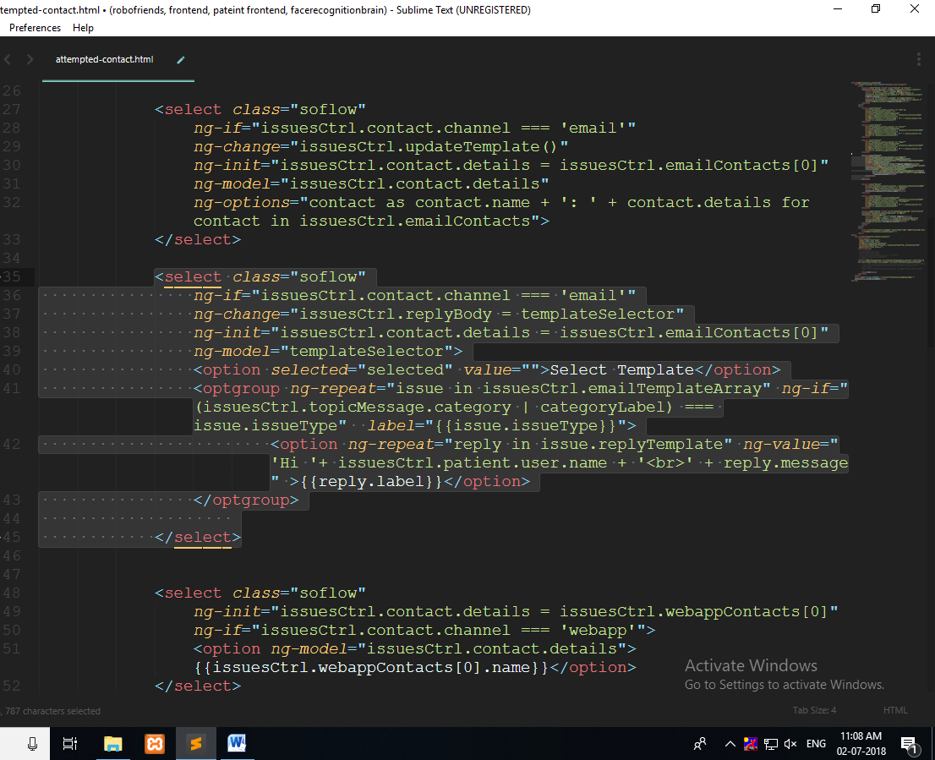

* + - Changes in “issuesController.js”
      * First an empty array of objects is initialized. This will contain all the issues and their corresponding templates.
      * A “templateLabel” object initialized with the label name and their corresponding message. If you want to add another label then add to this object by specifying the name of the label as property name(Enclosed in quotes) and then the message.
      * Refer the code below.

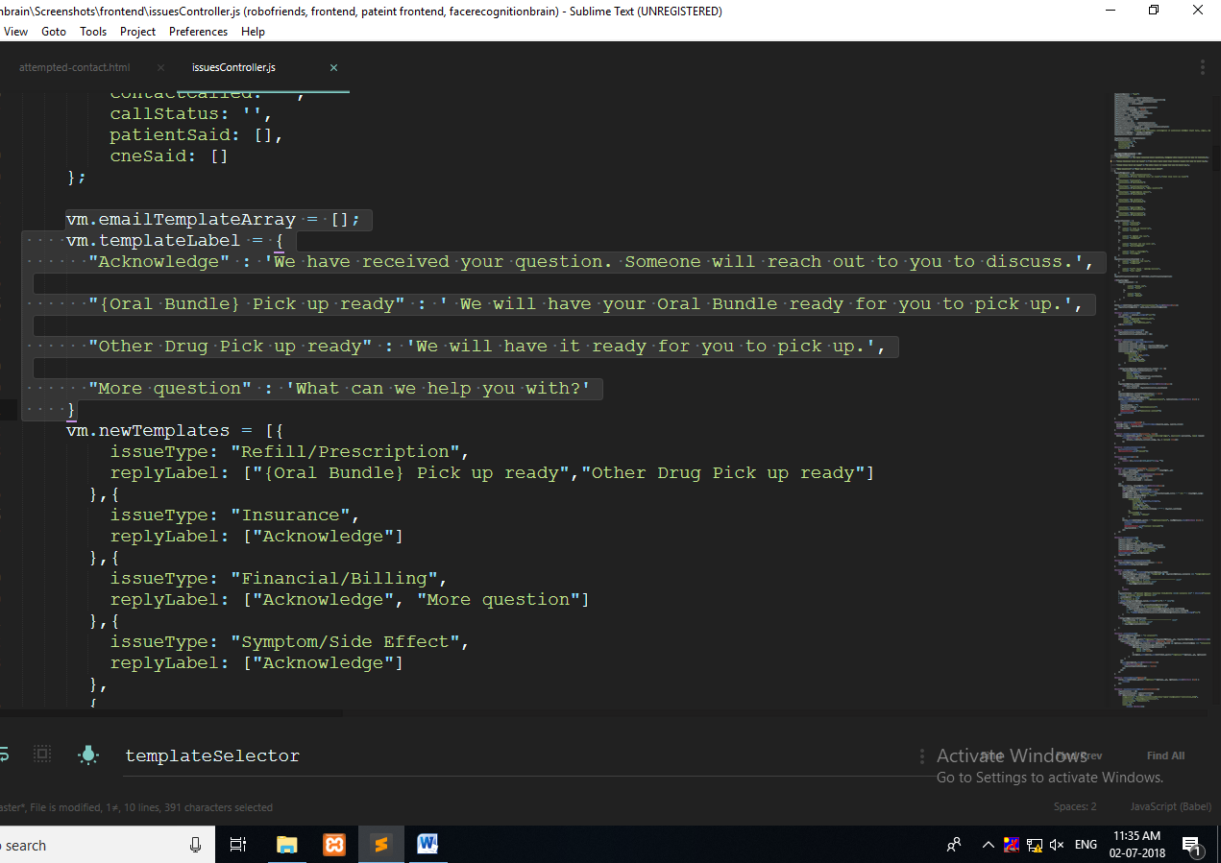

* A newTemplates array of objects is initialized which contains objects of two properties, issueType and replyLabel. To add a new template to a particular issue add the issue name in the issueType property and the message by specifying the reply label corresponding to the message from the templateLabel object.
* Add the reply label as array of strings to the replyLabel property this way you can specify multiple templates for a particular issue quickly and easily.
* Refer the code below.

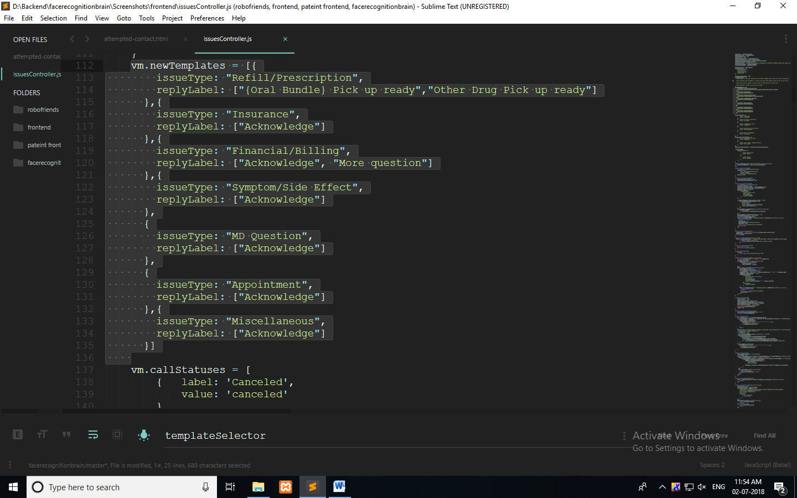

* The emailTemplateArray is initialized for each issue in the categories function after all the categories are fetched.
* Then the insertTemplate function is called by passing the newTemplates array to insert the templates to the issue.
* Refer the code below.

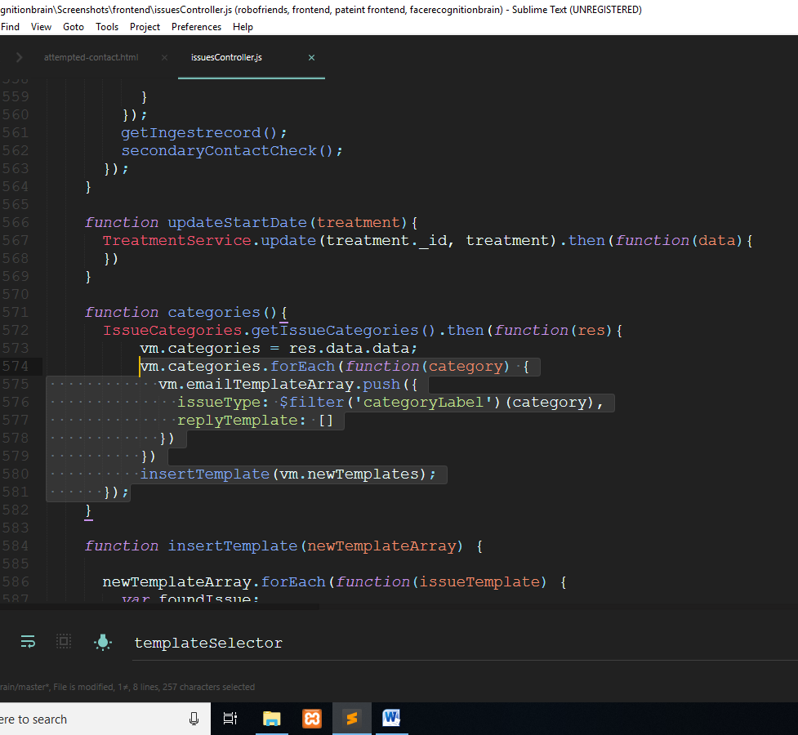

* The source code for the insert template function is given below.
* There is no need to make any changes in the function for insertion only make changes in the array and the object described above.

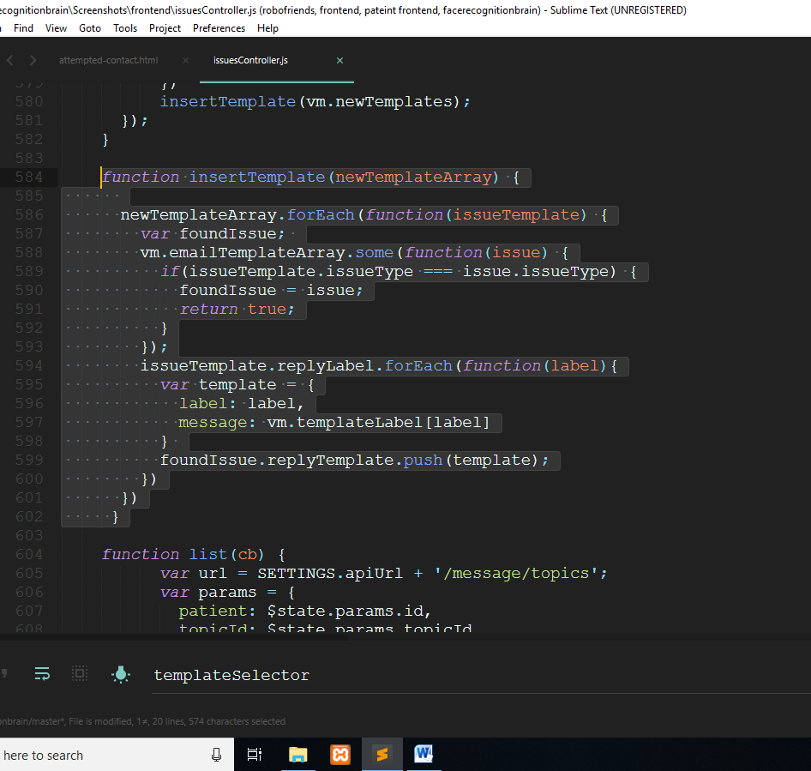

# TECHNOLOGY

|  |  |
| --- | --- |
| **S.No.** | **Technology** |
| 1 | AngularJS |
| 2 | JavaScript |

# DELIVERABLES

* + Source code