

**Prepared by Webdunia**

***Version – V1.0***

Webdunia (India) Pvt. Ltd.

Labh Ganga 582, M G Road

Indore 452 003

Madhya Pradesh, INDIA

Tel: +91-731-4273409  
Web: [www.webdunia.net](http://www.webdunia.net)

www.webdunia.com

**Statement of Work**

**For**

**Patient-Frontend**

**(LiveProject)**

# OBJECTIVE

The document is prepared and presented to share my contribution to the patient front end project

## Background

The tasks performed related to this project were given to me by Sir Hardik.

## Contact

Name : Sooraj Dube

Email: [soorajdube.is@gmail.com](mailto:soorajdube.is@gmail.com)

Phone no. :- 9425057088

# CORE OBJECTIVE OF ENGAGEMENT

# SCOPE OF WORK

* The Scope of work incorporates adding email templates to the web application so that replying to the customers becomes easier and fast



# TASKS

* **Setting up the project on windows machine.**
  + Setting up front-end that is the “Admin user front end”.
    - Steps provided in the read-me file are as follows:
      * 1. Under app/scripts/core/config/parameters, copy the file `local.sample.js` to `local.js`, and modify the settings to match your setup.
      * 2. Install dependencies

npm install

* + - * 3. Install bower globally

sudo npm install -g bower

* + - * 4. Run bower installation

bower install

* + - * 5. Install grunt globally.

sudo npm install -g grunt grunt-cli

* + - * 6. Serve application on port 9000.
    - **If the above steps do not create the component folder for angular in the app directory and the app doesn’t work as desired then follow these troubleshooting steps.**
      * 1. Create a resolution property in bower.json and add all the versioning that are provided in the dependency property before the devdependencies

Like this:

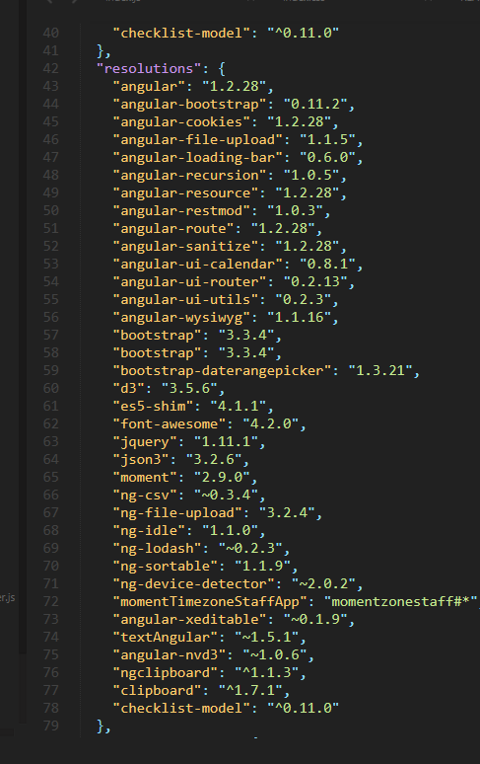

* + - * 2. Now run “ bower update ” to update all the packages
      * 3.This will probably create the components folder in the app directory and the app will run as desired.
      * 4.If this still somehow does not work then download the bower.json file from the link below.
        + **https://drive.google.com/file/d/1hT-O1NRWm4V58lKWGSNMUGAkrFW3bjef/view?usp=sharing**
      * Now run “ bower update
  + Setting up patient-front-end.
    - Steps provided in the read-me file are similar as above.
    - Follow same procedure as above for troubleshooting .
    - Note some exception:
      * Bower-components folder will be created in the root directory.
      * Link for bower.json file is:
        + <https://drive.google.com/file/d/15oWPb7ScPgdM6XIgIsPo_blUJHMcz5Uf/view?usp=sharing>
* **Add Email templates to the application**
  + **Objectives of the task**
    - Add a dropdown on the attempted contact page when general contact is selected as Email.
    - Options in the drop down should only contain templates which are attached to that particular issue.
    - Clicking on the templates should add the message attached to the template on the textbox given for reply.
    - Label should also be provided to every template.
    - Create an easy method to add new templates that can be compatible with JSON.
  + **Source code and explaination for the above objectives:**

# TECHNOLOGY

|  |  |
| --- | --- |
| **S.No.** | **Technology** |
| 1 | AngularJS |
| 2 | JavaScript |

# DELIVERABLES

* + Source code