;l

Foundations of Programming

Assignment No. : 01
- PROBLEM STATEMENT:
Write a program in C to check whether a given year is a Leap Year

OBJECTIVE:

- To understand the use of conditional statements in C programming.
- To implement logical conditions for solving real-world problems.
- To develop problem-solving skills using decision control structures.

THEORY:
- Theory for conditional statements with syntax (if , if-else, if-else ladder) are used in C programming
- Theory for a Leap Year - year that contains 366 days instead of the usual 365 days.
Rules:
• A year is a leap year if it is divisible by 400, OR
• A year is a leap year if it is divisible by 4 but not divisible by 100.
- Algorithm
PLATFORM: VS code

INPUT: Enter a year (integer value).

OUTPUT: Displays whether the entered year is a Leap Year or Not a Leap Year.
Sample Input
2024
Sample Output
2024 is a Leap Year

ALGORITHM :

STEP 1 : START.

STEP 2 : Read Year.

STEP 3 : Check if the year is completely divisible by 400, if YES then Print It is a leap year.

STEP 4 : if NO then check if not divisible by 100 but still divisible by 4 then Print that it is a leap year ; else print it is NOT a leap year.

STEP 5 : STOP.

FLOWCHART :
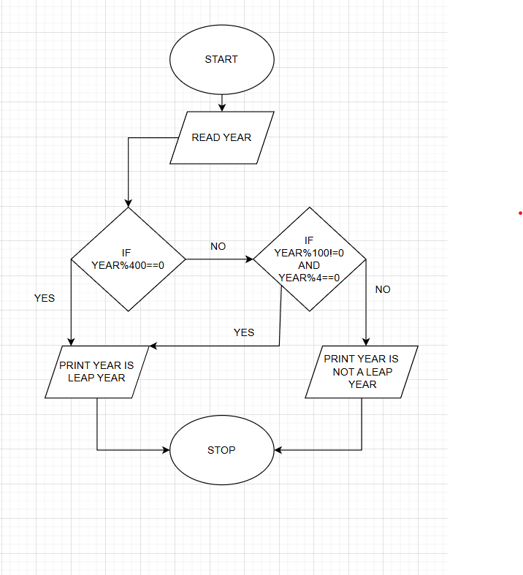
CODE :
INPUT :
#include <stdio.h>
int main()
{
int year
printf("Enter a year: ");
scanf("%d", &year);
if (year % 400 == 0)
{
printf("It is a Leap Year.");
}
else if (year % 4 == 0 && year % 100 != 0)
{
printf("It is a Leap Year.");
}
else
{
printf("It is NOT a Leap Year.");
}
return 0;
}
OUTPUT :
Enter a year: 2020
It is a Leap Year.

CONCLUSION: Thus, the program successfully checks whether a given year is a Leap Year using conditional statements in C.

FAQs:
- What is a leap year?
- Why is the year 1900 not a leap year but 2000 is?
- Which operators are used in this program?
- Difference between if and if–else statements.

