

Foundations of Programming

Lab Assignment No. : 03

PROBLEM STATEMENT:
Write a program in C to generate multiplication tables for a given number.
OBJECTIVES:
- To understand the use of looping statements in C.
- To generate multiplication tables using loops.
- To improve program logic and execution flow understanding.

THEORY:
Syntax for for loop example program
Syntax for while loop example program
Syntax for do while loop example program
ALGORITHM:
Algorithm
- Start
- Declare variables n and i
- Ask the user to enter a number
- Read the value of n
- Initialize i = 1
- Repeat until i ≤ 10
  - Calculate n * i
  - Display the result in the form n × i = result
  - Increment i by 1
- Stop

PLATFORM: VS CODE

INPUT:
Choice of operation and two numbers
#include <stdio.h>

int main()
{
int n, i;

printf("Enter a number: ");
scanf("%d", &n);

printf("Multiplication Table of %d\n", n);

for(i = 1; i <= 10; i++)
{
printf("%d x %d = %d\n", n, i, n * i);
}

return 0;
}

OUTPUT:
Enter a number: 5
Multiplication Table of 5

5 x 1 = 5
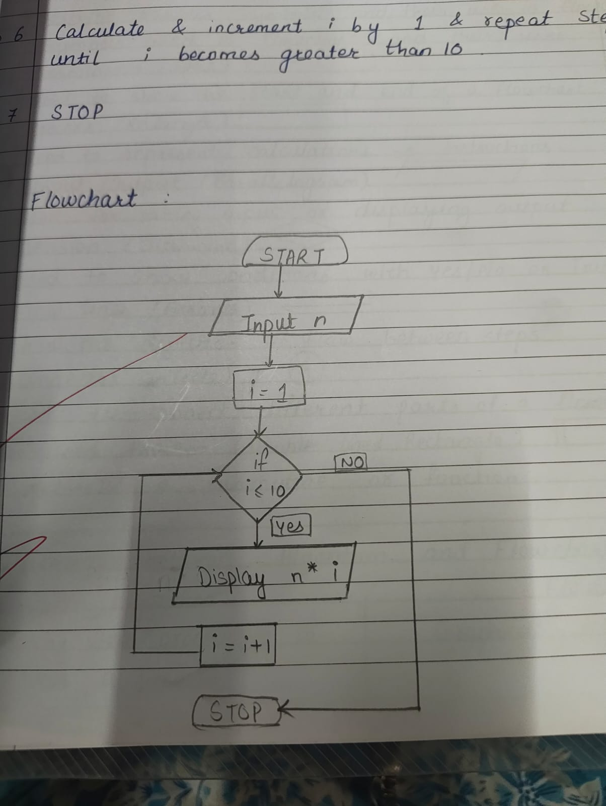
5 x 2 = 10
5 x 3 = 15
5 x 4 = 20
5 x 5 = 25
5 x 6 = 30
5 x 7 = 35
5 x 8 = 40
5 x 9 = 45
5 x 10 = 50

FAQs:
- Which loop is best suited for generating multiplication tables?
- What is the role of loop initialization?
- Difference between for loop, while loop and do while loop?
- Can a do–while loop be used to generate multiplication tables? Explain.
- Why is the do–while loop called an exit-controlled loop?

