

Foundations of Programming
Assignment No. : 13

PROBLEM STATEMENT:
Write a program in C to accept a number from the user and print the digits of the number in reverse order.

OBJECTIVE:
• To understand number manipulation using loops
. • To learn the use of modulo (%) and division (/) operators.
• To implement logic for reversing digits of a number.
• To improve problem-solving skills using iterative structures.

THEORY:
• To understand number manipulation using loops. • To learn the use of modulo (%) and division (/) operators. • To implement logic for reversing digits of a number. • To improve problem-solving skills using iterative structures.

PLATFORM:
Linux

ALGORITHM:
1. Start

2. Declare Variables
- num → to store the input number
- remainder → to store last digit
- reverse = 0 → to store reversed number

3. Input
- Read the number num from the user

4. Reverse Logic (Loop)
- Repeat while (num > 0):
  - Extract last digit:
remainder = num % 10
  - Append digit to reverse:
reverse = reverse * 10 + remainder
  - Remove last digit from number:
num = num / 10

5. Output
- Display reverse

6. Stop

FLOWCHARTL:
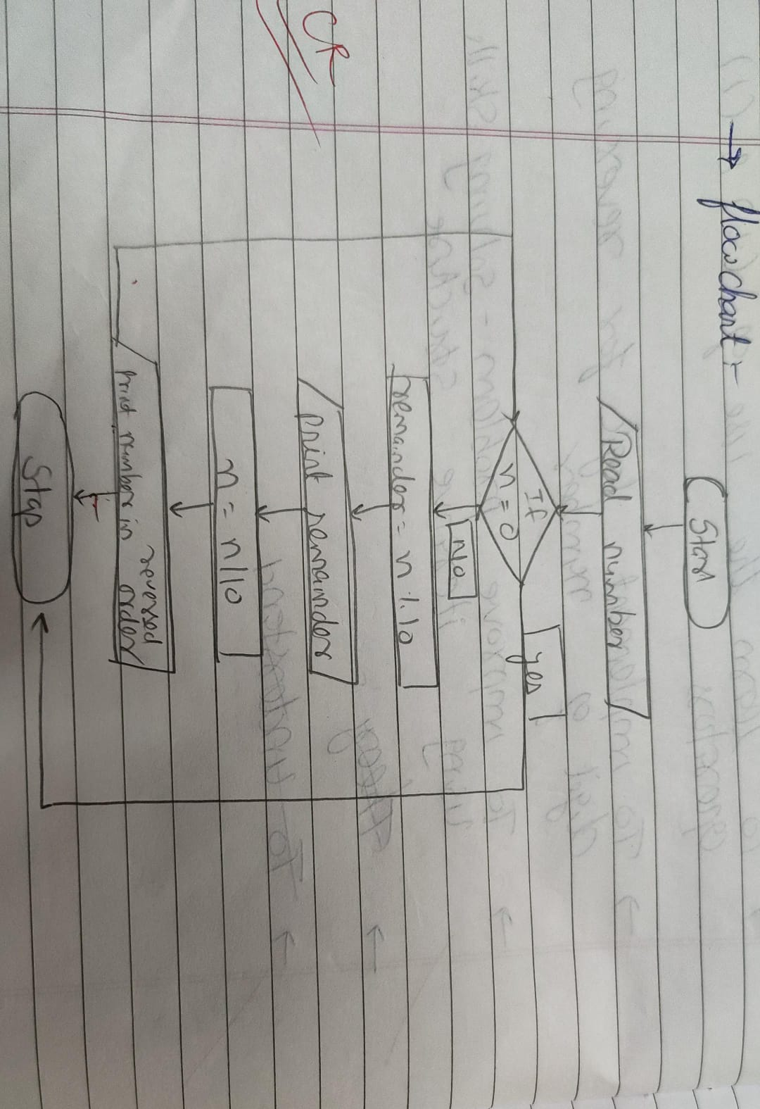

C PROGRAM:
#include <stdio.h>

int main()
{
int num,remainder;
printf("Enter a number: ");
scanf("%d", &num);
printf("The digits in reverse order are: ");
while (num != 0) {
remainder = num % 10;
printf("%d ", remainder);
num /= 10;
}
return 0;
}

INPUT:
INPUT:
The user enters an integer number.
Example Input: Number: 4567

Paste Screen Shot of Input

OUTPUT:
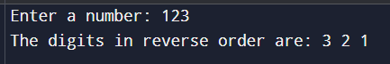
Paste Screen Shot of Output

CONCLUSION:
Thus, the program to print the digits of a number in reverse order was successfully implemented using C programming. The program demonstrates the effective use of loops, modulo operator, and division operator.

FAQs:
- Why is the modulo operator (%) used in this program?
- Why is division by 10 used after extracting each digit?
- What happens if the input number is zero?
- How will the program behave for negative numbers?
- Why is a while loop preferred for this operation?

