on this first page where it says WHO WE ARE
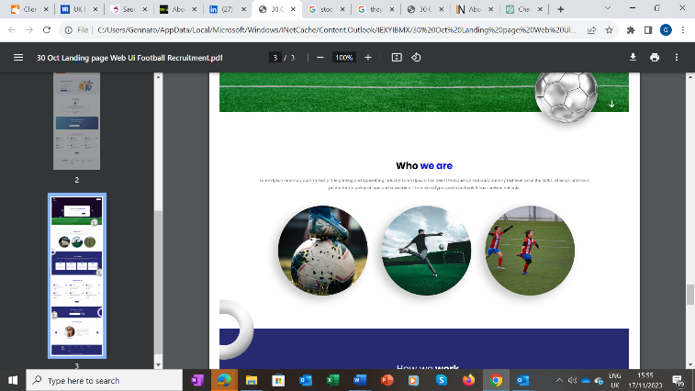
use the photo I am sending you on whatsup then put a link or a button there that shows this content BELOW:
on the side of the content put our logo then we will see how it looks

Football Recruitment: Elevating Excellence in the Football Industry Workforce.
Football Recruitment emerges as a pioneering global entity, exclusively dedicated to the meticulous recruitment of top-tier personnel within the realm of football.
Our distinguished focus extends to the executive echelons, encompassing Sporting Directors, CEOs, CMOs, CFOs, CTOs, and a spectrum of different operational roles, fortifying the foundation of football organizations worldwide.
Distinguished by an expansive international reach, Football Recruitment boasts an extensive candidate network, spanning across three continents, and maintains strategic offices in prominent hubs such as London, Rome, and New York. Our mission is to empower clients with a seamless avenue to procure talent across a myriad of football-related domains, including Sporting Directors, Recruitment Personnel, Scouting and Coaching Professionals, Sports Doctors, and an array of Medical Specialists.
The architects of Football Recruitment, brothers Gennaro and Giuseppe Capasso, bring to the fore a wealth of experience 35 years of expertise in Executive Search and Selection, spanning across two diverse sectors such as Automotive and Information Technology. This collective experience has birthed a stellar reputation and an unwavering global clientele.
Football Recruitment epitomizes a strategic ally for organizations and individuals seeking to excel within the intricate tapestry of the global football industry. Our Search and Selection Specialists, deeply rooted in the nuances of football, continuously discern what it takes to forge the path to success in this dynamic arena. With Football Recruitment, excellence is not just a goal; it's our pledge to the football world.

Where it says HOW WE WORK

HOW WE WORK
First Box – click on link –shows this content BELOW:
on the side of the content put our logo then we will see how it looks
In the realm of recruiting non-sport personnel for roles within the sports industry, our methodology is tailored to identify top-tier candidates who possess the unique skill sets and cultural fit required for success in this dynamic field. In keeping with the dynamic nature of the football industry, we remain abreast of its evolution, particularly in the realm of technology. To ensure precision and efficiency, we've devised an exceptional screening process tailored meticulously to the bespoke needs of our esteemed clientele. At Football Recruitment, we harness the cutting-edge capabilities of AI and Big Data Platforms, underpinned by Neuropsychological and Neuroscientific personal assessments. Our strategic partnerships with eminent experts in Global Sport Neuroscience and Sport Analytics fortify our commitment to delivering the most apt and qualified candidates for our clients. Moreover, we extend our engagement beyond mere recruitment, striving to nurture and optimize the potential of each candidate. Our profound understanding of the physical and cognitive demands of the football domain empowers us to guide candidates towards peak performance, both on and off the pitch.

SECOND BOX– click on link –shows this content BELOW AND ON THE LEFT OF THE CONTENT USE OUR LOGO
Extensive Network: We've cultivated an extensive network spanning various industries to identify and engage with top talent, from experienced executives to specialized professionals, ensuring a diverse pool of candidates. Leveraging data analytics and industry trends, we glean insights that aid in the identification of candidates who not only possess the requisite qualifications but also exhibit a track record of success and innovation in their respective fields.

THIRD BOX – click on link –shows this content BELOW AND ON THE LEFT OF THE CONTENT USE OUR LOGO
Strategic and Cultural Assessment: Utilizing a strategic assessment process, we delve into the qualifications, leadership capabilities, and industry-specific expertise of candidates. This involves understanding their adaptability to the unique demands of the sports industry. Recognizing the importance of cultural alignment, we assess candidates not just based on their skills but also on their compatibility with the ethos, values, and aspirations of the sports organizations they want to join.

FOURTH BOX – click on link –shows this content BELOW AND ON THE LEFT OF THE CONTENT USE OUR LOGO
Collaborative Approach: We work closely with our clients, gaining an in-depth understanding of their organizational goals, leadership style, and the specific requirements of the role. This collaborative approach ensures that our candidate recommendations are tailored to their unique needs. Our commitment extends beyond the hiring process. We provide continuous support, assisting with the onboarding process and ensuring a smooth integration of the selected candidates into the organization's culture and operations.
This refined methodology ensures that the individuals we recommend possess not only the requisite skills and experience but also the cultural fit and vision necessary to thrive within the specialized environment of the sports industry.

FIFTH BOX – click on link –shows this content BELOW AND ON THE LEFT OF THE CONTENT USE OUR LOGO
Our Recruitment Process: With 35 years of collective experience, we have designed a selection process tailor made for the world of Football utilising our Headhunting experience in over 3000 executed searches integrating World Famous Neuroscience techniques with the use of AI Tools and Big Data statistics to identify the best available and most suitable candidate on the market.
Here is how we do it.
We
Job Analysis
We identify the responsibilities, necessary skills, experience levels, and qualifications required for the job.
Creating a Job Description
We develop a clear and comprehensive job description that outlines the duties, qualifications, and competencies needed.
Sourcing Candidates
We find potential applicants using various channels like our vast network as well social media and referrals to attract candidates. We also use our own AI and Big Data Software Application developed in house that can help us identify and contact the best available candidates on the marketplace.
Screening Applications
We evaluate resumes to shortlist candidates who meet the main requirements.
Conducting Interviews
Our In-depth evaluation included interviews to assess candidates' skills, experience, and cultural fit. These interviews are also conducted by our trusted network of high-level Executives and Chief Executives and consultants employed by has because they have previously covered the role that they will be interviewing the candidate for.
Skill Assessments
We verify competencies using various tests as well as Neuropsychological and Neuroscientific personal assessments to evaluate the candidates' technical, professional, and interpersonal abilities.
Background and Reference Checks
We conduct background checks and contact references to verify candidates' employment history, qualifications, character, and performance record.
Decision Making
We selected the final shortlist by reviewing all the collected information and we select the most suitable candidates for the position, and we present it to the client. We also can sit with the client on site during the initial interview process.
Job Offer
We present the job offer to the chosen candidate, including details about salary, benefits, and other terms of employment to make sure that the candidate is happy with the opportunity available helping the negotiation process from both sides.
This process is designed to ensure that the best candidate is selected in a fair, efficient, and effective manner.

OR
YOU CAN DO IT LIKE THIS
CLICK ON
WHAT WE DO
THEN HAVE DROP DOWN MENUS ON THE SIDE
WITH OUR LOGO BELOW OR ON THE TOP LEFT OF THE PAGE
LIKE THIS

USE THIS SITE AS AN EXAMPLE FOR WHAT WE WANT
https://nolanpartners.com/
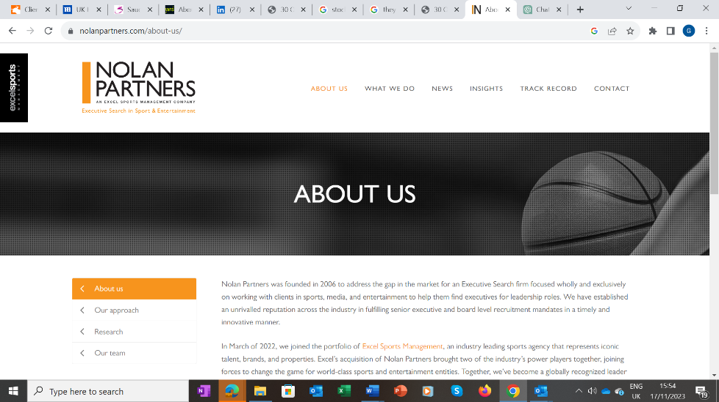
We will need to refine it and the site needs to use mainly the colours of our ogo but this is a good startying point
We will give you addresses - and telephone numbers and names etc etc to put in the correct places after you do this

Also
Then
We will look at the job - CV Page
OK ?

