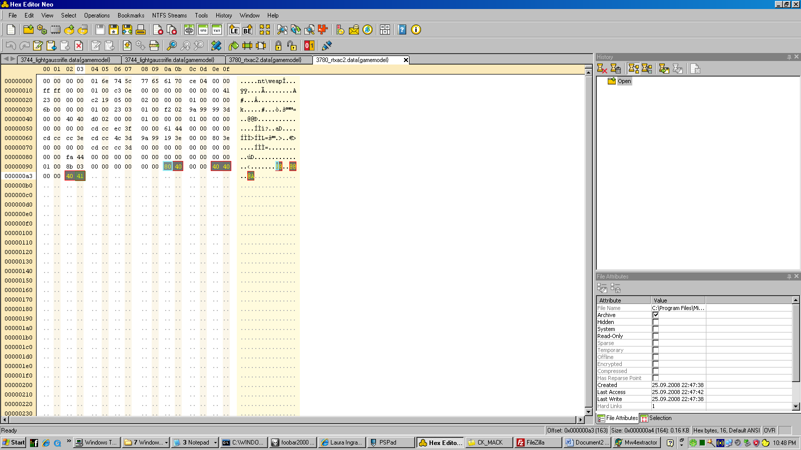

This is the gamemodel file for the RAC2. I highlighted the values that control jamming and clearing.

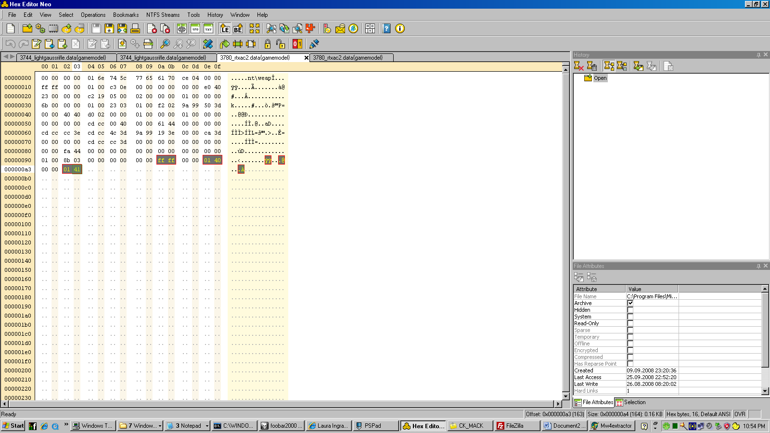

Setting the hex byte values for 9a-9b to FF FF and 9e-9f to 01 40, a2 a3 to 01 41 will make it so the RAC will never jam.

