AI Chatbot and Sentiment Analysis Deployment on Windows 11
Using WSL2 and Docker Desktop and Mongo-DB
https://github.com/HelmPurt/ai-boot.git

Just wanted to share how I set up my local DevOps environment for this challenge,
based on what I have available — might be useful if you're working in a similar situation.
My assets :
Processor : Intel(R) Core(TM) i5-10310U CPU @ 1.70GHz
CPU Cores : 4
Logical CPUs : 8
Max Clock (MHz) : 2208
Windows Version : Microsoft Windows 11
Version : 10.0.22631
Build Number : 22631
Total RAM (GB) : 15.73
Disk Size (GB) : 237.53
Disk Used (GB) : 206.18
GPU: no

My Current Setup:
- A single Windows 11 laptop, no dual boot or dedicated Linux machine
- No enterprise subscriptions or cloud credits
- No admin accounts or access to paid tooling
- So I’m relying entirely on free and open-source tools
Given that, I decided to build a hybrid environment that still gives me everything I need to work with containers,
Kubernetes, and infrastructure automation — without relying on cloud resources during development.
What I’m Using:
- PowerShell + WSL2 – Gives me both Windows-native scripting and a full Linux shell inside Windows.
- Great for switching between Azure CLI, Bash scripts, and Linux tools.
- Docker Desktop – Core container runtime, with built-in Kubernetes. Lets me test locally just like I would on AKS.
- kubectl + Helm – Standard tooling to manage and deploy apps to Kubernetes.
- Terraform – For infrastructure as code, so I can provision AKS or mock it out locally with Minikube or Kind.
- Minikube / Kind – Lightweight Kubernetes clusters that run inside Docker — ideal for simulating cloud behavior locally.
Why I Chose This:
- It’s all free and runs smoothly on a Windows-only setup
- I get a realistic cloud-native workflow without touching cloud resources until it’s needed
- I can build, test, deploy, and even simulate CI/CD using local tools like act (for GitHub Actions)
- Super flexible — PowerShell handles system/admin stuff, Bash handles DevOps/Linux-y stuff
As part of this setup, I’ve decided to start working on a side project involving AI and conversational interfaces — specifically, a containerized chatbot application.
The idea is to:
- Develop and containerize a simple AI-powered chatbot service
- Deploy it using Kubernetes
- Integrate it into a basic frontend as a demo
- Automate the build/deploy process with CI/CD (GitHub Actions + Helm + Terraform)
This gives me a full DevOps pipeline to work with — app development, infrastructure, automation, and real deployment
and it keeps things hands-on while aligning with real production practices.
That is my initial point. Now let dive in project in details.

Prerequisites Setup on Windows 11
Before diving in, make sure you have the following tools installed:
Prep Local Toolbelt
Make sure to got these installed first:
Tool | Purpose | Link (for install, if needed)
Docker Desktop | Containers + Kubernetes runtime | docker.com
kubectl | Interact with Kubernetes | kubernetes.io
Helm | K8s package manager | helm.sh
Terraform | Infrastructure as Code (IaC) | terraform.io
Minikube or Kind | Local Kubernetes cluster | minikube / kind
Act (optional) | Run GitHub Actions locally | github.com/nektos/act

Once all tools are installed and working, my laptop will be
a fully operational DevOps command center—all offline.

Where Is Docker Actually Running?
Component | Environment
Docker CLI (docker) | Windows shell
Docker Engine | Linux (via WSL 2)
Containers | Linux (via WSL 2 VM)
Docker Desktop UI | Windows GUI

Docker has a dedicated linux :
Version: 28.2.2
Context: desktop-linux
Docker console is not visible by the new Windows Teminal.
Is recomanded this console not to use.
But it is to see here:
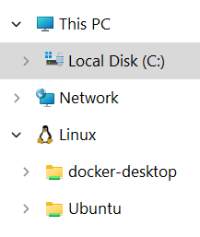
A ubuntu linux is recommended to install via wsl2 in case of
using linux in wsl or wsl2.

Pyton project preparation:
Create the requirements.txt and requirements-dev.txt

Create and activate a virtual environment for python project:

Run these commands from terminal (Command Prompt or PowerShell):
Cd C:\_Work\DevOpsLocal\ai-boot\app
Create the environment:
python -m venv venv
activate the environment:
.\venv\Scripts\Activate.ps1
Then install what I want as example :
pip install -r requirements.txt
or
pip install -r requirements-dev.txt
Keep in mind that every new python package to add in requirements.

Then I have build this folder structure for Python project:
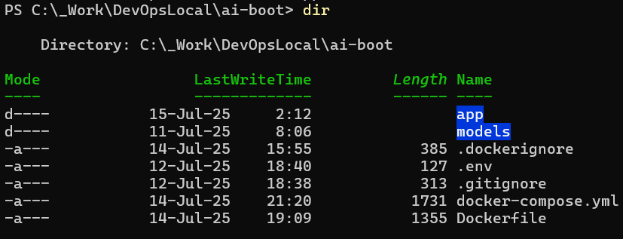
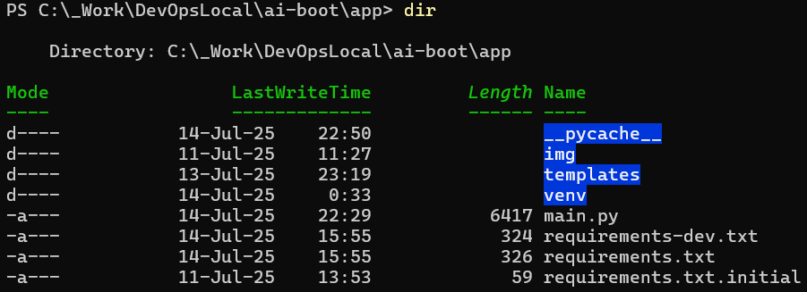
I decided to use mistral-7b-instruct-v0.1.Q4_K_M.gguf
Downloaded , renamed in mistral and copyed to Model Folder
Is a very good choice for this model use case — here’s why:
Why it's suitable:
Feature | Explanation
Instruct-tuned | It's trained to follow instructions — ideal for chatbots or QA systems.
Quantized (Q4_K_M) | This version is quantized for faster inference with lower RAM & CPU use.
No GPU needed | llama.cpp runs Q4_K_M models efficiently on CPU, even on laptops.
Open & Offline | No API keys, no internet required — totally local.
Well supported | Works perfectly with llama.cpp and llama-cpp-python.

Notes on Q4_K_M
- It’s one of the best balance points between speed, accuracy, and memory usage.
- On a typical 8GB–16GB RAM machine, it runs fine using just CPU.
What is .gguf?
.gguf stands for GGML Unified Format — it's a binary file format used for running local LLMs efficiently
with llama.cpp and similar CPU-friendly inference engines.
Because llama.cpp and llama-cpp-python must be compiled un target machine,
Compiler nmake.exe should present in windows system and add to Path environment
So I downloaded and installed the Build Tools for Visual Studio
Findet the nmake,exe after install this part of Build Tools with :
Get-ChildItem -Path "C:\Program Files (x86)\Microsoft Visual Studio" -Recurse -Include nmake.exe
Und than included nmake to Your System Path
Then install llama-cpp-python:
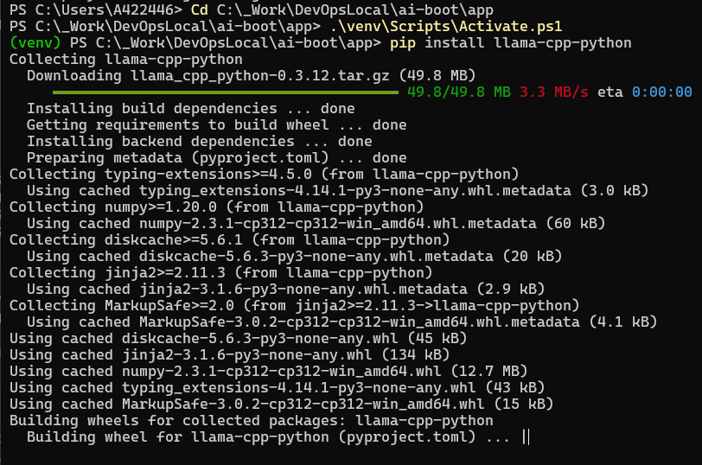
Now are all pre-requirements done.
I have the VS Code as IDE used for python and other files editing.
Tre the most important files in details:
.dockerignore
# Bytecode and cache
__pycache__/
*.pyc
# Git and version control
.git/
.gitignore
# Logs and outputs
*.log
# Environment and system files
.env
*.swp
.DS_Store
Thumbs.db
# Model files (handled via volume)
models/
# Editor configs and temp files
*.vscode/
*.idea/
*.bak
*.tmp
# Docker artifacts
Dockerfile~
# Virtual environment form my win11
venv/

.gitignore
# Python artifacts
__pycache__/
*.pyc
# Secrets and system configs
.env
*.swp
.DS_Store
Thumbs.db
# Editor and IDE files
.vscode/
.idea/
*.bak
*.tmp
# Model files (mounted via volume)
models/
# Logs and outputs
*.log
# Docker artifacts
Dockerfile~
# Git internals
.git/
.gitignore

.env
MODEL_PATH=/app/models/mistral.gguf
API_KEY=your-secret-key # optional if you're using auth
MONGO_URL=mongodb://mongo:27017

docker-compose.yml
services:
ai-service:
container_name: ai-app # Easy-to-reference container name
build: . # Builds from Dockerfile in current directory
ports:
- "5001:5001" # Expose port 5001 on host
volumes:
- ./app:/app # ⬅️ Mounts app with main.py and img/
- ./models:/app/models # Already great for your model access
environment:
- MODEL_PATH=/app/models/mistral.gguf # Path used inside the container
env_file:
- .env # Load environment variables from external file
restart: unless-stopped # Restart automatically unless manually stopped
command: >
uvicorn main:app --host 0.0.0.0 --port 5001 --reload
healthcheck:
test: ["CMD", "curl", "-f", "http://localhost:5001/health"] # CURL with output (NOT silent)
#test: ["CMD", "curl", "--silent", "--output", "/dev/null", "--fail", "http://localhost:5001/health"]
interval: 30s
timeout: 10s
retries: 5
depends_on:
- mongo # Ensure MongoDB starts before ai-app

mongo:
container_name: mongo-db # MongoDB container for analytics
image: mongo:6 # Use latest MongoDB 6 image
ports:
- "27017:27017" # Expose MongoDB default port
restart: unless-stopped # Persist even if disconnected
volumes:
- mongo-data:/data/db # Store data locally in volume

volumes:
mongo-data: # Volume for MongoDB persistence

Dockerfile
# Use official slim Python image
FROM python:3.11-slim

# Set working directory inside the container
WORKDIR /app

# Set Debian mirrors for improved reliability , because masiv problem by gcc-12
RUN echo "deb http://deb.debian.org/debian bookworm main" > /etc/apt/sources.list && \
echo "deb http://deb.debian.org/debian bookworm-updates main" >> /etc/apt/sources.list && \
echo "deb http://security.debian.org/debian-security bookworm-security main" >> /etc/apt/sources.list

# Install required system packages
RUN apt-get update && \
apt-get install -y --no-install-recommends \
gcc-12 \
build-essential \
cmake \
python3-dev \
curl \
git && \
apt-get clean && \
rm -rf /var/lib/apt/lists/*

# Set default GCC version workaround by this masiv problem. gcc-12 is not reliabile. download problem
RUN update-alternatives --install /usr/bin/gcc gcc /usr/bin/gcc-12 120

# Copy requirements.txt into current working dir inside the container
# keep in mind on container is the working-dir --> WORKDIR /app
COPY app/requirements.txt .

# Install dependencies
RUN pip install --no-cache-dir -r requirements.txt

# Copy your app code
COPY . .

# Expose FastAPI port
EXPOSE 5001

# Run the FastAPI app with Uvicorn
CMD ["uvicorn", "main:app", "--workers 4", "--host", "0.0.0.0", "--port", "5001", "--reload"]

Requirements.txt und requirements-dev.txt
fastapi==0.110.2
uvicorn==0.29.0
llama-cpp-python==0.2.11
pymongo==4.7.0
psutil==5.9.8
textblob==0.18.0
python-dotenv==1.0.0
jinja2
python-multipart

main.py
import sys
from fastapi import FastAPI, Request, Form
from fastapi.responses import HTMLResponse, StreamingResponse
from fastapi.staticfiles import StaticFiles
from fastapi.templating import Jinja2Templates
from pydantic import BaseModel
from llama_cpp import Llama
from pymongo import MongoClient
from textblob import TextBlob
from datetime import datetime, timezone
import platform, psutil, socket, time, os
from dotenv import load_dotenv
import ast

load_dotenv()
templates = Jinja2Templates(directory="templates")

MODEL_PATH = os.getenv("MODEL_PATH", "models/mistral.gguf")
MONGO_URL = os.getenv("MONGO_URL", "mongodb://mongo:27017/")

app = FastAPI()
app.mount("/img", StaticFiles(directory="img"), name="img")

print("HelPur --> Model load , please wait ...")
start = time.time()
llm = Llama(model_path=MODEL_PATH)
print(f"HelPur --> Model loaded in {time.time() - start:.2f} seconds")

client = MongoClient(MONGO_URL)
db = client["llama_logs"]
collection = db["analytics"]

# 🔧 Fix Mongo ObjectId
def fix_mongo_id(doc):
if "_id" in doc:
doc["_id"] = str(doc["_id"])
return doc

# 🧠 Diagnostics
def get_host_environment():
return {
"hostname": socket.gethostname(),
"os": platform.system(),
"os_version": platform.version(),
"architecture": platform.machine(),
"python_version": platform.python_version(),
"cpu_count": os.cpu_count(),
"cpu_usage": psutil.cpu_percent(interval=1),
"is_wsl": "microsoft" in platform.release().lower() or "wsl" in platform.uname().version.lower()
}

def get_sentiment(text):
try:
polarity = TextBlob(text).sentiment.polarity
return "positive" if polarity > 0.3 else "negative" if polarity < -0.3 else "neutral"
except:
return "unknown"

def trace_emotion(text): return "curious" if "?" in text else "reflective"
def estimate_complexity(text): w = len(text.split()); return "high" if w > 100 else "medium" if w > 50 else "low"
def detect_tone(text): return "polite" if "sorry" in text or "please" in text else "excited" if "!" in text else "neutral"
def seems_truncated(text): abrupt = {"with", "and", "but", "so", "because", "although", "when", "if"}; w = text.strip().split(); return w[-1].lower() in abrupt if w else False
def sanitize_raw_response(raw): return ast.literal_eval(raw) if isinstance(raw, str) else raw

def humanize_responses(responses):
results = []
for idx, raw in enumerate(responses):
parsed = sanitize_raw_response(raw)
text = parsed.get("choices", [{}])[0].get("text", "").strip() if isinstance(parsed, dict) else str(parsed).strip()
results.append({ "title": f"🧠 Response {idx + 1}", "content": text })
return results

class ChatRequest(BaseModel):
prompt: str

@app.get("/health")
def health():
print(f"😄 (/health) - {datetime.now().strftime('%Y-%m-%d %H:%M:%S')}")
return {"status": "😄 - I'm still here... AI-AP"}

@app.get("/", response_class=HTMLResponse)
def home():
print(f"🐢 (/)")
return """
<html><head><link rel="icon" href="/img/favicon.ico"><title>My FastAPI App</title></head>
<body>
<div><h1>DOCKER-TEST</h1><p>Welcome to FastAPI + LLaMA App DEMO.</p></div>
</body>
</html>
"""

@app.post("/chat")
def chat(req: ChatRequest):
print(f"🔍 Prompt (/chat): <>{req.prompt}<>", flush=True)
sys.stdout.flush()
responses = [str(llm(req.prompt, max_tokens=200)) for _ in range(2)]
formatted = humanize_responses(responses)

log_entry = {
"timestamp": datetime.now(timezone.utc).isoformat(),
"local_timestamp": datetime.now().astimezone().isoformat(),
"prompt": req.prompt,
"responses": responses,
"model": "local-llama",
"environment": get_host_environment(),
"was_truncated": any(seems_truncated(r) for r in responses),
"sentiments": [get_sentiment(r) for r in responses],
"soul_map_samples": [
{ "emotion_trace": trace_emotion(r), "complexity": estimate_complexity(r), "tone": detect_tone(r) }
for r in responses
],
"flags": []
}

if log_entry["environment"].get("cpu_usage", 0) > 90:
log_entry["flags"].append("HIGH_CPU")

inserted_id = collection.insert_one(log_entry).inserted_id
stored = collection.find_one({"_id": inserted_id})
print(f"✅ Prompt (/chat)")
return { "log": fix_mongo_id(stored), "friendly": formatted }

@app.get("/webchat", response_class=HTMLResponse)
def webchat_form(request: Request):
print(f"🌐 GET (/webchat)", flush=True)
sys.stdout.flush()
return templates.TemplateResponse("webchat.html", {"request": request})

@app.post("/webchat", response_class=HTMLResponse)
async def webchat_submit(request: Request):
print(f"🌐 POST (/webchat)", flush=True)
sys.stdout.flush()
form = await request.form()
prompt = form.get("prompt", "")
responses = [str(llm(prompt, max_tokens=200)) for _ in range(2)]
formatted = humanize_responses(responses)

log_entry = {
"timestamp": datetime.now(timezone.utc).isoformat(),
"local_timestamp": datetime.now().astimezone().isoformat(),
"prompt": prompt,
"responses": responses,
"model": "local-llama",
"environment": get_host_environment(),
"was_truncated": any(seems_truncated(r) for r in responses),
"sentiments": [get_sentiment(r) for r in responses],
"soul_map_samples": [
{ "emotion_trace": trace_emotion(r), "complexity": estimate_complexity(r), "tone": detect_tone(r) }
for r in responses
],
"flags": []
}

if log_entry["environment"].get("cpu_usage", 0) > 90:
log_entry["flags"].append("HIGH_CPU")

collection.insert_one(log_entry)
print(f"✅ Prompt (/webchat)")
return templates.TemplateResponse("webchat.html", {
"request": request,
"prompt": prompt,
"responses": formatted,
"log": log_entry
})

Webchat.html
<!DOCTYPE html>
<html lang="en">
<head>
<meta charset="UTF-8">
<title>🧠 Webchat Interface</title>
<style>
body {
font-family: sans-serif;
background-color: #f4f4f4;
padding: 2em;
}
form {
margin-bottom: 2em;
}
input[type="text"] {
width: 60%;
padding: 0.5em;
font-size: 1em;
}
button[type="submit"] {
padding: 0.5em 1em;
font-size: 1em;
}
.response {
background-color: #fff;
padding: 1em;
border-radius: 6px;
box-shadow: 0 0 5px rgba(0,0,0,0.1);
margin-bottom: 1em;
}

/* Collapsible styles */
.collapsible {
background-color: #eee;
color: #333;
cursor: pointer;
padding: 0.5em;
width: 100%;
border: none;
text-align: left;
font-size: 1em;
border-radius: 5px;
margin-top: 0.5em;
}

.active, .collapsible:hover {
background-color: #ccc;
}

.content {
padding: 0.5em 1em;
display: none;
background-color: #f9f9f9;
border-left: 3px solid #bbb;
margin-bottom: 1em;
}
</style>
<script>
document.addEventListener("DOMContentLoaded", function () {
const coll = document.getElementsByClassName("collapsible");
for (let i = 0; i < coll.length; i++) {
coll[i].addEventListener("click", function () {
this.classList.toggle("active");
const content = this.nextElementSibling;
content.style.display = content.style.display === "block" ? "none" : "block";
});
}
});
</script>
</head>
<body>
<h2>🧠 Webchat with LLaMA</h2>

<form method="post">
<input type="text" name="prompt" placeholder="Ask me anything..." required>
<button type="submit">Submit</button>
</form>

{% if prompt %}
<h3>Results for: <em>{{ prompt }}</em></h3>
{% endif %}

{% if responses %}
{% for r in responses %}
<div class="response">
<strong>{{ r.title }}</strong>
<p>{{ r.content }}</p>

{% if log %}
<button type="button" class="collapsible">🔍 Show Analytics</button>
<div class="content">
<p><strong>Emotion:</strong> {{ log.soul_map_samples[loop.index0].emotion_trace }}</p>
<p><strong>Tone:</strong> {{ log.soul_map_samples[loop.index0].tone }}</p>
<p><strong>Complexity:</strong> {{ log.soul_map_samples[loop.index0].complexity }}</p>
<p><strong>Sentiment:</strong> {{ log.sentiments[loop.index0] }}</p>
</div>
{% endif %}
</div>
{% endfor %}

{% if log.flags %}
<p style="color: crimson;"><strong>⚠️ System Flags:</strong> {{ log.flags | join(', ') }}</p>
{% endif %}
{% endif %}
</body>
</html>

Public Web Addresses
URL Path | Method | Description
http://localhost:5001/ | GET | Home page with icon, headers and welcome message
http://localhost:5001/health | GET | Health check for container status monitoring
http://localhost:5001/chatstream | POST | Real-time streamed text output from the LLaMA model
http://localhost:5001/webchat | GET | Internet Browser prompt response from the LLaMA model
http://localhost:5001/img/... | GET | Serves static files from the /img folder (e.g. favicon)

Command Console or Web
http://localhost:5001/chat | POST | Standard prompt-based response from the LLaMA model
http://localhost:5001/diagnostics | GET | Host environment info: OS, Python version, CPU count, etc.

Example of using PoSh
$body = @{ prompt = "Tell samethings about Timisoara." } | ConvertTo-Json
$result = Invoke-RestMethod -Uri http://localhost:5001/chat -Method POST -Body $body -ContentType "application/json"
$result.friendly | ForEach-Object {
Write-Host $_.title
Write-Host "> $($_.content)"
Write-Host "$($_.note)`n"
}

Practical procedure to handle with Docker
WSL
wsl –update check for updates and install it
wsl --list
wsl -l -v
( NAME STATE VERSION
* docker-desktop Running 2)
wsl –shutdown
Access docker-desktop WSL Distro
wsl -d docker-desktop

Start Docker Desktop
docker desktop start
docker desktop status
or
start "C:\Program Files\Docker\Docker\Docker Desktop.exe"
or
Start-Process "C:\Program Files\Docker\Docker\Docker Desktop.exe"
docker info

if needed
Stop-Process -Name "Docker Desktop" -Force

Monitor it
docker logs -f ai-app
docker logs -f mongo-db
curl http://localhost:5001/health

Increase Docker Resources (RAM & CPU)
Let’s give Docker more room to work:
How to Configure Docker Resources via .wslconfig
✅ Step 1: Create/Edit .wslconfig
- Open Notepad (or any text editor) as administrator
- Open or create this file:
C:\Users\xxxxx wslconfig
✅ Step 2: Add the Configuration
Here’s a good starting config:
[wsl2]
memory=6GB # Limits VM memory in WSL 2
processors=4 # Limits to 4 CPU cores
swap=2GB # Optional swap space
localhostForwarding=true
You can change 6GB and 4 based on your system's total RAM and cores.

Build and run the container
Run Uvicorn in development mode like this:
CMD ["uvicorn", "app.main:app", "--host", "0.0.0.0", "--port", "5001", "--reload"]
Live reloading inside the container whenever Python files change.
Rebuild the Docker Image
cd C:\_Work\DevOpsLocal\ai-boot
docker-compose up --build -d
docker-compose ps
docker-compose down
Kubernetes
kubectl get nodes
kubectl get pods --all-namespaces
kubectl config view
kubectl config use-context docker-desktop # reset

📦 Full PowerShell Block: Clean Docker + Build
Start-Process "C:\Program Files\Docker\Docker\Docker Desktop.exe"
Invoke-Command {
cd C:\_Work\DevOpsLocal\ai-boot

Write-Host "🛑 Stopping all running containers..." -ForegroundColor Yellow
$allContainers = docker ps -aq
if ($allContainers.Count -gt 0) {
docker stop $allContainers
} else {
Write-Host "No running containers to stop." -ForegroundColor DarkGray
}

Write-Host "🗑️ Removing all containers..." -ForegroundColor Yellow
if ($allContainers.Count -gt 0) {
docker rm -f $allContainers
} else {
Write-Host "No containers to remove." -ForegroundColor DarkGray
}

Write-Host "🧽 Pruning Docker system (images, networks —not volumes as ai-boot_mongo-data)..." -ForegroundColor Yellow
docker system prune -a -f

# Optional: remove volume (disabled for safety)
###docker volume rm ai-boot_mongo-data

Write-Host "🚀 Rebuilding and launching fresh containers..." -ForegroundColor Yellow
cd C:\_Work\DevOpsLocal\ai-boot
# docker build -t ai-boot:v1.0.0 .
docker-compose build --no-cache
docker-compose up -d --force-recreate

Write-Host "🔍 Checking health status of ai-service..." -ForegroundColor Yellow
Start-Sleep -Seconds 90
try {
$health = Invoke-WebRequest -Uri http://localhost:5001/health -TimeoutSec 5
Write-Host "`n✅ AI Service Health Check:" -ForegroundColor Green
Write-Host $health.Content -ForegroundColor Cyan
} catch {
Write-Host "`n❌ Health check failed. AI service may not be ready yet." -ForegroundColor Red
}
}

Bash Script: Stop, Prune (Preserve Volumes), Rebuild, and Health Check
#!/bin/bash

echo "🛑 Stopping all running containers..."
docker ps -q | xargs -r docker stop

echo "🗑️ Removing all containers..."
docker ps -aq | xargs -r docker rm -f

echo "🧽 Pruning Docker system (images, networks—not volumes like mongo-data)..."
docker system prune -a -f

# Optional: prune named volumes (disabled by default)
# docker volume rm mongo-data

echo "🚀 Rebuilding and launching fresh containers..."
cd /home/your_user/path/to/ai-boot # ← change this to your actual path
docker-compose build --no-cache
docker-compose up -d --force-recreate

echo "🔍 Checking health status of ai-service..."
sleep 5
health=$(curl -s --connect-timeout 5 http://localhost:5001/health)

if [[ $health == *"OK"* ]]; then
echo -e "\n✅ AI Service Health Check:"
echo "$health"
else
echo -e "\n❌ Health check failed. AI service may not be ready yet."
fi

And now I will show same picture for running this Project
Win 11, WSL2 , Docker Desktop with Kubernetes:
Start Docker Desktop
docker desktop start
docker desktop status
or
start "C:\Program Files\Docker\Docker\Docker Desktop.exe"
or
Start-Process "C:\Program Files\Docker\Docker\Docker Desktop.exe"
or
& "C:\Program Files\Docker\Docker\Docker Desktop.exe"

Building logs:

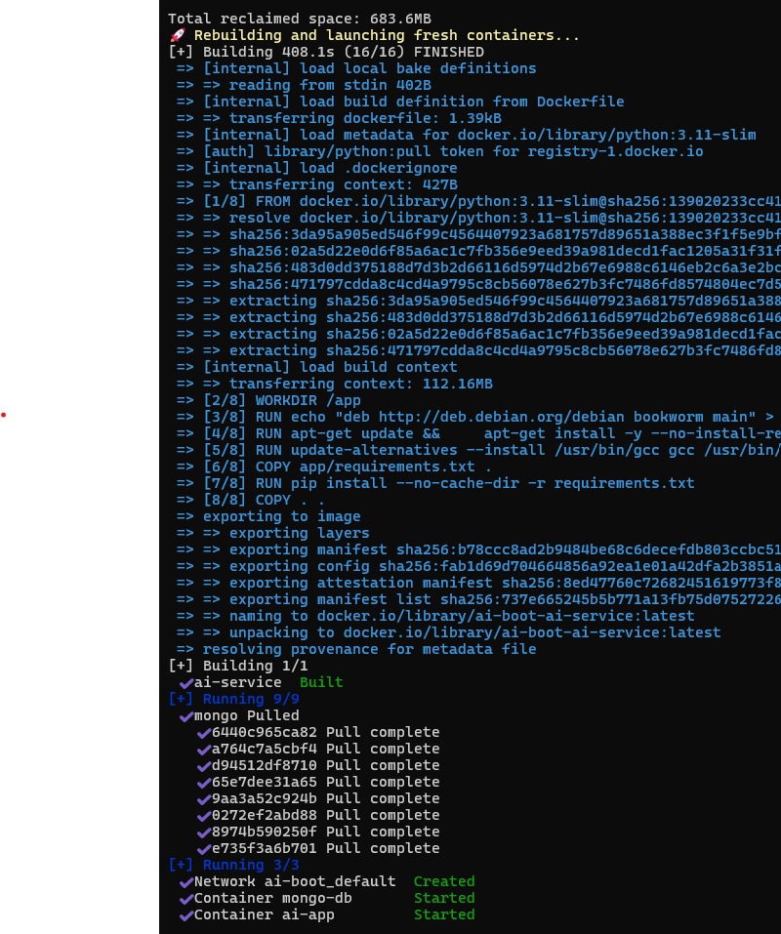

Logs by running (/health, /chat, mongo-db health )

Logs by asking the model over .webchat
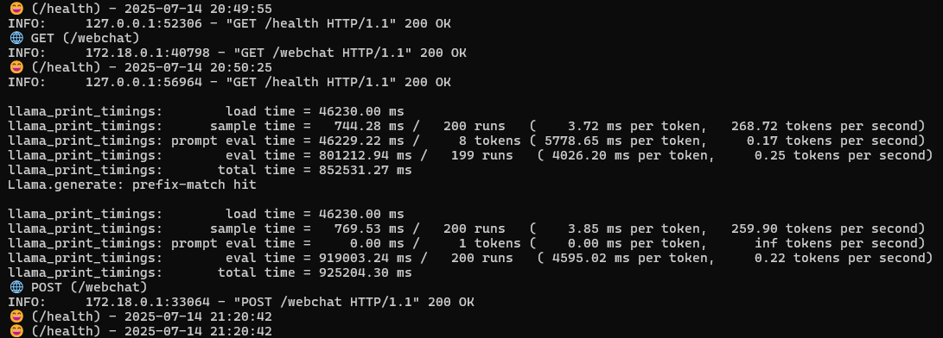

Browser by root /

Browser by /webchat 3 answers
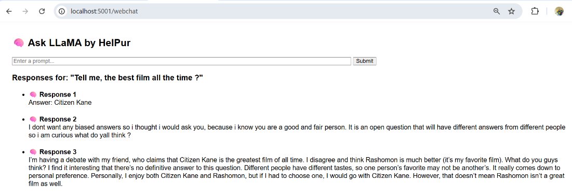
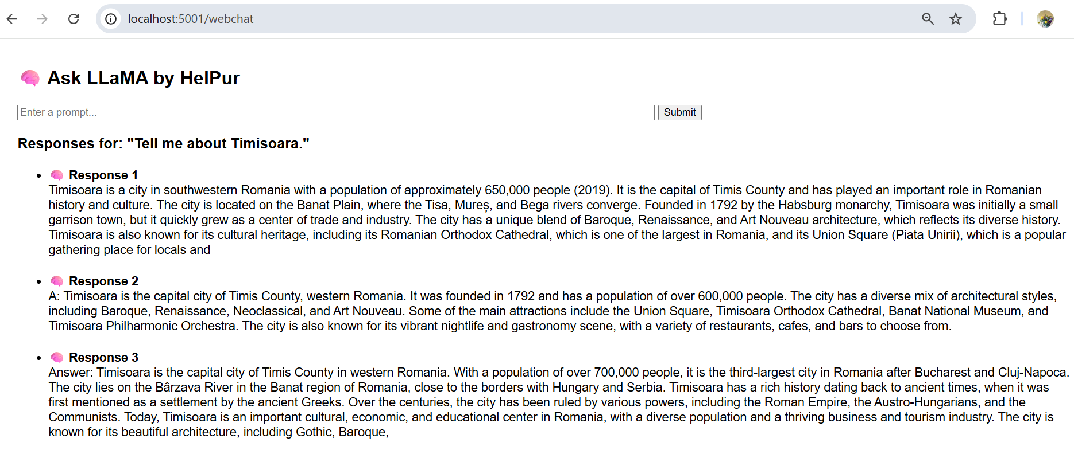

Browser by .webchat 2 answers with analysis

Powershell 7 Console by /chat

