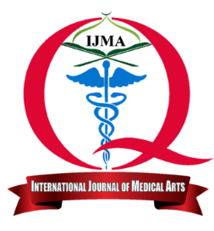 | Available online at Journal Website  https://ijma.journals.ekb.eg/  Main Subject [{{research_type}}] | 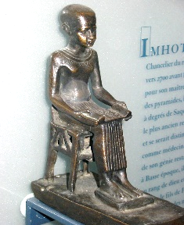
Original Article
{{research_title}}
{{authors}}

{{affiliation}}
 |  | Abstract
Article information |  | {{abstract}}
Received: | {{date_received}} | {{abstract}}
Professionally accepted: | {{date_accepted}} | {{abstract}}
*Corresponding author |  | {{abstract}}
Email: {{email}} |  | {{abstract}}
{{citation}} |  | {{abstract}}
{{keywords}}
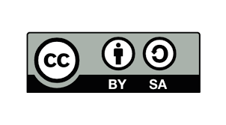 | This is an open-access article registered under the Creative Commons, ShareAlike 4.0 International license [CC BY-SA 4.0] [https://creativecommons.org/licenses/by-sa/4.0/legalcode.

INTRODUCTION
{{intro}}
PATIENTS AND METHODS
{{methods}}
RESULTS
{{results}}

{{tables}}
{{figures}}

DISCUSSION
{{discussion}}

REFERENCES
{{references}}

