1. Write a program to reverse the String (use char[] or String built in method)
2. Write programs to depict the usage of contains(), length(), replace(), concat(), equals()

OUTPUTS

Question1.

* **CODE1**

import java.lang.*;

import java.io.*;

import java.util.*;

// SBA CODE1 TEST UST BY HELNA ELDHO

public class ReverseString {

public static void main(String[] args)

{

String input = "HELNAELDHO";

char[] try1 = input.toCharArray();

for (int i = try1.length - 1; i >= 0; i--)

System.out.print(try1[i]);

}

}

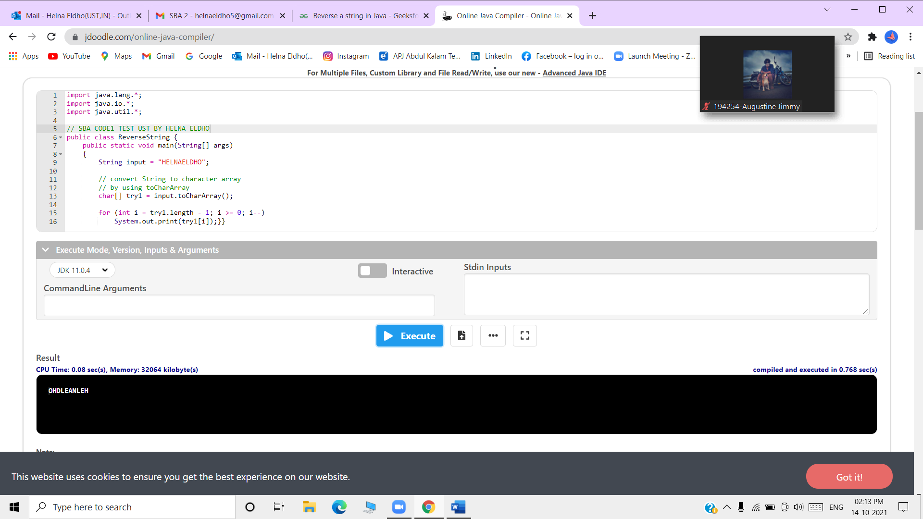

2nd Question

* CODE 2

Length()

// SBA CODE2 TEST UST BY HELNA ELDHO

public class LENGTH {

public static void main(String[] args)

{

String s1 = "HELNAELDHO";

String s2 = "ERNAKULAM";

String s3 = "KERALA";

System.out.println("The String length is "+s1.length());

System.out.println("The String length is "+s2.length());

System.out.println("The String length is "+s3.length());

}}

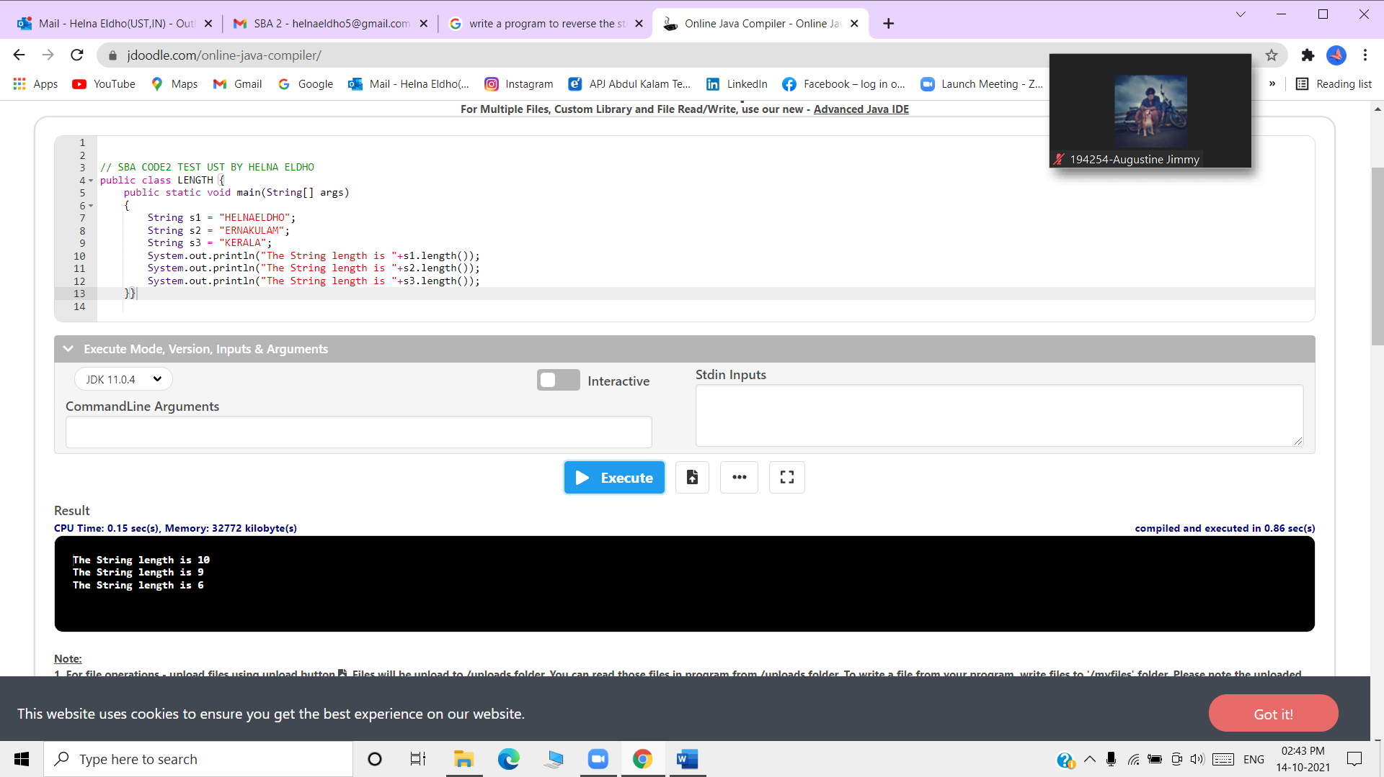

Replace()

// SBA CODE2 TEST UST BY HELNA ELDHO

public class REPLACE {

public static void main(String[] args)

{

String s1="HELNA";

String replaceString=s1.replace('L','N');

System.out.println(replaceString);

}}

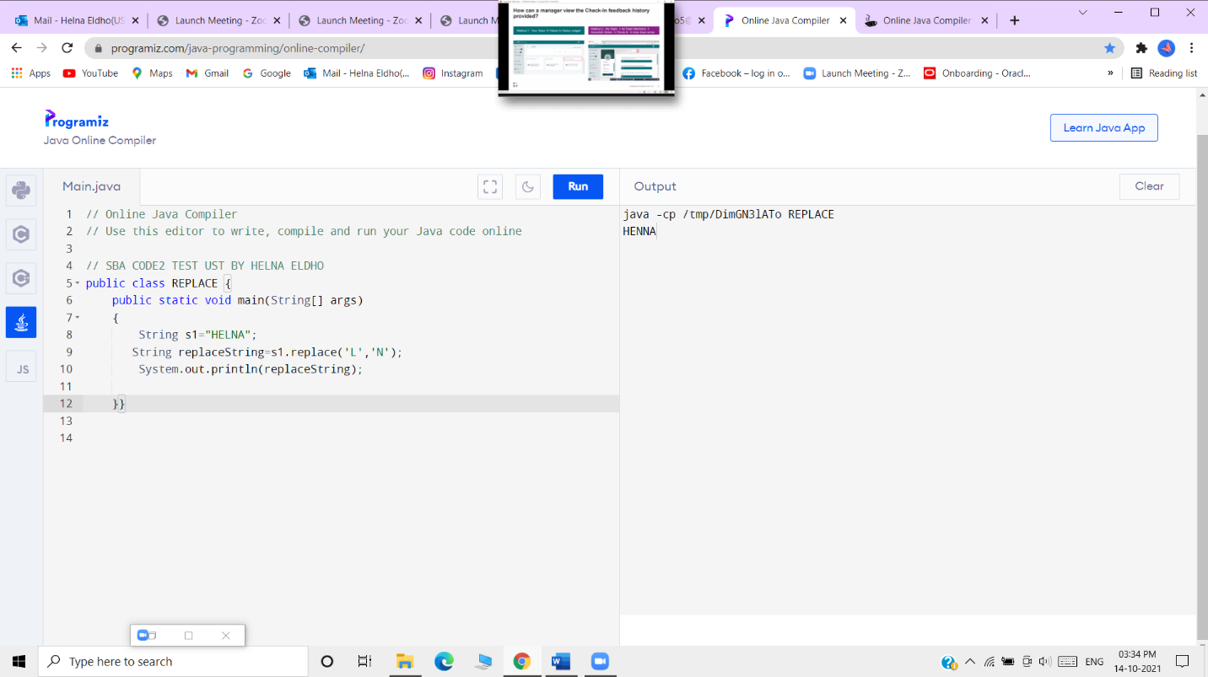

Equals()

// SBA CODE2 TEST UST BY HELNA ELDHO

public class EQUALS {

public static void main(String[] args)

{

String s1="HELNA";

String s2="HELNA";

System.out.println(s1.equals(s2));

}}

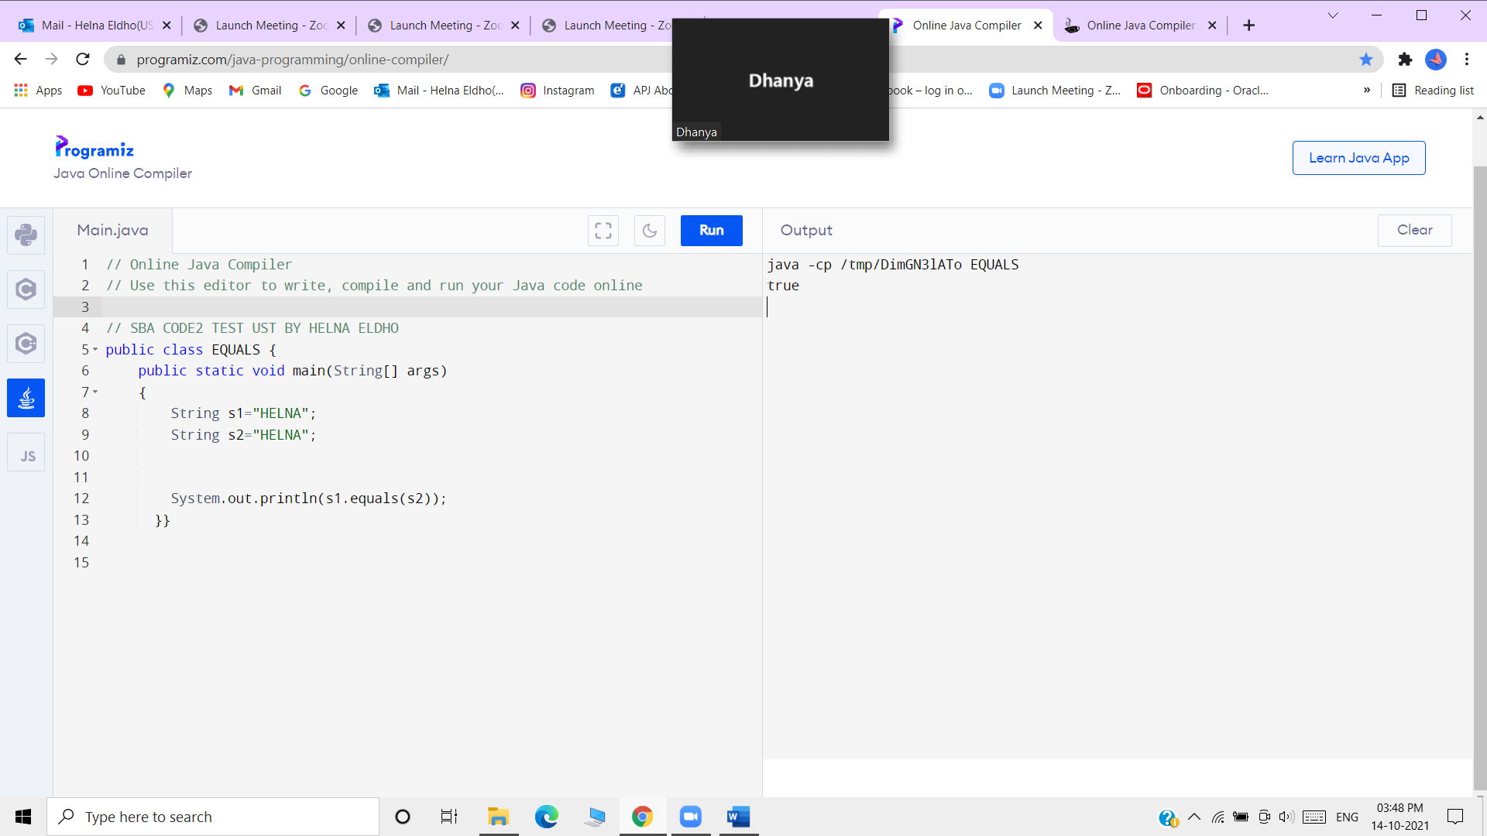

Contains()

// SBA CODE2 TEST UST BY HELNA ELDHO

public class CONTAINS {

public static void main(String[] args)

{

String name="This is a very good day";

System.out.println(name.contains("good"));

System.out.println(name.contains("day"));

}}

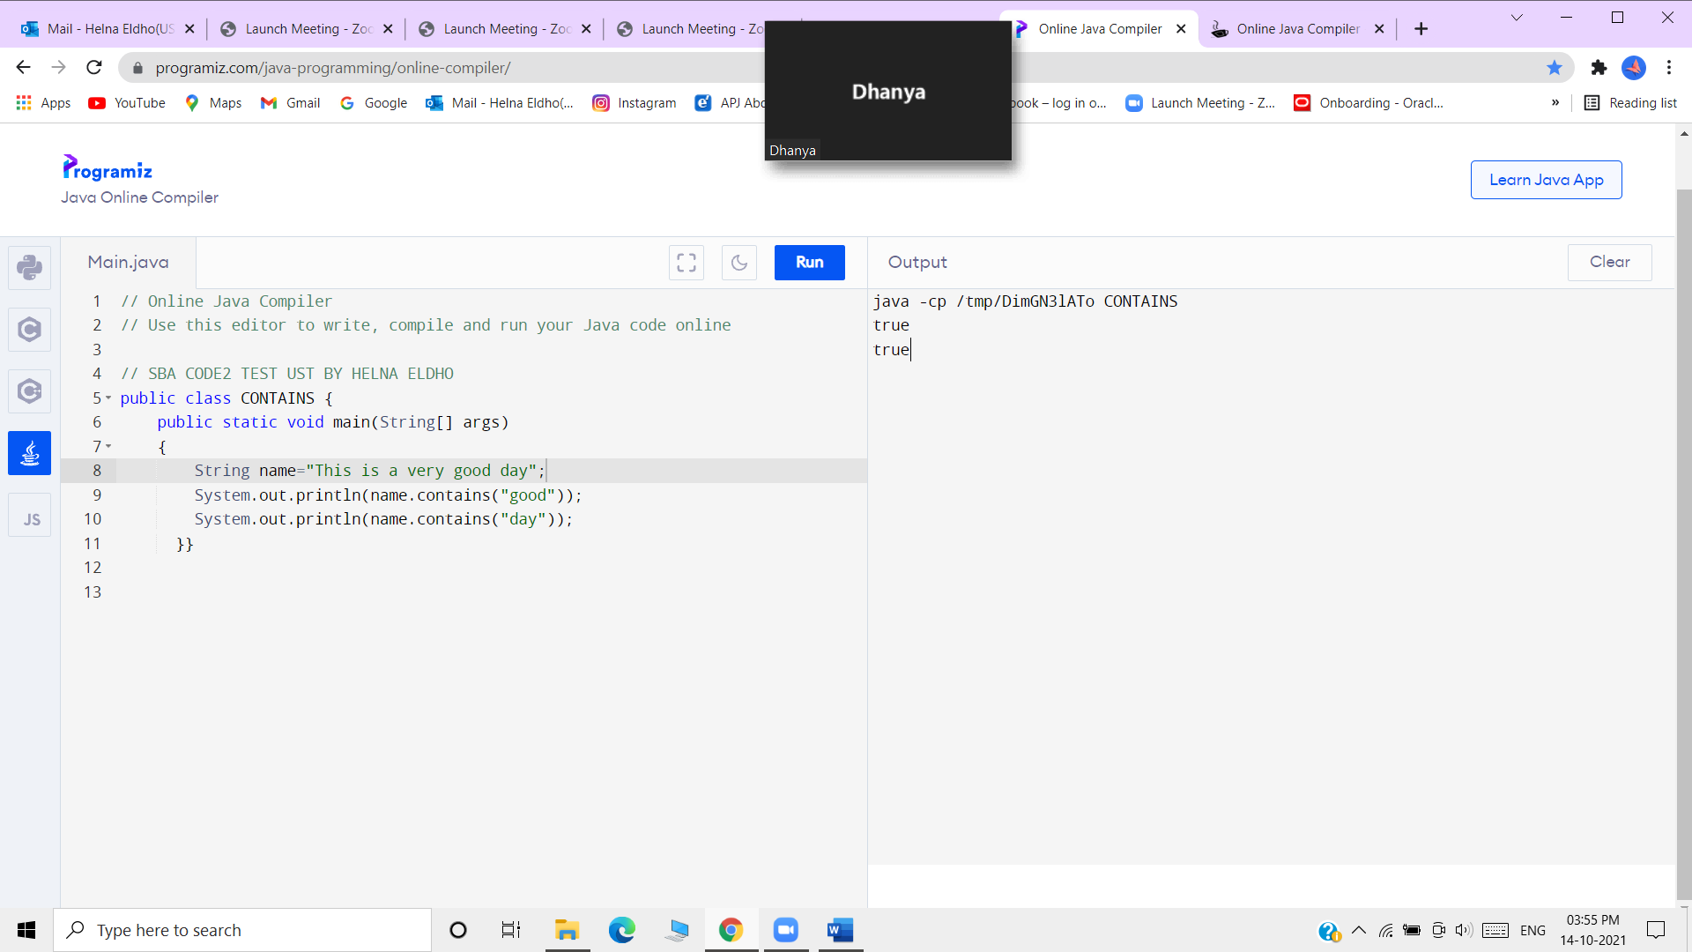

Concat()

// SBA CODE2 TEST UST BY HELNA ELDHO

public class CONCAT {

public static void main(String[] args)

{

String s1="Helna Eldho ";

s1.concat(" is coming ");

System.out.println(s1);

s1=s1.concat(" is coming from Ernakulam ");

System.out.println(s1);

}}

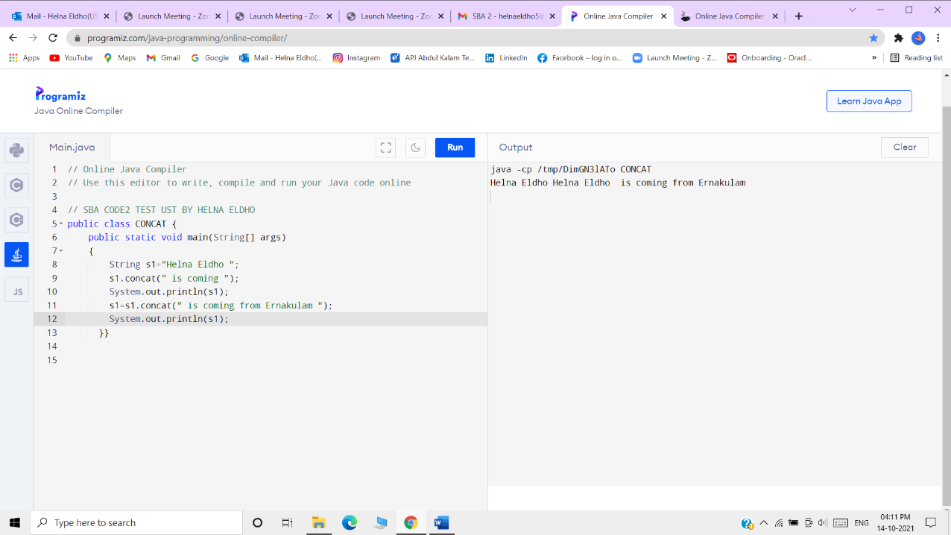

Submitted By,

HELNA ELDHO