We used Bluetooth Terminal app to check the

HC05 ( a Bluetooth module)

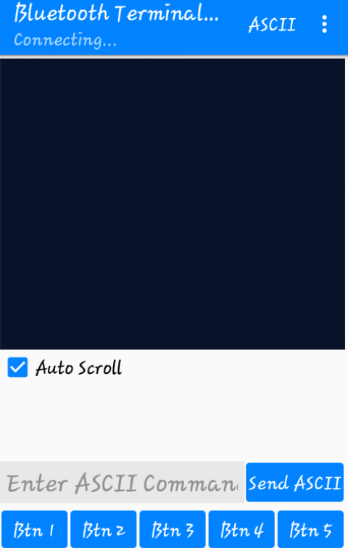

& Bluetooth Rc car with the robot

