Your tour



**SRS**

**Introduced by SE2018G08**

|  |  |  |  |  |
| --- | --- | --- | --- | --- |
| Version | Written by | Reviewed by | Approved by | Date |
| 7.0 | SE2018G08 | | | December 2018 |

|  |
| --- |
| **Table of Content** |
| 1. **Introduction**    1. 1.1 Executive Summary 4    2. 1.2 Document Overview 4    3. 1.3 Abbreviations and Terminologies 4 |
| 1. **System Description**    1. 2.1 Introduction 5    2. 2.2 Users 5 |
| **3. System User** 6 |
| 1. **System Modules**    1. 4.1 User module 7    2. 4.2 Administration module 8    3. 4.3 Company module 8    4. 4.4 Customer module 9 |
| 1. **System Function**    1. 5.1 Customer    2. 5.1.1 register… 10    3. 5.1.2 login… 11    4. 5.1.3 logout… 12    5. 5.1.4 tracking… 12    6. 5.1.5 rating… 13   5.2 Company   * 1. 5.2.1 register… 14   2. 5.2.2 login… 15   3. 5.2.3 logout… 16   4. 5.2.4add/edit/delete a trip… 16   5. 5.3 User   6. 5.3.1 search… 17   7. 5.3.2 Destination filter… 17   8. 5.3.3 cost filter… 18   9. 5.3.4 date filter… 18   10. 5.4 admin   11. 5.4.1 login… 19   12. 5.4.2 add company … 20   13. 5.4.3 add/edit/delete a trip … 20   14. 5.4.4 remove customer /company… 21   15. 5.4.5 logout… 21 |
| 1. **System Models**    1. 6.1 User and administrator user case 22   6.2 Sequence diagram 23-24 |
| 1. **Non-functional Requirement**   7.1 Performance 25   * 1. 7.2 Security 25   2. 7.3 Availability 25   3. 7.4 Accuracy 25   4. 7.5 Usability 25 |
| **8. Domain Requirement** 26 |
| **9. System Interface**  9.1 User interface 27-31 |

# 1.Introduction

## 1.1.Executive Summary

You Tour is a website which works like a platform for a number of tourism companies to offer their trips which are varying in cost & duration so that the customers will always find an offer satisfies their needs, the website also provides different ways of filtration to make it more easier for customers to get their point and many other user friendly functions.

**1.2.Document Overview**

This SRS document focuses on describing the software requirements of You Tour website, The document focuses on system description, system users, system modules, all the functional, nonfunctional requirements and system interfaces.

## 1.3Abbreviations and Terminologies

|  |  |
| --- | --- |
| SRS | Software requirement specifications |
| GUI | Graphical user interface |
|  |  |

# 2. System description

## 2.1 Introduction

**2.1.1About**

You tour is a system that provides various offers for different travel agencies and tourism companies. The main idea behind the system is instead of browsing the packages and offers of just one travelling agency, the user will have the opportunity to go through a larger number of offers without the effort of going into each company's website. It offers a large number of trips that varies in destinations, hotels with different rates and the duration time, so users can decide where to spend their holidays. The site will provide different ways of filtration to make it easier for users to find what they are looking for .You tour also makes communication with different agencies become easier by providing their contacts (number, address, websites, and email).

**2.1.2 Product feathers**

**-**Search and filter:

The user can search and filter through all the offers to narrow down the options. The user can filter by three criteria. First is filtering by the place they want to go to then the system will get all the offers for that chosen place. The second one is by the cost of the package as a whole. The user can enter a range of cost that suits them and the system will provide them with offers within that range. The last one is filtering by the date/timing of the trips. The user can search using one or all the filters to facilitate the searching process.

- Provide detailed description of the offers:

The system provides a very detailed description for every offer so that the user can know all the information from our system and won't feel obliged to contact the companies for more information. The description includes the place they are going to visit, the program of the trip, its duration, the hotel and its rating, the available activities at that place, the transportation details (if the transportation is provided), the cost of the trip. It will also include any further details that the travel agencies provide regarding any trip.

-Having a user profile:

Users are either companies or customers. companies contribute to the system by providing their tours schedule (plan and description ) and their contacts .Customers browse the companies offers and book them using his account (only registered user can use initial booking,trackingatrip and rating options).

-Booking:

The system provides with each offer/trip the contact information (mobile number, email, website and location) for the travel agency so that when the user decides on a specific offer, they can contact the agency and book the offer they want. The system provides also initial booking, but if the customer doesn’t confirm it, it will be cancelled.

-Show the best offers:

The system provides the option to look at the best offers first before searching so that it's easier for the user to find what suits them best before exploring all the other options.

-Rating:

Users can rate their experiences with the system and the tour offers.

-Tracking the trip:

The detailed schedule of the trip will be sent to registered users who booked the trip, and once the trip starts the user will receive notifications on their account following the schedule notifying them of the place they should be in at the moment.

## 2.2 Users

* **Admin :**someone who controls andmanage all the system.

**-User :**someone who can operate thewebsite. **-Customer:** a registered user as acustomer.

* **Company:** a registered user as acompany

# 3. System users

|  |  |
| --- | --- |
| Admin | -add new user  -edit or delete any user info  -add/edit/delete any trip |
| User | -browse the website.   * view the different offers and feedbacks . * get any company contacts. |
| Customer | -have an account .book a trip or more .  -organize his/her trips plan and time table  -rate the web siteand the trip and the tourism company. |
| Company | -Have anaccount ----add its contacts.  -add its trips description , time table.  -get a list of the customers who book any trip |

# 4. System Modules

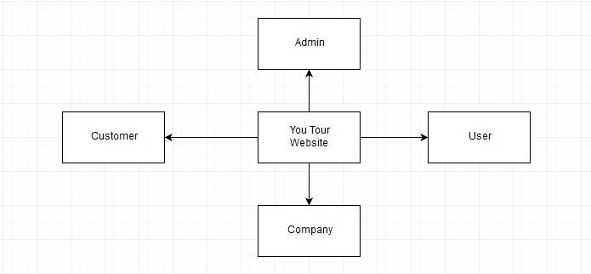

**Figure 1:You Tour Website Context Diagram.**

## 4.1.User module

This module contains the functions that User can use. User is anyone who browse the website. he can Search and use Filters to Navigate the Trips.

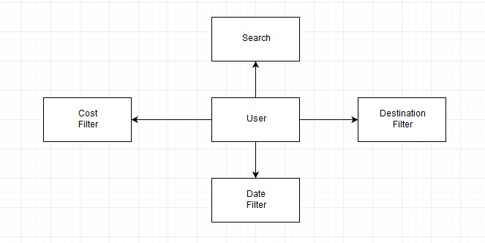

**Figure 2:** User **Module Context** Diagram**.**

## 4.2.Administration module

This module contains the functions that admin can use. admin is a user who controls and manage all the system. he can use user’s module functions. Also, he can add new user, edit/delete any user info, add/edit/delete any trip.

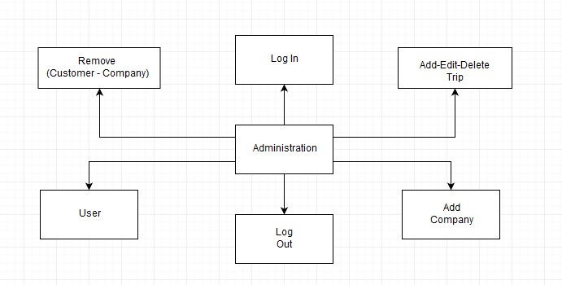

**Figure 3: Administration Module Context Diagram.**

## 4.3.Company module

This module contains the functions that User(Company) can use. Company is a registered user who can use user’s module functions. Also, he can make an account which allowing it to add its contacts, trips description, cost, time table, get a list of the customers who reserve a trip.

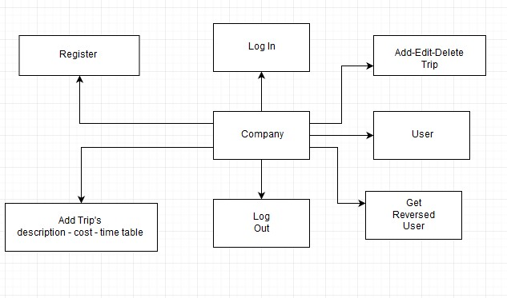

**Figure 4: Company Module Context Diagram.**

## 4.4.Customer module

This module contains the functions that User(Customer) can use. Customer is registered user who can use user’s module functions. Also, he can make an account which allows him/her to reserve a trip or more, organize his/her trips plan and time table and rate the web site, the trip and the tourism company.

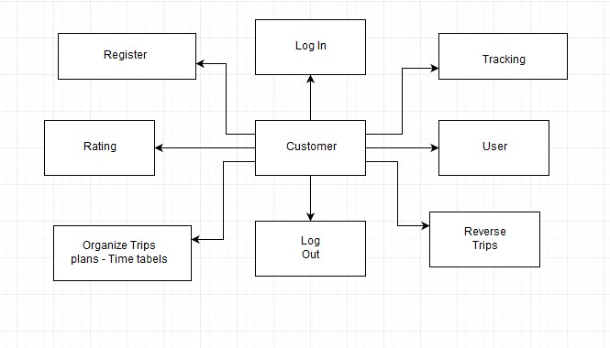

**Figure 5: Customer Module Context Diagram.**

Data flow diagram:

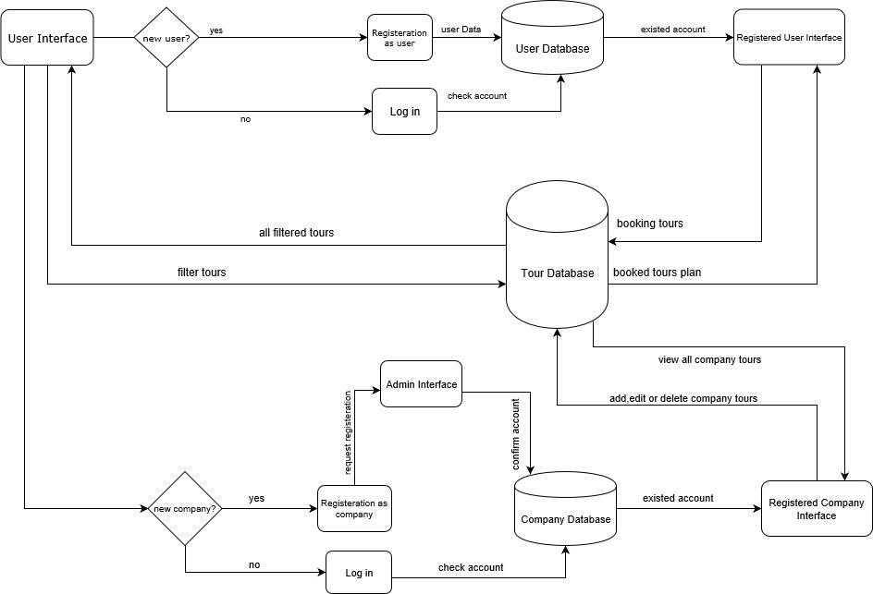

# 5. System Functions

## 5.1.customer

### 5.1.1 register

|  |  |  |
| --- | --- | --- |
| Name | Register | |
| index |  | |
| Actors | customer | |
| Precondition | Open web site "You tour "  If customer does not have an account he will sign up in first page in web site by pressing register as customer button. | |
| Post condition | Actors | System response |
| -You can log in as a user in a web site And you will enter to your home page as a user you select "customer”.  -User is unable to sign up for one or more reason like data is not correct. | -The system is successful  The system is failure- |
| Steps | Actors | System response |
| -User select option to  Register as customer -User enter data to sign up(first name , , password ,email) | -The system prompts  user for registration new account |
| Alternative | If you have an account you can log in. | |
| Description | The user have to fill the required data (first name, last-name ,email, password and other data | |

### 5.1.2 login

|  |  |  |
| --- | --- | --- |
| Name | Log in | |
| index |  | |
| Actors | customer | |
| Precondition | If customer has an account by signing up, he will log in by pressing login button with his (Email, password). | |
| Post condition | Actors | System response |
|  | -User will enter to your home page.  -You can do available works in your page.  -If user not authenticated | -The system is successful  -The system is failure |
| Steps | Actors | System response |
| -User enter email and password  -Click on login button | -The system validates the entered email and password ,making sure his data is valid -The system direct to home page |
| Alternative | Actors | System response |
| -If you forget your password you will enter  "forget password button | -The system describe why user failed authentication  -The system prompts the user to reenter valid data |
| Description | If the customer need to view his trips or see the tracking table he has to login to enter to his account.  If email or password is not correct, a warning message will be shown “Email or Password is not correct ". | |

### 5.1.3 logout

|  |  |  |
| --- | --- | --- |
| Name | Log out | |
| Actors | customer | |
| Precondition | Press logout button. | |
| Post condition | You will back to first page in web site and if you want to enter to your page again log in . | |
| steps | Actors | System response |
| User click on log out button | the system send massage if user want to save changes |
| Alternative | None | |
| Description | When clicking on log out, it will log out the user from the site. The website will deal with the customer as a normal user. | |

### 5.1.4 tracking

|  |  |
| --- | --- |
| Name | Tracking |
| index |  |
| actors | customer |
| Pre condition | Customer press see track button |
| Post conditions | The tracking is displayed |
| Description | In order to keep the website in touch with customer  The customer profile will allow the customer know where the rest of the group and it will send notifications to alarm the customers when an event is about to end . |

### 5.1.5 Rating

|  |  |
| --- | --- |
| Name | Rating |
| Index |  |
| Actors | customer |
| Description | the website allows the customer to rate his experience in this form  * weak  ** good  *** very good  **** excellent |
| Preconditions | Clicks on the stars shapes |
| Post conditions | Rating is displayed |

## 5.2.company

### 5.2.1 register

|  |  |  |
| --- | --- | --- |
| Name | Register | |
| index |  | |
| Actors | company | |
| Precondition | Open web site "You tour "  If customer does not have an account he will sign up in first page in web site by pressing register as copmpany button. | |
| Post condition | Actors | System response |
| -You can log in as a user in a web site And you will enter to your home page as a user you select "company”.  -User is unable to sign up for one or more reason like data is not correct. | -The system is successful  The system is failure- |
| Steps | Actors | System response |
| -User select option to  Register as company -User enter data to sign up( name , password ,address ,phone number  ,emails) | -The system prompts user for registration new account |
| Alternative | If you have an account you can log in. | |
| Description | The user have to fill the required data | |

### 5.2.2 login

|  |  |  |
| --- | --- | --- |
| Name | Log in | |
| index |  | |
| Actors | company | |
| Precondition | If company has an account by signing up, he will log in by pressing login button with his (Email, password). | |
| Post condition | Actors | System response |
|  | -User will enter to your home page.  -You can do available works in your page.  -If user not authenticated | -The system is successful  -The system is failure |
| Steps | Actors | System response |
| -User enter email and password  -Click on login button | -The system validates the entered email and  password ,making sure his data is valid -The system direct to home page |
| Alternative | Actors | System response |
| -If you forget your password you will enter  "forget password button | -The system describe why user failed authentication  -The system prompts the user to reenter valid data |
| Description | If company needs to add /edit /delete any trip it has to log in ..  If email or password is not correct, a warning message will be shown “Email or Password is not correct ". | |

### 5.2.3 logout

|  |  |  |
| --- | --- | --- |
| Name | Log out | |
| Actors | company | |
| Pre-conditions | Press logout button. | |
| Post conditions | You will back to first page in web site and if you want to enter to your page again log in . | |
| steps | Actors | System response |
| User click on log out button | the system send massage if user want to save changes |
| Alternative | None | |
| Description | If you want to finish your works on web site click on log out. The website will deal with the company as a normal user. | |

### 5.2.4 add/edit /delete a trip

|  |  |  |
| --- | --- | --- |
| Name | Add/ edit /delete a trip | |
| index |  | |
| Actors | company | |
| Pre-conditions | Press add/delete/ edit button. | |
| Post conditions | The trips are modified | |
| steps | Actors | System response |
| Company click on add /edit /delete buttons | the system send massage if user want to save changes |
| Description | If company need to add a new trip or edit or delete here are the fields required for doing so -trip name.  -type.  -begin date. -end date  -description  -cost  -destination  -durations | |

## 5.3.user

The functions at this section can be used by any user (registered or not ).

### 5.3.1 search

|  |  |
| --- | --- |
| Name | search |
| index |  |
| actor | User /company /customer |
| Description | The website allows the user to search by the trip name or destination. |
| Pre-conditions | The user isn’t allowed to enter Numbers or symbols.  Press search button. |
| Post conditions | The web site will show the results which match the input name |

### 5.3.2 Destination filter

|  |  |
| --- | --- |
| Name | Destination filter |
| index |  |
| actor | User /company /customer |
| description | The website allows the user to search by the trip name or destination. |
| Outputs | the trips which match the input . |
| Pre-conditions | The user isn’t allowed to enter numbers or symbols.  Press destination filter button |
| Post conditions | The web site will show the results which match the input name |

### 5.3.3 cost filter

|  |  |
| --- | --- |
| Name | Cost filter |
| index |  |
| actor | User /company /customer |
| Description | the website allows the user to enter the max cost he/she can afford and it will view all the trips which cost are lower than or equal the input |
| Pre-conditions | the user isn’t allowed to enter any text or symbols.  Press cost filter button. |
| Post conditions | The web site will show the results which match the input name |

### 5.3.4 date filter

|  |  |
| --- | --- |
| Name | Date filter |
| index |  |
| actor | User /customer /company |
| Description | the website allows the user to enter  the date in this format dd /mm/yy to  dd/mm/yy |
| Pre-conditions | The user isn’t allowed to enter text or Symbols.  Press the data filter button. |
| Post conditions | the trips which date is between the selected interval. |

## 5.4.admin

### 5.4.1 login

|  |  |  |
| --- | --- | --- |
| Name | Log in | |
| index |  | |
| Actors | admin | |
| Precondition | If admin has an account by signing up, he will log in by pressing login button with his (Email, password). | |
| Post condition | Actors | System response |
|  | -User will enter to your home page.  -You can do available works in your page.  -If user not authenticated | -The system is successful  -The system is failure |
| Steps | Actors | System response |
| -User enter email and password  -Click on login button | -The system validates the entered email and  password ,making sure his data is valid -The system direct to home page |
| Alternative | Actors | System response |
| -If you forget your password you will enter  "forget password button | -The system describe why user failed authentication  -The system prompts the user to reenter valid data |
| Description | If admin needs to get access the website he ‘ll have to log in .  If email or password is not correct, a warning message will be shown “Email or Password is not correct ". | |

### 5.4.2 add company

|  |  |
| --- | --- |
| Name | Add company |
| index |  |
| actor | admin |
| description | admins have all rights to check the identity of any company befor letting it have an account on the web site ,also admin can add any company (make an account for it ) |
| Pre-conditions | Admins have to log in |
| Post conditions | Users are modified |

### 5.2.3 add/edit /delete a trip

|  |  |  |
| --- | --- | --- |
| Name | Add/ edit /delete a trip | |
| index |  | |
| Actors | admin | |
| Pre-conditions | Press add/delete/ edit button. | |
| Post conditions | trips are modified | |
| steps | Actors | System response |
| Admin click on add /edit /delete buttons | the system send massage if user want to save changes |
| Description | Admins may be responsible for some company accounts so they will add /edit /delete their trips and here are the required fields of doing so -type.  -begin date. -end date  -description  -cost  -destination  -durations | |

### 5.4.4 remove customer /company

|  |  |
| --- | --- |
| Name | Delete customer /company |
| index |  |
| actor | admin |
| description | admins have all rights remove any customer or company account according to policy terms |
| Pre-conditions | Admins have to log in |
| Post conditions | Users are modified |

### 5.4.5 logout

|  |  |  |
| --- | --- | --- |
| Name | Log out | |
| Actors | admin | |
| Precondition | Press logout button. | |
| Post condition | You will back to first page in web site and if you want to enter to your page again log in . | |
| steps | Actors | System response |
| User click on log out button | the system send massage if user want to save changes |
| Alternative | None | |
| Description | When clicking on log out, it will log out the user from the site. The website will deal with the admin as a normal user. | |

# 6.System models

## 6.1. User and administrator use case

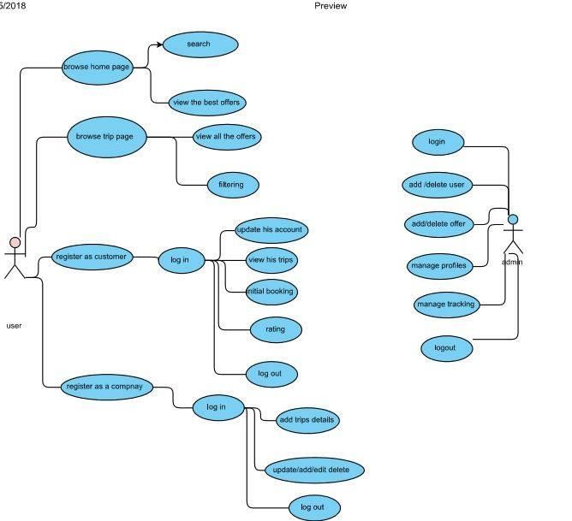

## 6.2. sequence diagram

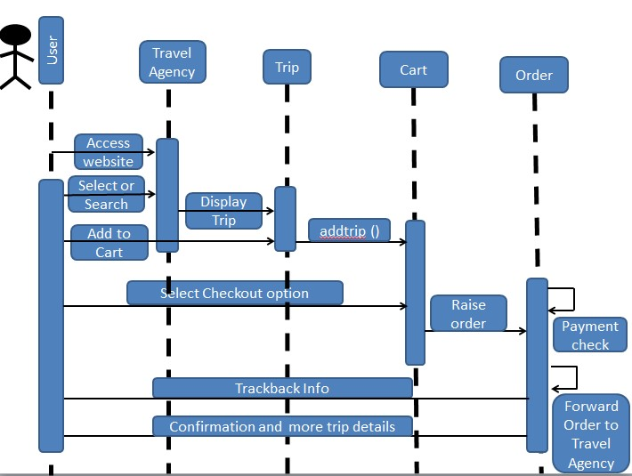

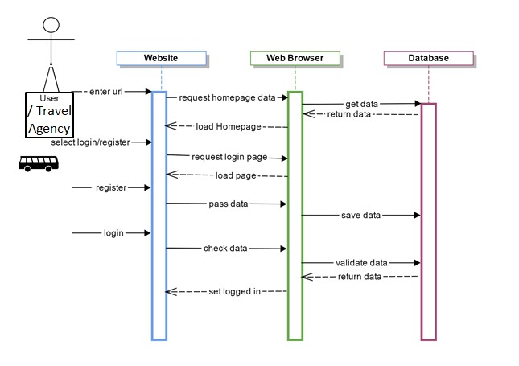

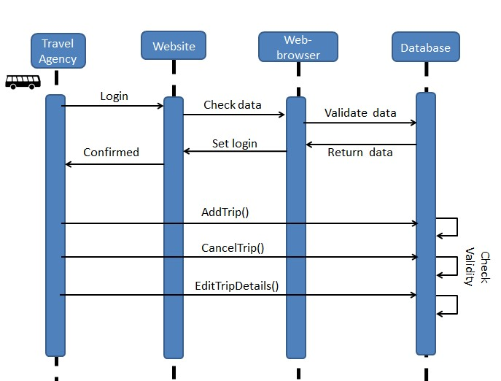

# 7. Nonfunctional Requirements

## 7.1. Performance

The system shall respond to the member in a short time.

The system shall be allowed to take more time when doing large processing jobs.

## 7.2. Security

The system will be reliable.

The System will have different type of users and every user has access constraints after entering the password the user can access his profile.

The details of the user will be safe and secure.

## 7.3. Availability

The system is available for the user at any time.

## 7.4. Accuracy

The requirement and the system will be clear enough and more accurate with every process will be done on the system.

If unable to process the request then appropriate error message.

## 7.5.Usability

The system is user friendly and online help makes using the system easy Reliability.

The system will be protected well from failure and there will be a strategy for error detection and correction.

# 8.Domain requirements

There are some places can’t be visited at any time of year. There are specific times at which you can launch a trip for, these places just like Luxor and Aswan, it is better for you as a tourist to visit them in the winter not in the summer as it is too hot in these places in summer which can affect the fun of the trip badly.

There are also some places can’t be visited at any time of the day as they have specific times after which these places are closed just like museums , they are always closed early, around at 5pm.

For camping also there are some dangerous places, for example not everywhere in saint catherine you can camp in there some places which are not prepared and have no signal so it is a risk to camp in such places.

# 9. System interface

## 9.1 user interface

1. customer can see offers , rate for trips , search for the trips according to the appropriate cost and duration for him

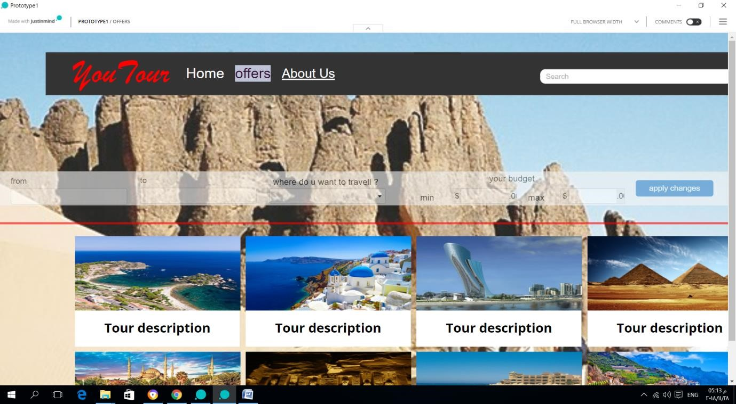

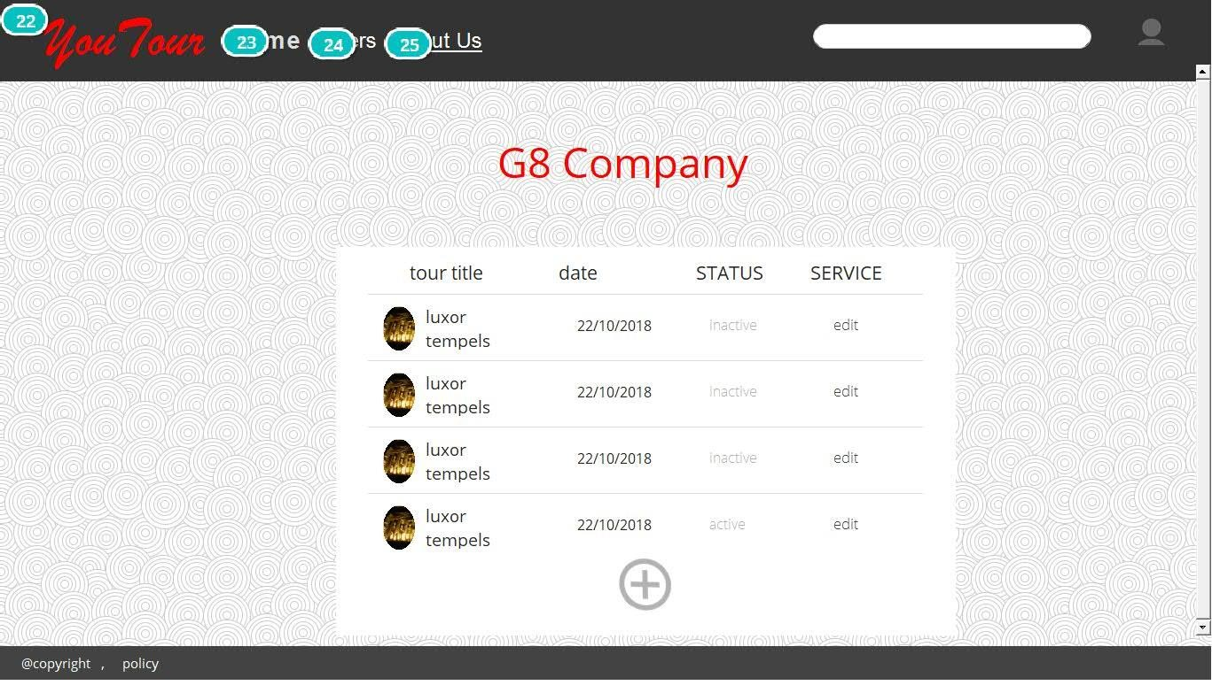

2.customer can make an account by signing up then logging in which manages him of rating trips , making initial booking and viewing the trips he has chosen.

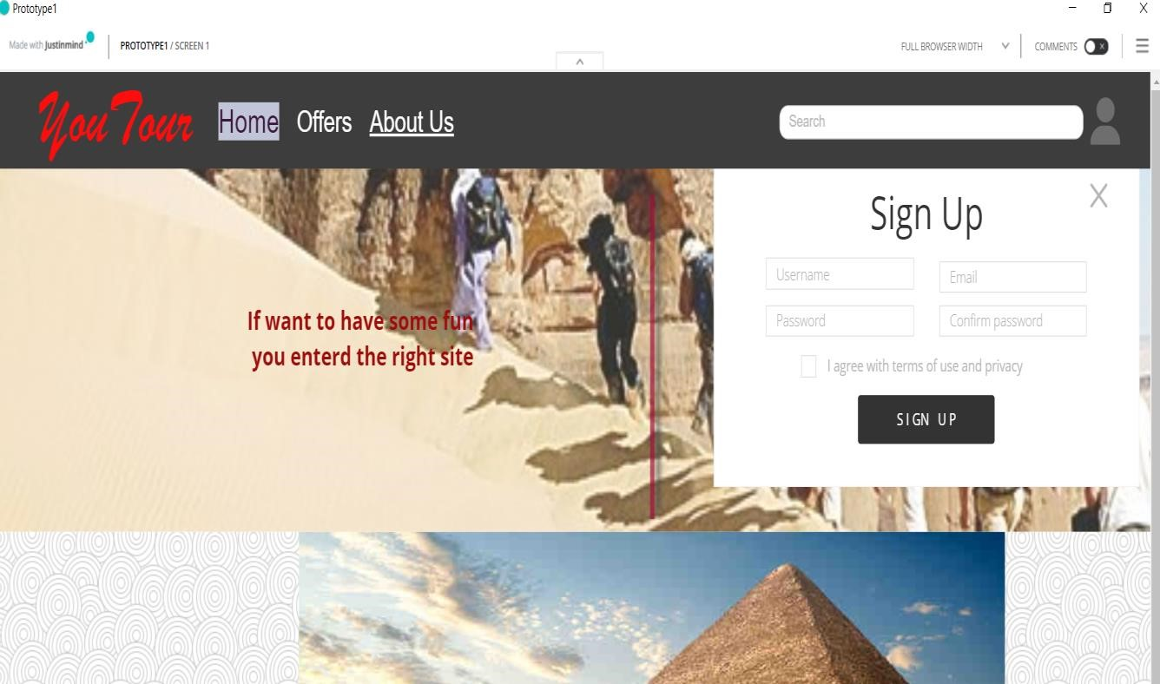

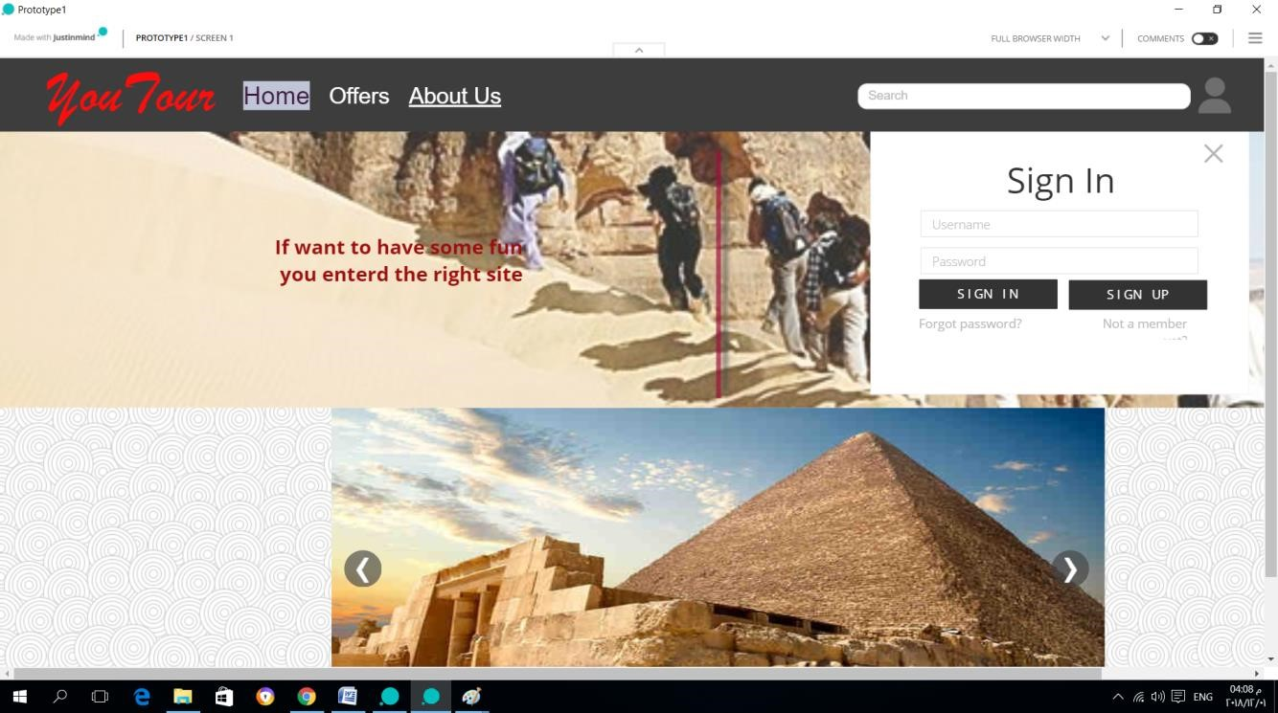

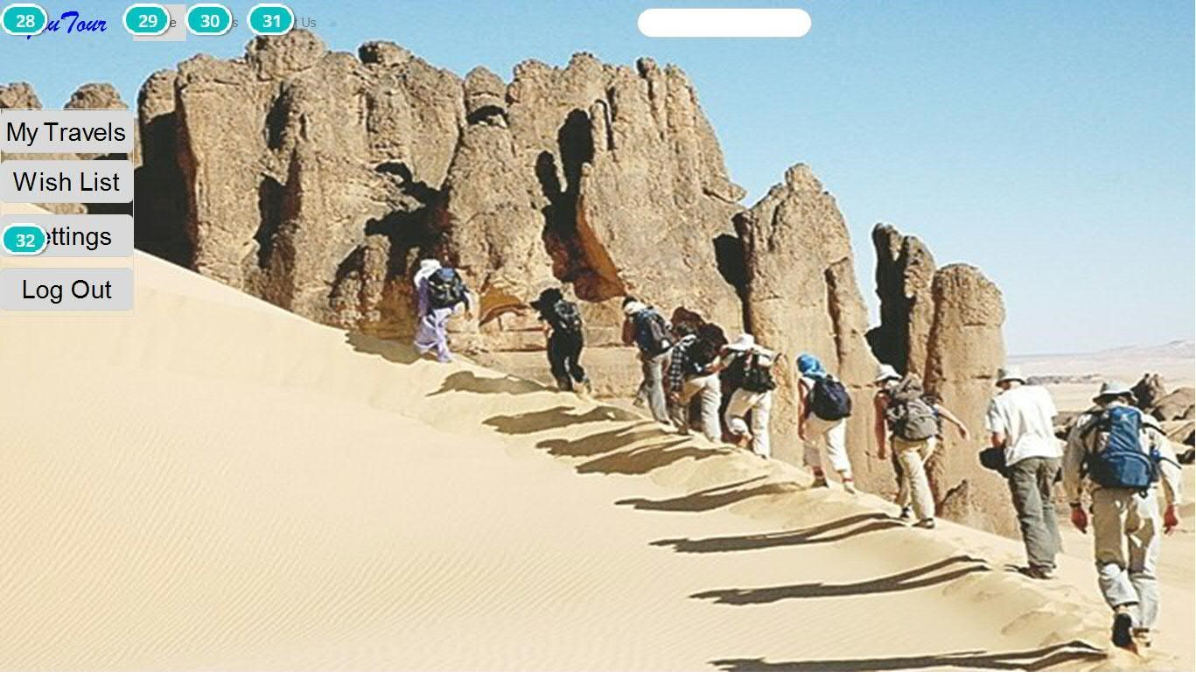

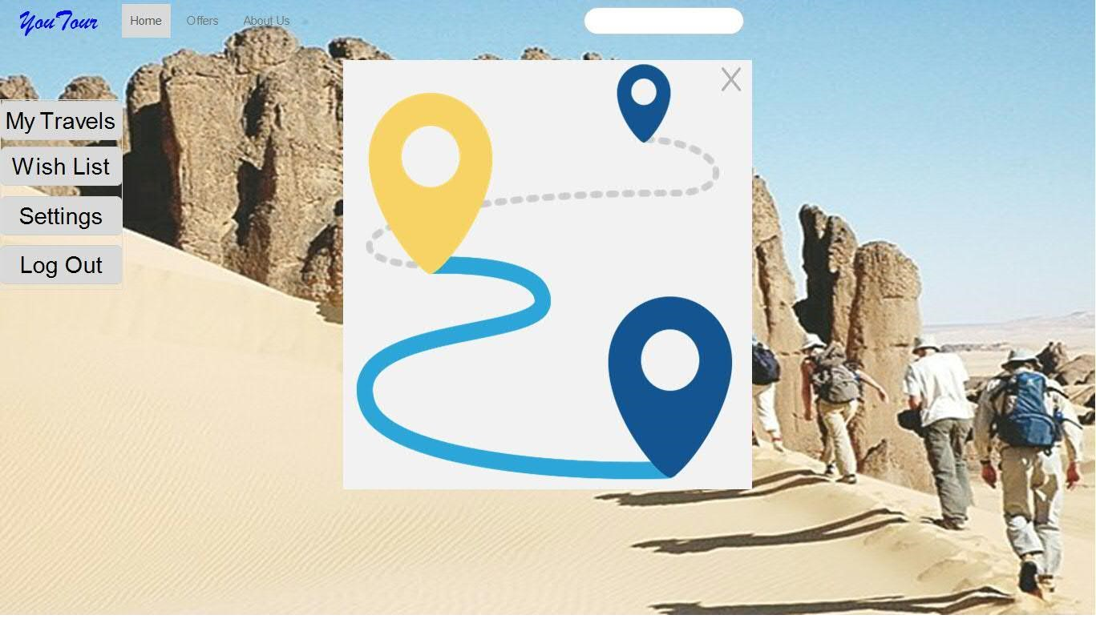

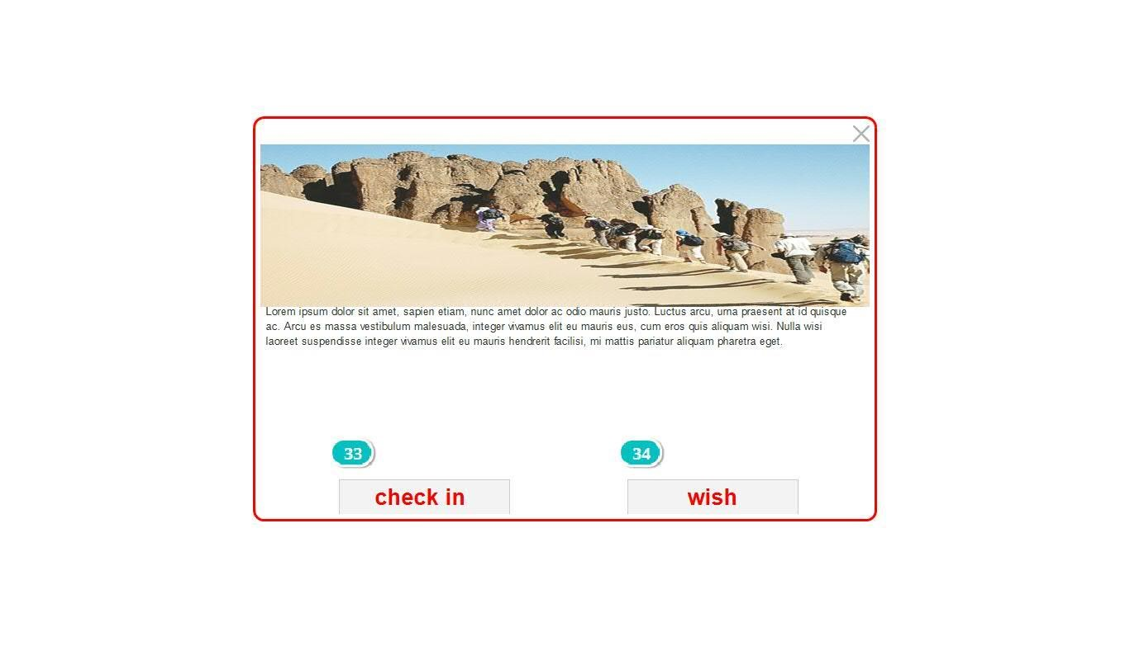

3.Also we have another users who are the companies they can add details for trips , update , edit or delete a trip through their accounts.

