**TRIGGERS**

**ALTER:**

ALTER TABLE STUD_SRINI

ADD TOTAL NUMBER(5);

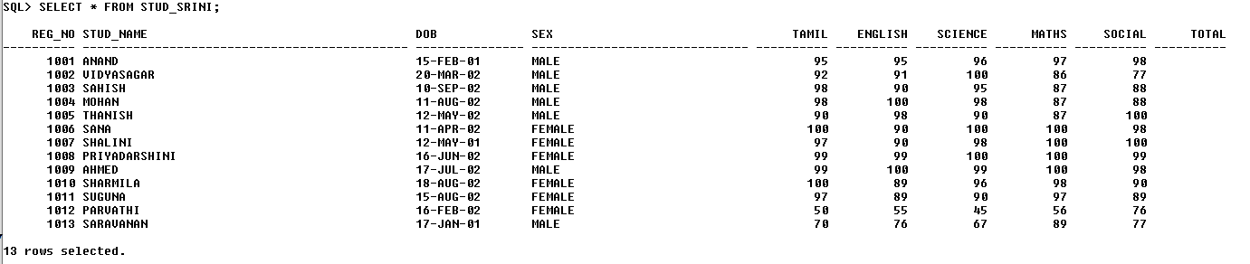

**UPDATE:**

UPDATE STUD_SRINI

SET TOTAL= (TAMIL+ENGLISH+SCIENCE+MATHS+SOCIAL);

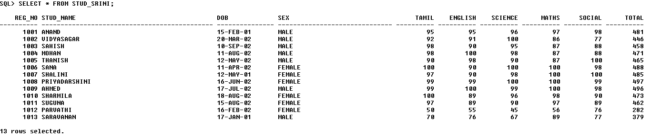

**TO CREATE TRIGGER:**

CREATE OR REPLACE TRIGGER Stud_Srini

BEFORE UPDATE OF TAMIL,ENGLISH,MATHS,SCIENCE,SOCIAL ON Stud_Srini

FOR EACH ROW

BEGIN

IF ((:OLD.TAMIL <>:NEW.TAMIL) OR

(:OLD.ENGLISH <>:NEW.ENGLISH) OR

(:OLD.MATHS <>:NEW.MATHS) OR

(:OLD.SCIENCE <>:NEW.SCIENCE) OR

(:OLD.SOCIAL<>:NEW.SOCIAL)) THEN

:NEW.TOTAL := NVL(:NEW.TAMIL,:OLD.TAMIL) +

NVL(:NEW.ENGLISH,:OLD.ENGLISH) +

NVL(:NEW.MATHS,:OLD.MATHS )+

NVL(:NEW.SCIENCE,:OLD.SCIENCE)+

NVL(:NEW.SOCIAL,:OLD.SOCIAL);

END IF;

END ;

/

Trigger Created.

**After Trigger Created. Update Science Mark = 85 Instead of 45 to the Reg_no = 1012:-**

**UPDATE:**

UPDATE STUD_SRINI

SET SCIENCE = 85 WHERE REG_NO=1012;

1 row updated.

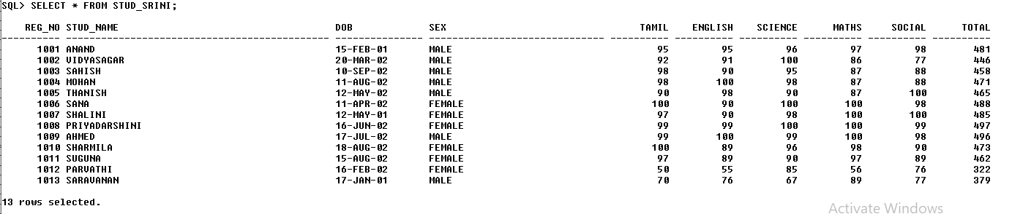

**Science Mark will be Updated through a Trigger with Reg_no = 1012**